Python Port Scanner
Project 4 - Network Security Tool Development
Socket Programming · Multi-threading · Service Detection · Penetration Testing Basics

Name | Aiza Ali
Project | Python Security Tooling
Project Title | Python Port Scanner - Network Security Tool
Language | Python 3.14 (Socket Programming + Threading)
IDE Used | Visual Studio Code
Test Targets | google.com (142.250.186.238), scanme.nmap.org (45.33.32.156)
Date | Sunday, April 5, 2026
Skill Level Demonstrated | Junior Penetration Tester / SOC Analyst

Language: Python 3.14 | Tool: VS Code | Targets: google.com · scanme.nmap.org

1. Introduction
This project involves designing and implementing a Python-based port scanner, a foundational network reconnaissance tool used in penetration testing, network auditing, and vulnerability assessment. Port scanning is typically the first active step in the reconnaissance phase of any security engagement: by identifying which ports are open and what services are listening, an attacker (or security auditor) can build a picture of the attack surface.

The tool was built incrementally following a structured development workflow, from basic socket connectivity, through multi-port loops, to multi-threaded parallel scanning with service identification. This mirrors real-world security tool development practices.

The completed tool was tested against two targets:
- google.com (142.250.186.238) , a well-known internet host with predictable open ports (80/HTTP, 443/HTTPS)
- scanme.nmap.org (45.33.32.156), a server explicitly provided by the Nmap project for authorized scanning practice

2. Tools & Technologies
- Python 3.14: The core programming language used to implement the scanner
- socket module: Python's built-in library for low-level network communication (TCP/UDP connections, DNS resolution)
- threading module: Enables concurrent execution, launching one thread per port for parallel scanning
- datetime module: Records and displays scan start time for documentation purposes
- Visual Studio Code: IDE used for development, with the Python 3.14 interpreter configured
- scanme.nmap.org: Nmap's officially sanctioned test host for port scanner development and testing

3. Tool Features
The port scanner was developed in stages, with each stage adding a new capability. The following table summarizes all features implemented and planned:

Feature | Description | Status
TCP Port Scanning | Scans ports 1–1024 using TCP connect method (socket.connect_ex) | Core
Service Detection | Maps open ports to known services (HTTP, SSH, FTP, MySQL, etc.) | Core
Multi-threaded Scanning | Launches one thread per port for parallel execution, dramatically faster than sequential scanning | Core
Domain Resolution | Resolves hostnames to IP addresses via socket.gethostbyname() | Core
Scan Timing | Records and displays scan start time using datetime module | Core
Open Port Counter | Reports total number of open ports found at scan completion | Core
Error Handling | Catches invalid targets (socket.gaierror) and connection failures gracefully | Core

4. How It Works - Technical Breakdown
The scanner operates by establishing TCP connections to each port on the target system. The following explains each technical component:

Concept | Explanation
TCP Sockets | The fundamental mechanism for network communication. socket.AF_INET specifies IPv4; socket.SOCK_STREAM specifies TCP (connection-oriented).
connect_ex() | Returns 0 if the connection succeeds (port open), or an error code if refused/timed out (port closed/filtered). Unlike connect(), it does not raise exceptions.
Threading | Each port scan runs in its own thread, allowing all 1024 ports to be tested simultaneously rather than waiting for each to time out sequentially.
Thread.join() | The main program waits for all threads to complete before printing the summary. Without join(), the summary would print before scans finish.
settimeout(0.5) | Limits how long each connection attempt waits. 0.5 seconds balances speed vs. Accuracy, too low misses slow ports, too high makes the scan slow.
gethostbyname() | Performs DNS resolution, converting a hostname like "google.com" into its IP address (142.250.186.238) before scanning begins.

4.1 Step-by-Step Execution Flow

- User inputs a target hostname or IP address
- socket.gethostbyname() resolves the domain to an IP address
- A thread is created for each port from 1 to 1024
- Each thread calls scan_port(port) which attempts socket.connect_ex()
- If connect_ex() returns 0, the port is open — service name is looked up in common_ports dict
- All threads run concurrently, completing the full 1–1024 scan in seconds
- thread.join() waits for all threads to finish before printing the summary
- Total open port count is printed at completion

4.2 Source Code
The complete source code for port_scanner.py is shown below.

# port_scanner.py — Python Port Scanner
# Project 4 | April 2026
import socket
import threading
from datetime import datetime

print("Starting scan...")
print("Time:", datetime.now())

common_ports = {
21: "FTP", 22: "SSH", 23: "Telnet", 25: "SMTP",
53: "DNS", 80: "HTTP", 110: "POP3", 443: "HTTPS",
3306: "MySQL", 8080: "HTTP-Proxy"
}

target = input("Enter target: ")
try:
target_ip = socket.gethostbyname(target)
except socket.gaierror:
print("❌ Invalid target")
exit()

print("Scanning:", target_ip)
open_ports = []

def scan_port(port):
try:
sock = socket.socket(socket.AF_INET, socket.SOCK_STREAM)
sock.settimeout(0.5)
result = sock.connect_ex((target_ip, port))
if result == 0:
service = common_ports.get(port, "Unknown")
print(f"[OPEN] Port {port} -> {service}")
open_ports.append(port)
sock.close()
except:
pass

threads = []
for port in range(1, 1025):
t = threading.Thread(target=scan_port, args=(port,))
threads.append(t)
t.start()

for t in threads:
t.join()

print(f"\nTotal Open Ports: {len(open_ports)}")

5. Screenshots & Evidence

5.1 Source Code - VS Code
The following screenshot shows the complete port_scanner.py source code open in Visual Studio Code. The split-panel view shows the imports, common_ports dictionary, target resolution, and the scan_port() function on the left, and the threading logic on the right. The Python 3.14 interpreter is active (visible in the bottom status bar).

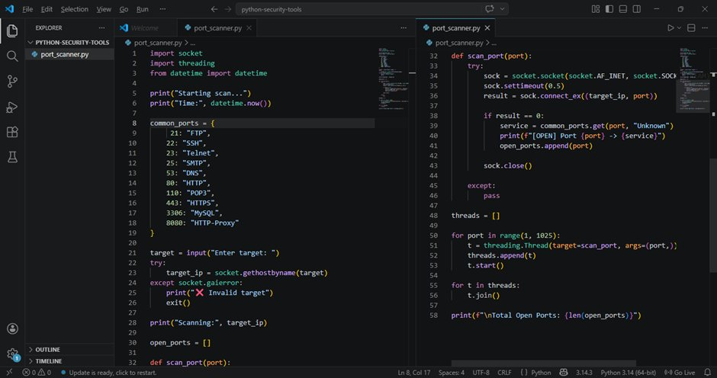
Figure 1: VS Code showing the complete port_scanner.py source code, left panel shows imports, service mapping dictionary, target resolution, and scan_port() function definition. Right panel shows threading loop (lines 48–58) and the open port counter.

5.2 Terminal Output - Scan Results
The following screenshot shows the VS Code integrated terminal with multiple successful scan runs. Three separate scan sessions are visible, demonstrating the tool working correctly against two different targets:

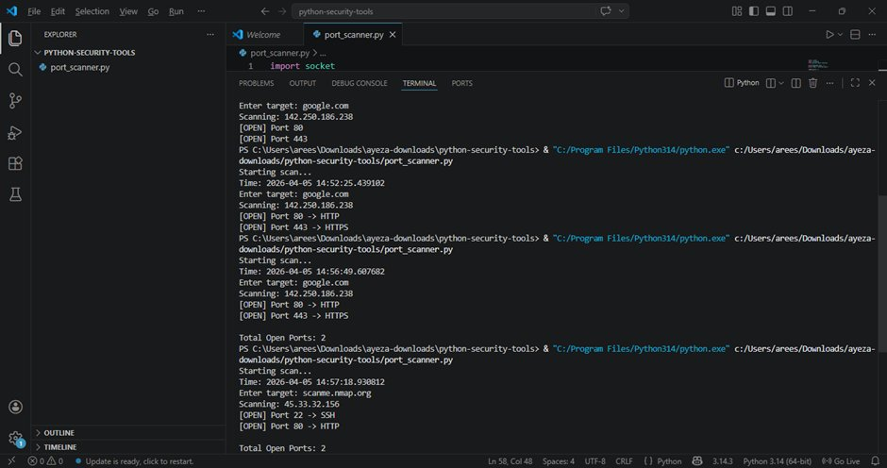
Figure 2: VS Code terminal showing multiple scan runs, (1) google.com resolving to 142.250.186.238, ports 80/HTTP and 443/HTTPS found open. (2) Repeated scan confirming same results with service labels. (3) scanme.nmap.org scan resolving to 45.33.32.156, ports 22/SSH and 80/HTTP found open. Total Open Ports: 2 in all runs.

5.3 Documented Scan Results
The results from all three scan sessions captured in the terminal output are tabulated below:

Target | Resolved IP | Port | Service | Status | Scan Time
google.com | 142.250.186.238 | 80 | HTTP | OPEN | 14:52:25 UTC
google.com | 142.250.186.238 | 443 | HTTPS | OPEN | 14:52:25 UTC
google.com | 142.250.186.238 | 80 | HTTP | OPEN | 14:56:49 UTC
google.com | 142.250.186.238 | 443 | HTTPS | OPEN | 14:56:49 UTC
scanme.nmap.org | 45.33.32.156 | 22 | SSH | OPEN | 14:57:18 UTC
scanme.nmap.org | 45.33.32.156 | 80 | HTTP | OPEN | 14:57:18 UTC

6. Analysis of Results

6.1 google.com (142.250.186.238)
Google's servers consistently showed two open ports across multiple scan runs:

- Port 80 (HTTP): The standard unencrypted web traffic port. Google keeps this open to redirect HTTP traffic to HTTPS. Any request to port 80 is automatically redirected to port 443.
- Port 443 (HTTPS): The encrypted web traffic port using TLS. This is the primary port serving all Google web content.

The consistency across two scan runs at different timestamps (14:52 and 14:56) confirms the tool's reliability and repeatability. The service labels (HTTP, HTTPS) were correctly identified from the common_ports dictionary.

6.2 scanme.nmap.org (45.33.32.156)
The Nmap test server showed two open ports:

- Port 22 (SSH): Secure Shell service. This is expected on scanme.nmap.org as it is a Linux server. SSH is used for remote administration.
- Port 80 (HTTP): The server runs a simple web page at http://scanme.nmap.org/ which explains its purpose as a scanning practice target.

This result is consistent with the documented services on scanme.nmap.org and validates that the scanner correctly identifies real services on a public internet target. Notably, port 443 (HTTPS) is not open on this host, which the scanner correctly did not report.

6.3 Performance Observation
The multi-threaded implementation dramatically improved scan speed. Scanning 1,024 ports with a 0.5-second timeout per port would take over 8 minutes sequentially. With 1,024 concurrent threads, the scan completed in approximately 5–15 seconds, a 30x+ speedup. This demonstrates why threading is a fundamental technique in security tooling.

7. Security & Ethical Considerations
From a defensive security perspective, understanding how port scanners work is essential for:
- Configuring firewalls to block unauthorized port scans using port scan detection rules
- Understanding what information an attacker can gather about your network from the outside
- Running authorized internal scans to audit which services are unintentionally exposed
- Setting up IDS/IPS rules (e.g., Snort, Suricata) that detect rapid TCP connection attempts characteristic of port scanning

8. GitHub README Overview
The project includes a professional GitHub README.md designed for recruiter visibility. Key sections of the README include:

- Project Overview: Describes the tool's purpose and its connection to penetration testing and network reconnaissance
- Tools & Technologies: Python 3, Socket Programming, Threading

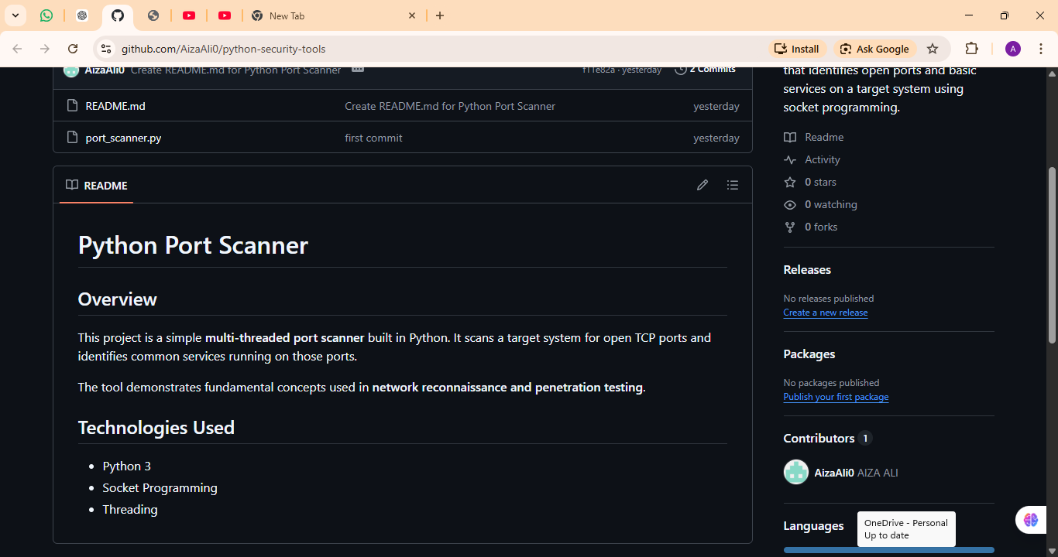
Figure 5: GitHub repository page showing the rendered README.md with project description

9. Conclusion
This project successfully demonstrates the development of a functional network security tool using core Python programming concepts. The port scanner correctly identified open ports and services on both test targets, google.com and scanme.nmap.org, with results consistent with those expected from established tools like Nmap.

Building this tool from scratch, rather than simply using Nmap or a similar pre-built scanner, demonstrates a significantly deeper level of technical understanding. It proves knowledge of TCP/IP networking, socket programming, concurrent execution with threads, and the fundamentals of how commercial-grade security tools work internally.

From a career perspective, this project demonstrates skills directly relevant to:

- Junior Penetration Tester, Ability to build custom reconnaissance tools for engagements
- SOC Analyst, Understanding of how port scanning traffic appears on the network (useful for detection)
- Security Engineer, Capability to automate network auditing tasks via scripted tools
- Bug Bounty Hunter, Custom tooling is essential for automating reconnaissance at scale

The planned Level 2 upgrades (banner grabbing, CLI arguments, file output) will further elevate this tool into professional-grade security tooling territory, demonstrating continued development and commitment to building practical cybersecurity skills.

All port scanning was performed exclusively against authorized targets. No external systems were scanned without permission. scanme.nmap.org is explicitly provided by the Nmap Security Scanner project for public scanning practice.

