

**PLM XL Assist+ Admin Console**

**v1.4.2**

**User Manual**

June 2013

**P L M X L A S S I S T + A D M I N C O N S O L E - X A V O R C O R P O R A T I O N**

User Manual



By

[**Xavor Corporatio**](http://www.xavor.com/)**n**

8105 Irvine Center Drive • Suite 780

Irvine, CA 92618, USA

Phone +1.949.529.7372 • Fax 264+1.1471.949.



Copyright © 2013 Xavor Corporation. All rights reserved. PLM XL and the PLM XL logo are trademarks or registered trademarks of Xavor Corporation or its affiliates in the U.S. and other countries. Other names may be trademarks of their respective owner

Table of Contents

1 Overview 4

1.1 What’s in this Manual? 4

1.2 Overview of Admin Console- Assist+ 4

2 Admin Console 5

2.1 Assist+- Admin Console 6

2.2 Logging & Logout 7

2.2.1 Login 7

2.2.2 Logout 7

2.3 Settings: 8

2.3.1 Change Password: 8

2.3.2 Role and User Groups Preference: 9

2.3.3 Configurations: 11

2.4 Assist Text 12

2.4.1 Add Assist Text 13

2.4.2 Edit Assist Text 15

2.4.3 Delete Assist Text 15

2.4.4 Use different Theme 15

2.4.5 Change Label Color 16

2.4.6 Filter (Classes, Attributes) 17

2.5 About 17

2.5.1 License Info 18

# Overview

This section provides an overview of tasks that can be performed for XL Assist+ Admin Console.

## **What’s in this Manual?**

Section



1

This manual is a detailed view of Admin Console of Assist+ Application. Every new user needs to have a good grasp of the following functions:

o To view logging in/out details, see page 7

o To view /add/edit settings, see page 8 - 11

o To change password settings, see page 8

o To update role preferences settings, see page 9

o To update user groups preferences settings, see page 10

o To add/update configuration settings, see page 11

o To Add/Update Assist text settings for base class, class and sub class, see page 12-17

o To see how to add multiple assist text for multiple roles/user groups, See page 13-15

o To see how to change label color for fields, See page 16

o To view how to filter classes & attributes from lists, See page 17

o To view about license info, see page 17

## Overview of Admin Console- Assist+

The Admin Console of Assist+ provides a way to perform configuration settings, set role preferences according to selected roles in PLM, change password and provide guided text help for Agile PLM classes, and attributes to display so the user better understands the fields on the page.



**4**

# Admin Console

This section details the steps required to use Assist+ Admin

Console. These steps include:

1. Login & Logout
2. Add/Change configurations
3. Role /user Groups Preferences
4. Change password
5. Add/edit/delete Assist text according to roles /user groups
6. Add/edit/delete Assist text according to workflow
7. Change Label for fields
8. Activate License



Section



2

**5**

## **Assist+- Admin Console**

Invoke Assist+ URL as follows:

http://*<AgilePLMServer>.<Domain>:<port>*/AssistPlus e.g. http://plm.xavor.com:7001/AssistPlus

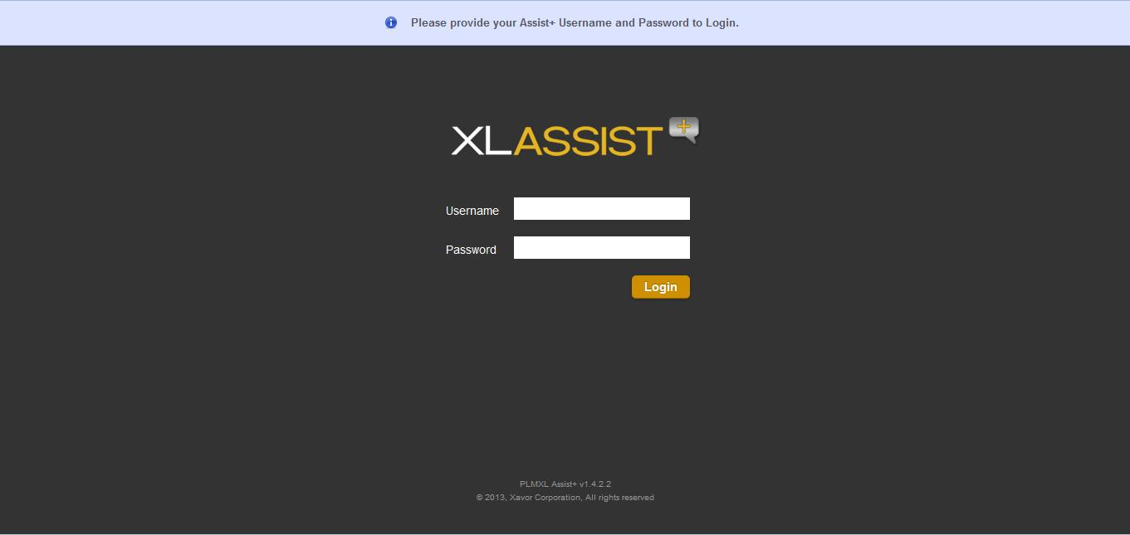

**6**

## Logging & Logout

### Login

o Start your browser & invoke Assist+ Admin Console

o **Provide User Name:** admin

o **Password:** plmflex o Click to login

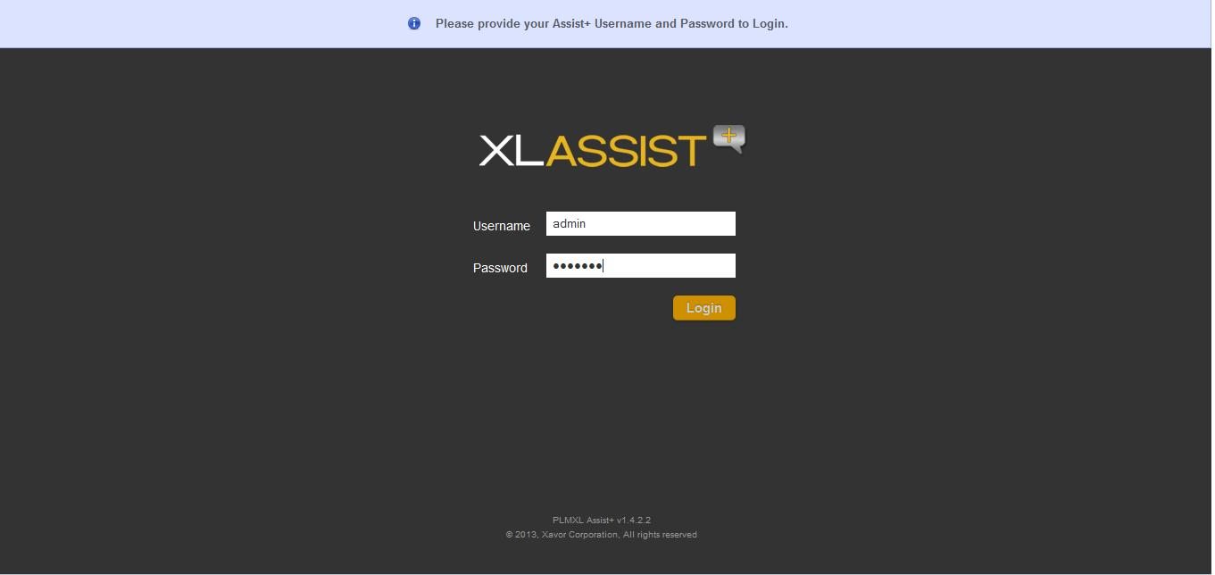

* **Note:** This is the only default admin user for Assist+ admin console. Password can be changed oncelogged in.

### Logout

o Click on logout tab, user will be logged out and returned to the Home page



**7**

## Settings:

There are 3 sections displayed:

o Change Password

o Role/User Groups Preference

o Configurations

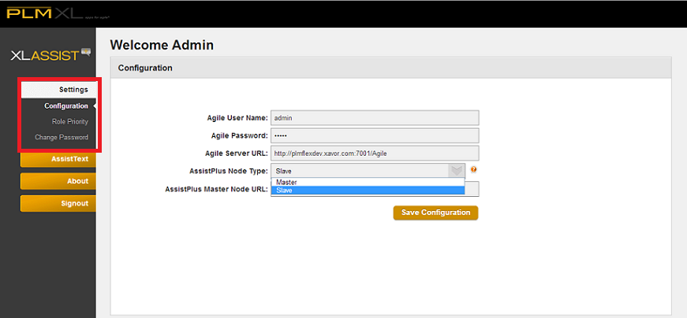

### Change Password:

Please enter the following information:

1. **User Name:** An Agile PLM user with Administration rights.
2. **Current Password:** Administrator user current password
3. **New Password:** Administrator user new password
4. **Confirm New Password:** Administrator user new password to confirm
5. Click change the password save to. The notification bar below shows success message if password changed successfully.



**8**

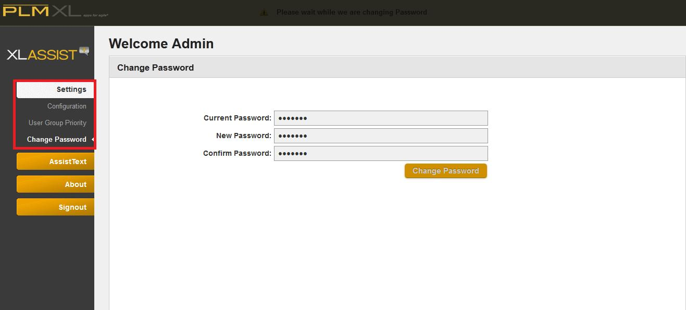

### Role and User Groups Preference:

#### Role Preference:

As user clicks, the following screen will be displayed:

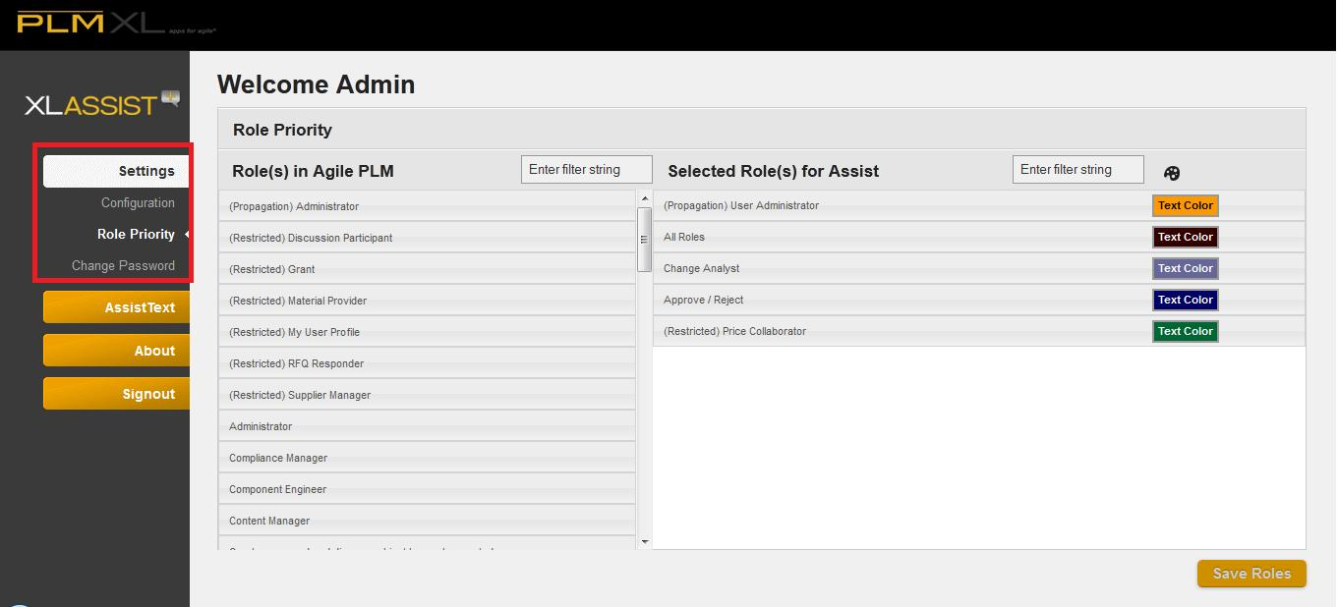

1. User is able to filter the roles based on keyword.
2. User drags roles from Agile PLM column to Selected Roles for Assist column. Roles placement is ordered according to its priority
3. User can assign color themes to the selected roles.
4. Click the “Save Roles” to save the configurations. The notification bar below shows the

Success message if role preferences are saved successfully.



**9**

* **Note:** Only the roles the user has selected and saved here will be populated when Assist text isinserted. Priority will also be set from this screen.

#### User Groups Preference

As user clicks, the following screen will be displayed:

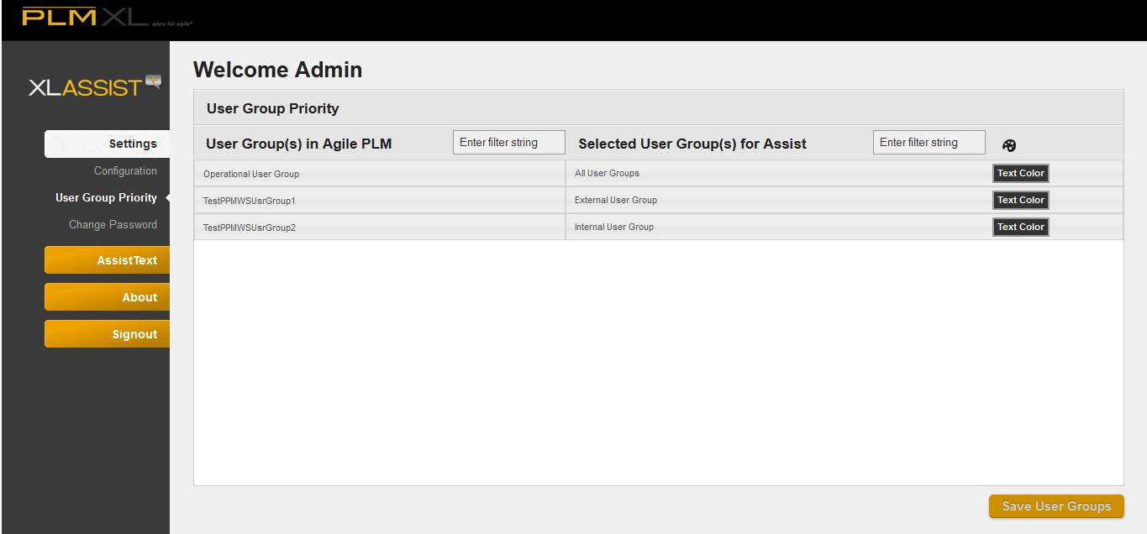

* 1. User is able to filter the user group based on keyword.
  2. User drags roles from Agile PLM column to Selected User Groups for Assist column. User Groups placement is ordered according to its priority
  3. User can assign color themes to the selected user groups.

1. Click the UserGroups “Save” to save the configuration. The notification bar below shows the

Success message if user group preferences are saved successfully.

* **Note:** Only the user groups the user has selected and saved here will be populated when Assist text isinserted. Priority will also be set from this screen.



**10**

### Configurations:

As user clicks, the following screen will be displayed:



1. **Agile Server URL:** This is the Agile PLM application URL that XL Assist+ willwork with. Provide the URL as: http://<AgilePLMServer>.<Domain>/Agile
2. **User Name:** An Agile PLM user with Administration rights.
3. **Password:** Administrator user password
4. **AssistPlus Node Type**: User is able to select as Master/Slave option from drop down. Select Master option to keep the current AssistPlus instance as Master Node. Select Slave to provide some other AssistPlus instance as Master Node
5. **AssistPlus Master Node URL**: Displays when Slave option is selected from AssistPlus Node Type. User is able to provide another AssistPlus instance URL to serve as Master node.
6. Click the “Save Configurations” to save the configurations. The notification bar below shows success message if configurations are saved successfully. An error message is displayed if configurations were not successfully saved or application is unable to connect to Agile using the provided credentials.





**11**

## Assist Text

As user clicks, the following screen will be displayed:

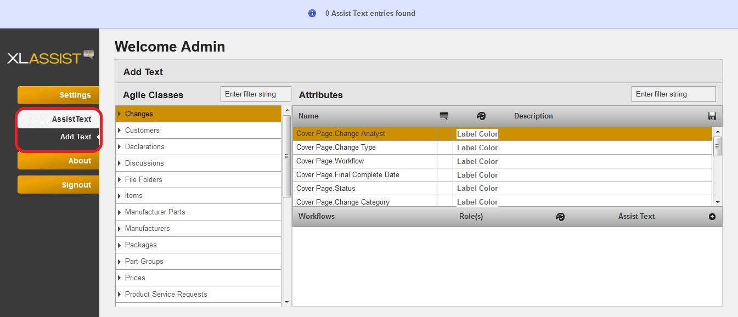

User is able to perform the following activities:

1. Add, edit or delete Assist Text for any role/ user groups against any attribute of class with respect to any work flow or state of the workflow selected.
2. Filter the classes, attributes based on keyword.
3. Change the color of labels with given color box



**12**

### Add Assist Text

 **Note:** Assist Text can only be added when logged in and on Assist Text page.

Click to Add text icon  , the following screen will be displayed:

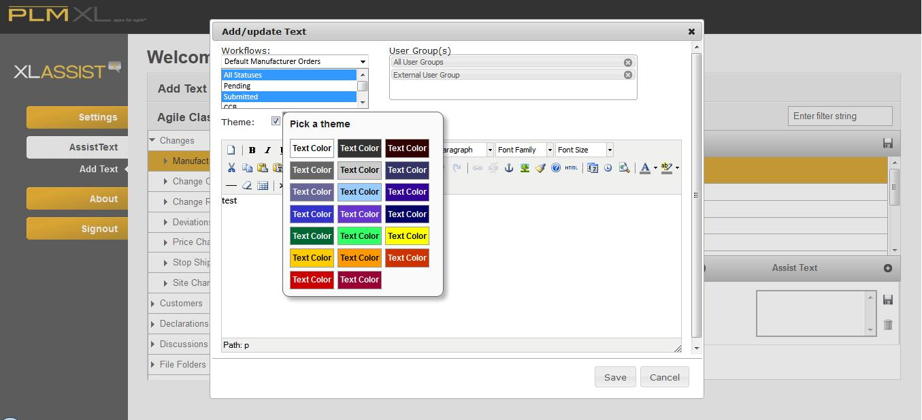

* 1. Select any class, such as Changes, it will be highlighted
  2. Select Attribute, such as Cover.page.change.analyst, it will be highlighted
  3. Click to Add text icon  , It will display a pop up to Add role/User Groups and insert text as in image
  4. Select Workflow and its state as in the image.
  5. Select Role/User Group or select from the options displayed, as in the following image:
  6. Insert text for this role/User group for this particular workflow and state
  7. Click the save button to save the Assist text.
  8. User will be navigated to the main screen with success message that indicates that Assist text is saved successfully.
* **Note:** To Add Assist Text for multiple roles/User groups, repeat the same procedure, as the imagebelow shows, for each of the roles/user groups selected:

 **Note:** User is not able to add Work flow for theclass. For base class, user can only add Assist Text for user groups/ roles

* **Note:** To add Assist Text for sub class, expand the class, base class, and select to load attributes, seeimage below:



**13**

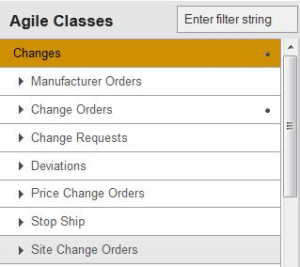

And see the image to expand for sub class:

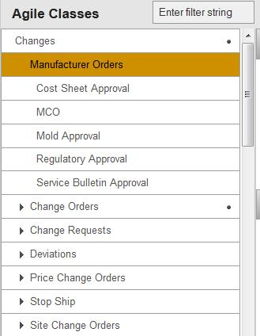

**14**

### Edit Assist Text

**Note:** To Add Assist Text, See Page 11.

* 1. Select any class, such as Changes, it will be highlighted
  2. Select Attribute, such as Cover.page.change.analyst, it will be highlighted
  3. Click to text to Edit
  4. It will display the pop up with prepopulated value
  5. Change Text for this user group

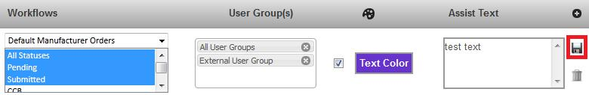

* 1. Click to save icon  to save the Assist text. The notification bar below shows success message if Assist text saved successfully.

### Delete Assist Text

* 1. Select any class, such as Changes, it will be highlighted
  2. Select Attribute, such as Cover.page.change.analyst, it will be highlighted
  3. Click on delete icon alongside the text to be deleted, it will remove text and display the following screen

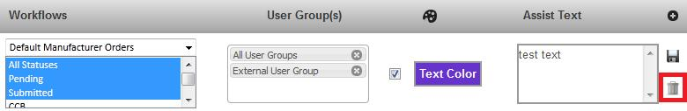

### Use different Theme

|  |  |  |
| --- | --- | --- |
| 1. | User is able to select any different theme from the assist text field |  |
| 2. | Click to checkbox namedwilloverlay pick“userathemeboxdifferent. | t |
| 3. | Select any theme and save. |  |



**15**

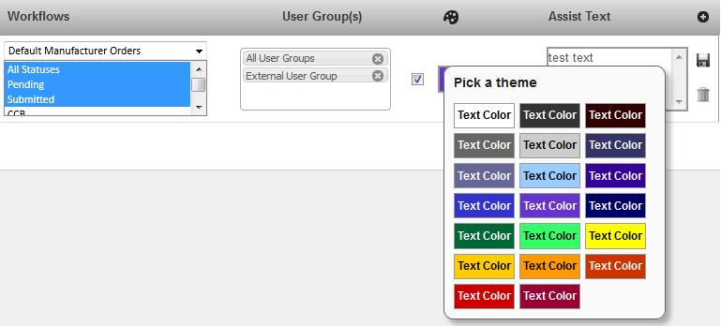

### Change Label Color

* 1. Select any class, such as Changes, it will be highlighted
  2. Select Attribute, such as Cover.page.change.analyst, it will be highlighted
  3. Click on label color
  4. It will overlay a color box, as in image below. Select any color; it will be displayed as your label color for the specific field.

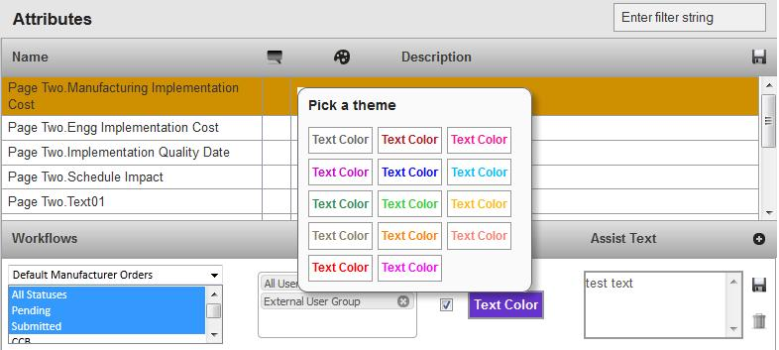

**16**

### Filter (Classes, Attributes)

|  |  |
| --- | --- |
| 1. | Select any class, such as Changes, it will be highlighted |
| 2. | Enter a keyword, such asimplemen“” in boxtheinthe filterAttributespane |
| 3. | It will display filtered attributes according to the keyword as in the image below: |

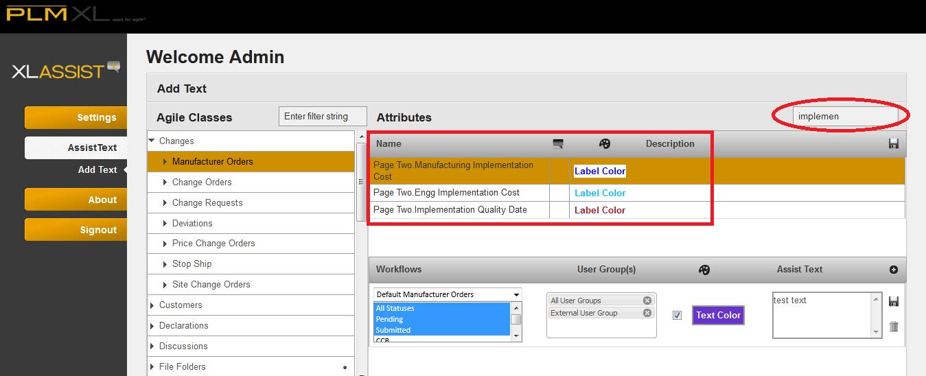



**17**

## About

### License Info

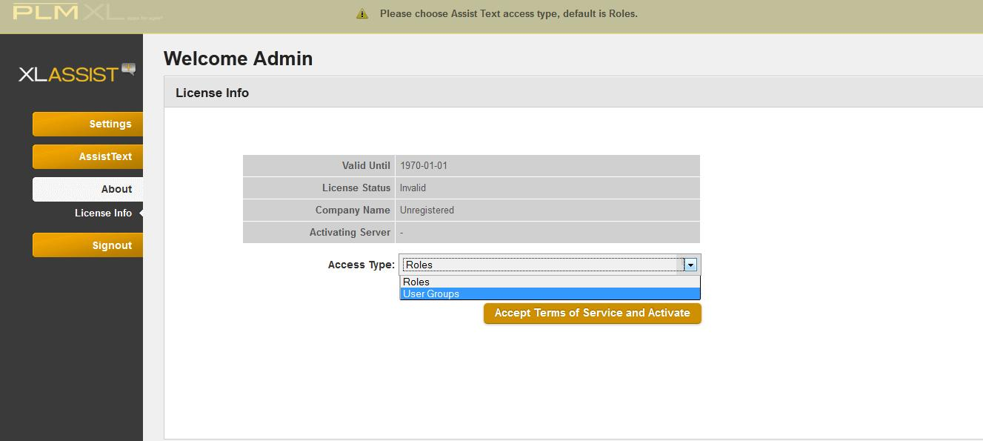

This screen displays the license information; user needs to select the Access Type and click “Accept Terms of service and Activate” to activate the product for use.

**Note:** Select Access Type as Roles/ User Groups before activating. This is a one-time selection for an instance and affects the behavior of the application. In case this needs to be changed later, all the configured Assist Texts will have to be removed and instance will be re-configured.



* **Note:** if user hasn’t activated its license thenthe one activates its license.
* **Note:** Access Type is only one time selection, as user activates its license, one will be able to selectaccess type and rest of the configurations will be displayed with respect to selection.



**18**