|  |  |
| --- | --- |
|  |  |

|  |
| --- |
| **Flex Assist+ Admin Console**  **v1.4** |
| **User Manual** |
| v1.1 |
| May 2012 |
|  |
|  |

PLM flex Assist+ Admin COnsole- xavor corporation

User Manual



By

[**Xavor Corporation**](http://www.xavor.com/)

8105 Irvine Center Drive • Suite 780

Irvine, CA 92618, USA

Phone +1.949.529.7372 • Fax +1.949.264.1471

oracle

Copyright © 2012 Xavor Corporation. All rights reserved. PLM Flex and the PLM Flex logo are trademarks or registered trademarks of Xavor Corporation or its affiliates in the U.S. and other countries. Other names may be trademarks of their respective owners

Table of Contents

**OVERVIEW**

1 What’s in this Manual? 4

2 Overview of Admin Console- Assist+ 4

ADMIN CONSOLE

1 Assist+- Admin Console 6

2 Logging & Logout 7

2.1 Login 7

2.2 Logout 7

3 Settings: 9

3.1 Change Password: 9

3.2 Role Preference: 10

3.3 Configurations: 11

4 Assist Text 12

4.1 Add Assist Text 13

4.2 Edit Assist Text 15

4.3 Delete Assist Text 15

4.4 Use different Theme 15

4.5 Filter (Classes, Attributes) 16

5 ABOUT 15

5.1 License Info 16

|  |  |
| --- | --- |
| Overview  This section provides an overview of tasks that can be performed for Flex Assist+ Admin Console. | Section  1 |

# **What’s in this Manual?**

This manual is a detailed view of Admin Console of Assist+ Application. Every new user needs to have a good grasp of the following functions:

* To view logging in/out details, see page 7
* To view /add/edit settings, see page 9 - 11
* To change password settings, see page 9
* To update role preferences settings, see page 10
* To add/update configuration settings, see page 11
* To update Assist text settings for base class, class and sub class, see page 11-15
* To see how to add multiple assist text for multiple roles, See page 15
* To view how to filter classes & attributes from lists, See page 16
* To view about license info, see page 17

# **Overview of Admin Console- Assist+**

The Admin Console of Assist+ provides a way to perform configuration settings, set role preferences according to selected roles in PLM, change password and provide guided text help for Agile PLM classes, and attributes to display so the user better understands the fields on the page.

|  |  |
| --- | --- |
| Admin Console  This section details the steps required to use Assist+ Admin Console. These steps include:   1. Login & Logout 2. Add/Change configurations 3. Role Preferences 4. Change password 5. Add/edit/delete Assist text according to roles. 6. Activate License | Section  2 |

# **Assist+- Admin Console**

Invoke Assist+ URL as follows:

http://*<AgilePLMServer>.<Domain>:<port>*/AssistPlus

e.g. http://plmflex.xavor.com:7001/AssistPlus

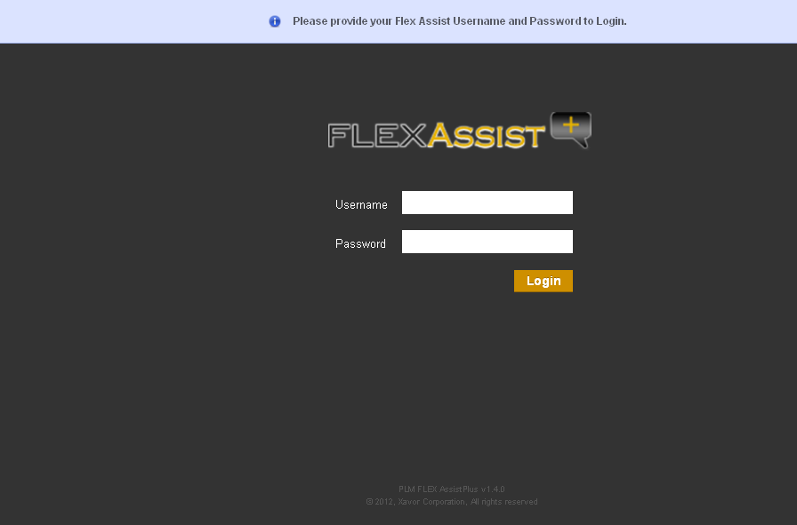

# **Logging & Logout**

## Login

* Start your browser & invoke Assist+ Admin Console
* **Provide User Name:** admin
* **Password:** test123
* Click to login

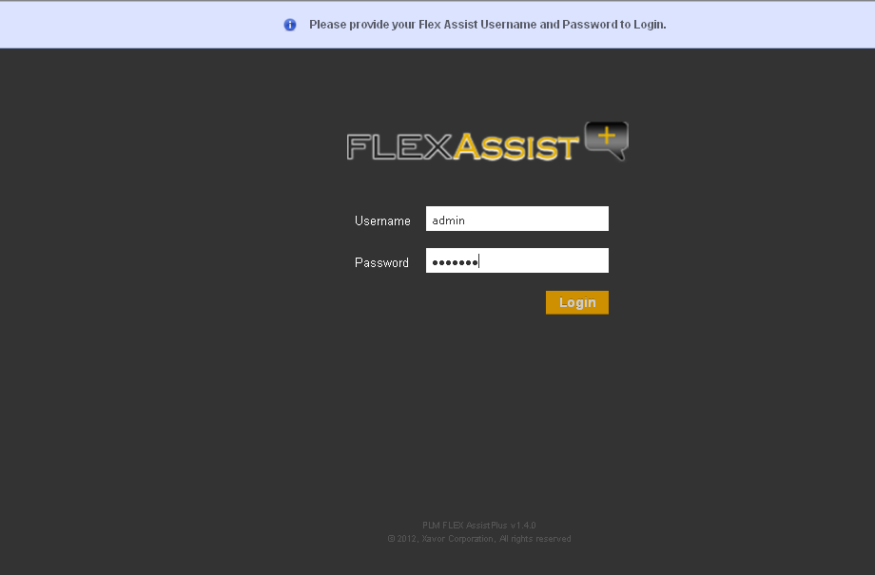

* **Note:** This is the only default admin user for Assist+ admin console. Password can be changed once logged in.

## Logout

* Click on logout tab, user will be logged out and returned to the Home page

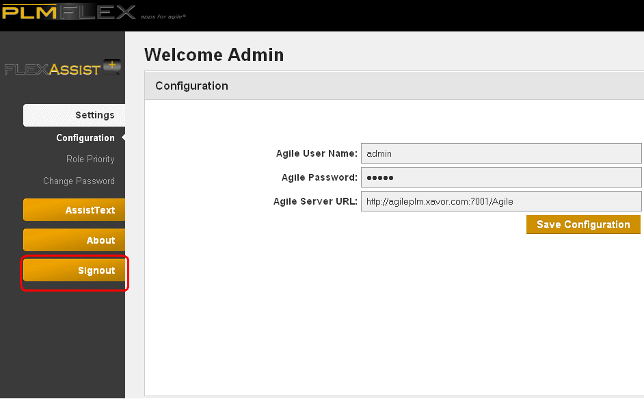

# **Settings:**

There are 3 sections displayed:

* + Change Password
  + Role Preference
  + Configurations

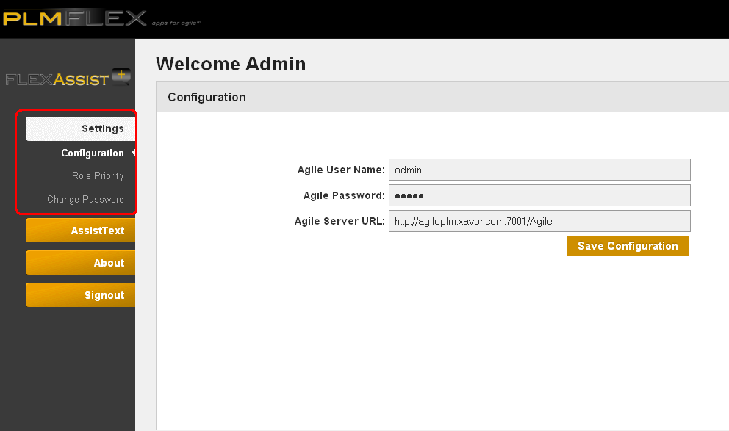

## Change Password:

Please enter the following information:

* 1. **User Name:** An Agile PLM user with Administration rights.
  2. **Current Password:** Administrator user current password
  3. **New Password:** Administrator user new password
  4. **Confirm New Password:** Administrator user new password to confirm
  5. Click the “change password” to save. The notification bar below shows success message if password changed successfully.

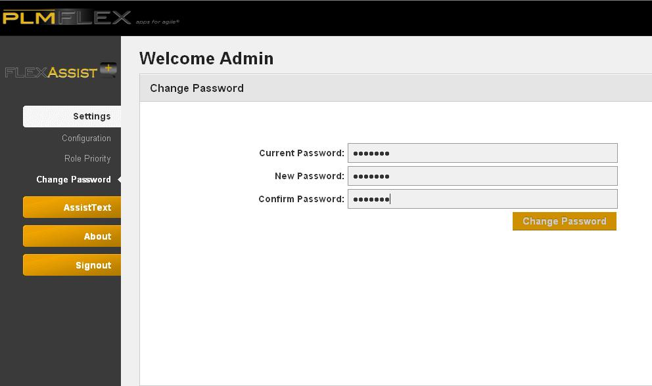

## Role Preference:

As user clicks, the following screen will be displayed:

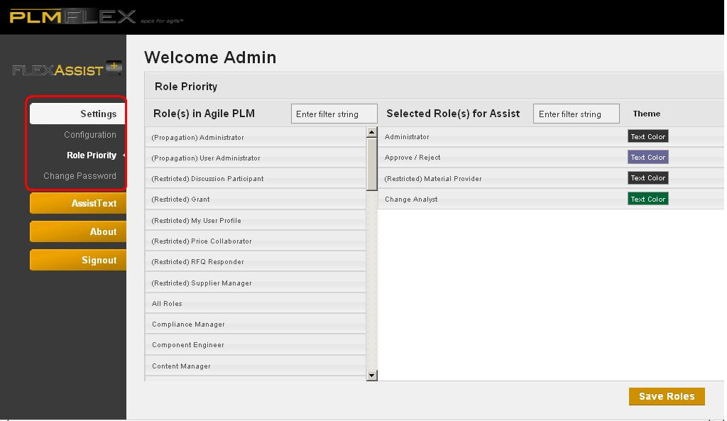

1. User is able to filter the roles based on keyword.
2. User drags roles from Agile PLM column to Selected Roles for Assist column. Roles placement is ordered according to its priority
3. User can assign color themes to the selected roles.
4. Click the “Save Roles” to save the configurations. The notification bar below shows success message if role preferences are saved successfully.

**Note:** Only the roles the user has selected and saved here will be populated when Assist text is inserted. Priority will also be set from this screen.

## Configurations:

As user clicks, the following screen will be displayed:

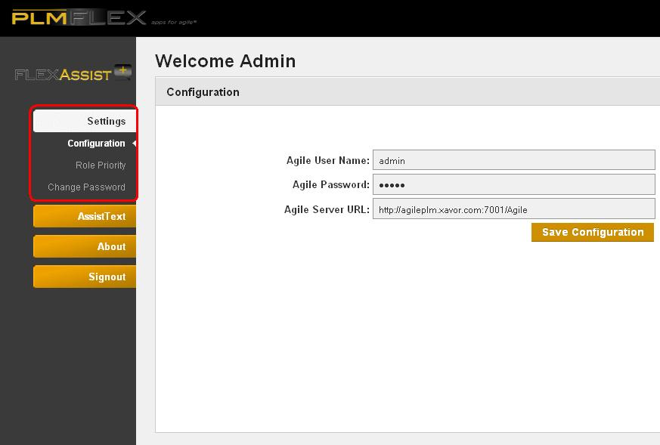

1. **Agile Server URL:** This is the Agile PLM application URL that Flex Assist+ will work with. Provide the URL as: http://<AgilePLMServer>.<Domain>/Agile
2. **User Name:** An Agile PLM user with Administration rights.
3. **Password:** Administrator user password
4. Click the “Save Configurations” to save the configurations. The notification bar below shows success message if configurations are saved successfully. An error message is displayed if configurations were not successfully saved or application is unable to connect to Agile using the provided credentials.

# **Assist Text**

As user clicks, the following screen will be displayed:

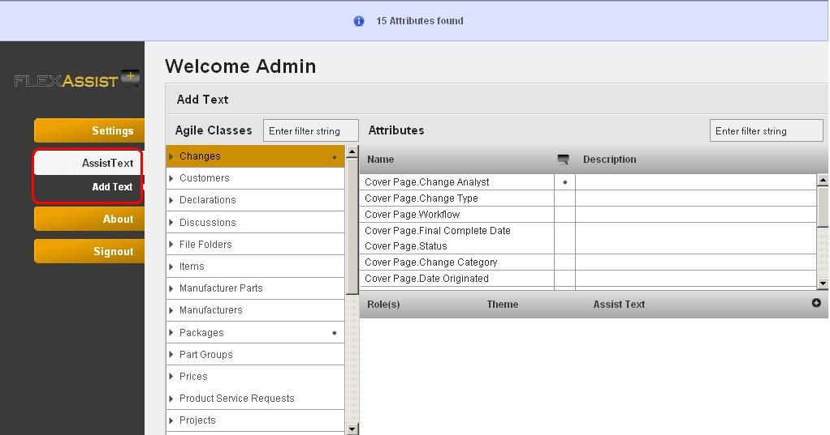

User is able to perform the following activities:

1. Add, edit or delete Assist Text for any role against any attribute of class
2. Filter the classes, attributes based on keyword.

## Add Assist Text

* **Note:** Assist Text can only be added when logged in and on Assist Text page.

Click to Add text icon  , the following screen will be displayed:

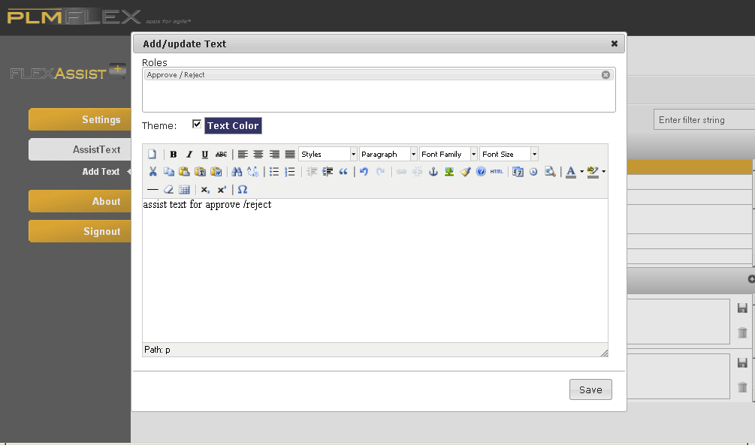

1. Select any class, such as Changes, it will be highlighted
2. Select Attribute, such as Cover.page.change.analyst, it will be highlighted
3. Click to Add text icon  , It will display a pop up to Add role and insert text as in image
4. Provide Role or select from the options displayed, as in the following image:
5. Insert text for this role
6. Click the save button to save the Assist text.
7. User will be navigated to the main screen with success message that indicates that Assist text is saved successfully.

* **Note:** To Add Assist Text for multiple roles, repeat the same procedure, as the image below shows, for each of the roles selected:
* **Note:** To add Assist Text for sub class, expand the class, base class, and select to load attributes, see image below:

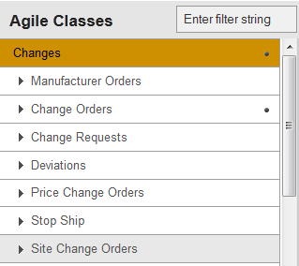

And see the image to expand for sub class:

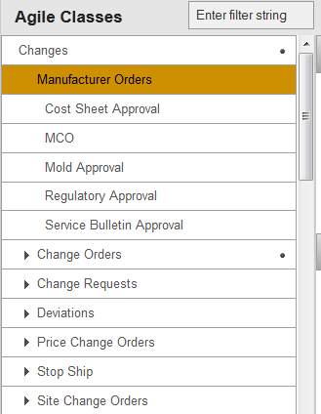

## Edit Assist Text

* **Note:** To Add Assist Text, See Page 11.

1. Select any class, such as Changes, it will be highlighted
2. Select Attribute, such as Cover.page.change.analyst, it will be highlighted
3. Click to text to Edit
4. It will display the pop up with prepopulated value
5. Change Text for this role

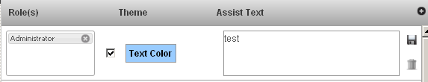

1. Click to save icon  to save the Assist text. The notification bar below shows success message if Assist text saved successfully.

## Delete Assist Text

1. Select any class, such as Changes, it will be highlighted
2. Select Attribute, such as Cover.page.change.analyst, it will be highlighted
3. Click on delete icon alongside the text to be deleted, it will remove text and display the following screen

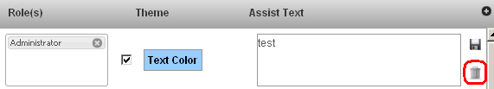

## Use different Theme

1. User is able to select any different theme from the assist text field
2. Click to checkbox named “user different theme”, it will overlay pick a theme box.
3. Select any theme and save.

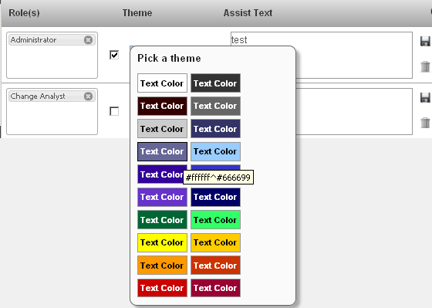

## Filter (Classes, Attributes)

1. Select any class, such as Changes, it will be highlighted
2. Enter a keyword, such as “wor” in the filter box in the Attributes pane
3. It will display filtered attributes according to the keyword as in the image below:

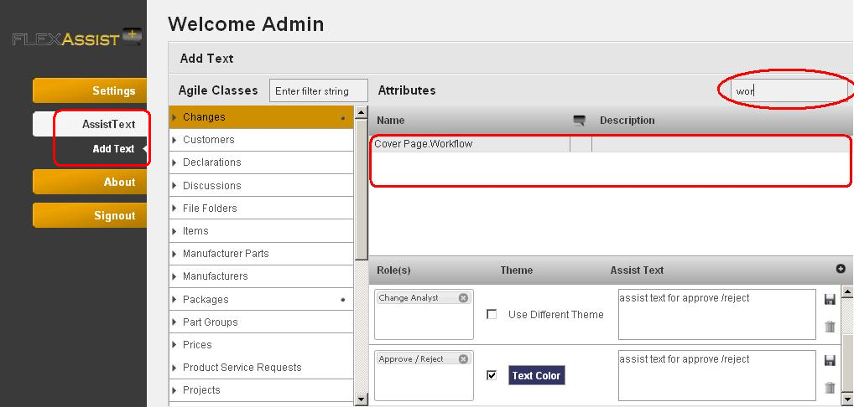

# **About**

## License Info

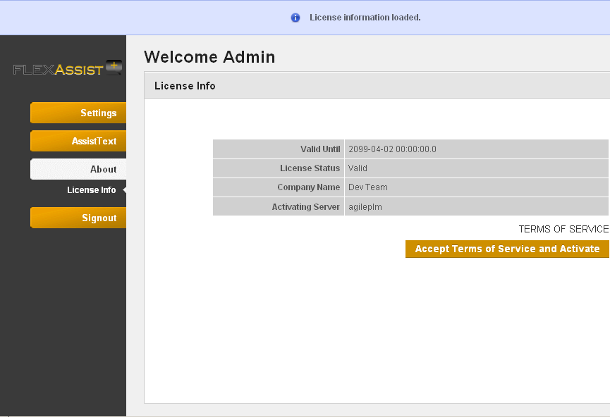

* 1. This screen displays the license information, user needs to click to “Accept terms of service and Activate” button and updated info will be displayed
* **Note:** if user hasn’t activated its license then it will not allow user to navigate to any other screen until the one activates its license.