|  |  |
| --- | --- |
|  |  |

|  |
| --- |
| **Flex Assist+ 1.4.0** |
| **Installation Guide** |
|  |
| April 2012 |
|  |
|  |

PLM flex assistPLUS - xavor corporation

Installation Guide



A division of

[**Xavor Corporation**](http://www.xavor.com/)

8105 Irvine Center Drive • Suite 780

Irvine, CA 92618, USA

Phone +1.949.250.4390 • Fax +1.949.250.4391

oracle

Copyright © 2012 Xavor Corporation. All rights reserved. PLM Flex and the PLM Flex logo are trademarks or registered trademarks of Xavor Corporation or its affiliates in the U.S. and other countries. Other names may be trademarks of their respective owners

Table of Contents

Overview 2

1 Installation Tasks Overview 2

2 Package Contents 2

Pre-Requisites 3

1 Application Server Requirement 3

2 Java Requirement 3

3 Agile PLM Admin Account 3

Installation 4

1 Copy package Contents 5

2 Deploy AssistPlus Application on the Agile Application Server 7

3 Deploy JS component 16

4 AssistPlus- Admin Console (One-time Configuration) 17

5 Configure Agile Web Proxy (Optional) 24

6 Verify Installation 25

|  |  |
| --- | --- |
| Overview  This section provides an overview of tasks to be performed for Flex Assist Installation and Setup in a Windows Server. | Section  1 |

# **Installation Tasks Overview**

The installation process for PLM Flex Assist+ has following sequence of steps. These will be subsequently described in detail in the following sections:

* Check system pre-requisites
* Create Environment Variable (Windows)
* Deploy the Flex Assist+ war file to the Agile application server.
* Initial Assist+ configuration for admin access to Agile PLM
* Copy a single .js file to Agile
* Agile Web Proxy Server configuration (optional)
* Test that the application works

# **Package Contents**

File AssistPlusPackage.rar extracted should contain:

|  |  |  |  |
| --- | --- | --- | --- |
| **#** | **Content** | **Type** | **Description** |
| **1.** | InstallationGuide.pdf | FILE | Installation Document (this file) |
| **2.** | AdminConsole-UserManual.pdf | FILE | User Manual for AssistPlus Admin Console |
| **3.** | Content\ | FOLDER | Application deployment and resource files |
| **4.** | JS\ | FOLDER | Version specific JavaScript files |
| **5.** | WAR\ | FOLDER | Version specific Application WAR files |

|  |  |
| --- | --- |
| Pre-Requisites  This section lists the System Requirements and Pre-requisite steps and checks for Flex Assist+ Installation. | Section  2 |

# **Application Server Requirement**

Flex AssistPlus Application will be installed on the same application server as Agile

You will need to access the WebLogic or OAS Application Server Admin Console.

# **Java Requirement**

[**JRE 1.5 or above**](http://www.oracle.com/technetwork/java/javase/downloads/index.html) must be pre-installed on the server.

# **Agile PLM Admin Account**

Flex AssistPlus requires an Administrator account to access Agile. This account is used by the application to get metadata of Agile objects and to talk to Agile Server.

|  |  |
| --- | --- |
| Installation  This section provides steps to install, configure and verify Flex AssistPlus Installation. The high level steps include:  1 Setup Package Contents  2 Deployment WAR on Application Server  3 First-time Configuration  4 Deploy JS component  5 Configure Agile Web Proxy (Optional)  6 Verification | Section  3 |

|  |
| --- |
| * **Note:** The Pre-Requisites mentioned in Section 2 of this document must be checked before proceeding with installation. * **Paths** stated in the documentation use Windows style notation. Unix paths will work. |

# **Copy package Contents**

# If the Agile Application Server components are hosted on a Windows-based machine, follow the below steps for setting up package contents:

1. UnPack **AssistPlusPackage.zip**

# Create a folder named PLMFlexHome at manageable file system location (e.g. D:\PLMFlexHome\)

|  |
| --- |
| * **Note:** The PLMFlexHome folder will be used by the application and the contents must not be vulnerable to unauthorized modification. |

# Create an environment variable named PLMFLEX_HOME and provide path of the PLMFlexHome directory (from step 1) as value.

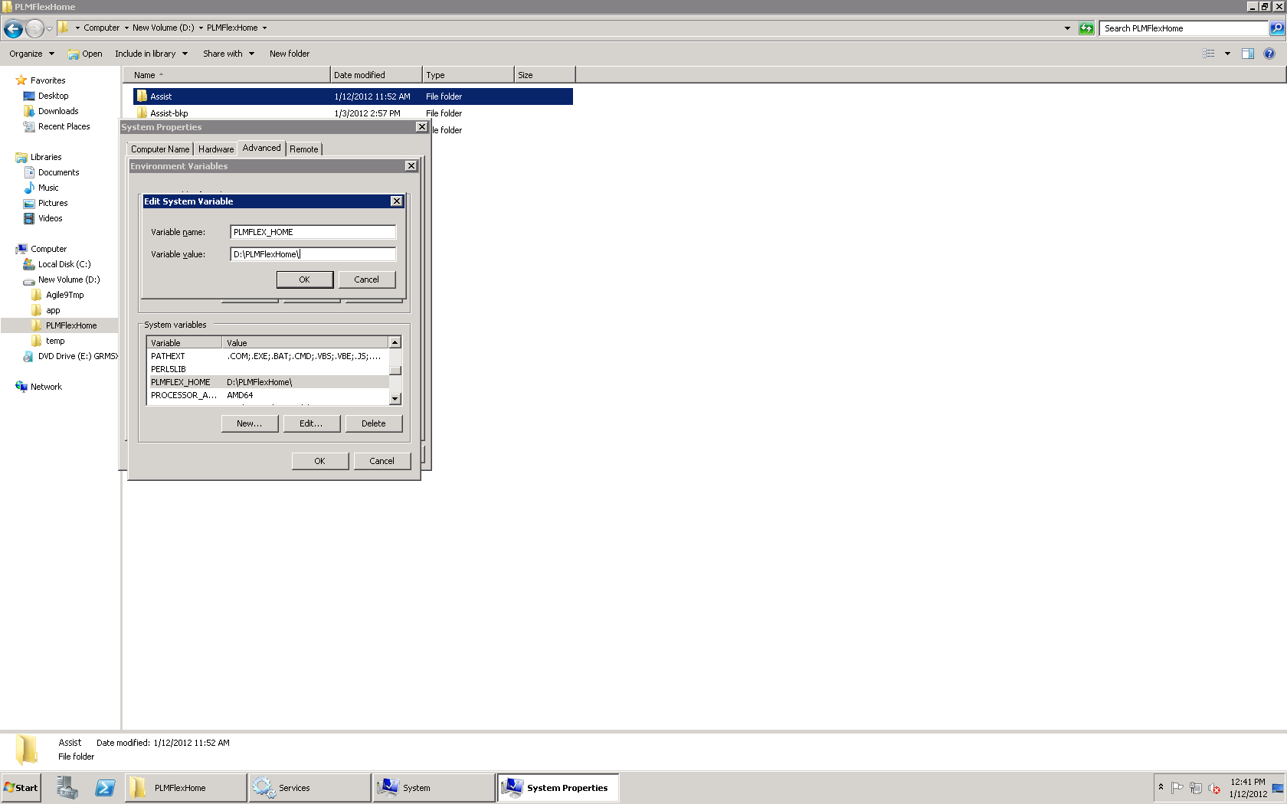

.

1. Copy the contents of **Content** folder (i.e. the AssistPlus folder) to PLMFlexHome folder (created in step 1 above).

# **Deploy AssistPlus Application on the Agile Application Server**

Below are the steps specific to the Application Server being used for Agile PLM application:

|  |
| --- |
| * **Note:** The steps mentioned below are for a simple deployment. The process may vary for Application Server or Domain Administrators with environment specific requirements |

1. **Deploying AssistPlus on WebLogic Application Server (WLS)**

Below are the steps to deploy AssistPlus Application on WebLogic Server

* 1. Open WebLogic Admin Console for agileDomain and login as superadmin:

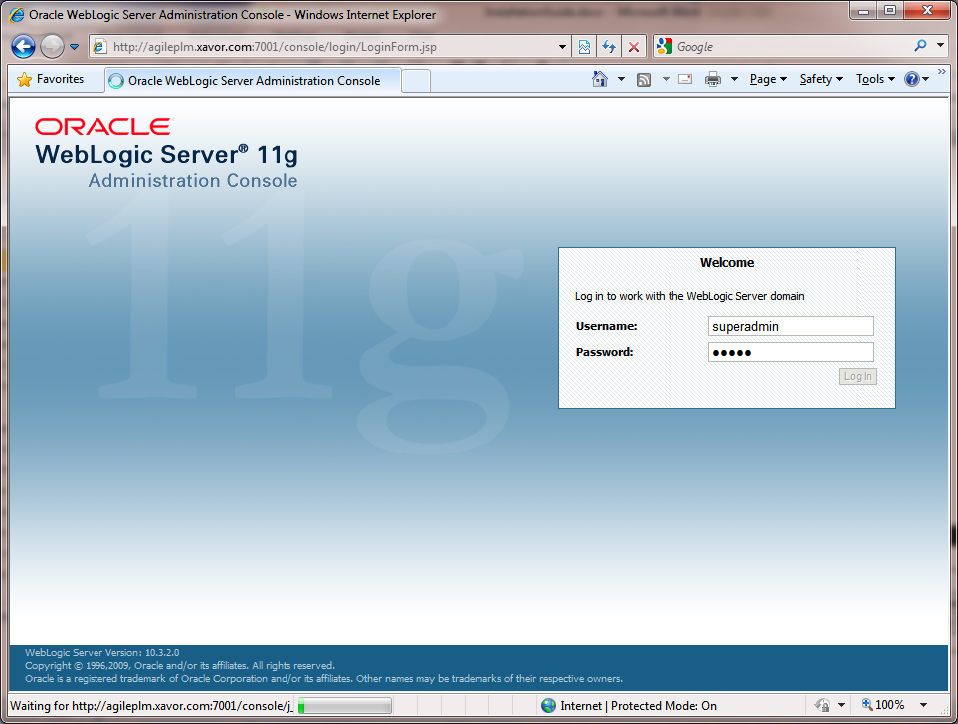

* 1. In the top left “Change Center” box, click “Lock & Edit”

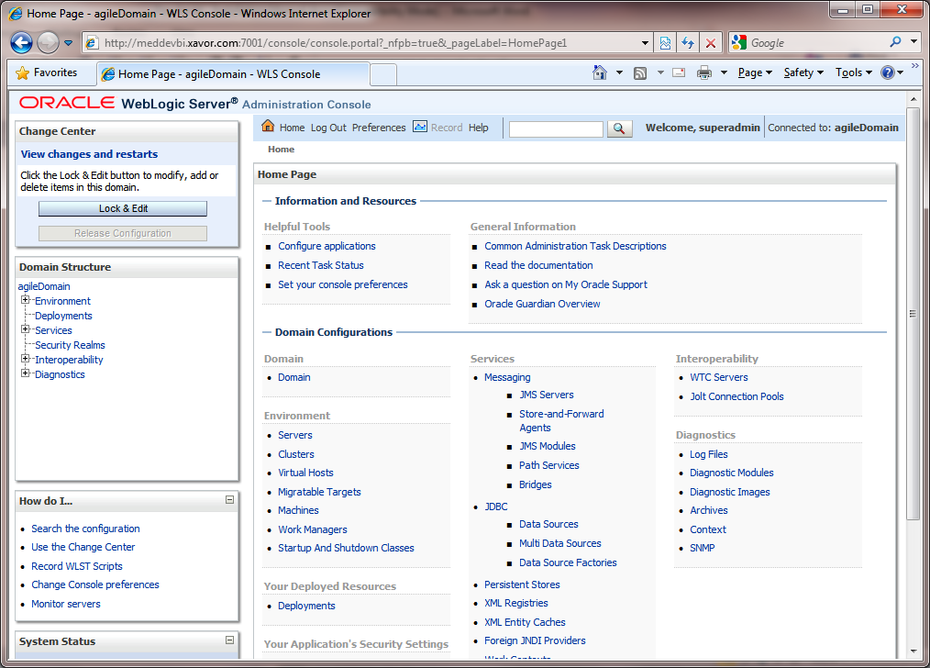

* 1. From the “Domain Structure” box in the left-pane, click on “Deployments”.

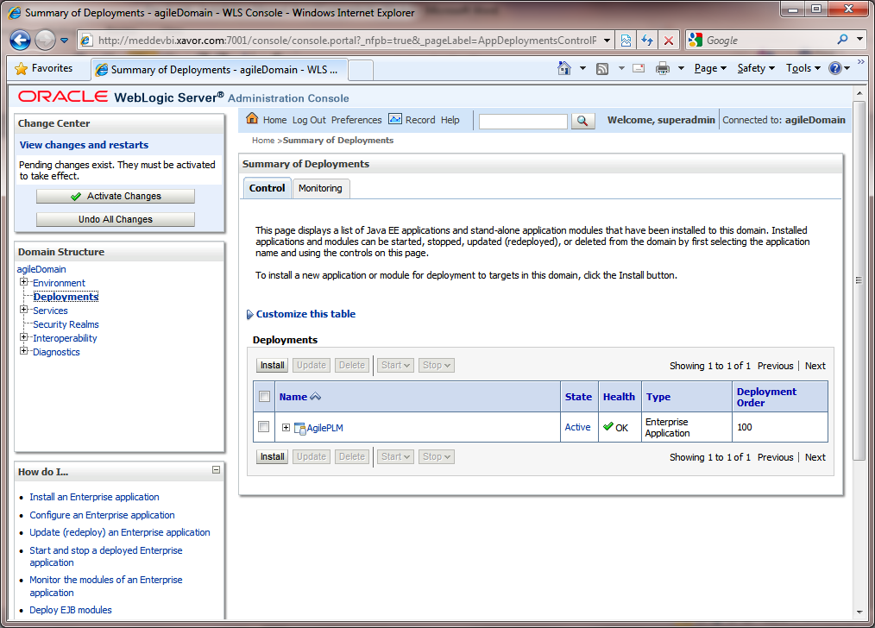

* 1. From the Deployments table, click on the Install button

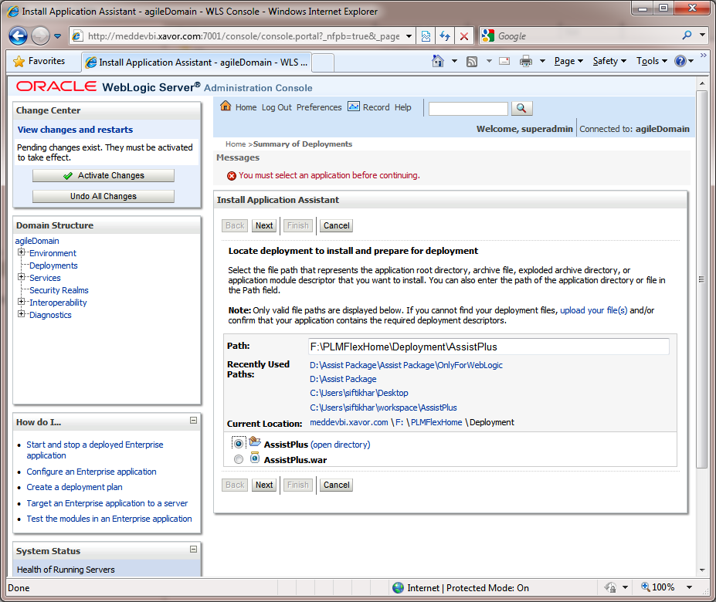

* 1. In the Path text box, enter the path where version specific WAR file is placed.

e.g. for Agile 9.3.1, give the path of file <AssistPlusPackage>\WAR\9.3.1\

* 1. Select the **AssistPlus.war** file radio button and click Next.

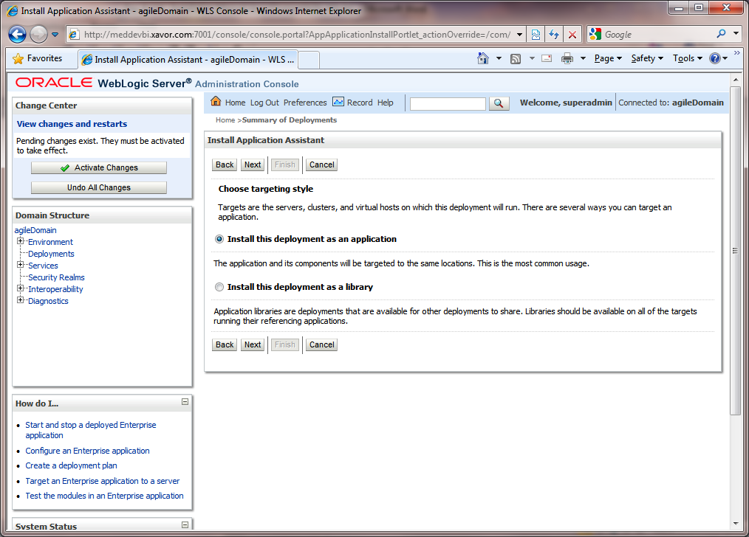

* 1. Click Next

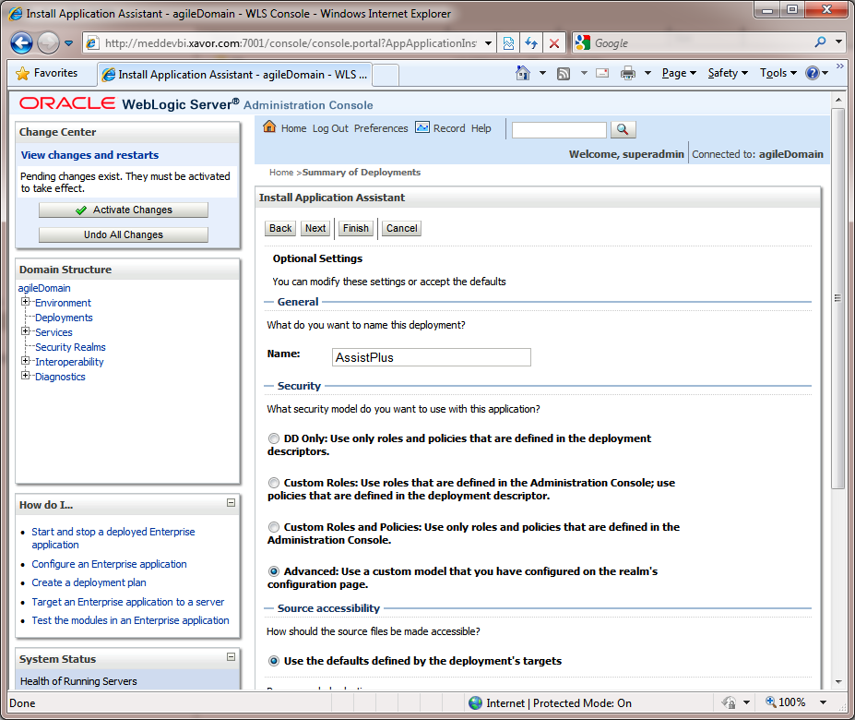

* 1. Verify that the deployment Name is **AssistPlus** and click on Next and then Finish.

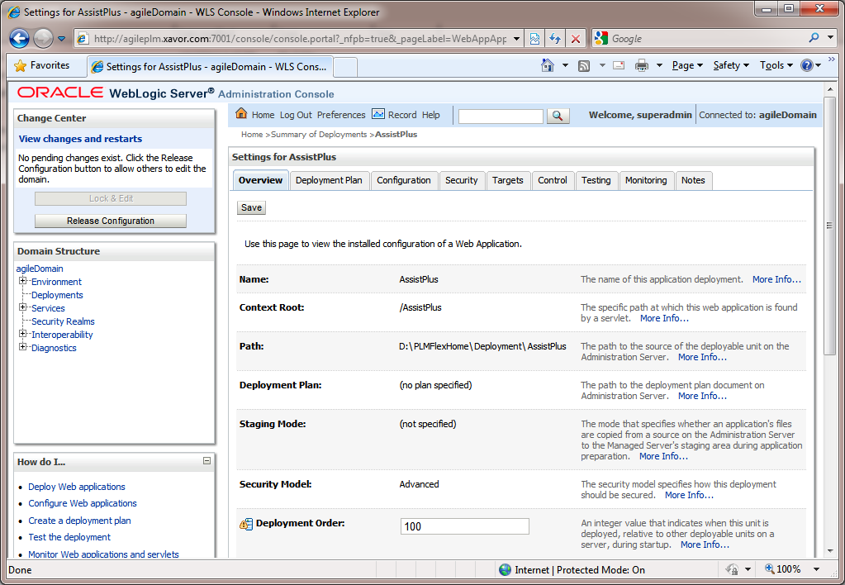

* 1. Verify that the Name and Context Root is **AssistPlus**.
  2. Click on **Activate Changes** button in the **Change Center** box on the left.
  3. Click on **Deployments** in **Domain Structure** box on the left.

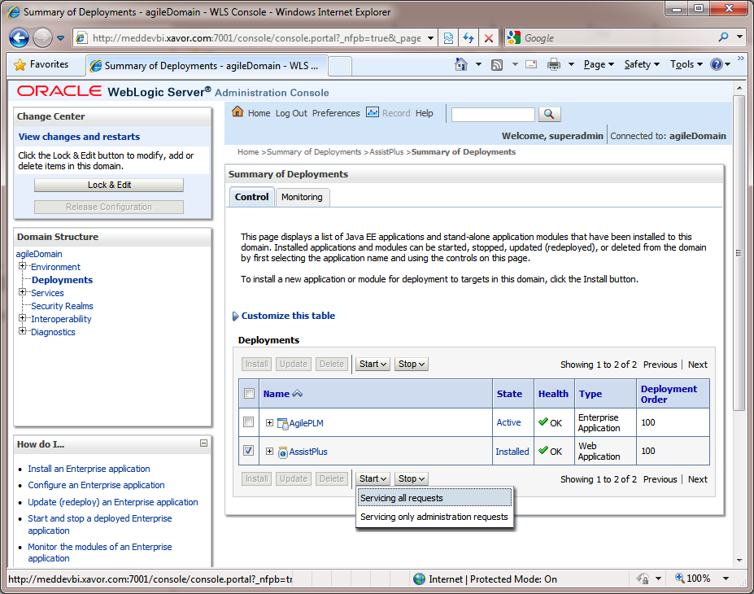

* 1. Select the **AssistPlus** Web Application in the **Deployments** table and click on the **Start** > **Servicing All Requests**.

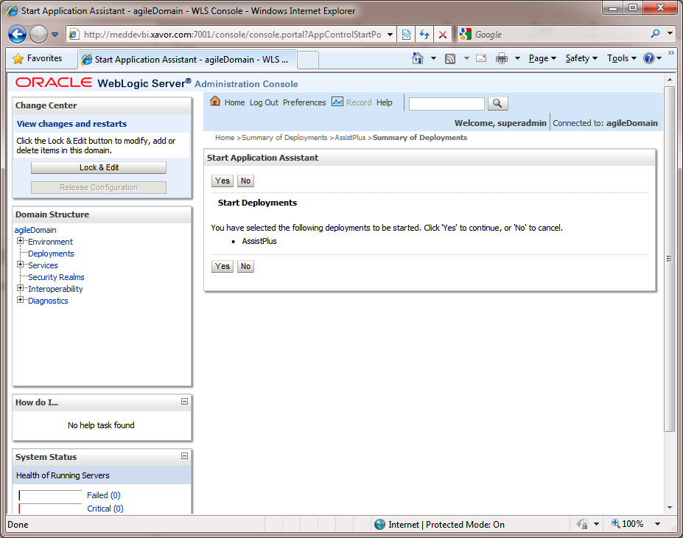

* 1. Click **Yes** on Confirmation screen.

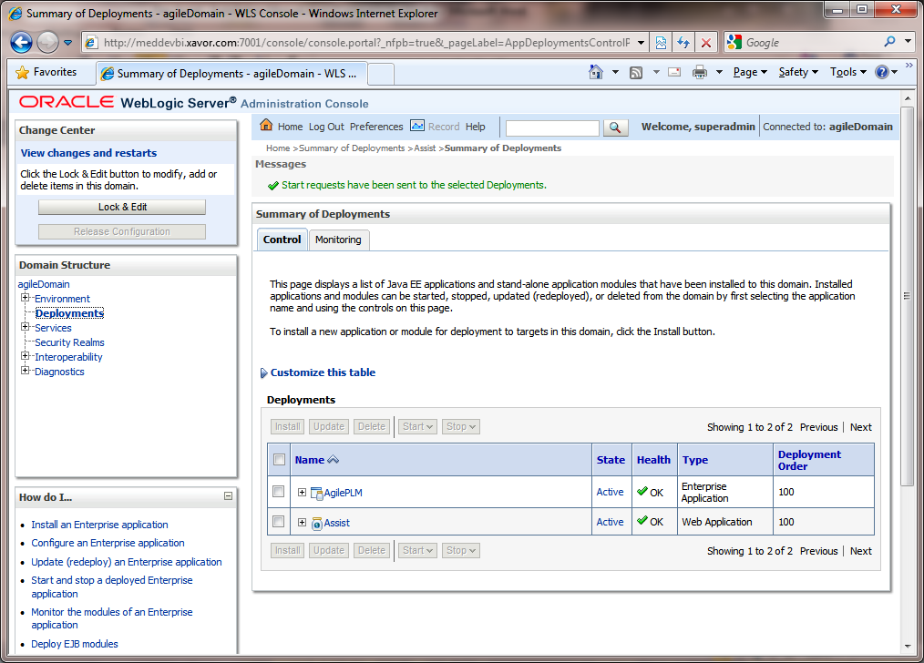

* 1. Verify that the **AssistPlus** application **State** is **Active**.
  2. Logout of the Admin Console and proceed with **Step 3**, for further configuration of AssistPlus.

1. **Deploying AssistPlus on Oracle Application Server (OAS)**

Use the <PLMFLEX_HOME>\AssistPlus.war file to deploy into the OAS server. Log in as admin into the OAS console and use similar deployment steps as described in WebLogic.

# **Deploy JS component**

AssistPlus Package contains a version specific JS file

**core-agile-min.js**

This file needs to be deployed with the existing Agile PLM application.

Steps to follow:

1. Log on to the Agile server machine, go to the folder where Agile Application Server components are installed.
2. Search the **core-agile-min.js** file deployed as part of Agile PLM application. The path of this file is specific to the Application Server (OAS or WLS) that hosts Agile.

**For OAS:** Search for the file in <OAS_HOME> directory e.g. D:\OASHome\j2ee\home\applications\Agile

**For WLS**: Search for the file in <AgileDomainServer> directory e.g. D:\Agile\Agile931\agileDomain\servers\PLMFLEX-AgileServer

1. Take a backup of the existing **core-agile-min.js** file and replace it with the version specific JS file from the AssistPlus Package folder: **<AssistPlus Package>\JS\<AgileVersion>\core-agile-min.js** folder.

E.g. for Agile 9.3.1 copy file: D:\AgileFlexExtension\AssistPlus Package\JS\9.3.1\core-agile-min.js

# **AssistPlus- Admin Console (One-time Configuration)**

Once the **AssistPlus** application is successfully deployed on the corresponding Application Server, perform the below steps for a one-time configuration:

1. **NOTE**: A separate **PLMFlexAssistPlus.lic** file will be shared that activates software usage. This file should be copied to the **$PLMFLEX_HOME/AssistPlus** folder. Editing this file will make your license data invalid.
2. Invoke AssistPlus URL as follows:

http://*<AgilePLMServer>:<port>*/AssistPlus

e.g. <http://plmflex.xavor.com:7001/AssistPlus>

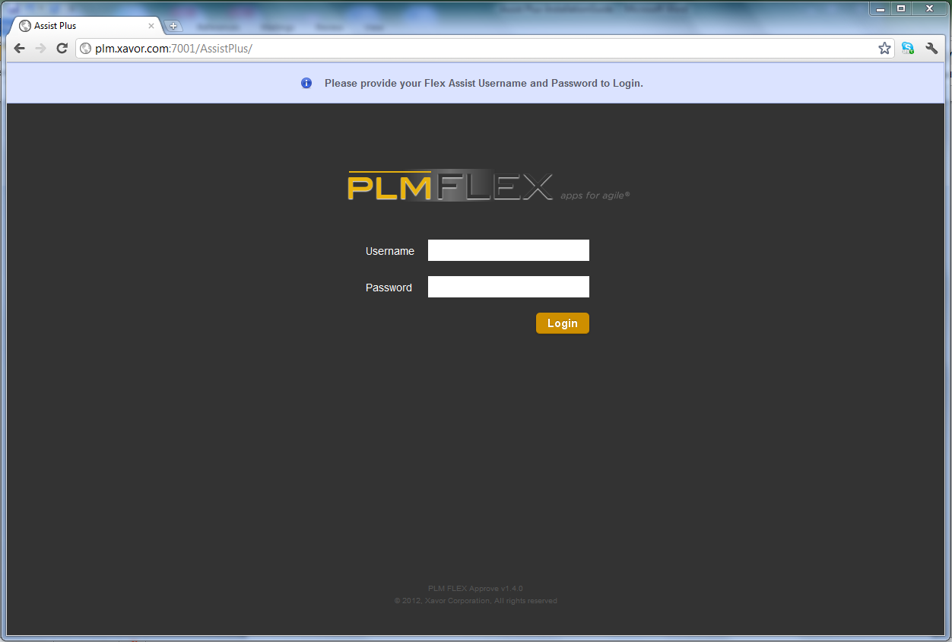

Use the following default admin credentials to login.

**User Name:** admin

**Password:** plmflex

|  |
| --- |
| * **Note:** This is the only default admin user for AssistPlus admin console. Password can be changed once logged in. |

1. The AssistPlus License Agreement page should display. Review terms of service and accept. This should set up the license agreement policies and activate the software.

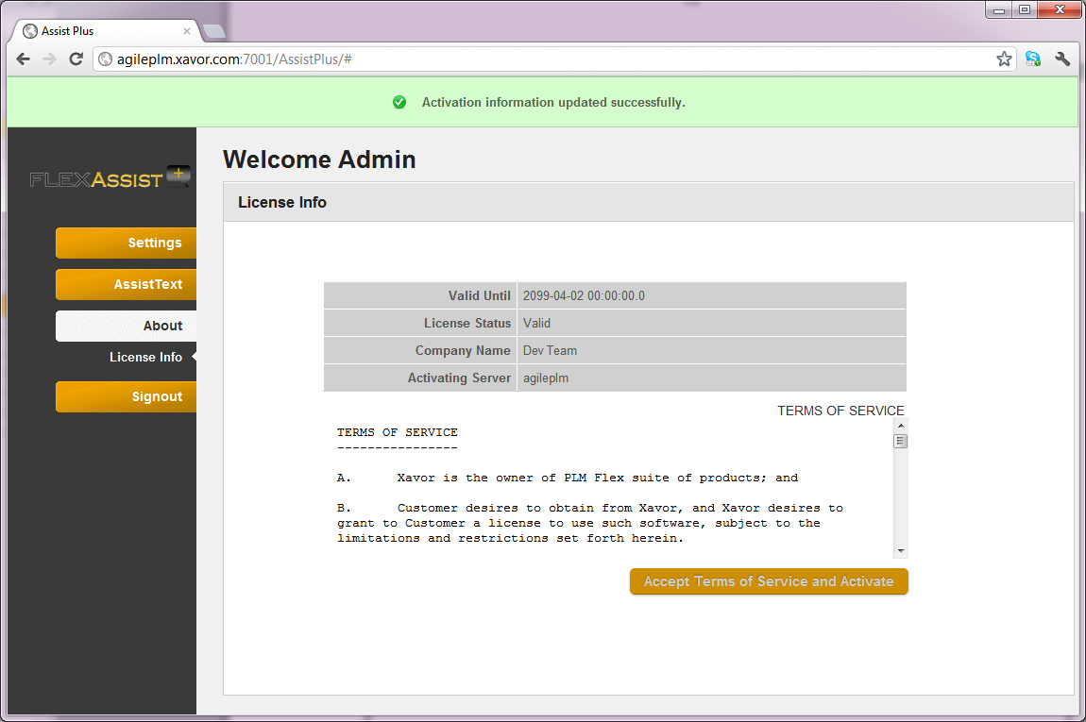

|  |
| --- |
| * **Note:** If the **PLMFlexAssistPlus.lic** is not in the $PLMFLEX_HOME\AssistPlus folder, this step will fail * **Note:** Unless the activation step is done, further configuration/usage of admin console will be not be possible. |

1. In the Settings tab, 3 sections are displayed:

Configurations

Role Priorities

Change Passwords

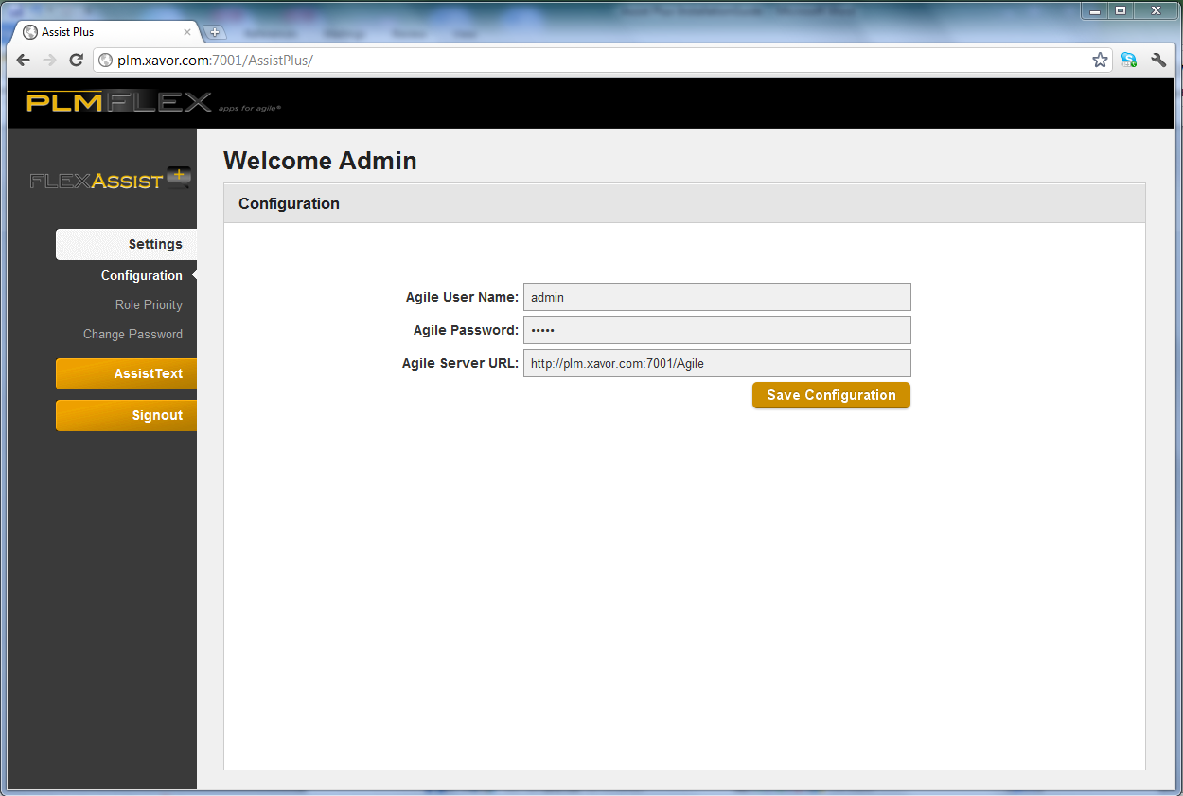

**Configuration** section, enter the following information one time.

* **User Name:** An Agile user with Administration rights.
* **Password:** The password
* **Agile Server URL:** This is the target Agile instance URL that application will work with. Give the URL as: http://<AgilePLMServer>.<Domain>/Agile
* Click the “Save Configuration” to save. The notification bar below shows a success message.

**Change Password** Section

* **User Name:** An Agile PLM user with Administration rights.
* **Current Password:** Administrator user current password
* **New Password:** Administrator user new password
* **Confirm New Password:** Administrator user new password to confirm
* Click the “change password” icon to save. The notification bar below shows success message if password changed successfully.

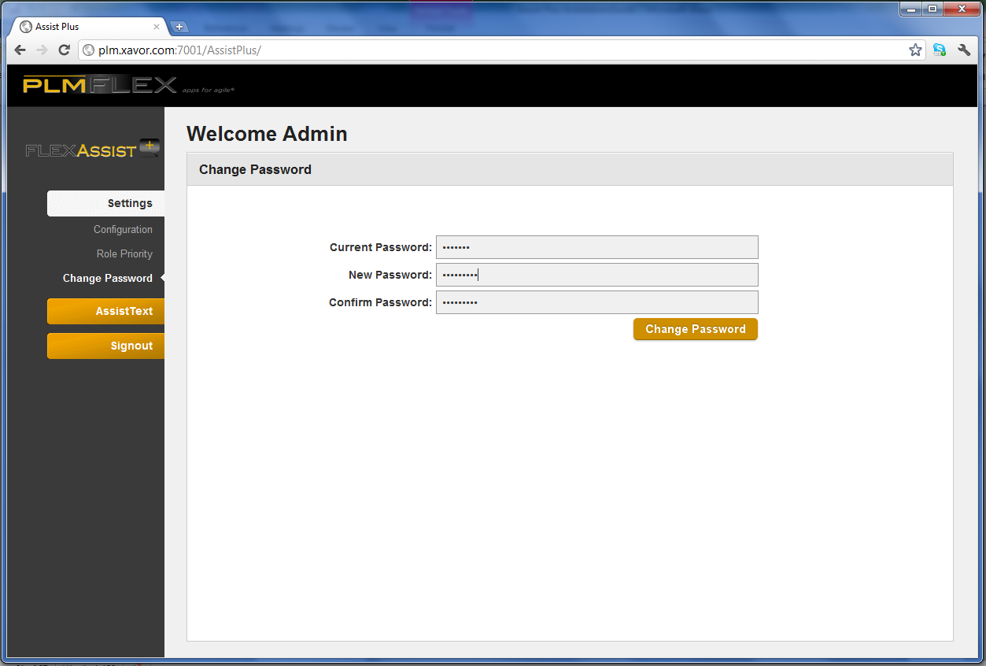

**Role Preference** Section allows admin create a set of allowable roles and the prioritize the message in case user is assigned to multiple roles

* User is able to filter the roles based on keyword.
* User drags roles from Agile PLM column to Selected Roles for Assist column. Roles placement is done with respect to its priority
* Click the “Save” icon to save the configurations.

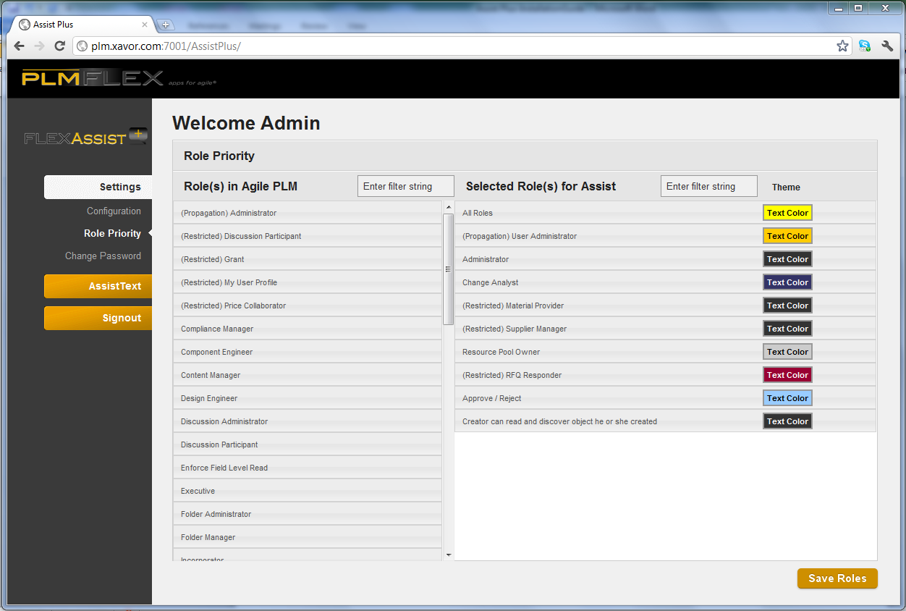

1. The Assist Text tab allows for setting messages

* Use the Agile Classes tree to select a base-class, class, or sub-class to view their respective pages 1, 2 and 3 attributes
* Click on the attribute to view or enter help text
* Edit roles to target the help text message. Use “All Roles” for access by everyone
* Optionally select text color

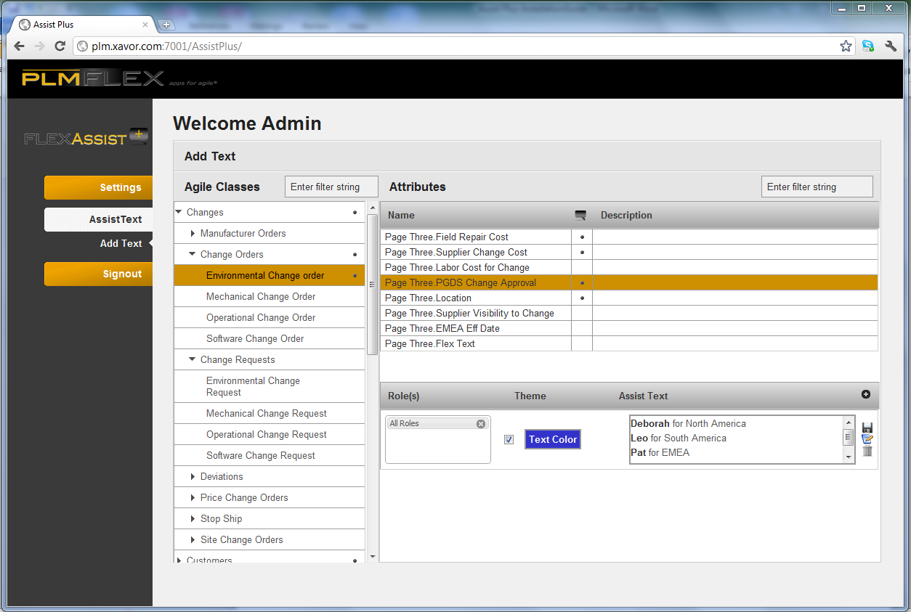

* Click the  icon to create a new help text.
* Click the  icon to edit an existing help text
* The  icon against the attributes signifies that a help text entry already against it.
* The edit screen is a rich text editor that can be switched to a pure HTML editor is needed, with editing for roles.

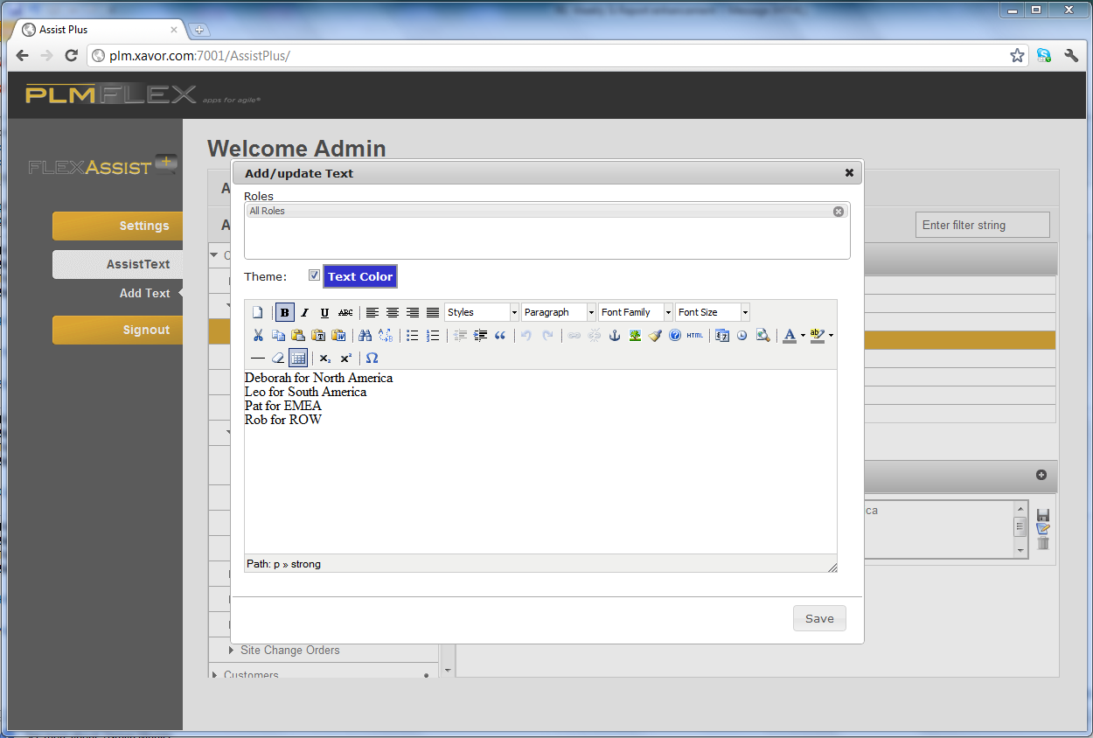

# **Configure Agile Web Proxy (Optional)**

|  |
| --- |
| * **Note:** This step is required only if Agile Web Proxy is configured and used for accessing Agile PLM. * **Note:** Below steps are for IIS as web server and WebLogic Server as Application Server for Agile. Similar steps will be required for other servers |

Follow the following steps for configuring Agile web proxy to pass through AssistPlus context root (/AssistPlus):

1. Logon on to the machine where Web Server (IIS) is hosted.
2. Go to <Agile_Home>\AgileProxies folder. (e.g. D:\Agile\Agile931\AgileProxies)
3. Open **9ias.conf** file in an editor.
4. Add the following line after similar entry for /Agile/ context:

**oproxy.<AgilePLM Server Name>.urlrule=/AssistPlus/\***

e.g. oproxy.MEDDEVBI.xavor.com.urlrule=/AssistPlus/*

1. Save and close the file
2. Open **iisproxy.ini** file in an editor and look for **wlForwardPath** property.
3. Append AssistPlus context to the value of this property

e.g. wlForwardPath=/Agile,/AssistPlus,/JavaClient,/CoreService

1. Save and Close the file
2. Restart the Web Server and make sure cache is refreshed.

# **Verify Installation**

Once installed and configured, the following steps can be performed to verify working of AssistPlus application.

1. Login to Agile PLM web client as any user:

http://<AgilePLMServer>.<DomainName>/Agile/PLMServlet

1. Full refresh your browser in case Web Client is already opened.
2. Click on the User icon on top left corner to open the current User’s page
3. Hover mouse pointer over the “User ID” field name, which will show a call-out displaying “User’s Unique Identifier”.

“Users > User ID” is the only assist text configured by default for verification purpose Only.

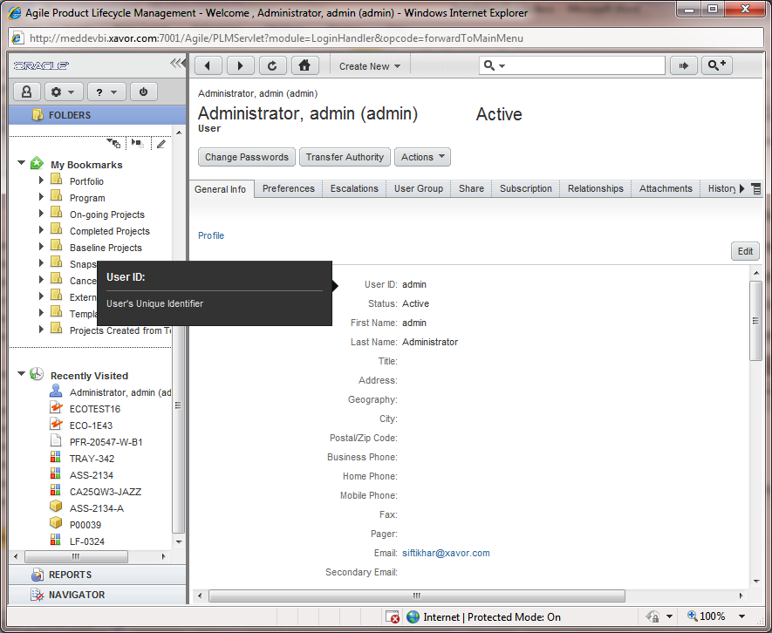

- This page intentionally left blank -