­­

**Assist+ 1.6**

**Installation Guide**

May 2014

**A S S I S T + - X A V O R C O R P O R A T I O N**

Installation Guide



[**Xavor Corporatio**](http://www.xavor.com/)**n**

8105 Irvine Center Drive • Suite 780

Irvine, CA 92618, USA

Phone +1.949.250.4390 • Fax +1.949.250.4391



Copyright © 2014 Xavor Corporation

Contents

Overview 4

1. Installation Tasks Overview 4

2. Package Contents 4

Pre-Requisites 5

1. Application Server Requirement 5

2. Java Requirement 5

3. Agile Cookie Configuration 5

4. Agile PLM Admin Account 6

Installation 7

1. Copy package Contents 8

2. Deploy AssistPlus Application on the Agile Application Server 10

2.1 Deploying AssistPlus on WebLogic Application Server (WLS) 10

2.2 Deploying AssistPlus on Oracle Application Server (OAS) 17

3. Deploy JS component 23

4. AssistPlus- Admin Console (One-time Configuration) 24

6. Configure Agile Web Proxy (Optional) 29

7. Verify Installation 31

Environment Variable setting for OAS 32

Assist+ Master/Slave Configuration 34

# Overview

This section provides an overview of tasks to be performed for Assist+ Installation and Setup in a Windows Server.

## Installation Tasks Overview

Section

1

The installation process for Assist+ has following sequence of steps. These will be subsequently described in detail in the following sections:

* Check system pre-requisites
* Create Environment Variable (Windows)
* Deploy the Assist+ war file to the Agile application server.
* Initial Assist+ configuration for admin access to Agile PLM
* Copy a single .js file to Agile
* Agile Web Proxy Server configuration (optional)
* Test that the application works

## Package Contents

File AssistPlusPackage.zip extracted should contain:

|  |  |  |  |
| --- | --- | --- | --- |
| **#** | **Content** | **Type** | **Description** |
| **1.** | InstallationGuide.pdf | FILE | Installation Document (this file) |
|  |  |  |  |
| **2.** | Content\ | FOLDER | Application deployment and resource files |
| **3.** | JS\ | FOLDER | Version specific JavaScript files |
|  |  |  |  |
| **4.** | WAR\ | FOLDER | Version specific Application WAR files |
|  |  |  |  |

|  |  |  |
| --- | --- | --- |
|  |  |  |
|  |  |  |
| Pre-Requisites | Section |  |
| This section lists the System Requirements and Pre-requisite steps and checks for Assist+ Installation. | 2 |  |
|  |  |
|  |  |  |

## Application Server Requirement

Assist+ Application will be installed on the same application server as Agile

You will need to access the WebLogic or OAS Application Server Admin Console.

## Java Requirement

[**JRE 1.5 or above**](http://www.oracle.com/technetwork/java/javase/downloads/index.html)mustbe pre-installed on the server.

## Agile Cookie Configuration

Assist+ uses Agile PLM session cookies. Therefore, the cookie related properties for Agile instance needs to be configured correctly.

|  |
| --- |
| * Agile PLM’s cookie domain setting can be found in Agile’s configuration file: agile.properties in the Agile Home Folder path (e.g. C:\Agile\Agile931\agileDomain\config\agile.properties)under the key **cookie.domain**. Set proper domain value under this key.   E.g.  **cookie.domain=.xavor.com**  **cookie.path=/**  Set value of the key **agile.sso.checkOneTimePXToken,** to **false**  **agile.sso.checkOneTimePXToken = false**  Set value of the key  **agile.sso.expirationTime** equal to the agile session timeout**.** E.g. if agile session timout is one hour, set:  **agile.sso.expirationTime = 3600**  **Repeat** exactly this same step on agile.properties file present in this location:  Agile\Agile933\agileDomain\applications\application.ear\APP-INF\classes |

## Agile PLM Admin Account

Assist+ requires an Administrator account to access Agile. This account is used by the application to get metadata of Agile objects and to talk to Agile Server.

|  |
| --- |
| * The Agile account for Assist+ requires the built-in privilege: “Administrator”. No other privileges are necessary for working Assist+. |

# Installation

This section provides steps to install configure and verify Assist+ Installation. The high level steps include:

1. Setup Package Contents
2. Deployment WAR on Application Server
3. First-time Configuration
4. Deploy JS component
5. Configure Agile Web Proxy (Optional)
6. Verification

Section

3

|  |
| --- |
| * Pre-Requisites mentioned in Section 2 of this document must be checked The before proceeding with installation. * Paths stated in the documentation use Windows style notation. Unix paths will work. |

## Copy package Contents

If the Agile Application Server components are hosted on a Windows-based machine, follow the below steps for setting up package contents:

1. Unpack **AssistPlusPackage.zip** to any file system location for use during installation.
2. Create a folder named AssistPlus at manageable file system location (e.g. D:\ AssistPlus \)

|  |
| --- |
| * The AssistPlus folder will be used by the application and the contents mustnot be vulnerable to unauthorized modification. * AssistPlus application must have privileges to read and write to this folder location. |

1. Copy the following files from **Content/AssistPlus** folder to AssistPlus folder (created in step 1 above).
2. AssistPlus.properties.
3. log4jConfig.properties (In production environment, copy the log4jConfig.properties file from the **Content/AssistPlus/Production** folder**.)**
4. xacs.assist.db. Copy this file only if you are doing a fresh install.
5. XSDgroup.xsd & XSDrole.xsd.
6. Create an environment variable named PLMFLEX_HOME and provide path of the AssistPlus folder(from step 1) as value.

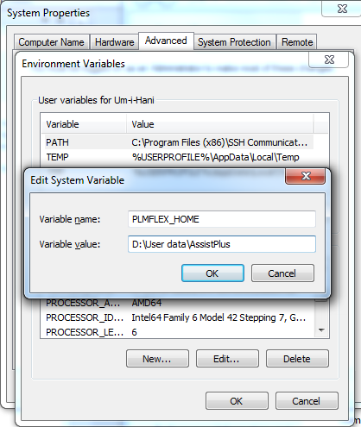

|  |
| --- |
| * Application Server service may need to be restarted in order to gain access to new environment variable. * When deploying on OAS, the environment variable needs to be created in OAS EM. For specific instructions please refer to Appendix A of this document. |

## Deploy AssistPlus Application on the Agile Application Server

Below are the steps specific to the Application Server being used for Agile PLM application:

|  |
| --- |
| * The steps mentioned below are for a simple deployment. The process may vary for Application Server or Domain Administrators with environment specific requirements. |

### Deploying AssistPlus on WebLogic Application Server (WLS)

Below are the steps to deploy AssistPlus Application on WebLogic Server

* + 1. Open WebLogic Admin Console for agileDomain and login as superadmin:

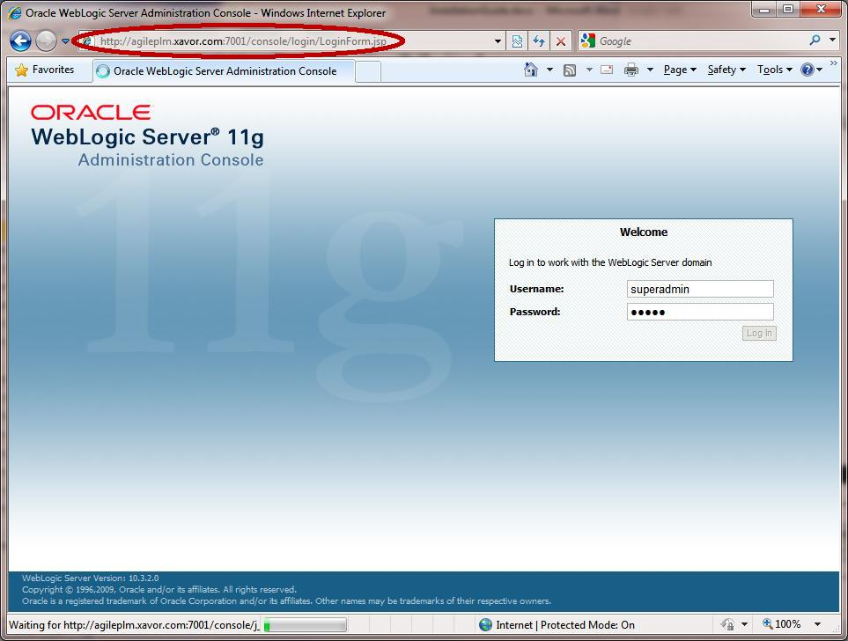

* + 1. In the top left“Change Center” box, click “Lock & Edit”

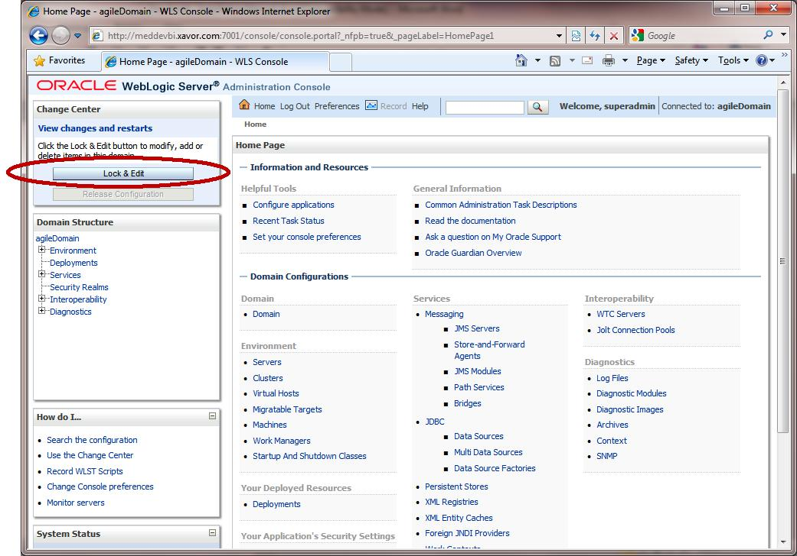

* + 1. From the “Domain Structure” box in the left-pane, click on “Deployments”.

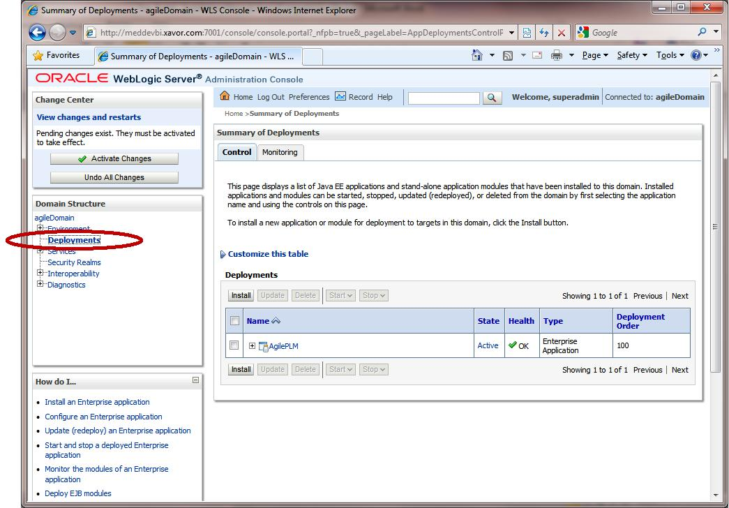

* + 1. If AssistPlus is previously installed, from the deployment table select AssistPlus and click the stop button. After the deployment is stopped, select AssistPlus and click delete.

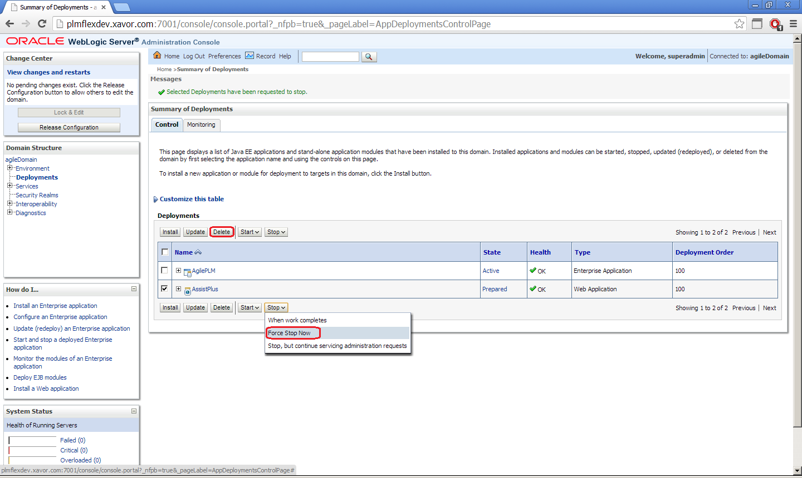

* + 1. From the Deployments table, click on the Install button

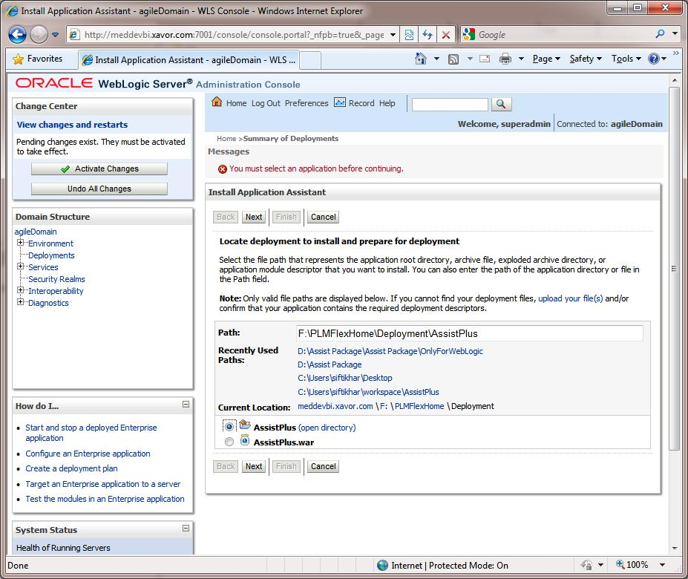

* + 1. In the Path text box, enter the path where version specific WAR file is placed. e.g. for Agile 9.3.1, give the path of file <AssistPlusPackage>\WAR\9.3.1\
    2. Select the AssistPlus.war file radio button and click Next.

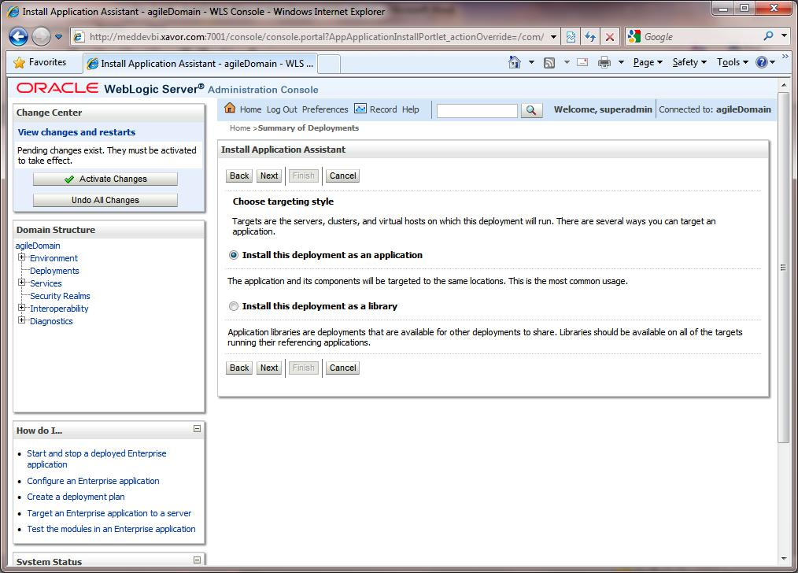

* + 1. Click Next



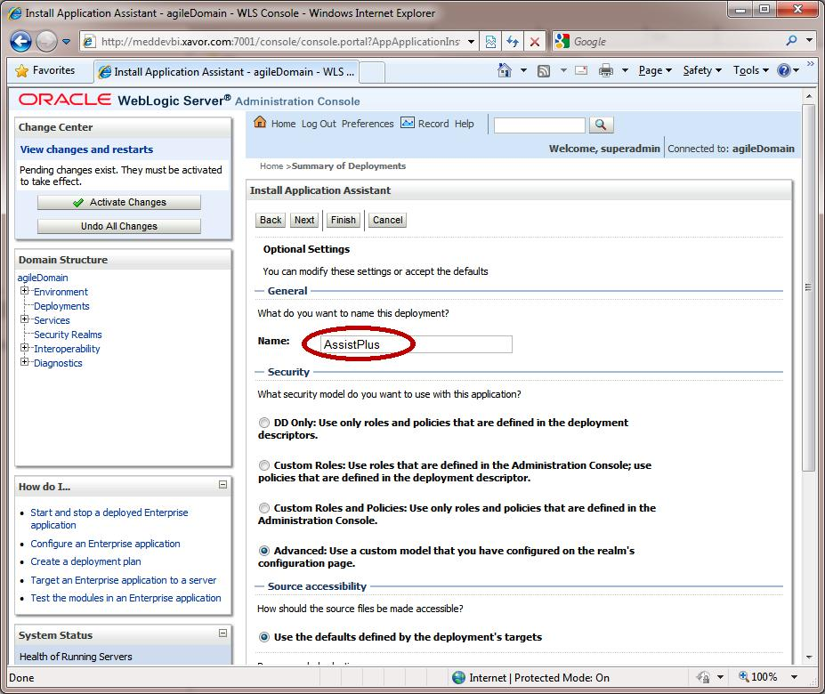

* + 1. Verify that the deployment Name is AssistPlus and click on Next and then Finish.

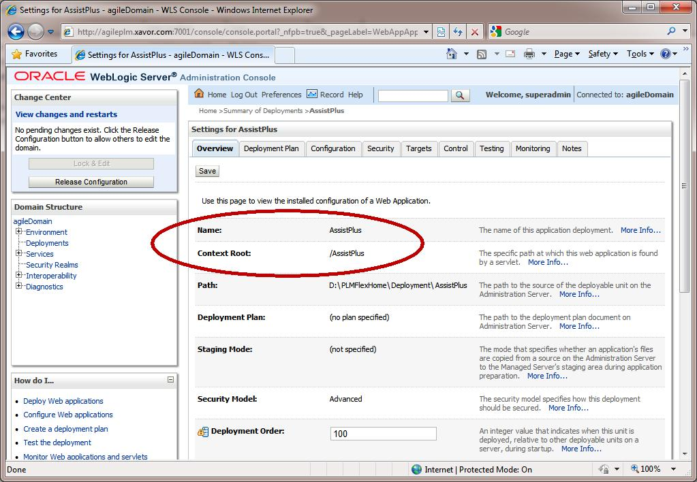

* + 1. Verify that the Name and Context Root is AssistPlus.
    2. Click on Activate Changes button in the Change Center box on the left.

* + 1. Click on Deployments in Domain Structure box on the left.

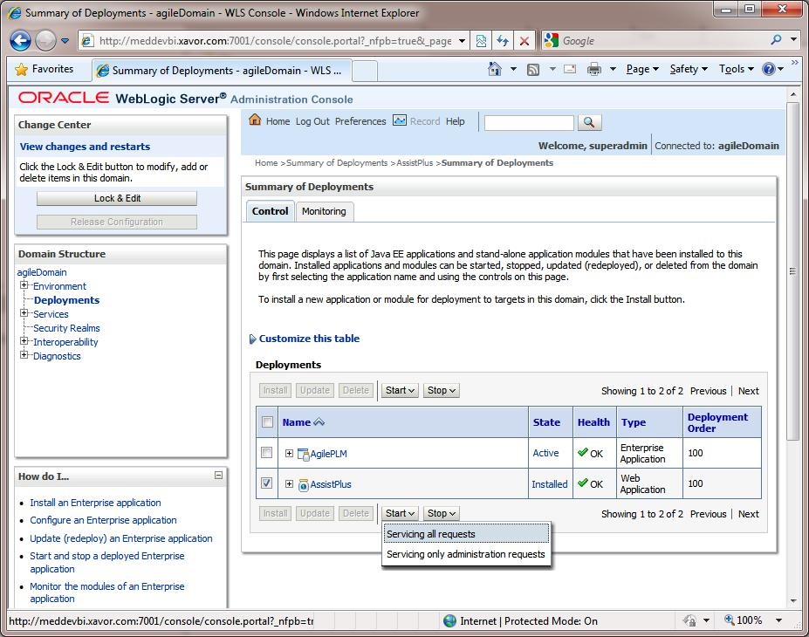

* + 1. Select the AssistPlus Web Application in the Deployments table and click on the Start > Servicing All Requests.

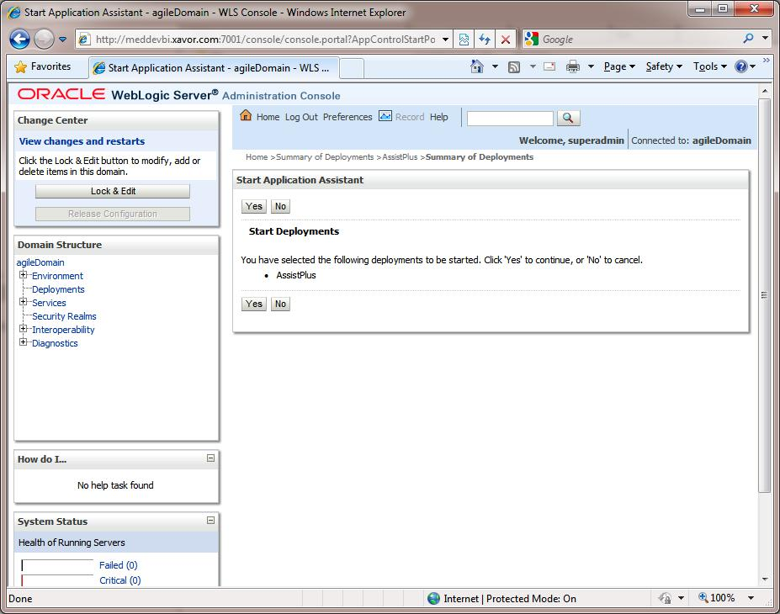

* + 1. Click Yes on Confirmation screen.

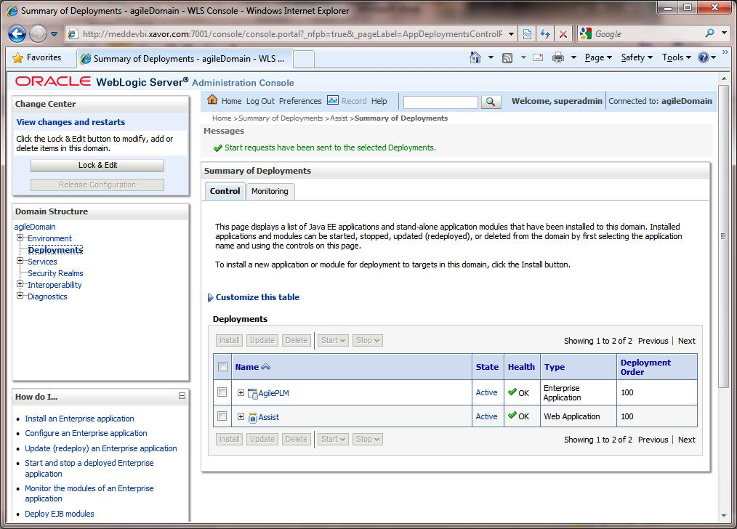

* + 1. Verify that the AssistPlus application State is Active.
    2. Logout of the Admin Console and proceed with Step 3, for further configuration of AssistPlus.

### Deploying AssistPlus on Oracle Application Server (OAS)

Use the <AssistPlus>\AssistPlus.war file to deploy into the OAS server. use following deployment steps.

* + 1. Login:

Log in as admin into the OAS console.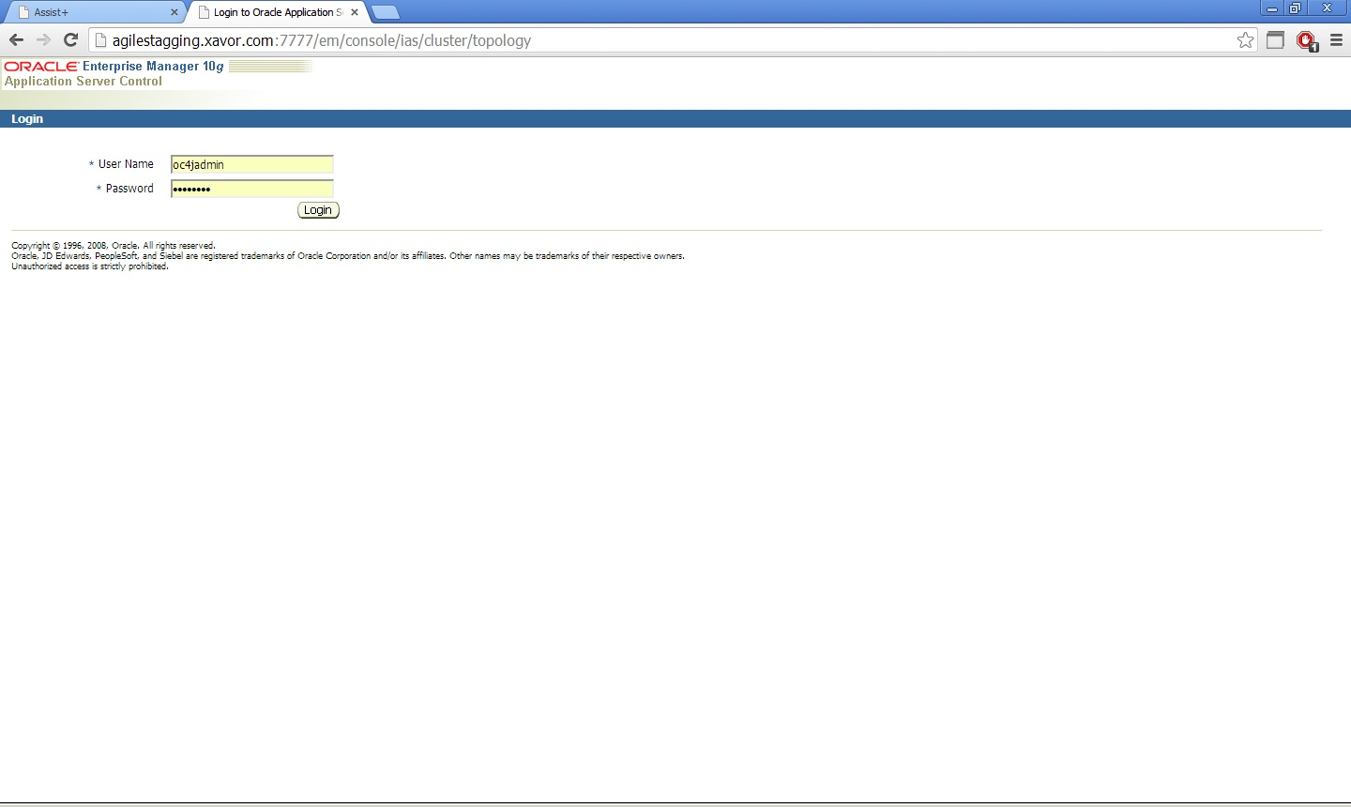

* + 1. Select Group:

Select the group in which you want to deploy the application. Following screenshot lists the default group.

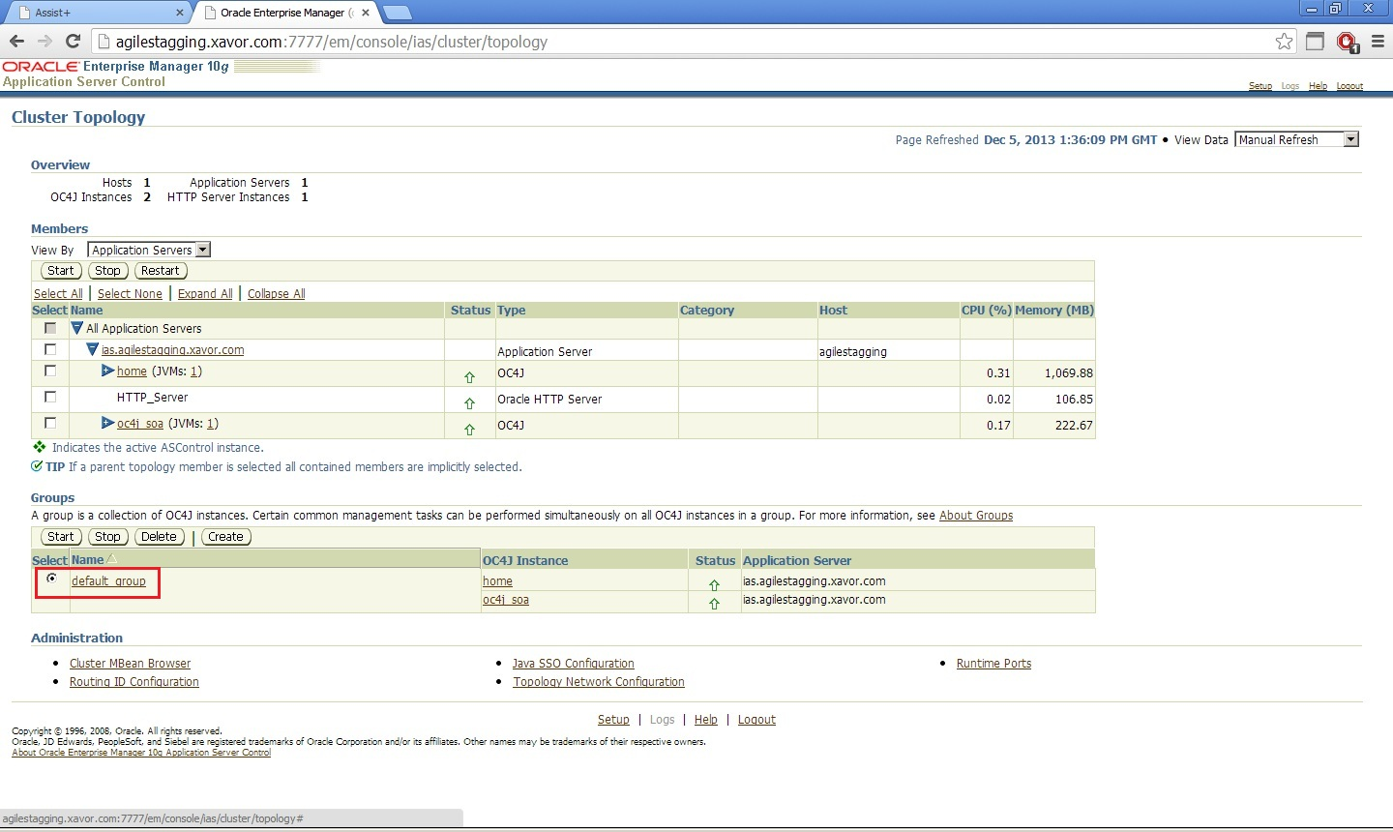

* + 1. UnDeploy Application:

If Assist+ is already deployed, navigate to the applications tab and click Undeploy as shown in following screenshot.

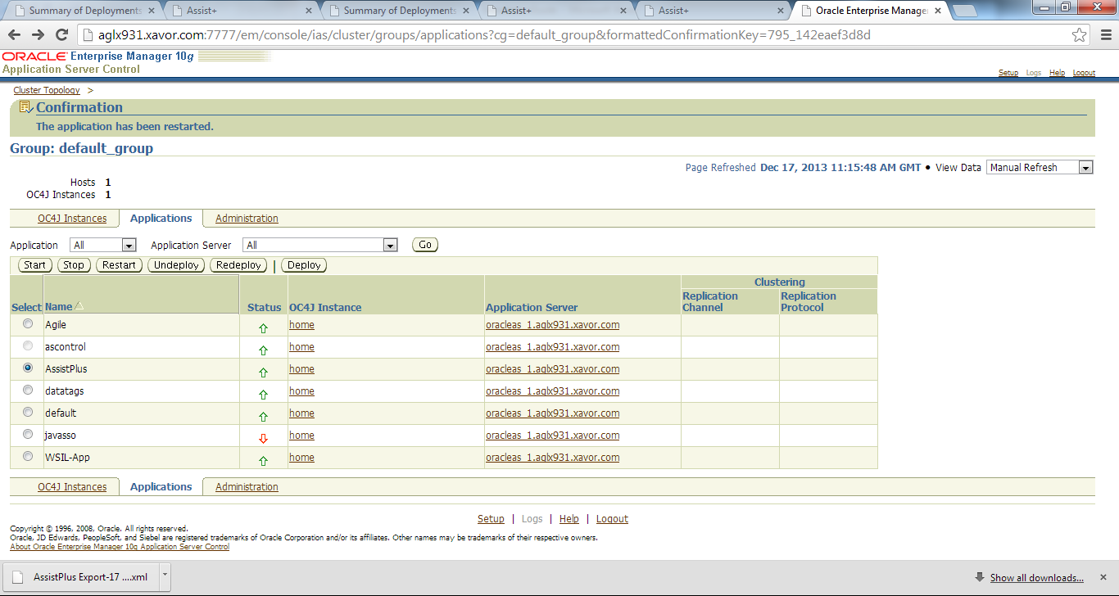

* + 1. Deploy Application:

Navigate to the applications tab and click deploy as shown in following screenshot.

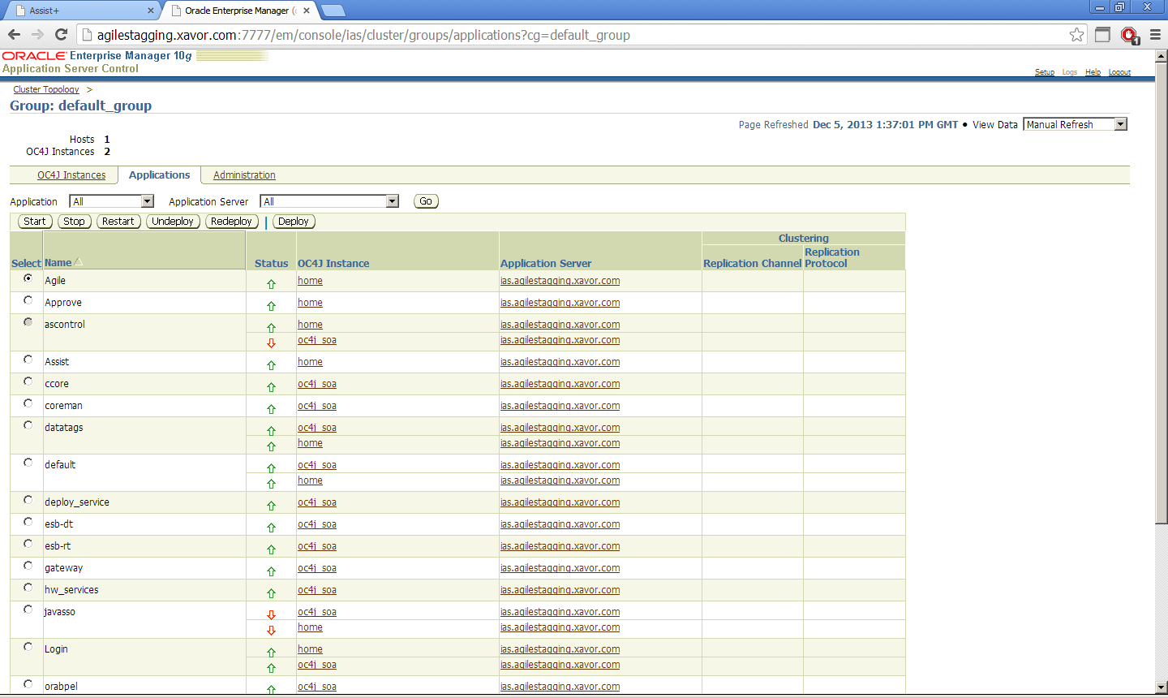

* + 1. Choose war file:

Choose the <AssistPlus>\AssistPlus.war file using the choose file button.

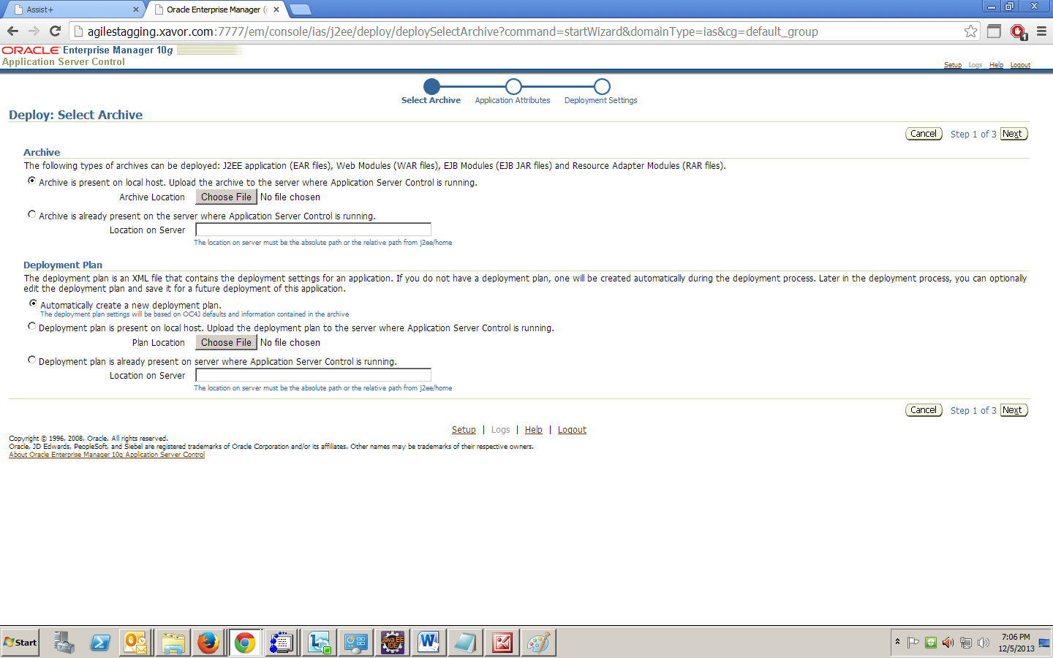

* + 1. Choose Application Name:

Click next and choose Application name as AssistPlus.

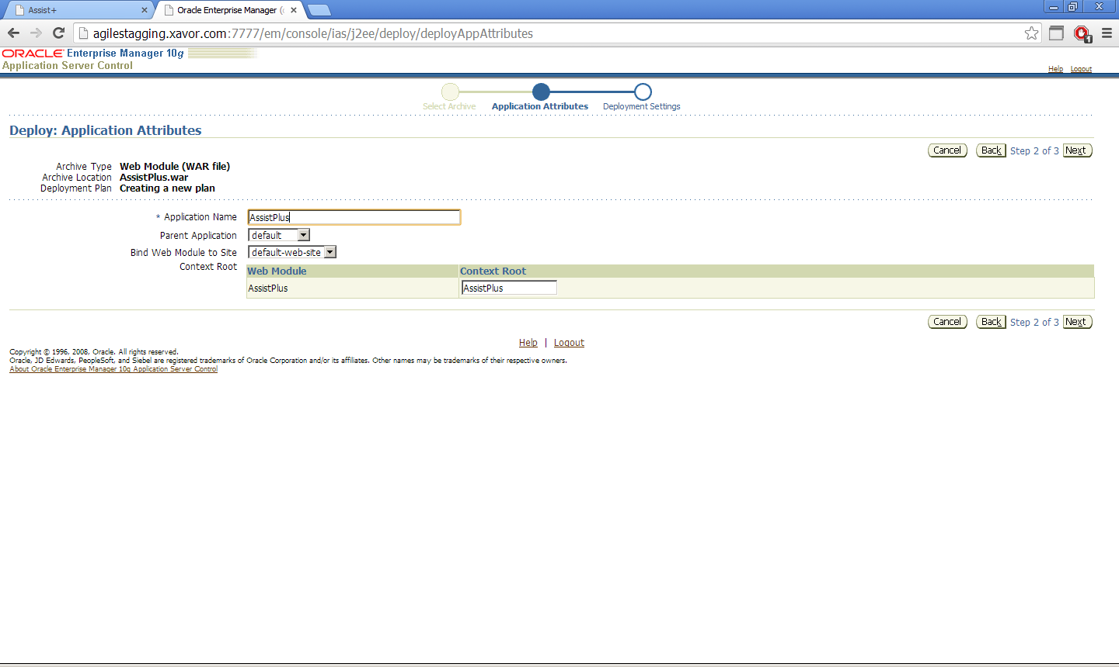

* + 1. Deploy WAR:

Click next and hit deploy.

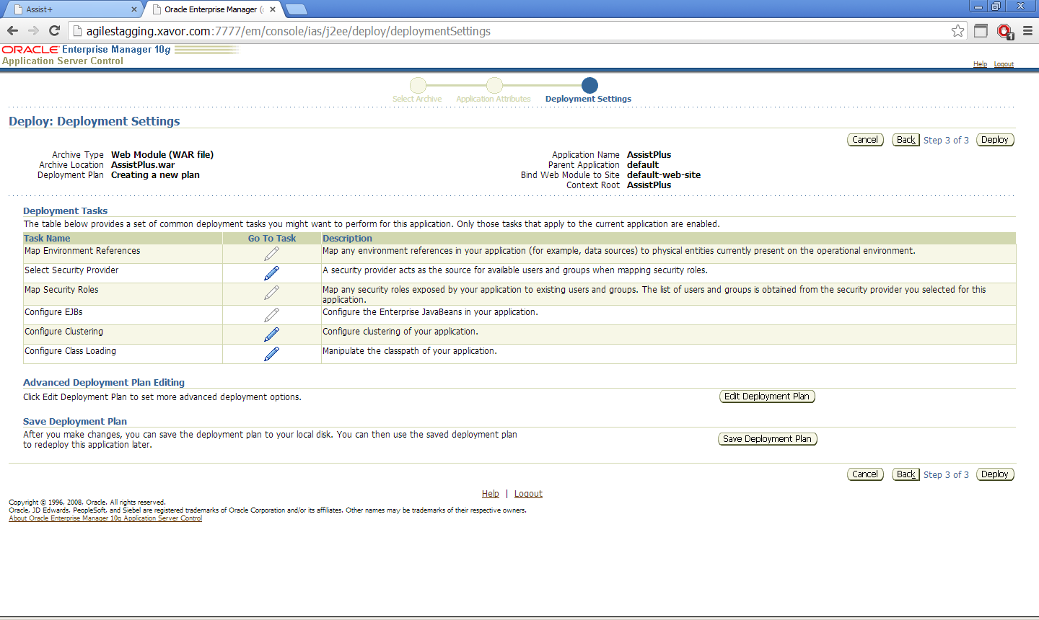

Notification would be shown In case of success.

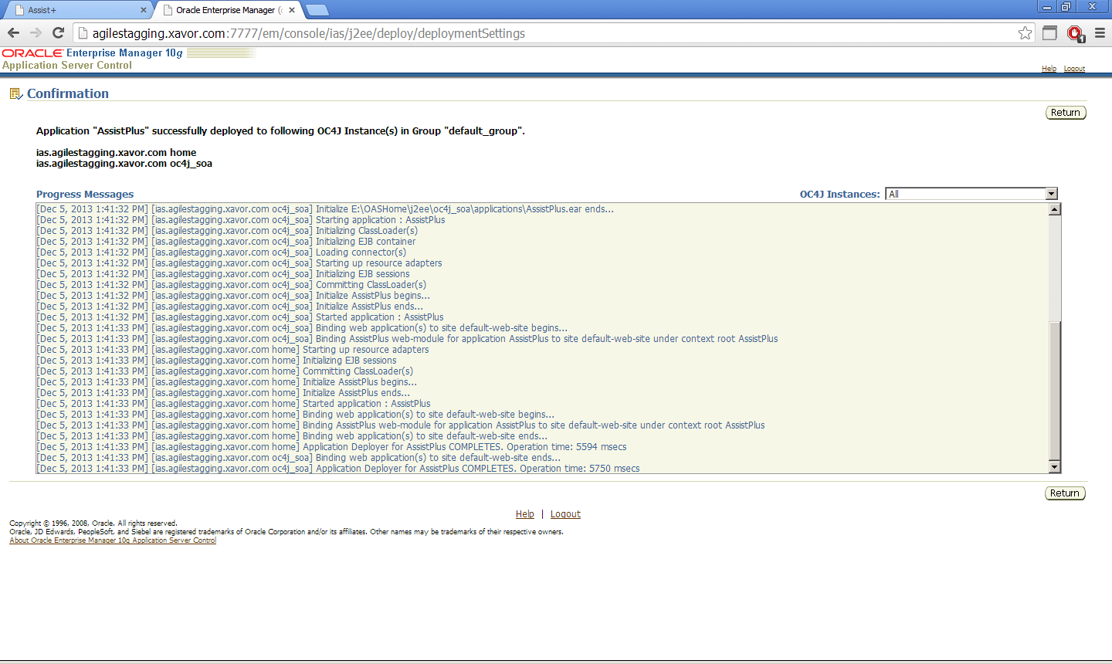

* + 1. Environment Variable:

For environment variable creation for Assist+ in OAS, refer to Appendix A.

* + 1. Start:

Click return. On the Applications page, click start as shown in screenshot.

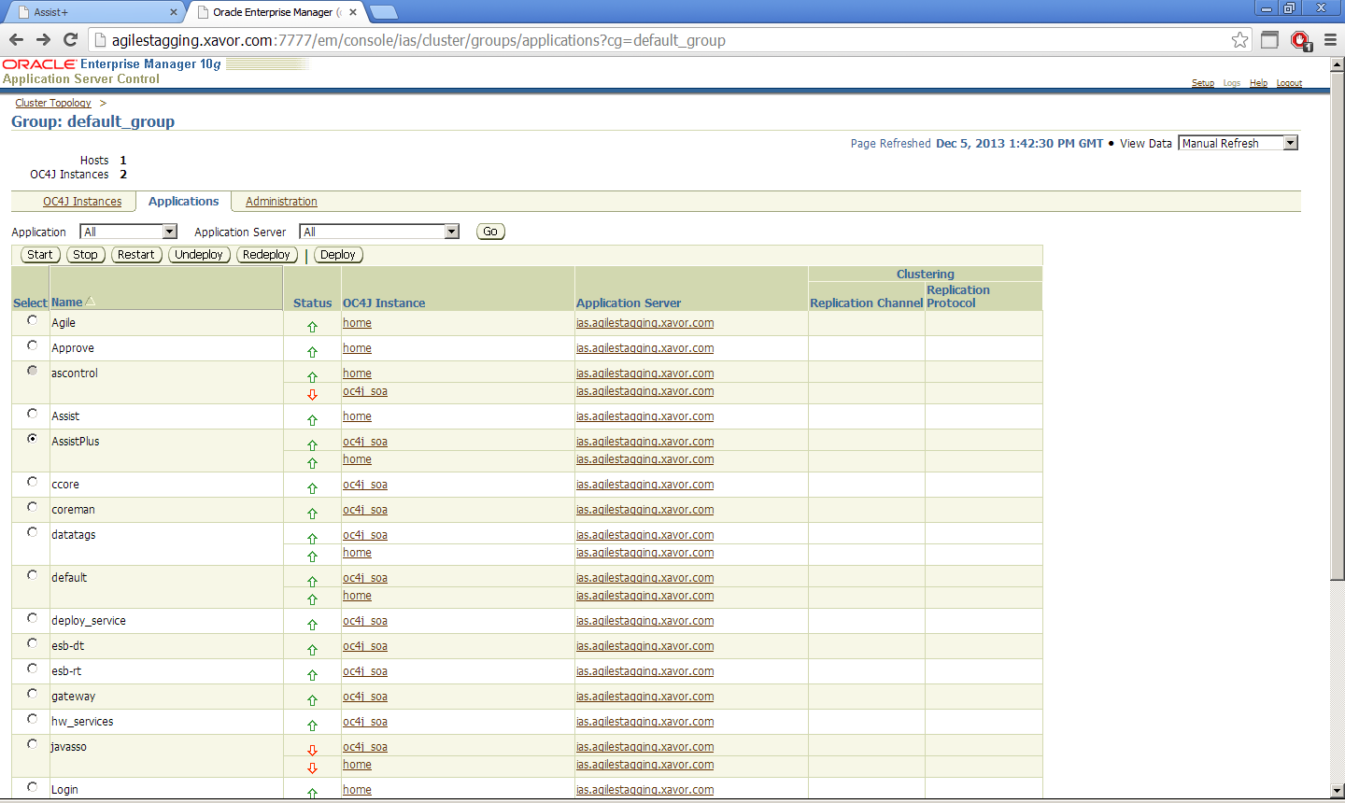

Notification would be shown on successful start.

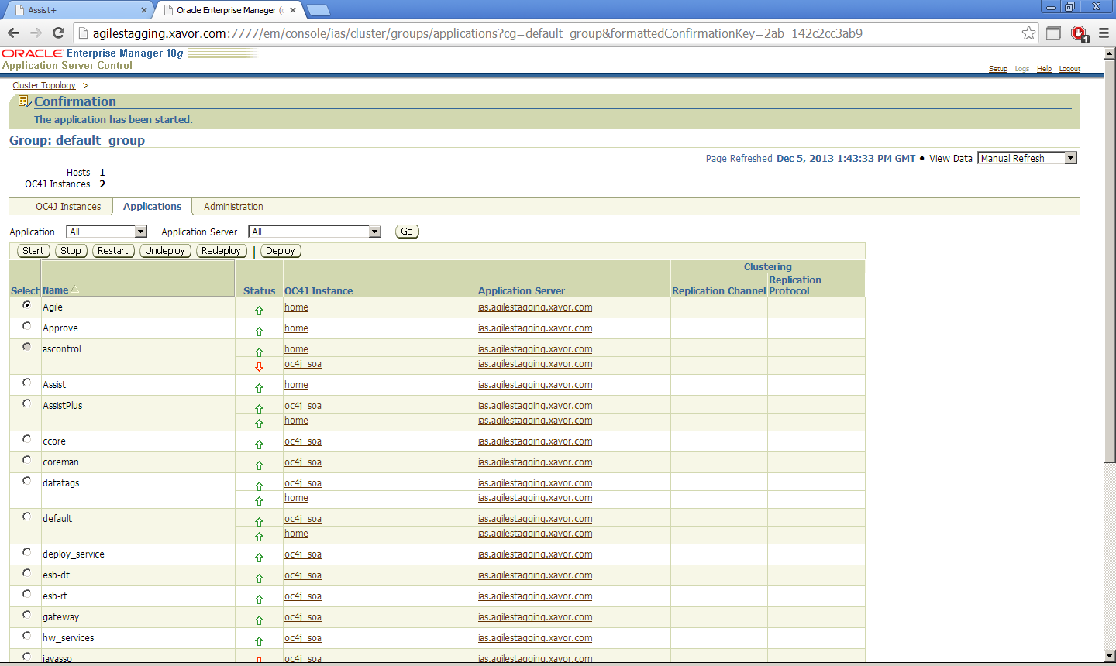

## Deploy JS component

AssistPlus Package contains a version specific JS file

**core-agile-min.js**

This file needs to be deployed with the existing Agile PLM application.

Steps to follow:

1. Log on to the Agile server machine; go to the folder where Agile Application Server components are installed.
2. Update **core-agile-min.js** in agile.ear if the JS files are being extracted from the ear on server restart. Restart Agile server after replacing the file in agile.ear. Next steps can be skipped if this is the case.
3. Search the **core-agile-min.js** file deployed as part of Agile PLM application. The path of this file is specific to the Application Server (OAS or WLS) that hosts Agile.

**For OAS:** Search for the file in <OAS_HOME> directory e.g.

D:\OASHome\j2ee\home\applications\Agile

**For WLS**: Search for the file in <AgileDomainServer> directory e.g.

D:\Agile\Agile931\agileDomain\servers\PLMFLEX-AgileServer

**For Linux:** Type command to search for in the OAS/WLS home directory.

find < OAS/WLS home directory> -name 'core-agile-min.js" -type f

1. Take a backup of the existing **core-agile-min.js** file and replace it with the version specific JS file from the AssistPlus Package folder: **<AssistPlus Package>\JS\<AgileVersion>\core-agile-min.js** folder.

E.g. for Agile 9.3.1 copy file: D:\AgileFLEXExtension\AssistPlus Package\JS\9.3.1\core-agile-min.js

1. Restart Agile Server.
2. Browser cache should be cleared for loading the new js if the Agile web client is already open in the browser, as browsers mostly cache JS files. For IE8 clear cache and then restart browser.

## 4. AssistPlus- Admin Console (One-time Configuration)

Once the **AssistPlus** application is successfully deployed on the corresponding Application Server, perform the below steps for a one-time configuration:

1. **NOTE**: A separate **PLMFLEXAssistPlus.lic** file will be shared that activates software usage.This file should be copied to the **$PLMFLEX_HOME** folder. Editing this file will make your license data invalid.
2. Invoke AssistPlus URL as follows:

http://*<AgilePLMServer>:<port>*/AssistPlus

e.g. <http://agiletest.xavor.com:7001/AssistPlus>

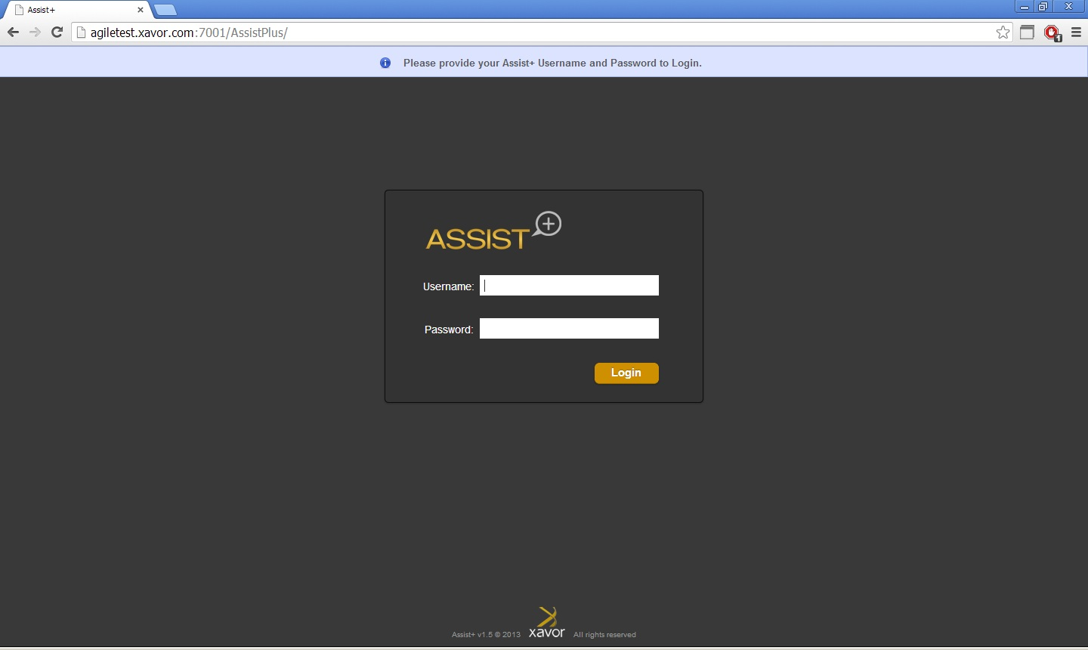

Use the following default admin credentials to login.

**User Name:** admin

**Password:** assistplus

* This is the only default admin user for AssistPlus admin console. Password can be changed once logged in.
* Existing users migrating to new version of Assist+ would retain the old username/password.
* Database would be auto upgraded to version 1.6 while logging in for the first time after deployment.

1. The AssistPlus License Agreement page should display. Review terms of service and accept. This should set up the license agreement policies and activate the software. This step will be omitted if the user is upgrading from an existing version of AssistPlus.

**License Info**, provide the following information one time.

* **Access Type**:User is able to select as User Groups/Roles using radio buttons.
  + Note: This is one time configuration and cannot be changed later.
* **Accept Terms of Service and Activate**: Press the button to activate license, the notification bar below shows a success message.

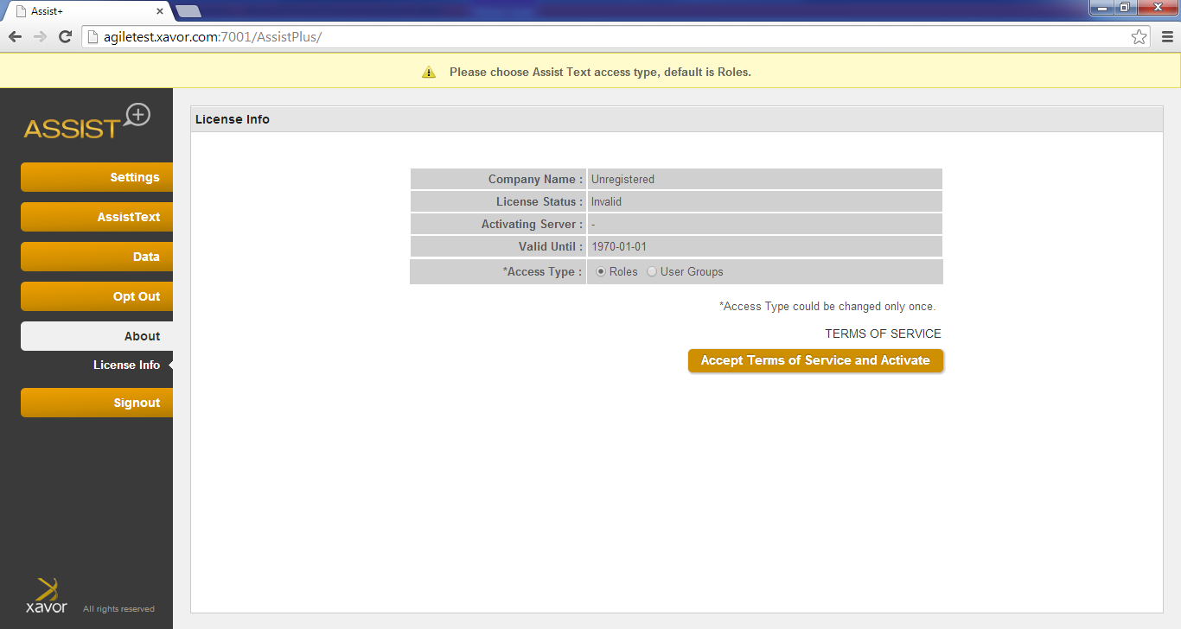

|  |
| --- |
| * If the PLMFlexAssistPlus.lic is not in the $PLMFLEX_HOME folder, this step will fail * Unless the activation step is done, further configuration/usage of admin console won’t be possible. |

1. ­­In the Settings tab, 3 sections are displayed:

* Configurations
* Role /user Group Priorities
* Change Password

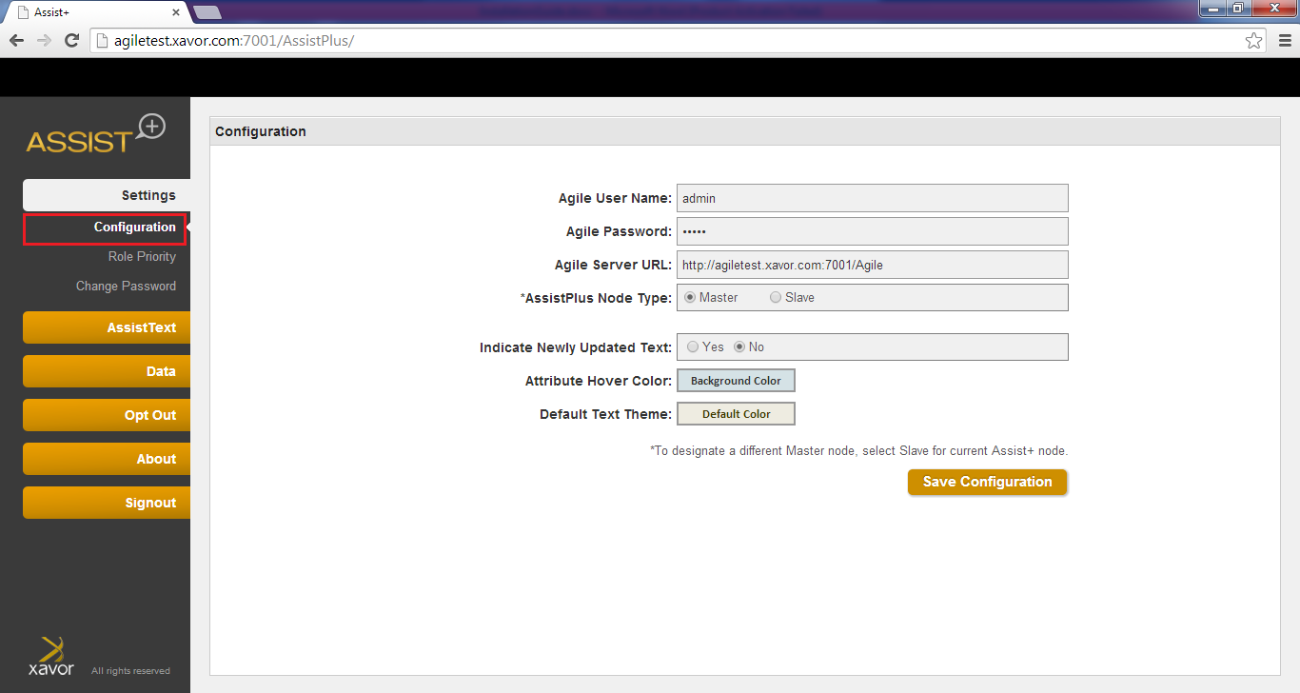

**Configuration** section, enter the following information one time.

* **User Name:** An Agile user with Administration rights.
* **Password:** The Agile user password.
* **Agile Server URL:** This is the target agile instance URL that application will work with.Give the URL as: http://<AgilePLMServer>.<Domain>/Agile
* **AssistPlus Node Type:** User is able to select as Master/Slave option using radio buttons.

Select Master to keep the current AssistPlus instance to serve as Master node.

Select Slave to provide another AssistPlus instance URL as Master Node

* **AssistPlus Master Node URL:** Displayed when Slave is selected as AssistPlus Node type option. User is able to provide another AssistPlus instance URL to serve as the Master node.
* **Indicate Newly Updated Text:** This option provides the user the flexibility of opting to indicate Agile users about newly updated help texts.
* **Updated Text Duration (Days):** If the previous option is selected to be yes, user can select the number of days a text would be indicated as newly updated.
* **Attribute Hover Color:** User can set the background color of the attributes when mouse is hovered on attributes associated with Assist + help text.
* **Default Text Theme:** User can specify a default color theme for callouts here. This color will appear for the callouts if not overridden while specifying text/role priority.

|  |
| --- |
| * For details on the Master/Slave Configuration options, please refer to **Appendix B: Assist+ Master/Slave Configuration**. |

**Change Password** Section

* **User Name:** An Agile PLM user with Administration rights.
* **Current Password:** Administrator user current password
* **New Password:** Administrator user new password
* **Confirm New Password:** Administrator user new password to confirm
* Click the “change password” icon to save. The notification bar below shows success message if password changed successfully.

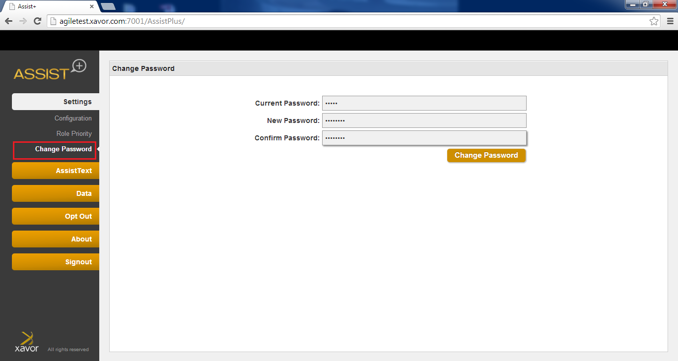

**Role Preference** Section allows admin create a set of allowable roles and the prioritize themessage in case user is assigned to multiple roles

* User is able to filter the roles based on keyword.
* User drags roles from Agile PLM column to Selected Roles for Assist column. Roles placement is done with respect to its priority
* Click the “Save” icon to save the configurations.

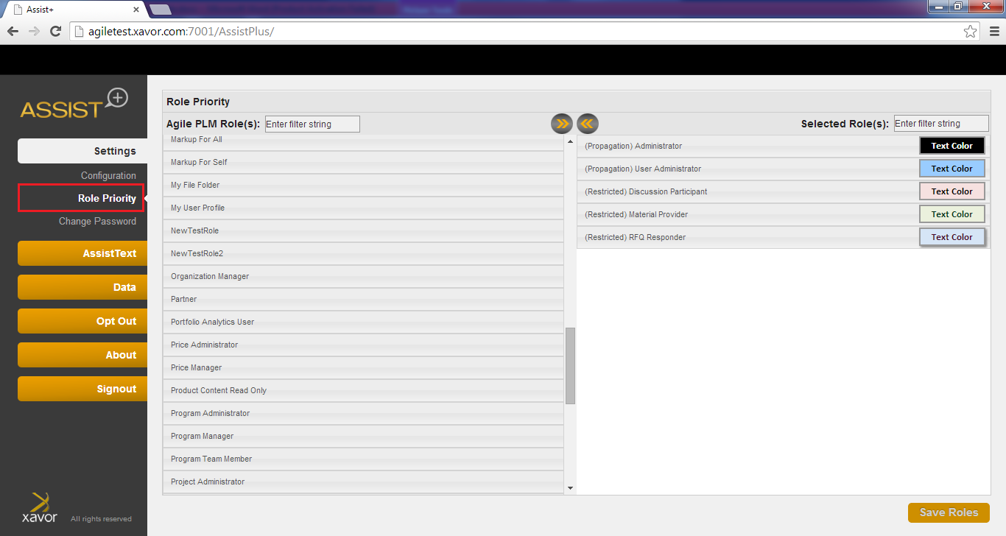

**User Group Preference** Section allows admin create a set of allowable user groups and theprioritize the message in case user is assigned to multiple user groups

* User is able to filter the user groups based on keyword.
* User drags user groups from Agile PLM column to Selected Roles for Assist column. user groups placement is done with respect to its priority
* 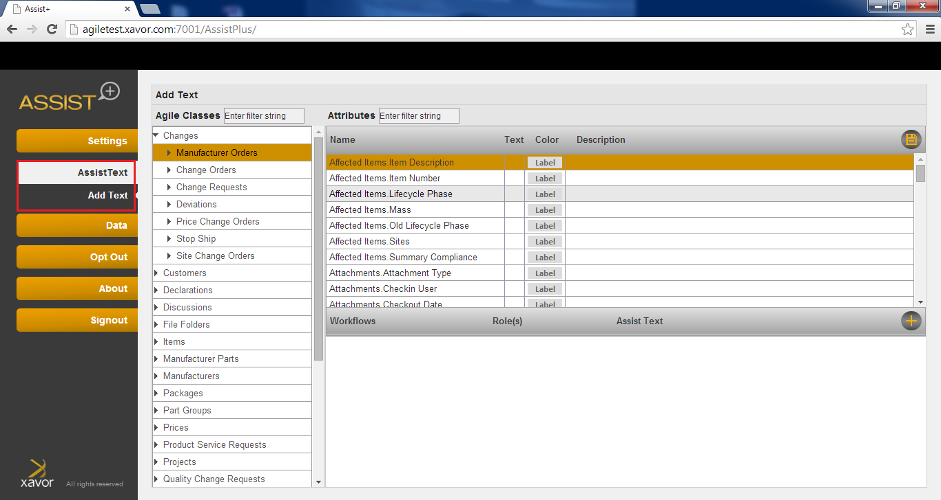Click the “Save” icon to save the configurations.

1. The Assist Text tab allows for setting messages

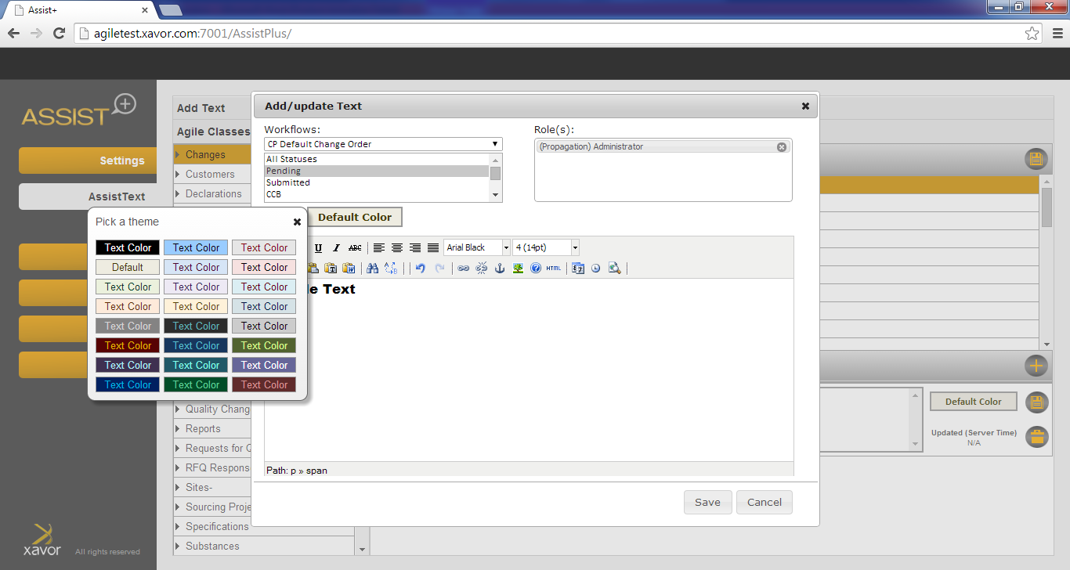

* Use the Agile Classes tree to select a base-class, class, or sub-class to view their respective pages 1, 2 and 3 attributes
* Click on the attribute to view or enter help text
* Edit roles/user groups to target the help text message. Use “All Roles” or “All groups” for access by everyone
* Optionally select text color
* Optionally change label color
  + Click the C:\Users\uhani\Desktop\icon.png icon to create a new help text.
  + Double click to edit an existing help text
  + The  icon against the attributes signifies that a help text entry already against it. 
  + The edit screen is a rich text editor that can be switched to a pure HTML editor is needed, with editing for roles.

## Configure Agile Web Proxy (Optional)

|  |
| --- |
| * This step is required only if Agile Web Proxy is configured and used for accessing Agile PLM. * Below steps are for IIS as web server and WebLogic Server as Application Server for Agile. Similar steps will be required for other servers |

Follow the following steps for configuring Agile web proxy to pass through AssistPlus context root (/AssistPlus):

1. Logon on to the machine where Web Server (IIS) is hosted.
2. Go to <Agile_Home>\AgileProxies folder. (e.g. D:\Agile\Agile931\AgileProxies)
3. Open **9ias.conf** file in an editor.
4. Add the following line after similar entry for /Agile/ context:

**oproxy.<AgilePLM Server Name>.urlrule=/AssistPlus/\***

e.g. oproxy.MEDDEVBI.xavor.com.urlrule=/AssistPlus/*

1. Save and close the file
2. Open **iisproxy.ini** file in an editor and look for **wlForwardPath** property.
3. Append AssistPlus context to the value of this property

e.g. wlForwardPath=/Agile,/AssistPlus,/JavaClient,/CoreService

1. Save and Close the file
2. Restart the Web Server and make sure cache is refreshed.

## Verify Installation

Once installed and configured, the following steps can be performed to verify working of AssistPlus application.

1. Login to Agile PLM web client as any user: http://<AgilePLMServer>.<DomainName>/Agile/PLMServlet
2. Full refresh your browser in case Web Client is already opened.
3. Click on the User icon on top left corner to open the current User’s page
4. Hover mouse pointer over the “User ID” field name, which will show a call-out displaying

“User’s Unique Identifier”.

“Users > User ID” is the only assist text configured by default for verification purpose only.

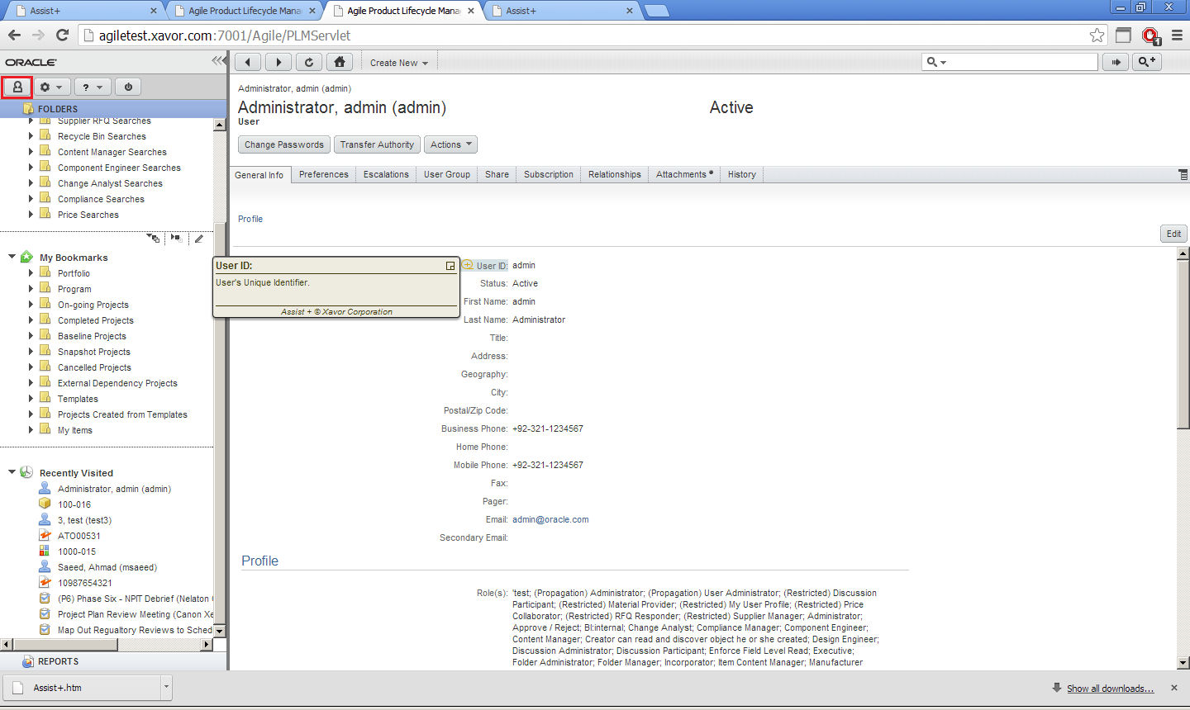

1. In the home folder specified in the environment variable e.g. D:/AssistPlus, a Logs folder will appear after application starting for 1st time. This will contain two files INFO.out (containing useful information for admin) and ERROR.out (Exception stack traces from application). This will help in the identification of any problem occurring while using the application.

|  |  |  |
| --- | --- | --- |
|  |  |  |
| Environment Variable setting for OAS | Appendix |  |
| This section provides instructions for creating Environment Variable required when installing AssistPlus on OAS. | A |  |
|  |  |
|  |  |  |

**Steps:**

1. Login to OAS Application Server Control as admin

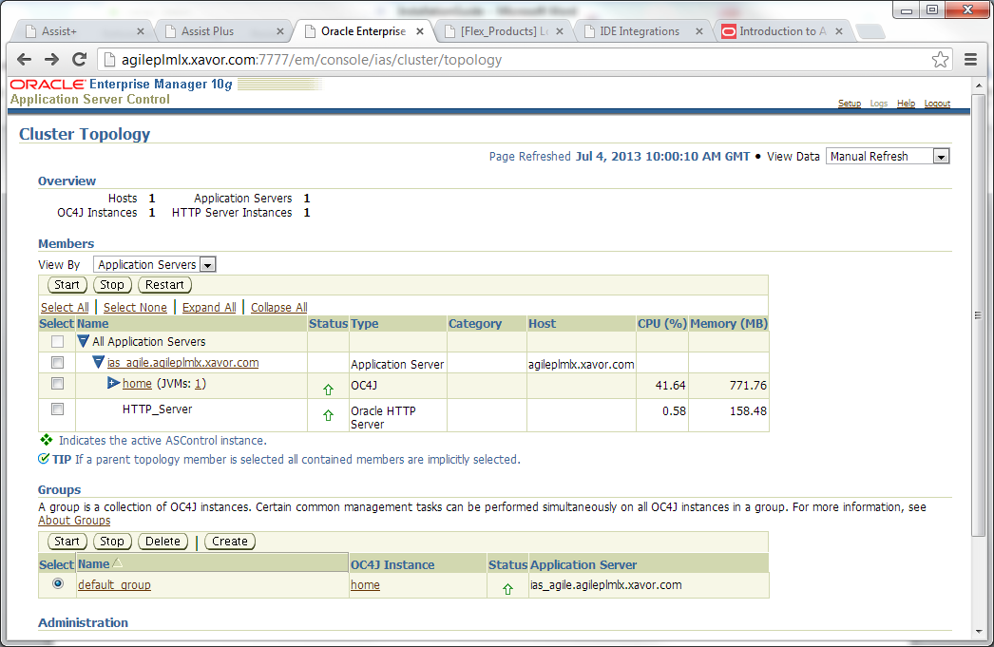

1. Go to the Group where AssistPlus application will be deployed and open Administration tab

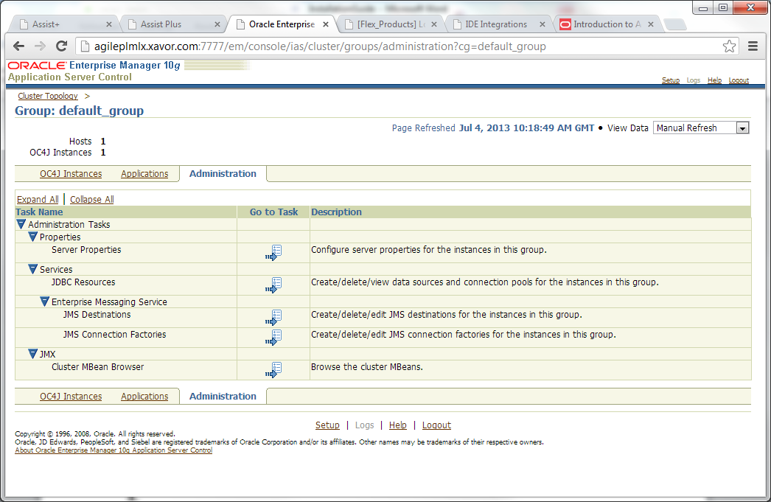

1. Edit Server Properties and scroll down to Environment Variables section

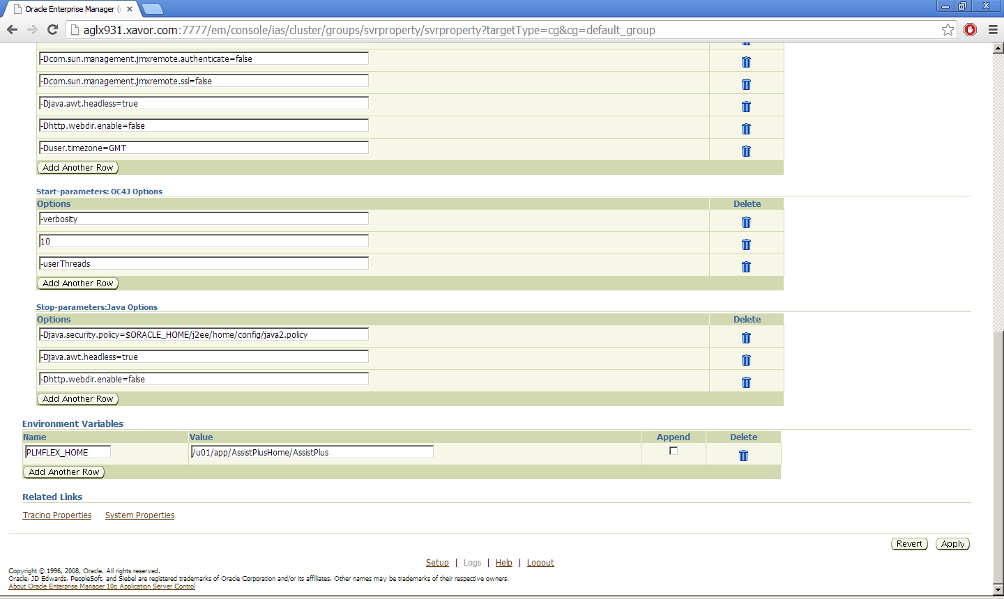

1. Add a variable named PLMFLEX_HOME with the folder path as value and click on Apply
2. Restart the application server instance for changes to take effect.

|  |  |  |
| --- | --- | --- |
|  |  |  |
|  |  |  |
| Assist+ Master/Slave Configuration | Appendix |  |
| This section provides details for better understanding of the Assist+ Master/Slave configuration option. | B |  |
|  |  |
|  |  |  |

Assist+ supports Master-Slave configuration in case there are multiple nodes of Agile PLM behind a load balancer. One of the AssistPlus node, in this case may serve as Master while others can refer to it for all Assist Text Data. It is assumed that the Agile PLM systems participating in this topology are similar in configuration (classes and fields).

Configuring this approach is optional and serves as an alternate to sharing configurations files between nodes over network. In case this approach is not required, all nodes can be set as Master for a regular working.

Below is an illustration of a two-node Master/Slave configuration working:



- This page intentionally left blank -