Midterm Project: Beauty Salon

Student: Sembayeva Aizada
Group: SE-2439
Link: https://admirable-lolly-5dedff.netlify.app/

Part 1. Website Structure and Design
In this project, I developed a multi-page website themed around a Beauty Salon using HTML5, CSS3, and Bootstrap 5.
The site consists of five interconnected pages:
- Home – introduction, hero section, and price table
- About – salon description and team section
- Services – list of beauty treatments with hover effects
- Gallery – image showcase using CSS Grid
- Contact – booking form and working hours
The header and footer are consistent across all pages, featuring navigation links and social media icons.
Semantic HTML tags (header, main, section, article, footer, nav) are used for accessibility and proper structure.
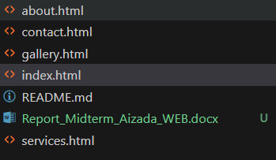

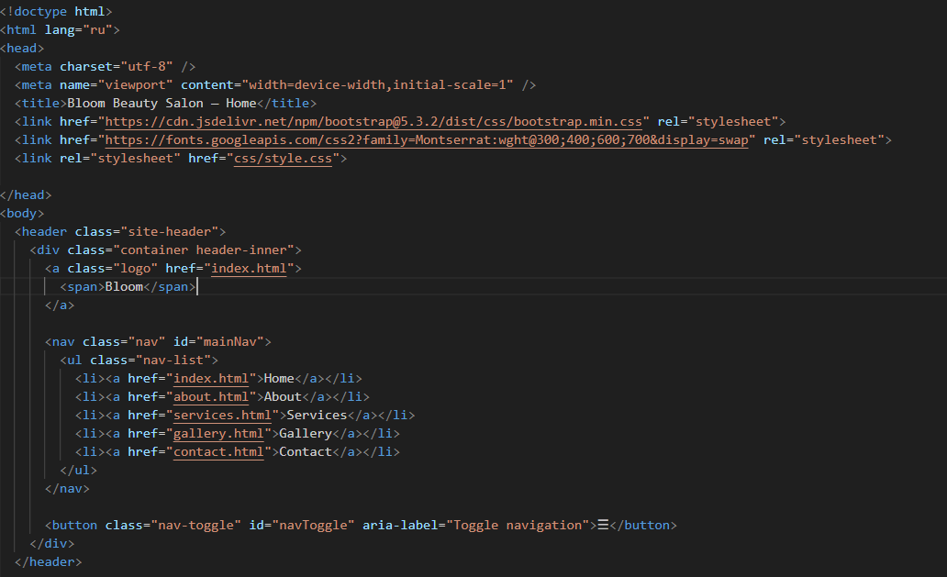
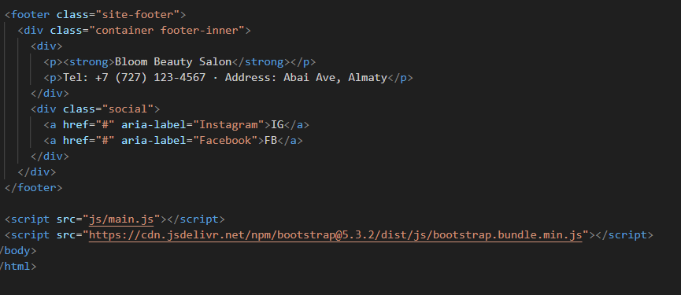

Part 2. Styling and Color Palette
The external stylesheet (css/style.css) defines all design rules using modern CSS practices:
- CSS Variables: stored in :root for brand consistency (--brand-deep, --brand-pink, --bg, --text).
- Color Palette:
  - Deep Burgundy — #660024 (primary)
  - Soft Pink — #ff3374 (accent)
  - Light Background — #faf7f8
  - Text — #2b2b2b
This balanced palette ensures sufficient contrast and an elegant feminine look.
Typography uses Montserrat from Google Fonts, emphasizing readability and a modern aesthetic.
Hover states and focus outlines are implemented for better interactivity and accessibility.

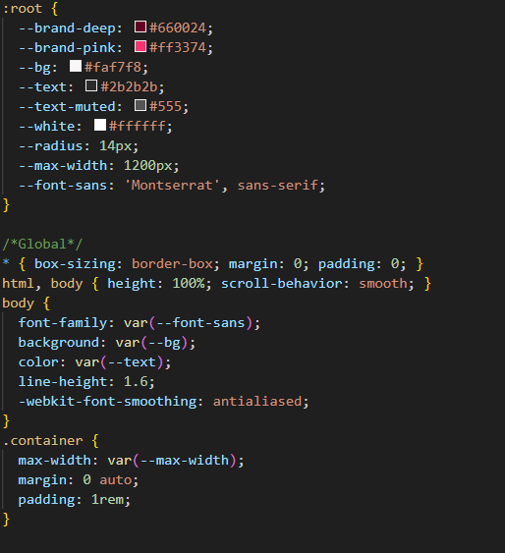

Part 3. Layout Techniques
The layout combines Flexbox, CSS Grid, and Bootstrap 5 components:
- The navigation bar and footer use Flexbox for horizontal alignment.
- The Services, Gallery, and Team sections use CSS Grid for evenly spaced, responsive card layouts.
- The Home page table demonstrates tabular data styling with Bootstrap classes.
- The Contact page includes a form with labels, inputs, and a submit button styled with CSS and validated in JavaScript.
Responsive design is achieved through media queries at 992px and 700px breakpoints, ensuring smooth scaling across desktop, tablet, and mobile devices.

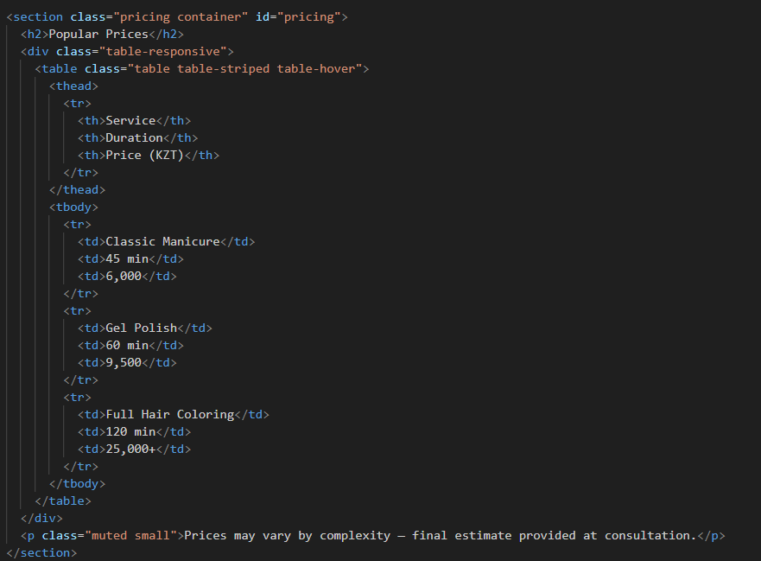
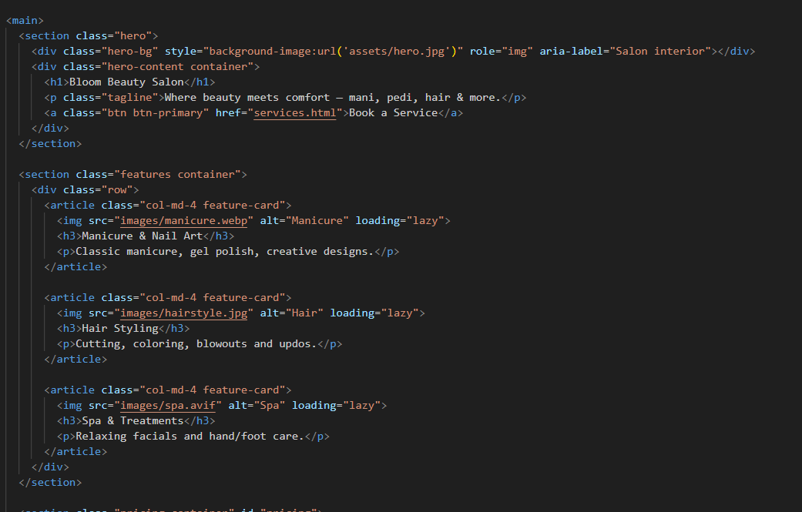

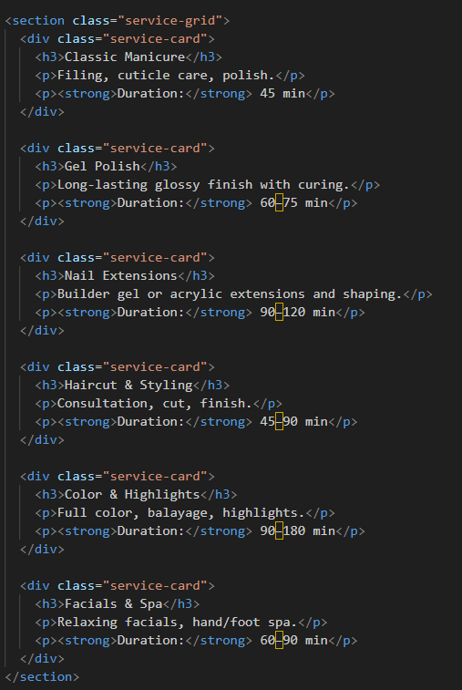
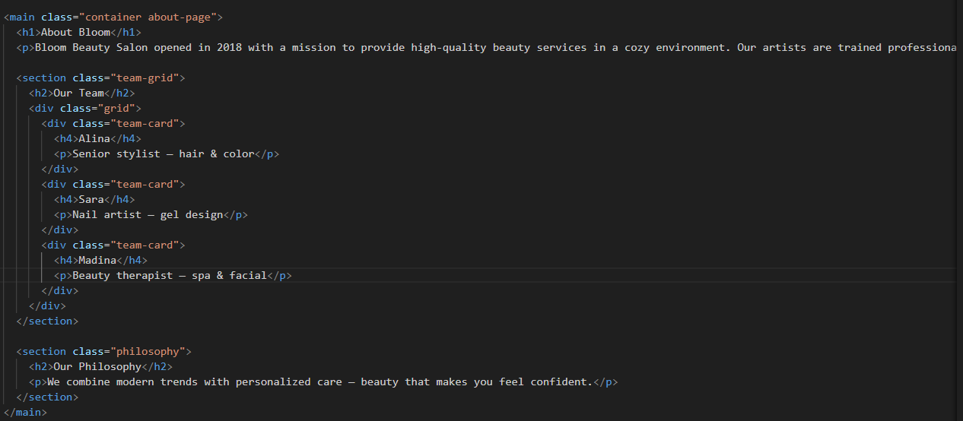

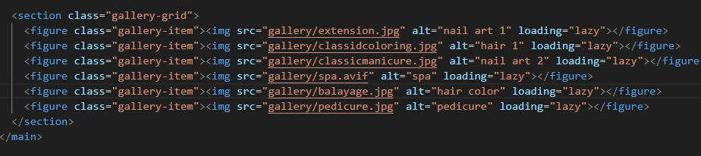

Part 4. Interactivity and Responsiveness
A small custom JavaScript file (js/main.js) adds basic interactivity:
- Mobile navigation toggle (menu expands/collapses on smaller screens).
- Contact form submission feedback (alert message confirming the booking request).
All images below the fold include the loading="lazy" attribute to improve performance.
The layout dynamically adjusts:
- 3 columns on desktop,
- 2 columns on tablets,
- 1 column on smartphones.
This guarantees a consistent user experience on all devices.
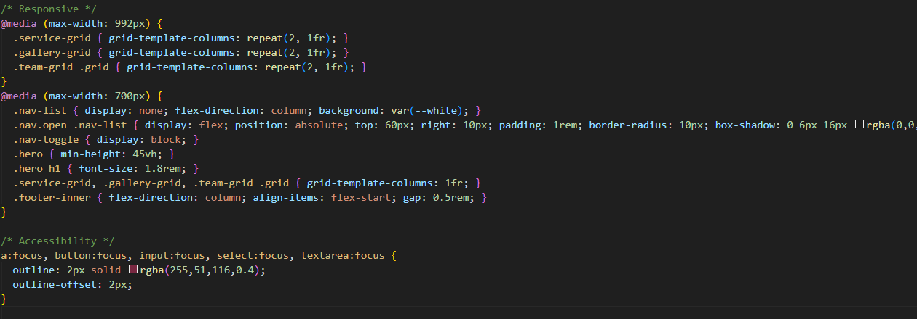

Part 5. Visual Consistency and UX
Design consistency is maintained throughout:
- Rounded corners (border-radius: 14px) unify visual style.
- Shadow effects create depth and separation between sections.
- Buttons (.btn) follow the brand colors, turning pink on hover.
- Headings use the main burgundy color for strong visual anchors.
Each page maintains clean spacing and balanced typography.
Images are well-contrasted, and text remains readable on every background.

Summary:
All requirements of the final website project have been successfully met.
- 5 pages with unified header/footer navigation
- External CSS file with variables, Flexbox, and Grid
- Table and form integrated
- Modern responsive design with Bootstrap and custom media queries
- Accessible, performant, and visually consistent
- Improved color contrast and typography for professional look
The final project demonstrates full mastery of front-end fundamentals — semantic HTML, CSS organization, responsive layout, accessibility, and UI aesthetics — through a real-world theme implementation.

