Assignment 2

Screenshots

EN3_A04

“Central park” Team(4 people)

“Almaty Flowers” Project

Actors of application:

1) Clients

2) Flower Shops

Use-cases:

Clients:

1) Can search flowers

2) Can leave information as how many flowers and what kind of flowers they want, contacts

3) Can order flowers

4) Can view proposes of flower shops

5) Can make an agreement with flower shop

Flower Shops:

1) Can search client’s orders

2) Can propose their service

3) Can make an agreement with client

Screenshot #1

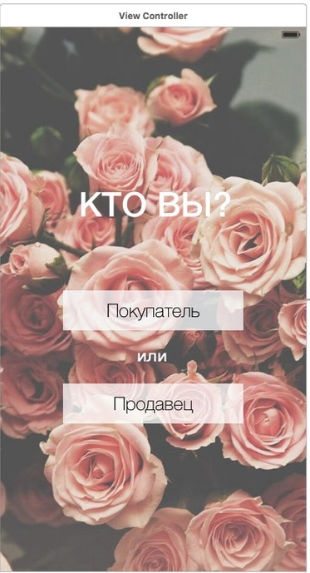

This application is for user who wants order flower and companies that want sell flowers. So, at the beginning user should answer who are they seller or buyer as it is shown on screenshot #1. When any button is pressed it goes to screenshot #2.

Screenshot #2

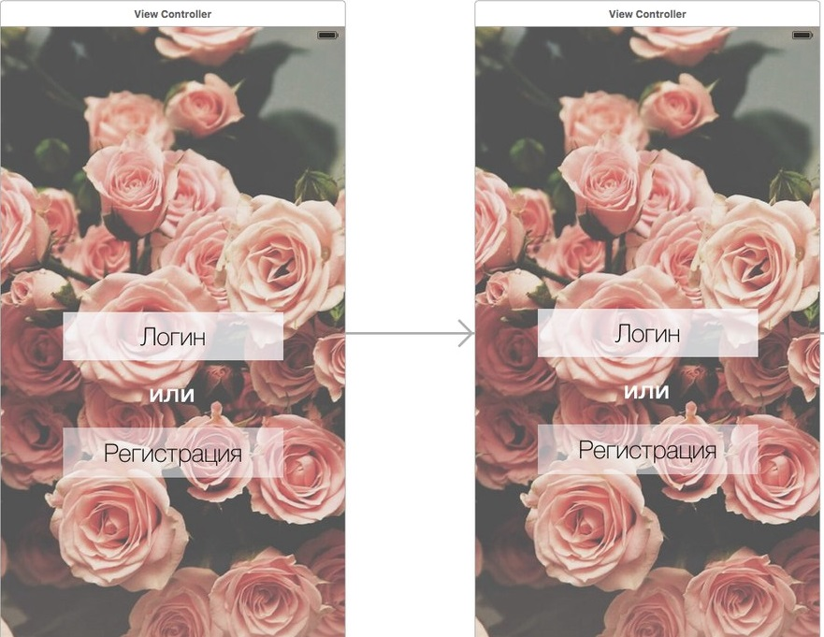

Then user can log in or do registration as it is shown on screenshot #2. This step is similar to both seller and buyer. When button “Registration” is pressed it goes to screenshot #3 and when button “Log in” is pressed it goes to screenshot #4.

Screenshot #3

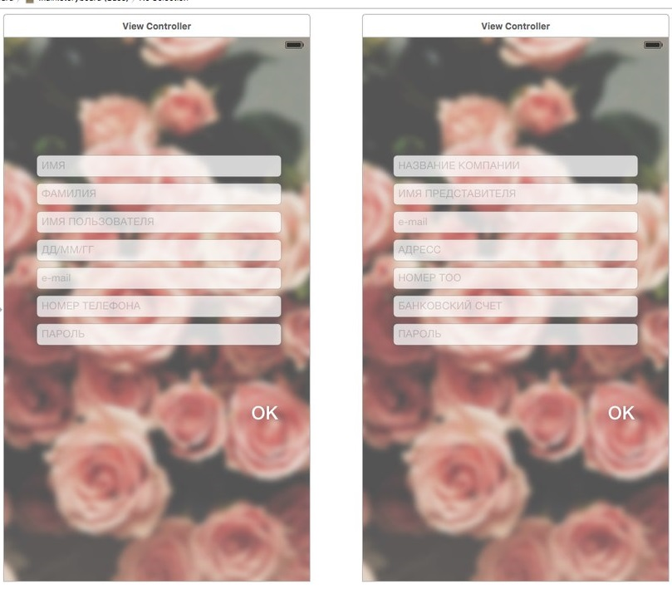

First screenshot is for buyer, it includes text fields for information about buyer as name, surname, nickname, birth date, e-mail, phone number and password. By pressing ok button user can be registered and it goes to screenshot #5.

Second screenshot is for seller or company, it includes text fields for information about seller as name of company, name of administrator, e-mail, address, number of company, bank account and password. By pressing ok button user can be registered and it goes to screenshot #5.

Screenshot #4

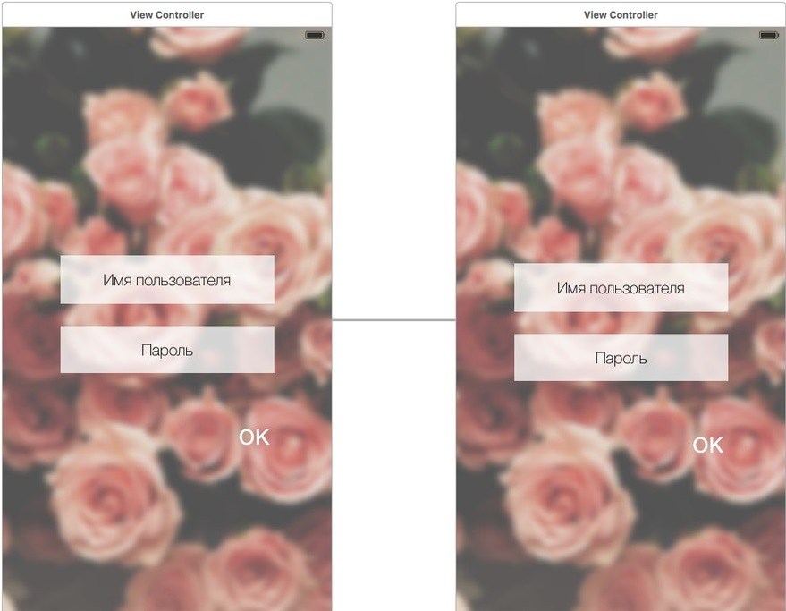

In this screenshot already registered users can enter their logins and passwords. It is similar to both seller and buyer. By pressing ok button user can sign in and start using the application and it goes to screenshot #5 for buyer and to screenshot #11 for seller.

Screenshot #5

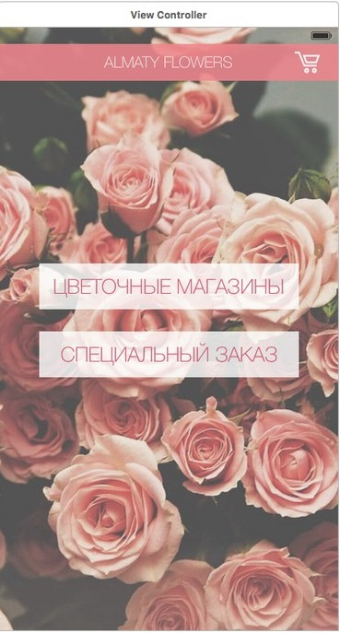

By pressing button ”Flower shops” user gets list of companies that sell flowers and it goes to screenshot #6. By pressing button “Special order” user can do special order describing his/her needs and it goes to screenshot #8.

Screenshot #6

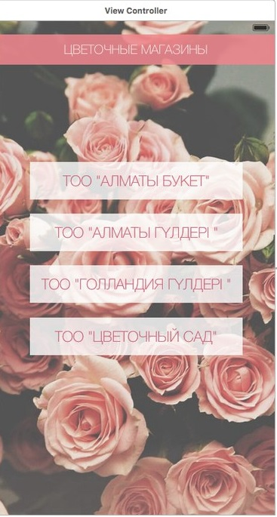

By pressing the wanted company, user can observe list of products that the company offers and it goes to screenshot #7.

Screenshot #7

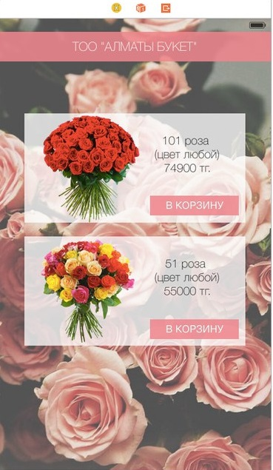

By pressing button “Into bucket” user can add it into their bucket of orders and it goes to screenshot #10.

Screenshot #8

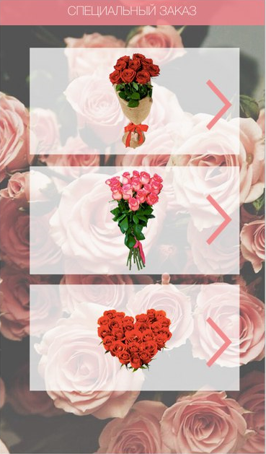

On screenshot #8 it is introduced list of types of bouquets of flowers. Choosing one of them user can define the count of flowers and it goes to screenshot #9.

Screenshot #9

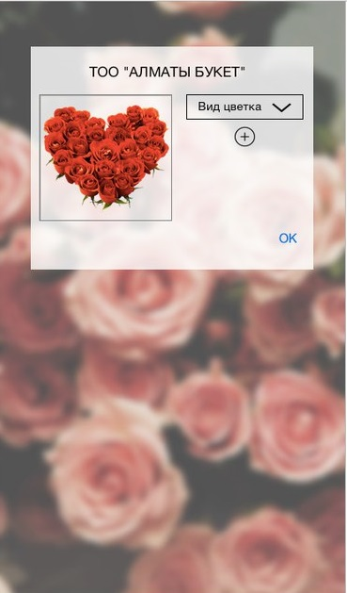

In the drop-down-box “Type of flower” user can select his/her wanted type of flower. By pressing ok button user commits order and add it into bucket of orders and it goes to screenshot #10.

Screenshot #10

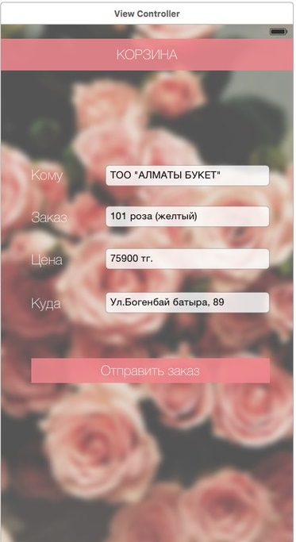

This is how ordering flowers looks like. There is information about order. By pressing button “Order”, user sends his/her order to the chosen company.

Screenshot #11

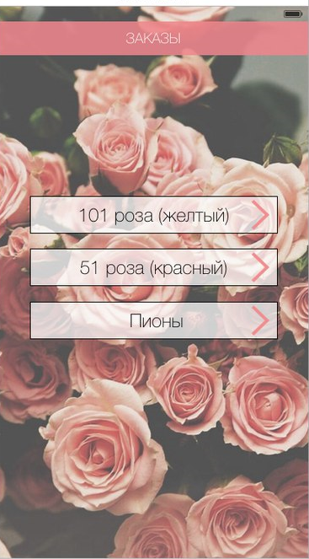

This is list of orders, which company can observe. By pressing the some defined order, company can get information about that order and it goes to screenshot #12.

Screenshot #12

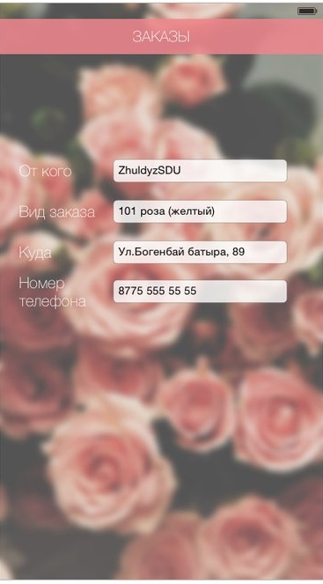

There is more information about order chosen by company.

Screenflow

