**Software Requirements Document for “Almaty Flowers”**

**Author: Team 10, “Central Park”**

Sandibekova Aizhana

Taspolat Madina

Tunbay Aidana

Suindikova Zhuldyz

Version: 0.1

Date: 24/02/16

Author: Team 20

Change: Initial Document

Table of Contents

1 Introduction 3

1.1 Purpose 3

1.2 Scope 3

1.3 Definitions, acronymns, abbreviations 3

1.4 References 3

1.5 Overview 3

2 Overall Description 3

2.1 Product Perspective 3

2.1.1 Concept of Operations 4

2.1.2 Major User Interfaces 4

2.1.3 Hardware 4

2.1.4 Software Interfaces 4

2.1.5 Communication Interfaces 4

2.1.6 Memory Constraints 4

2.1.7 Operations 4

2.1.8 Site Adaptation Requirements 4

2.2 Product functions 5

2.2.1 Search flowers 5,6

2.2.2 Order flowers 7

2.2.3 Search Client’s order 8

2.2.4 Adds their products 9

2.3 User characteristics 10

2.4 Constraints 10

2.5 Assumptions and Dependencies 10

3 Specific Requirements 10

3.1 External Interface Requirements 10

3.1.1User Interfaces 10

3.1.2Hardware Interfaces 10

3.1.3Software Interfaces 10

3.1.4Communications Interfaces 10

3.2 FEATURES 10

3.3 Performance requirements 10

3.4 Design Constraints 10

3.5 Software System Attributes 10

3.6 Other Requirements 10

I Introduction

1.1 Purpose

The purpose of this document is to provide detailed requirements information about the “Almaty Flowers”.

1.2 Scope

This document will describe the use cases and features of the ”Almaty Flowers”.

1.3 Definitions, acronyms, abbreviations

|  |  |
| --- | --- |
| Term | Description |
| Basket | Consists of favorite selected products |
| Buyer | User who can view list of production and can order by leaving information as address, name, phone number. |
| List of product | List of available to buy flowers |
| Product | Defined type of flower |
| Seller | User who can register and log in and who can add their products. |

1.4 References

Wikipedia: <http://wikipedia.org>

1.5 Overview

[OMIT]

II Overall Descr

Iption

This application helps people order flowers fast, easy and enjoyable. Also it allows companies, that sells flowers, introduce their production to the buyers. Buyers can find plenty of different types of flowers and order them from home.is over

2.1 Product Perspective

There is no active application like this in Kazakhstan nowadays. That is why this application might be very popular. Also this application will simplify searching and ordering flowers to buyers and selling flowers to seller companies.

// Sandibekova Aizhana

2.1.1 Concept of Operations

Any user can open and enter to this application and view products without account. Only if you are seller-company you have account and you must register. In the first page there will be introduced list of flowers that companies offer to buy. If user likes some product he selects it and it goes to basket. After that in basket user presses button “order” then he fills required fields with information about order.

Company have to register if it didn`t do it. Then seller can view order from clients and can get full information about this order. Also seller can add products leaving information. And of course seller can call client to make deal.

2.1.2 Major User Interfaces

See Appendix 1.ScreenFlow

2.1.3 Hardware

This software requires Apple mobile phone.

2.1.4 Software Interfaces

// example: CGI-URL or function signatures etc (OMIT for now).

2.1.5 Communication Interfaces

// example: modem etc (OMIT for now)

2.1.6 Memory Constraints

Phone memory or flash memory.

2.1.7 Operations

// special operations (if any) (OMIT for now)

2.1.8 Site Adaptation Requirements

Russian language

// Suindikova Zhuldyz

2.2 PRODUCT FUNCTIONS

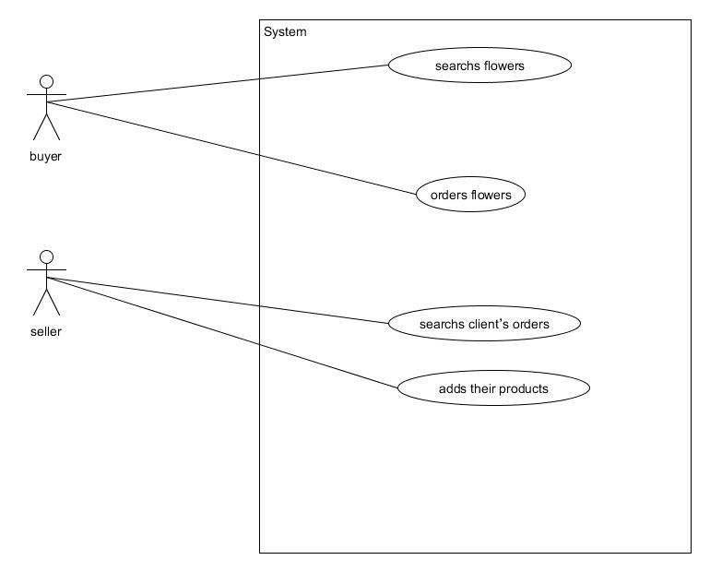 Company have to register if it didn`t do it. Then seller can view order from clients and can get full information about this order. Also seller can add products leaving information. And of course seller can call client to make deal.

In the first page there will be introduced list of flowers that companies offer to buy. If user likes some product he selects it and it goes to basket. After that in basket user presses button “order” then he fills required fields with information about order.

2.2.1 Search flowers

Description: To order flowers user have to search flower’s list

Actors: Buyer.

2.2.1.1 Buyer has to click “View Flowers” button

2.2.1.2 Then viewListOfFlowers() method will run.

// Sandibekova Aizhana

2.2.1.3 This method takes information from database.

2.2.1.4 Server will send to user interface list of flowers.

2.2.1.5 Client receives page with list of flowers.

Pre-conditions: User installed application on his/her mobile phone.

Post-conditions: User will view list of flowers.

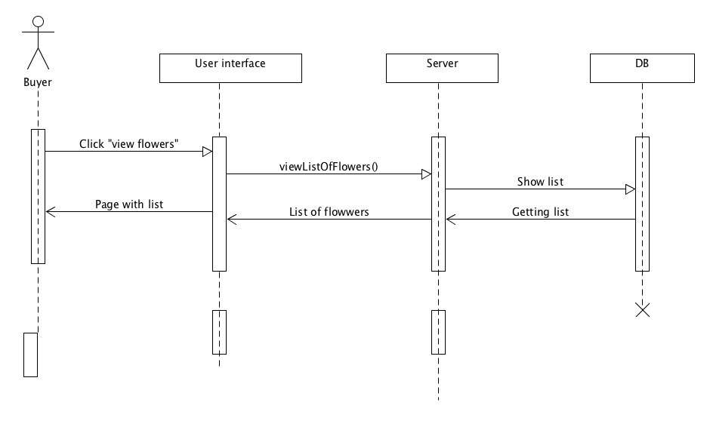

// Sandibekova Aizhana

2.2.2 Order flowers

Description: To order flowers user have to search flowers list

Actors: Buyer.

2.2.2.1 Buyer has to click “Order” button in basket

2.2.2.1.1 Buyer can change count of flowers

2.2.2.1.2 Buyer will add own information (mobile phone, name, address)

2.2.2.2 Then addOrder() method will run.

2.2.2.3 This method takes information from database.

2.2.2.4 Server displays a pop-up window.

2.2.2.5 Client receives a pop-up message “Success”.

Pre-conditions: User installed application on his/her mobile phone.

Post-conditions: User will view list of flowers in basket page and send an order.

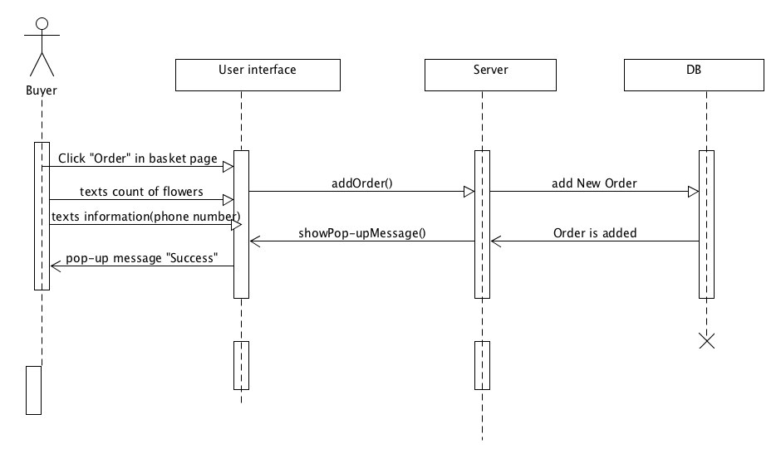

// Suindikova Zhuldyz

2.2.3 Search Client’s order

Description: To make deal seller have to search list of orders

Actors: Seller

2.2.3.1 Seller has to click “View orders” button

2.2.3.2 Then getListOfOrders() method will run.

2.2.3.3 This method takes information from database.

2.2.3.4 Server will send to user interface list of orders.

2.2.3.5 Client receives page with list of orders.

Pre-conditions: User installed application on his/her mobile phone.

Post-conditions: User will view list of orders.

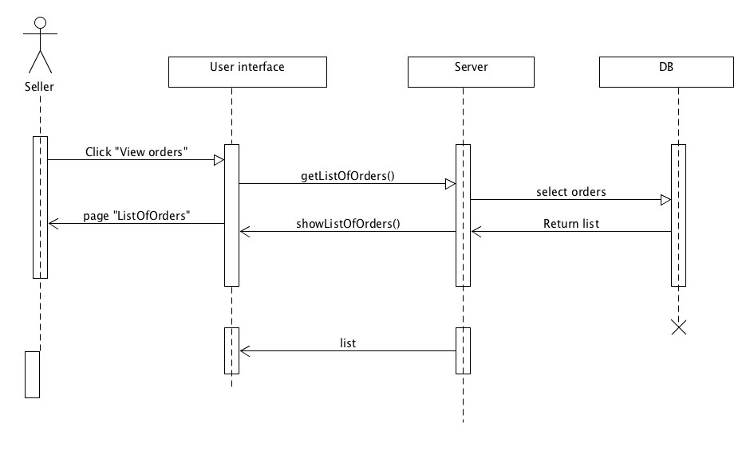

// Taspolat Madina

2.2.4 Adds their products

Description: Seller can to add their products

Actors: Seller

2.2.4.1 Seller has to click “+” button

2.2.4.2 Seller has to click “load image” button

2.2.4.3 Seller has to fill in “text with description”

2.2.4.4 Then addProduct () method will run.

2.2.4.5 This method takes information from database.

2.2.4.6 Server will send to user interface showPop-upMessage().

2.2.4.7 Seller receives page with the pop-up message “Success” .

Pre-conditions: User logged in with his/her account.

Post-conditions: User will add new product

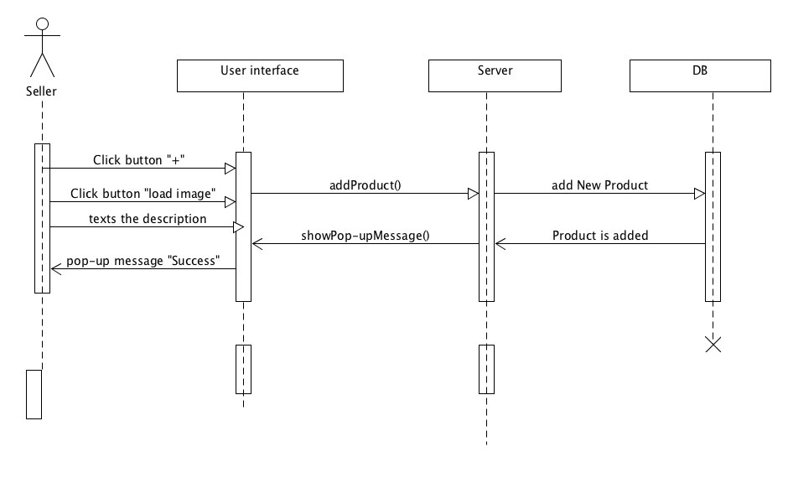

// Tunbay Aidana

2.3 USER CHARACTERISTICS

Buyer: a person who wants to buy the flowers and save time

Seller: a person who wants to sell their products

Developer: Administrate all the content and users of the application, can do everything

2.4 CONSTRAINTS

1. This application designed to be used by all.

2. This is an application for Flowers shop.

3. Used for people who wants to save their times and can find plenty of different types of flowers and order them from home.is

2.5 ASSUMPTIONS AND DEPENDENCIES

1.Browser dependency.

III Specific Requirements

3.1External Interface Requirements

3.1.1User Interfaces

3.1.2Hardware Interfaces

None

3.1.3Software Interfaces

None

3.1.4Communications Interfaces

3.2 FEATURES

3.2 Our application help for people to find different types of flowers also save their time

3.3. In our application has function of delivery

3.4. There is no active application like this in Kazakhstan nowadays.

3.5. Our application help for sellers view their products

3.6. Buyers can see type of views.

// Taspolat Madina, Tunbay Aidana