**1 Introduction**

***1.1 Purpose***

The purpose of this document is to provide detailed requirements information about the “Almaty Flowers”.

***1.2 Scope***

This document will describe the use cases and features of the ”Almaty Flowers”.

***1.3 Definitions, acronyms, abbreviations***

|  |  |
| --- | --- |
| ***Term*** | ***Description*** |
| Basket | Consists of favorite selected products |
| Buyer | User who can view list of production and can order by leaving information as address, name, phone number. |
| List of product | List of available to buy flowers |
| Product | Defined type of flower |
| Seller | User who can register and log in and who can add their products. |

***1.4 References***

Wikipedia: <http://wikipedia.org>

***1.5 Overview***

[OMIT]

**2 Overall Descr**

**Iption**

This application helps people order flowers fast, easy and enjoyable. Also it allows companies, that sells flowers, introduce their production to the buyers. Buyers can find plenty of different types of flowers and order them from home.is **overa**

**llOverall Description**

***2.1 Product Perspective***

There is no active application like this in Kazakhstan nowadays. That is why this application might be very popular. Also this application will simplify searching and ordering flowers to buyers and selling flowers to seller companies.

**2.1.1 Concept of Operations**

Any user can open and enter to this application and view products without account. Only if you are seller-company you have account and you must register. In the first page there will be introduced list of flowers that companies offer to buy. If user likes some product he selects it and it goes to basket. After that in basket user presses button “order” then he fills required fields with information about order.

While company have to register if it didn`t do it. Then seller can view order from clients and can get full information about this order. Also seller can add products leaving information. And of course seller can call client to make deal.

**2.1.2 Major User Interfaces**

See Appendix 1.ScreenFlow

**2.1.3 Hardware**

***This software requires Apple mobile phone.***

***2.1.4 Software Interfaces***

***// example: CGI-URL or function signatures etc (OMIT for now).***

***2.1.5 Communication Interfaces***

***// example: modem etc (OMIT for now)***

***2.1.6 Memory Constraints***

***Phone memory or flash memory.***

2.1.7 Operations

// special operations (if any) (OMIT for now)

2.1.8 Site Adaptation Requirements

Russian language

2.2 PRODUCT FUNCTIONS

Company have to register if it didn`t do it. Then seller can view order from clients and can get full information about this order. Also seller can add products leaving information. And of course seller can call client to make deal.

In the first page there will be introduced list of flowers that companies offer to buy. If user likes some product he selects it and it goes to basket. After that in basket user presses button “order” then he fills required fields with information about order.

2.2.1 Search flowers

Description: To order flowers user have to search flower’s list

Actors: Buyer.

2.2.1.1 Buyer has to click “View Flowers” button

2.2.1.2 Then viewListOfFlowers() method will run.

2.2.1.3 This method takes information from database.

2.2.1.4 Server will send to user interface list of flowers.

2.2.1.5 Client receives page with list of flowers.

Pre-conditions: User installed application on his/her mobile phone.

Post-conditions: User will view list of flowers.

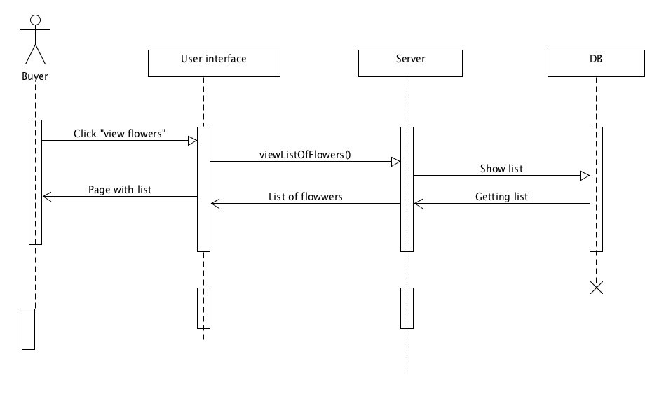

2.2.2 Order flowers

Description: To order flowers user have to search flowers list

Actors: Buyer.

2.2.2.1 Buyer has to click “Order” button in basket

2.2.2.1.1 Buyer can change count of flowers

2.2.2.1.2 Buyer will add own information (mobile phone, name, address)

2.2.2.2 Then addOrder() method will run.

2.2.1.3 This method takes information from database.

2.2.1.4 Server displays a pop-up window.

2.2.1.5 Client receives a pop-up message “Success”.

Pre-conditions: User installed application on his/her mobile phone.

Post-conditions: User will view list of flowers in basket page and send an order.

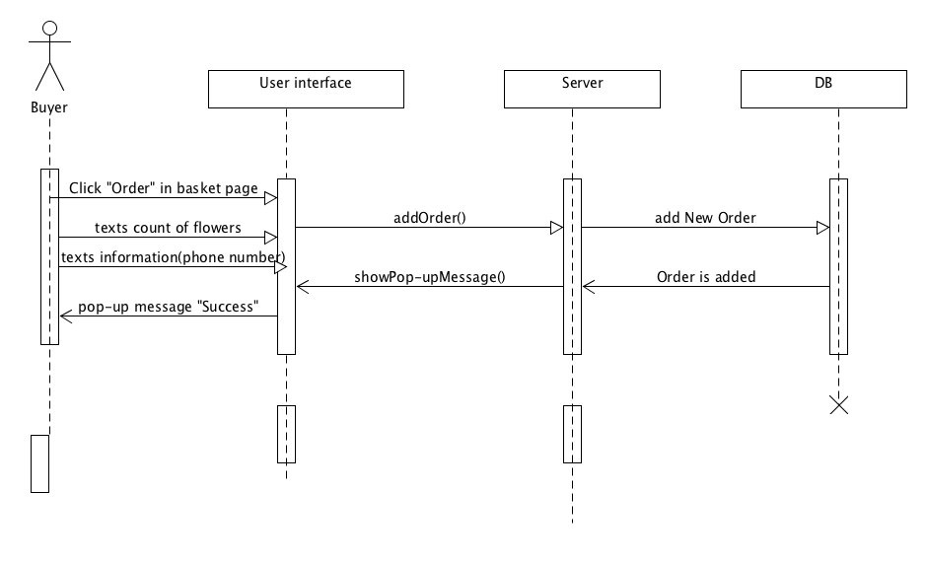

2.2.3 Search Client’s order

Description: To make deal seller have to search list of orders

Actors: Seller

2.2.3.1 Seller has to click “View orders” button

2.2.3.2 Then getListOfOrders() method will run.

2.2.3.3 This method takes information from database.

2.2.3.4 Server will send to user interface list of orders.

2.2.3.5 Client receives page with list of orders.

Pre-conditions: User installed application on his/her mobile phone.

Post-conditions: User will view list of orders.

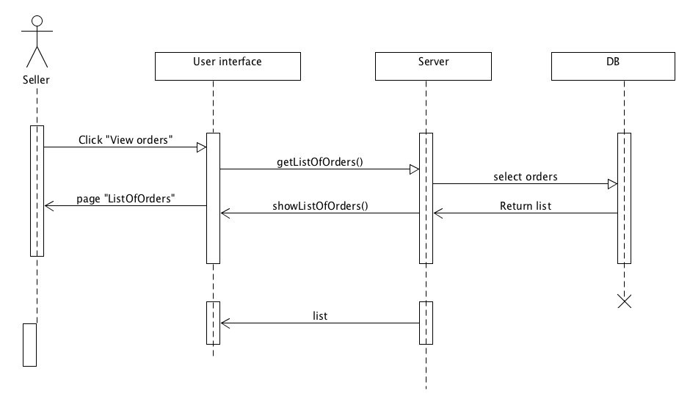

2.2.4 Adds their products

Description: Seller can to add their products

Actors: Seller

2.2.4.1 Seller has to click “+” button

2.2.4.2 Seller has to click “load image” button

2.2.4.3 Seller has to fill in “text with description”

2.2.4.4 Then addProduct () method will run.

2.2.4.5 This method takes information from database.

2.2.4.6 Server will send to user interface showPop-upMessage().

2.2.4.7 Seller receives page with the pop-up message “Success” .

Pre-conditions: User installed application on his/her mobile phone.

Post-conditions: User will view new product

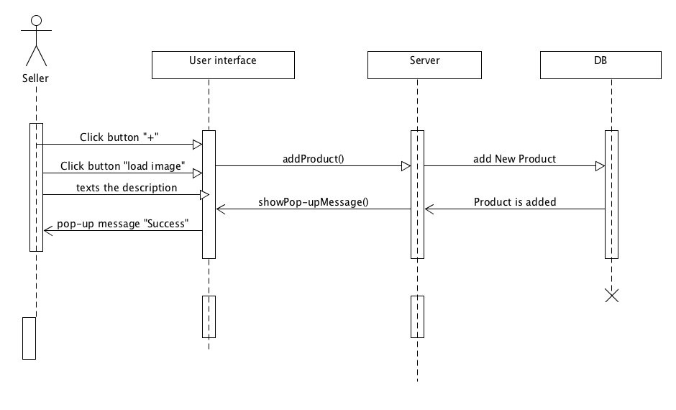

2.3 USER CHARACTERISTICS

Buyer: a person who wants to buy the flowers and save time

Seller: a person who wants to sell their products

Developer: Administrate all the content and users of the application, can do everything

2.4 CONSTRAINTS

1. This application designed to be used by all.

2. This is an application for Flowers shop.

3. Used for people who wants to save their times and can find plenty of different types of flowers and order them from home.is

2.5 ASSUMPTIONS AND DEPENDENCIES

1.Browser dependency.

**3 Specific Requirements**

3.1External Interface Requirements

3.1.1User Interfaces

3.1.2Hardware Interfaces

None

3.1.3Software Interfaces

None

3.1.4Communications Interfaces

**3.2 FEATURES**

3.2. Our application help people to find different types of flowers also save their time

**3.2.1 Login Page for seller**

3.2.1.1 Seller enters into application and will registrate if he didn't.

3.2.1.2 If seller is already registrated, he will log in with his login and password.

3.2.1.3 If seller forgot his/her password, there will be button ”Forgot password”, using which application will send new password to his/her email.

**3.2.2 Adding products**

3.2.2.1 Seller will be able to add his/her products using button ”Add product”

3.2.2.2 After seller will add photo of product and add short description and price.

3.2.3 Search flowers

3.2.3.1 Buyer will enter into application

3.2.3.2 Then buyer will press ”Search flowers” button

3.2.3.3 Buyer will see list of flowers which he/she can order

**3.2.4 Search orders**

3.2.4.1 Buyer will see list of client’s orders when he/she pressed button “Search orders”

**3.2.5 Order flowers**

3.2.5.1 Buyer will press button “Into basket”

3.2.5.2 If buyer wants to really order some product, he will go to the basket using button “go to basket”

3.2.5.3 Then he/she will press button “Order”

3.2.5.4 Then he will see page where he/she will have to fill fields with information about his/her address, phone, name, count of flower.

**3.2.6a Error Handling for Help**

3.2.6.1a If entered login and password were not correct, there will appear pop-up message “Your login or password is not correct.”

3.2.6.2a If buyer didn’t fill the fields with information about name, address or phone, he/she will not be able to order and there will be warning pop-up message with text «You didn’t fill the fields with required information.»

**3.3 Performance requirements (SS)**

1. Usable by dial connection. Most of the postbacks must return the new page within a minute for users connected through 56k dial-up connections, exceptions include when the user try to integrate calendars

2. Scalable to at least hundreds or thousands of users

**3.4 Design Constraints**

Java, PHP, MySQL, iOS application

**3.5 Software System Attributes**

3.5.1 Reliability

3.5.2 Availability

This application will be installed on internet web-server. So it will be available through local network and also through internet.

3.5.3 Security

3.5.4 Maintainability

All of parts of application will be developed by modules. So all parts of application are extremely maintainable by adding/updating or even deleting some parts of application.

3.5.5 Portability

This software is web based; thus, it is extremely portable.