Assignment-1

* **Team:**

Group: «Central Park»

Student full names:

1) Taspolat Madina

2) Sandibekova Aizhana

3) Tunbay Aidana

4) Suindikova Zhuldyz

* **Portal logins:**

1) 13506

2) 13361

3) 13627

4)14391

* **Photos:**

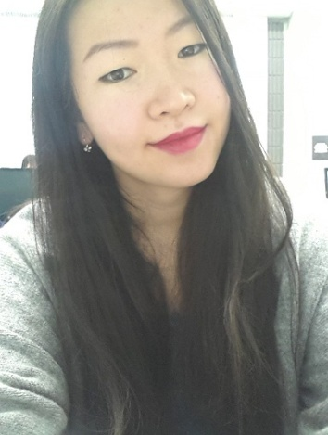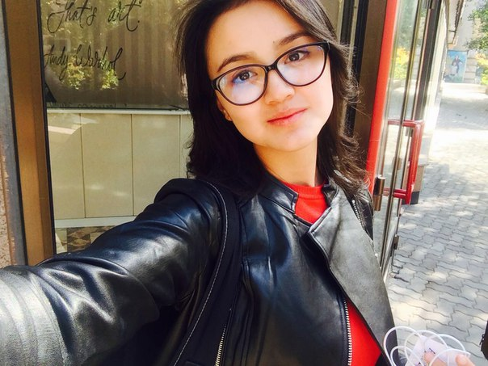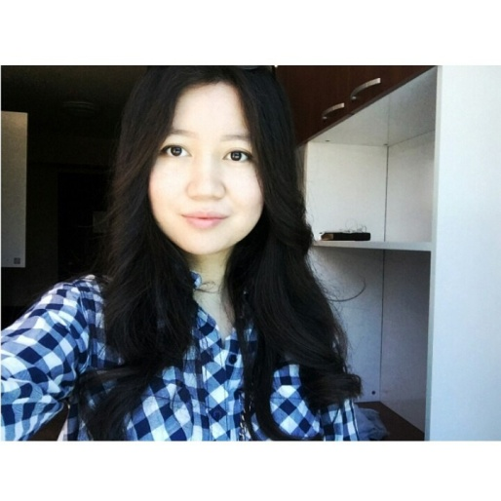

* **Name:** “Almaty Flowers”
* **Description:** It is a mobile application for buying beautiful lowers. The main idea of this application to get customer choosing cheaper price. It will be like auction. The customer will fill in the fields what kind of flowers, price and delivery he want. By these criteria shops will offer his price and customer will choose the better one. Nowadays traffic jam is the first problem in big cities, but the demand for flowers is very huge. This application will help people avoid traffic jam and save precious time.
* **Languages/Platforms:** It will be an IOS application. We also going to use database because user, staff and administrator will have their own logins and passwords.
* **Complexity:** As it said, there are 3 types of user of this application. They are user, staff and administrator. It means application content and appearance will be different to each of them. So user can sign up, staff can approve and administrator will run it.
* **Customer: “Almaty Flowers”**

ИП “Куандык”

Phone number: 87024466494

This organization sells flowers and takes orders.

* **Source control:** https://github.com/AizhanaA04/software