Supermarket Sales & Profit Analysis
Prepared by: Anubhuti Jha
1. Introduction
This report summarizes a complete sales and gross-income analysis of historical supermarket transactions for business decision support.

2. Problem Statement
Understand performance by branch, products, customers, payments, and time to identify insights and actions.

3. Objectives
Measure KPIs, compare business segments, visualize trends, and produce evidence-based recommendations.

4. Dataset Description
Dataset file: data/supermarket_sales.csv with 10 transactions and 20 columns.

5. Technologies Used
Python, Pandas, NumPy, Matplotlib, Seaborn, Plotly, Jupyter Notebook, python-docx.

6. Data Cleaning and Preprocessing
Checked missing values and duplicates, converted Date/Time fields, and created Month_Name, Day_Name, and Hour features.

7. Exploratory Data Analysis
Branches present: A, B, C. Product lines analyzed: 5. Payment modes: Cash, Credit card, Ewallet.

8. KPI Analysis
KPI | Value
Total Sales | 4175.7240
Total Gross Income | 198.8440
Total Quantity Sold | 62
Total Transactions | 10
Average Transaction Value | 417.5724
Average Rating | 7.0800

9. Sales Analysis
Highest-sales branch: A (2522.76); Lowest-sales branch: B (172.75).
Top product line by sales: Electronic accessories (1141.53).

10. Profit/Gross Income Analysis
Total gross income: 198.84. Highest gross-income branch: A (120.13).

11. Product Analysis
Highest-sales product line: Electronic accessories (1141.53).
Lowest-sales product line: Food and beverages (172.75).
Highest gross-income product line: Electronic accessories (54.36).
Lowest gross-income product line: Food and beverages (8.23).

12. Branch Analysis
Branch sales ranking: A (2522.76), C (1480.22), B (172.75).
Branch gross-income ranking: A (120.13), C (70.49), B (8.23).

13. Customer Analysis
Customer-type sales: Member=1720.60, Normal=2455.12.
Gender sales: Female=2084.16, Male=2091.57.

14. Payment Analysis
Payment-wise sales: Ewallet=3506.09, Credit card=589.42, Cash=80.22.

15. Time-Based Analysis
Peak month: February (2013.20). Peak day: Sunday (1601.95). Peak hour: 13:00 (1062.24).

16. Key Findings
- Branch A contributes the highest sales (2522.76).
- Electronic accessories is the strongest product category by sales (1141.53).
- Ewallet is the leading payment mode (3506.09 sales).
- Normal customers generated 2455.12 sales vs Members at 1720.60.
- Peak sales period appears in February and around 13:00.

17. Business Recommendations
- Finding: Branch A leads sales -> Recommendation: replicate its operating practices in lower-performing branches.
- Finding: Electronic accessories leads and Food and beverages lags -> Recommendation: stock top category and run offers for lagging category.
- Finding: Normal customers spend more than Members -> Recommendation: deploy membership-conversion campaigns.
- Finding: Ewallet dominates payments -> Recommendation: keep digital-payment incentives active.
- Finding: Sales peak at 13:00 -> Recommendation: align staffing and replenishment to peak demand.

18. Conclusion
The analysis provides data-backed patterns across sales, profitability, products, branches, customers, and timing, supporting practical business decisions.

19. Future Scope
Future enhancements can include a larger date range, branch-level forecasting, and periodic monitoring dashboards.

20. References
Kaggle Dataset: https://www.kaggle.com/datasets/lovishbansal123/sales-of-a-supermarket

Charts
Monthly Sales Trend
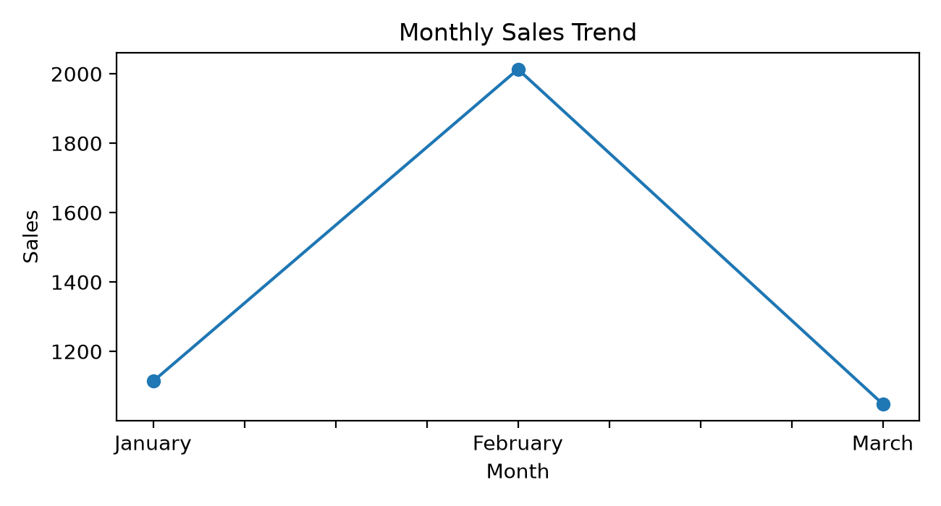
Sales by Branch
