IAM-task
01: Create one IAM user and assign EC2 and S3 full access roles.
Ans: first sign in to aws consol and search for iam and click on user and create user entre the name 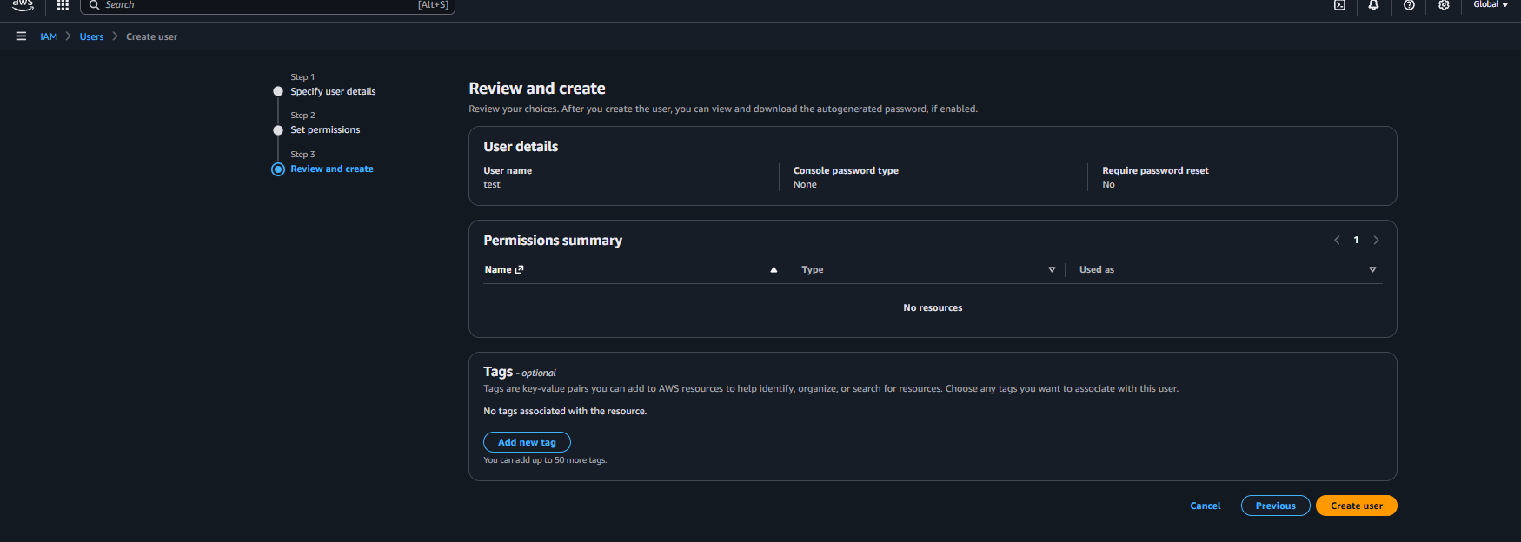
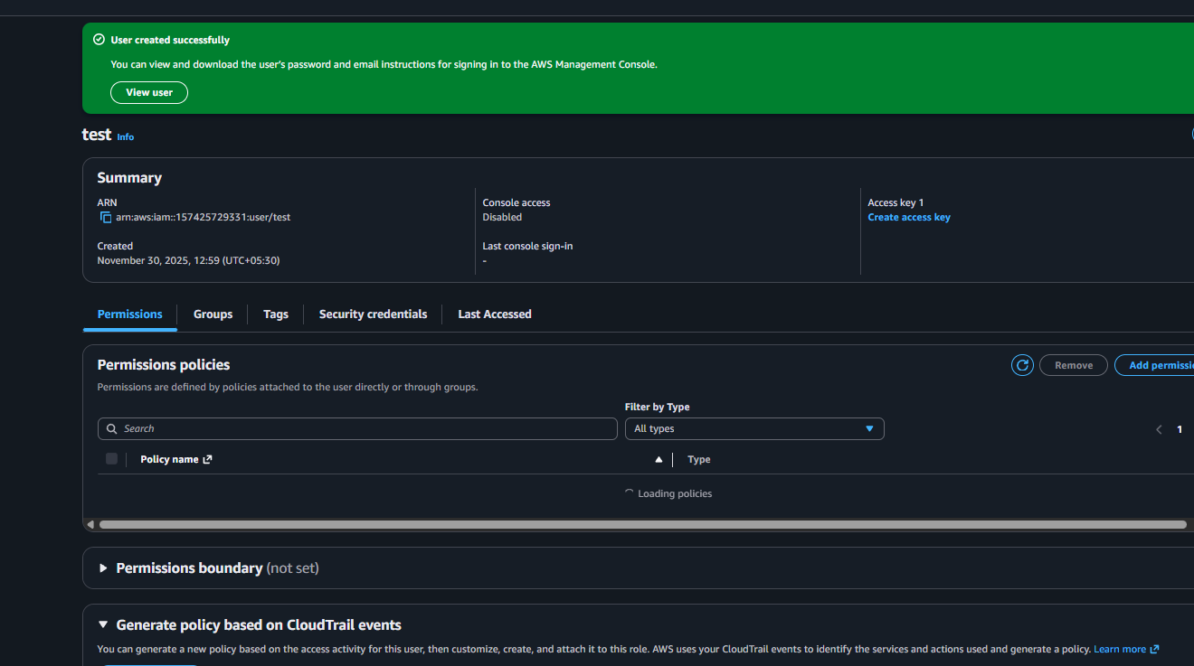
Once the user is been created then need to enable the access the consol access need to click on security credentials and click on console access 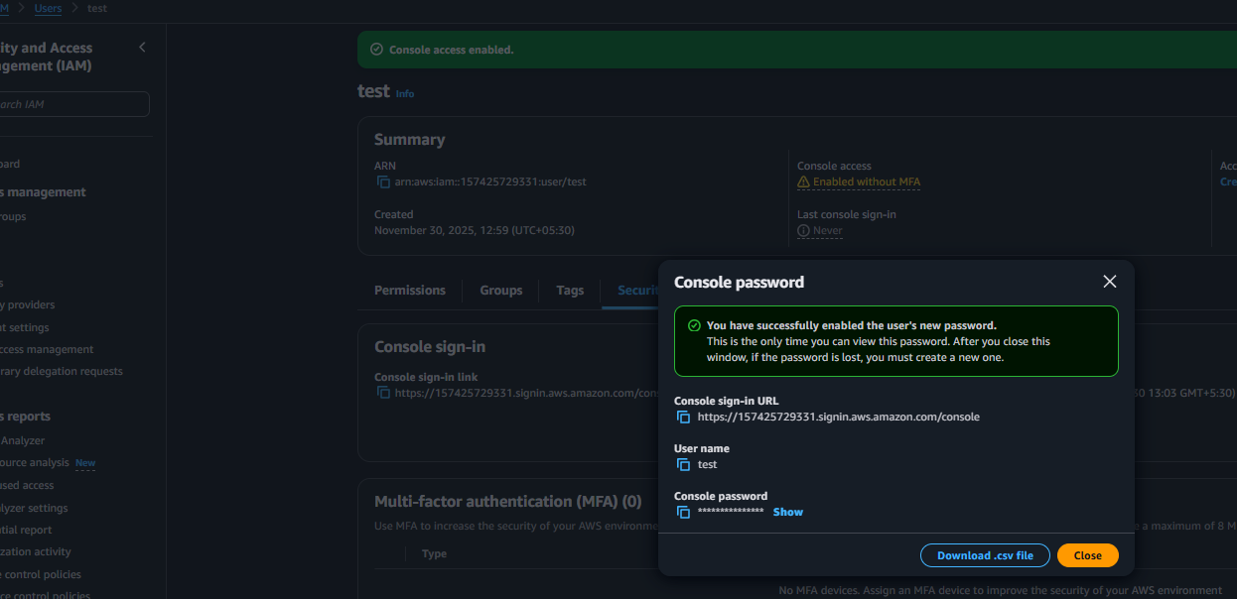
Once the access is been provided logging in to user console 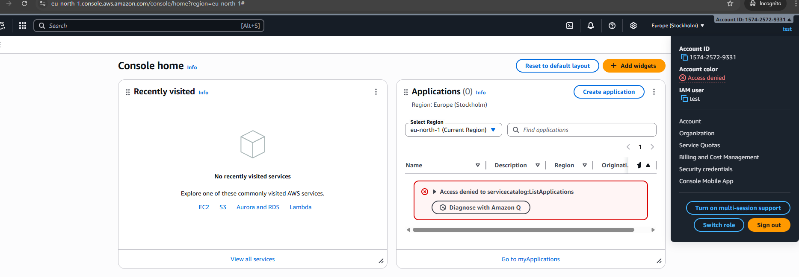the user is been logged in successfully and can be check in profile name showing switch role this means its not root user
Now we need to give the access for ec2 before need to check wither it is able to access or not 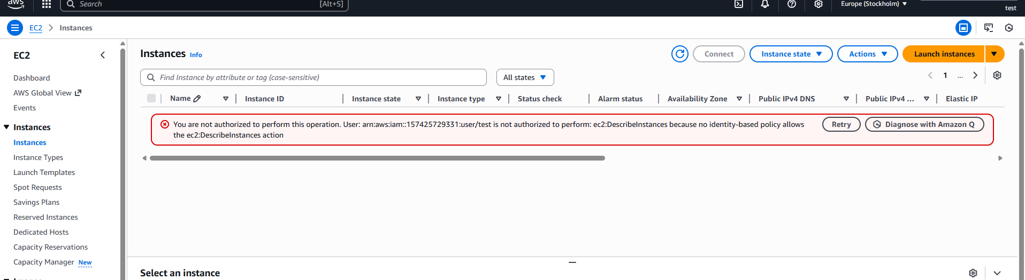since unable to access ec2 now need to give permission to access ec2 for the user log in to iam as root and click on policy 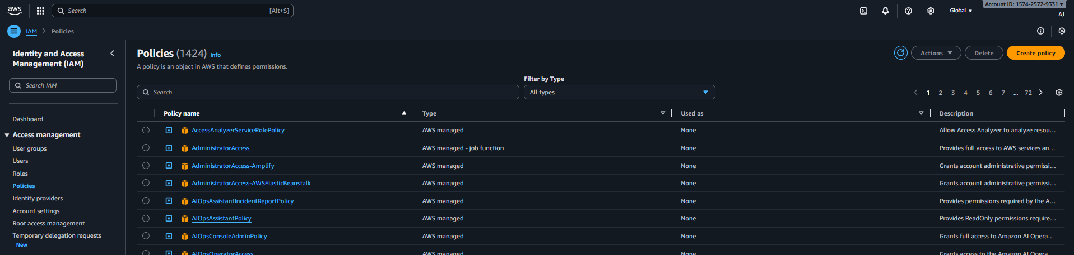 create policy select for json and create a policy to allow test user to access ec-2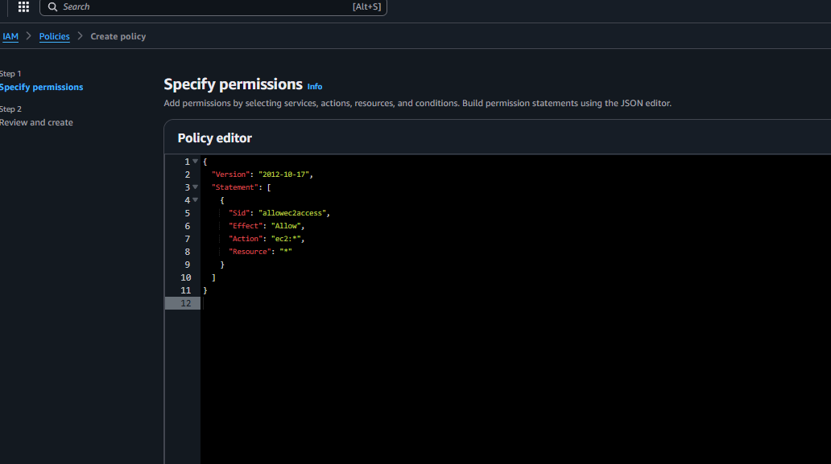
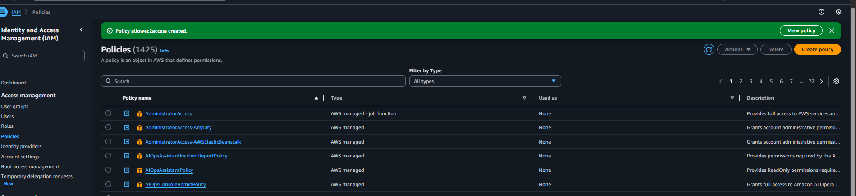
Once the policy is been created now assign the policy to user click on user and select the user then click add permission select the permission and add permission
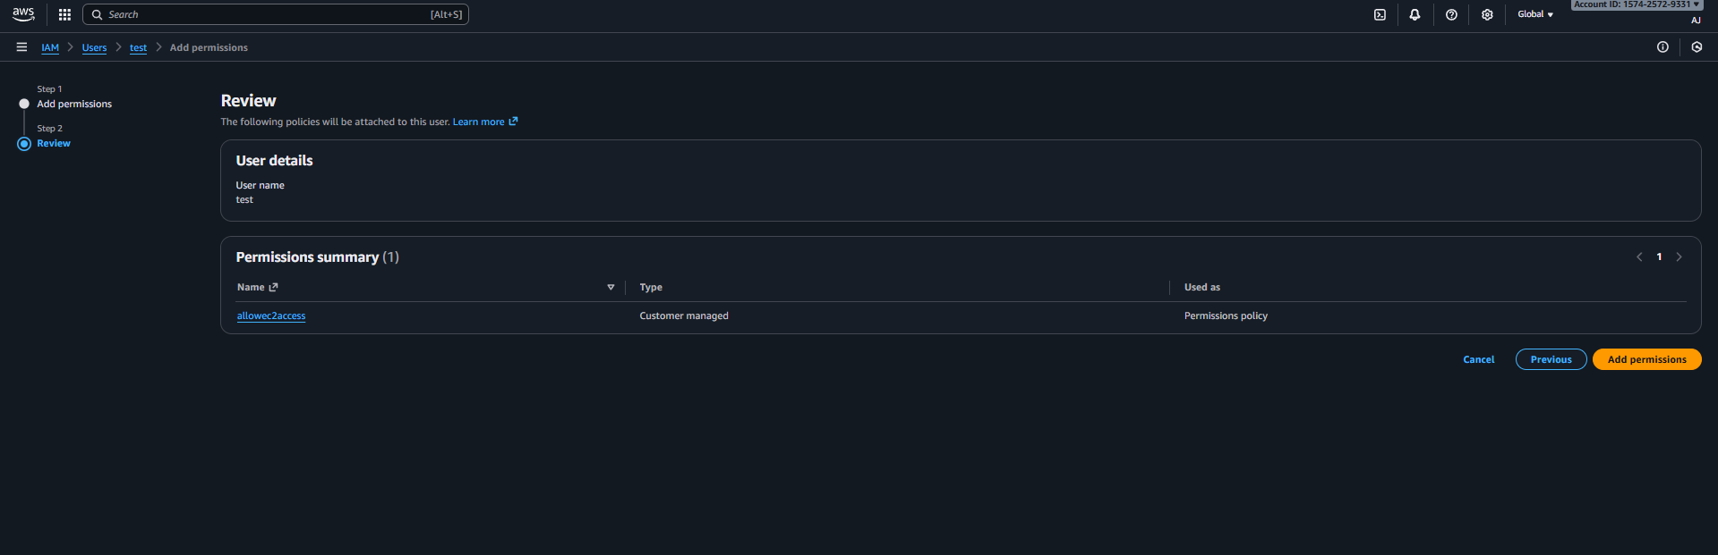
Once it got save test-user can access ec2 and able to launch instance 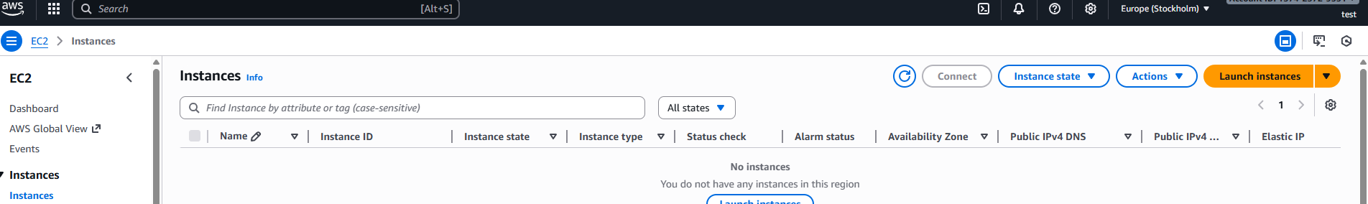
Same goes for s3 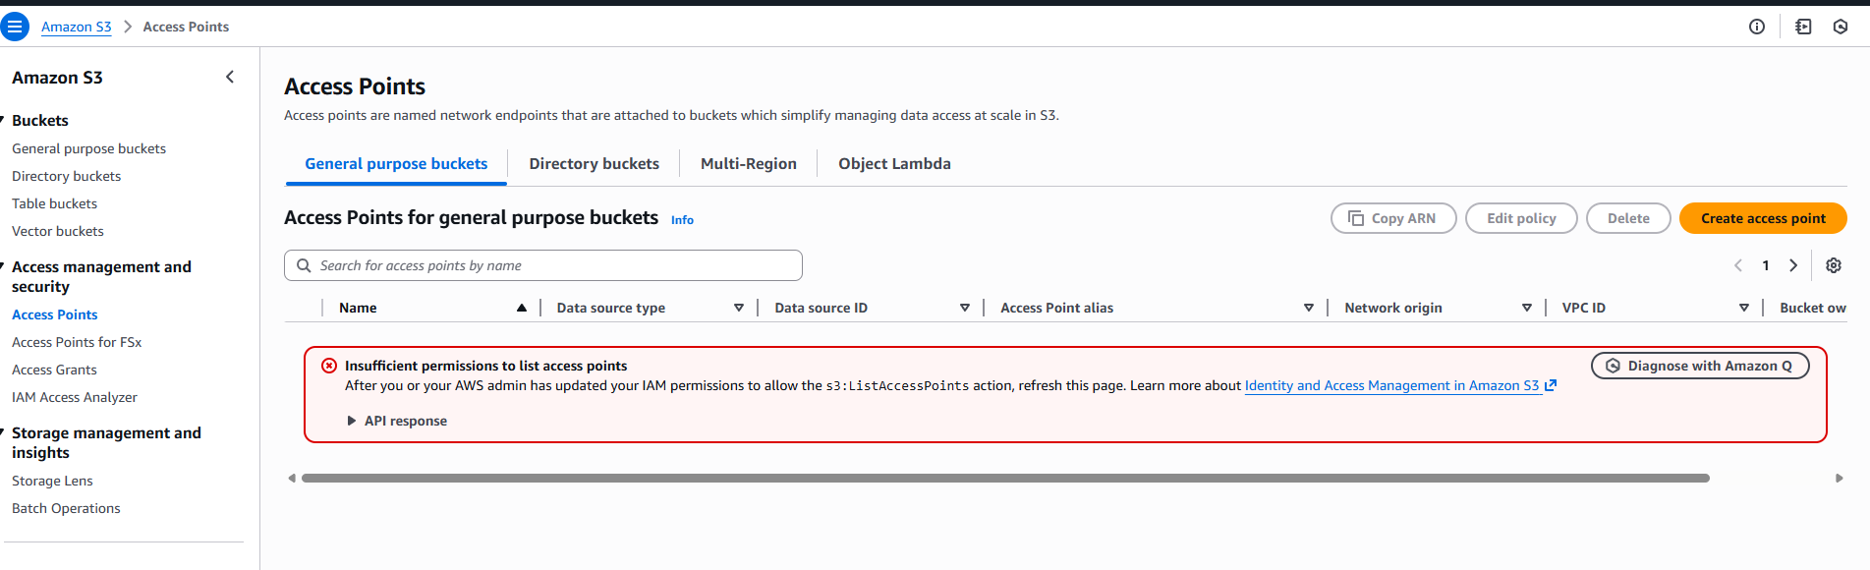
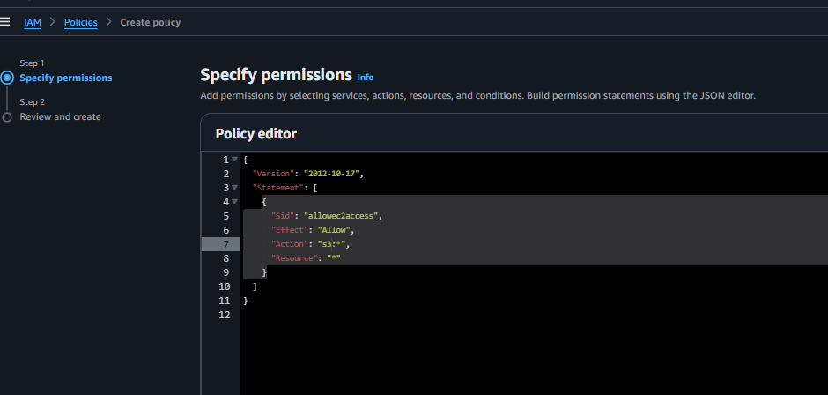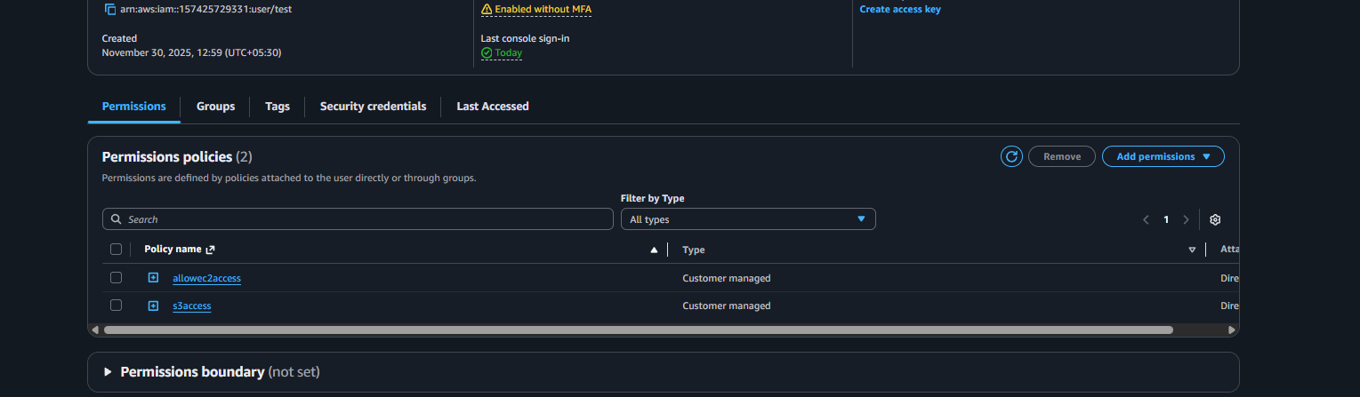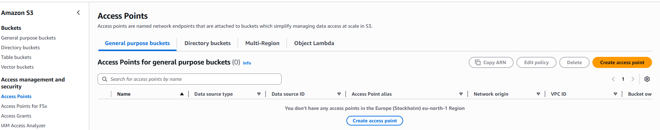

02: Create one group in IAM and assign read access for EC2.
Ans: First need to create group in iam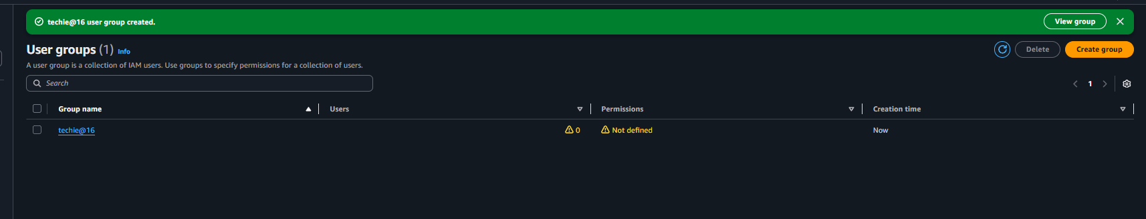 and add the user in the group 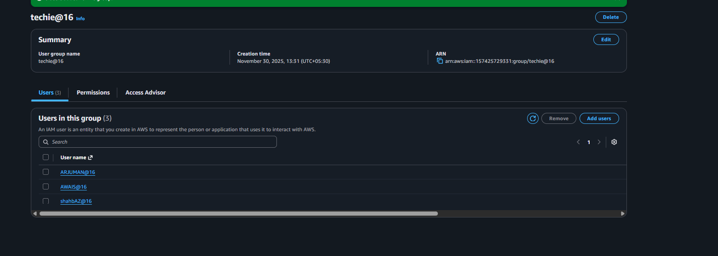
Then need to enable to console access to each user 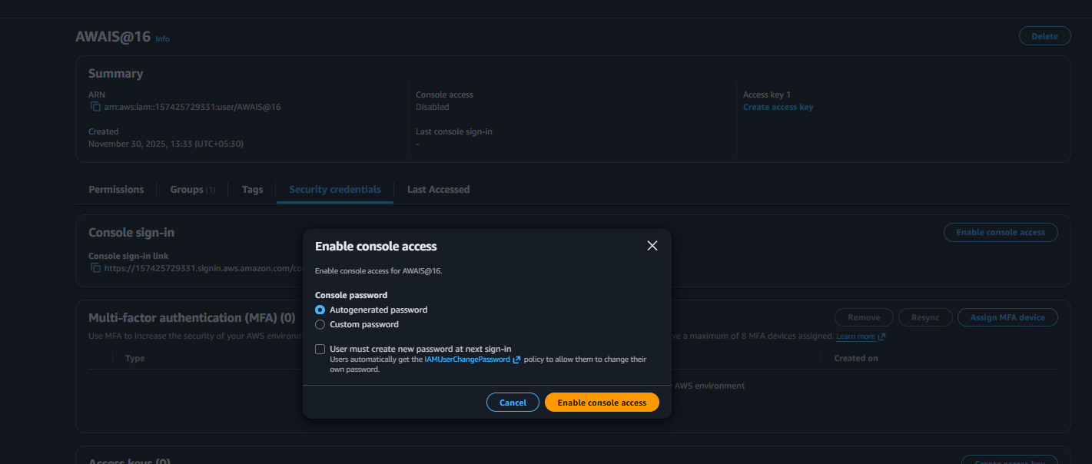
Then need to add policy to read ec2 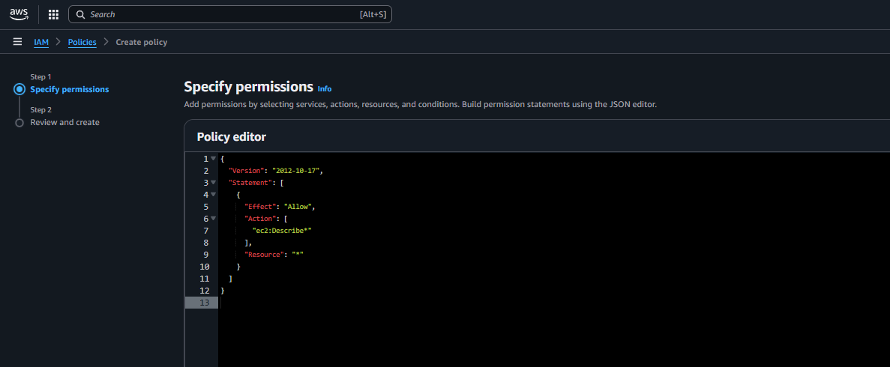then save the policy 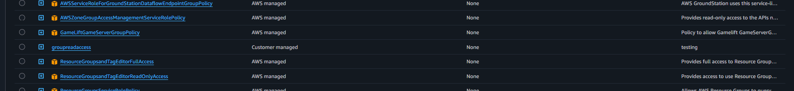now need to attach the policy to group 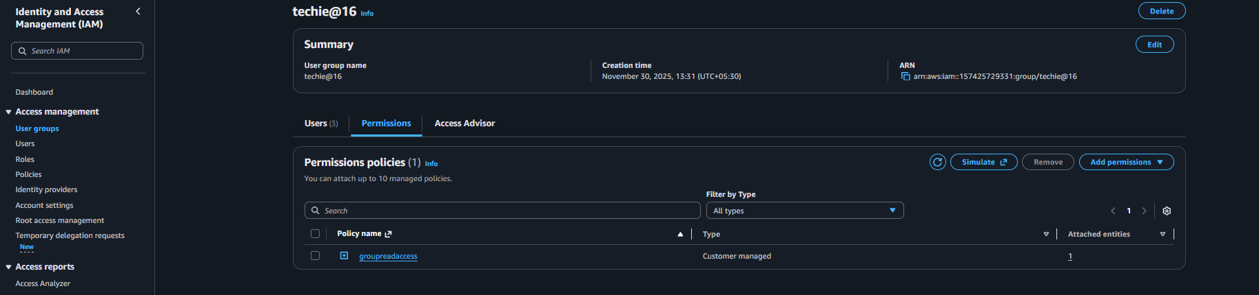
Now any one user need to access to their console and check is it readable or not 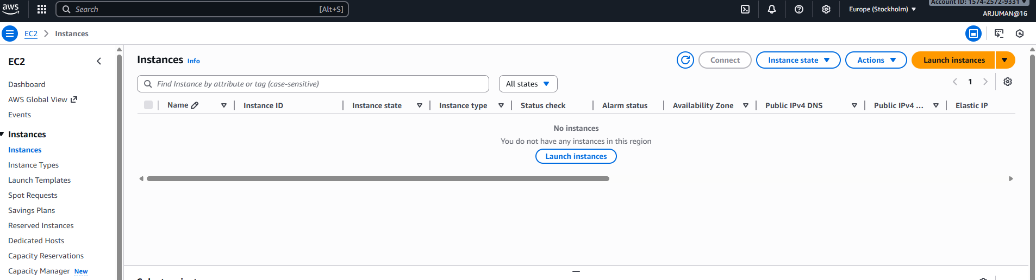so the read access is been there but not able to launch 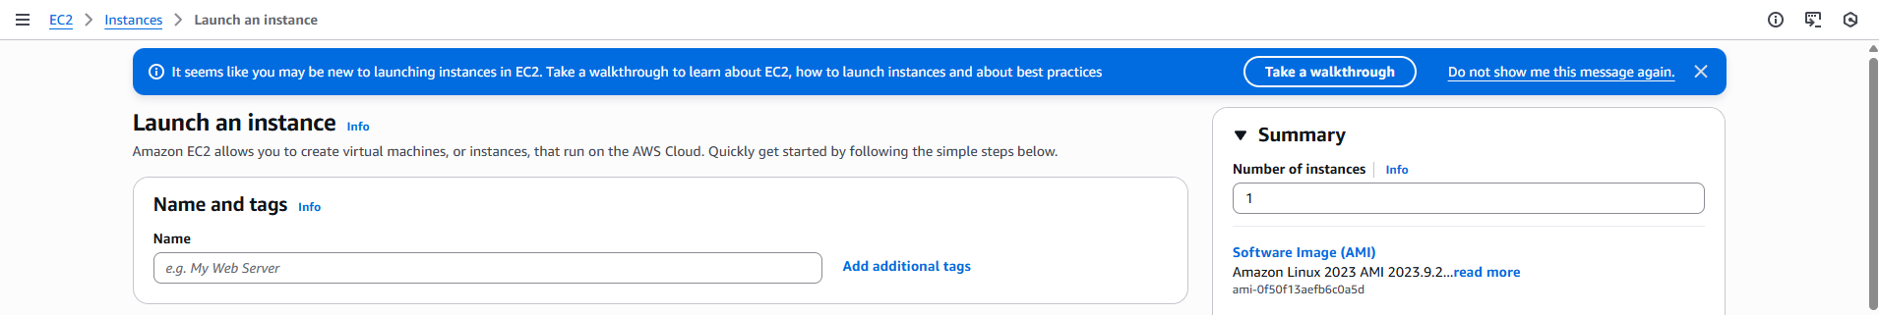

03: Create a new user named "Devops" and add to the group created in task 2.
Ans: go to iam as a root user and click on add user 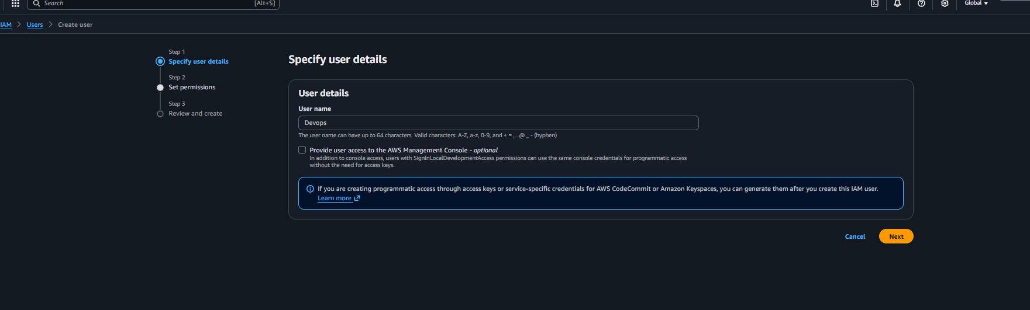
While creating under the second steps it will ask to add any group need to select group and create the user 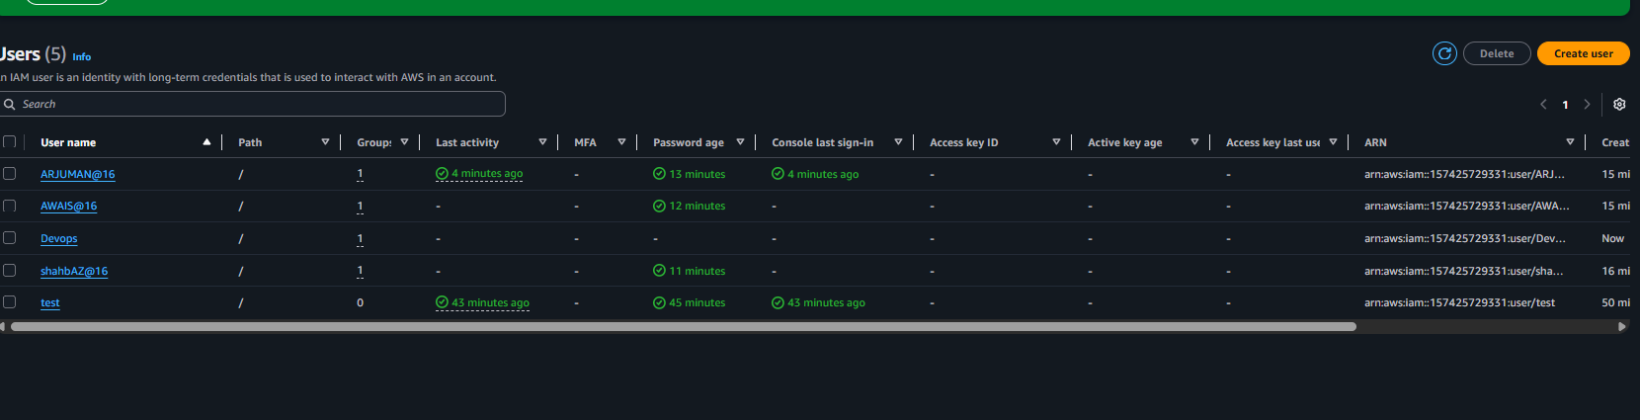

04: Write a bash script to create an IAM user with VPC full access.
Ans: first configure aws in terminal once it got configure create a file and edit the file insert the script 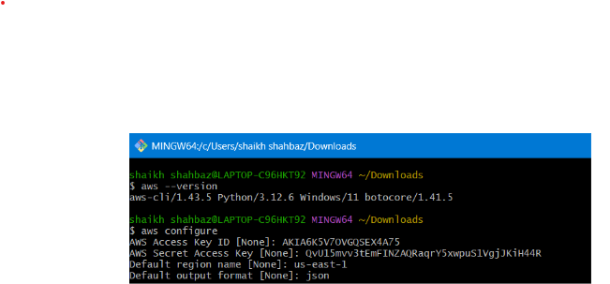
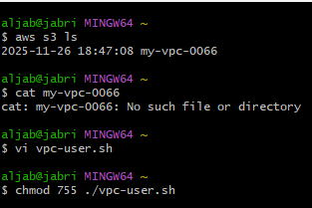
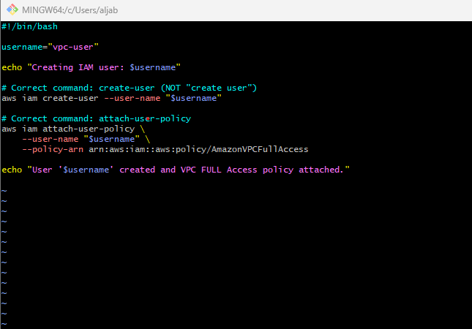
Then need to change the permission and run the file 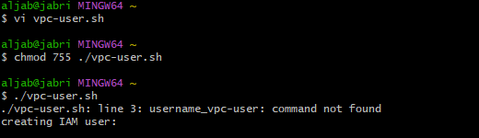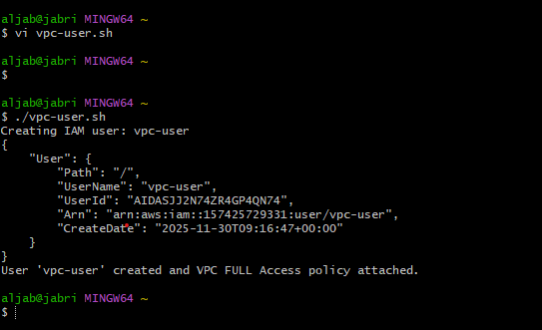
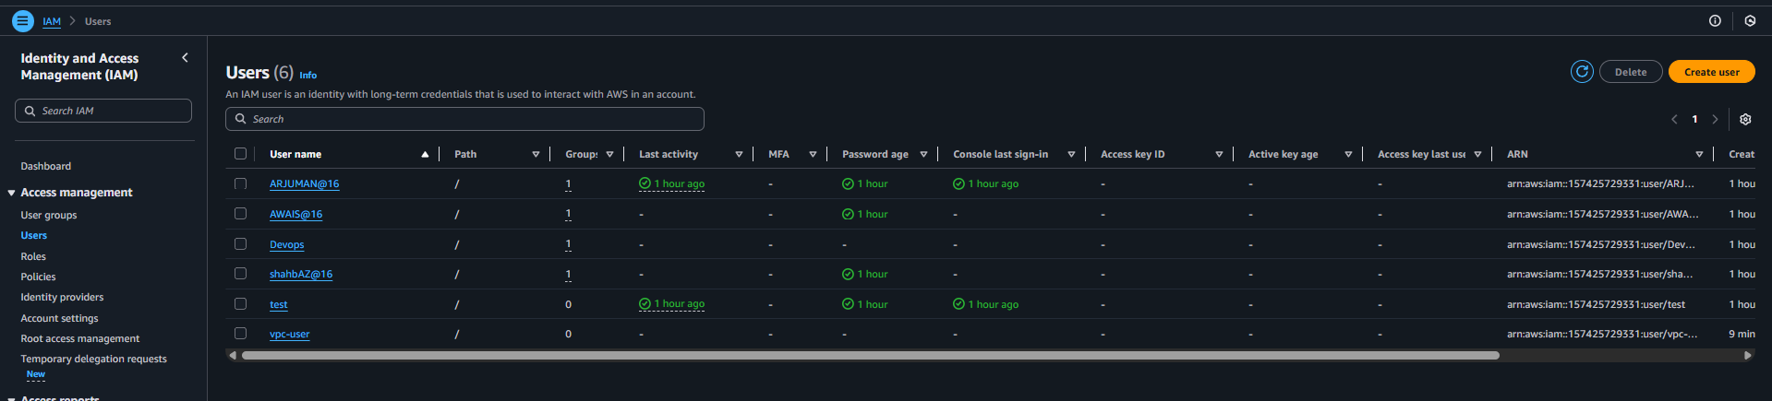
User is been created for vpc

05: Create an IAM policy to allow EC2 access for a specific user in specific regions only.
Ans: login to aws console as root and go to iam and click on policy and click on create policy select json and add the script 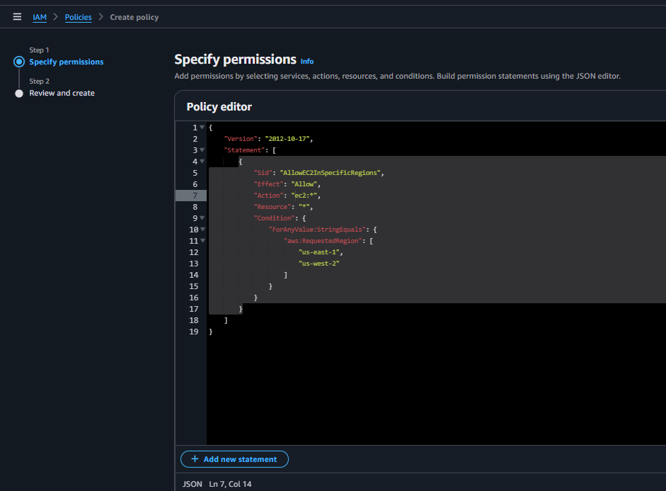
Then need to give permission to user 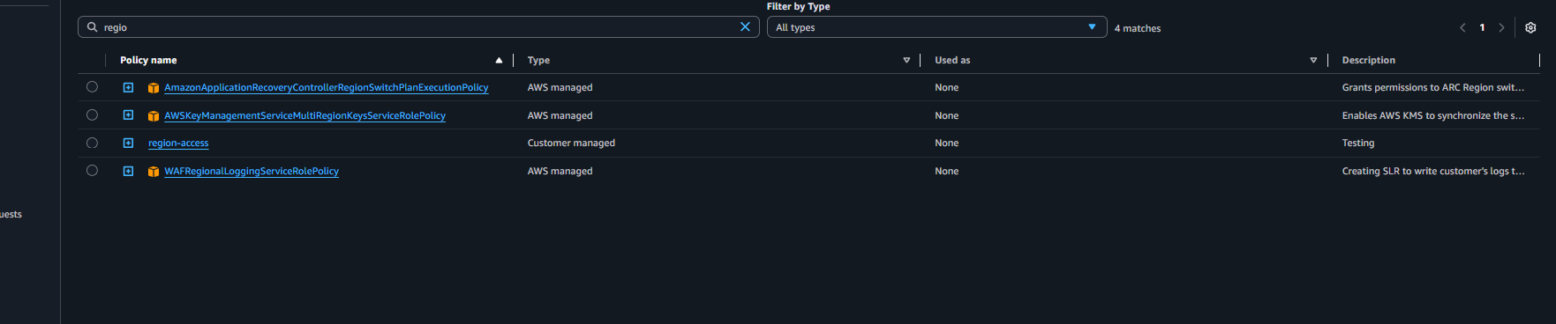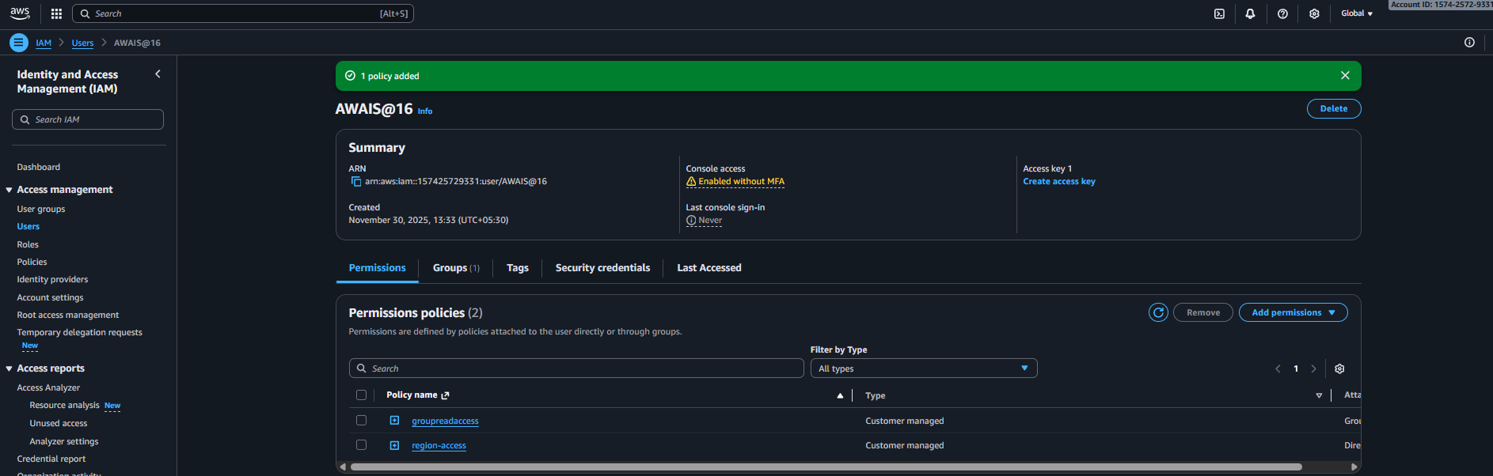

06: We have two accounts: Account A and Account B. Account A user should access an S3 bucket in Account B.
Ans: so I was account A under my bucket I have entre the policy to get access the account B 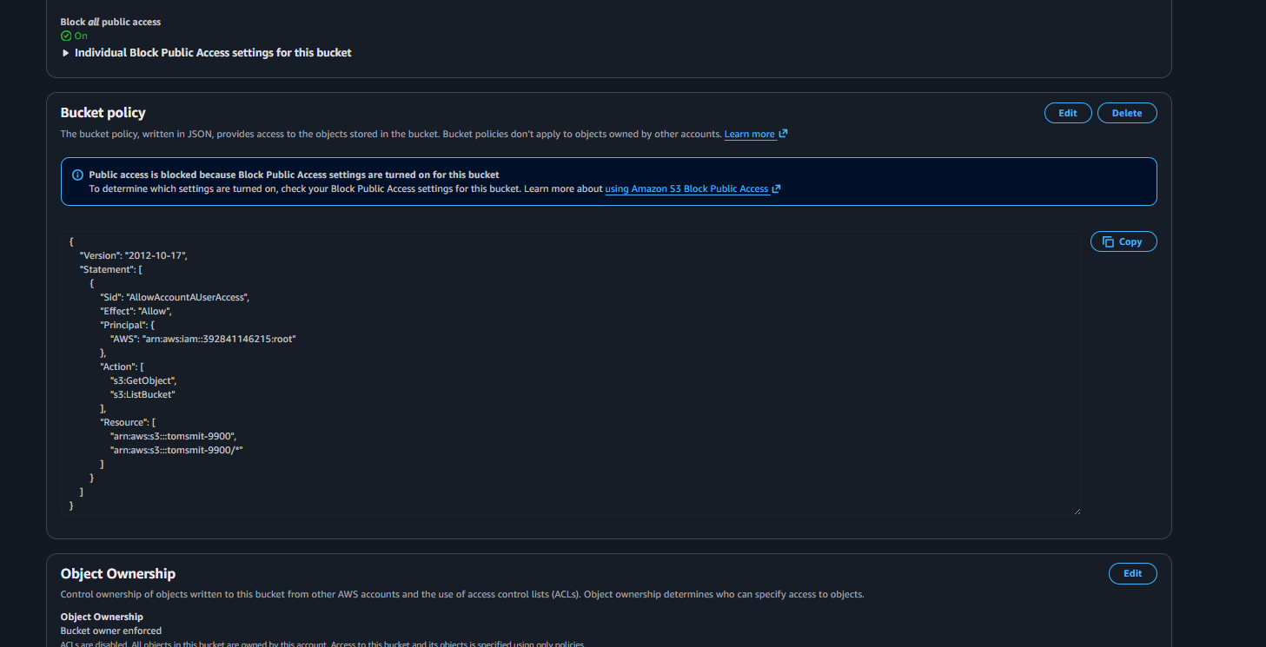
Once it got saved with the aws root number and bucket id then account B will be configure the terminal with aws once it got configure need to run the command (aws s3 ls s3://bucket-name/)
