S3-Tasks

01: Create an S3 bucket and upload some objects to S3.
Ans: First need to login to aws consol as root and search for s3 and click on create bucket 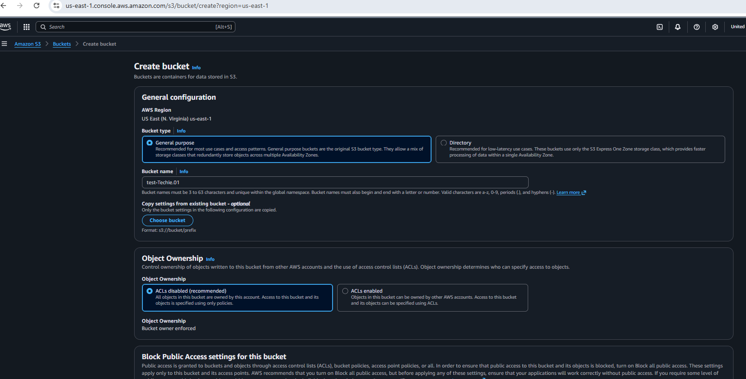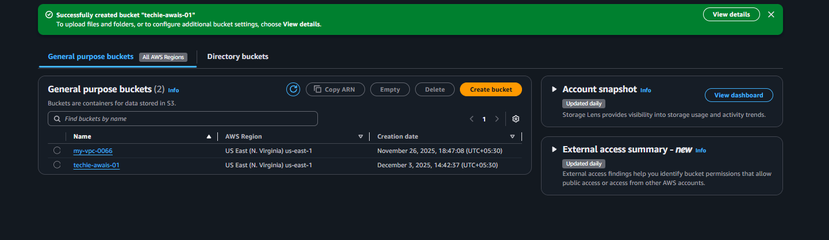
Once the bucket is been created then need to select the bucket and click on upload and select the file and upload 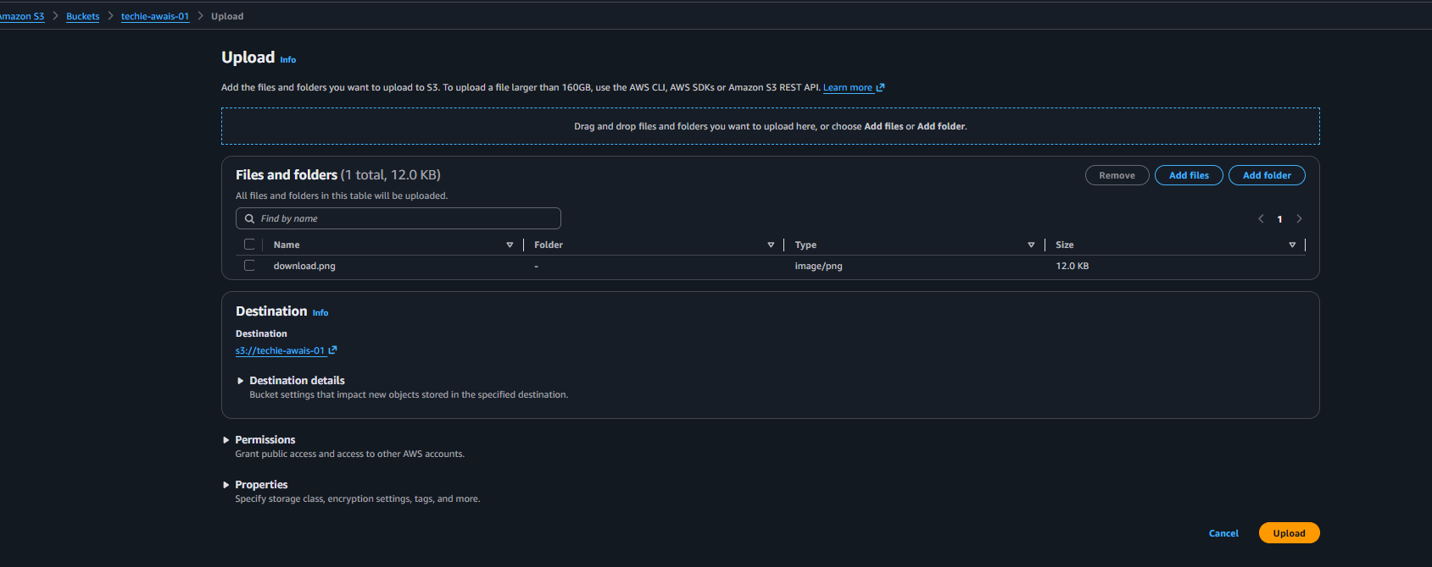
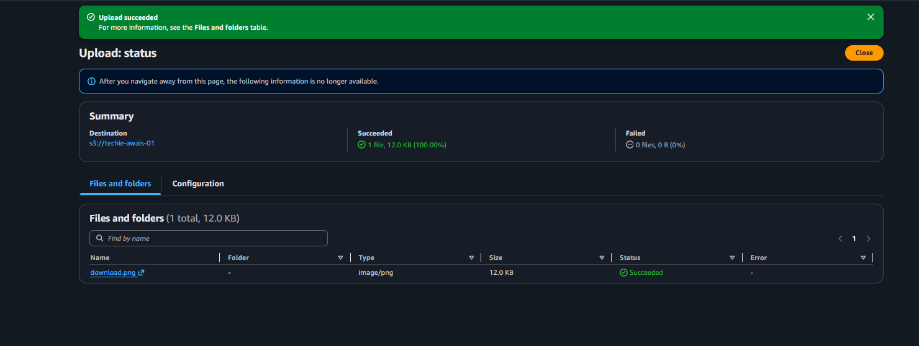
The object is been uploaded.

02: Deploy a static website in the S3 bucket.
Ans: select the bucket and click on permission and select for static website hosting enable the permission and entre the file name 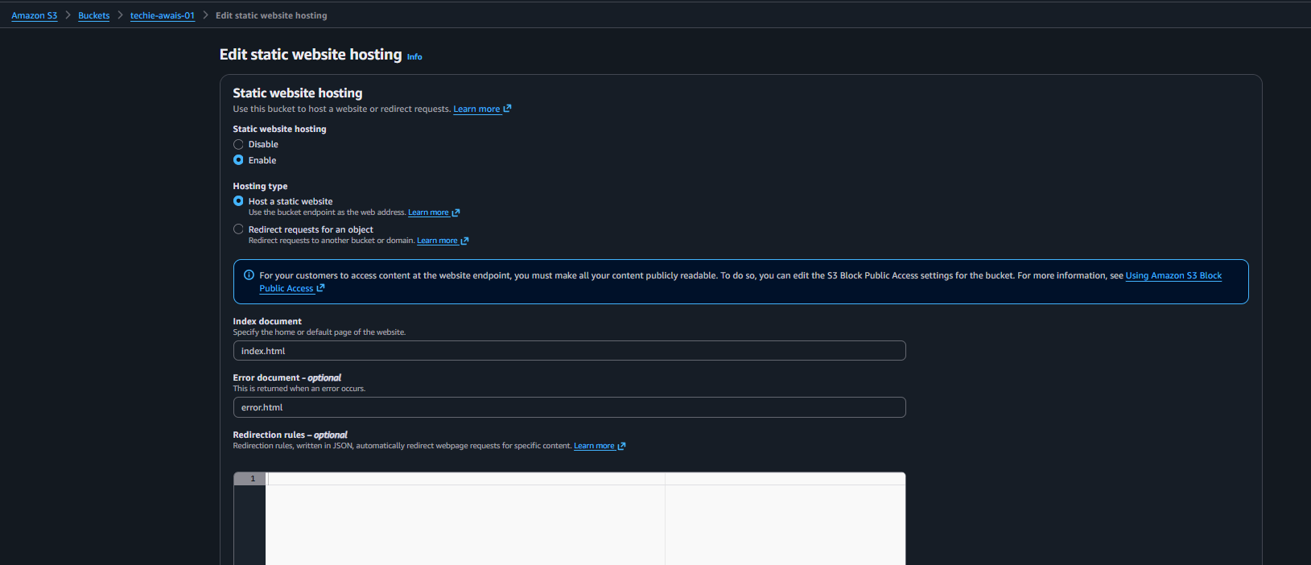
Once the permissions saved and need to enable the abac permissions 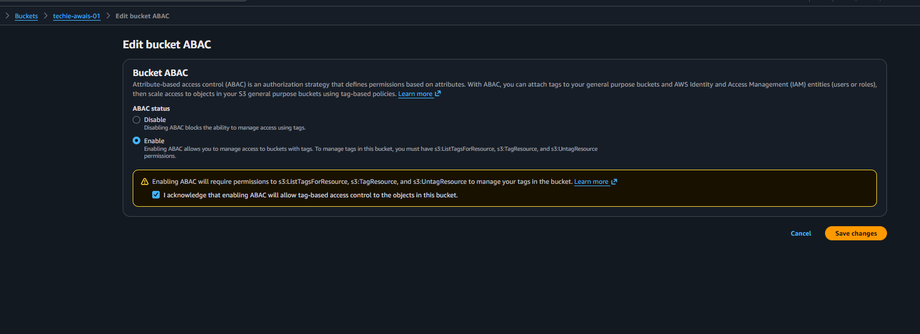
Now need to upload the index files and error files
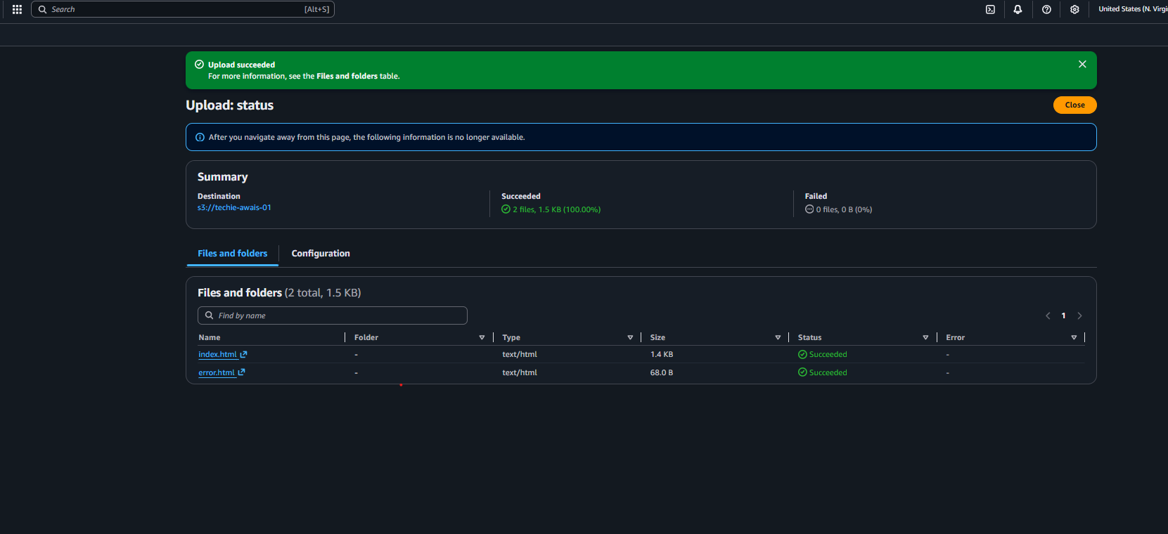
Then need to add bucket policy and save the policy 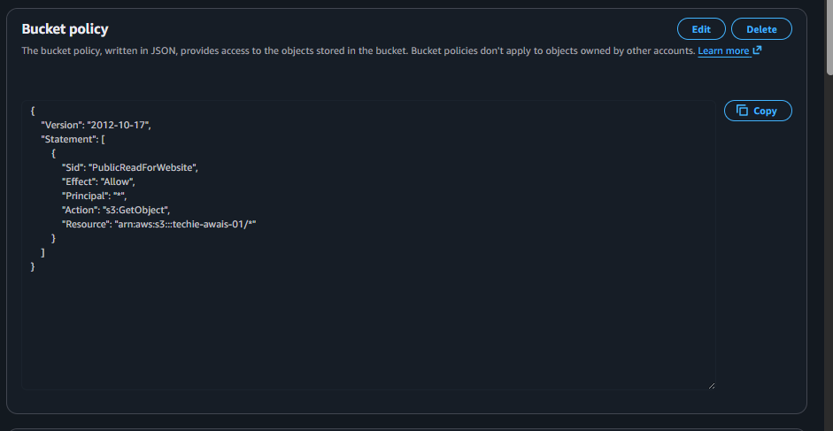once it got saved now need to copy the website link of s3 bucket and paste in browser to check the site 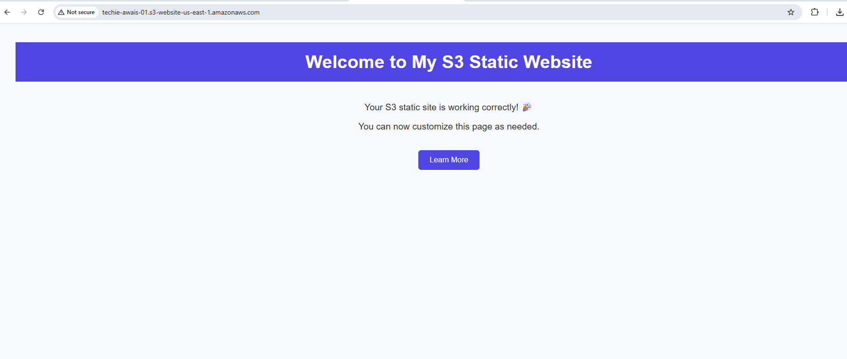so the site is been working. Deleting the index.html to check error.html is working or not 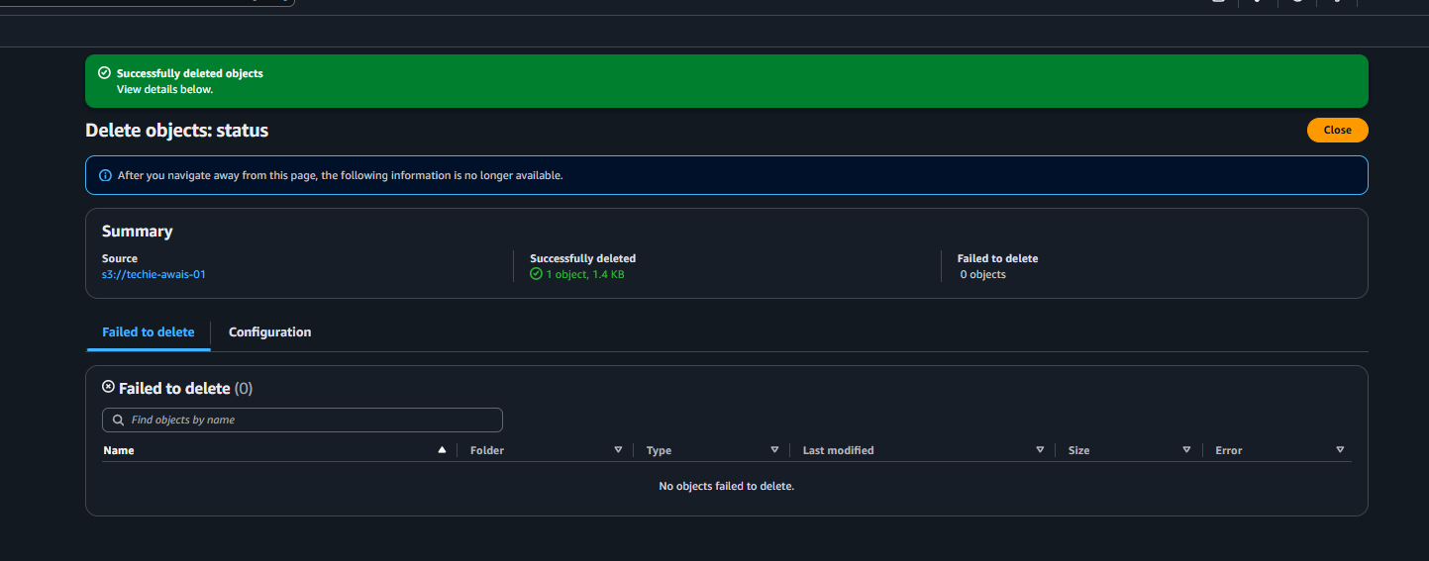
File is been delete checking the site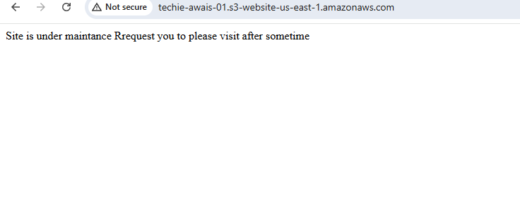
Error site is been working .

03: Enable cross-region replication on S3 buckets.
Ans: first need to enable the cross-region replication under the properties and enable the bucket versioning and enable 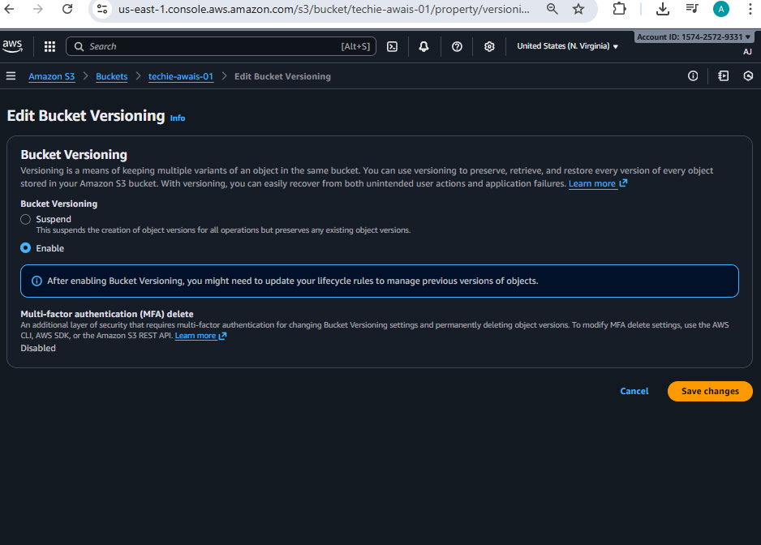

And need to create rule for replication and save the file and once it save create a new bucket in different region 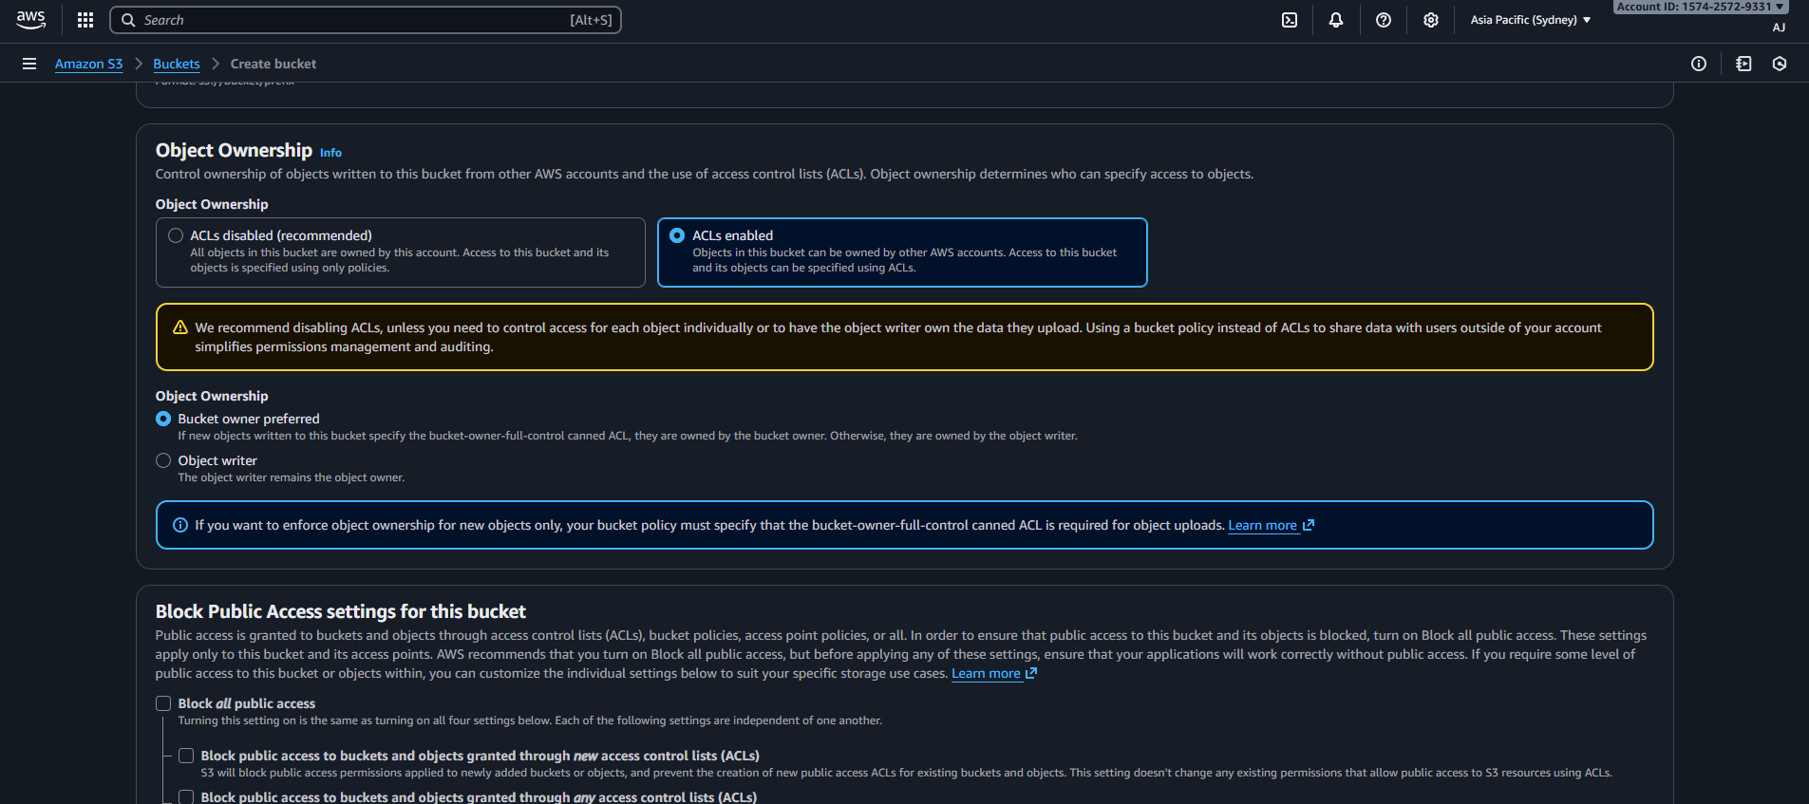
Once it got created got to the source bucket and click on replication rules and entre the information 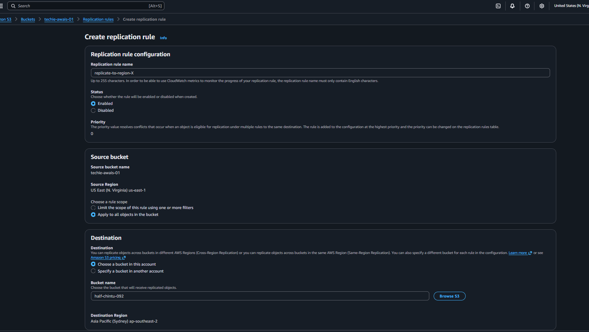then it will ask for existing objects or new I’ve selected for new one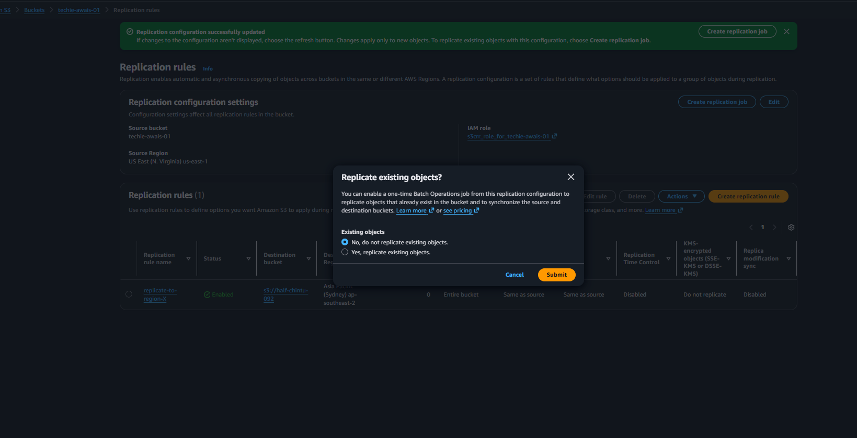
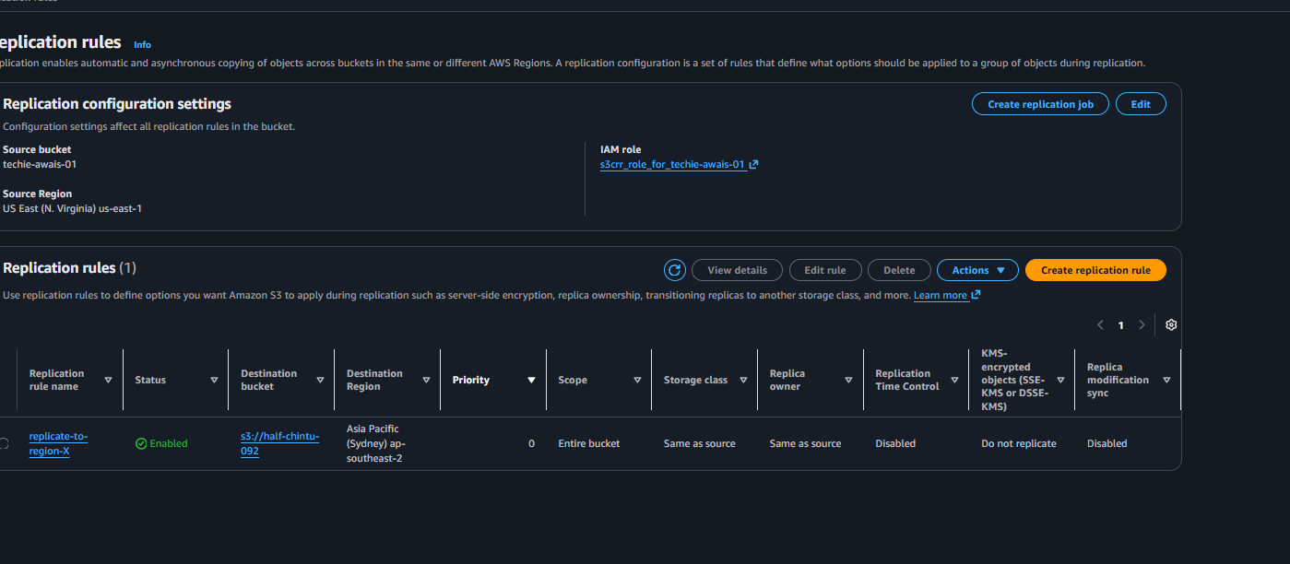
Now need to check trying to upload the object and checking its showing in another bucket or not 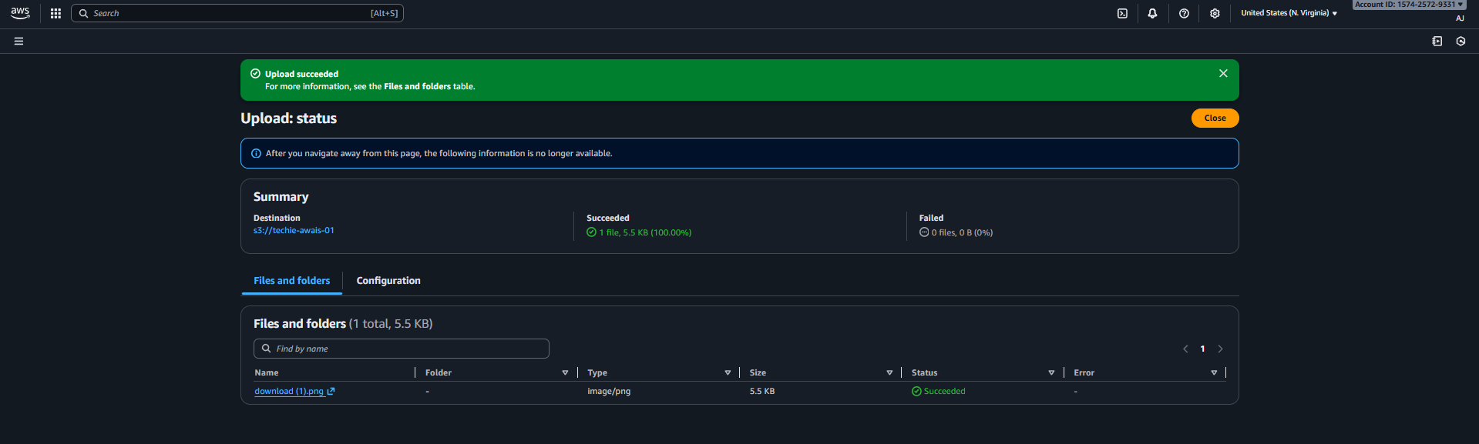
Object uploaded in verginia 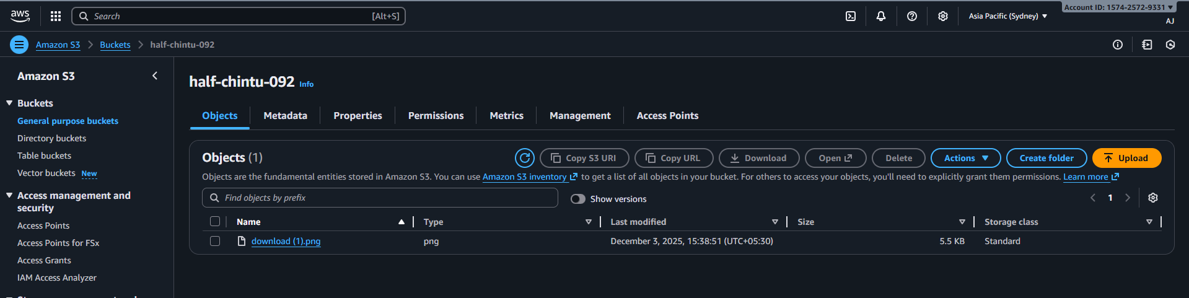and under the Sydney bucket it shows replication is been completed successfully.

04: Configure a bucket policy so only the Admin user can see the objects of the S3 bucket.
Ans: first create a user in iam and once the user is been created need to give gim permission of s3 access 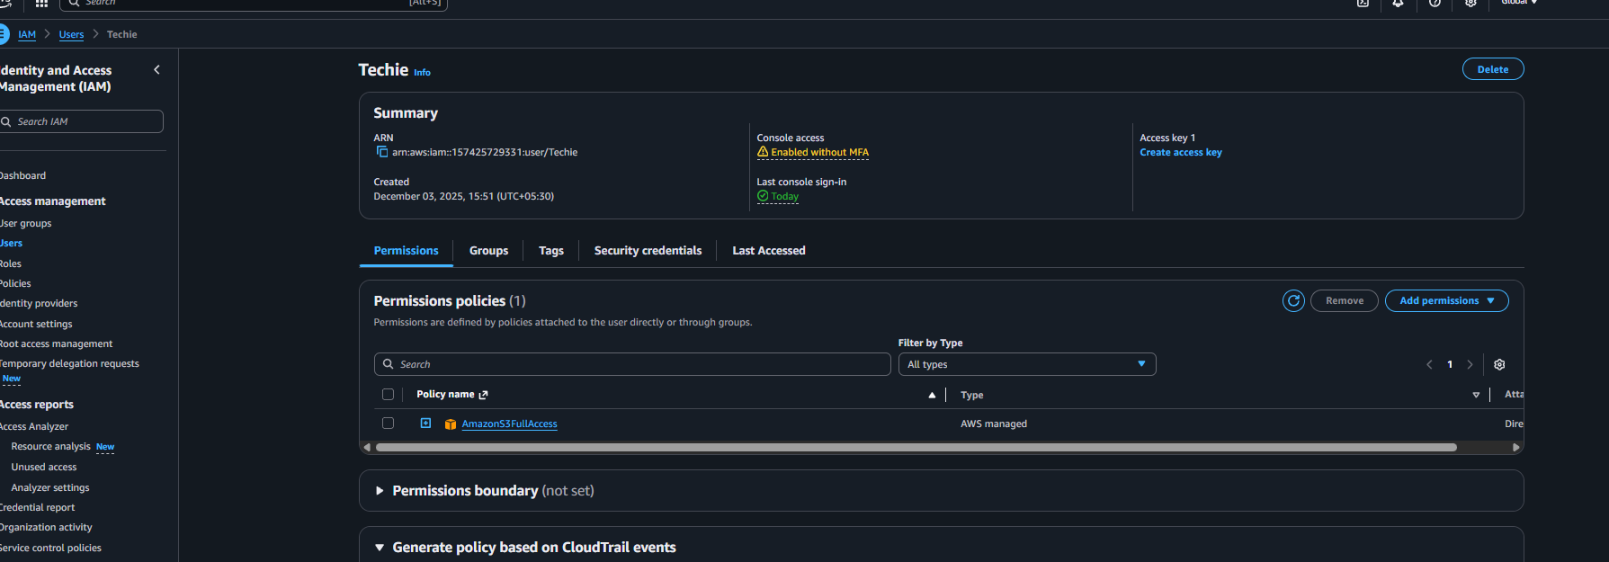
Then go s3 buckets and then select the bucket and go for permissions and entre the edit the policy and entre the code to see the objects for iam user 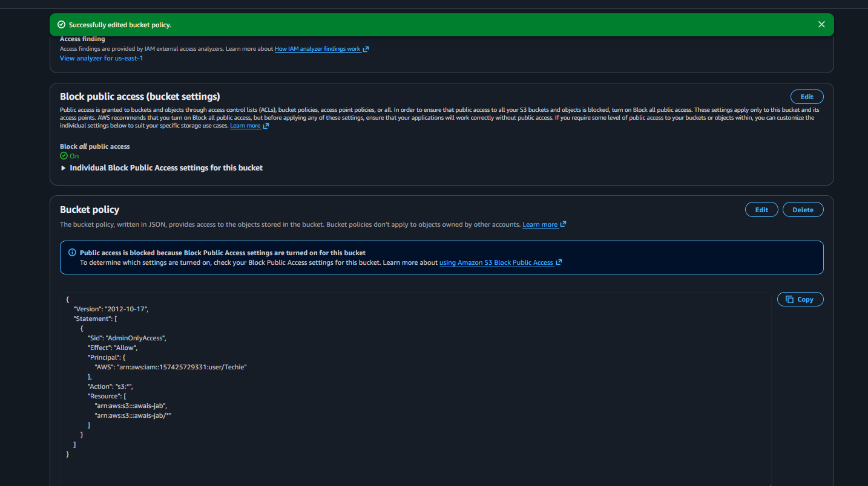
Once it got saved try to login iam user and check we can able to see the access of our bucket 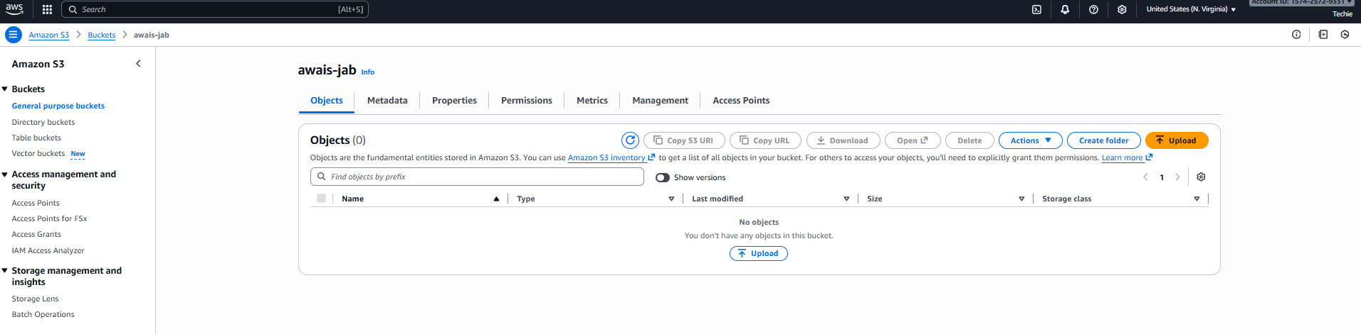

05: Set up lifecycle policies to automatically transition or delete objects based on specific criteria.
Ans: go to buckets and click on management and create a lifecycle rule then need to name the rule and entre the rules for automatically transition and delete 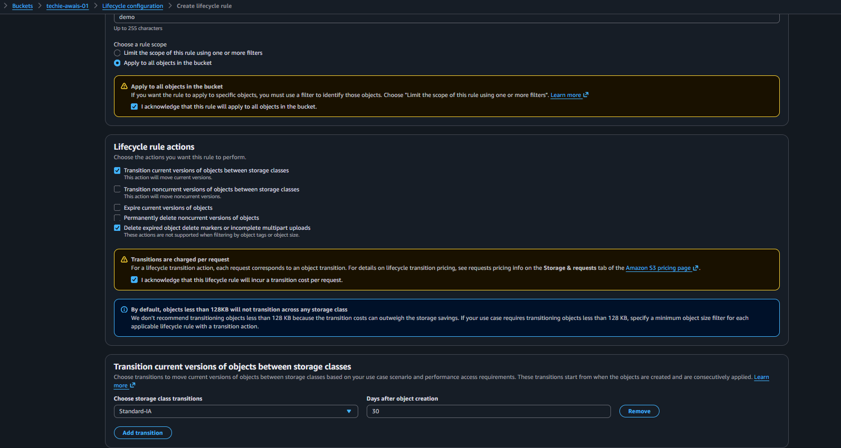
Save the rule 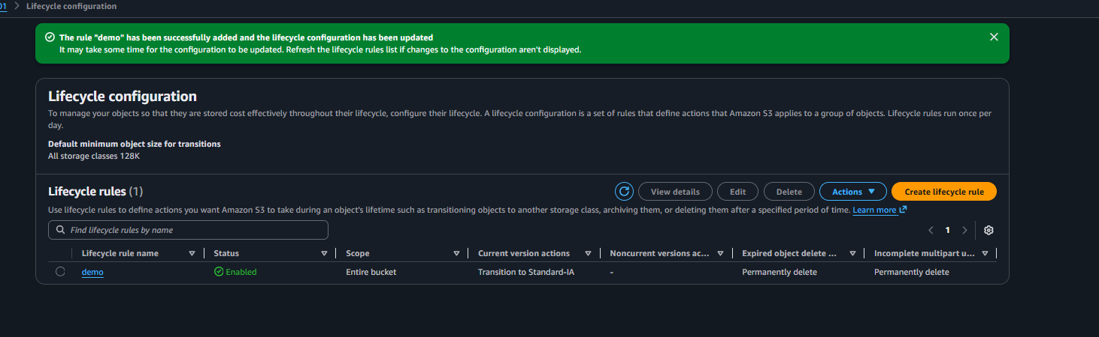

06: Push some objects to S3 using the AWS CLI.
Ans: first need to configure the aws cli so open the terminal and run the command to connect aws cli (aws configure) entre the access key and check thus aws cli is been connected or not (aws s3 ls) 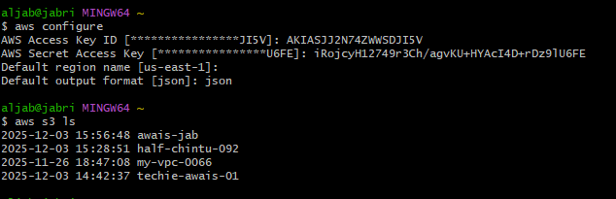
then created 2 files and run the command to move those files in s3 bucket (aws s3 mv filename.txt s3://bucket-name/)
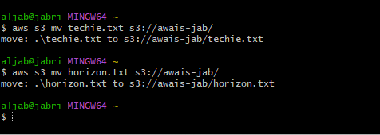
Then check in your bucket thus the files is been moved successfully or not 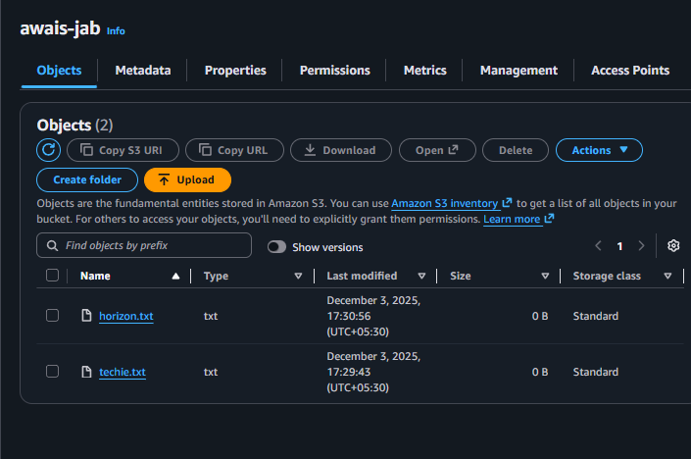

07: Write a Bash script to create an S3 bucket.
Ans: open the terminal and create a file add the script and save the file once it got saved change the permission and run the command by using (./filename new bucket name )it got created

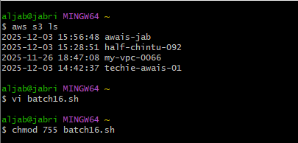

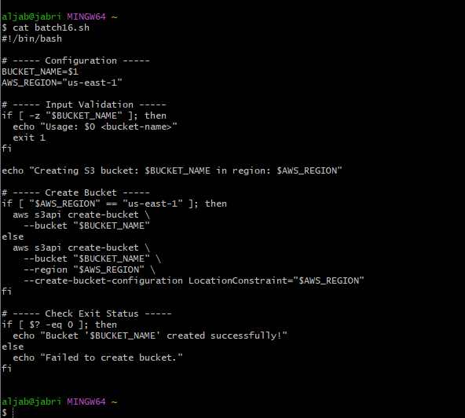

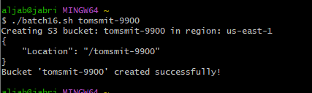
And the bucket is been created
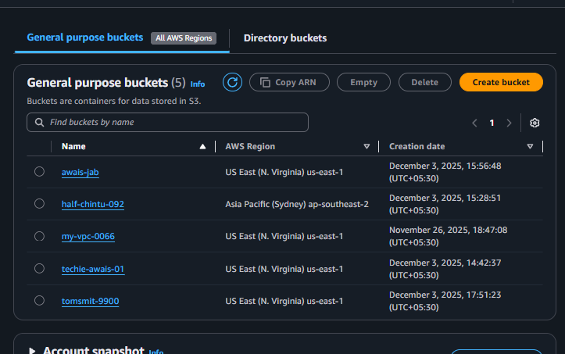

08: Upload a 1 GB file to S3 using the CLI.
Ans: To able to upload files open the terminal and connected to aws cli and moving the folder to bucket used the command of (aws s3 cp Techiehorizon s3://awais-jab/Techiehorizon/ --recursive) 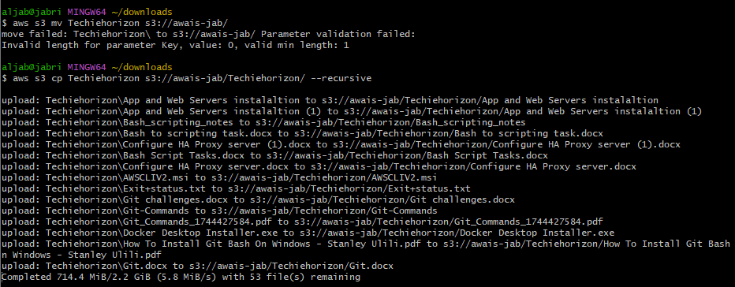

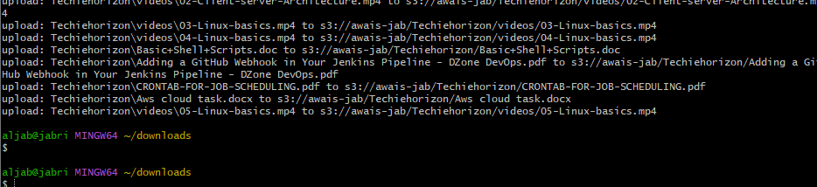
If we check the bucket the files is been trtansferred successfully 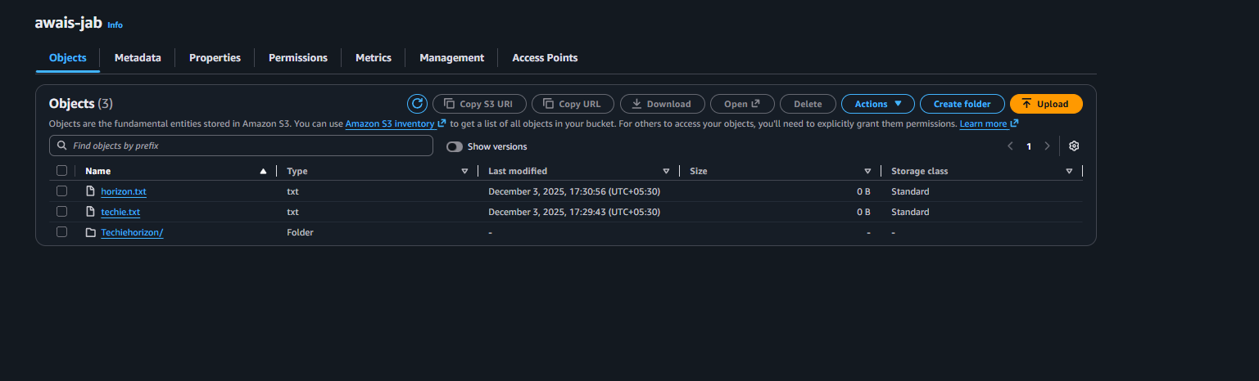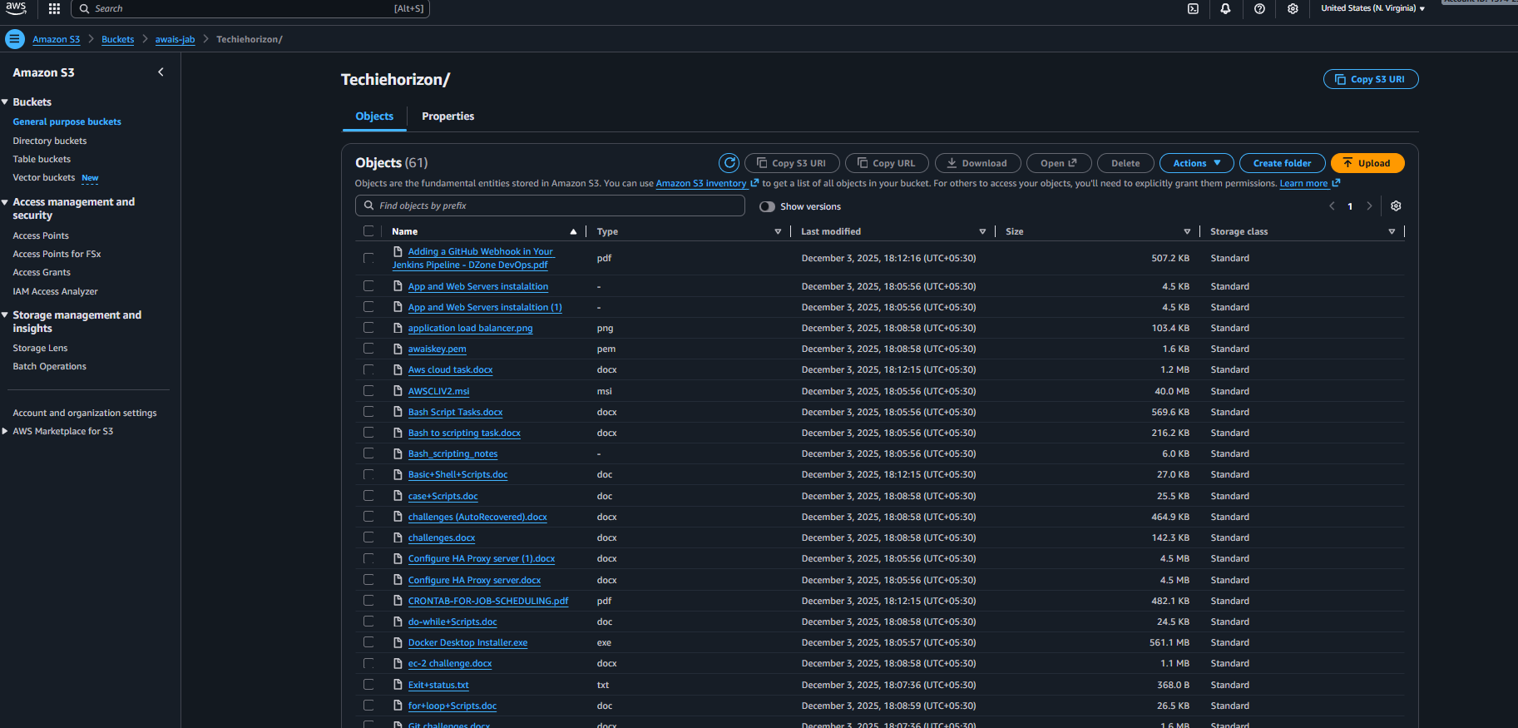

All the files is been transferred successfully.

