CDN-Tasks

01: Configure VPC peering in cross regions.
Ans:
Purpose of the tasks: configuring “vpc” across benefits especially for global or geographically distributed systems. Like “Global Application Availability” “Disaster Recovery & High Availability”.

Prerequisites:
Listing all requirements before starting:
VPC
Subnets
Route tables
VPC peering

Implementation process:
The very first we have to login our aws consol as root 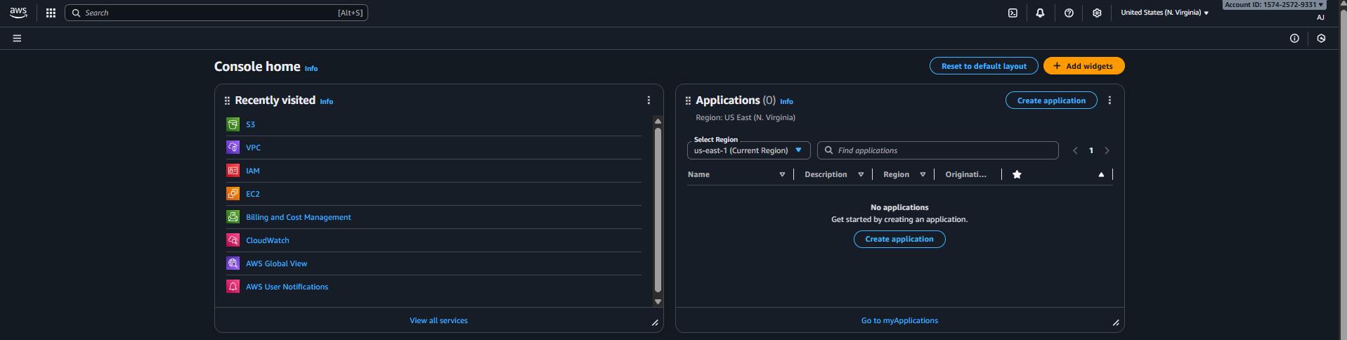and search vpc and go to vpc consol and create one vpc 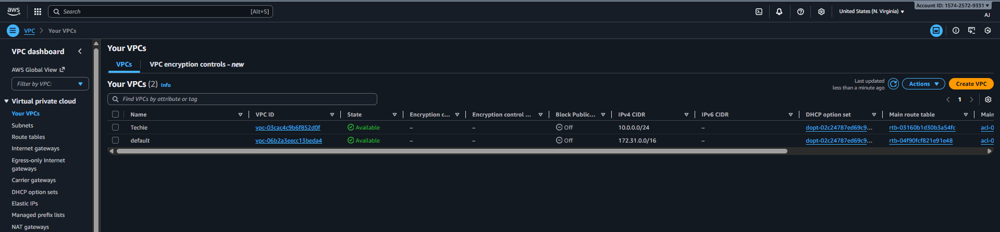

Then need to change to another region and create one region on another region 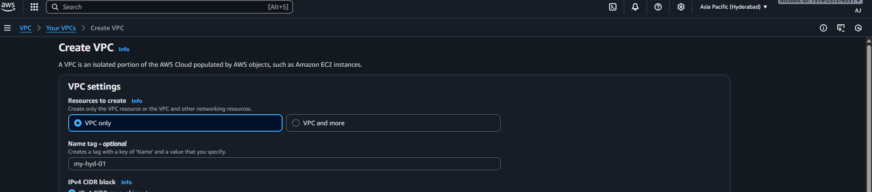
Above the screenshot can able to view there 2 different region and 2 vpc is been created

Then creating subnet in each vpc 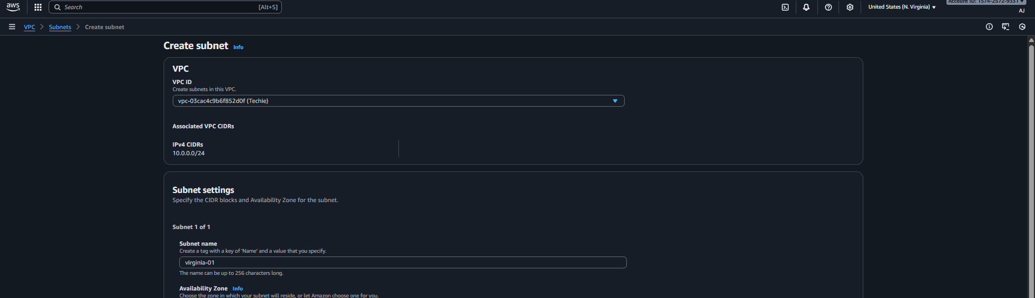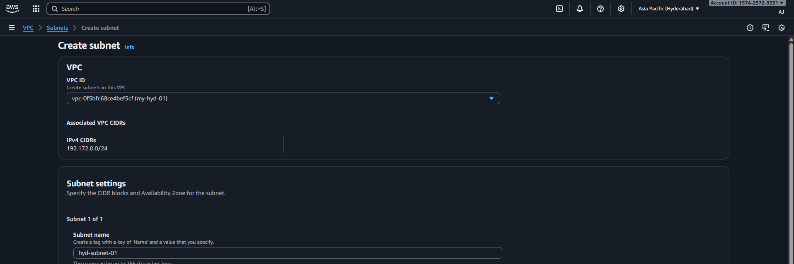
So 2 different subnets cerated for 2 vpc’s
Then need to create route table for each vpc under the vpc console
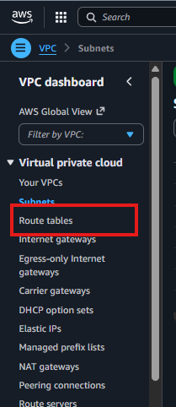
Create 2 route tables for each vpc 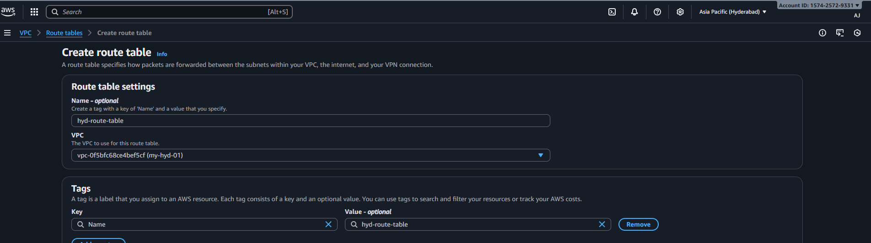

Then need to click on peering connections under vpc consol
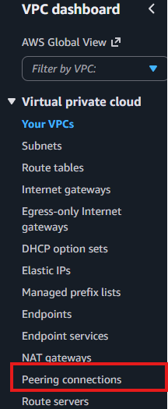
create one peering for another region 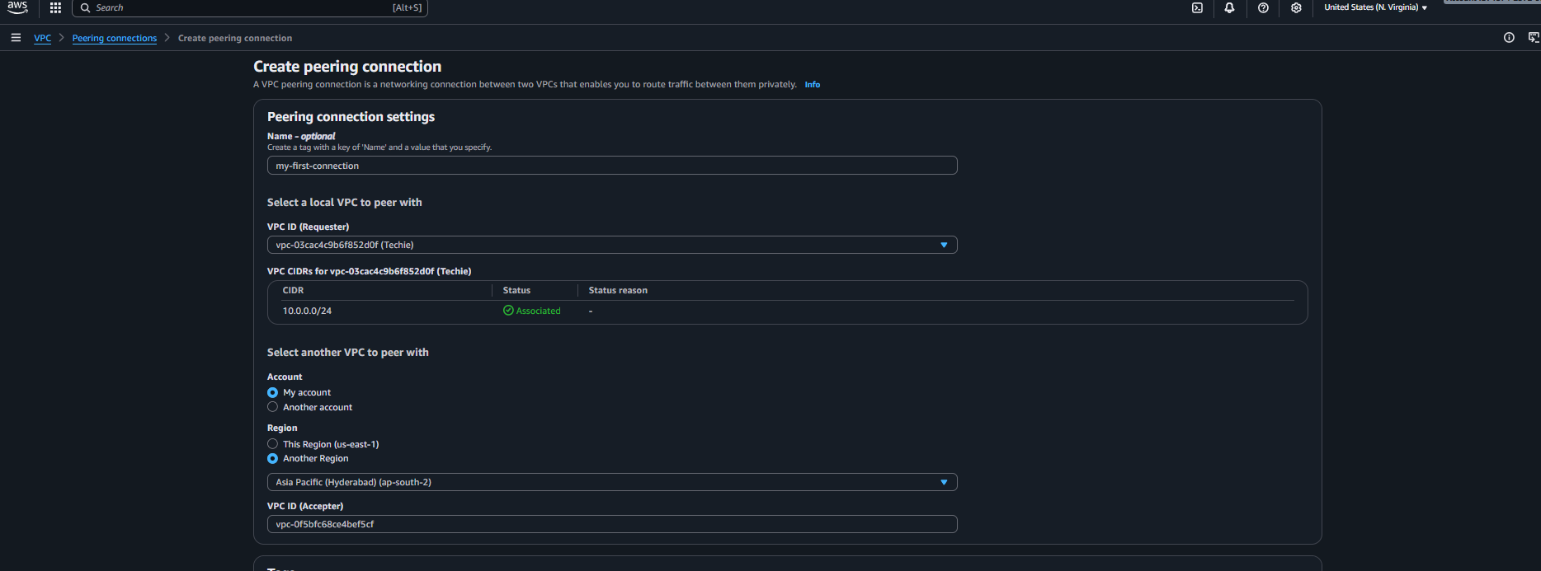
Once the peering connection is been created other regions vpc need to accept the request 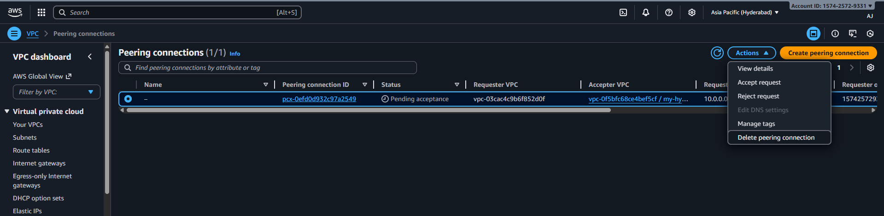

Validation Steps
The subnets is been creted with cidir range 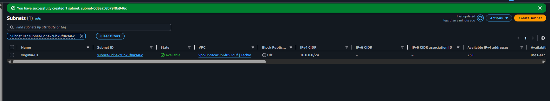

Route table is been created for vpc’s 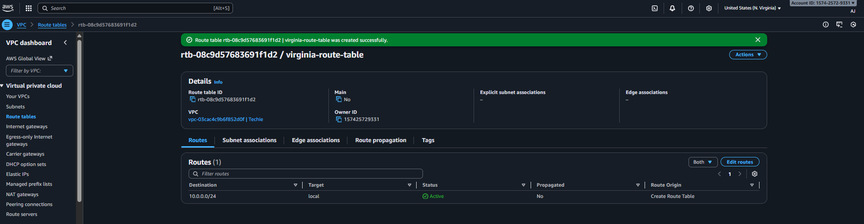

Peering connections is been created successfully 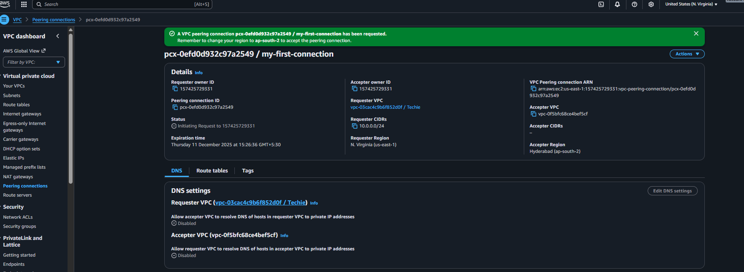

Connected with another vpc in different region 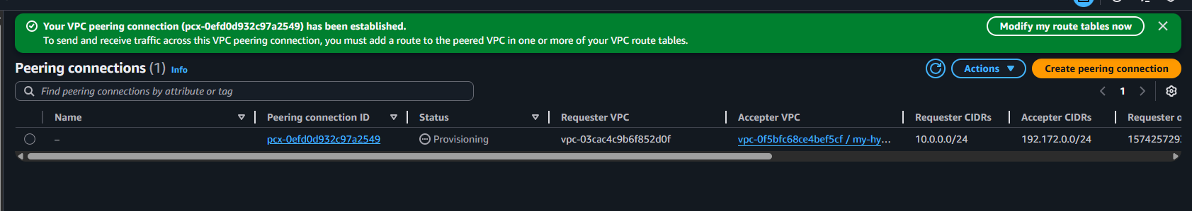

Conclusion: Now the peering connection is been completed successfully

02: Purchase one domain from GoDaddy.
Ans:
Objective: purchasing the domain for next task
Prerequisites: visiting godaddy site
steps: visited godaddy site created a account
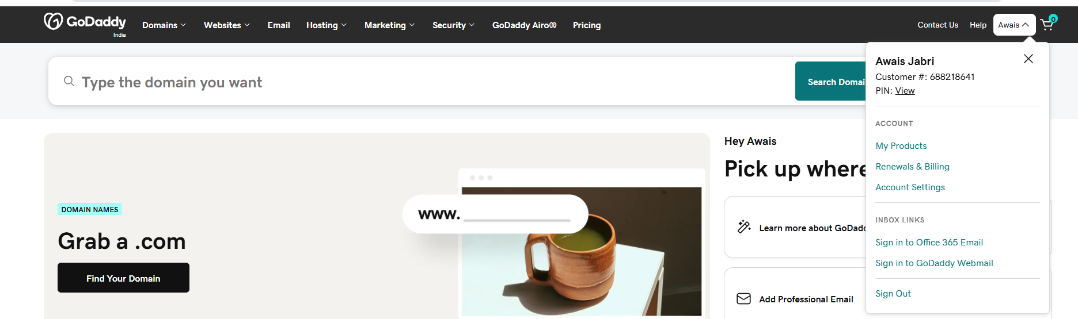

Searching for domain and added to the cart and made the purchase 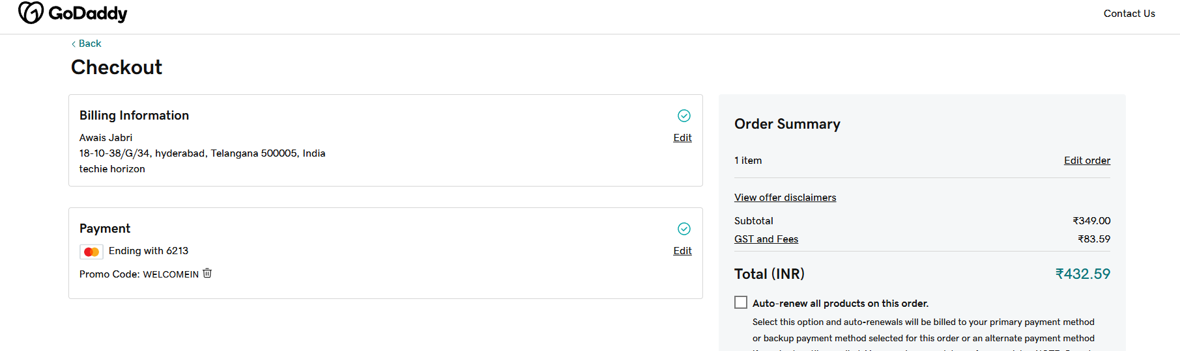

Validation Steps:
The domain is been purchased successfully coonline.info
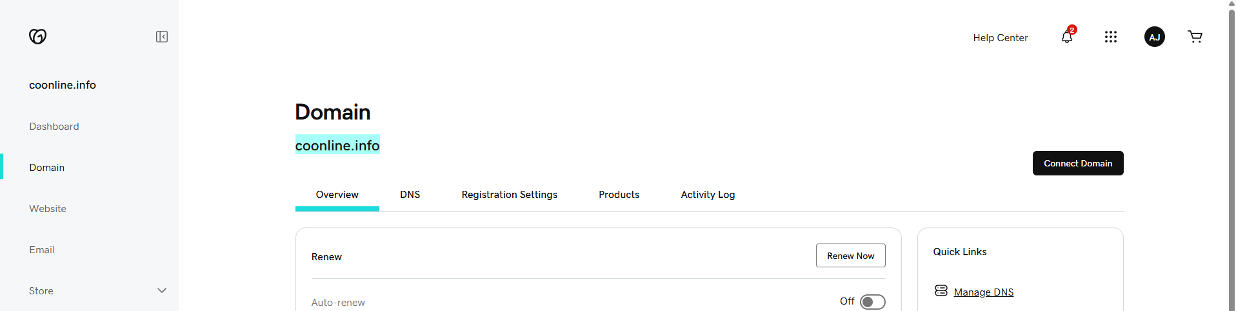

Conclusion: the domain is booked successfully for 1 year.

03: Deploy static website in S3.
Ans: Purpose of the tasks: creating one test website for the demo purpose

Prerequisites:
List all requirements before starting:
S3
buket
git
aws cli

Implementation process:
·First search for s3 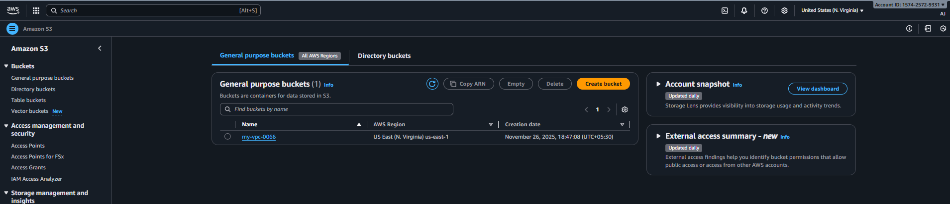

·then create one new bucket 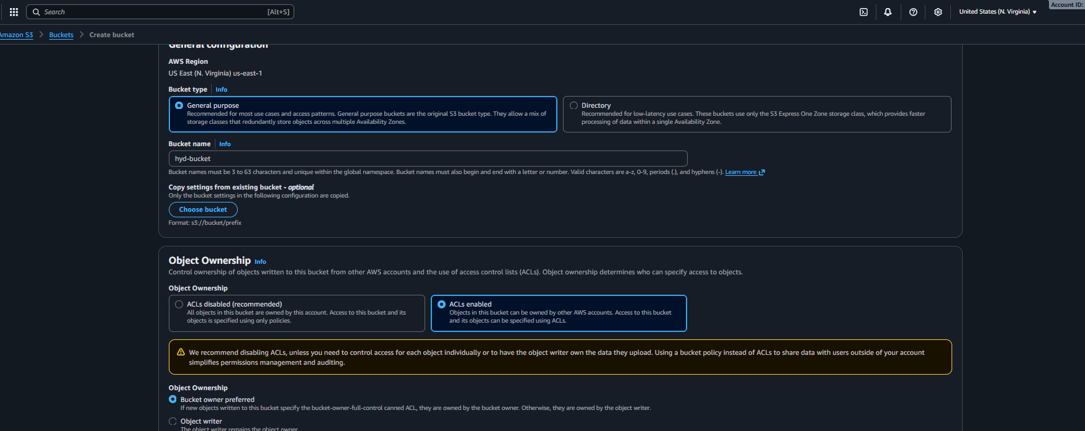

·once the bucket is been created select the bucket and go for properties 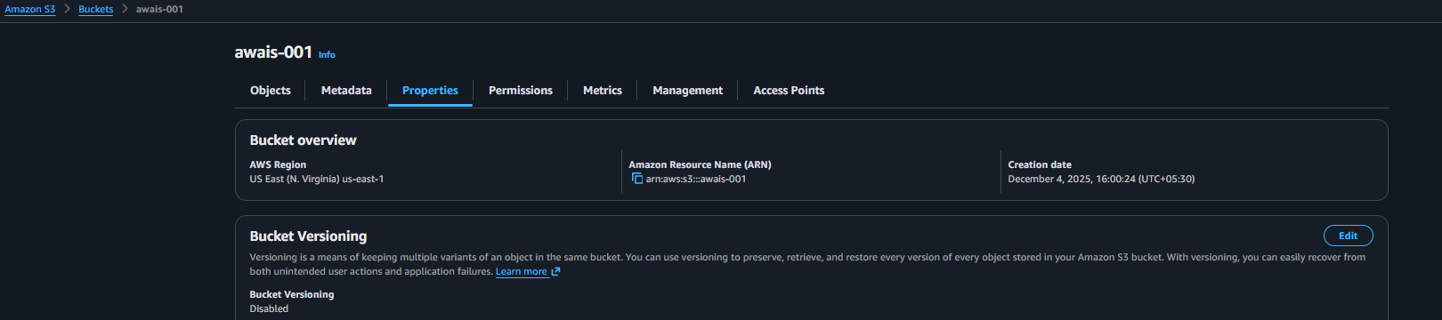
·Then scroll down and enable the static website hosting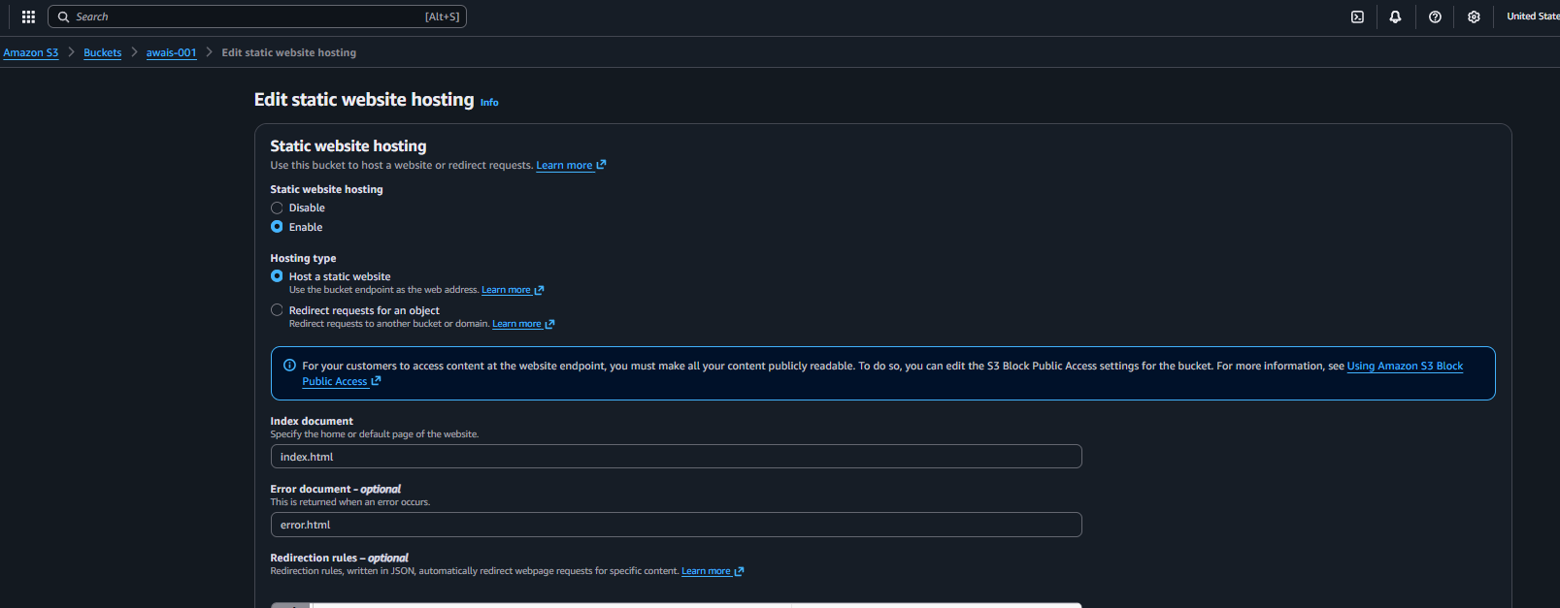
·Then need to open the terminal and connect to aws 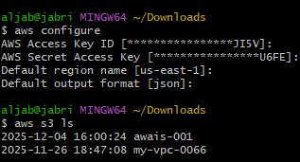
·I already have index files now moving index files in s3 bucket by using command of (aws s3 mv filename.txt s3://s3bucketname/)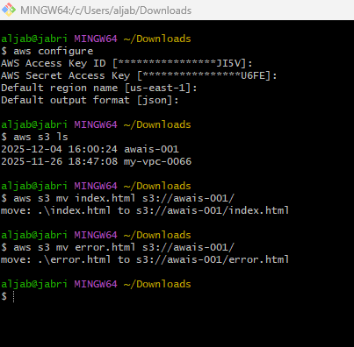
·Now need to cope the link of static website hosting and paste in browser check if its working or not
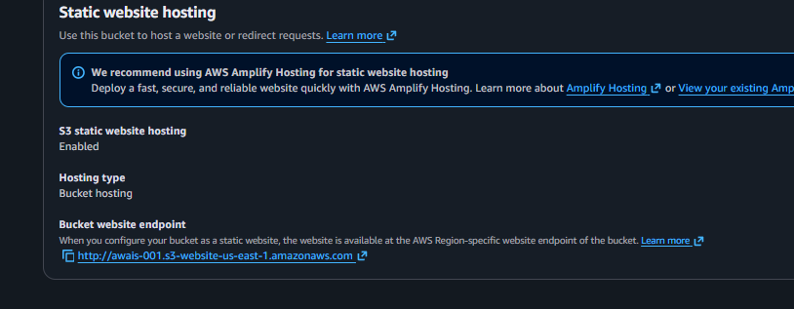
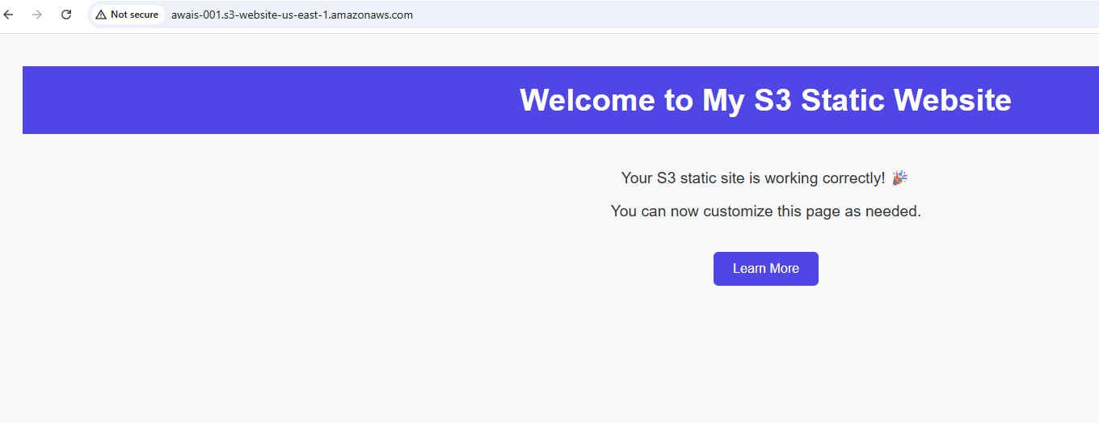

Validation Steps:
created new s3 bucket with the name of awais-001 successfully 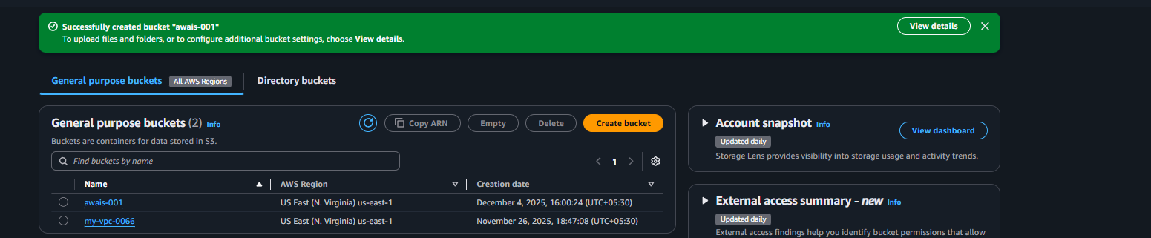
Enable the static website hosting under the properties
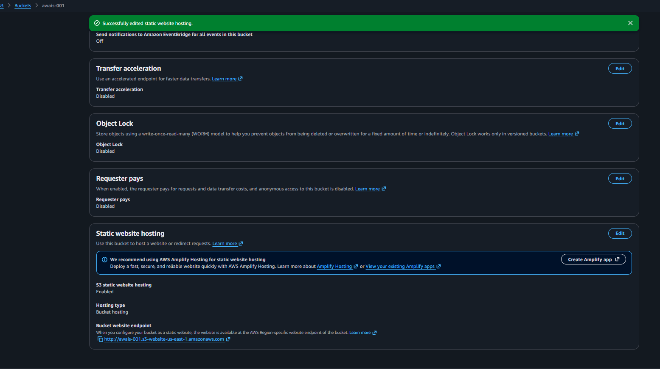
Transfer index.html and error.html file from local to bucket
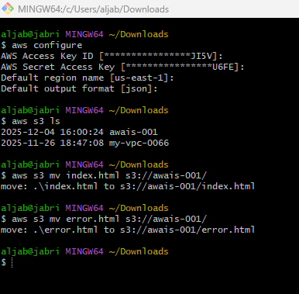

Issues Faced: while copy the static website hosting link and paste on the browser faced an error 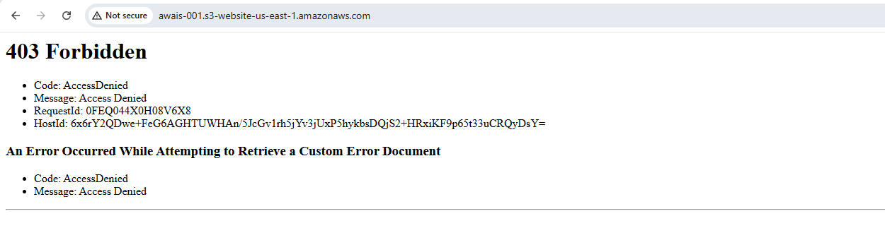
To able to resolve this issue needed to allow the object for public 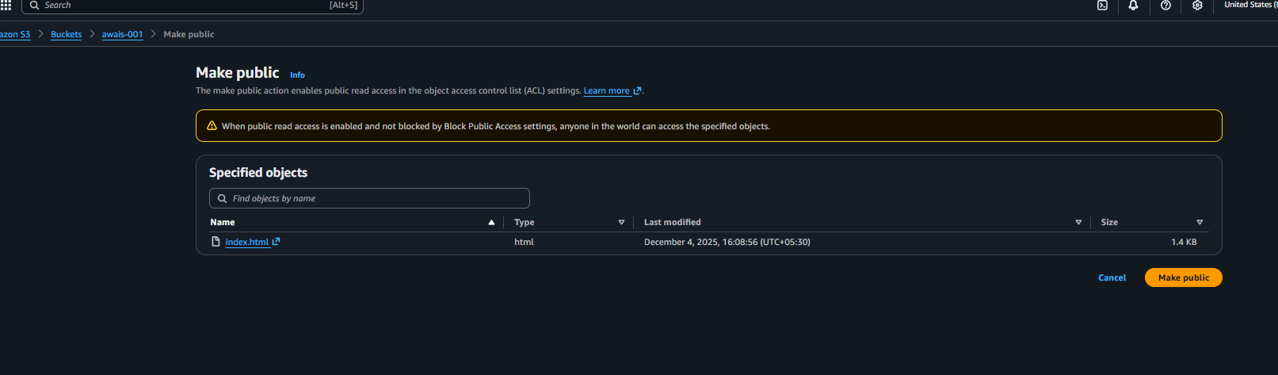
And save the file and web site is started working 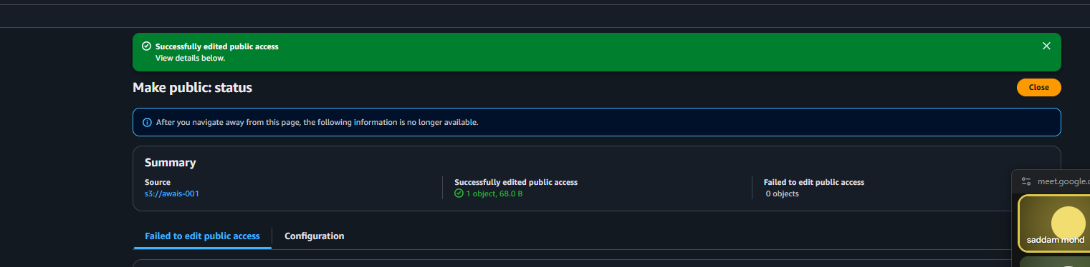

Conclusion: the website started working with index.html content 

04: Create a CDN and attach one SSL certificate.
Ans:
purpose of the task:making connection to cdn and attaching ssl certificate
prerequisites:
Cloudfront
R53
S3

steps of deploying :
first search for cloudfront and create a distribution 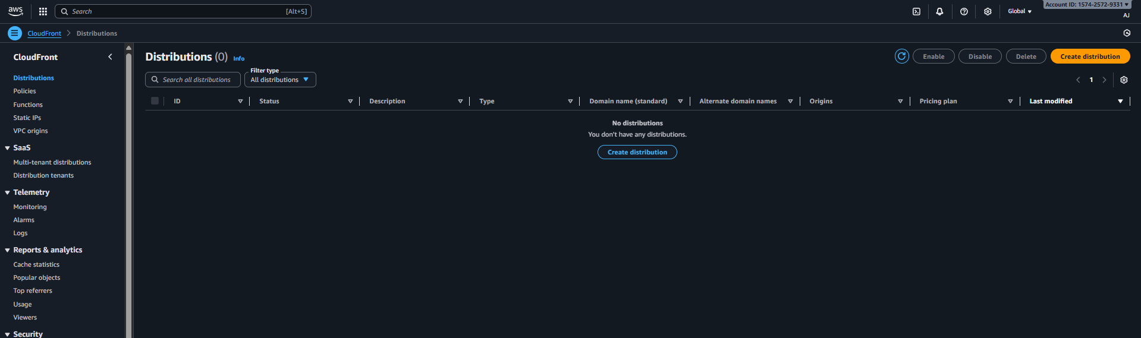
once it got created need to visit for acm (amazon certificate manager and request for certificate 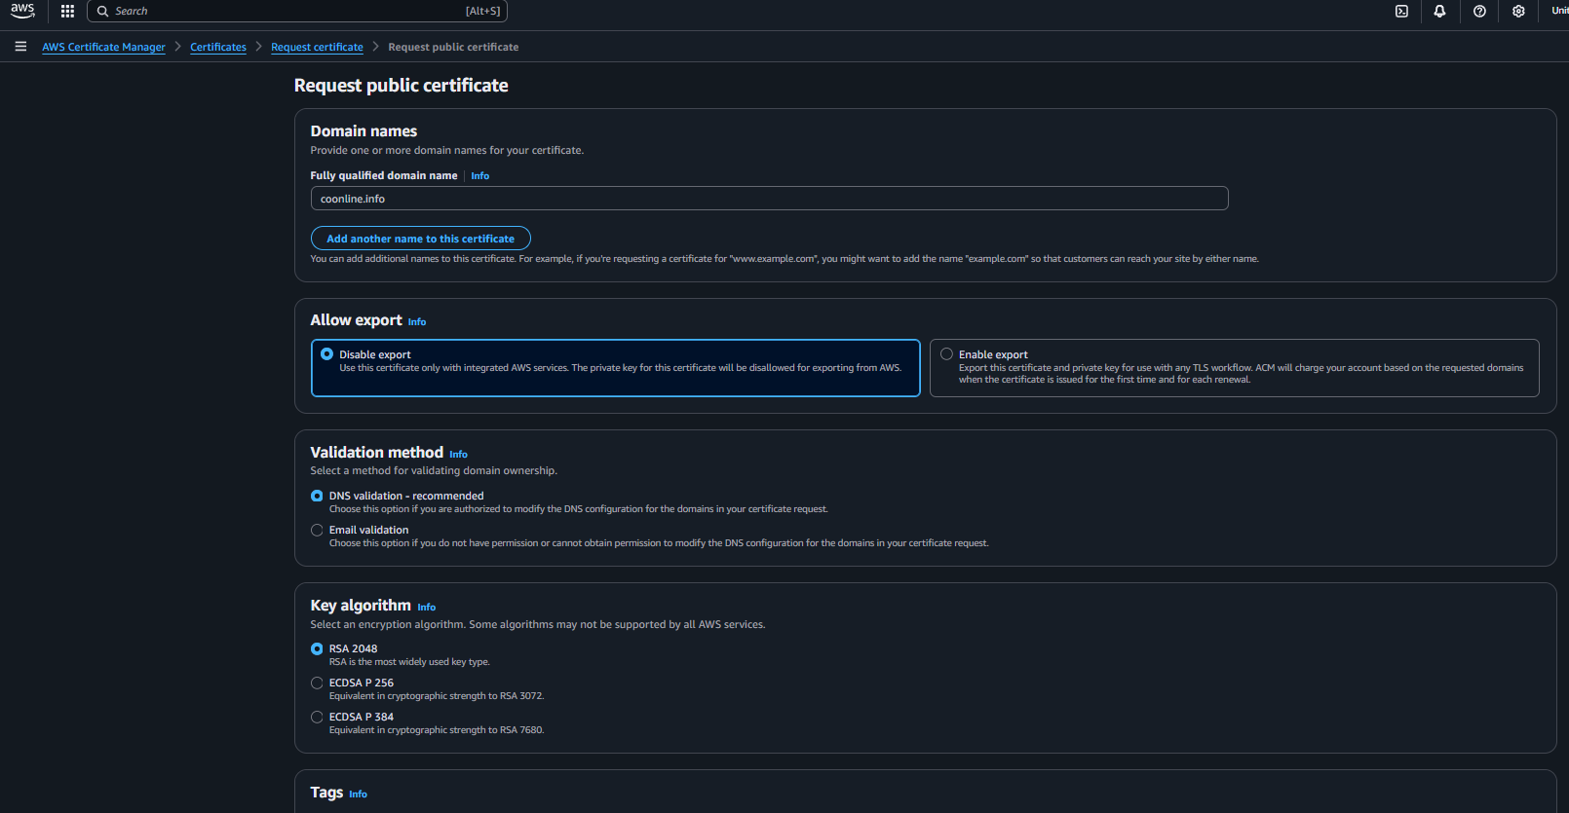
then it will ask us to add cname record in domain dns at R53 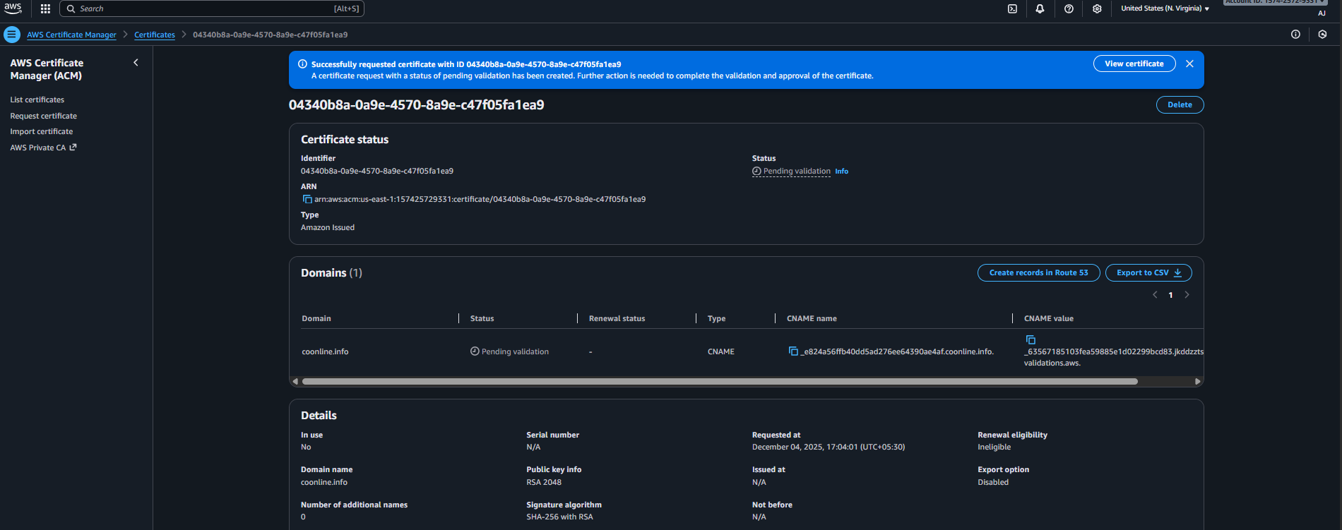
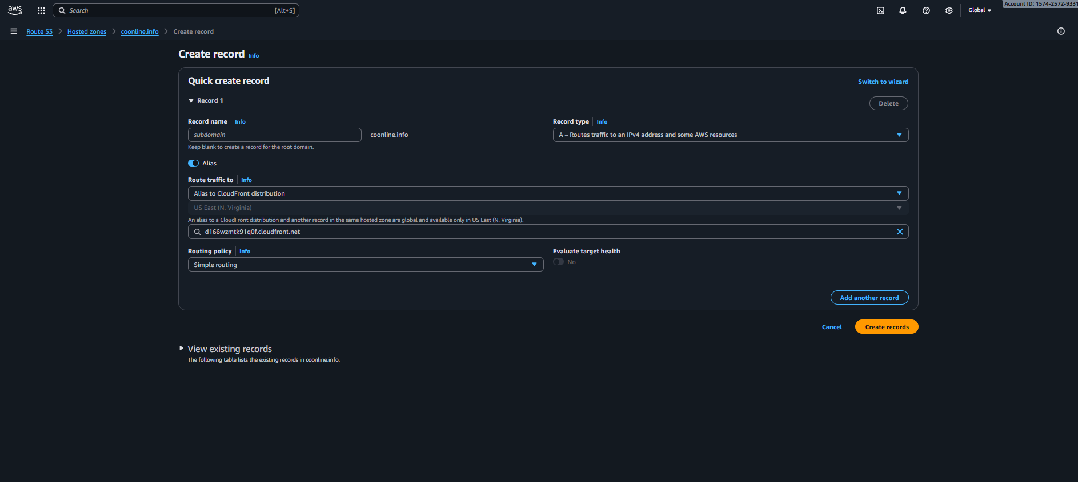then need to wait for 15 to 20 minutes once the ssl is been generated finally it got

Evidence: created couldfront distribution 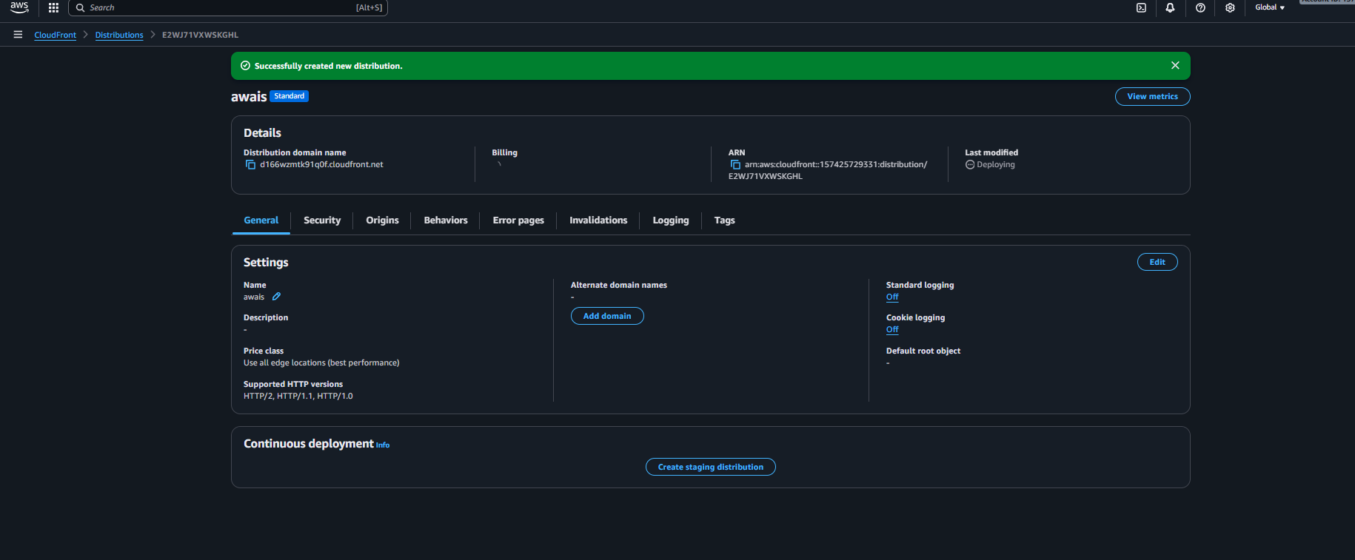
Created ssl certificate 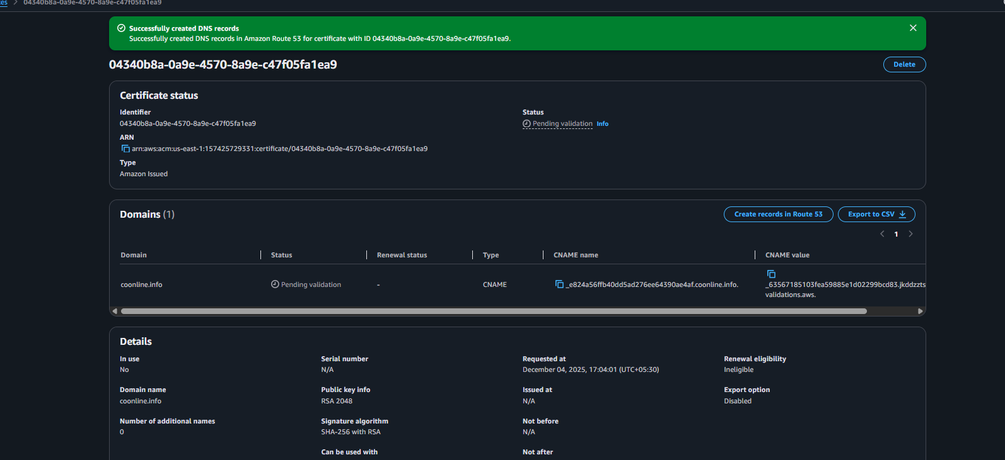

conculsion : the cdn is been connected with ssl certificate

05: Create a Route 53 hosted zone and map the domain with the CDN.
Ans:
purpose of the task: making connection of domain which got purchase with route53 and with cdn which is connected with ssl certificate
Prerequisites:
listing all services which is getting used for this task:
S3
New bucket (domain name)
R53
cloudfront
godaddy(domain dns)

steps: first need to go on s3 region and create a new bucket with the same domain name
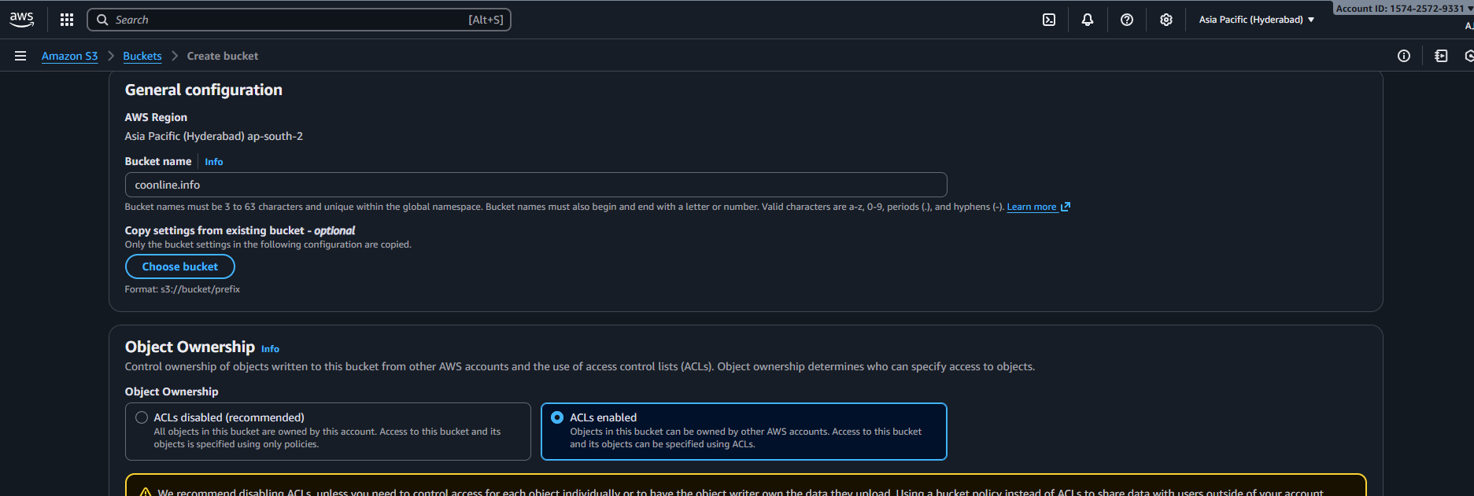
Then need to search for R53 and click on hosted zones 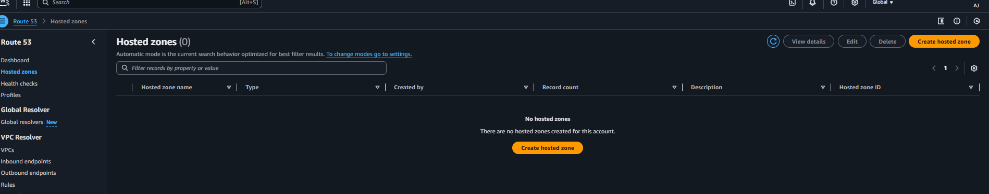
Need to create a zone with the domain name 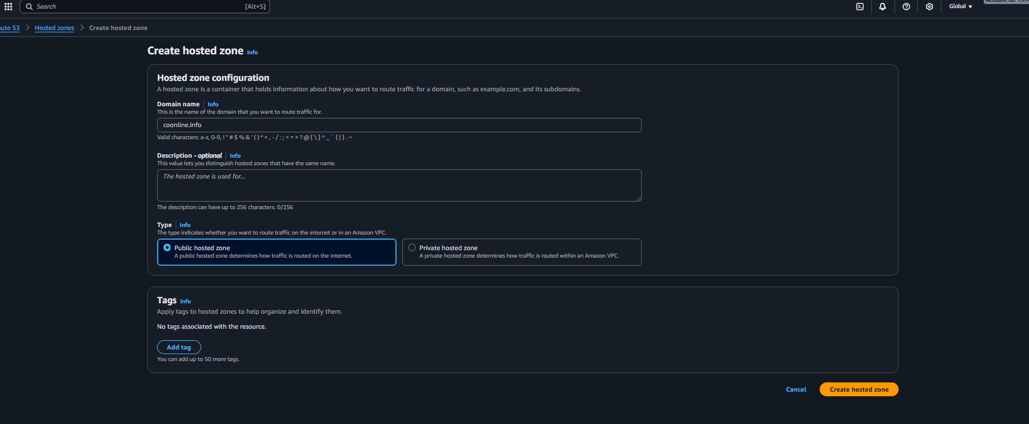
Need to copy the name server of the connection and need to go godaddy doman dns and change the name server 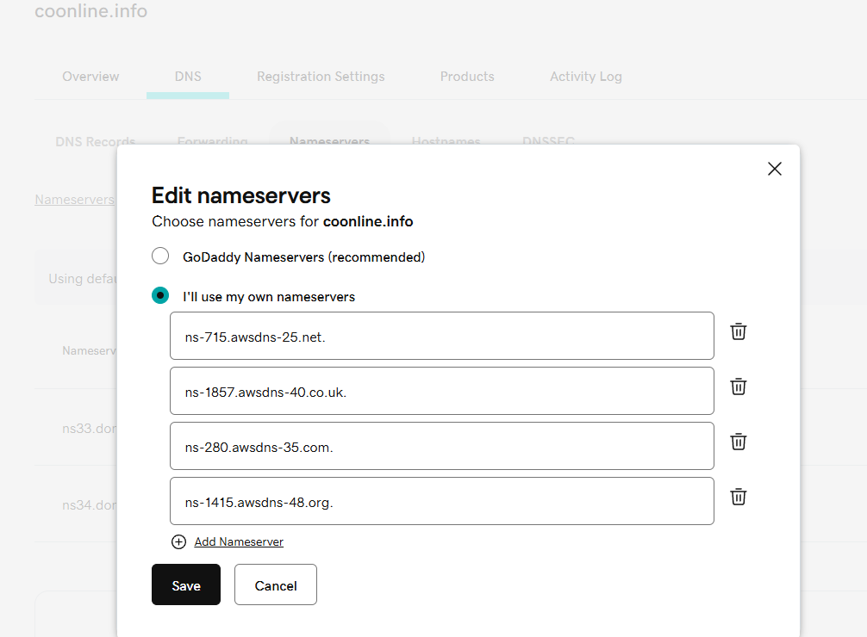
Then need to search for cloudfront and create the distribution with the domain name and connect the
Ssl certification to the distribution 

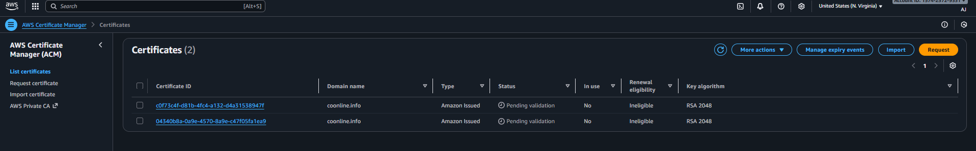

Evidence: created the bucket with the domain name 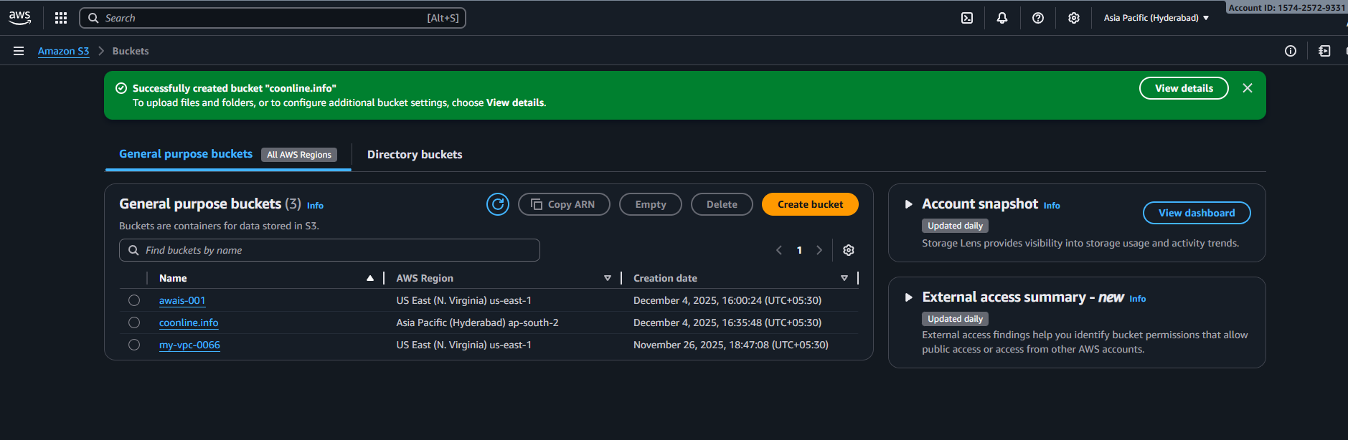
Roasted the name server of domain 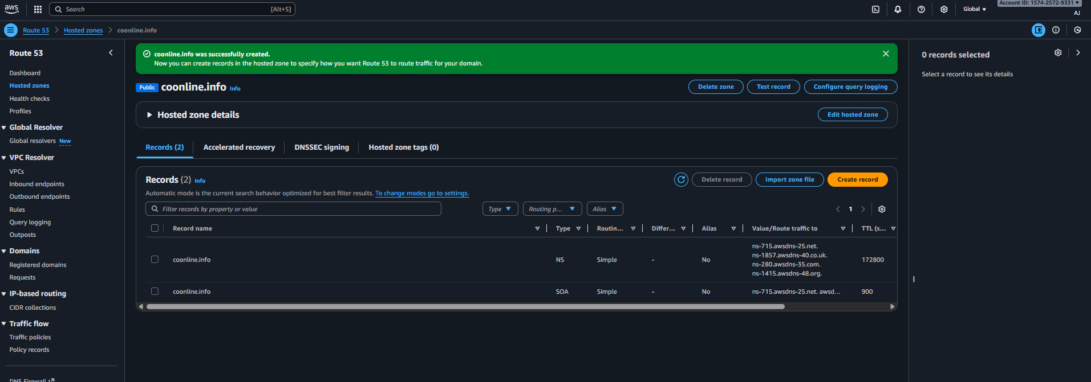
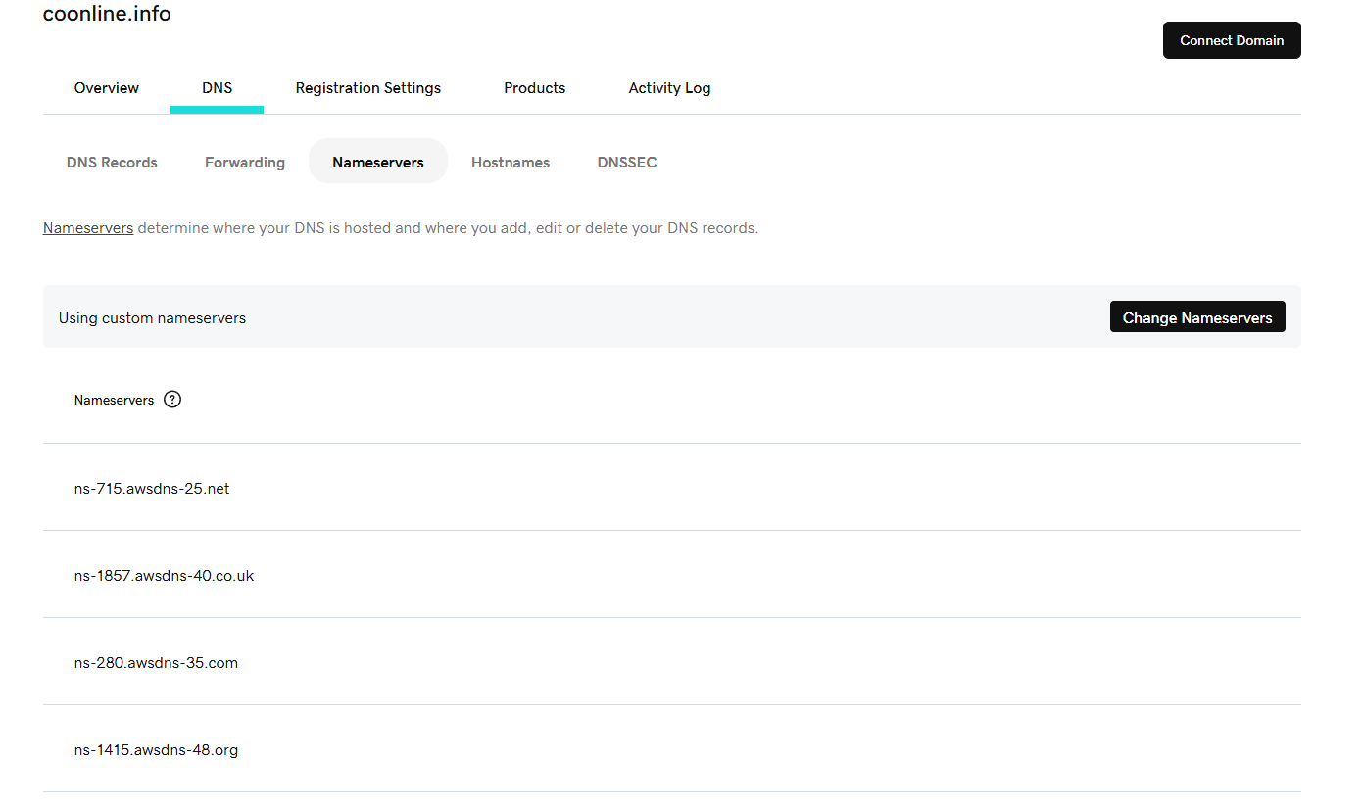
Disrribution is been added with the domain name 
Issues Faced: while chaning the name server getting error 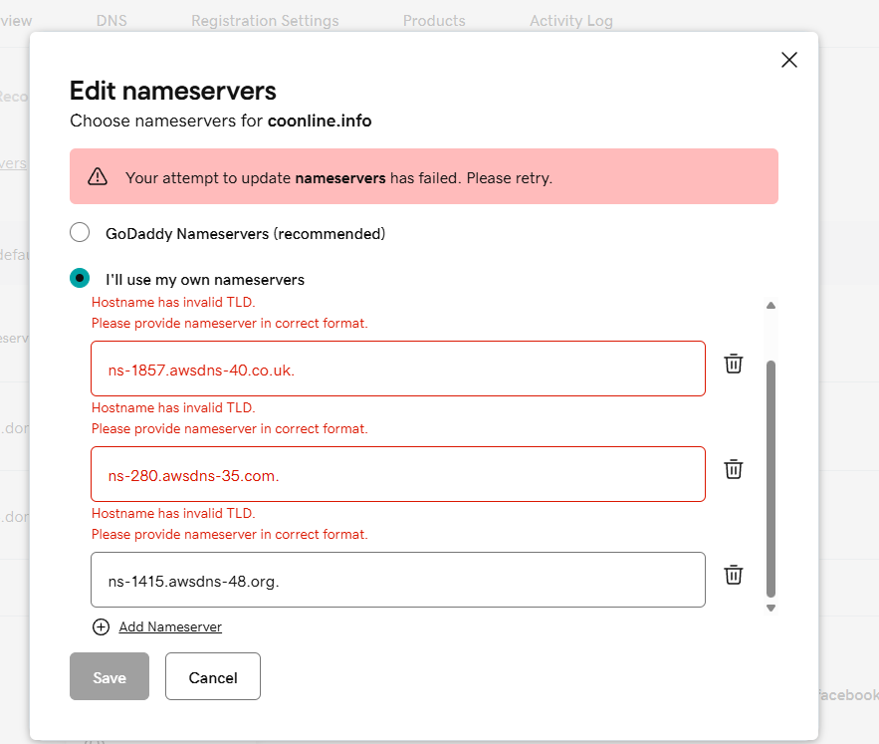
So removed the . under the records and it got saved
While ssl certificate is been requested took time need to wait for issued

conculsion : website is been searched for domain name and redirecting to https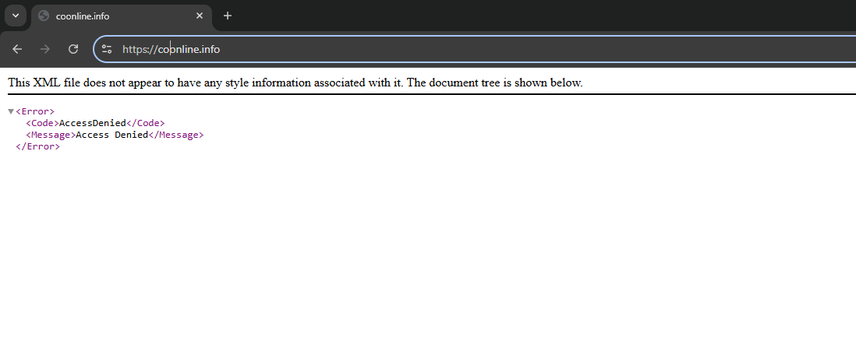

06: Update the index.html in the S3 bucket and ensure the updated file is accessible using the domain name.
Ans:
purpose of the task: to make the site visible to user with domain
Prerequisites:
S3
Bucket
Git
Awscli

steps of deploy :the very first step need to create s3 bucket with the domain name
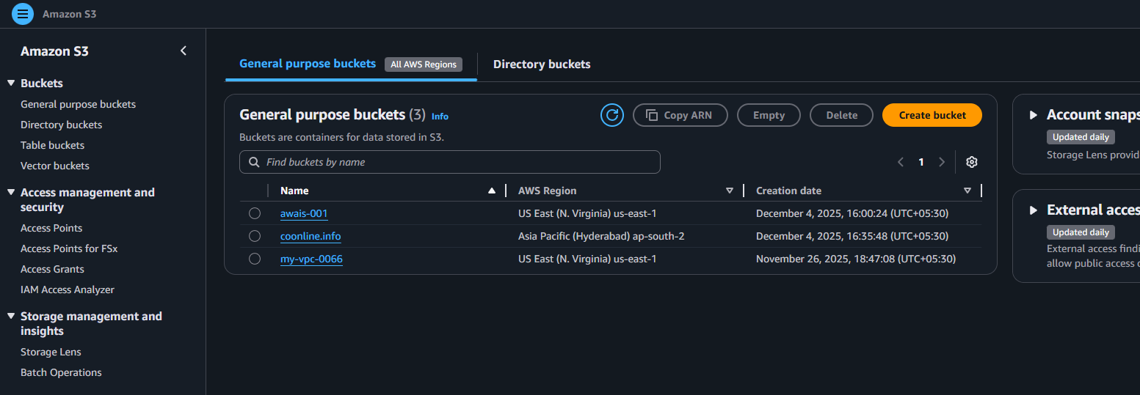

Then need to open the terminal and conenct the aws cli 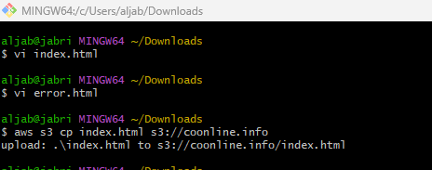
Need to move the index.html and error.html files move the s3 bucket
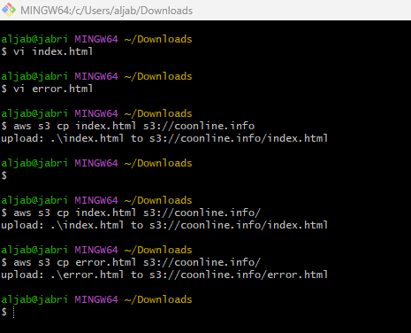
Once the files is been moved then need to select the object and enable for public 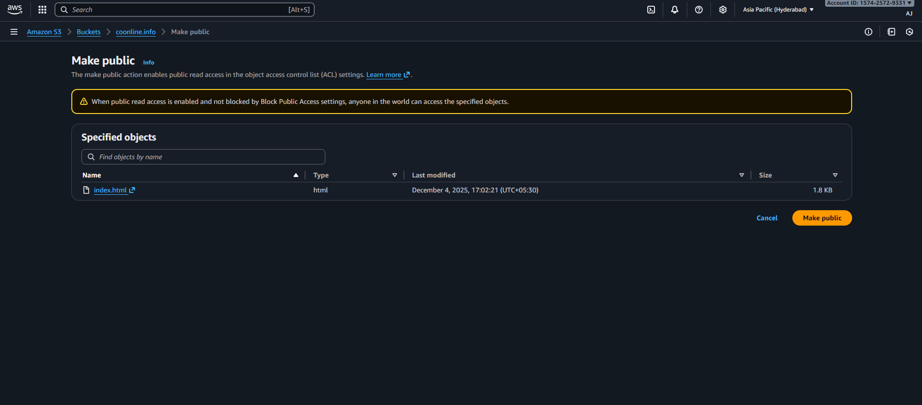
Thus need to do for error.html object as-well

Conclusion: now the domain is live with the index.html and error.html files 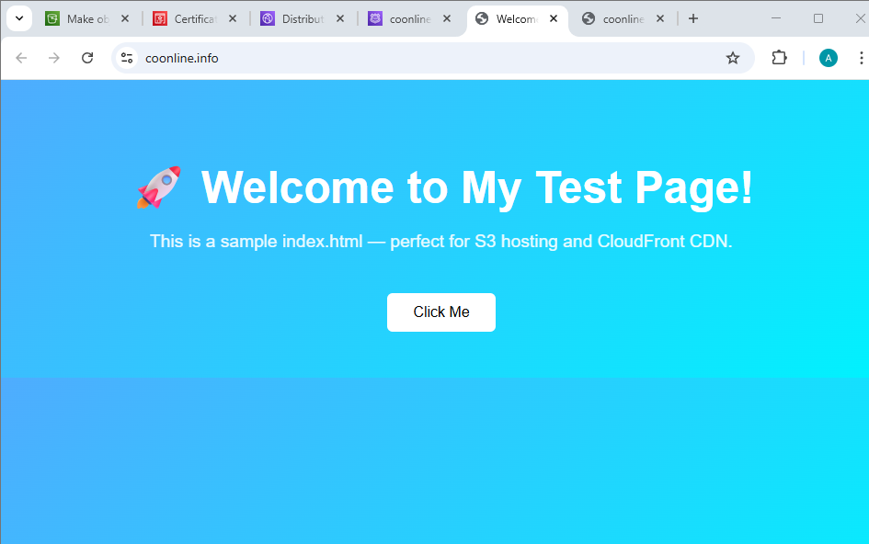

07: Share the domain name in Slack to test the connectivity.
Ans: https://coonline.info/

