VPC-Challenge-03

01: Design and deploy a scalable network architecture using AWS Transit Gateway to simplify network connectivity between multiple VPCs.
Ans: first need to create 3 vpc and 1subnets accordingly 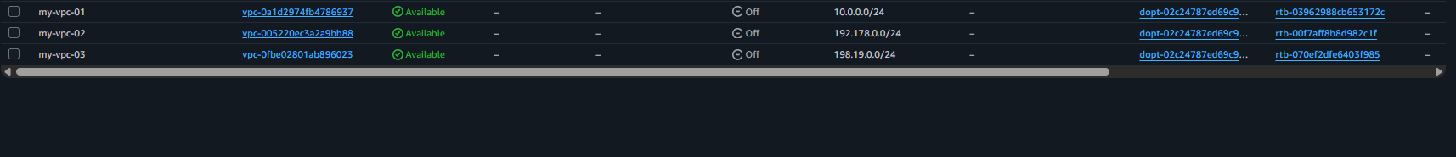
Then need to add route tables for each subnet and internet gateway for the subnets 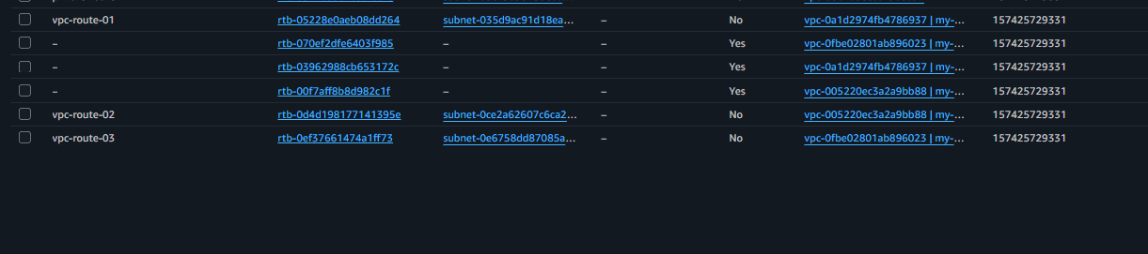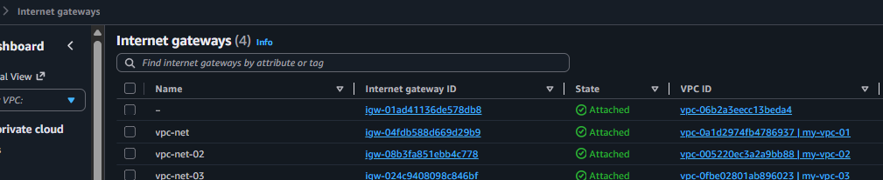
And add internet gateway in route tables and save it 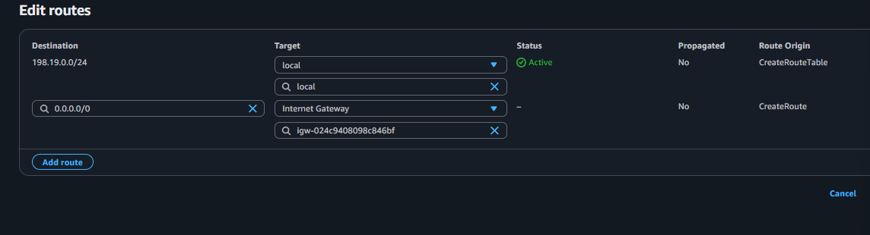
Now need to connect transit gateway and need to attach 3 vpc in attachment 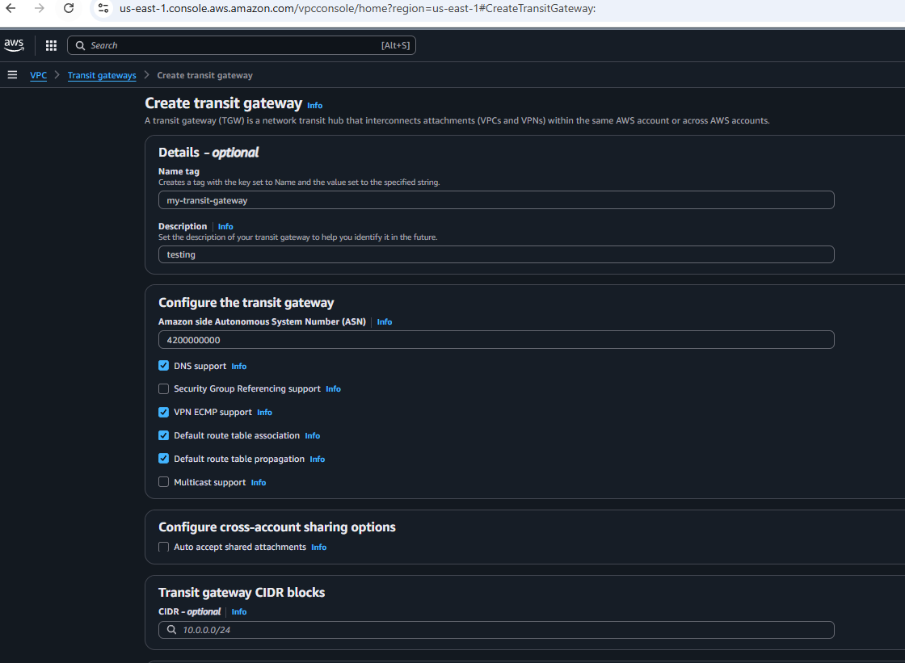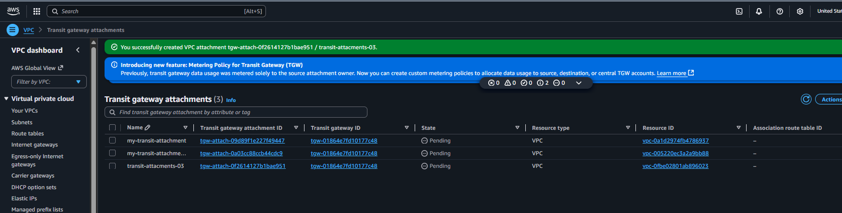
Now need to entre in the vpc route tables and save it 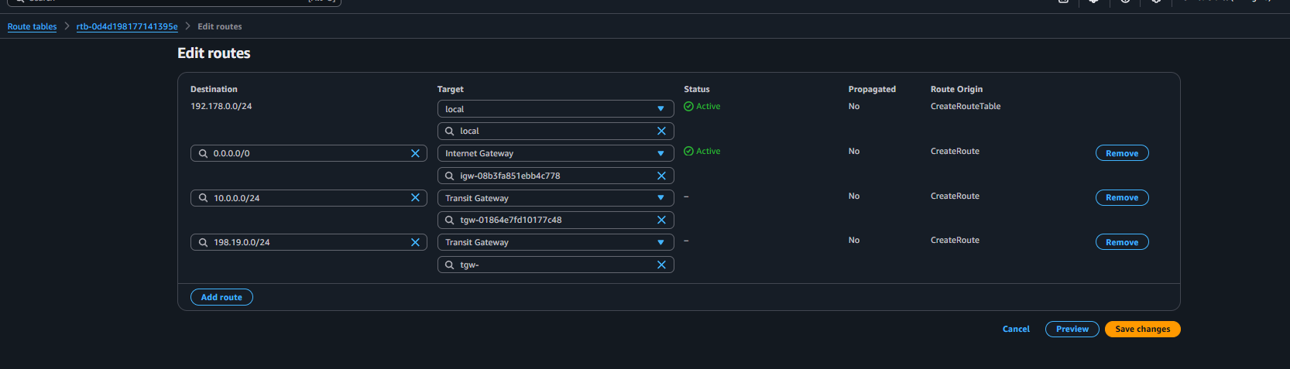
Once it got saved now launch the instance and check with their public and private ip 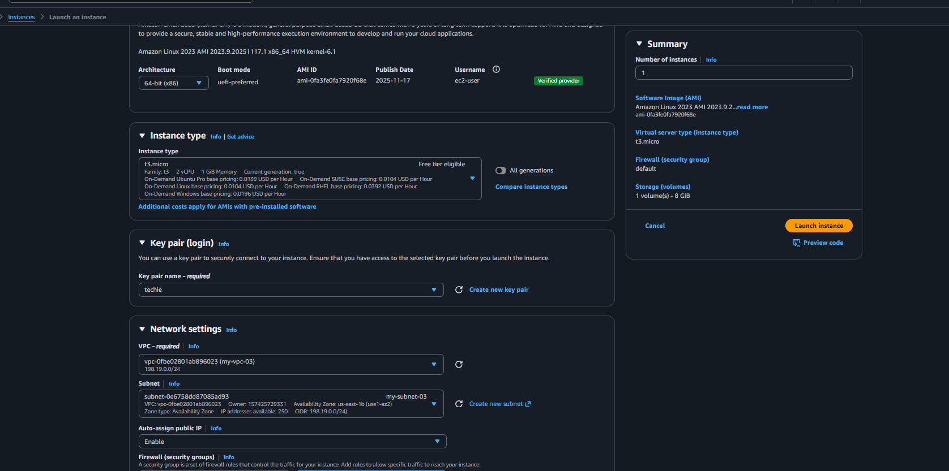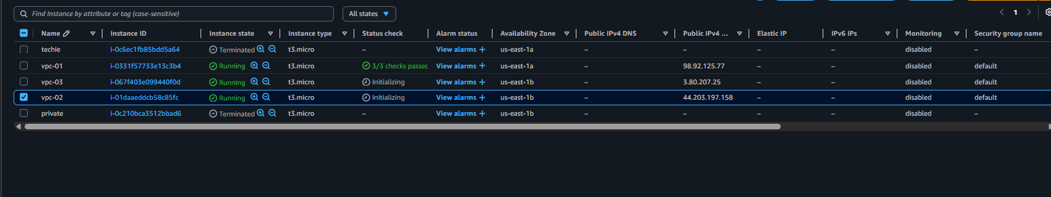
Check with all public and private ip it was working its been connected 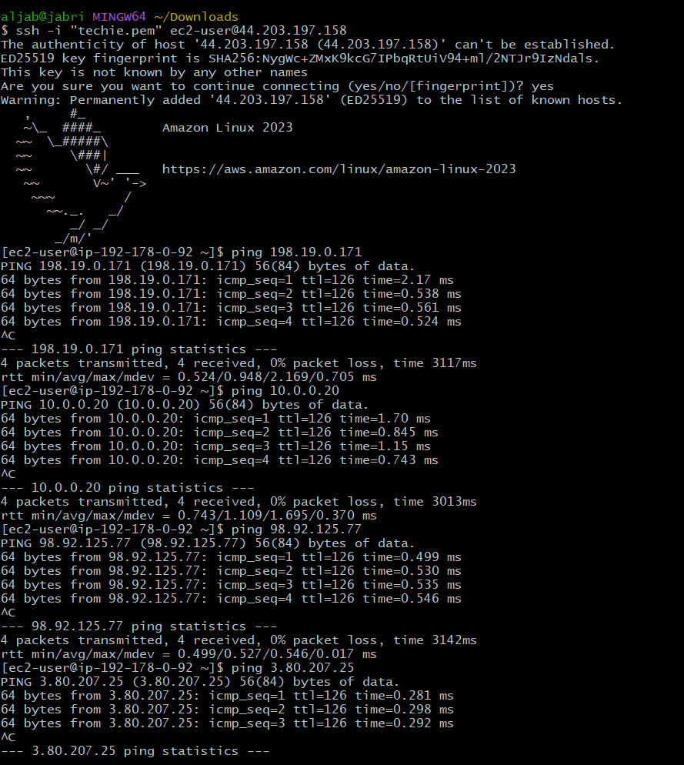

02: Configure VPC endpoints to securely access AWS services without internet gateways or NAT gateways, ensuring data privacy and minimizing exposure to external threats.
Ans: the vpc need to create 2 subnets 1 public and 1 private adding route tables for both subnet and for public adding internet gateway 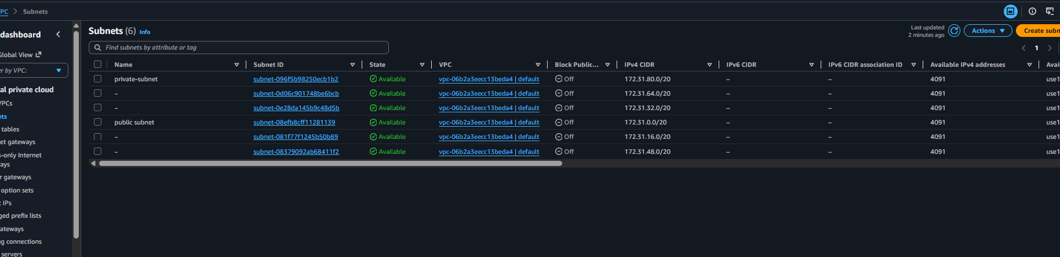
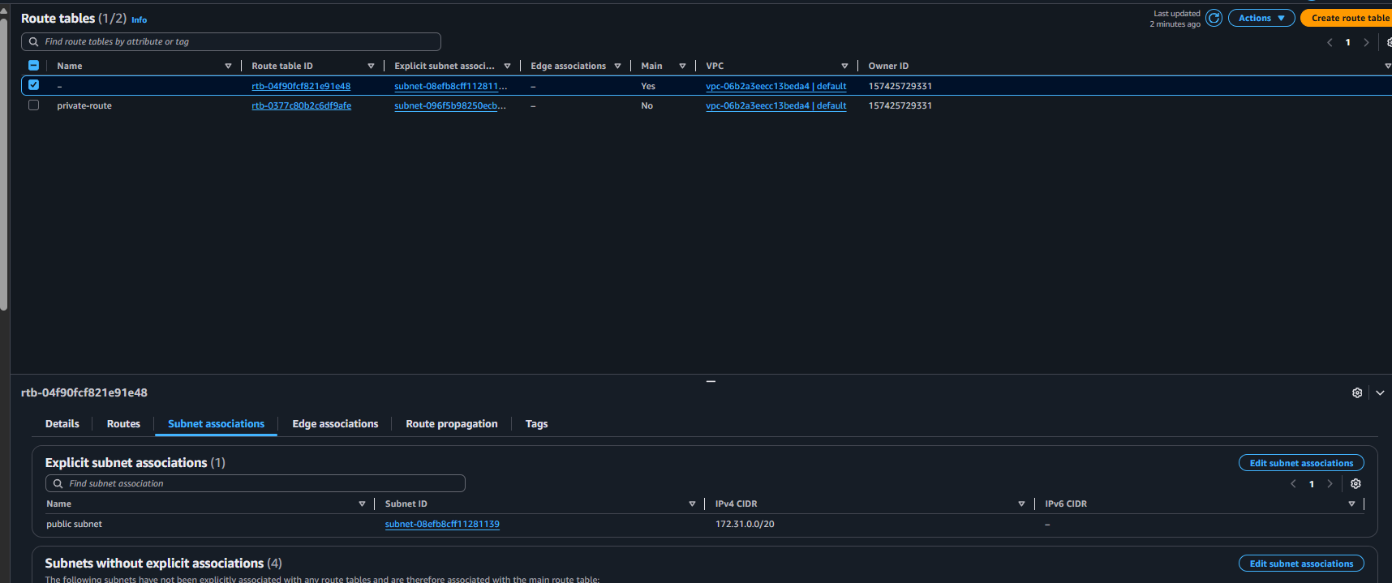

Now need to launch ec-2 instance for public and private vpc 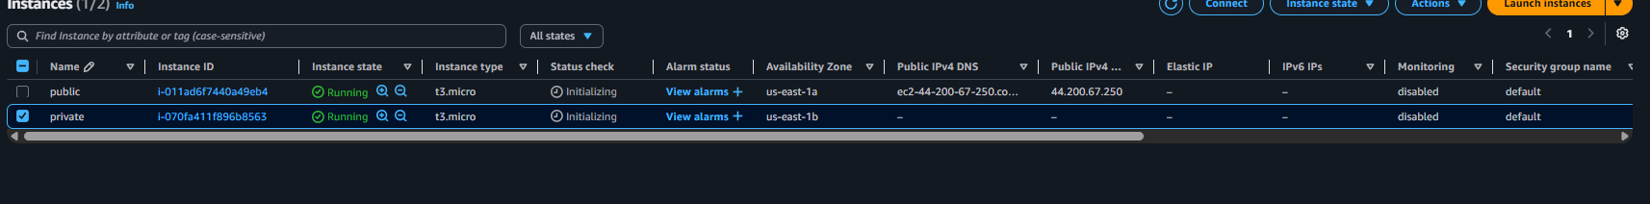
now need check security groups and added rule for all traffic 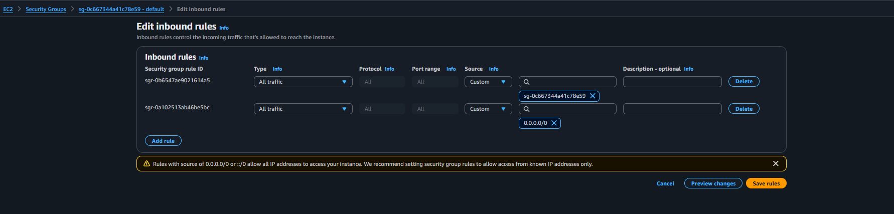
once the security groups is been saved need to open the git and access to aws configure
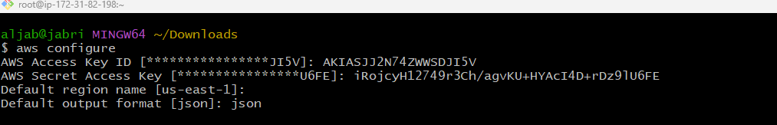
Then read the pem.key 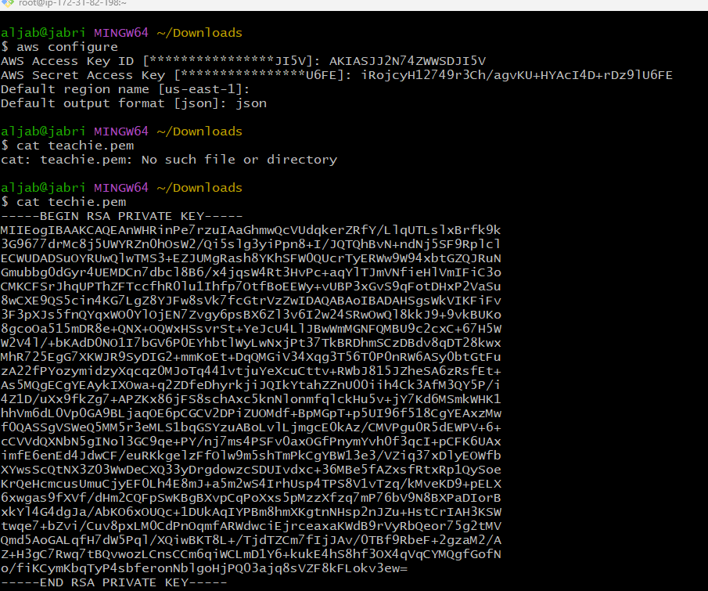
Then need to access the public server with (ssh -i privatekey.pem ec2-user@public ip ) and once it got connected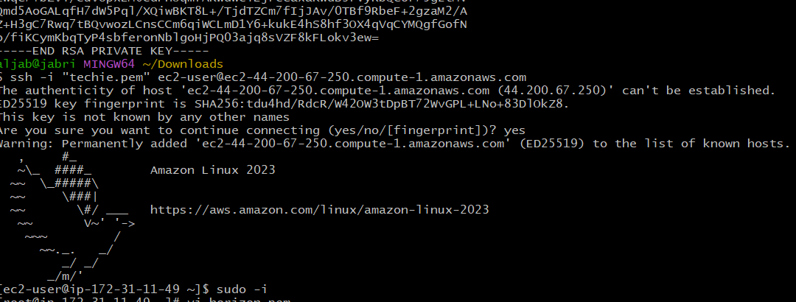 need to be create a new file with editing so then we can copy the pem.key and paste it and save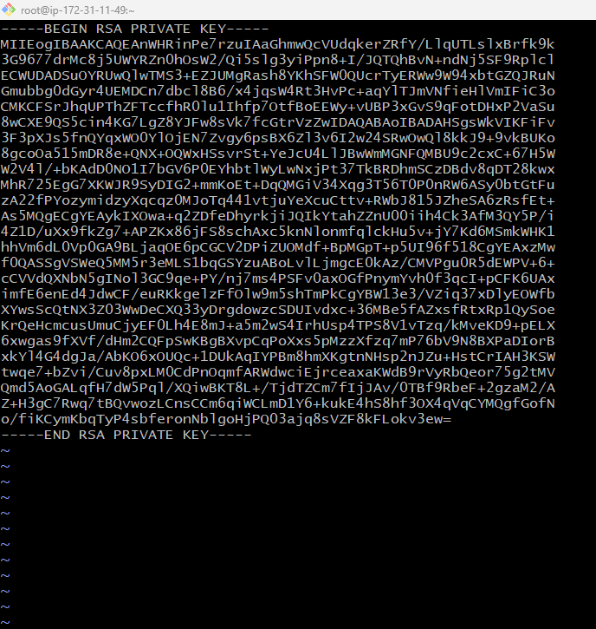
then changing the permission of file and access to private server (ssh -I new.pem ec2-user@privateip) 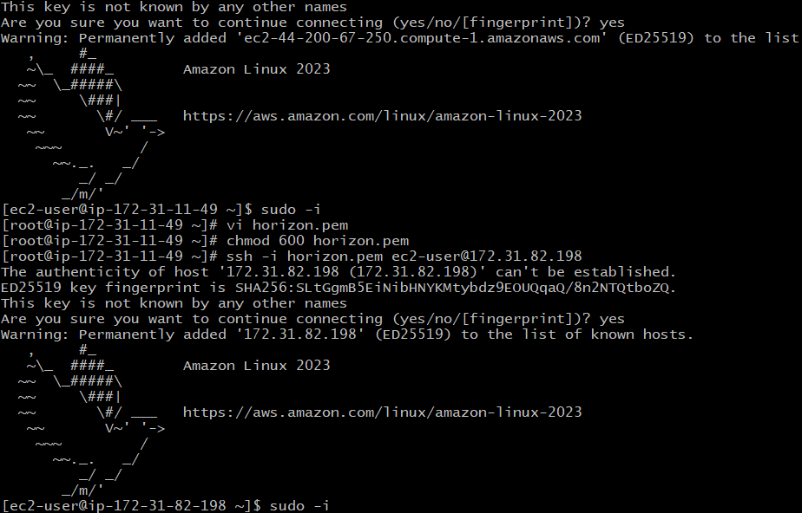

need to configure the aws entre the details and then need to add endpoint and save it now check the (aws s3 ll)
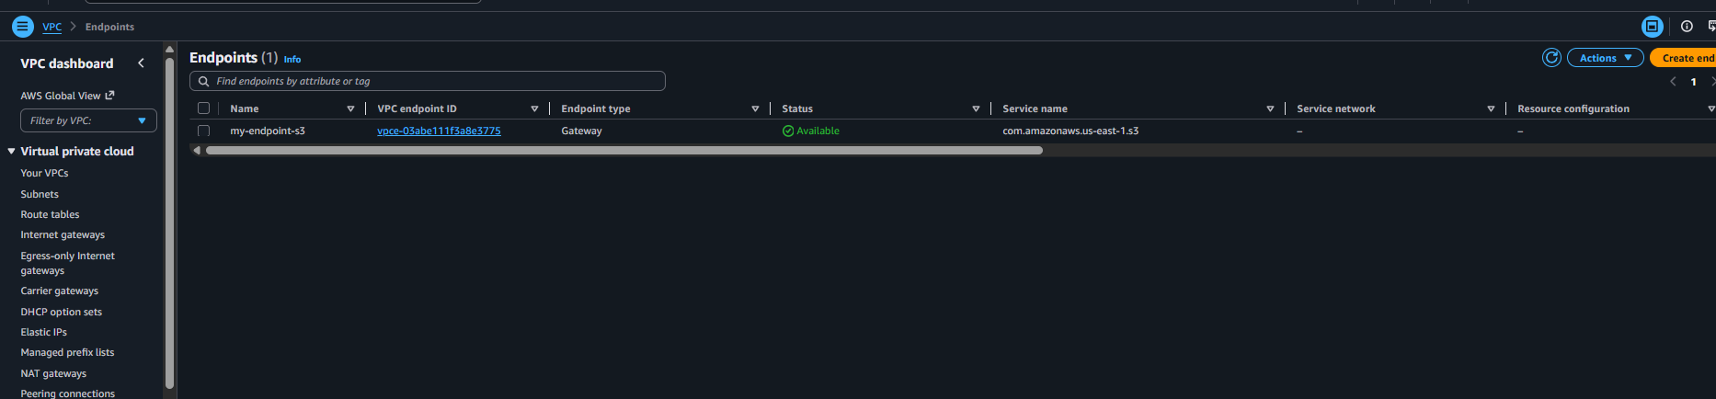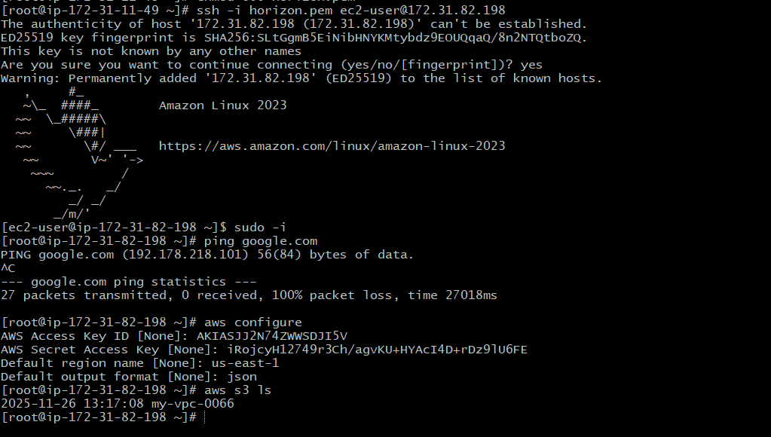
Now its been working ..

