Git Challenges

1. Resolve Merge Conflicts
Create a merge conflict intentionally (two users editing the same line).
Resolve the conflict and push the changes.
To create a new branch use command
git checkout -b user1 ---- -b allow user to create a new branch and switch to new branch at the same time
Then edit README file in user1 branch
vi README ---- this will open README file in notepad
Edit one line “resolve merge conflicts – edited by user1” and save
Then add and commit the changes
git add README
git commit -m “user1 edited READEME”
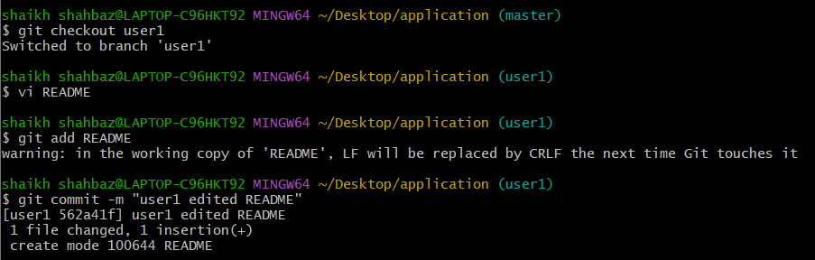
Now switch to master branch
git checkout master
Edit README file in master branch
vi README
edit one line “master edited README”
Then add and commit the changes
git add README
git commit -m “master updated README”
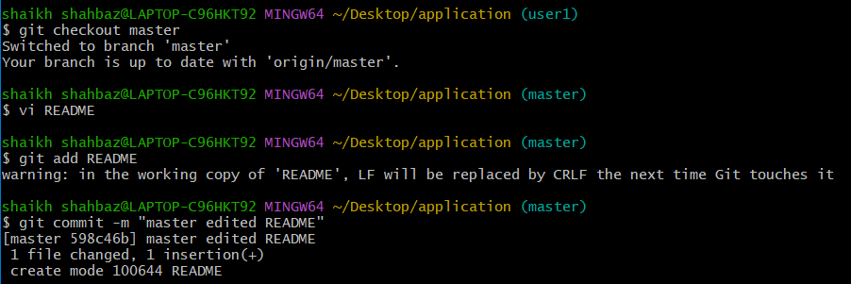
Now try to merge user1 into master
git merge user1
Here we can see merge conflict ------------------------------------------------
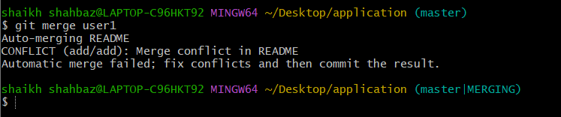
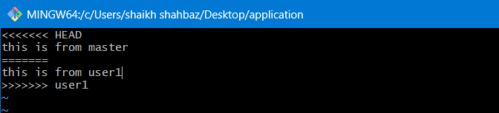
To resolve the merge conflict, we need to edit the file manually
“this is resolved content”
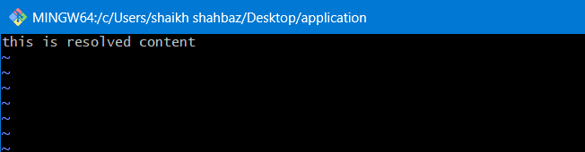

Now to complete the merge we need to add , commit and push to CR
git add README
git commit -m “resolved merge conflict in README”
git push -u origin master
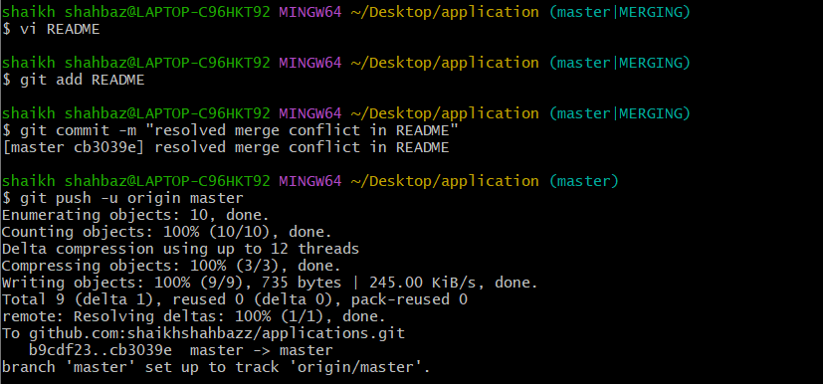
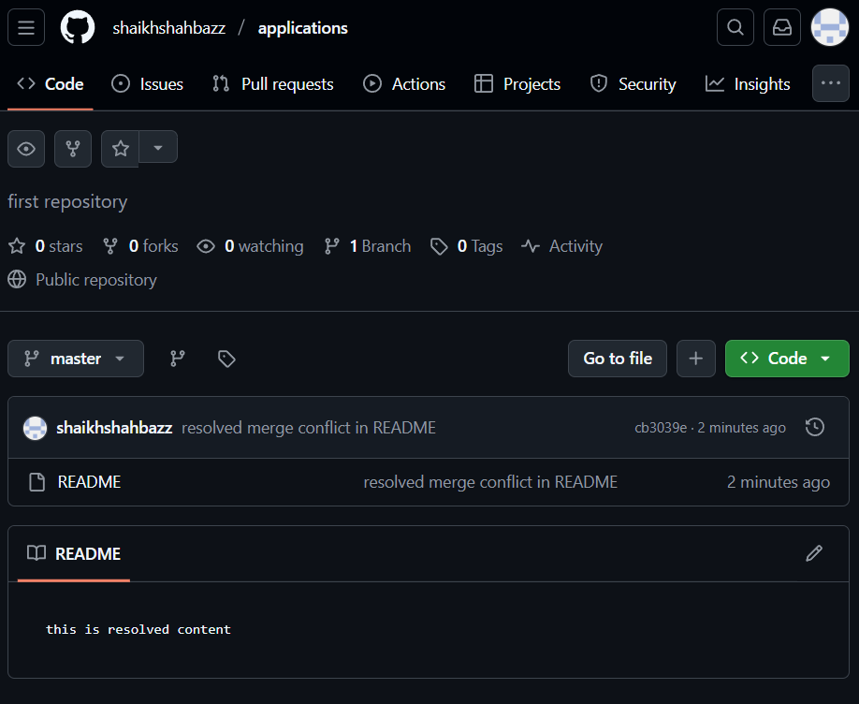
2. Recover Deleted Branch
Delete a local branch and then recover it using the reflog.

To delete a local branch use command
git branch -D user1
-D forcefully delete a branch even if it is merged or not
-d tries to delete a branch but stops if it is not fully merged
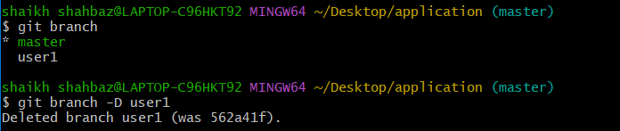
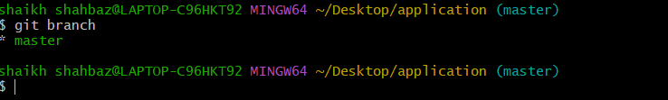
To find the deleted branch use reflog use command
git reflog ---- shows the deleted branch
Here we will look for the commit where user1 branch was last active
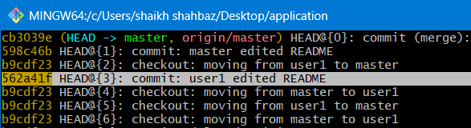
Now to recover the deleted branch user1 use command
git checkout -b user1_recovered <commit id>
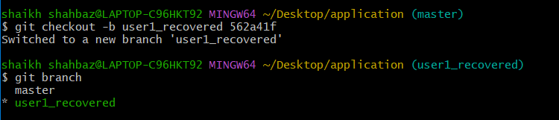
3. Undo Wrong Push
Push a wrong commit to GitHub, then undo it without losing history.

I am pushing a new commit to undo that commit
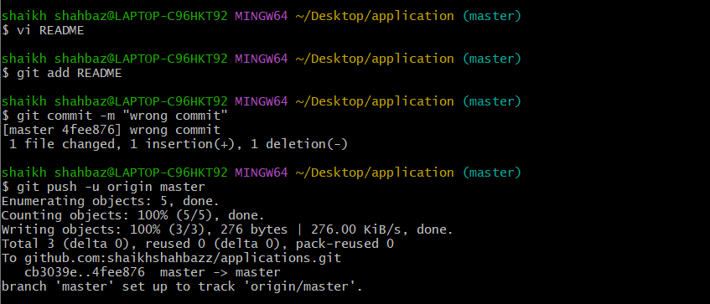

To find the commits use command
git log --oneline ---- shows the commits
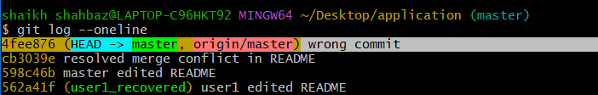
Now to revert that commit use command
git revert <commit id>

This will open an editor, close and save it
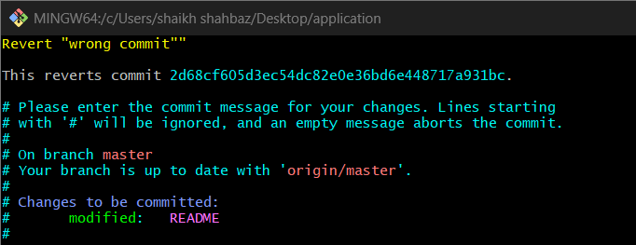
This new commit undoes the old commit in GitHub
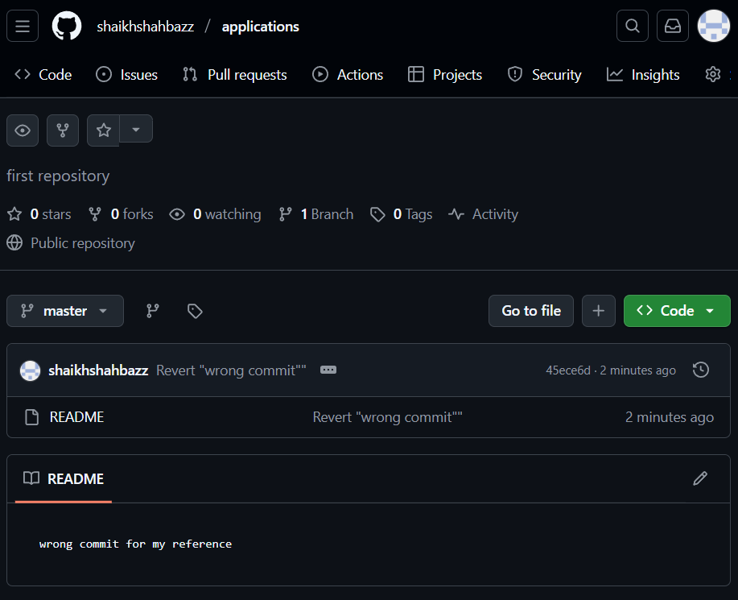

4. Amend a Commit
Make a commit, then add a missing file to it using git commit --amend.

Create a new file
echo “hello” > file1
Then add and commit the file1
git add file1
git commit -m “first commit”
git push -u origin master
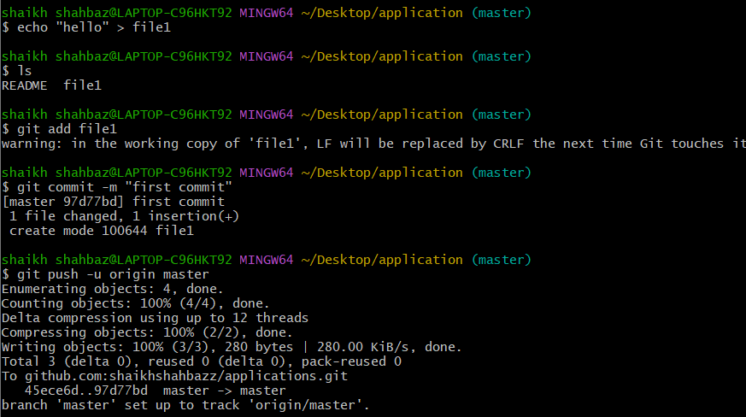
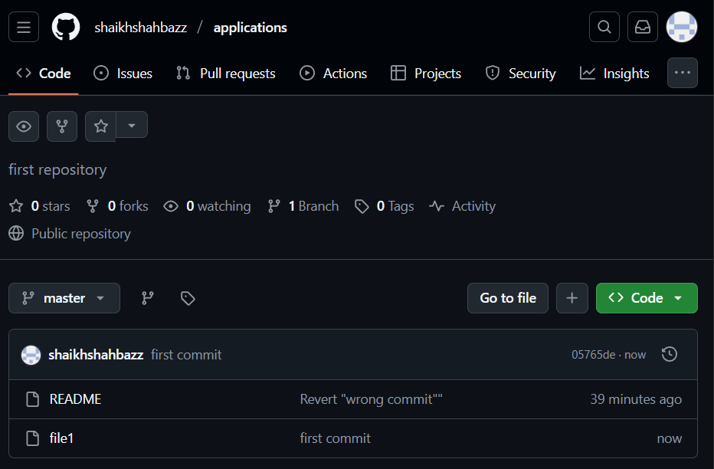
Create the file you missed to add to the commit
echo “this is missing file” > file2
Then add the missing file2
git add file2
Now to add this file2 to the previous commit with file1 use command
git commit --amend
This opens an editor just save and exit it
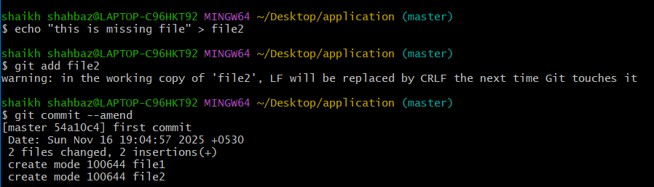
To check the commit use command
git log –oneline
It will show the same commit message as before, but now it contains both files.
If the commit is already pushed then you must force-push
git push –force
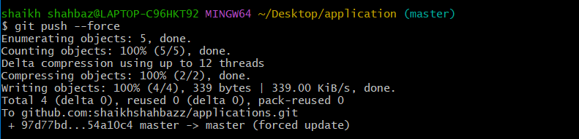
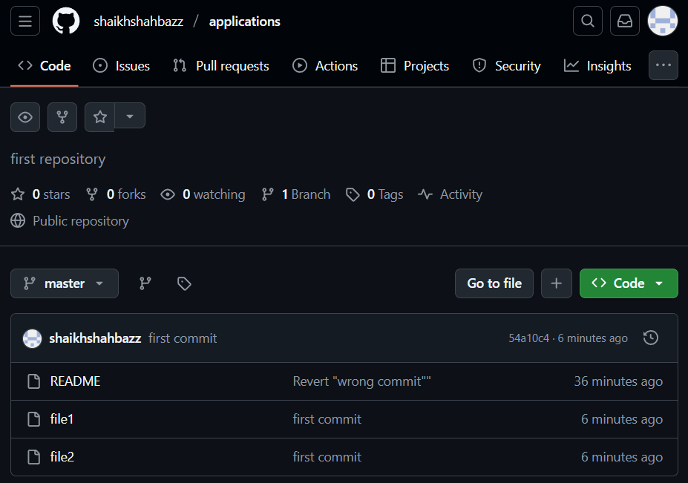

5. Cherry-pick a Commit
Take a specific commit from one branch and apply it to another branch.
Switch to the branch where you want the commit to be applied
git checkout <user1_recovered>
Go to the branch that has the commit you wanted
git checkout <master>
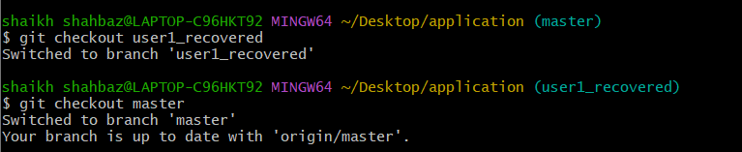

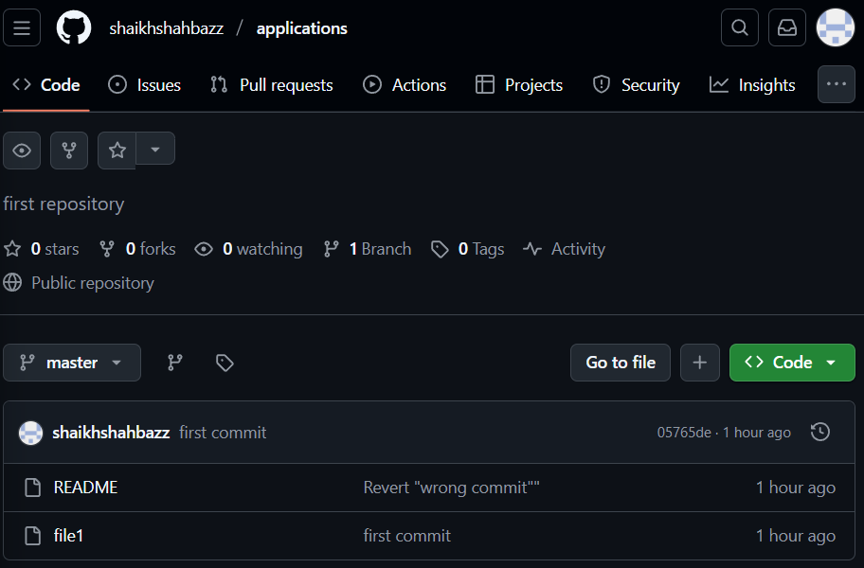
Then find the commit you want to copy
git log --oneline
Choose the commit you want -----------------------------
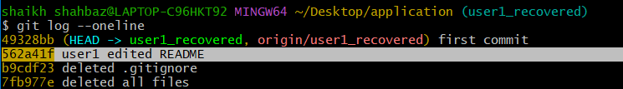
Go back to the destination branch user1_recovered
git checkout <user1_recovered>
Now cherry-pick the commit you selected to apply
git cherry-pick <commit id>
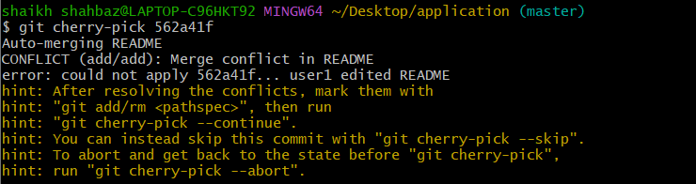
After resolving the conflict add README
Then do cherry-pick again
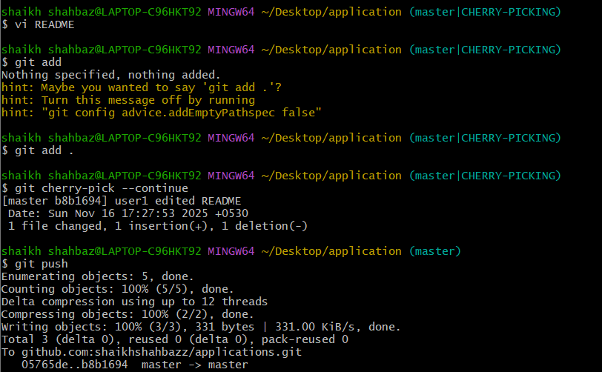
Push the changes to Central Repo
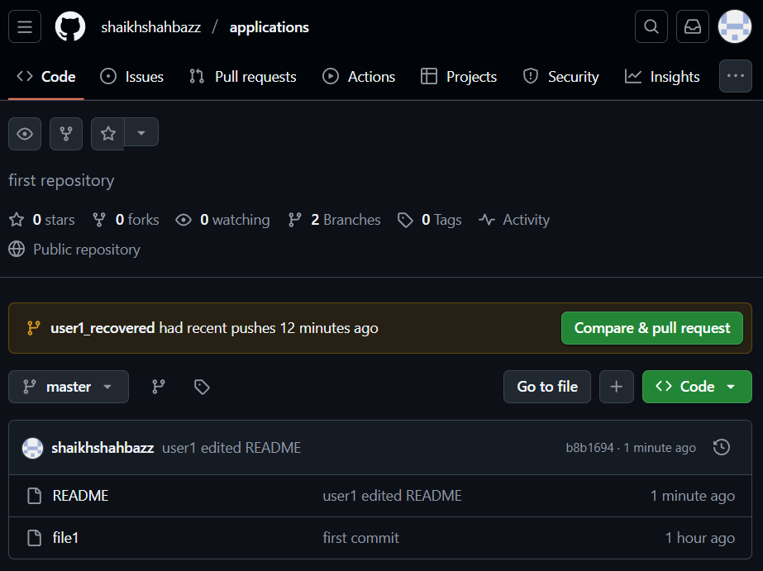
Here we can see that README file commit is changed from “Revert wrong commit” to “user1 edited README”

6. Interactive Rebase
Reorder and squash multiple commits into a single clean commit.
Create 3 – small commits
echo “line1” > file1
echo “line2” > file2
echo “line3” > file3
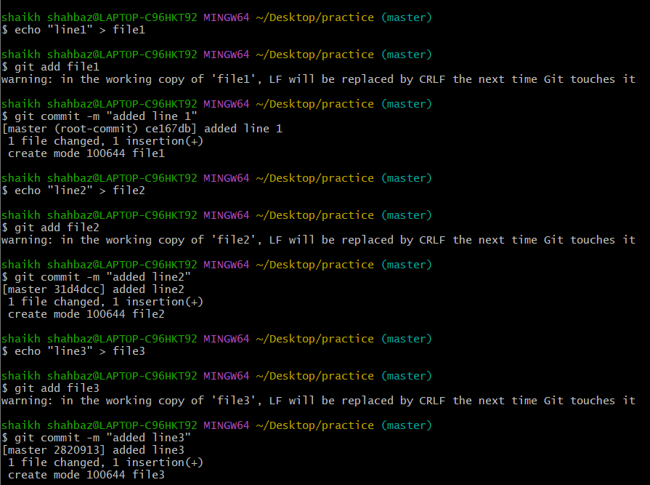
Now start interactive rebase
We want to squash the last 3 commits into 1 use command
git rebase -i HEAD~3
Change “pick” to “squash” for second and third commits
First commit is the base commit
Next two commits will be merged into first one
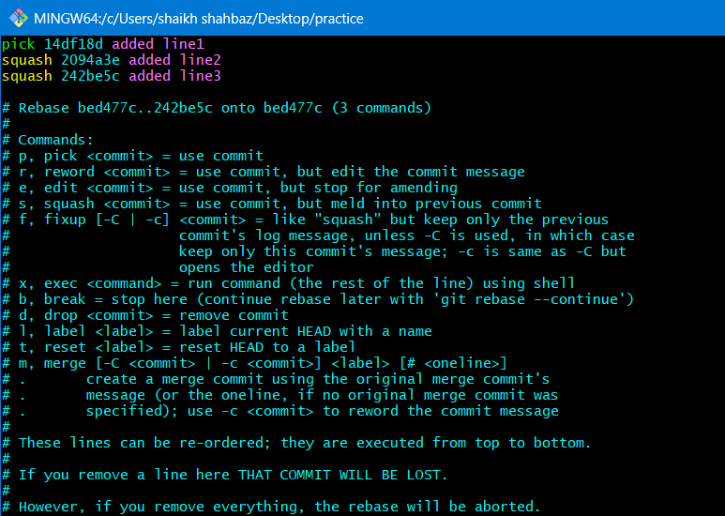
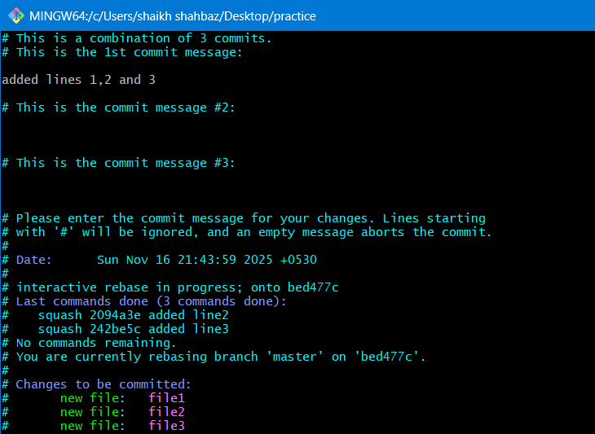
After that use command ------- git push
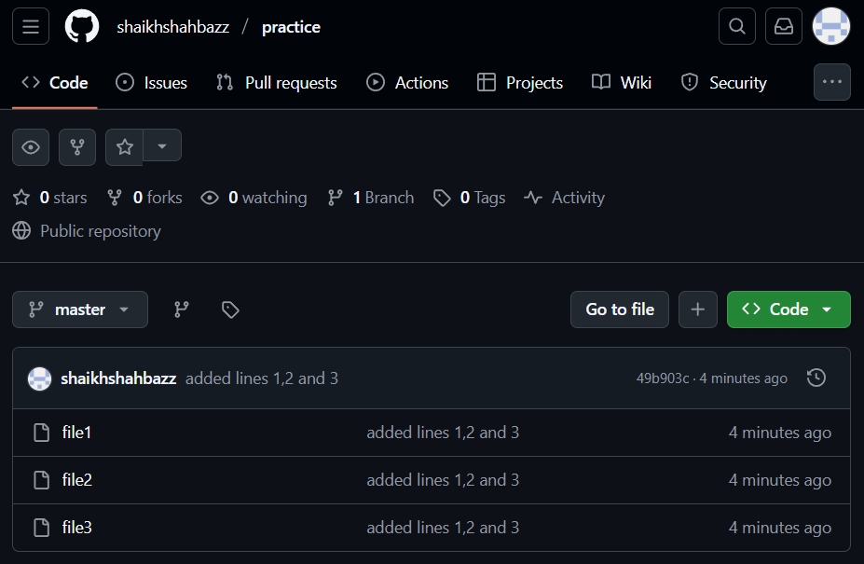

7. Tagging & Release
Create a version tag (v1.0), push it to GitHub, then delete and restore it.

Create a version tag (v1.0)
We can tag the latest commits like bellow
git tag v1.0
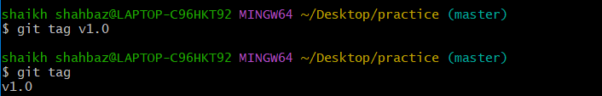

Then push the tag to GitHub use command
git push origin v1.0
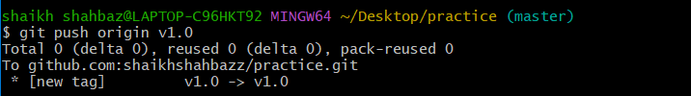

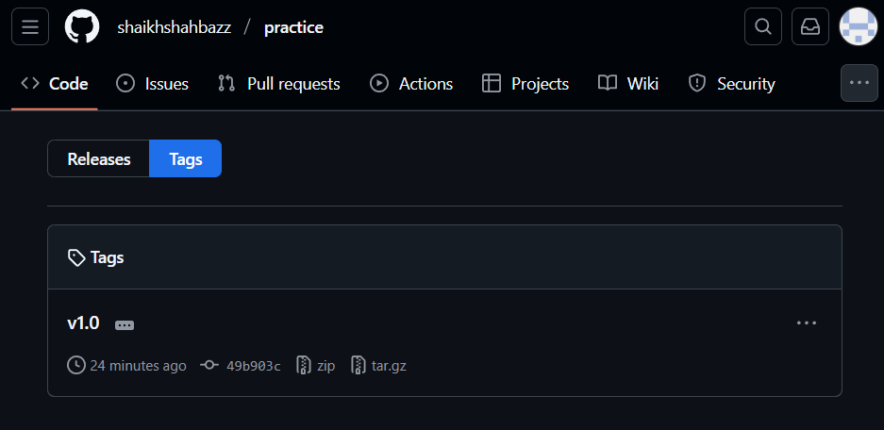
Delete the tag locally use command
git tag -d v1.0 ------ -d is used to delete
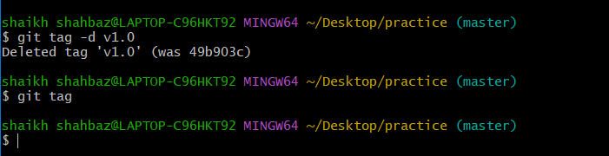

Now to delete the tag on GitHub use command
git push --delete origin v1.0
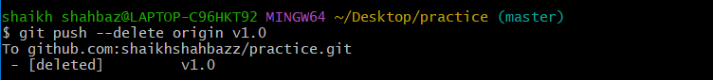
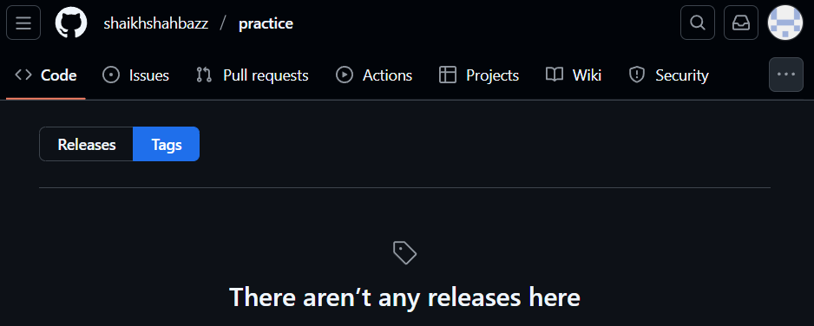

Since tags point to commits, restoring is easy. Just we need to recreate it again
To restore the tag use command
git tag v1.0
git push origin v1.0
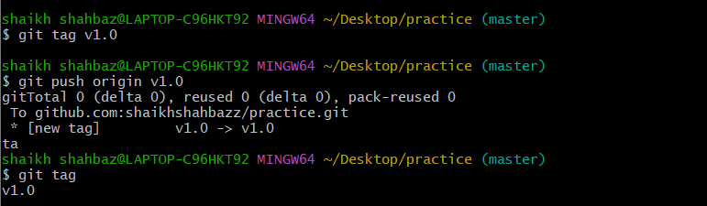
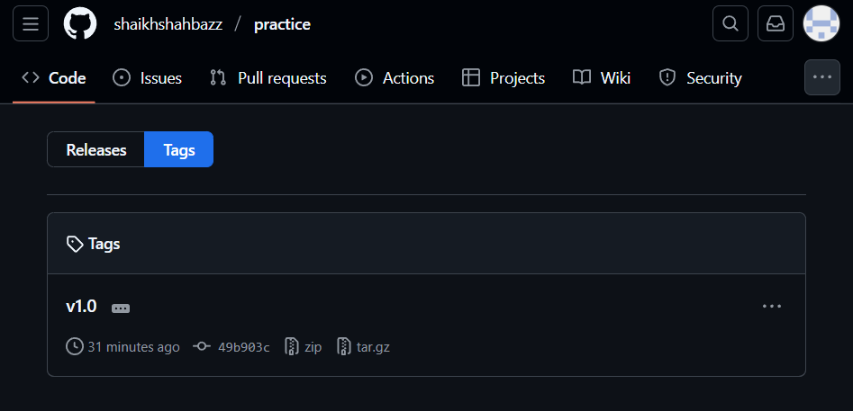

8. Clone with Sparse Checkout
Clone only a subdirectory of a repo using sparse checkout.

Clone the repository without files we use command
git clone –no-checkout <repo-url>
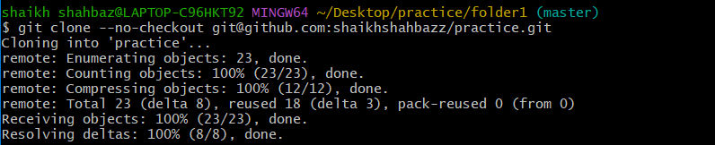
Enter the repository use command
cd practice ---- practice is repo name
Now enable sparse checkout use command
git sparse-checkout init --cone ----- this turns on sparse mode
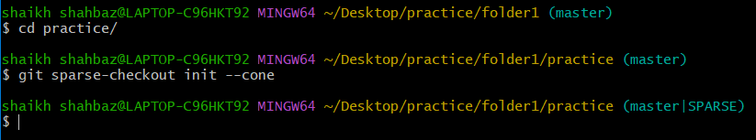
Now select the subdirectory you want use command
git sparse-checkout set folder1 ---- provide folder
Then pull the files from the GitHub use command
git checkout master ----- now git downloads only the selected folder
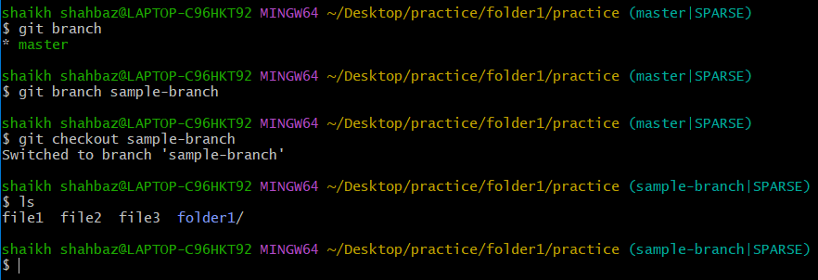
9. Reset vs Revert Challenge
Demonstrate the difference between git reset --hard and git revert in a repo.
----------------------
Git reset --hard :
----------------------
This removes commits from history and deletes the files
Reset to commit b ----- take the commit id of commit b
git reset --hard <commit b id>
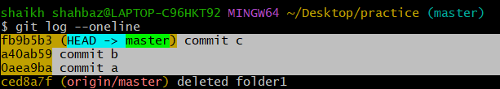
After reset commit c disappears from history
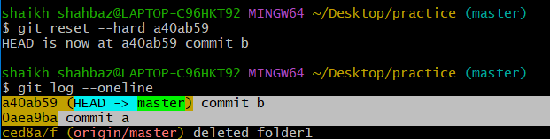
Now we must force push to GitHub use command
git push --force
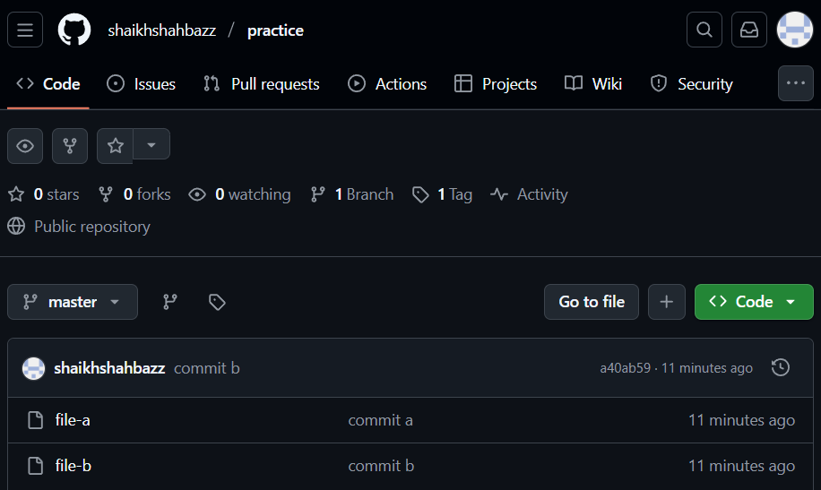
---------------
Git revert :
---------------
This is safe instead od deleting commits, Git creates a new commit that undoes the changes
Recreate file-c and commit it again
echo “c” > file-c
git add file-c
git commit -m “commit c again”
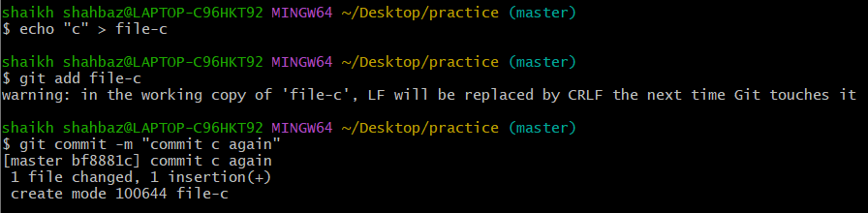
Now revert commit c use command
git revert <commit-id of c >
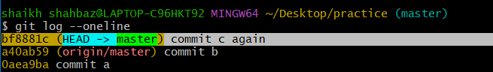
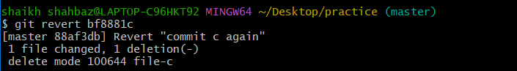
Git creates a new commit “commit c again”
Commit history remains ,file c will be removed abd safe for remote branches, no force push needed
git log --oneline
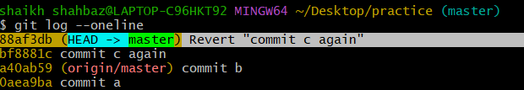
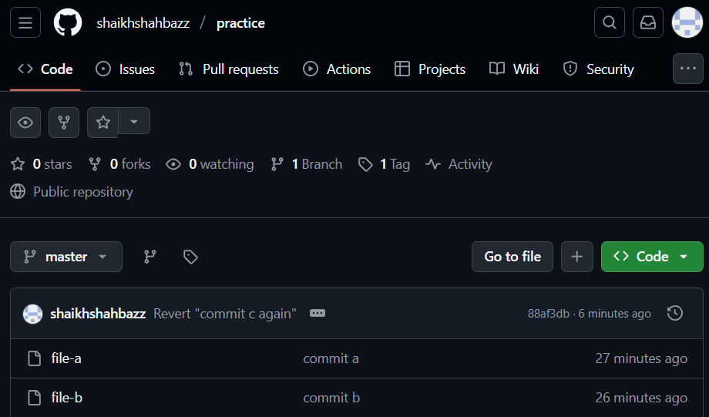

10. Detached HEAD Challenge
Checkout a specific commit (detached HEAD state) and create a new branch from it.
What is detached HEAD : it means you are not working currently working on a branch, but rather directly on a specific commit

View your commit history use command
git log --oneline
pick any commit u want to checkout
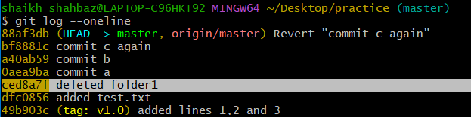
<Commit : ced8a7f deleted folder>

Now checkout that commit (detached HEAD) use command
git checkout <commit id>
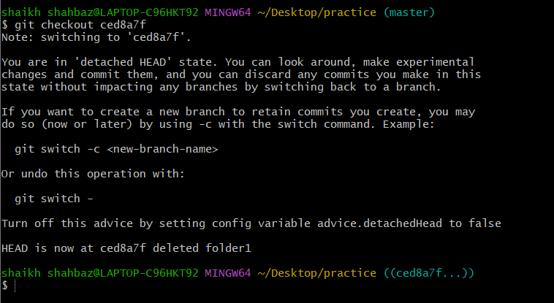
This means you are now in detached HEAD state
You are not on any branch
If you make any commits here they are “floating commits”
They will be lost unless you create a branch

Now create a new branch from this point
“This is the main part of the challenge”
git checkout -b floating-branch
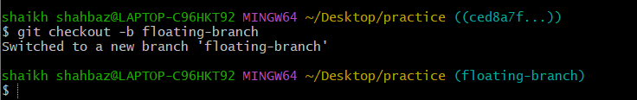
Now you are no longer detached, you have a proper branch
This branch starts from the old commit you selected, you can safely commit and push now

Make commit to test it:
echo “this branch starts from the older commit” > demo
git add demo
git commit -m “added demo file in branch from detached HEAD”
git push -u origin floating-branch ------ floating-branch is the branch name
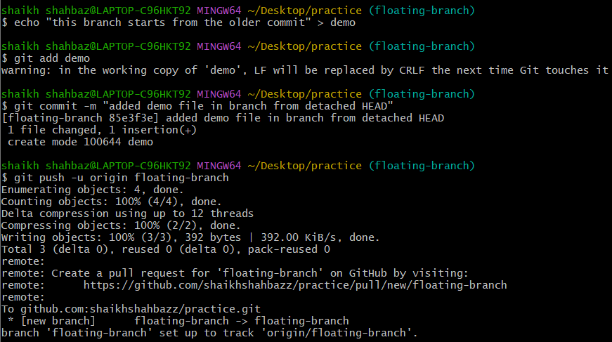
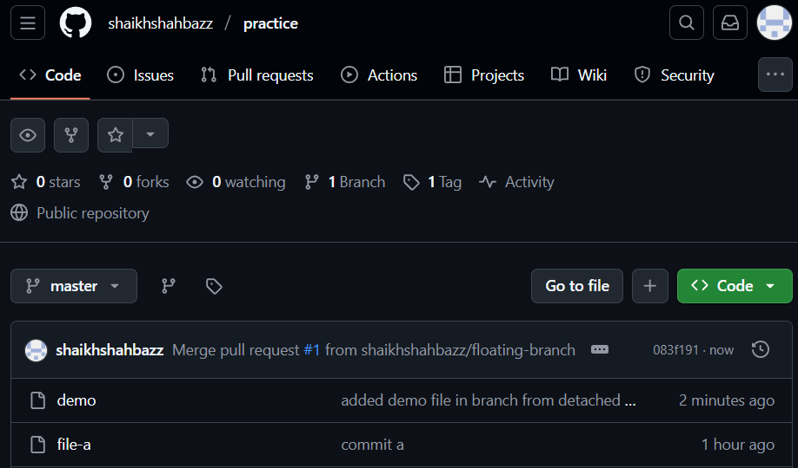

11. Git Hooks Challenge
Configure a pre-commit hook to reject commits without a message format (e.g., must start with JIRA-XXX).

Go to your repository
cd practice
Open the hooks directory use command
cd .git/hooks
create a new pre-commit hook file use command
touch pre-commit
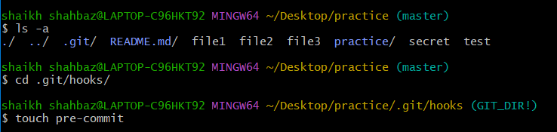
Add this script inside pre-commit
#!/bin/sh
commit_msg_file=$(git rev-parse --git-dir)/COMMIT_EDITMSG
commit_msg=$(head -n 1 "$commit_msg_file")
if ! echo "$commit_msg" | grep -Eq "^JIRA-[0-9]+"; then
echo " ERROR: Commit message must start with JIRA-XXX"
exit 1
fi
exit 0
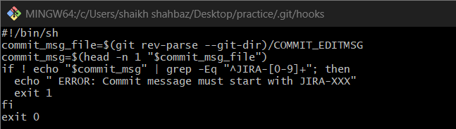
After allowing executable permissions to the pre-commit file
chmod +x pre-commit
git commit -m “JIRA-101: fixed login issue”
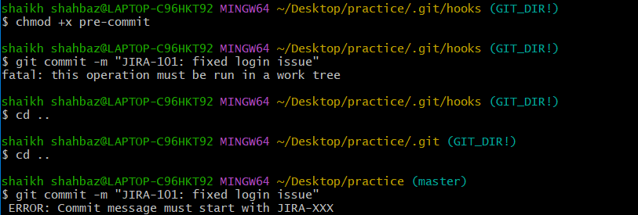

12. Squash Merge vs Rebase Merge
Show the difference between squash merge and rebase merge with evidence.

Squash merge :
Create a feature branch and add commits to it use commands
git checkout -b feature ---- creates a branch and switch to it

echo “line1” >> test
git add test
git commit -m “added line1”

echo “line2” >> test
git commit -m “added line 2”
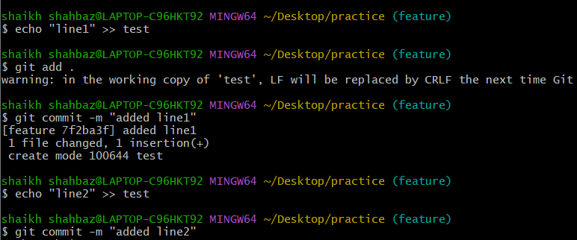
Now Switch back to main branch use command
git checkout master
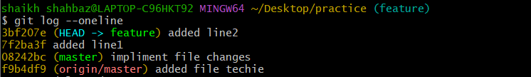

Squash merge the commits use command
git merge –squash feature
git commit -m “added lines 1 and 2 (squashed)”
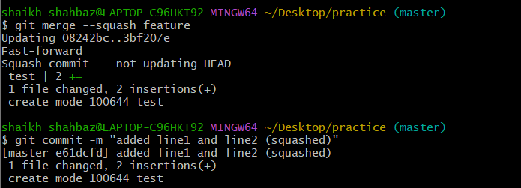
to see the commit history use command
git log –oneline
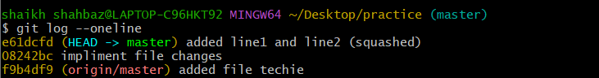
three commit became one after squash

Rebase merge :
Switch to feature branch use command
git checkout feature
git rebase master ------- this replays the 3 commits on latest main
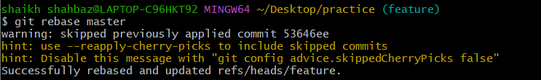
Now switch to master branch and merge feature branch
git checkout master
git merge feature
To see the commit history with graph use command
git log –oneline --graph

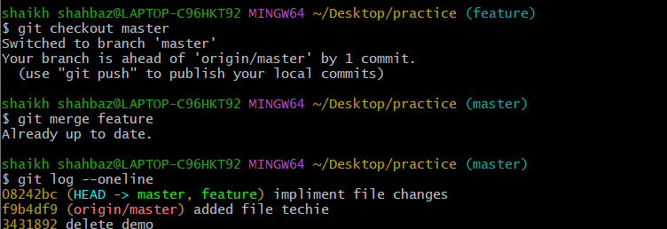

13. Fork & Pull Request Workflow
Fork a repo, make a change, and submit a pull request to the original repo.

Fork the repository
First Clone your fork use command
git clone <url>
create a folder project
cd README.md

Then add upstream remote use command
git remote add upstream <url>

then switch to feature branch use command
git checkout feature

Then add and commit the changes using command
echo “hello from shahbaz” >> newfile
git add .
git commit -m "added newfile"

Then Push to your fork use command
git push -u origin feature

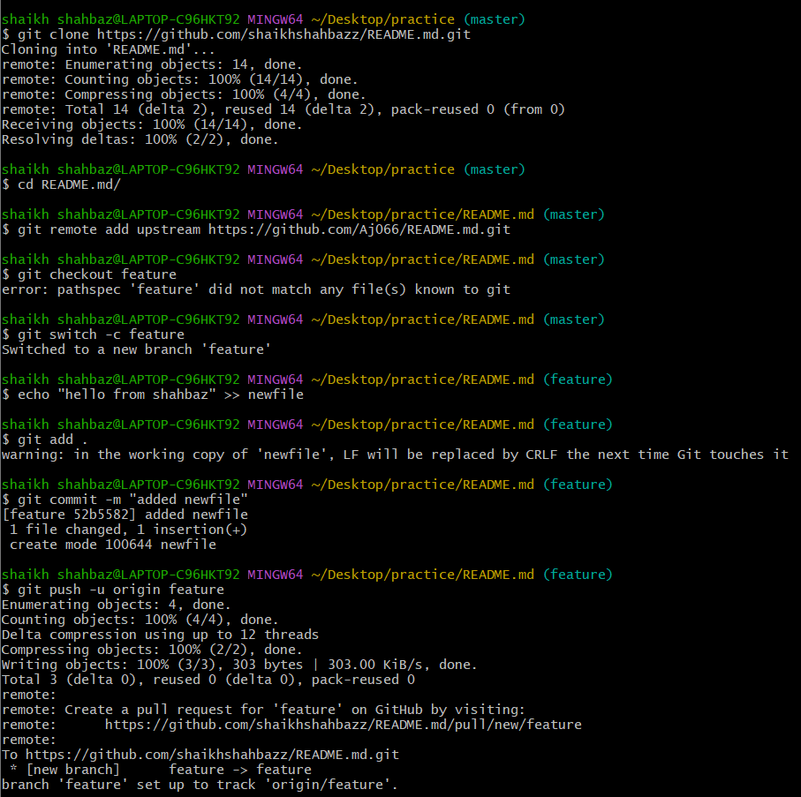

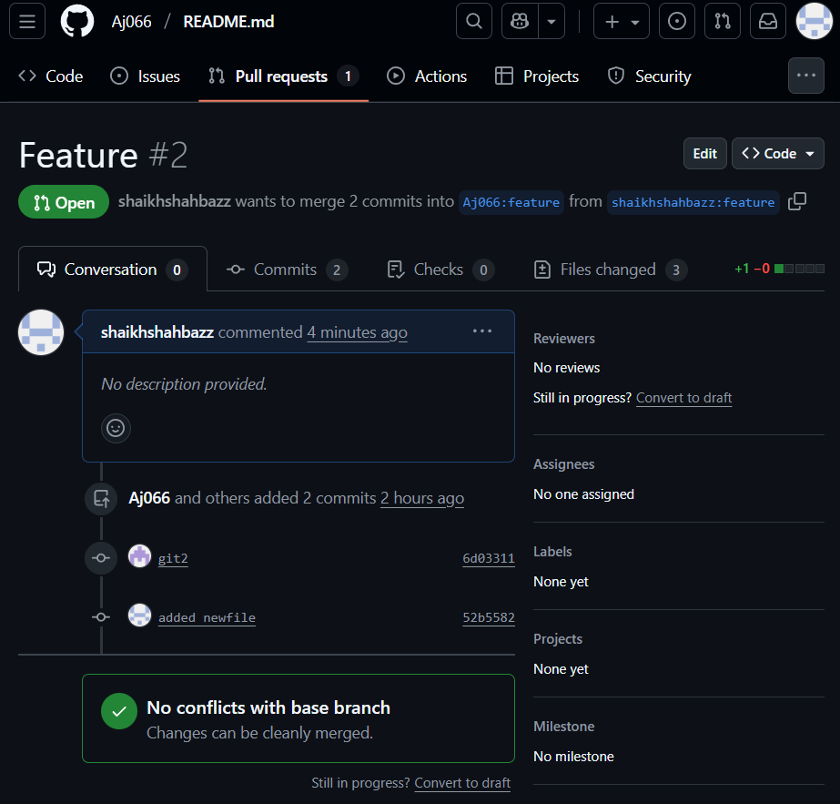
14. Recover Lost Commit
Commit something, reset hard, and then recover it using git reflog

Create a new file and commit id
echo “this is a secret commit” > secret
git add secret
git commit -m “added secret file”

Check your commit logs use command
git log –oneline
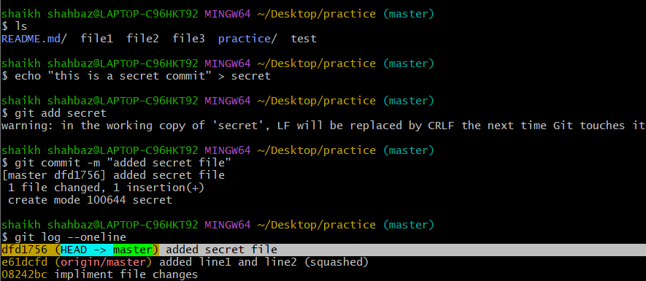
Now go back in history and loose commit
We will reset hard to previous commit use command
git reset –hard HEAD~1
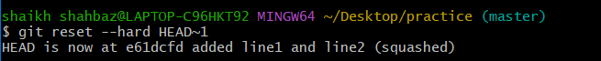
Then use git riflog to locate the lost commit
git reflog ----this command shows every moment of HEAD, even those removed by reset
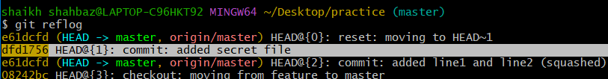
(find commit id of your lost commit)
Restore the commit as the head use command
git reset –hard <commit id>
Verify recovery use command
git log –oneline
ls
