Git -02 tasks
- Install git
Ans: To able to install the git need to visit the git page and download the git file and install it once it get install able to check through the command (git version)
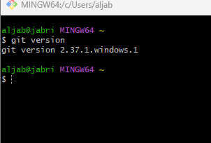

- Create a repo in github with README.md and .ignore file.
Ans: First we need to login to our github account and click to create new repository with the name of readme.md and .ignore file.
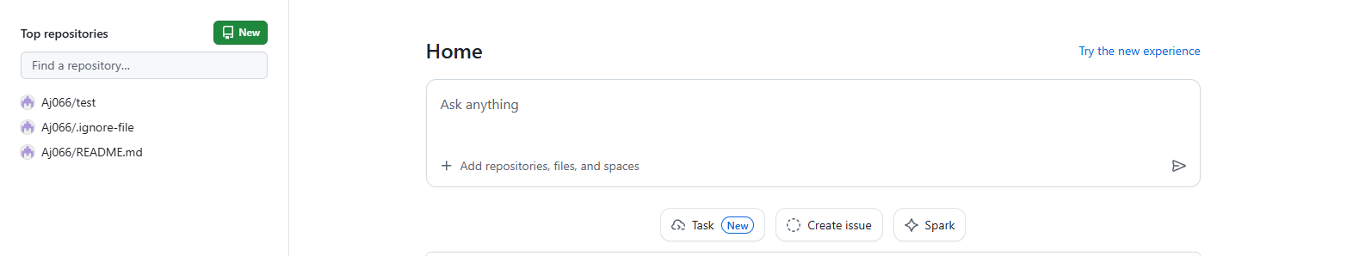

- Clone the created repo to local
Ans: to able to clone need to use the command used below
(git clone <ssh keygon link>) 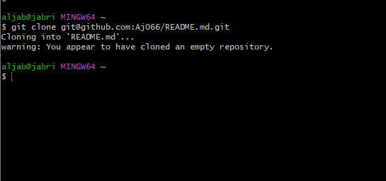

- Create two files in local repo.
Ans: need to use the touch command to create files
(Touch file name) and check with (git status) to able to move from untracking to tracking area use the command (git add files name ) 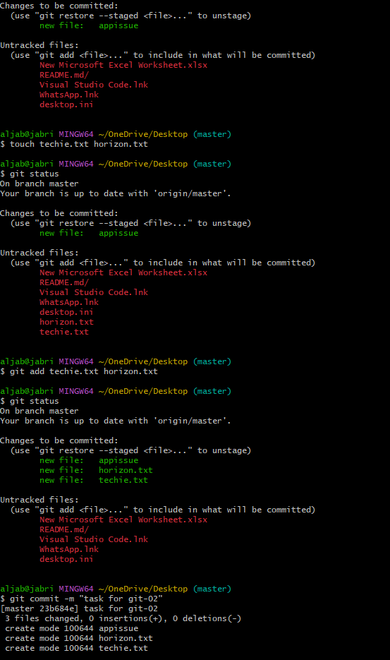
05: Commit two files and push to central Repository.
Ans: first need to use touch command to create files once it got created
then move to tracking area (git add .)
add a message by (git commit -m “message”)
then use the command to push in central repository
(git push ) 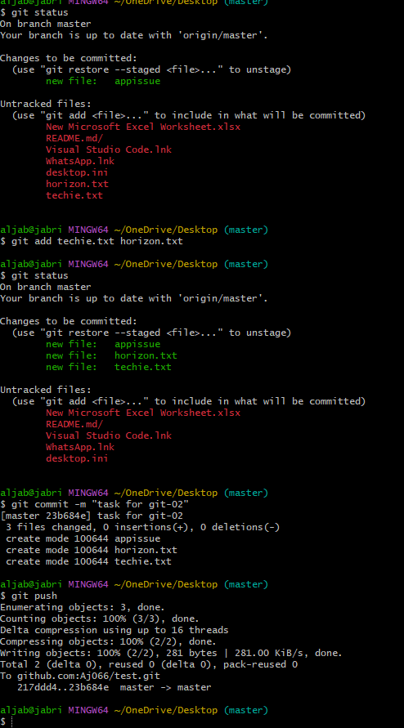
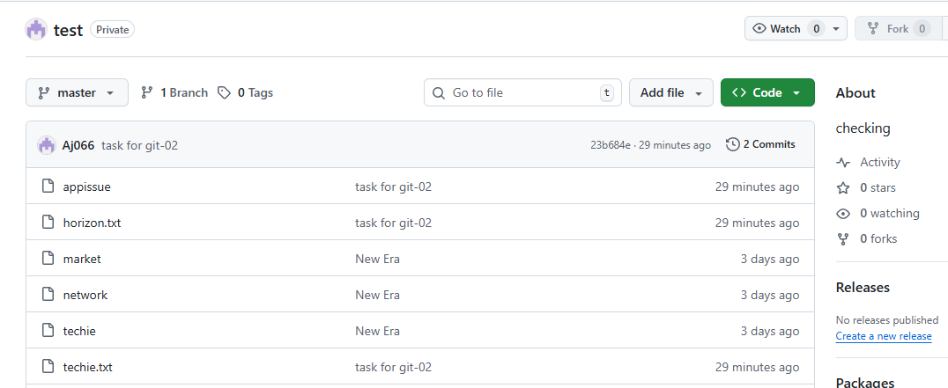

06.Create a branch in local and create a sample file and push to central.
Ans:First need to create branch with the command of (git branch name of breanch)
Then need to move to another branch with (git checkout branch name)
need to connect with the central remote with the help of command (git push --set-upstream origin release)once it get connect create the file with touch command and add message (git commit -m"message”) then push to central (git push)
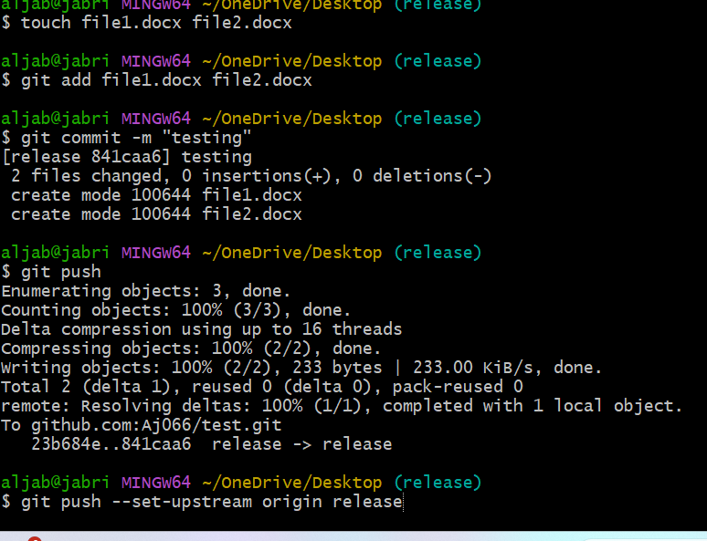 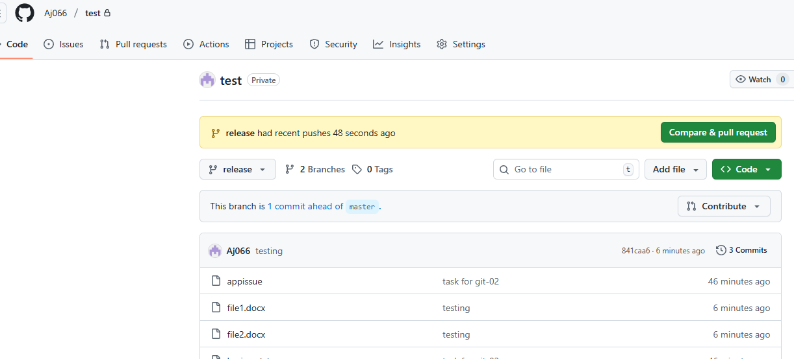

7. Create a branch in github and clone that to local.
Ans: Under the github need to click on branch Switch click to create new branch once it got created need to click on add file and create new files and save it now to able to clone specfic branch need to use the command of (git clone-b
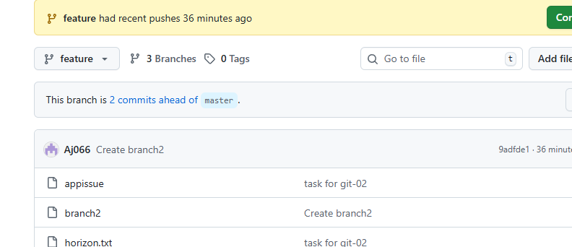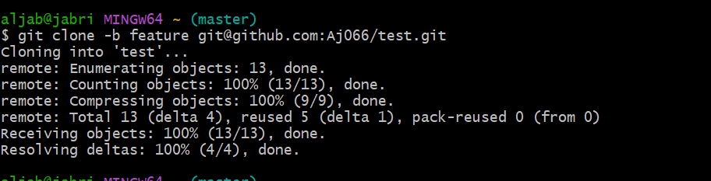

8. Merge the created branch with master in git local.
Ans: to able to merge the branch need to use the command of (git merge branch name)
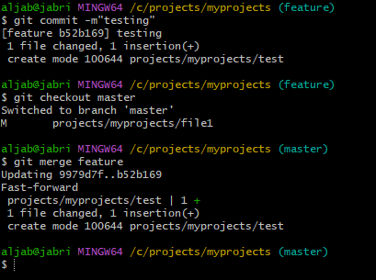

9. Merge the created branch with master in github by sending a pull request.
Ans: need to select the branch in github and then click on pull request selected the branches and clicked on the pull request 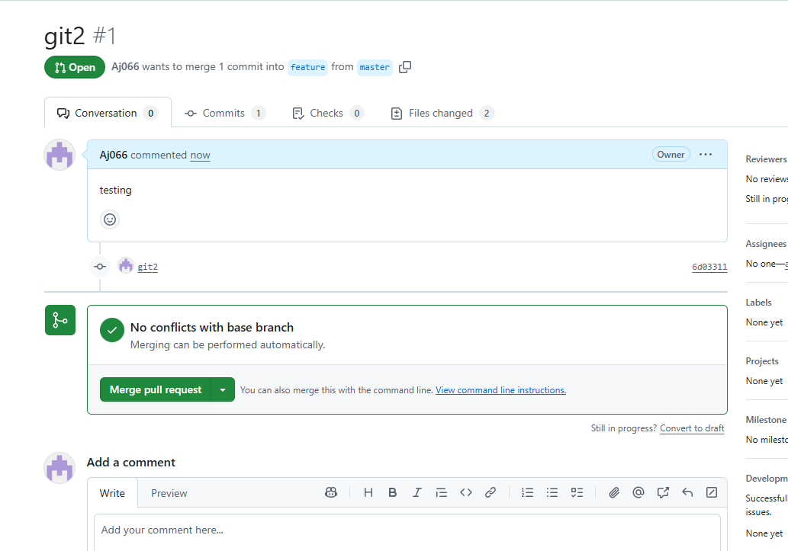
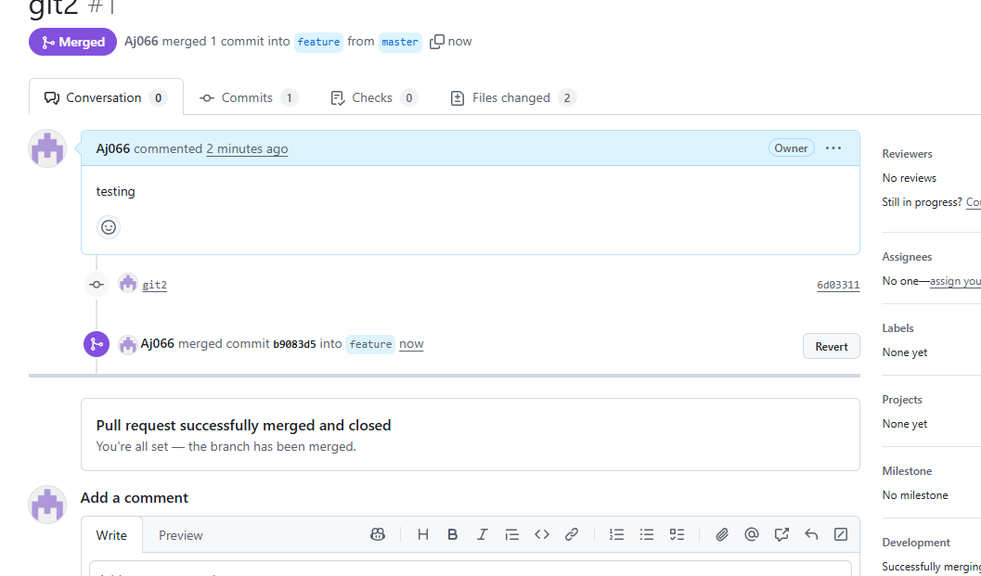

10. Create a file in local and send that to branch in github
Ans: by using touch command need to create file then use the command to bring file in tracking area and use the command to add message git commit -m”messgae” then use git push to run in github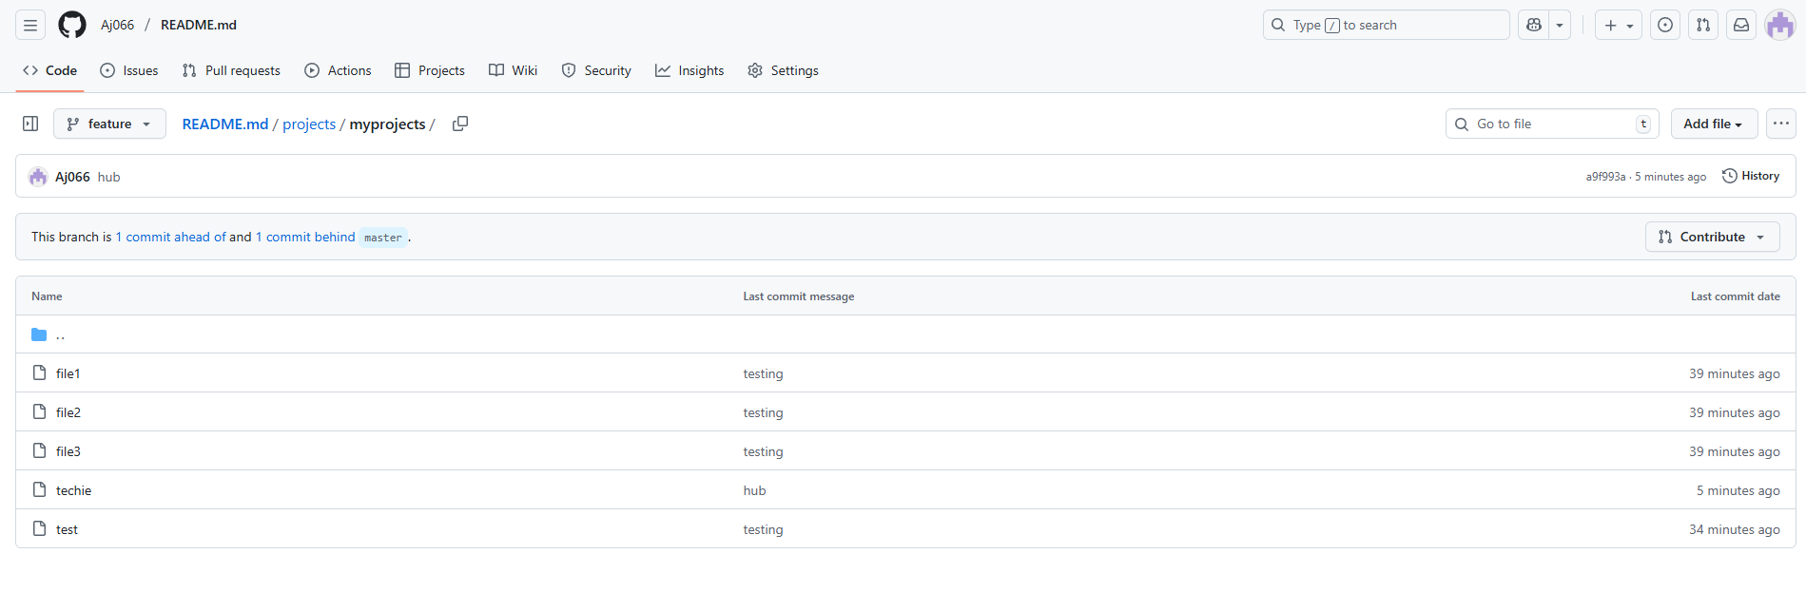

11. Clone only a branch from github to local.
Ans: To able to clone single branch need to use the command used below
(git clone --single-branch --branch future codelink)
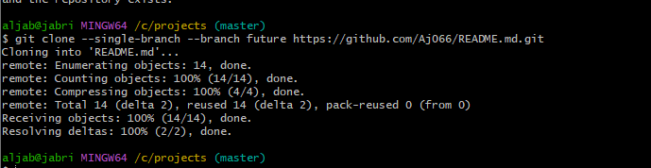

12. Create a file with all passwords and make that untrackable with git
Ans: first need to create a files with the name of passwords.txt make edit the file and save it hten create a file with the file name of .gitignore and entre password and save the file and check the status 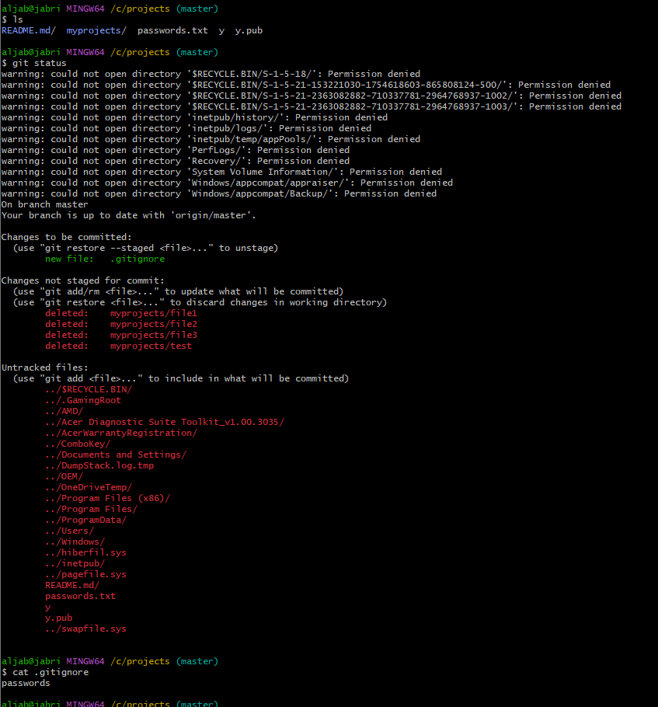

13. Make a commit and make that commit reset without savings changes.
Ans: first need to commit a file (git commit -m “message”) once it got commit need to use the command to reset (git reset –hard HEAD~1) 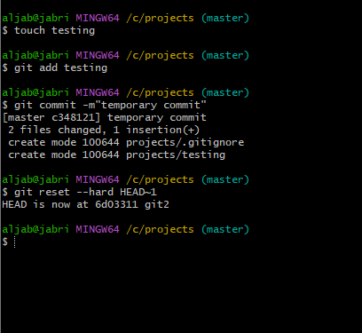

14.Revert a commited commit to the older version.
Ans: need to use the command (git revert log id) 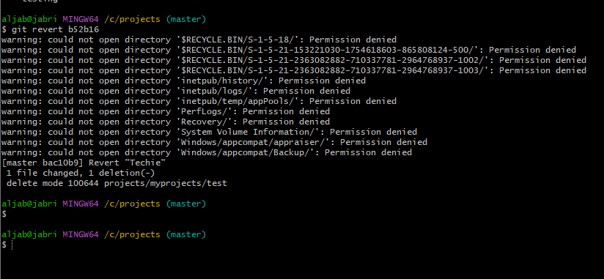

15. Push a file to stash without savings the changes and work on another file.
Ans: To able to stash a file without saving changes need to use command(git stash push -m "stash message" path/to/file)

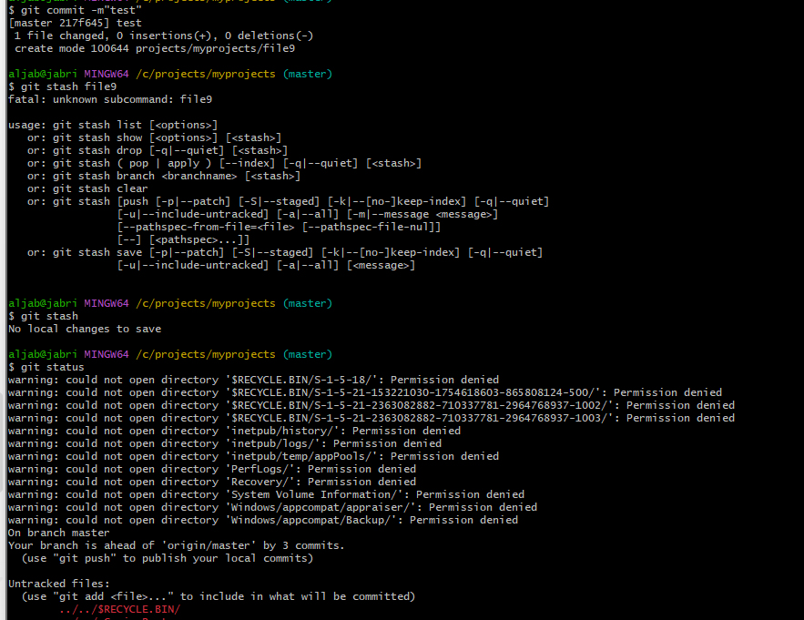
16. Undo the stash file and start working on that again
Ans: 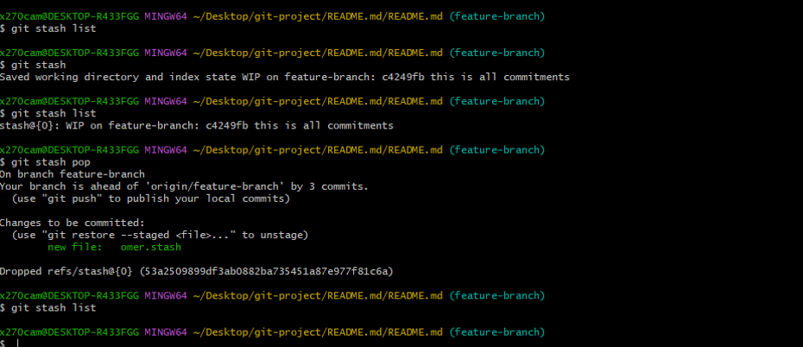

17. Generate a ssh-keygen and configure into github.
Ans: run the command (ssh-keygen) use the cat file and copy the public key and move the github add ssh key 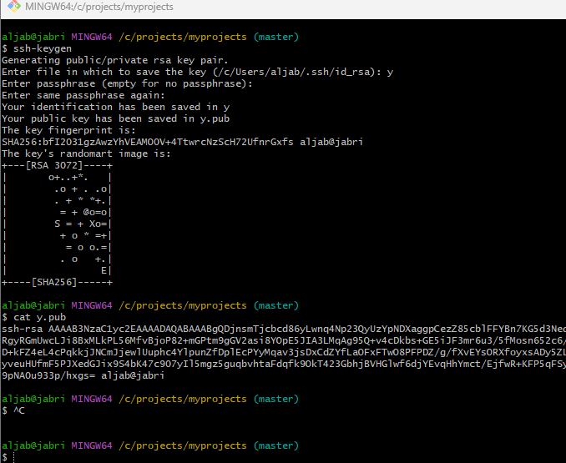 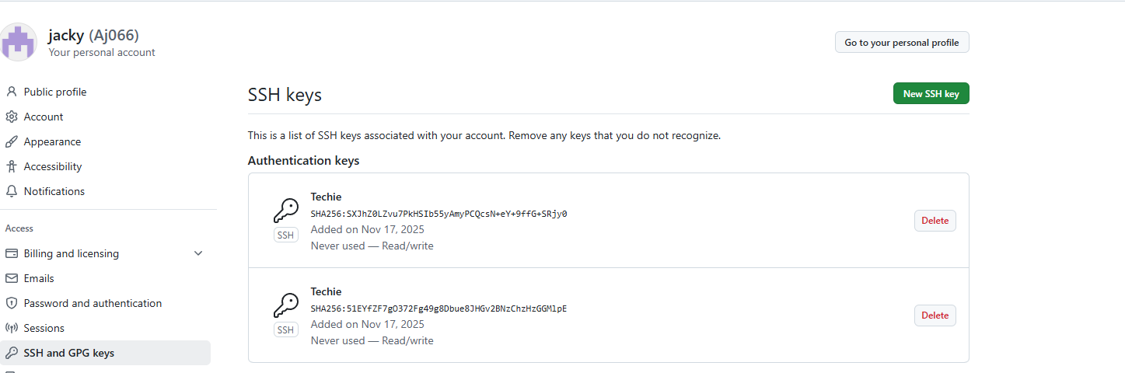

18. Basic understanding of .git file.
Ans: .git is a local repository which we initiate in our local when we start project.
#.git repository is the heart of our project. Because everything you are creating will be store in .git repo only.
#if you delete .git you have nothing related to you poroject.
# .git holds no of derectories and files by default.
What are the things available by default in .git.
*Head-
*configure file
*hook
*info
*logs
Thise will be available by default.
19. Check all the logs of git.
Ans: To able to check all logs use the command of (git log) 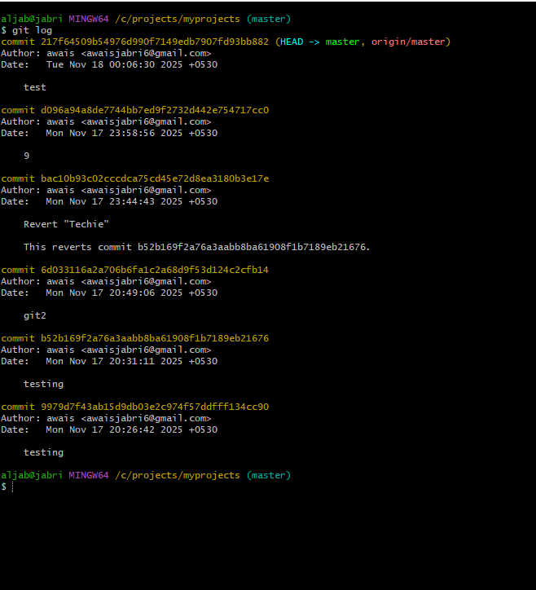
20. Rename the commit message
Ans: need to use the command (git commit --amend -m "New commit message") 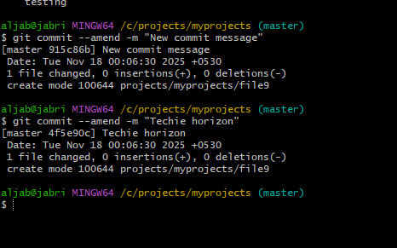

21. Merge multiple commits into single commit.
Ans: To able to merge the multiple commits need to use the command (git rebase -i HEAD~3) 