GIT-GITHUB-TASKS: Batch-16 Mohammed Mujahed

- Install git.
STEPS: to install git yum install git.
<git --version> tocheck which git version is using.
- Create a repo in github with README.md and .ignore file.
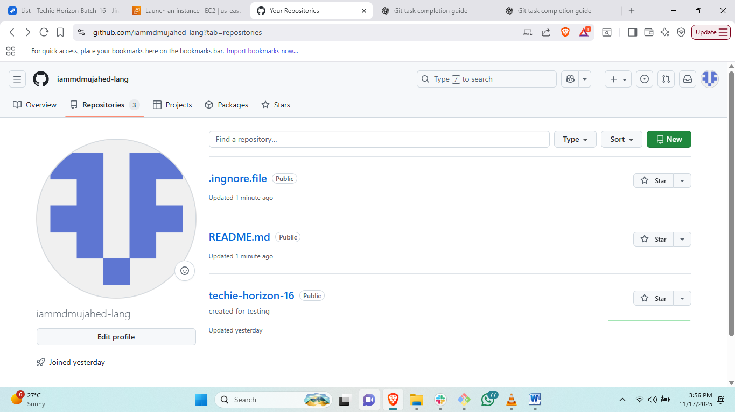
Steps: to create repository login to github account and click on repositories and add new
Then create new repository.
- Clone the created repo to local.
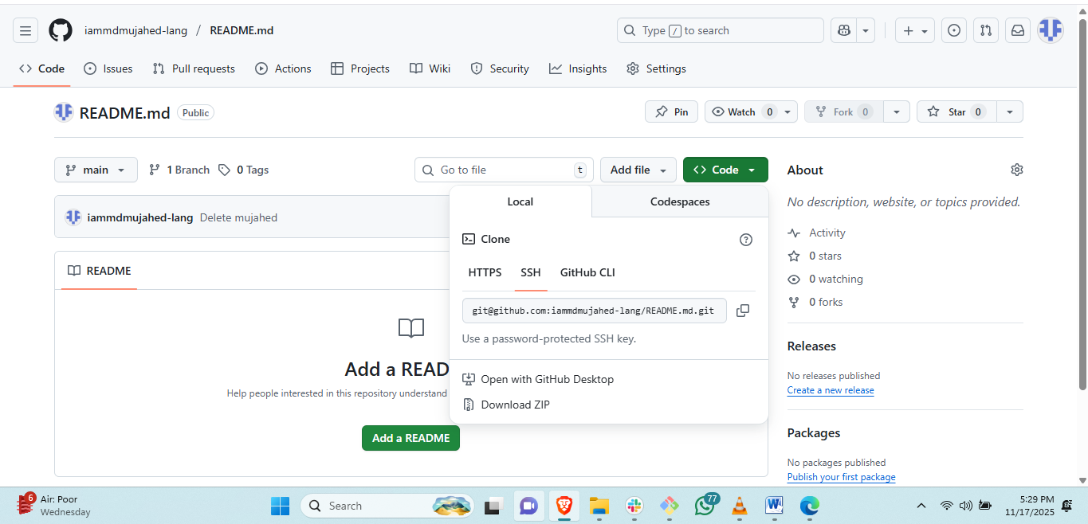
Go to created repo and copy ssh URL
then # <git clone “URL”> in local machine git.
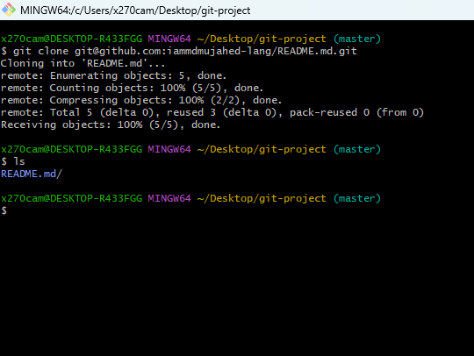
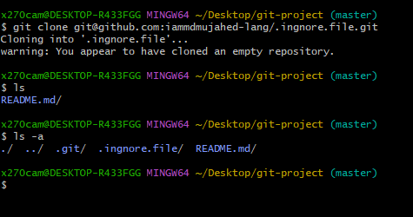
# the repository is started with .ignore.file will be hidden.
- Create two files in local repo.
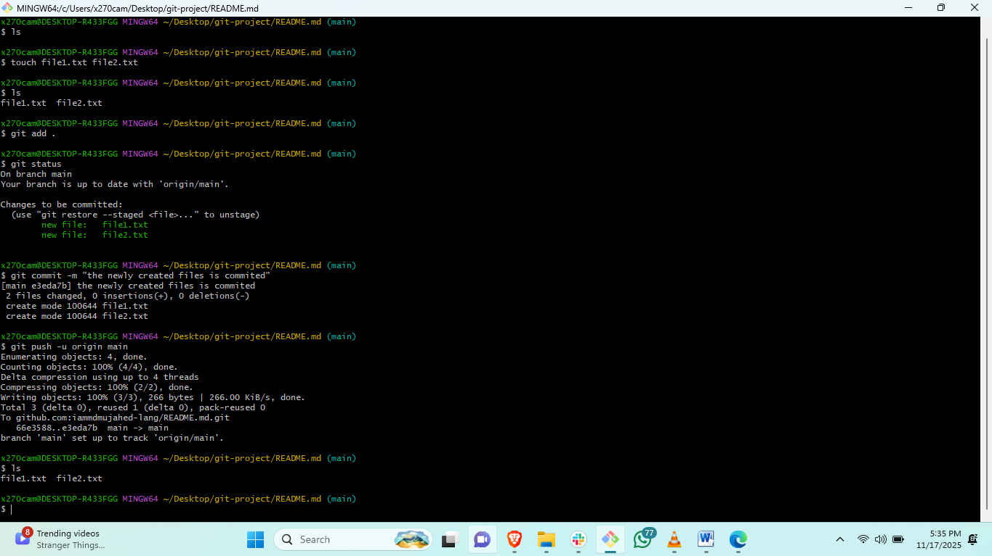
Steps: go to README.md directory and create two files with touch command.
# <git add file1.txt file2.txt>and commit the tracking files with <git commit –m “message”>
# <git push –ui origin main> to push the commited file to central repository
- Commit two files and push to central Repository.
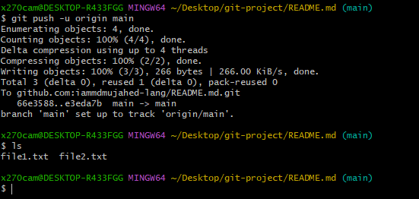
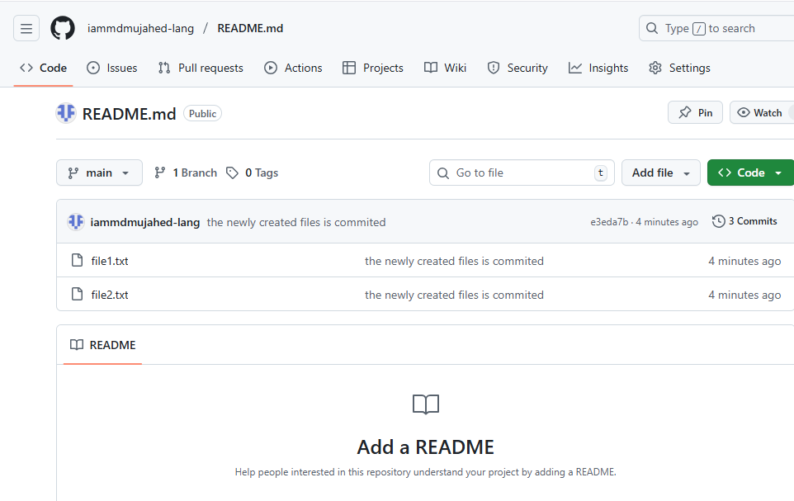
Steps: # <git push –ui origin main> to push the commited file to central repository
- Create a branch in local and create a sample file and push to central.
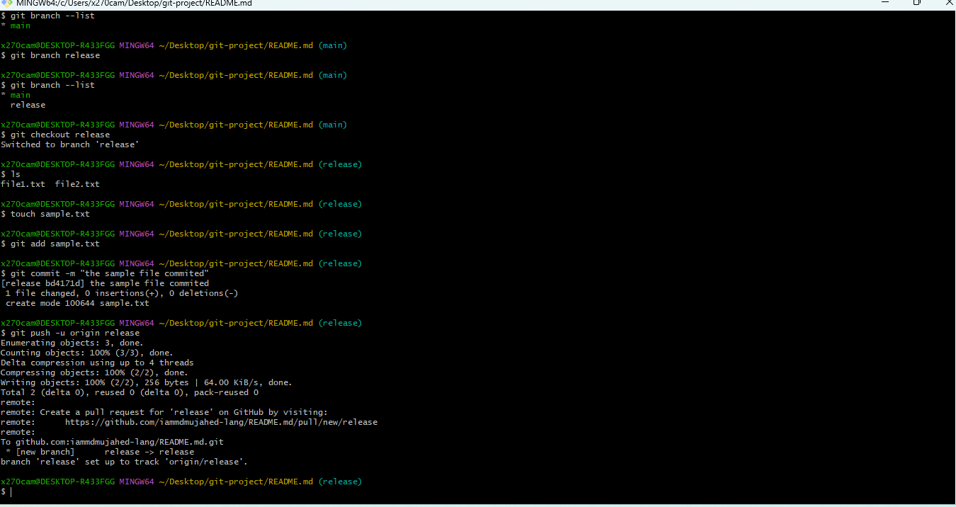
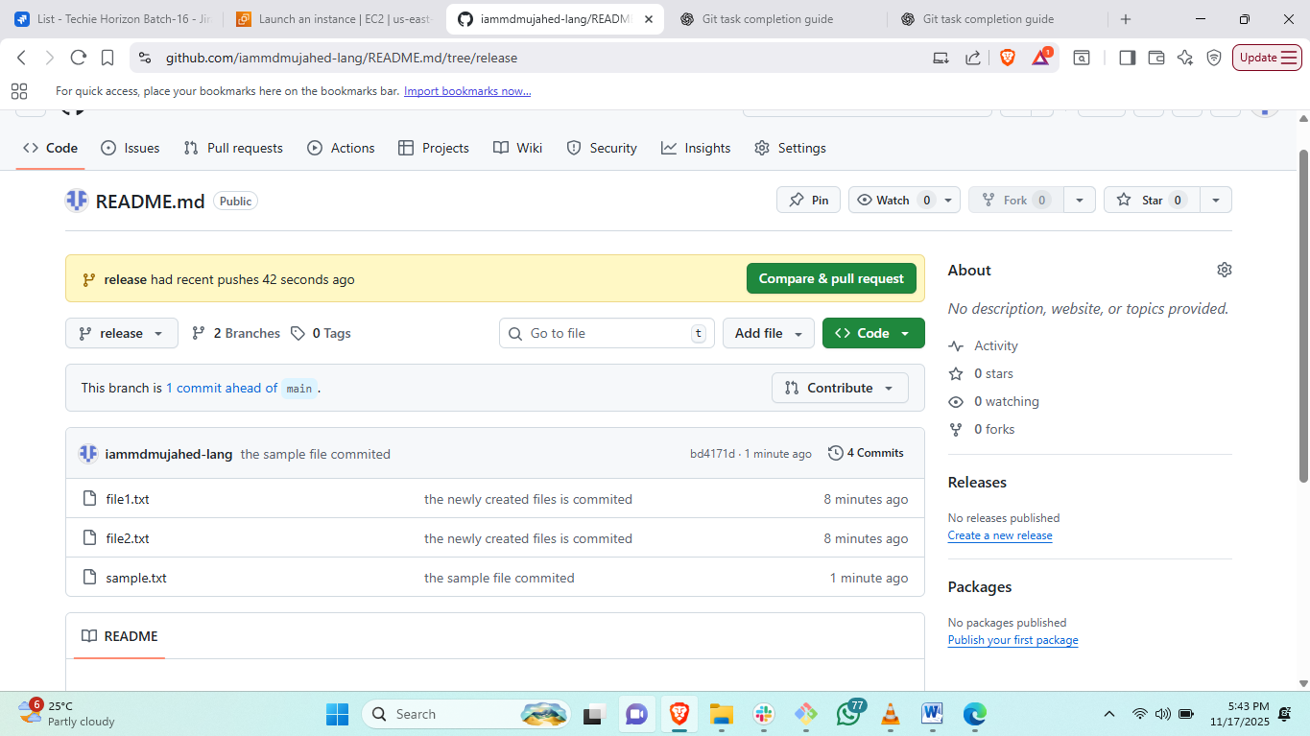
Steps: to create new branch <git branch “branchname”>
#to check the branch list<git branch --list>
# to switch to created branch <git checkout “branch name”>
#create a sample file and add to tracking area <git add .>
#then commit and push to origin branch name<git commit –m ><git push –u origin release>
- Create a branch in github and clone that to local.
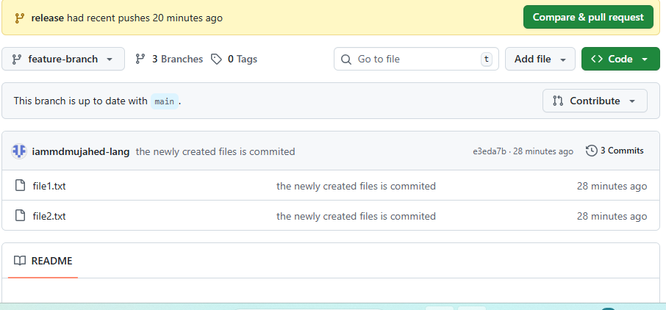
Steps: to create new branch from git hub go to git hub and create branch
# to clone the selected branch<git clone –-branch “branch name” repo url>
- Merge the created branch with master in git local.
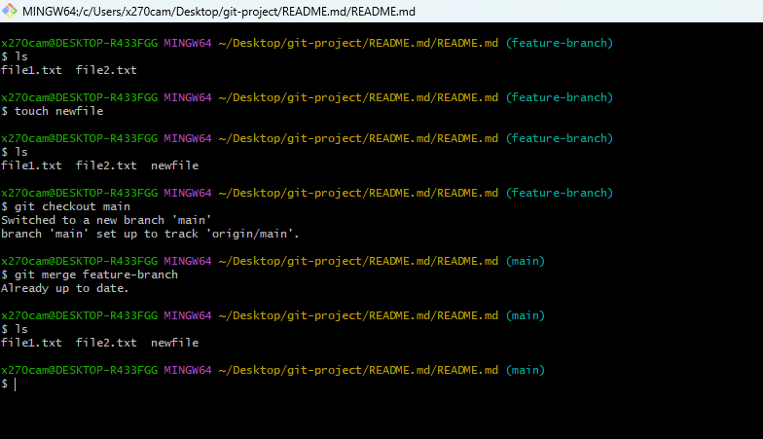
Steps: to merge newly created branch switch to main branch <git checkout main>
# git merge “branch name” to merge the branch
- Merge the created branch with master in github by sending a pull request.
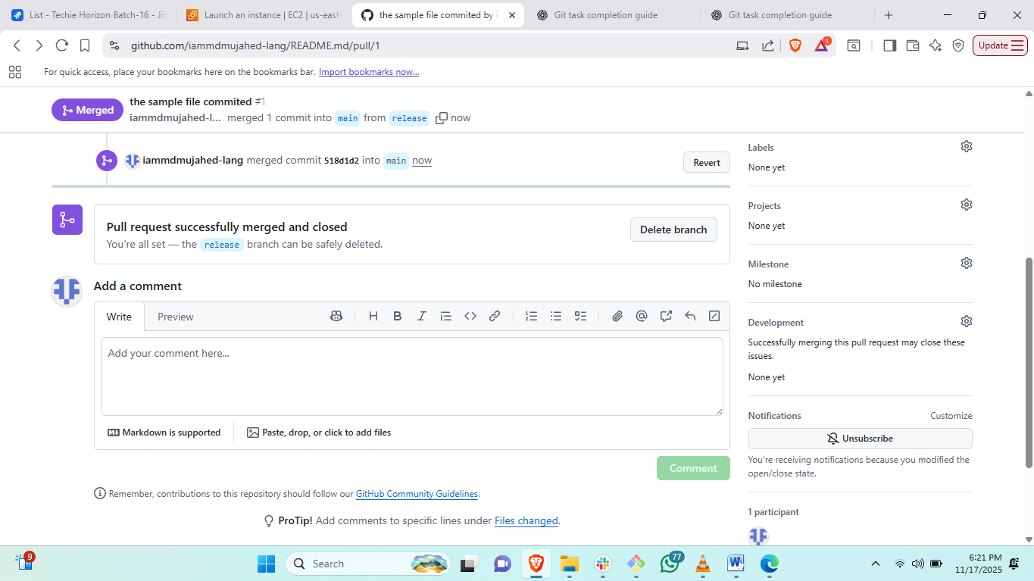
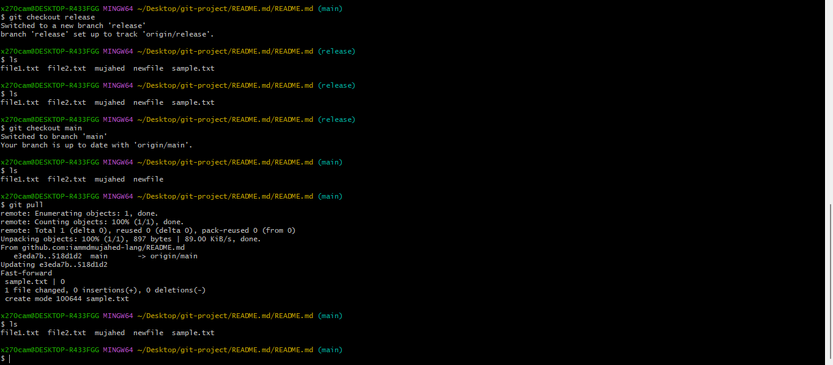
Steps: go to github account and create pull request and seleck branches which branch should be shared to each other and create pull .
#then go to local and change to main branch and<git pull>
- Create a file in local and send that to branch in github.
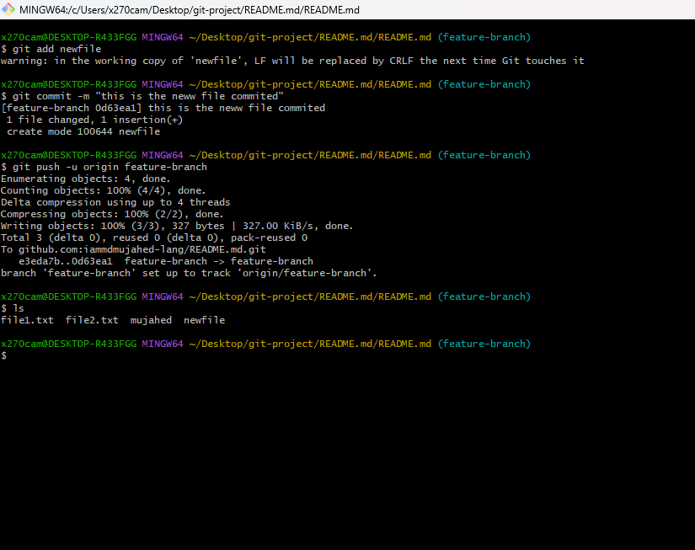
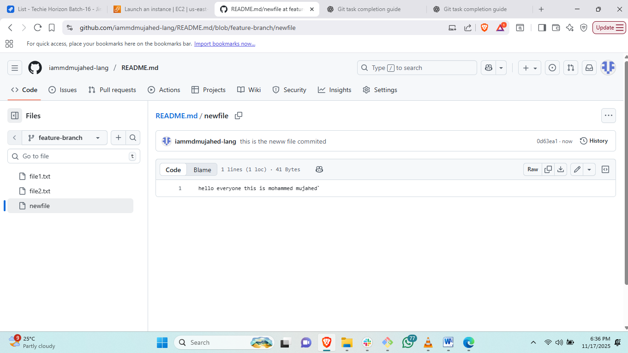
Steps: create a file in local and add to tracking area<git add .>
# git commit –m filrename
#git push –u origin branch-name
- Clone only a branch from github to local.
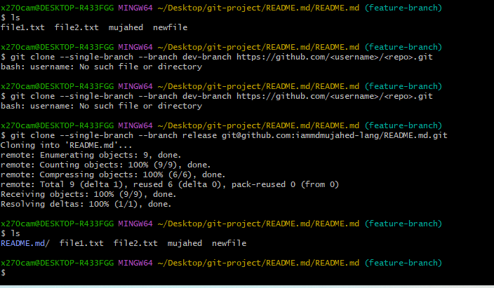
Steps: to clone the release branch to feature branch <git clone --single-branch --branch dev-branch https://github.com/<username>/<repo>.git>

- Create a file with all passwords and make that untrackable with git.
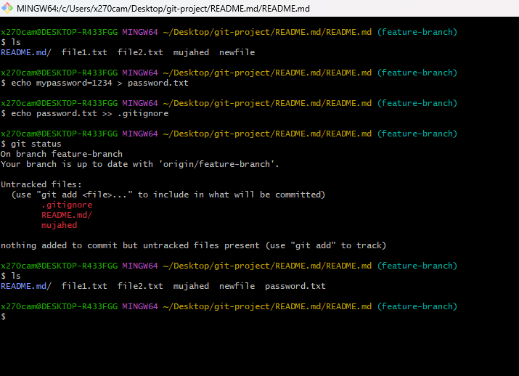
Steps: create password.txt file and create anethor file with .git.ignore
#then edit the file .git.ignore and add the file name password file name.
#then look for <git status>
- Make a commit and make that commit reset without savings changes.
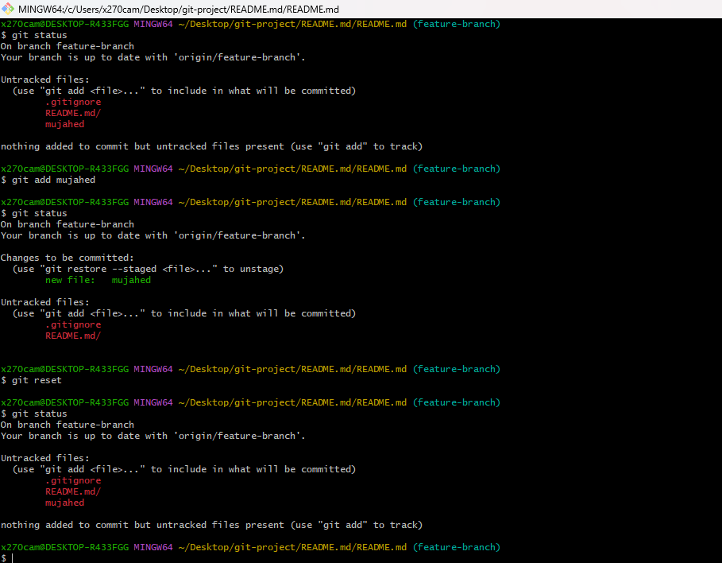
Steps:to reset the file from tracking area to untracking area.
Git add <filename>
Git status: then git reset to move back to untracking area.
- Revert a commited commit to the older version.
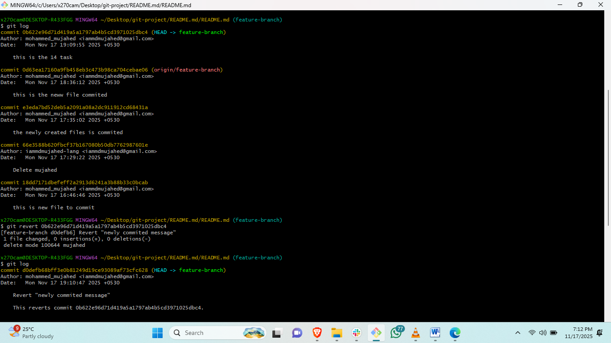
Steps: to revert the commit we need to check the commit id by<git log>then
#git revert <commit id> then edit the commit message. And save file
- Push a file to stash without savings the changes and work on another file.
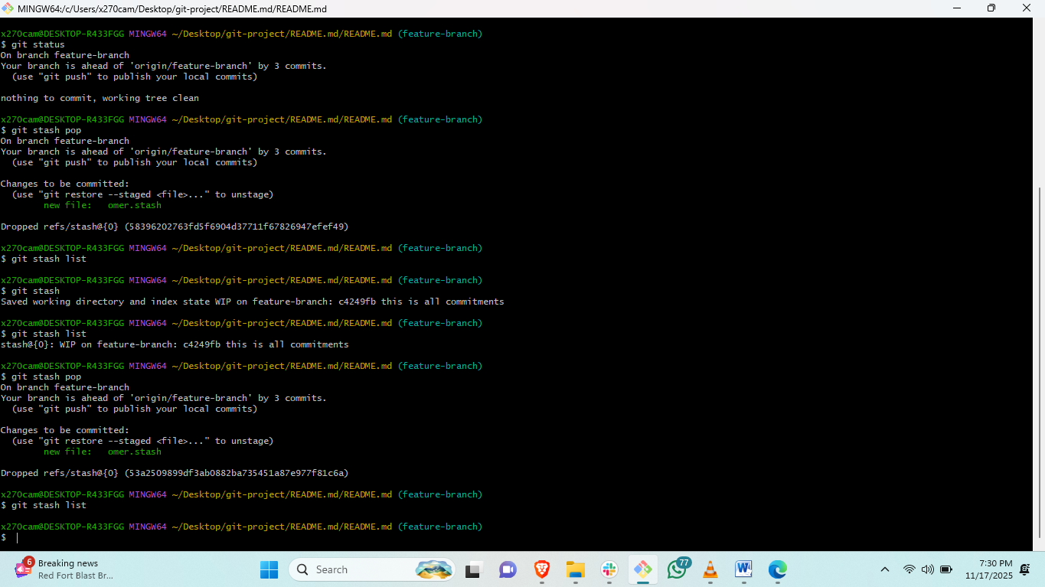
Steps: create a file and add to tracking area<git add filename>
# then check status <git status>
#<git stash>
#git status and check ls it will save in stash memory.
#<git stash pop>
- Undo the stash file and start working on that again.

- Generate a ssh-keygen and configure into github.
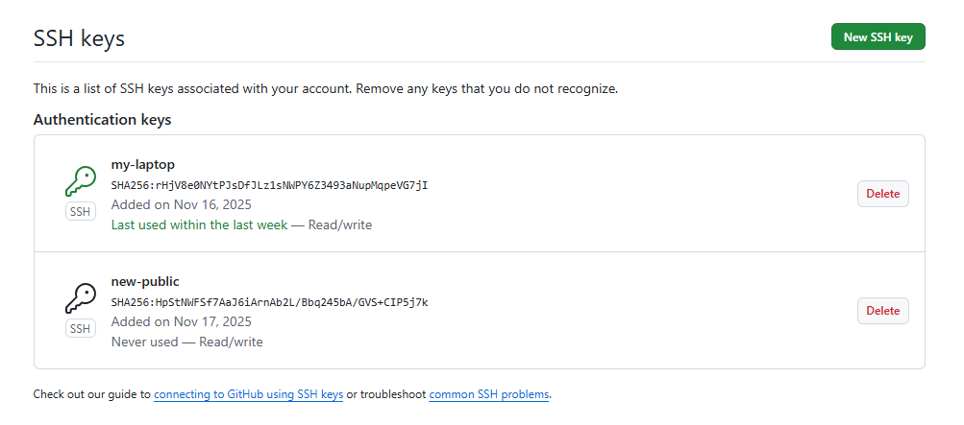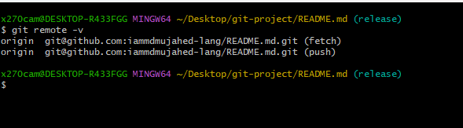
Steps: firstr generate ssh-keygen<ssh-keygen>and copy public key and go to github.
#go to setting and click on ssh and add ssh remote and paste public key.
#and go to gitbash and check <git remote -v>
- Basic understanding of .git file.
#.git is a local repository which we initiate in our local when we start project.
#.git repository is the heart of our project. Because everything you are creating will be store in .git repo only.
#if you delete .git you have nothing related to you poroject.
# .git holds no of derectories and files by default.
What are the things available by default in .git.
*Head-
*configure file
*hook
*info
*logs
Thise will be available by default.
- Check all the logs of git.
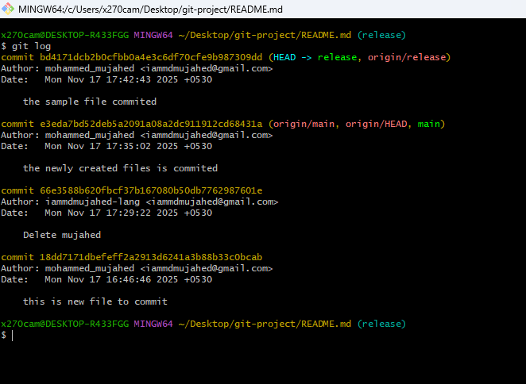
Steps: to check the log files in git <git log>
- Rename the commit message.
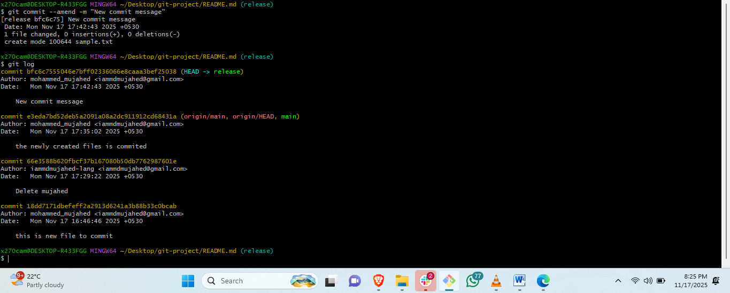
Steps: to change the commit message.< git commit --amend -m "New commit message" >
- Merge multiple commits into single commit.
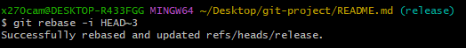
Steps: <git rebase -i HEAD~3>this is to commit three commits in on commit.

