Ec-02-tasks
01: Create one VPC, with 1 public subnet and 1 private subnet.
Ans: login to aws console and search for vpc and click on vpc 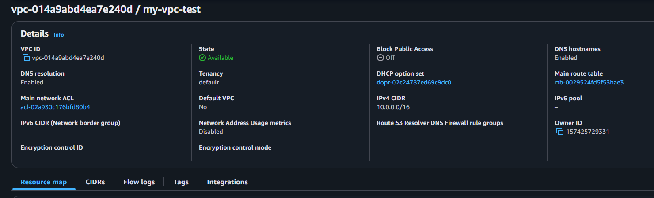
Once it got created then clicked on subnets click on create subnets creating one public and one private subnets 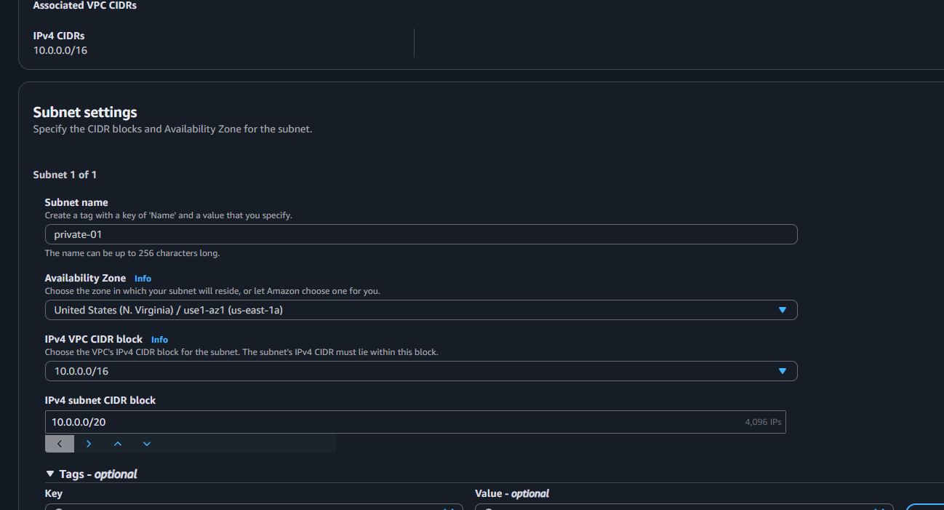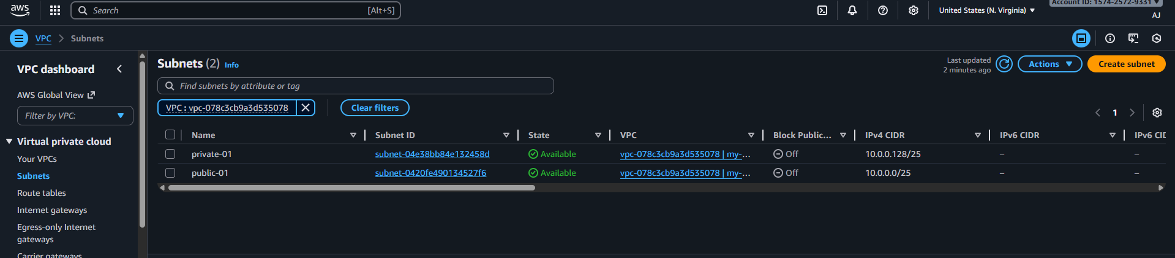

02: Enable VPC peering for cross-region.
Ans: first need to create the 2 ec-2 instance in two different region 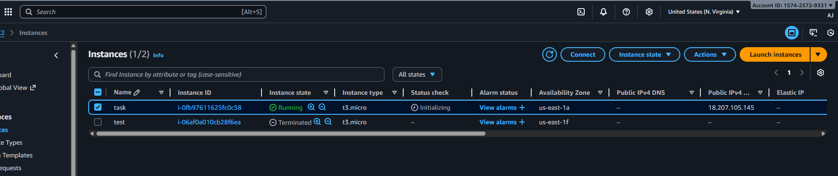
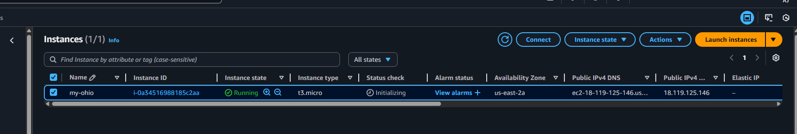
Connect to remote server with git and check with public and private ip 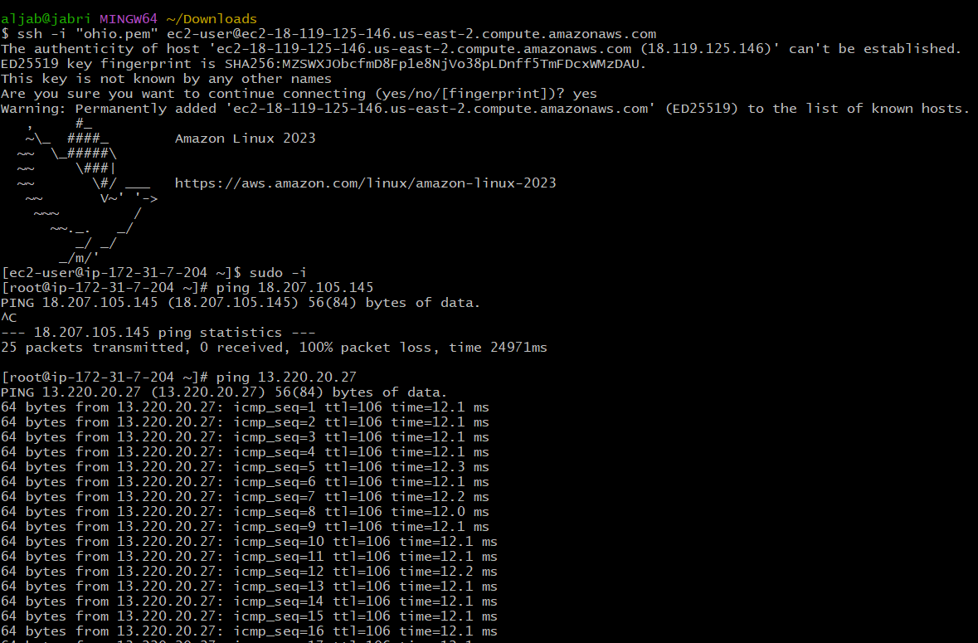
With private ip its not working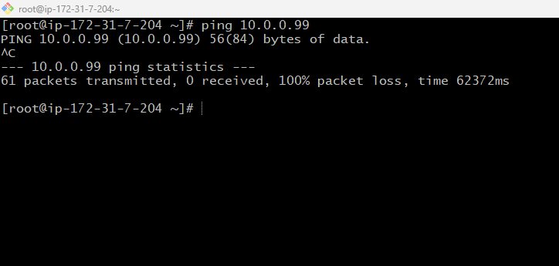 hence now need to go on vpc and slick on vpc peering and create the peering entre the details for the different region and entre the vic id and click on create 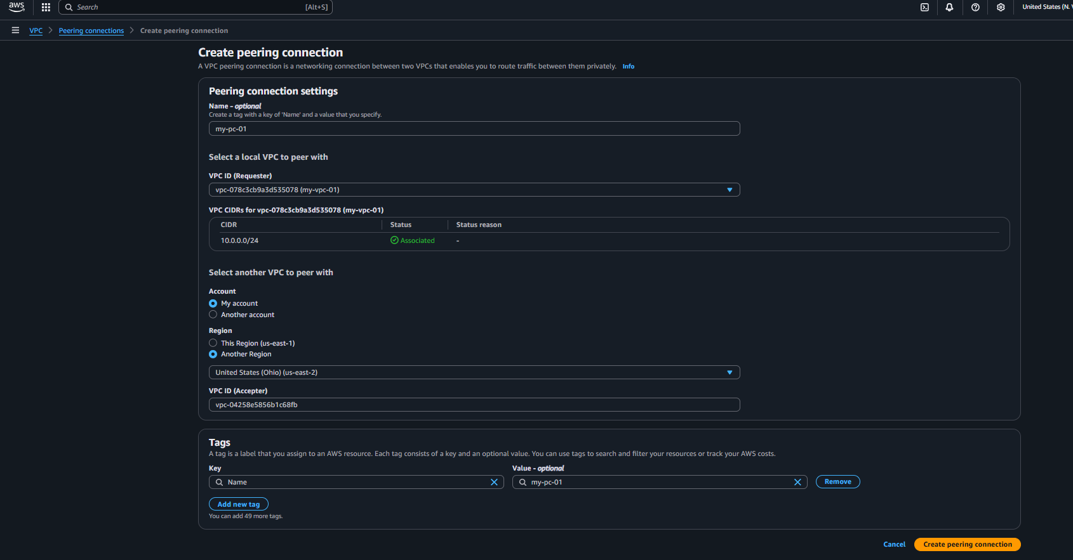
Then access to different region vpc peering and click on actions and accept request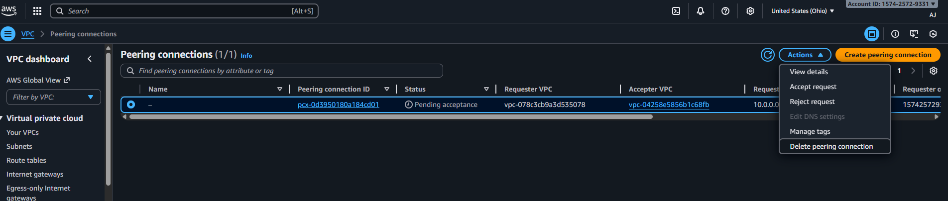
Once it got accepted status shows active 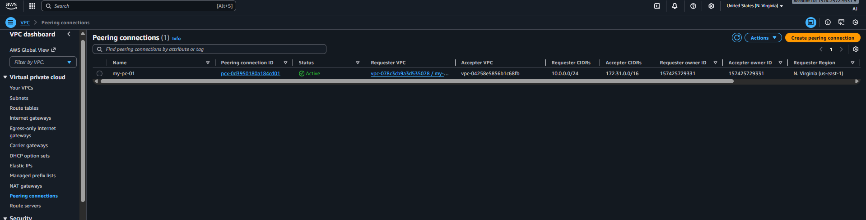
Then need to add route table to vpc ip and selecting peering connection at both vpc’s route table and save the changes 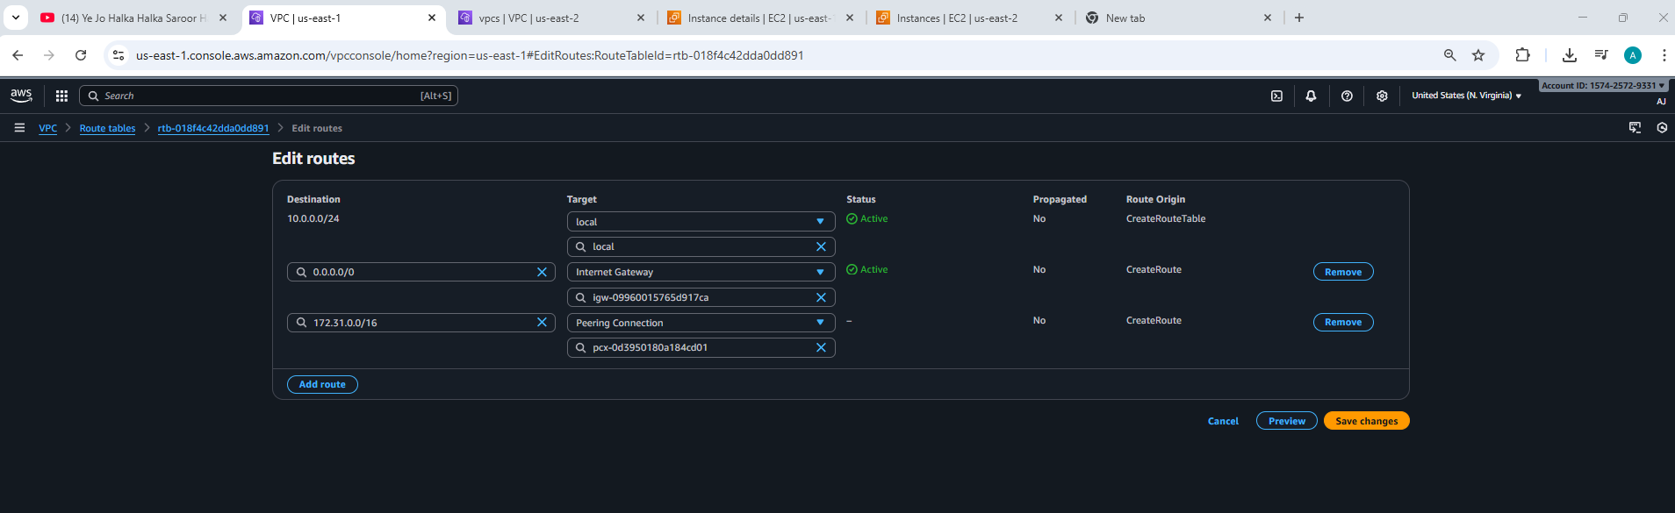
Then check in git with private ip 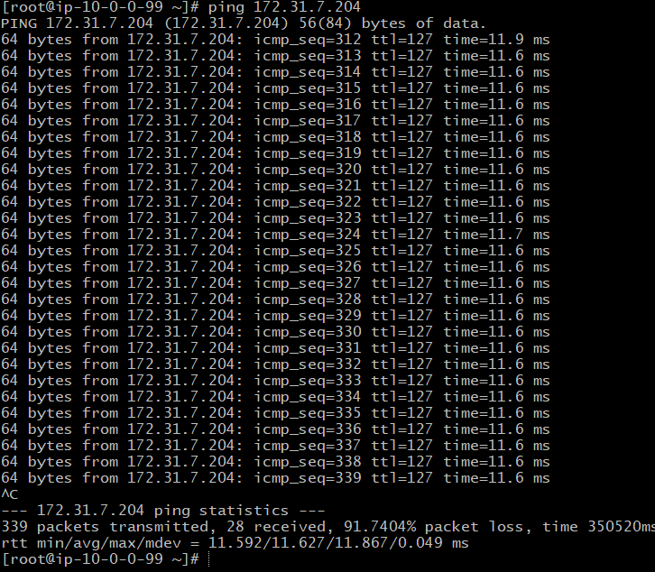

03: Enable VPC peering for cross-account
Ans : To able make peering cross the account first need to click on peering connection and entre the account id 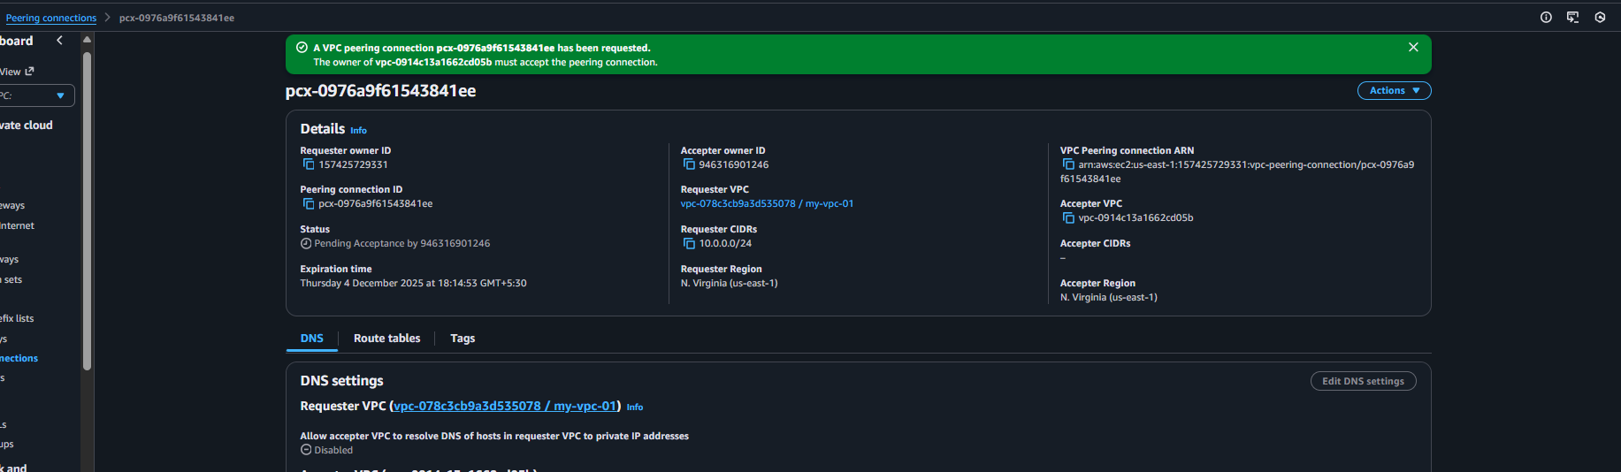
And once it got created and got accepted check 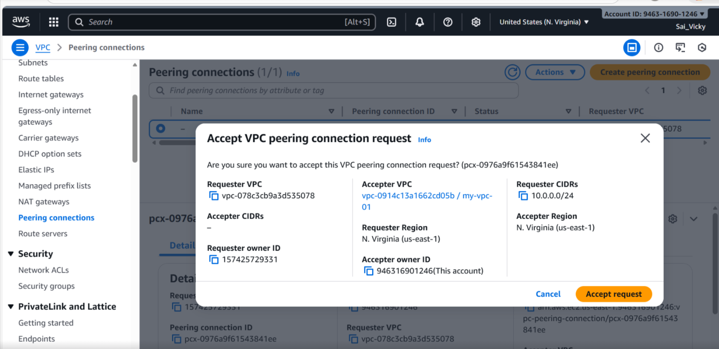
Now need to entre the vpc ip in route table 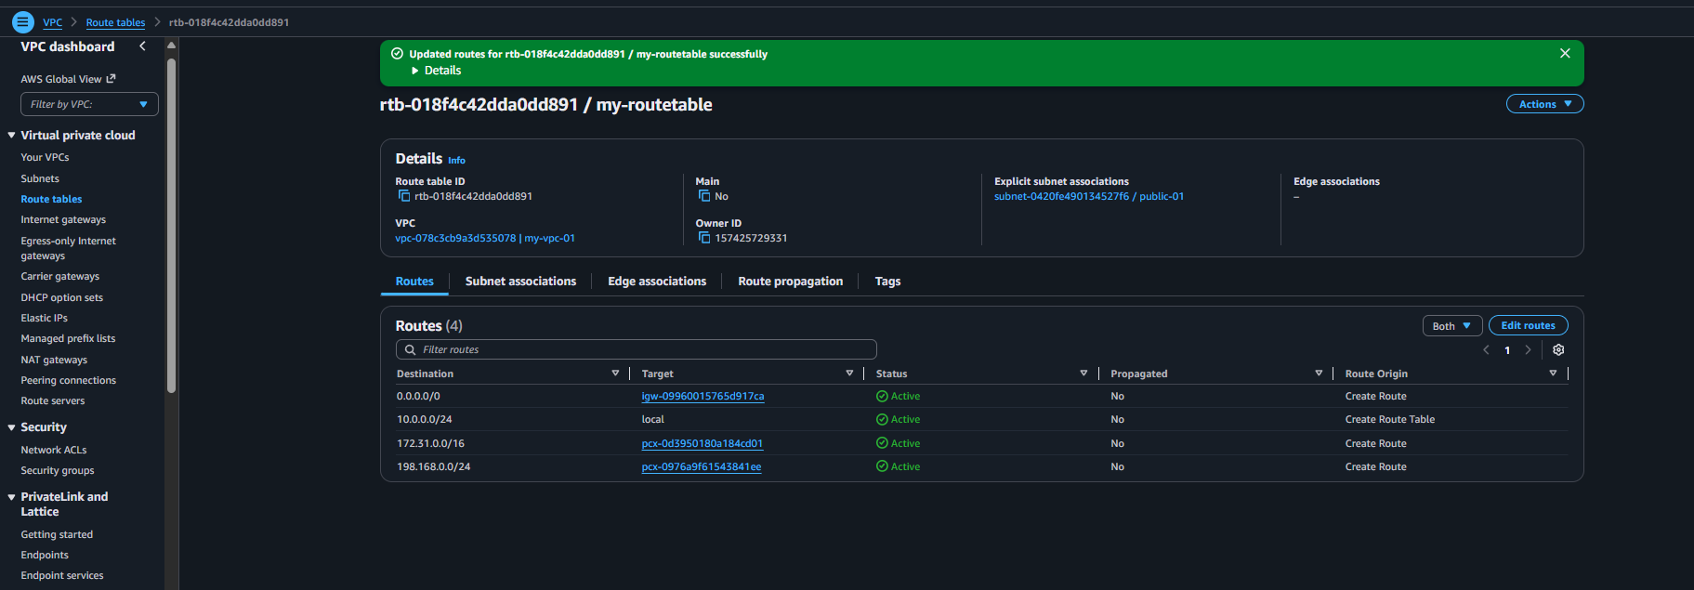 now check under the git with public and private ip for the connection both are working 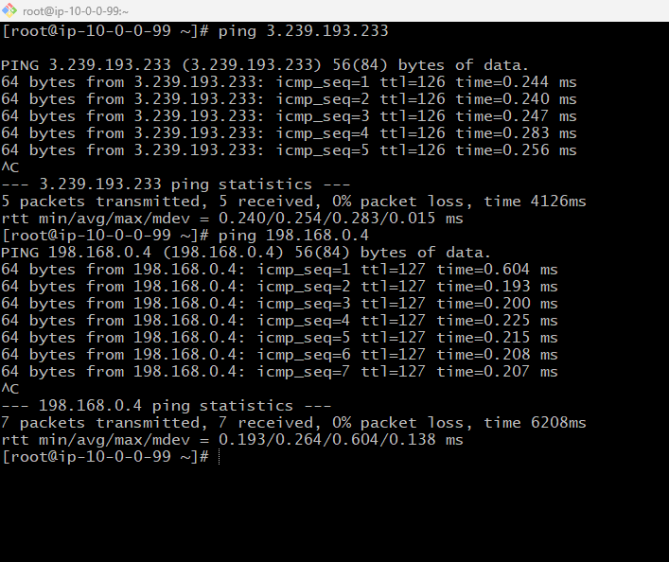

04: Set up a VPC Transit Gateway.
Ans: first need to launch 3 vpc’s and their subnets
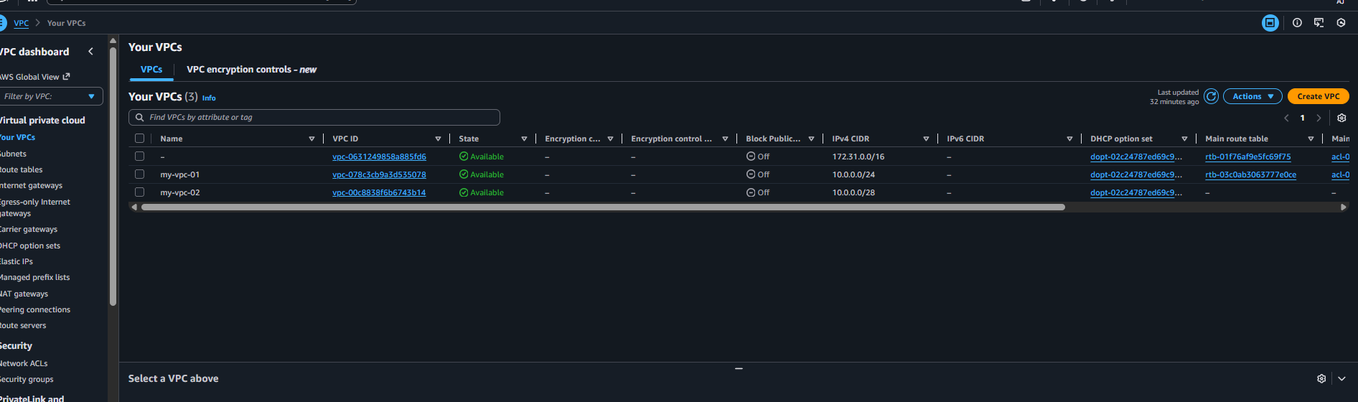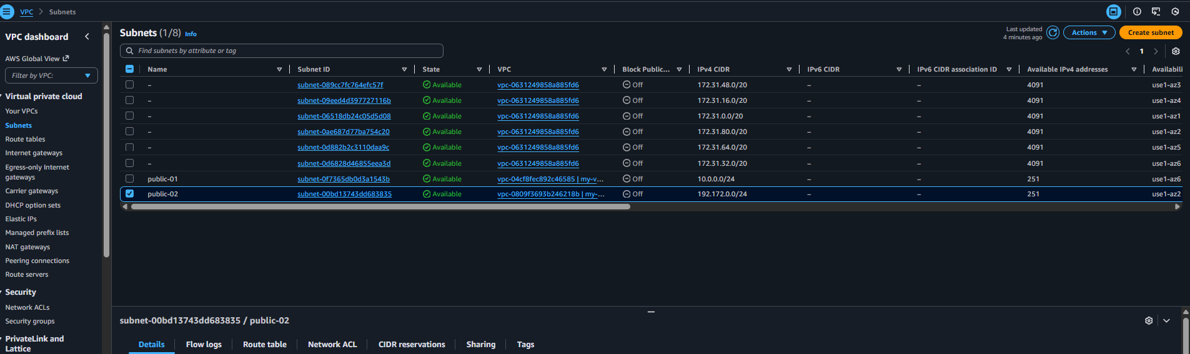
Then create the route table and internet gateway for three vpc and add the route tables 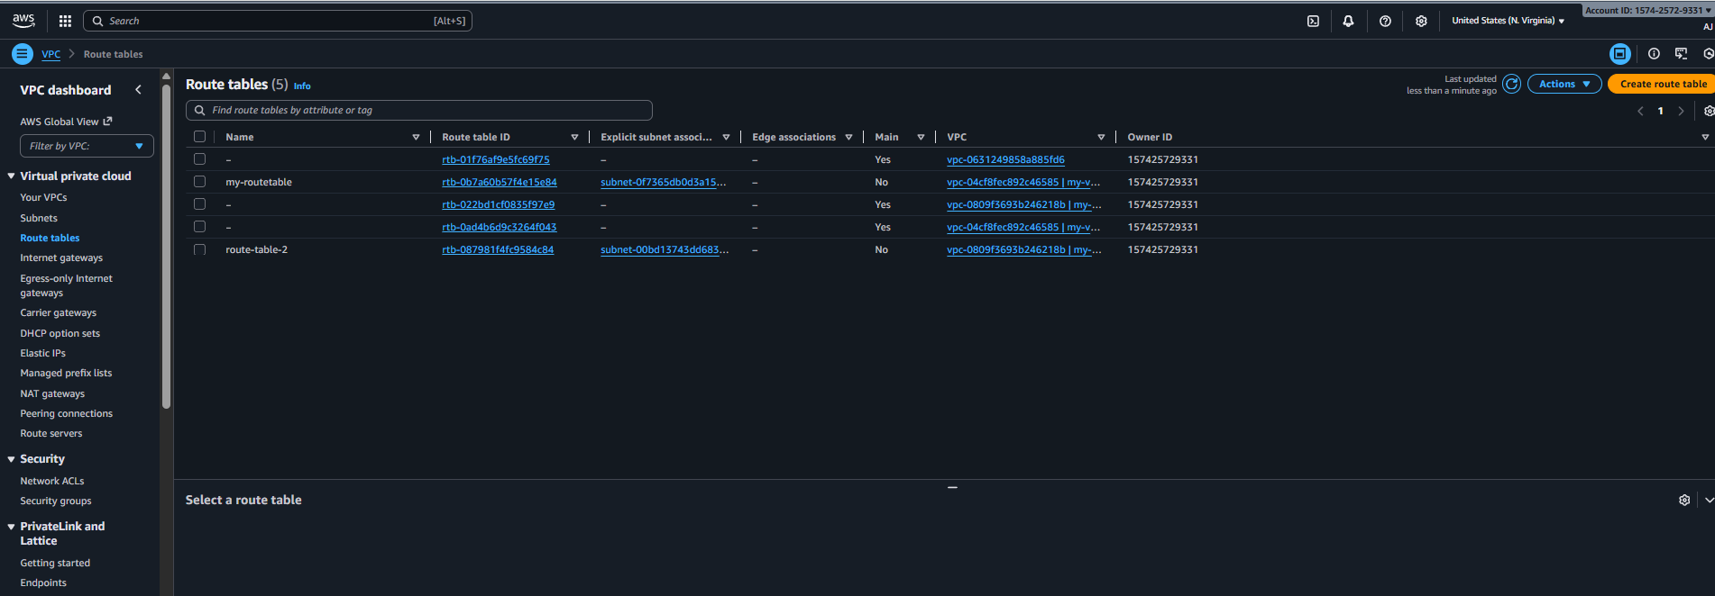
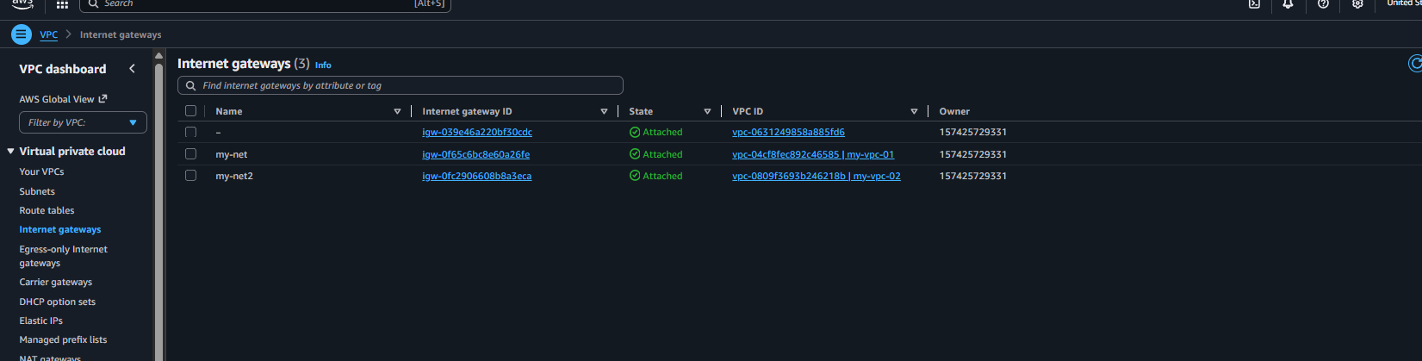
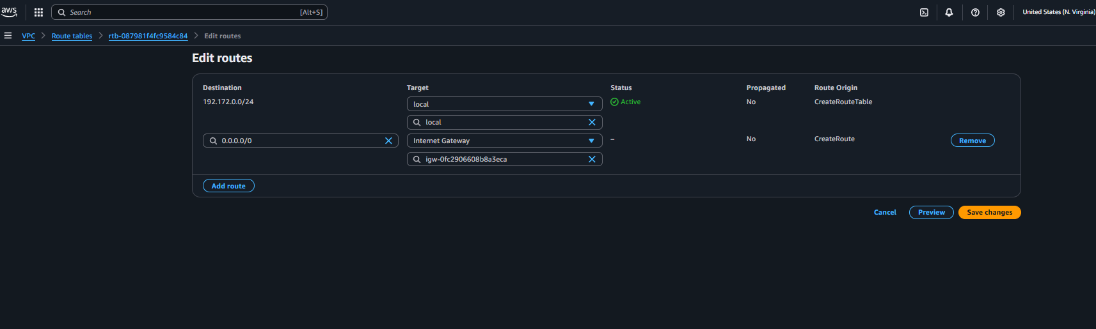
Now need click on transit gateway 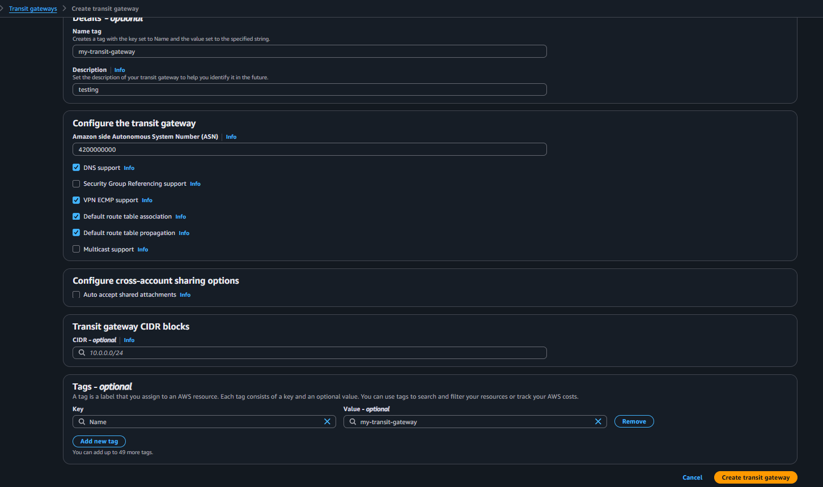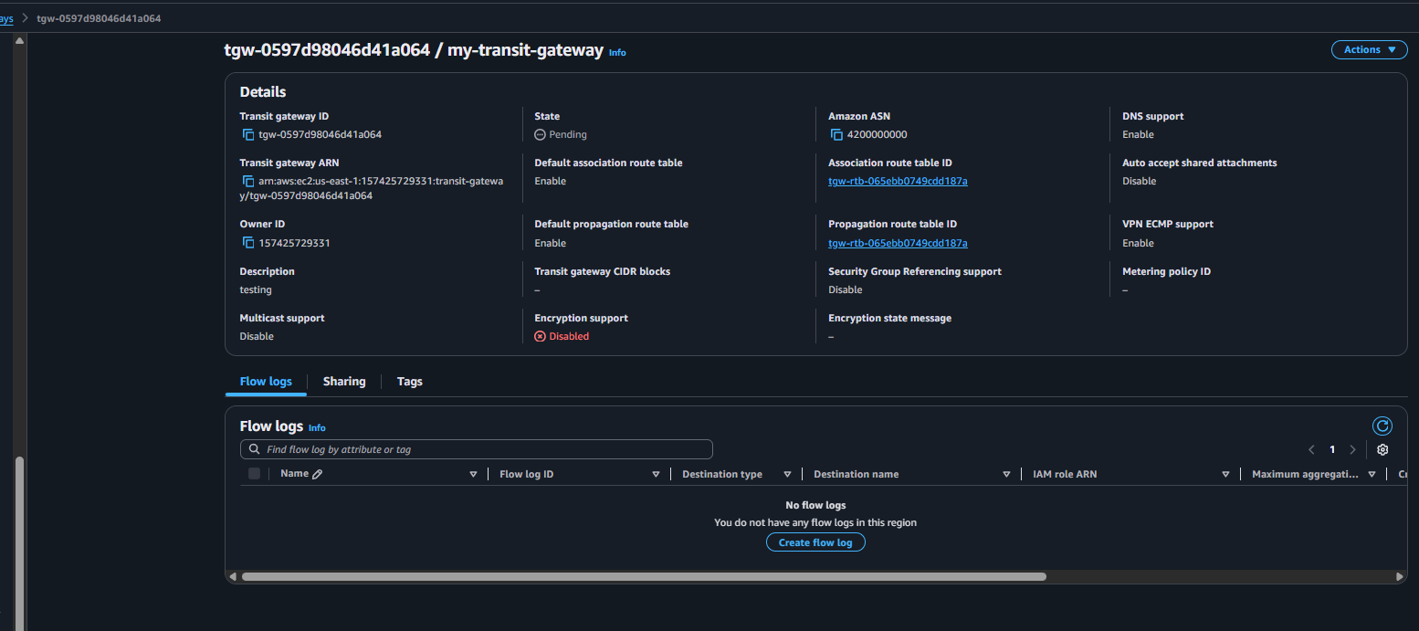Now need to attach the vpc in transit gateway added three vpc unader transit gateway attachments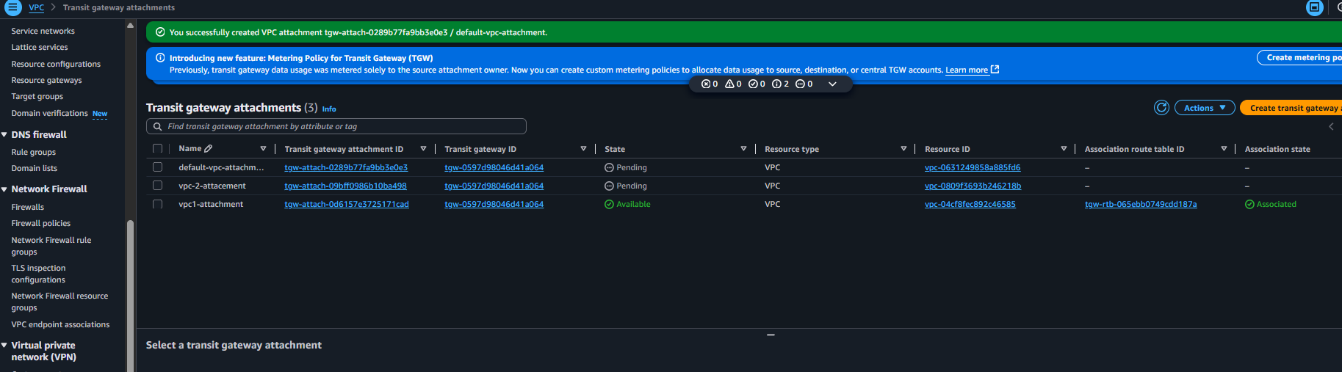
Then need to add route tables and each vpc route table need to add another 2 details and save it 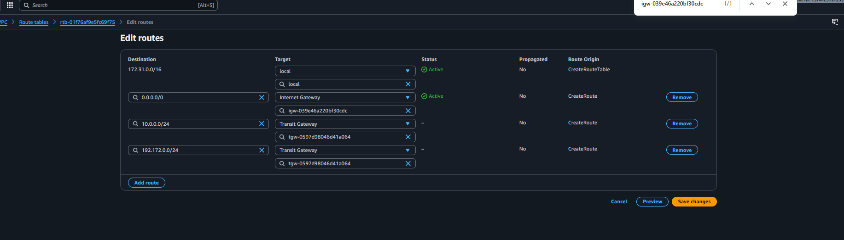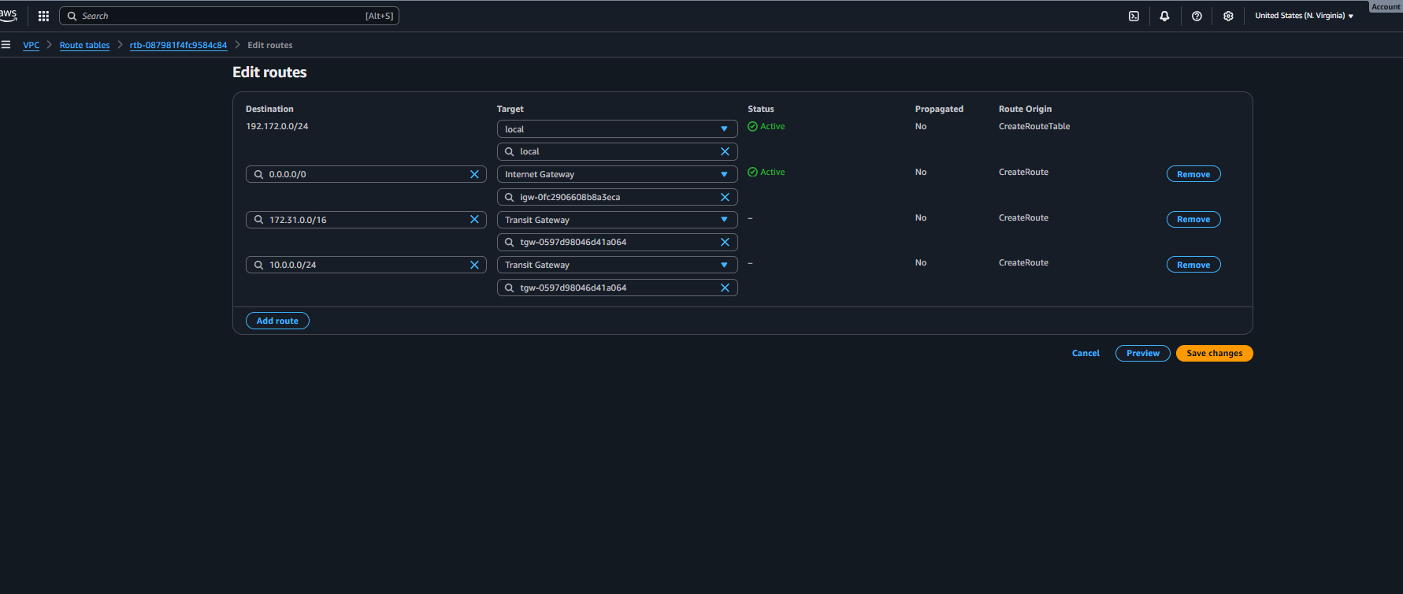
Now to need to launch 3 ec-2 instance with 3 vpc 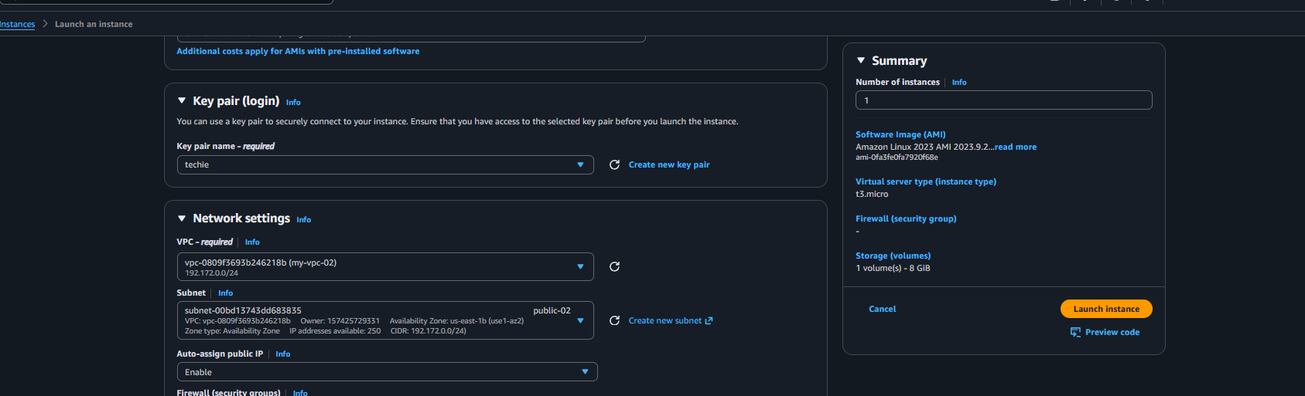
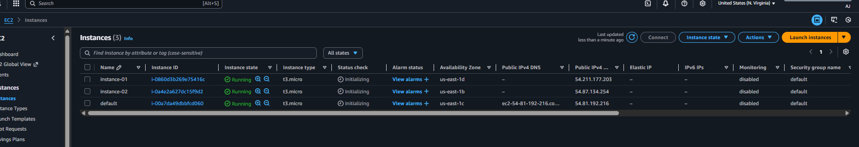
Now need to connect to ssh server 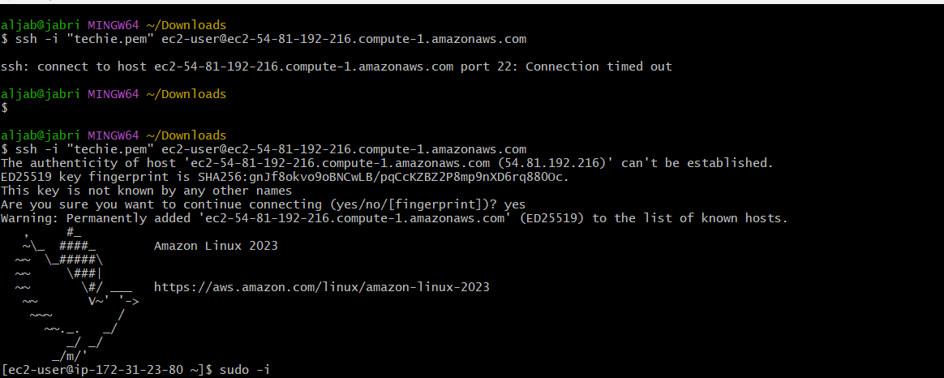and check it with public and private ip’s 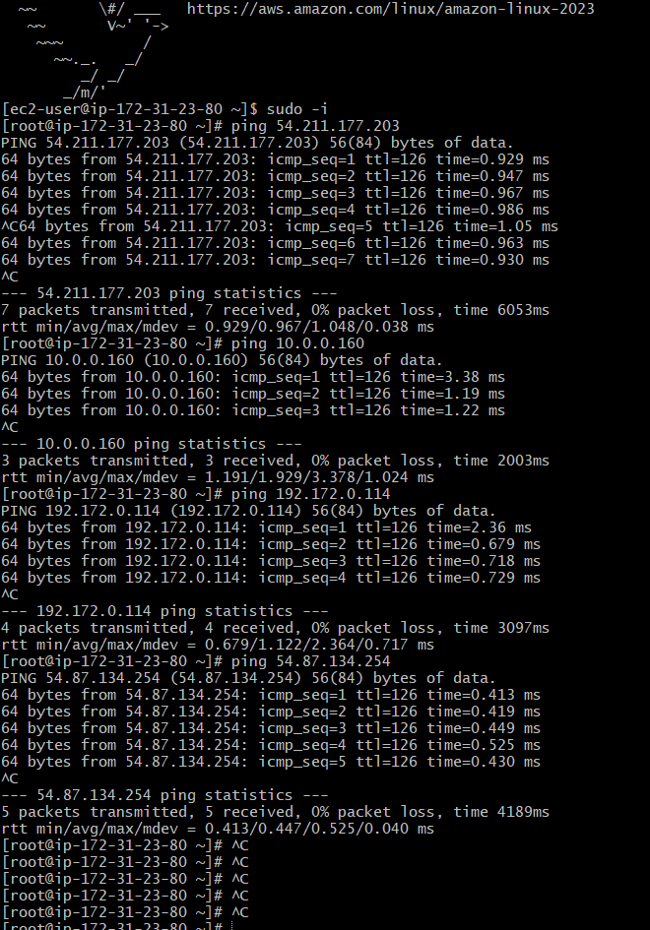
It was working .

05: Set up a VPC Endpoint.
Ans: need to create one public and one private subnet and add route table for public add internet-gateway 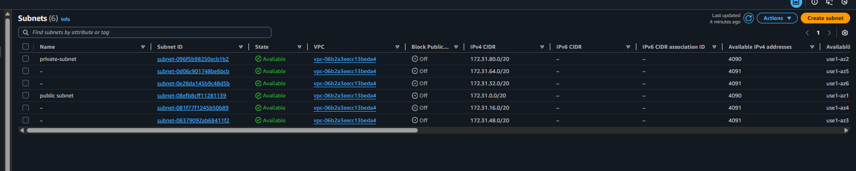
Launch instance with both subnets 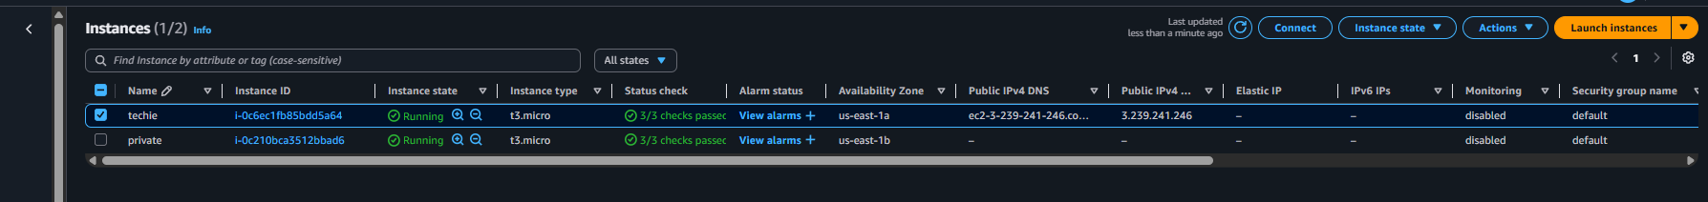
Under the public instance add security group all traffic then open git and check for aws configure 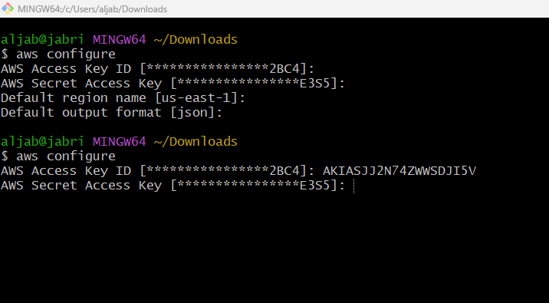
See the private key.pem and connect to ssh with public server and create a file with .pem and add the copy the private key file and paste in .pem file save it change the permission chmod 600 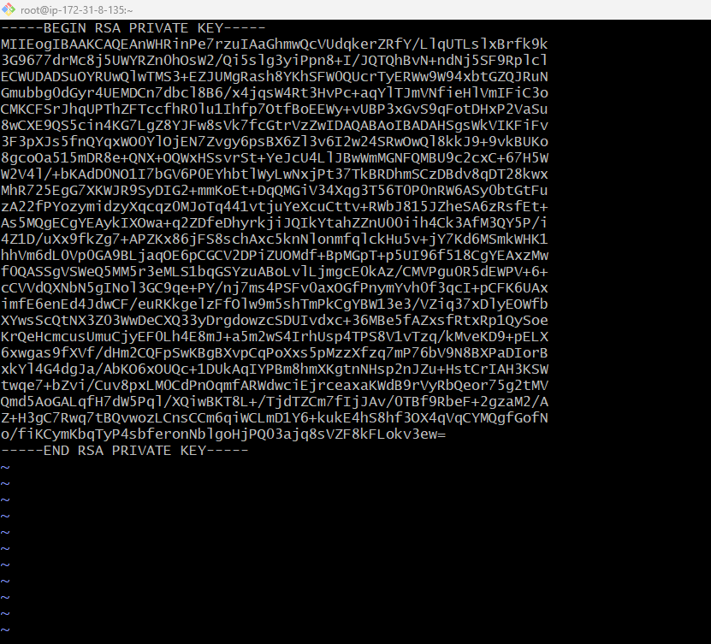
Then access to private server with ssh -i private file.pem ec2-user@private ip
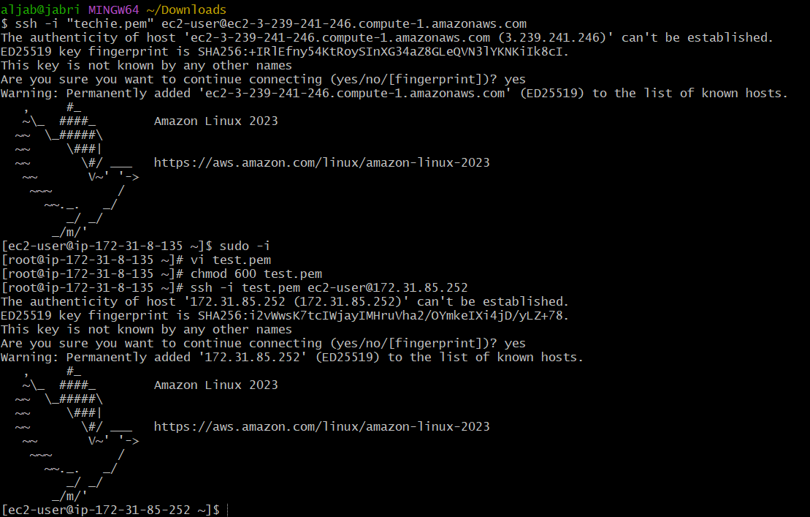
Once it connect check for aws configure 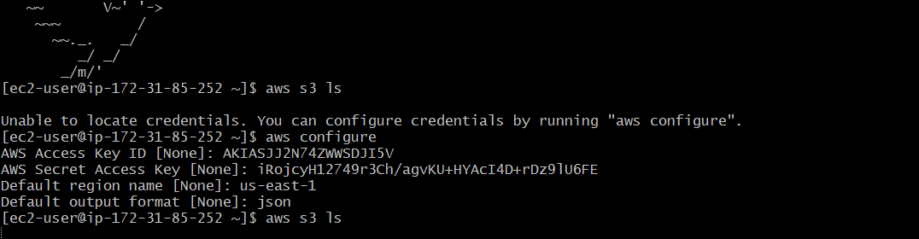not working now we need to add endpoint on private subnet and save it 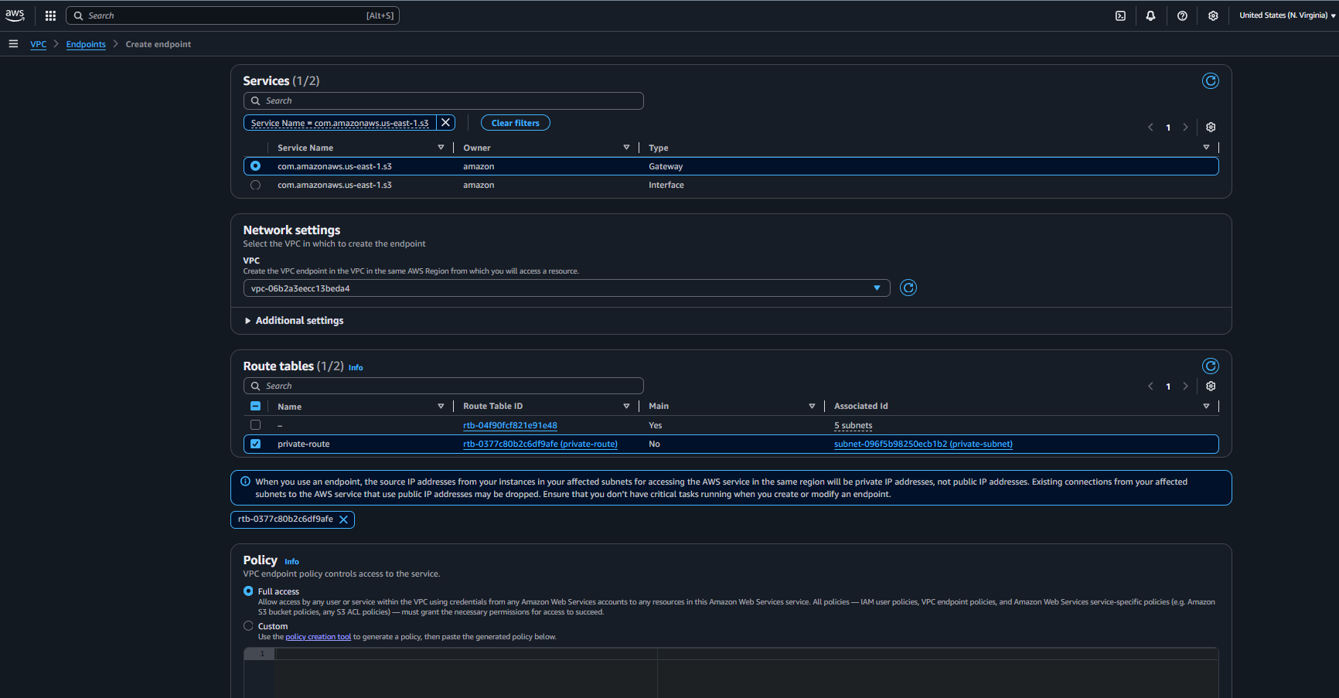
Once it got save run the command again aws configure 