ASG-Tasks

- Create one VPC in N. Virginia region.
Ans: Task Title
Create a Virtual Private Cloud (VPC) in the N. Virginia (us-east-1) region.
Objective
To create a dedicated virtual network environment that will host public and private
subnets, EC2 instances, NAT gateway, and other AWS resources.
Prerequisites:
• Region selected: N. Virginia (us-east-1)
• No overlapping CIDR with existing VPCs
Step-by-Step Implementation (With Evidence):
First need to login to aws console and search for vpc and cerate one vpc 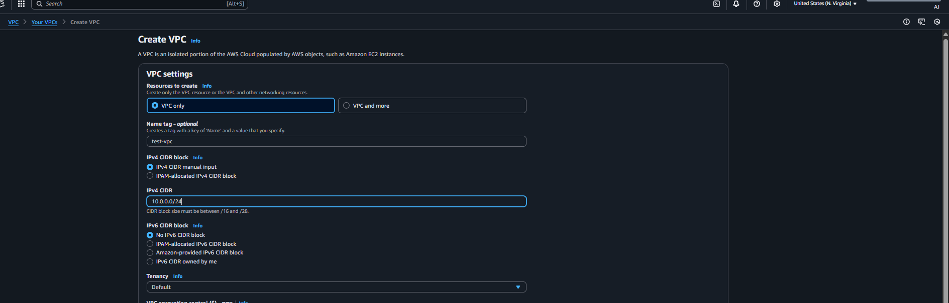
Validation Steps (With Evidence):
The vpc is been created successfully 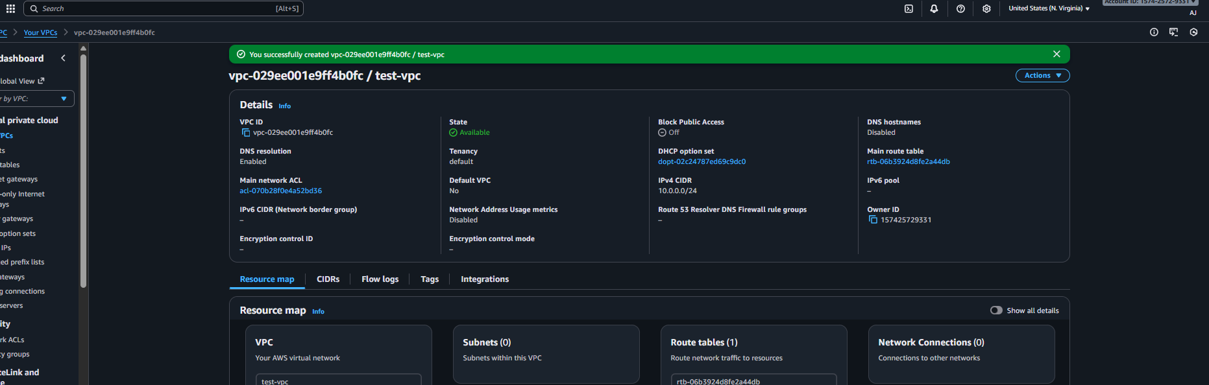

No issue found while creating vpc

- Create two subnets: one public subnet and one private subnet.
Ans: Task Title
Create a public subnet and a private subnet inside the existing VPC.
Objective
To build the subnet architecture required for hosting public-facing resources (like
NAT gateway, public EC2) and private internal resources (private EC2, backend
services).
Prerequisites
• VPC (Production-VPC)
• Non-overlapping CIDR plan
• Region: N. Virginia (us-east-1)
Step-by-Step Implementation (With Evidence):
Under the vpc console need to click on vpc subnets and click on create subnet 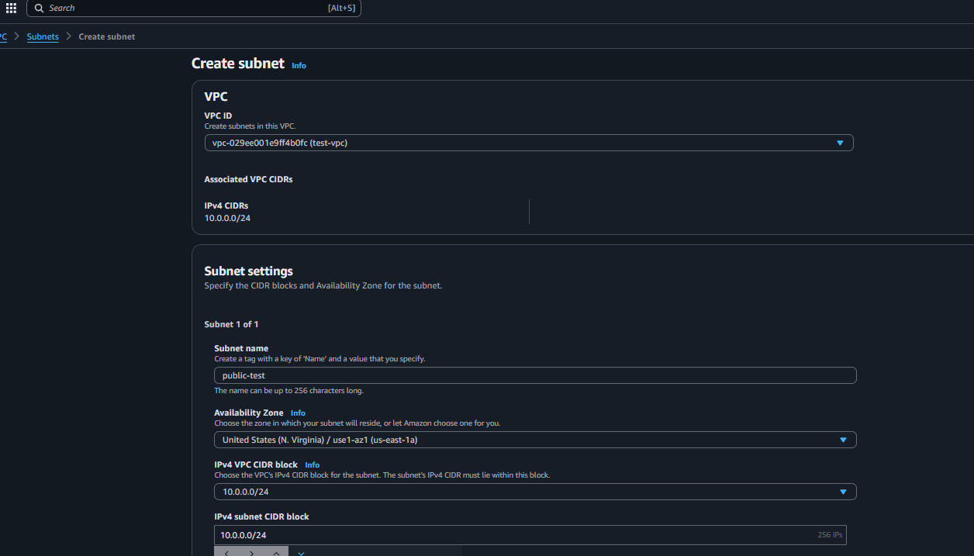
Now need to create one more subnet for private 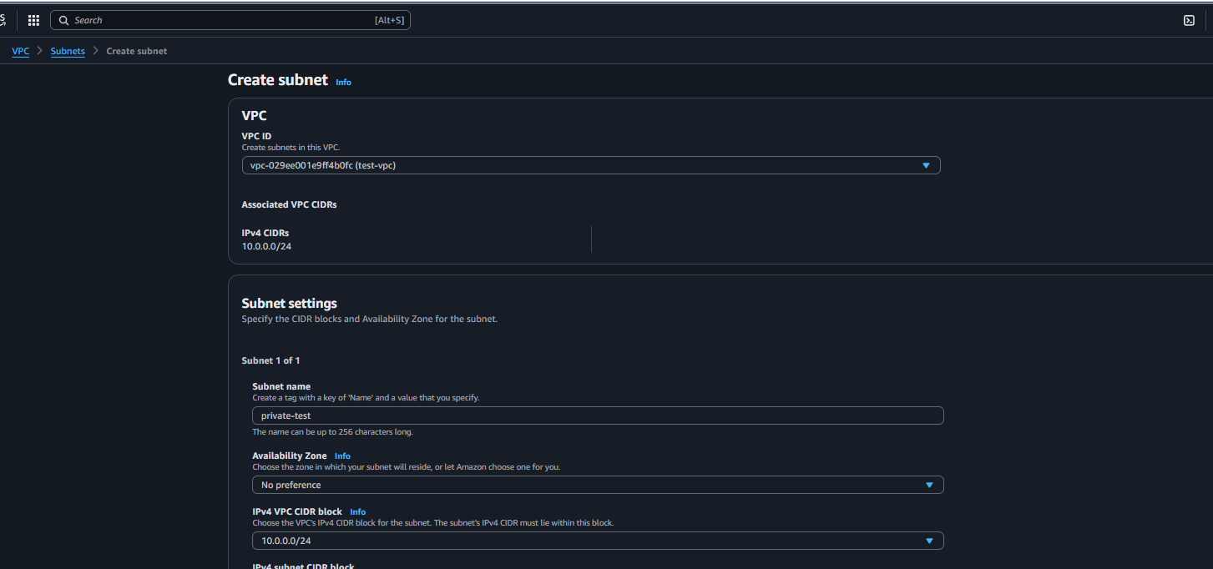

Validation Steps (With Evidence): created 2 subnets one for public 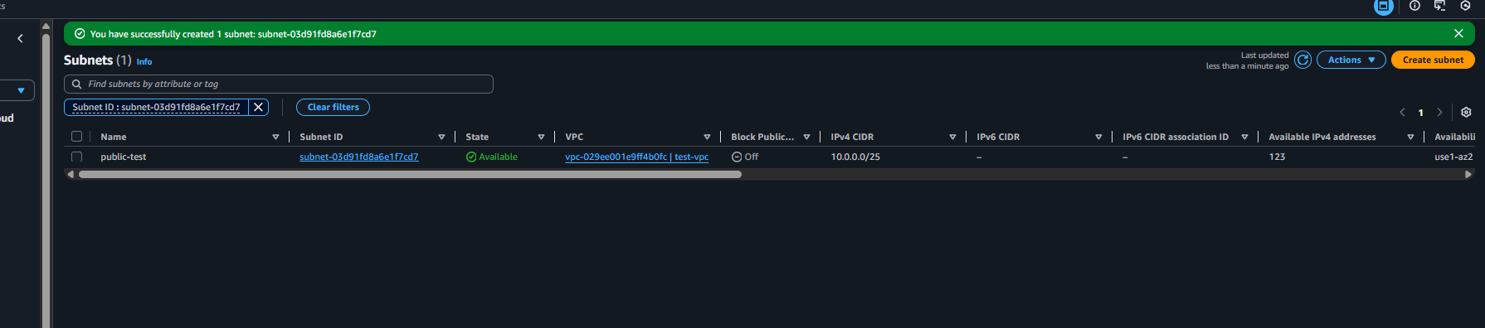
And one is for private subnet successfully is been created 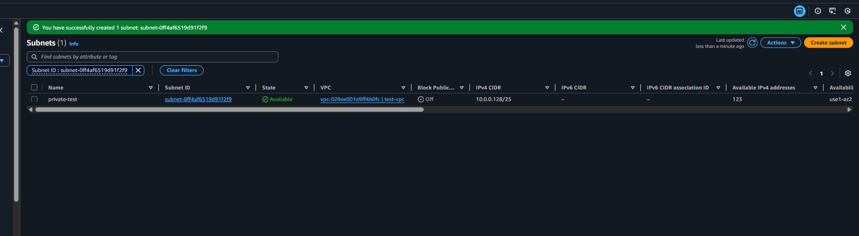

No issue is been faced.

- Attach an IGW to the VPC.
Ans: Task Title
Create and attach an Internet Gateway (IGW) to the existing VPC.
Objective
To enable internet connectivity for resources placed in the public subnet.
Prerequisites:
• Internet Gateway
• vpc
• Region: N. Virginia (us-east-1)
Step-by-Step Implementation (With Evidence):
internet gateway under vpc console and create one internet gateway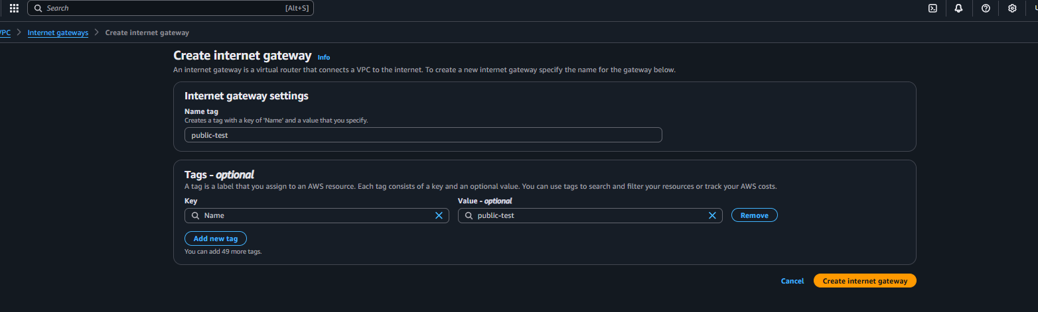
Then attach the internet gateway to vpc 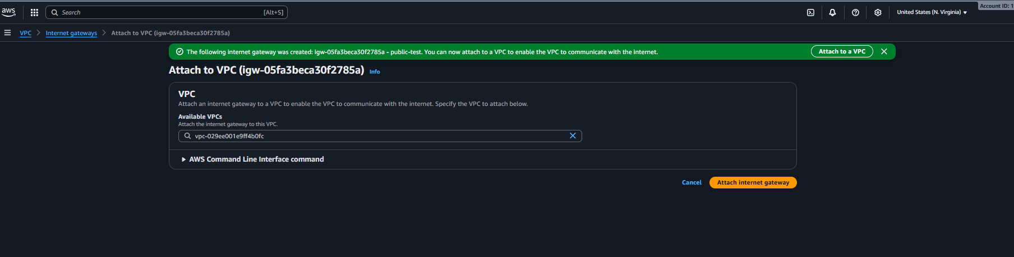

Validation Steps (With Evidence):
Successfully created internet gateway 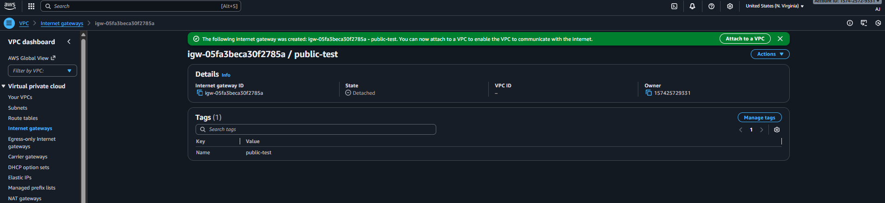
And attached internet gateway to vpc 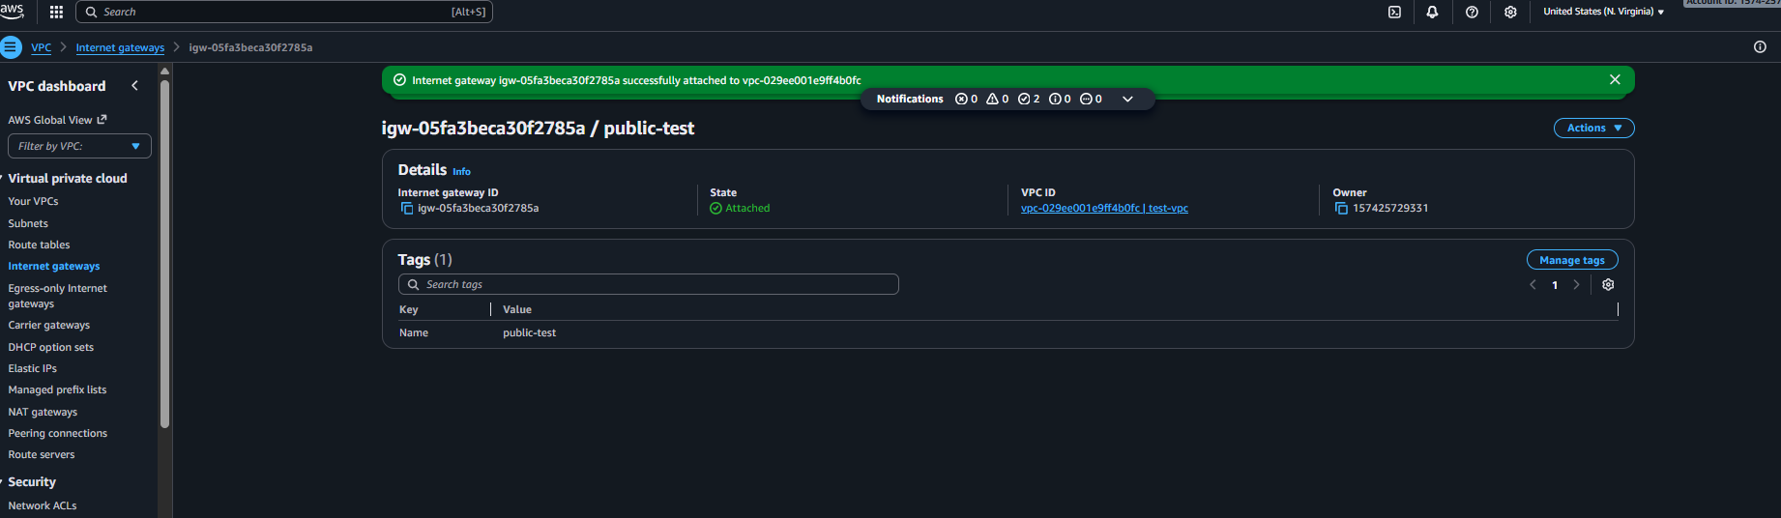

- Create one public route table (RT) and one private route table.
Ans: Task Title
Create and configure public and private route tables for proper network routing in
the VPC.

Objective
To ensure the public subnet routes traffic to the Internet Gateway and the private
subnet routes traffic through the NAT Gateway.
Prerequisites
• VPC: Production-VPC
• Public-Subnet (10.0.1.0/25)
• Private-Subnet (10.0.2.0/25)
• Internet Gateway attached (Production-IGW)
• Region: N. Virginia (us-east-1)
Step-by-Step Implementation (With Evidence)
Under the vpc console we have route-tables need to create one route-tables for public subnet
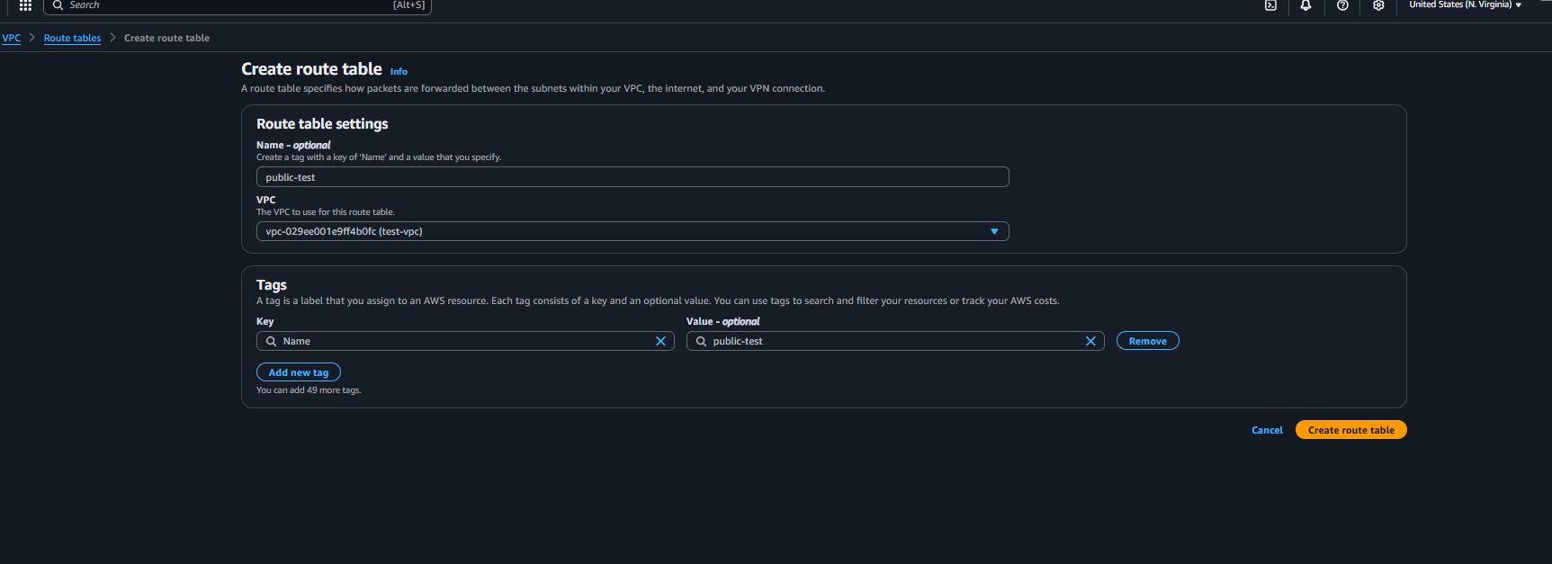
Then need to create for private subnet 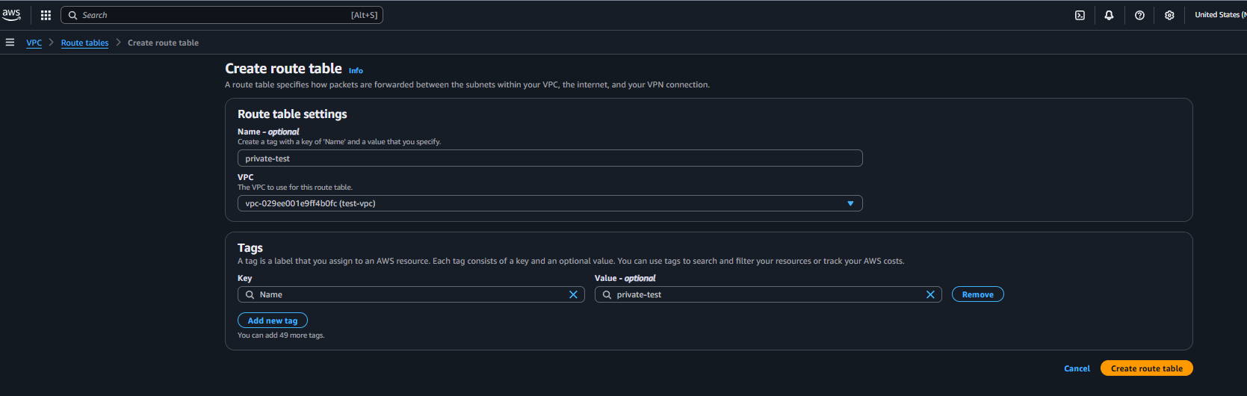
Once the route table is been created we have to attach the internet record in public route-tables 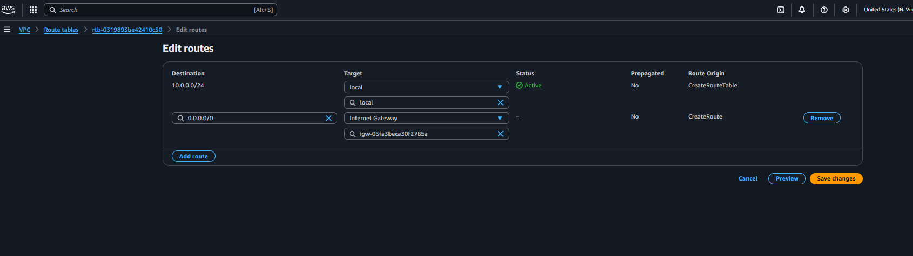

Validation Steps (With Evidence):
Successfully created the route-tables for public and private subnets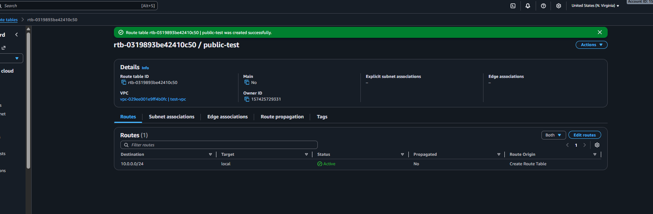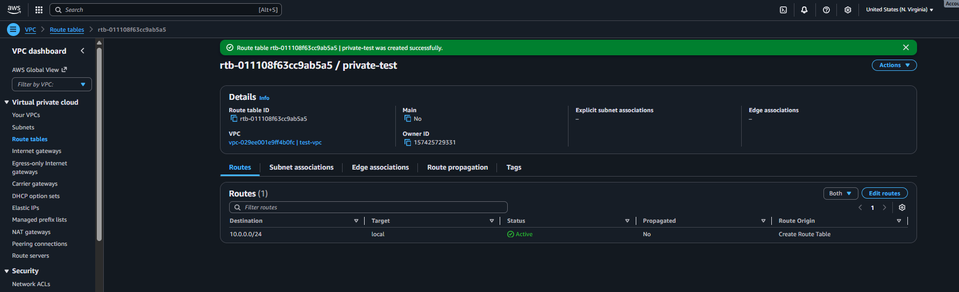

And added internet gateway record in public route table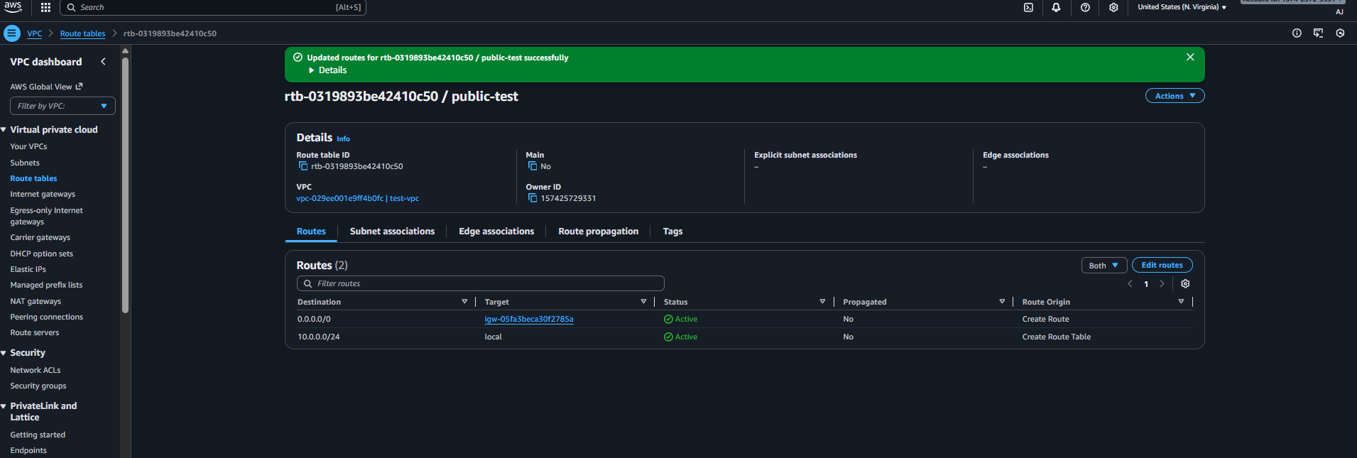

Successfully created 2 route tables one for public and one for private under the public route table added internet gateway successfully.
- Deploy a NAT gateway in the public subnet and attach the NAT gateway to the private subnet.
Ans: Task Title
Create a NAT Gateway in the public subnet and configure the private route table to
route outbound traffic through it.
Objective
Allow private subnet instances to access the internet for updates and package
installations without exposing them to inbound public traffic.
Prerequisites
• VPC: Production-VPC
• Public-Subnet (10.0.1.0/25)
• Private-Subnet (10.0.2.0/25)
• Public Route Table
• Private Route Table
• Internet Gateway attached
• Region: N. Virginia (us-east-1)
Step-by-Step Implementation (With Evidence)
open the nat gateway under vpc console and create the nat gateway attached the vpc which is been created 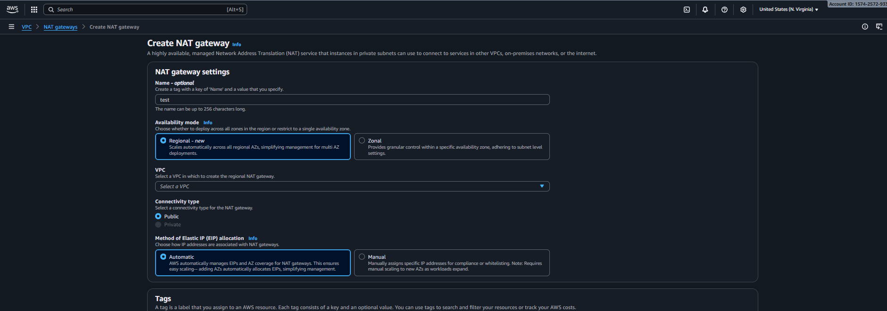
Once the nat gateway is been created need to add a record in private route table 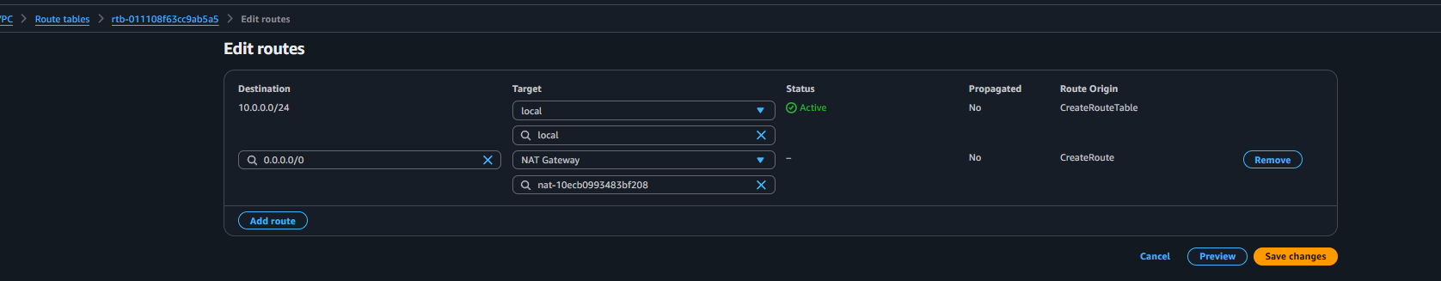

Evidence: Screenshots of both route tables:
Created the nat-gateway successfully 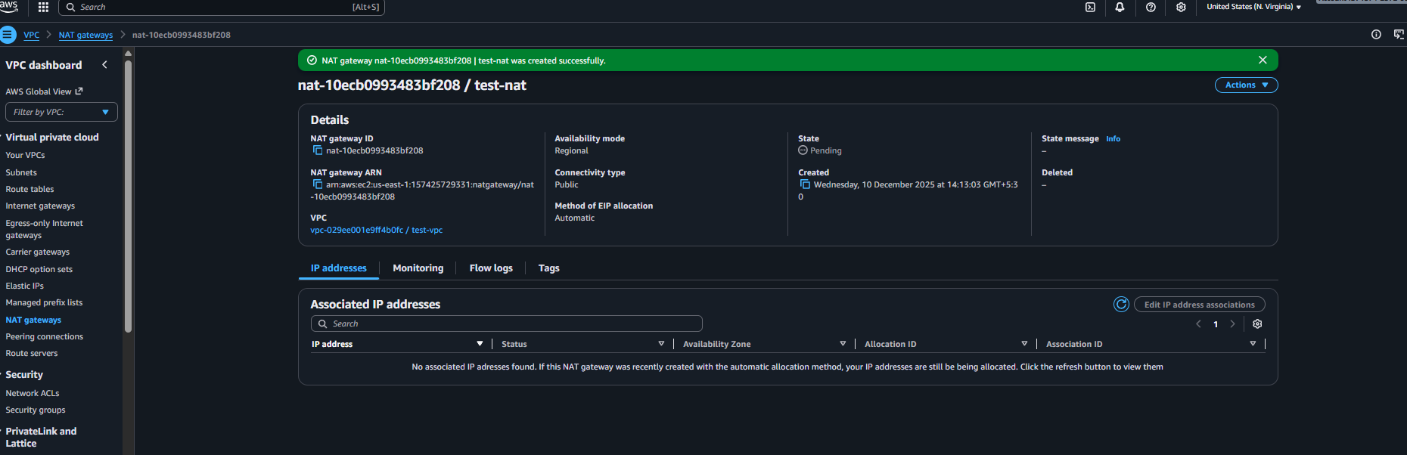
Associated with private route table 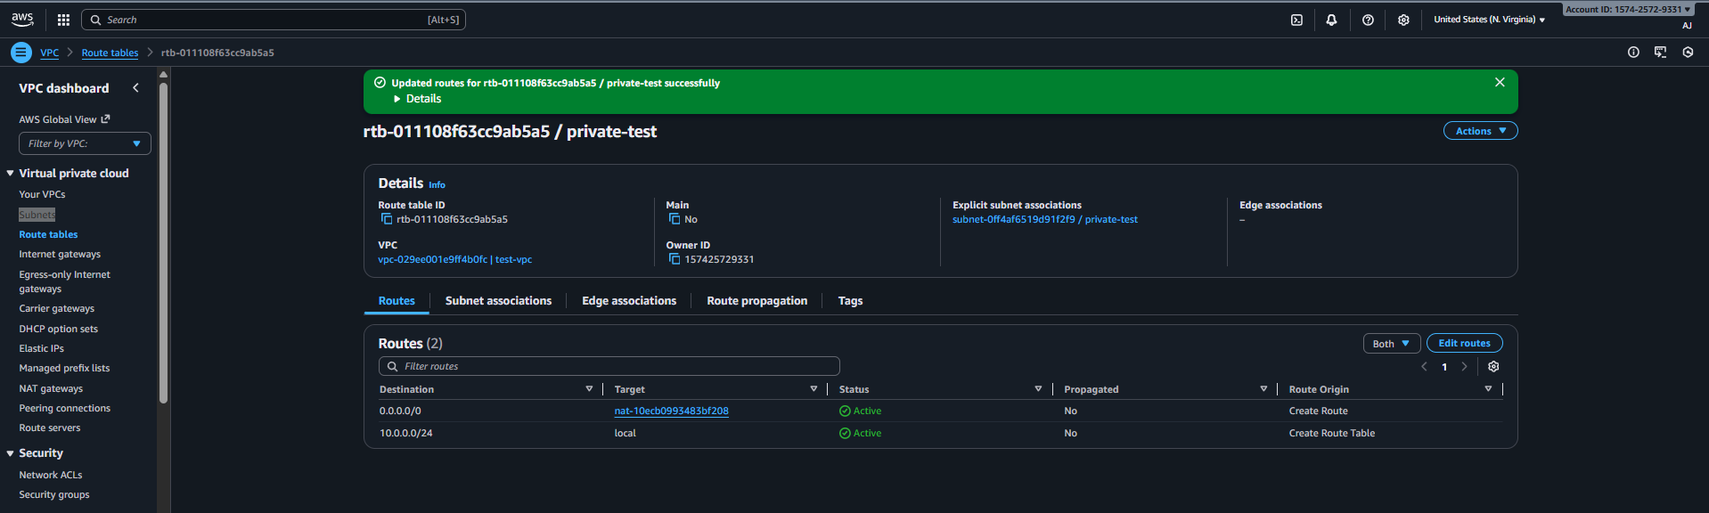
Nat gateway is been deploy for private subnet.

- Create two instances, one in the public subnet and one in the private subnet and deploy Apache server in both instance with sample index.html file.
Ans: Task Title
Launch two EC2 instances: one in the public subnet and one in the private subnet.
Objective
To deploy compute resources inside the VPC for public and internal workloads.
The public instance will have internet access directly.
The private instance will access the internet via NAT Gateway.
Prerequisites
• VPC: Production-VPC
• Public-Subnet (10.0.1.0/25)
• Private-Subnet (10.0.2.0/25)
• Ec2 instance
• User data bash scripting
• Security Groups
• Key Pair created (test.pem)
• NAT Gateway configured
• Public subnet must have “Auto-assign public IP = Enabled”
• Region: N. Virginia (us-east-1)
Step-by-Step Implementation (With Evidence)
First need to search for vpc and click vpc console need to launch the instance with public subnet 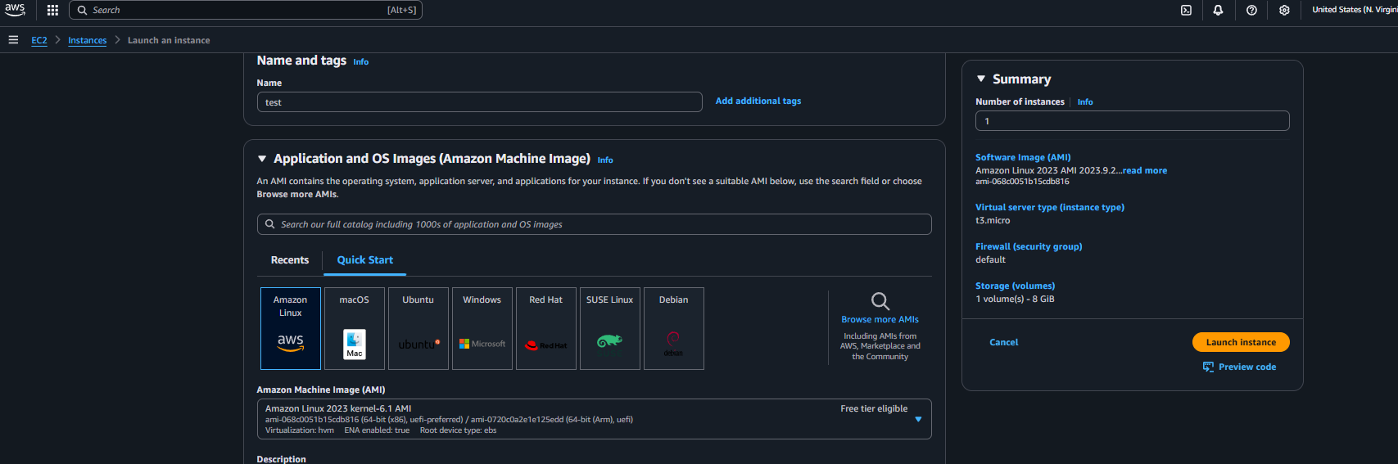
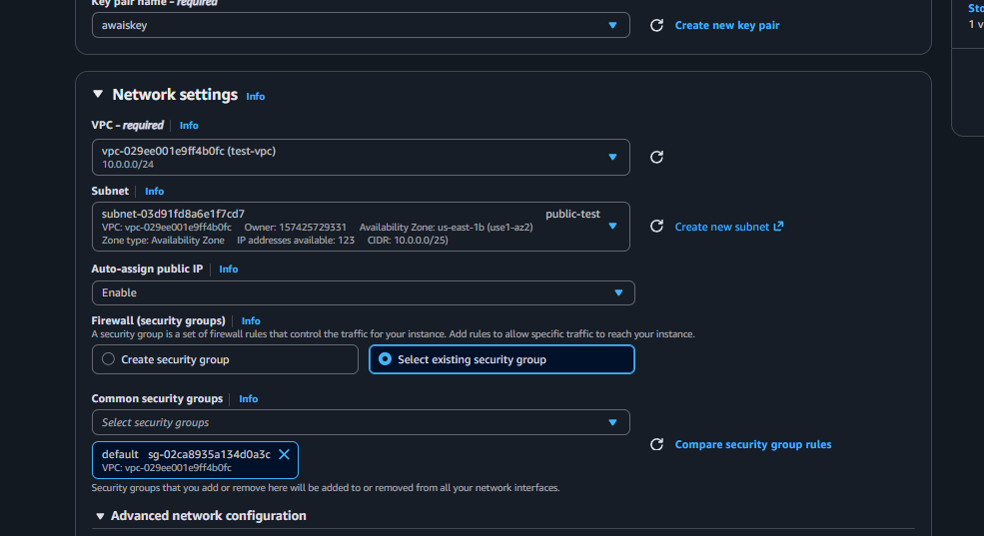
And before launching the instance adding scripting in user data to install Apache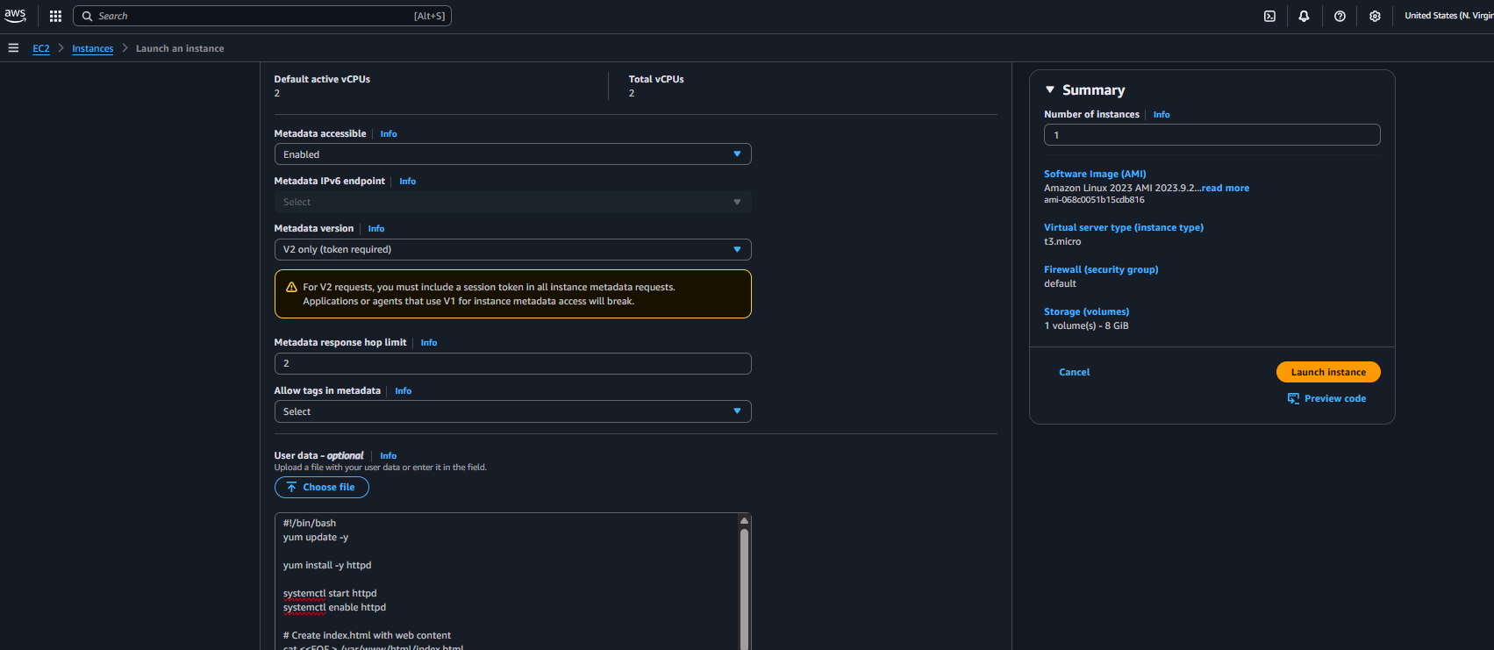
Public instance is been launched now launching new ec2 instance with private subnet 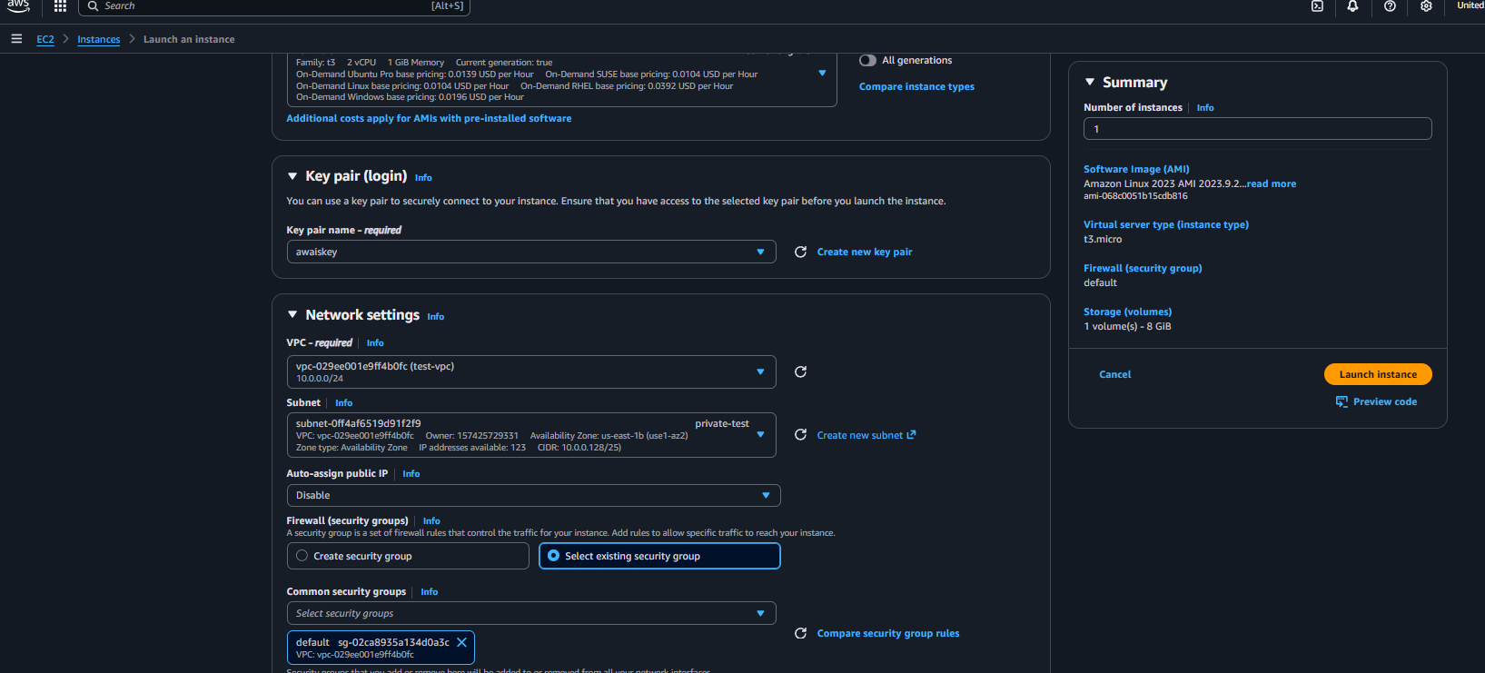
Once the instance is been created add rule to access in security groups and save the rule 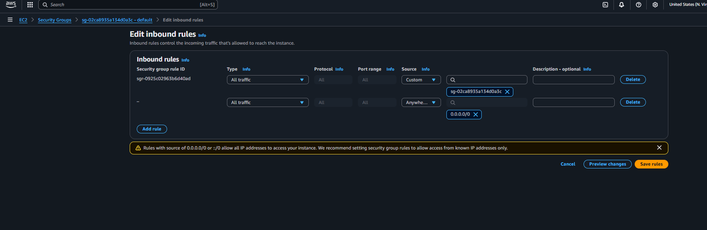
Connected to instance and check httpd status 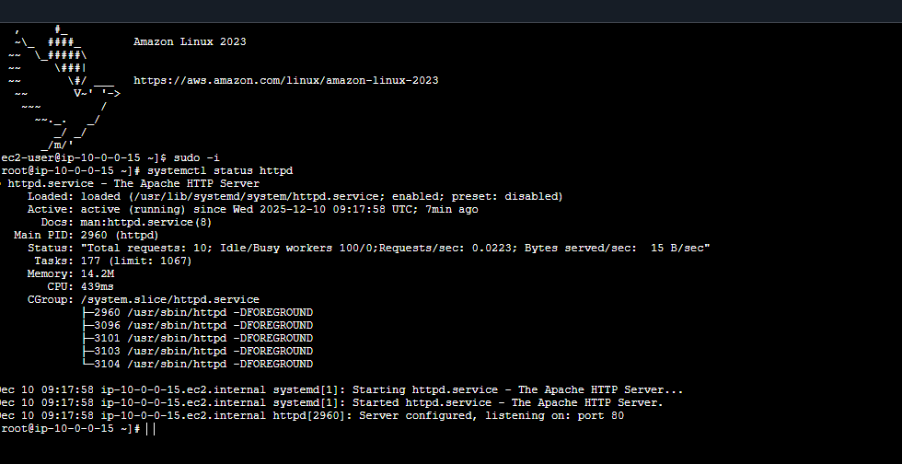

Validation Steps (With Evidence):
Launched ec2 instance with public subnet 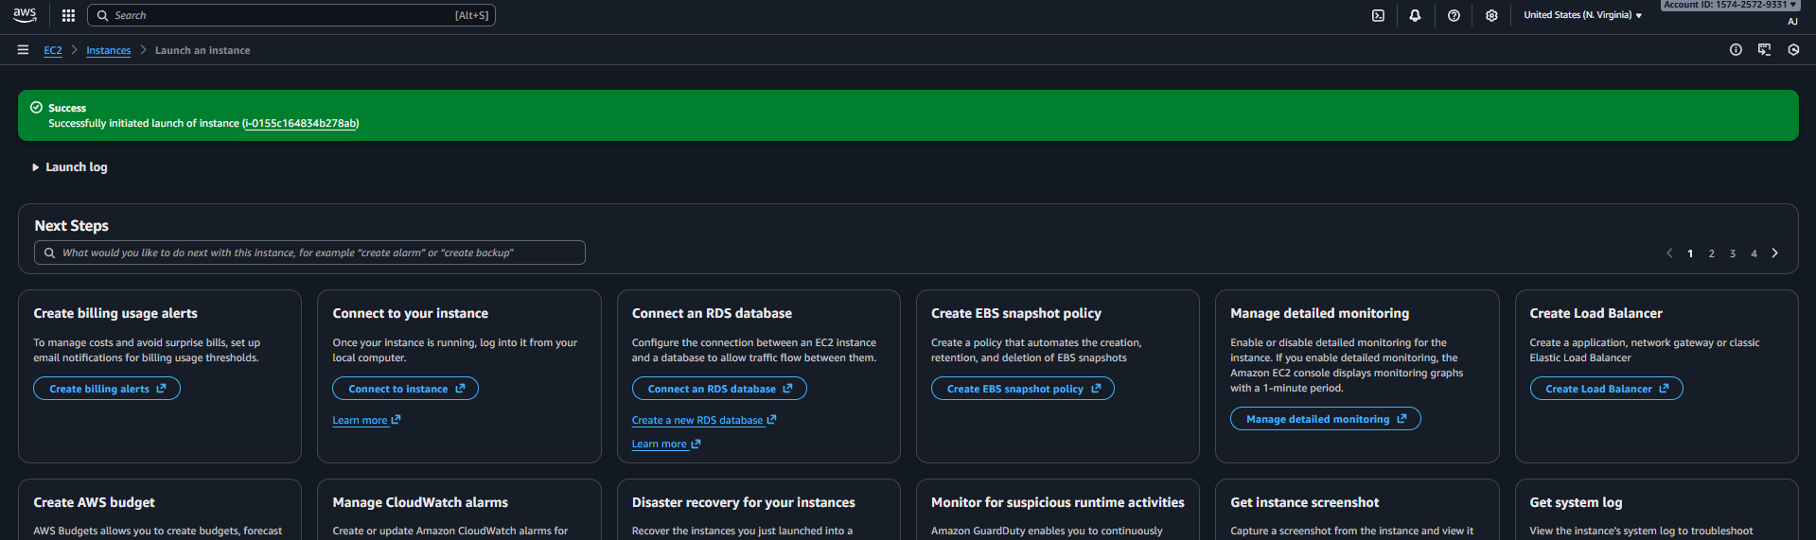
Launched ec2 second instance with private subnet 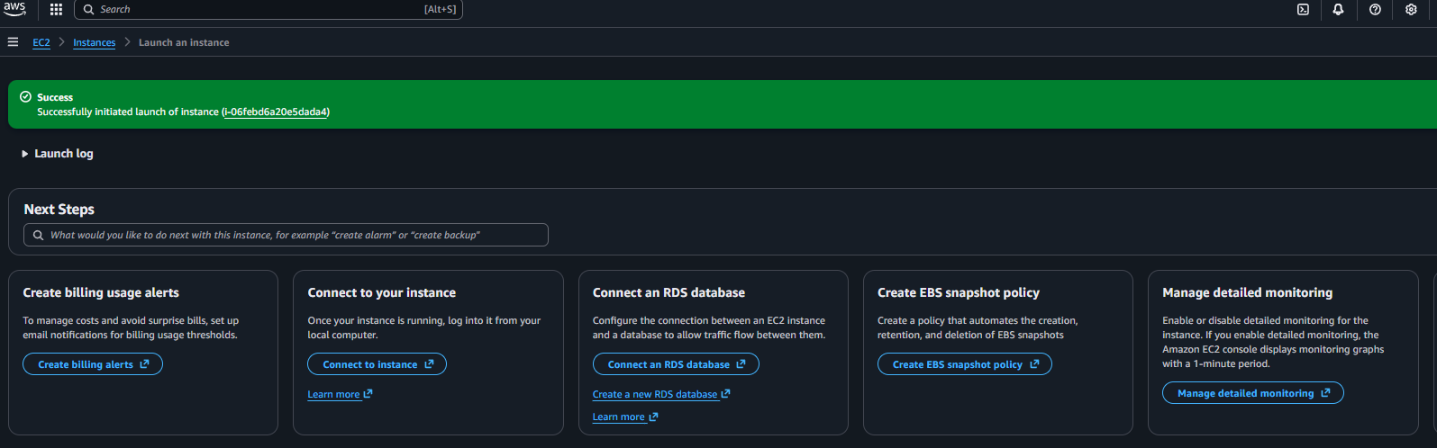
Add rule in security group 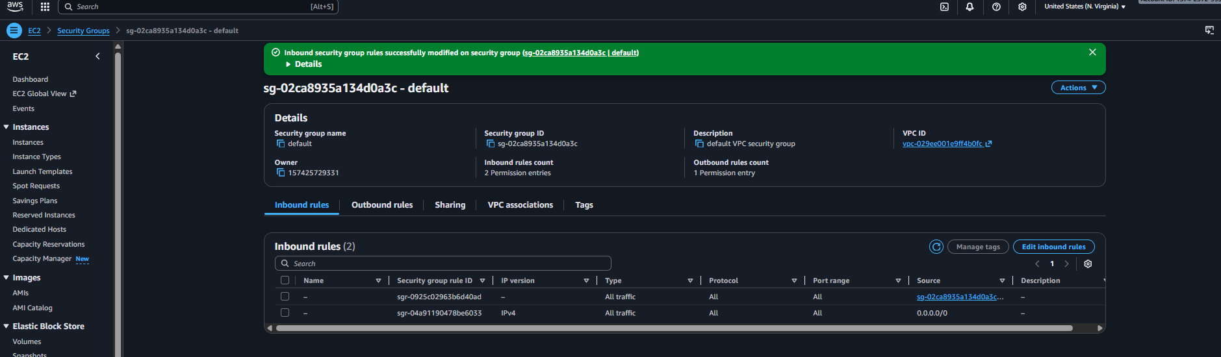
Successfully connected to instance with 3/3 checks and httpd is been running 
Checked with public ip and :80
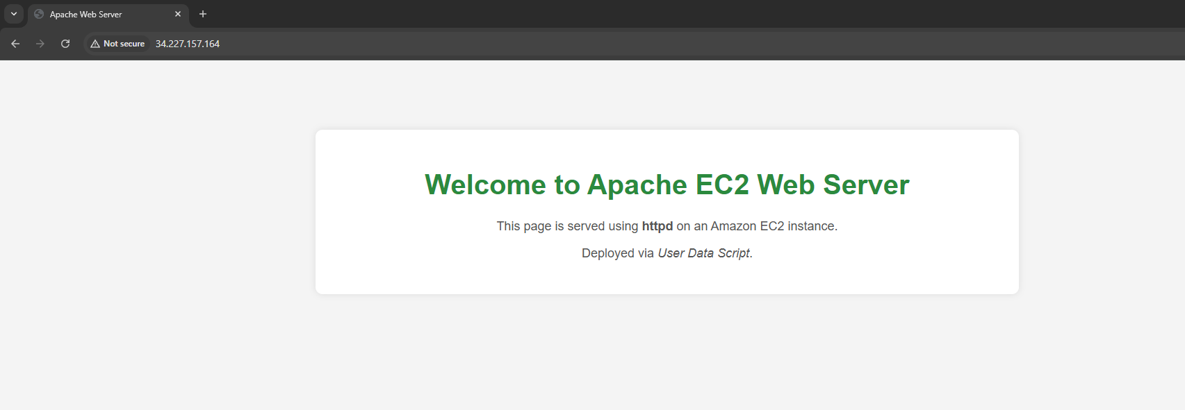
The ec-2 instance is been created one with public and one with private and installed httpd in both instance successfully.

- Create one application load balancer and attach it to both EC2 instances.
Ans: Task Title
Create an Application Load Balancer (ALB) and Register Both EC2 Instances
Objective:
Deploy an Application Load Balancer that distributes incoming traffic to both EC2
instances (public + private) to ensure high availability and load distribution.
Prerequisites:
• EC2 instances running
• Apache installed on both EC2s
• Security group allowing HTTP (80)
• Internet-facing ALB requires:
• Two public subnets in different AZs
• Target group configuration
Step-by-Step Implementation (With Evidence):
First need to click on load balancer in ec-2 console and select the application load balancer 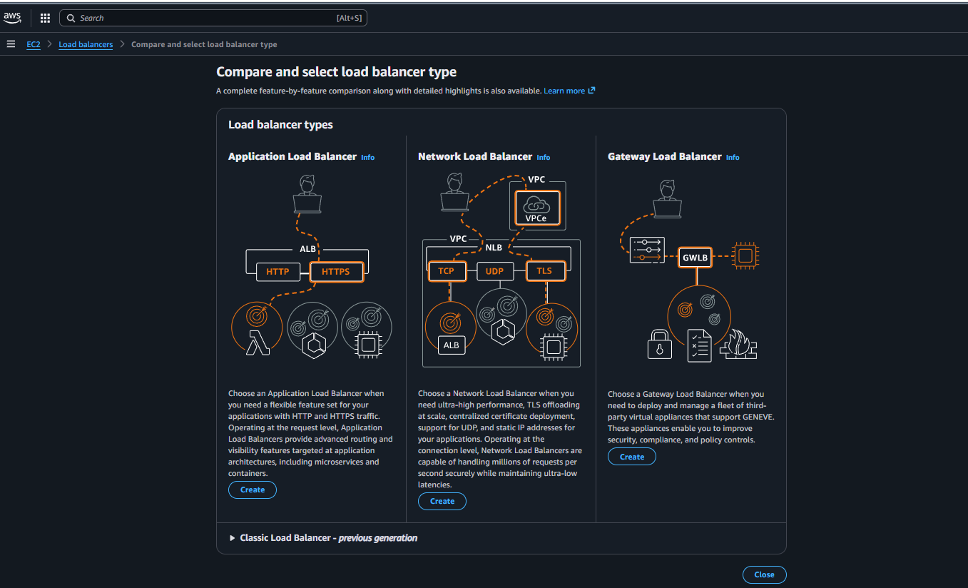
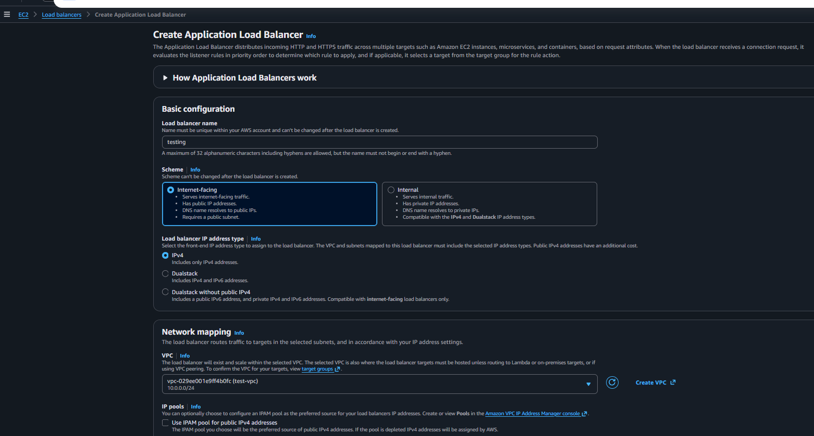
Once the details is getting entered need to add target so first we have to create a target 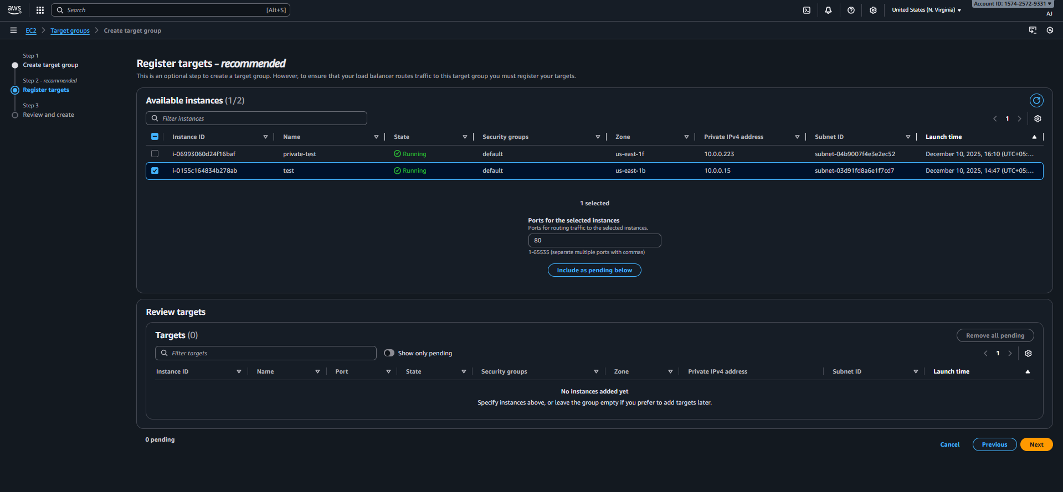
Now target is been created going to load balancer and added the target and click on create 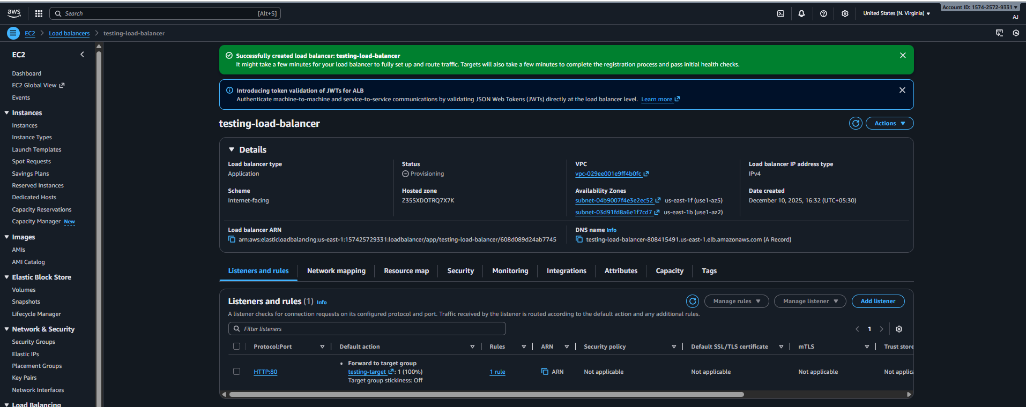

Evidence:
target group is been created successfully 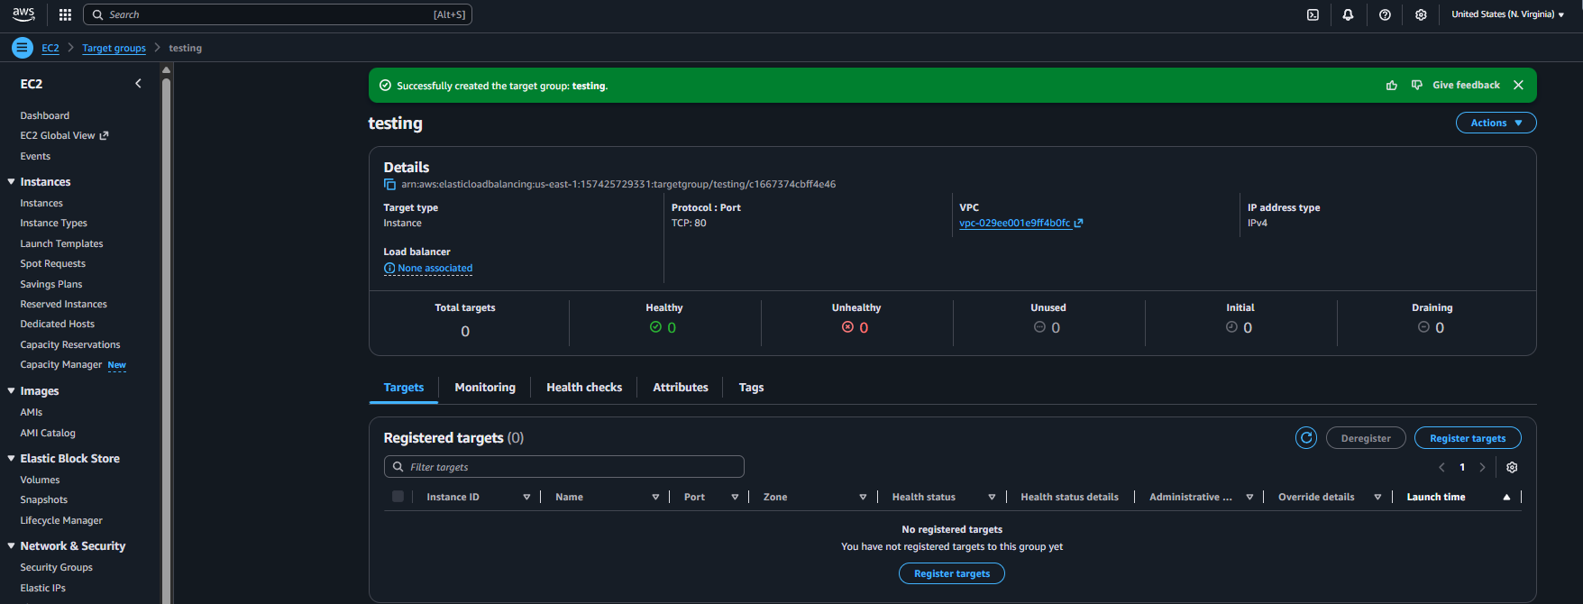
and loan balancer is been created successfully
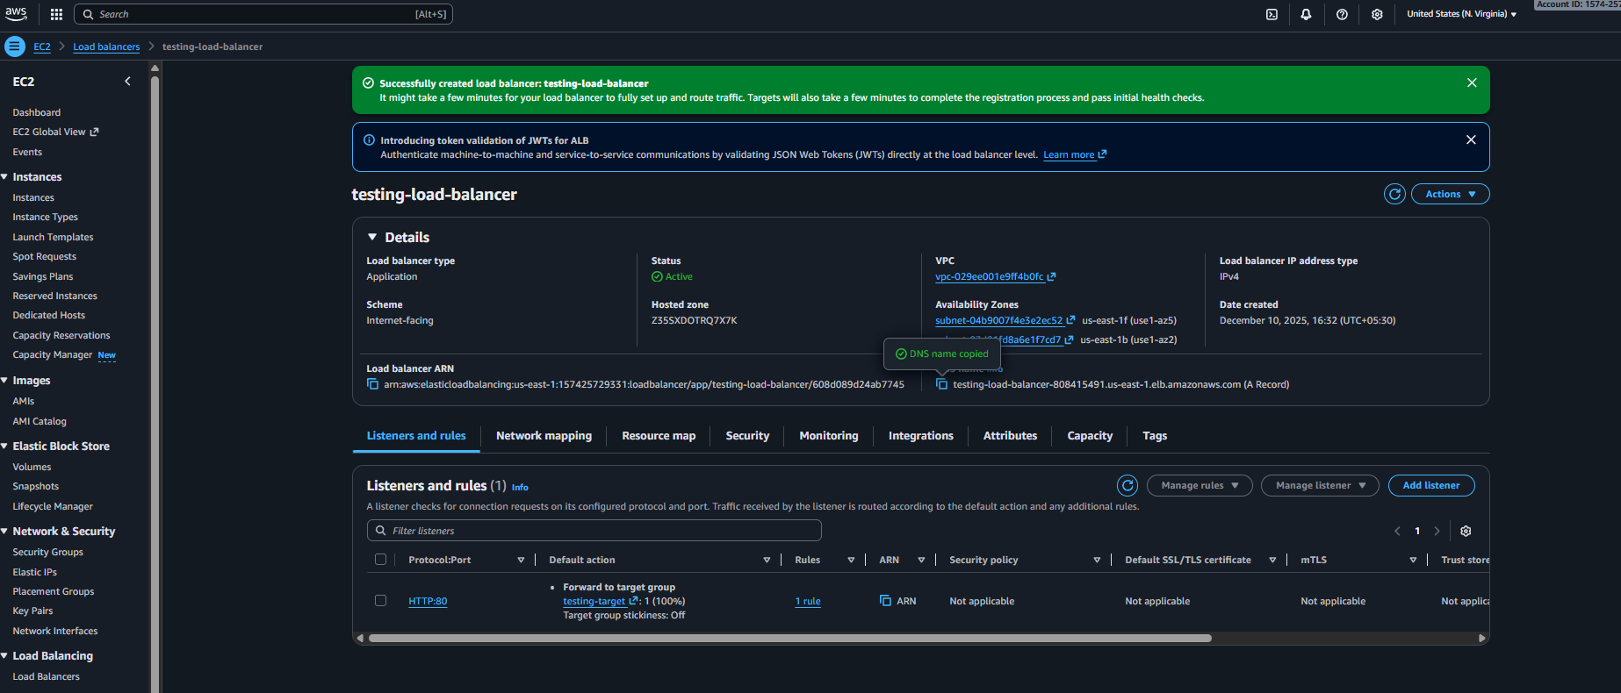

With the help of dns records A record can able to see the public and private httpd site 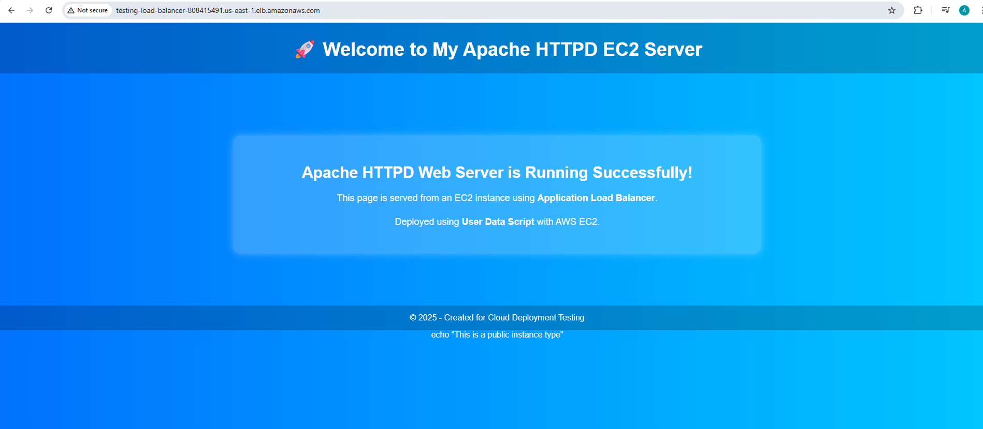
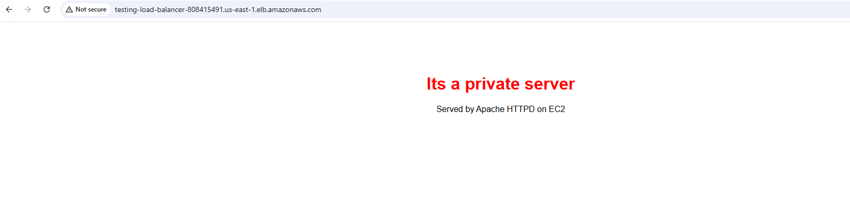

Finally load balancer is been created and deploy on our public and private instances

- Store application load balancer logs in S3.
Ans: Task Title
Enable ALB Access Logging to S3

Objective:
Configure the Application Load Balancer to store access logs (requests, client IP, latency, target info) into an S3 bucket for auditing, troubleshooting, and compliance.

Prerequisites
- ALB already created and running
- EC2 instances registered & healthy
- S3 bucket created for log storage
- Bucket policy allowing ALB to write logs
- Correct region-specific logging prefix

Step-by-Step Implementation (With Evidence):
First need to create a bucket in s3 search for s3 bucket in aws console and created one bucket 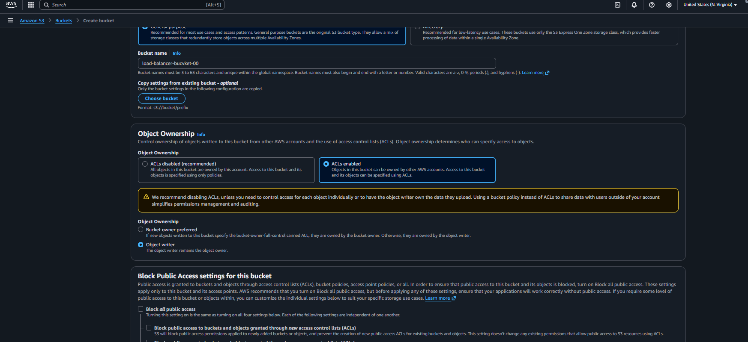
Once the bucket is been created we have to change the permission of bucket
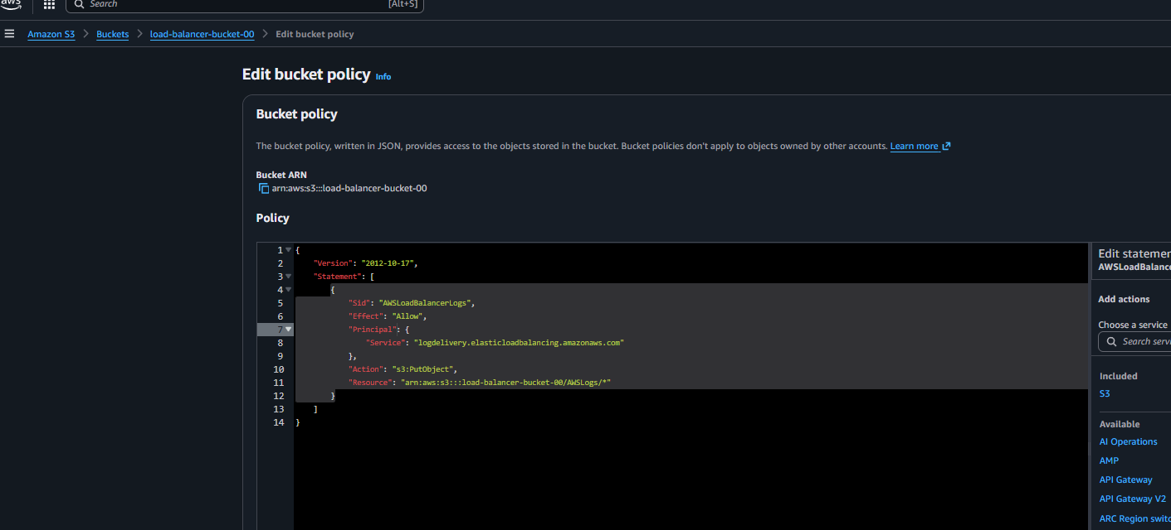
And save the permissions now need to give access to ALB(application load balancer) need to go on attributes click on edit and added the S3 bucket and save the file 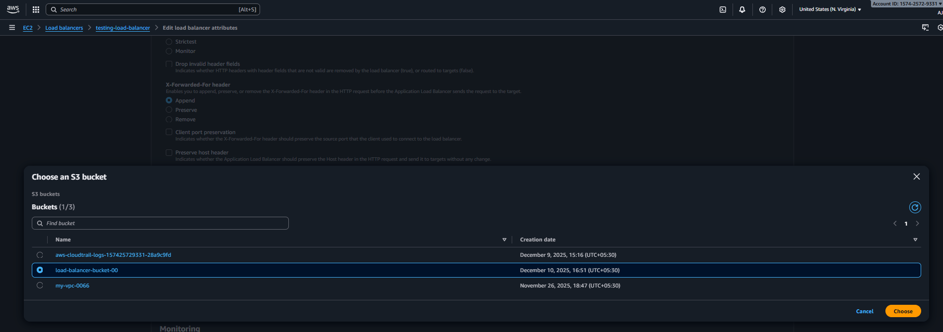
With this we have completed the steps

Evidence:
Created load balancer bucket globally 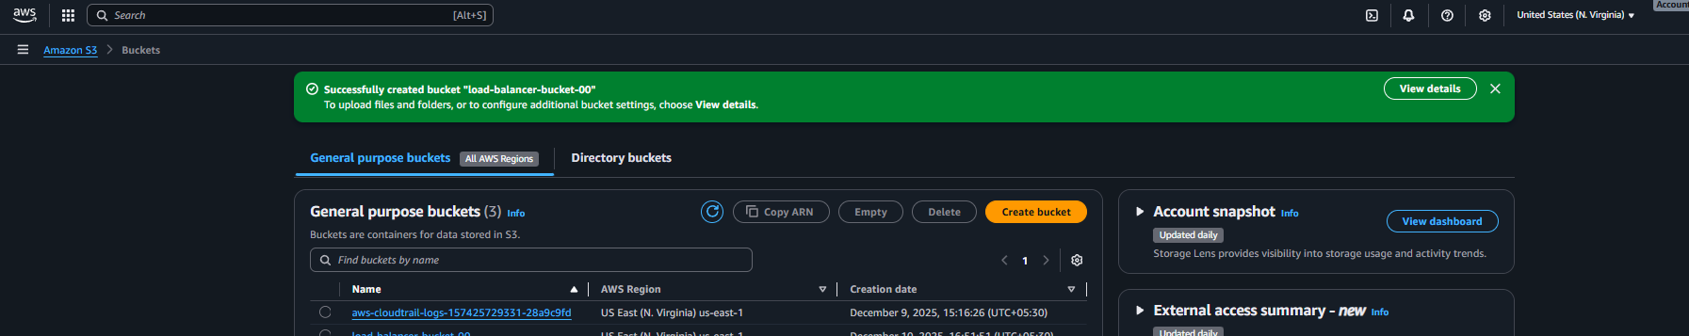

Successfully added the permissions to bucket for load balancer 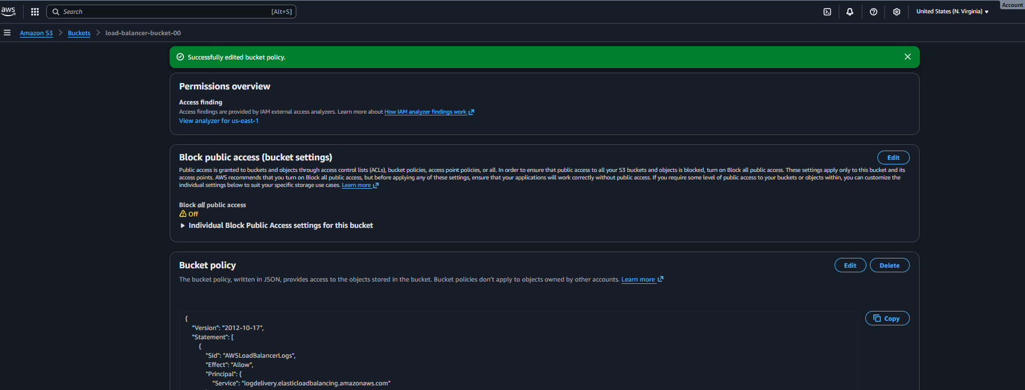
And finally created APL(application load balancer)logs in s3 bucket 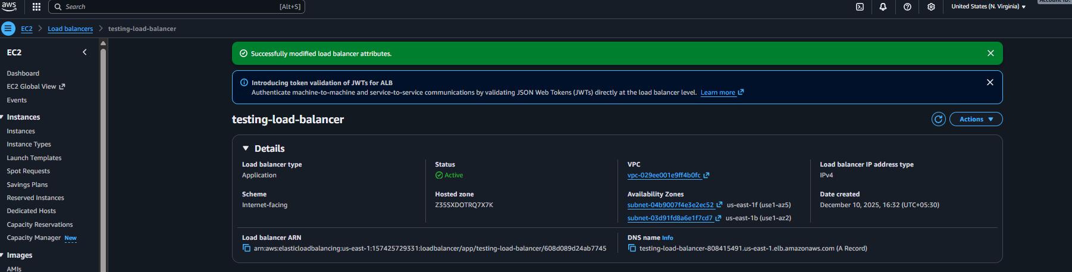
In S3 bucket we can see the load balancer logs 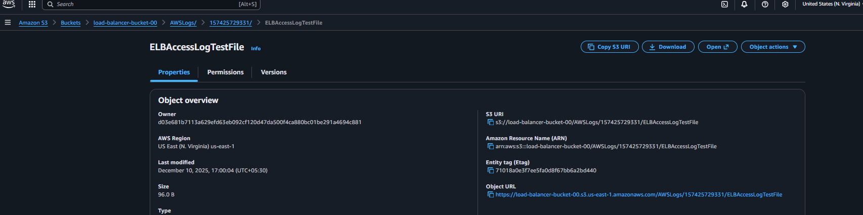
Conclusion: created a S3 bucket and given the permission to s3 bucket for load balancer and successfully store the load balancer logs in S3.

- Store the VPC flow logs in a CloudWatch log group.
Ans: Objective
Enable VPC Flow Logs to capture network traffic (accepted/denied) within the VPC and store them in CloudWatch Logs for monitoring and troubleshooting.

Prerequisites
• Existing AWS VPC
• Subnets configured (Public & Private)
• Security Groups applied to resources
• vpc flowlogs
• IAM permissions to create roles & log groups
• cloudwatch log groups

Step-by-Step Implementation (With Evidence):
First we need to create the log group in cloudwatch 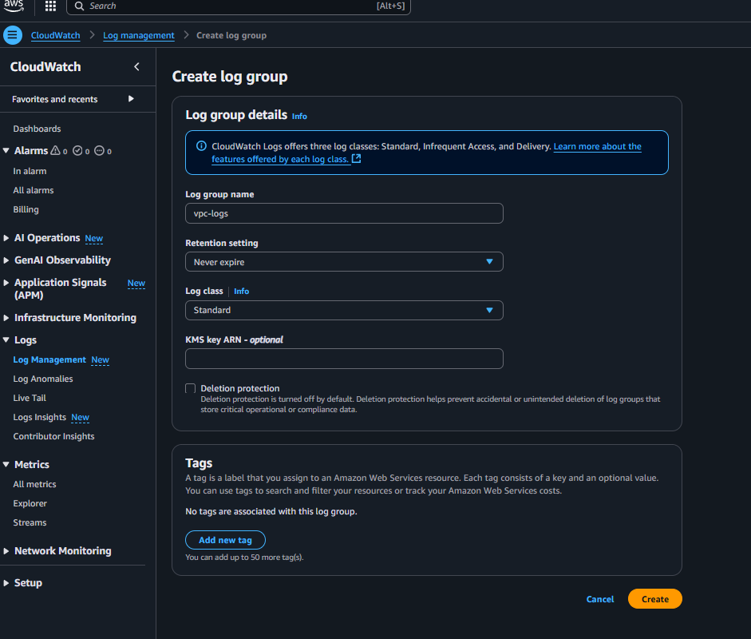
Once the log group is been created we need to search vpc go for vpc select the vpc in which we want to add logs selected the logs and click on flow logs created the flow log
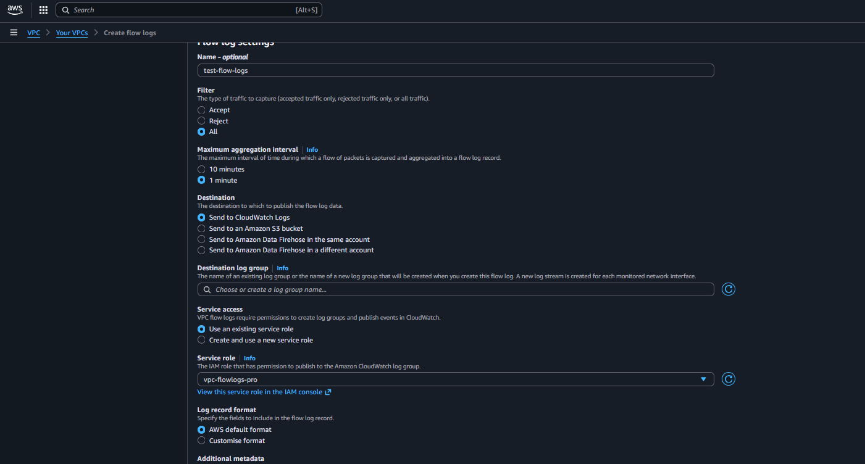
By this flow-logs is been created successfully

Evidence: created log-group in cloud-watch 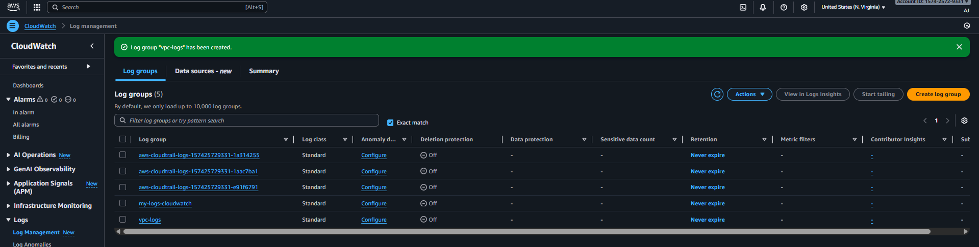
Created the flowlogs in vpc for cloudwatch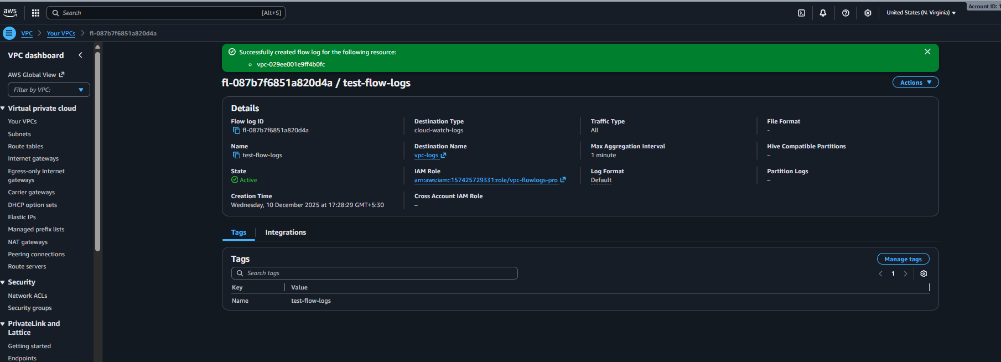
Finally check in cloud-watch log groups logs are getting shows 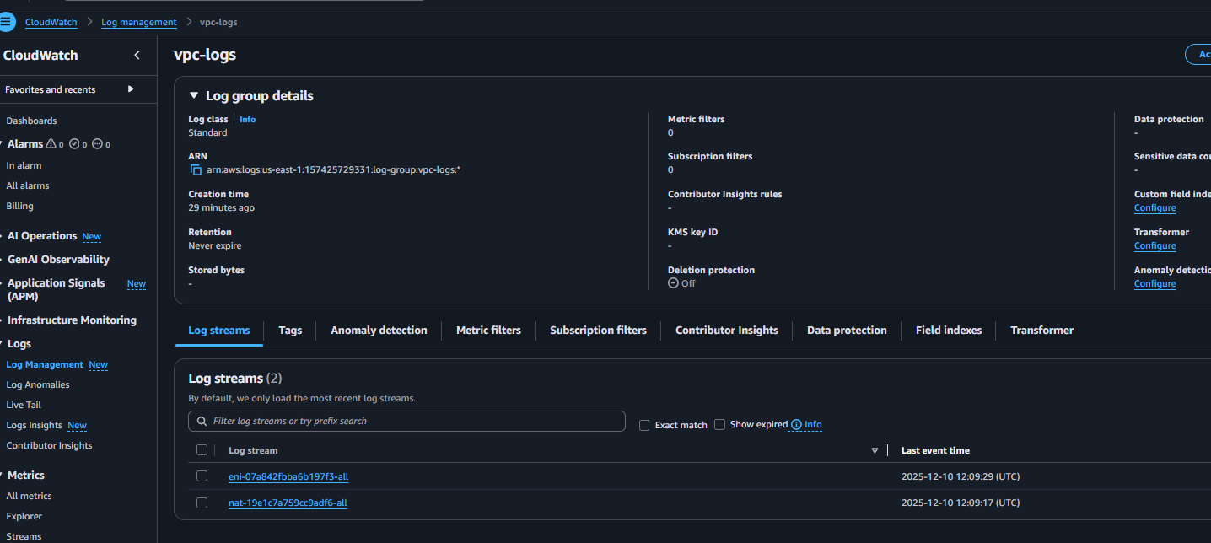

Conclusion : successfully stored the Vpc flow logs in cloud-watch

- Create monitoring dashboards to monitor CPU utilization and to monitor the Apache service.
Ans: Objective
Create a CloudWatch Monitoring Dashboard to visually track:
- EC2 instance CPU utilization
- Apache HTTP server service availability

Prerequisites
- EC2 instance running Apache Web Server
- CloudWatch Agent installed and configured on EC2 (required for service monitoring)
- Security Group allows HTTP (Port 80)
- Apache service actively running

Step-by-Step Implementation (With Evidence):
First need to go on cloudwatch and create a dashbaod entre the instance id and selected for cpu utilization 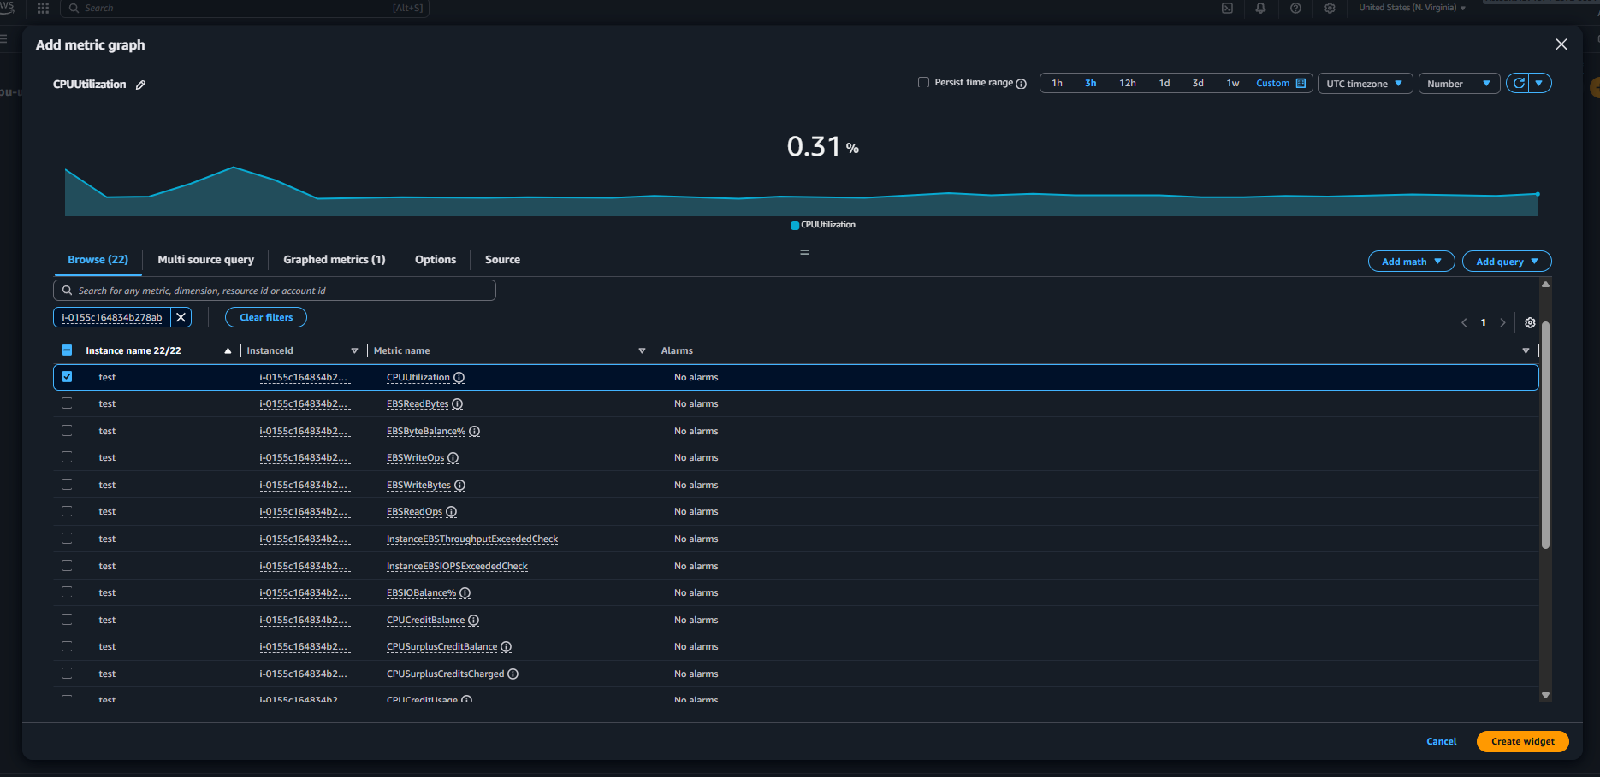
Cpu utilization is been completed now we have to add Apache httpd now going for different process to deploy connected to remote server and connected to ssh remote server added the script and added the wedgit
Successfully 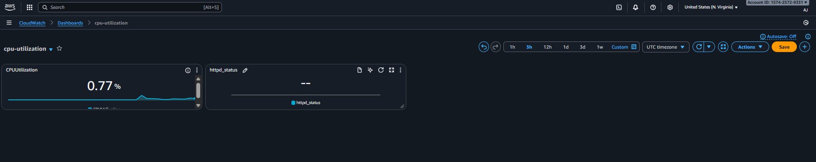
- If CPU utilization is more than 70%, then it should trigger auto scaling and launch new instance.
Ans: Task Title
Auto Scale EC2 Instances When CPU Utilization Exceeds 70%

Objective:
Automatically launch additional EC2 instances when CPU utilization goes above 70% using an Auto Scaling Group (ASG) and CloudWatch alarms.

Prerequisites:
• VPC
• Public and/or Private Subnets
• IAM Role for EC2
• Key Pair
• Security Groups
• Launch Template or AMI
• CloudWatch Alarm permissions
• Auto Scaling Group

Step-by-Step Implementation (With Evidence):
First need to go on ec2 console and under that there is an option of auto-sacling click and create one 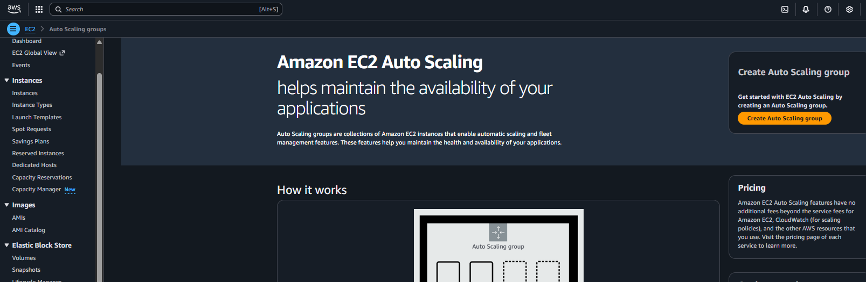
And before creating the auto scaling need to create a template so created the template 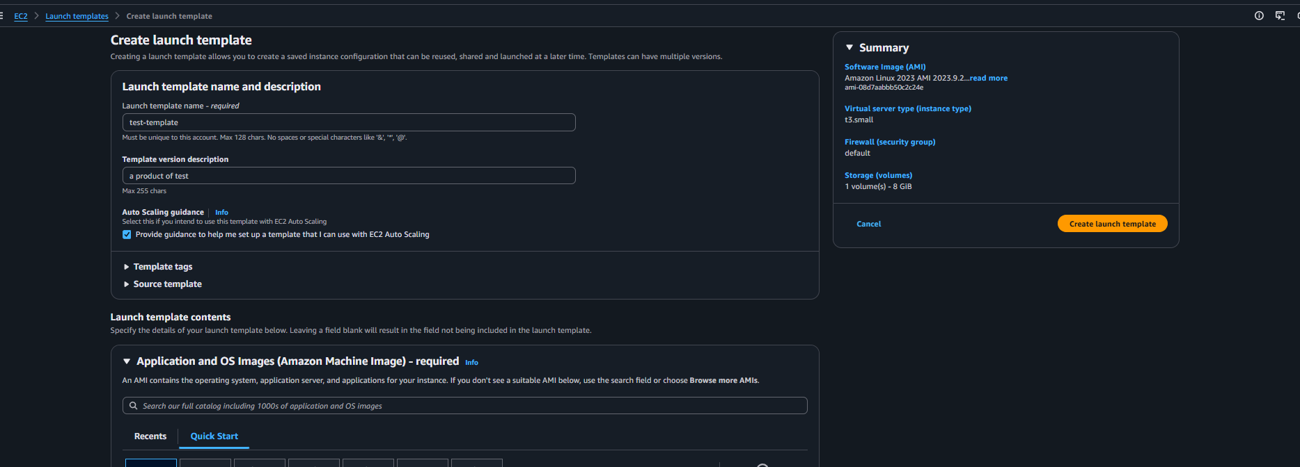
Once the tamplate is been created need to create for auto scaling by the selecting the template 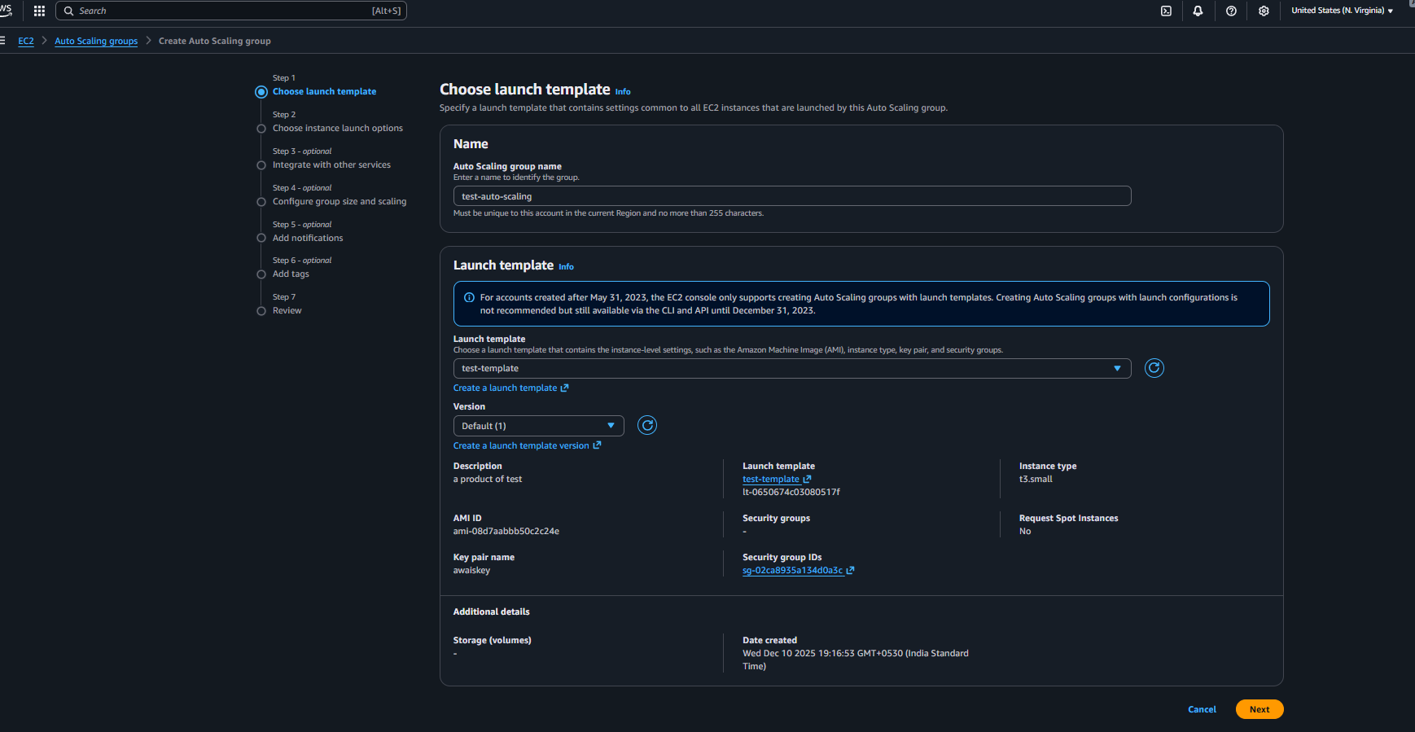
Need to enter the details 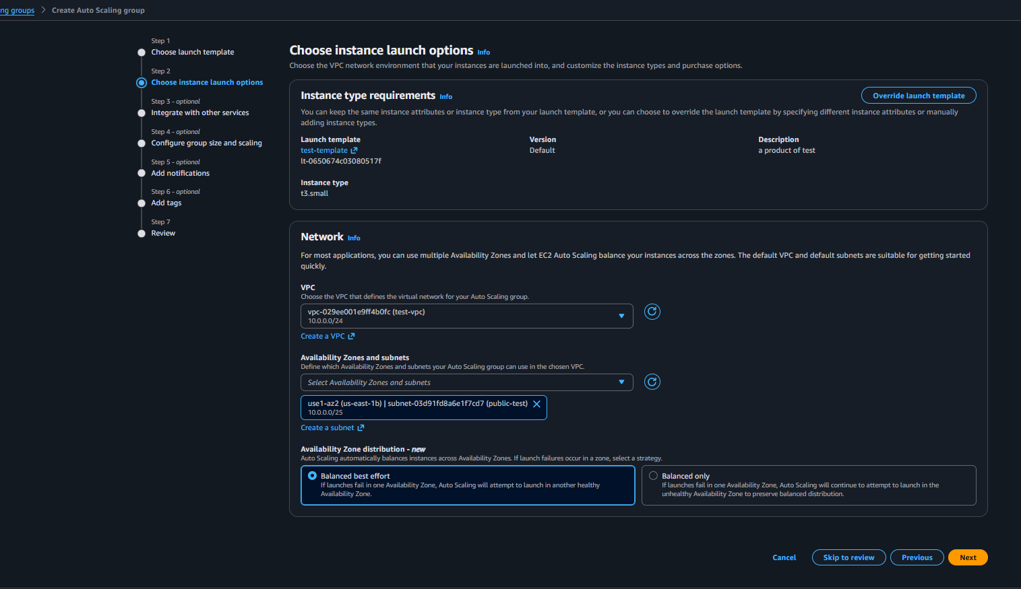
Then need to add the loan balancer 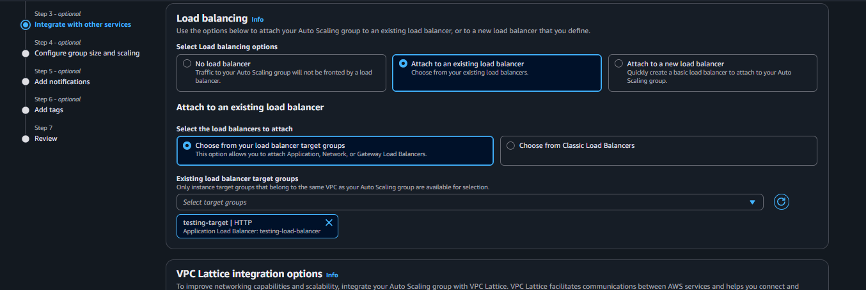

Then adding the size for the auto scaling 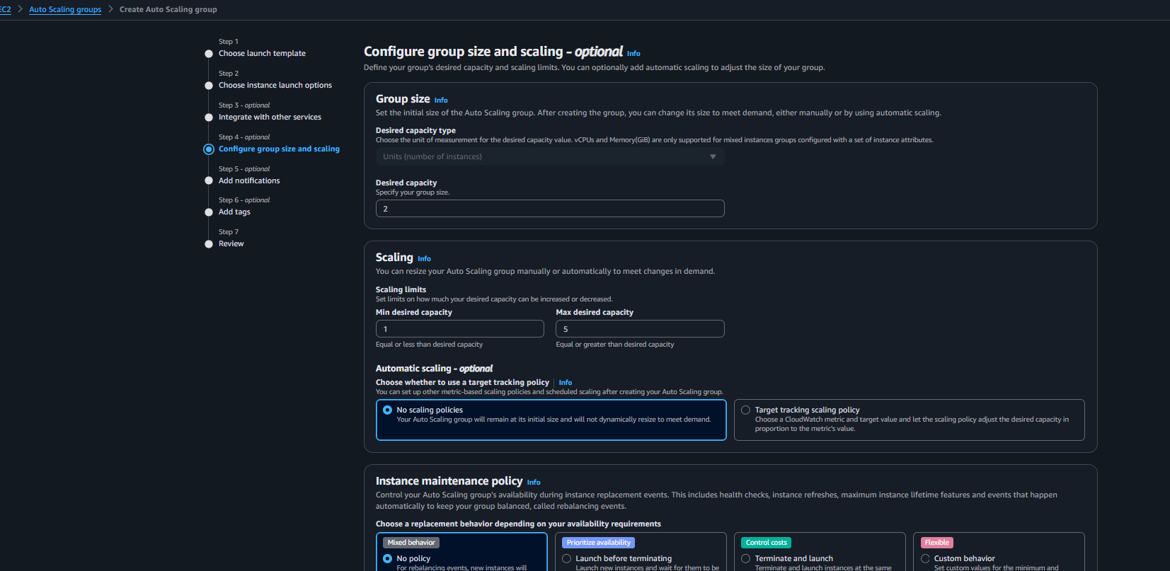
Once all details is been added need to click on create 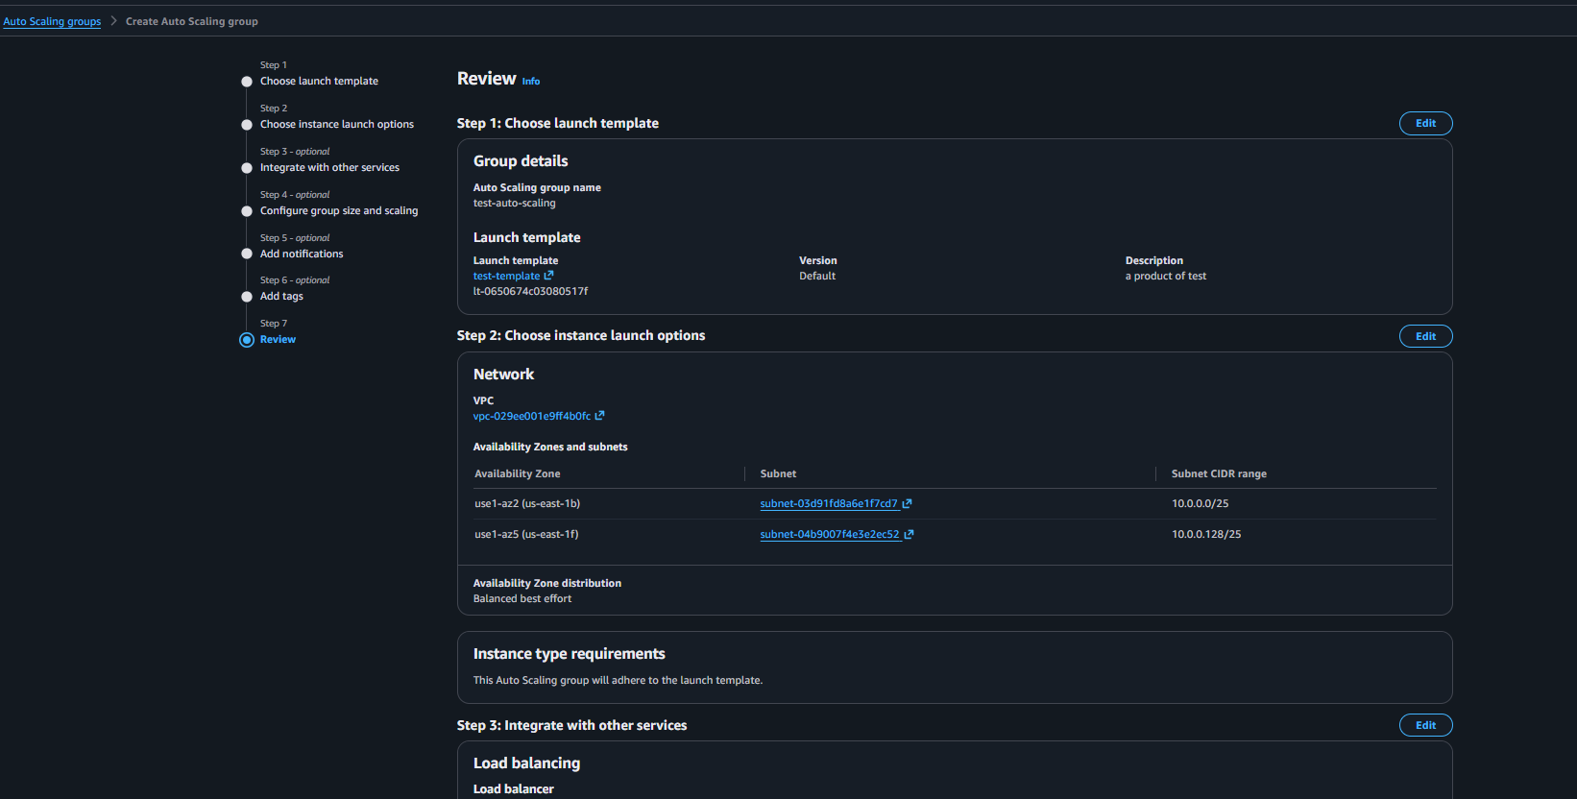
Once the auto-sacling is been created it will automatically create the instance 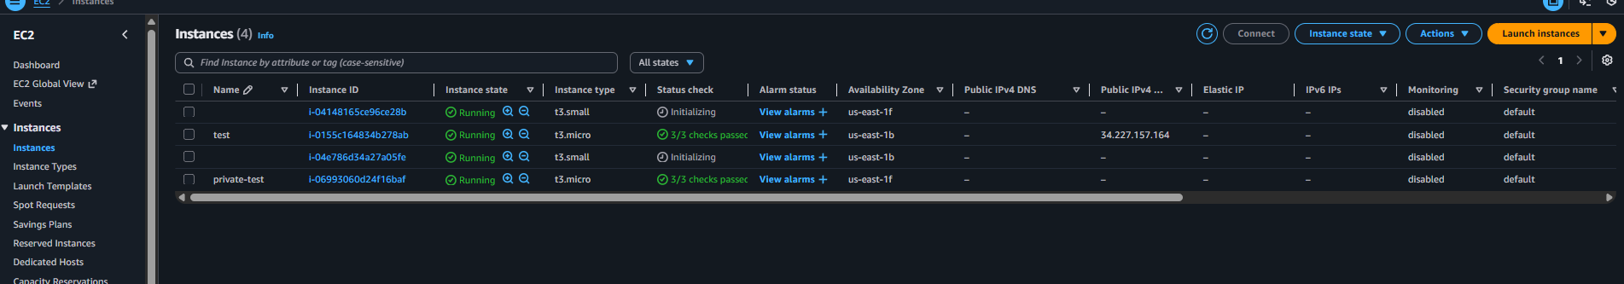

For the testing purpose tried to terminate the instance automatically new instance getting launch 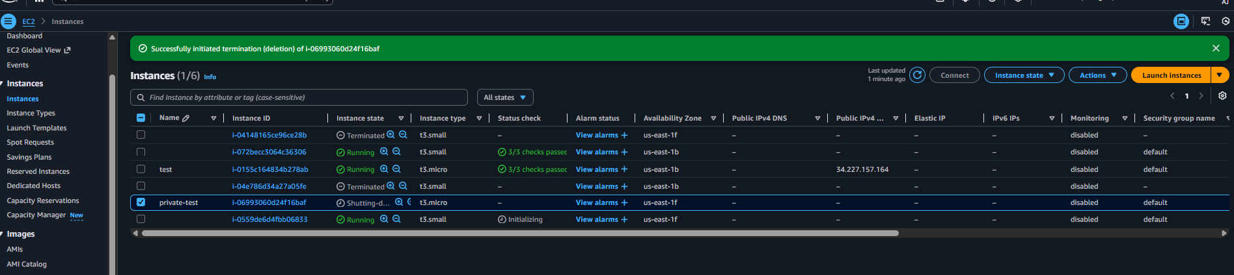
Now connecting the remote server and adding some load to check auto scaling is working or not isntall stress to add some load 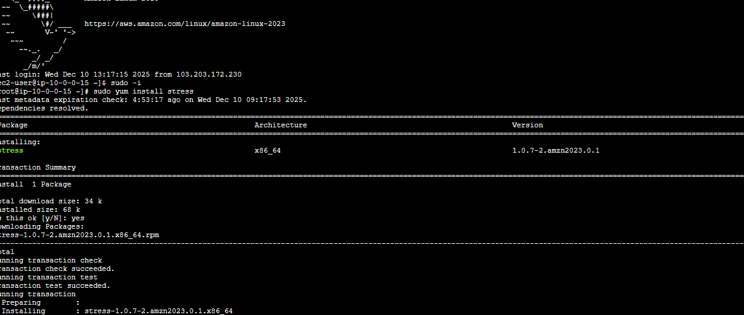
Added the load in the cpu 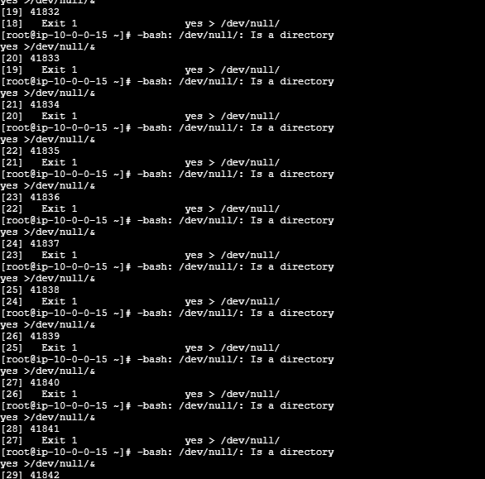

Evidence:
First created templates 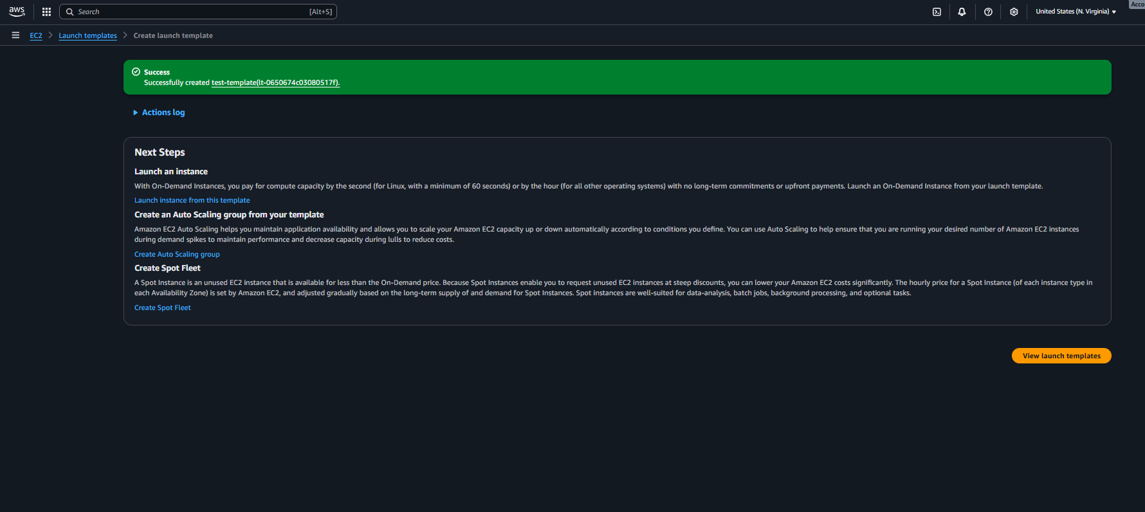
Then created the autoscaling
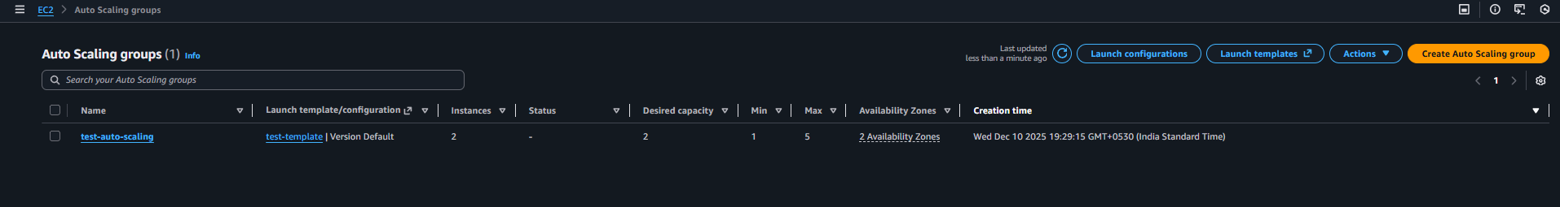
And finally once the load is more than 70% new instance is been creating automatically 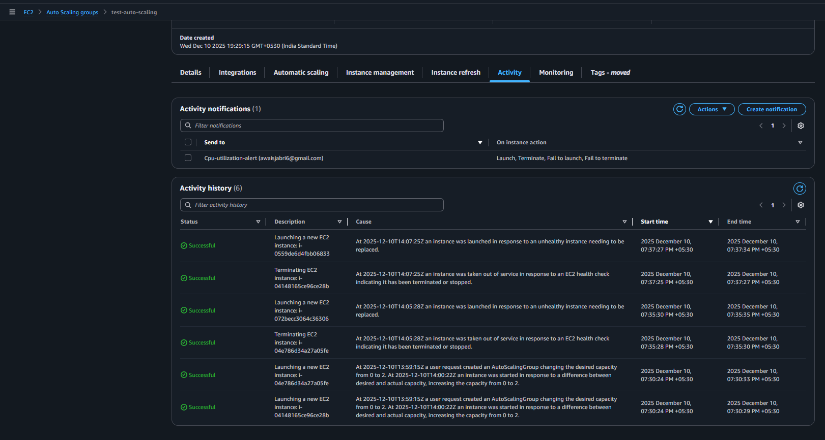

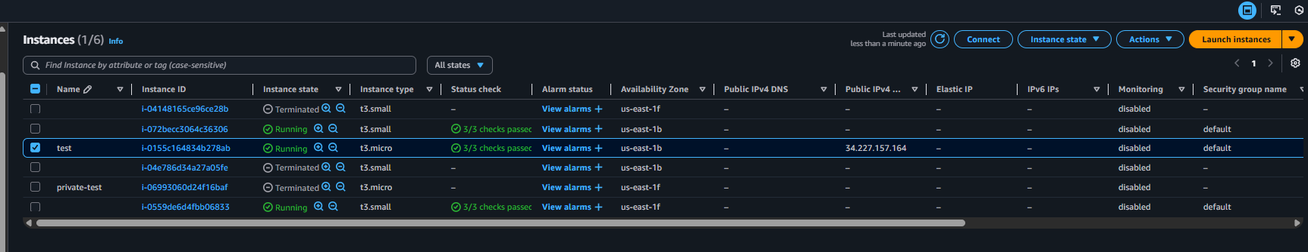

Conclusion: successfully created the autoscaling for cpu utilization more than 70%

