Lab Cycle 6

Experiment 1

Aim:Define a class to represent a bank account. Include the following details like name of the depositor, account number, type of account, balance amount in the account. Write methods to assign initial values, to deposit an amount, withdraw an amount after checking the balance, to display details such as name, account number, account type and balance.

Source code
class BankAccount:
# Constructor to initialize the details of the bank account
def __init__(self, name, account_number, account_type, balance):
self.name = name
self.account_number = account_number
self.account_type = account_type
self.balance = balance

# Method to deposit an amount into the account
def deposit(self, amount):
if amount > 0:
self.balance += amount
print(f"Deposited {amount}. New balance: {self.balance}")
else:
print("Deposit amount must be greater than zero.")

# Method to withdraw an amount from the account
def withdraw(self, amount):
if amount <= 0:
print("Withdrawal amount must be greater than zero.")
elif amount > self.balance:
print("Insufficient balance!")
else:
self.balance -= amount
print(f"Withdrew {amount}. New balance: {self.balance}")

# Method to display account details
def display_details(self):
print(f"\nAccount Details:")
print(f"Name: {self.name}")
print(f"Account Number: {self.account_number}")
print(f"Account Type: {self.account_type}")
print(f"Balance: {self.balance}")

# Taking user input for account details
def get_account_details():
name = input("Enter the name of the depositor: ")
account_number = input("Enter the account number: ")
account_type = input("Enter the account type (e.g., Savings, Current): ")
balance = float(input("Enter the initial balance: "))

return name, account_number, account_type, balance

# Main function to create and interact with the BankAccount object
def main():
# Get account details from the user
name, account_number, account_type, balance = get_account_details()

# Creating a BankAccount object with the provided details
account = BankAccount(name, account_number, account_type, balance)

# Display initial account details
account.display_details()

# Performing transactions
while True:
print("\nChoose an option:")
print("1. Deposit")
print("2. Withdraw")
print("3. Display account details")
print("4. Exit")

choice = int(input("Enter your choice: "))

if choice == 1:
amount = float(input("Enter the amount to deposit: "))
account.deposit(amount)
elif choice == 2:
amount = float(input("Enter the amount to withdraw: "))
account.withdraw(amount)
elif choice == 3:
account.display_details()
elif choice == 4:
print("Exiting... Thank you!")
break
else:
print("Invalid choice. Please try again.")

# Run the main function
if __name__ == "__main__":
main()

Output
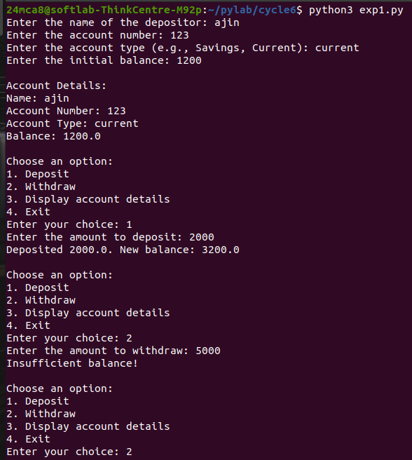

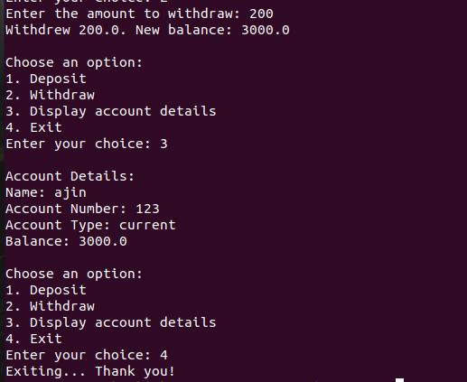

Experiment 2

Aim:Create a class Publisher with attributes publisher id and publisher name. Derive class Book from Publisher with attributes title and author.Derive class Python from Book with attributes price and no_of_pages. Write a program that displays information about a Python book. Use base class constructor invocation and method
overriding.

Source code

class Publisher:
def __init__(self, publisher_id, publisher_name):
self.publisher_id = publisher_id
self.publisher_name = publisher_name

def display_publisher(self):
print(f"Publisher ID: {self.publisher_id}")
print(f"Publisher Name: {self.publisher_name}")

class Book(Publisher):
def __init__(self, publisher_id, publisher_name, title, author):

super().__init__(publisher_id, publisher_name)
self.title = title
self.author = author

def display_book(self):
print(f"Title: {self.title}")
print(f"Author: {self.author}")

class Python(Book):
def __init__(self, publisher_id, publisher_name, title, author, price, no_of_pages):
super().__init__(publisher_id, publisher_name, title, author)
self.price = price
self.no_of_pages = no_of_pages

def display_python_book(self):
print(f"Price: {self.price}")
print(f"Number of Pages: {self.no_of_pages}")

if __name__ == "__main__":
publisher_id = input("Enter Publisher ID: ")
publisher_name = input("Enter Publisher Name: ")
title = input("Enter Book Title: ")
author = input("Enter Author Name: ")
price = float(input("Enter Book Price: "))
no_of_pages = int(input("Enter Number of Pages: "))

python_book = Python(publisher_id, publisher_name, title, author, price, no_of_pages)
python_book.display_publisher()
python_book.display_book()
python_book.display_python_book()

Output
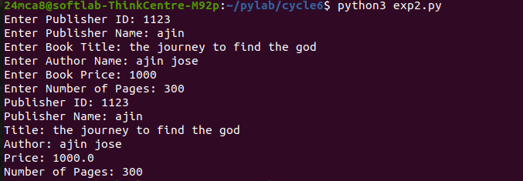

Experiment 3

Aim:Write a program that has an abstract class Polygon. Derive two classes Rectangle and Triangle from Polygon and write methods to get the details of their dimensions and hence calculate the area.

Source code

from abc import ABC, abstractmethod

class Polygon(ABC):
@abstractmethod
def get_dimensions(self):
pass

@abstractmethod
def calculate_area(self):
pass

class Rectangle(Polygon):
def __init__(self):
self.length = 0
self.width = 0

def get_dimensions(self):
self.length = float(input("Enter the length of the rectangle: "))
self.width = float(input("Enter the width of the rectangle: "))

def calculate_area(self):
area = self.length * self.width
return area

class Triangle(Polygon):
def __init__(self):
self.base = 0
self.height = 0

def get_dimensions(self):
self.base = float(input("Enter the base of the triangle: "))
self.height = float(input("Enter the height of the triangle: "))

def calculate_area(self):
area = 0.5 * self.base * self.height
return area

if __name__ == "__main__":
while True:
print("Choose a polygon to calculate area:")
print("1. Rectangle")
print("2. Triangle")
choice = input("Enter your choice (1/2): ")

if choice == "1":
rectangle = Rectangle()
rectangle.get_dimensions()
area = rectangle.calculate_area()
print(f"The area of the rectangle is: {area}")
break
elif choice == "2":
triangle = Triangle()
triangle.get_dimensions()
area = triangle.calculate_area()
print(f"The area of the triangle is: {area}")
break
else:
print("Invalid choice. Please select either 1 or 2.")

Output

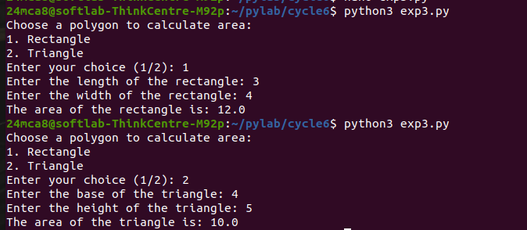

Experiment 4

Aim:Create a Rectangle class with attributes length and breadth and methods to find area and perimeter. Compare two Rectangle objects by their area.

Source code
from abc import ABC, abstractmethod

class Polygon(ABC):
@abstractmethod
def get_dimensions(self):
pass

@abstractmethod
def calculate_area(self):
pass

class Rectangle(Polygon):
def __init__(self):
self.length = 0
self.width = 0

def get_dimensions(self):
self.length = float(input("Enter the length of the rectangle: "))
self.width = float(input("Enter the width of the rectangle: "))

def calculate_area(self):
area = self.length * self.width
return area

class Triangle(Polygon):
def __init__(self):
self.base = 0
self.height = 0

def get_dimensions(self):
self.base = float(input("Enter the base of the triangle: "))
self.height = float(input("Enter the height of the triangle: "))

def calculate_area(self):
area = 0.5 * self.base * self.height
return area

if __name__ == "__main__":
while True:
print("Choose a polygon to calculate area:")
print("1. Rectangle")
print("2. Triangle")
choice = input("Enter your choice (1/2): ")

if choice == "1":
rectangle = Rectangle()
rectangle.get_dimensions()
area = rectangle.calculate_area()
print(f"The area of the rectangle is: {area}")
break
elif choice == "2":
triangle = Triangle()
triangle.get_dimensions()
area = triangle.calculate_area()
print(f"The area of the triangle is: {area}")
break
else:
print("Invalid choice. Please select either 1 or 2.")

Output

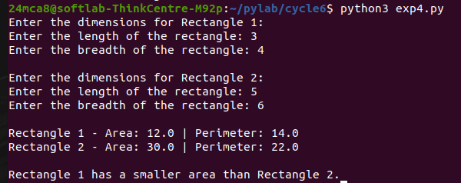
Experiment 5

Aim:Create a class Time with private attributes hour, minute and second. Overload ‘+’ operator
to find sum of 2 times.

Source code
class Time:
def __init__(self, hour=0, minute=0, second=0):
self.__hour = hour
self.__minute = minute
self.__second = second

def get_hour(self):
return self.__hour

def get_minute(self):
return self.__minute

def get_second(self):
return self.__second

def set_hour(self, hour):
self.__hour = hour

def set_minute(self, minute):
self.__minute = minute

def set_second(self, second):
self.__second = second
def __add__(self, other):
if isinstance(other, Time):
total_seconds = self.__to_seconds() + other.__to_seconds()
return self.__from_seconds(total_seconds)
else:
raise TypeError("Operand must be of type 'Time'")
def __to_seconds(self):
return self.__hour * 3600 + self.__minute * 60 + self.__second
def __from_seconds(self, total_seconds):
hours = total_seconds // 3600
minutes = (total_seconds % 3600) // 60
seconds = total_seconds % 60
return Time(hours, minutes, seconds)
def display(self):
return f"{self.__hour:02}:{self.__minute:02}:{self.__second:02}"
def get_time_input():
hour = int(input("Enter hours: "))
minute = int(input("Enter minutes: "))
second = int(input("Enter seconds: "))
return Time(hour, minute, second)
print("Enter the first time:")
time1 = get_time_input()

print("Enter the second time:")
time2 = get_time_input()

time3 = time1 + time2

print(f"\nTime 1: {time1.display()}")
print(f"Time 2: {time2.display()}")
print(f"Sum of Time 1 and Time 2: {time3.display()}")

Output

