Lab Cycle 7

Experiment 1

Aim:Write a Python program to read a file line by line and store it into a list.

Source code

ajin.txt
hello ajin jose
your are great.
this is a test file.
please keep it as secret

exp1.py
def read_file_to_list(file_name):
lines_list = []
with open(file_name, 'r') as file:
for line in file:
lines_list.append(line.strip())
return lines_list

file_name = 'ajin.txt'
lines = read_file_to_list(file_name)
print(lines)

Output

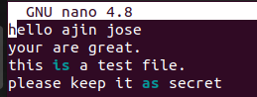

Experiment 2

Aim:Python program to copy odd lines of one file to other.

Source code

ajin.txt
hello ajin jose
your are great.
this is a test file.
please keep it as secret

exp2.py
def copy_odd_lines(input_file, output_file):
try:
with open(input_file, 'r') as infile:
with open(output_file, 'w') as outfile:
for line_num, line in enumerate(infile, start=1):
if line_num % 2 != 0:
outfile.write(line)
print("Odd lines have been copied successfully.")
except FileNotFoundError:
print(f"Error: The file {input_file} does not exist.")
except Exception as e:
print(f"An error occurred: {e}")
input_file = 'ajin.txt'
output_file = 'jose.txt'
copy_odd_lines(input_file, output_file)

Output

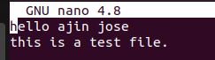

Experiment 3

Aim:Write a Python program to read each row from a given csv file and print a
list of strings.
Source code

exp3.py
import csv
def read_csv_file(filename):
with open(filename, mode='r') as file:
reader = csv.reader(file)
for row in reader:
print(row)

csv_filename = "example.csv"
read_csv_file(csv_filename)

example.csv
ajin,was,great,son
jose,was,great,father
is,he,great?
a jin,is,great
greater,than,me
buddy,how,is,that

Output

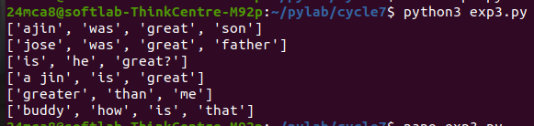

Experiment 4

Aim:Write a Python program to read specific columns of a given CSV file and
print the content of the columns.

Source code

exp4.py
import csv
def read_specific_columns(filename, columns):
with open(filename, mode='r', newline='') as file:
reader = csv.reader(file)
for row in reader:
selected_columns = [row[i] for i in columns]
print(selected_columns)

csv_filename = "data.csv"
columns_to_read = [0, 2]
read_specific_columns(csv_filename, columns_to_read)

data.csv
Name, Age, City
John, 28, New York
Anna, 22, London
Peter, 34, Berlin
Maria, 25, Madrid
David, 30, Paris

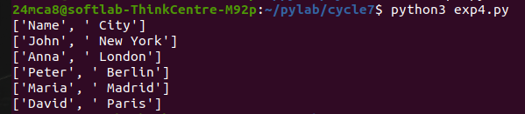
Output

Experiment 5

Aim: Write a Python program to write a Python dictionary to a csv file. After
writing the CSV file, read the CSV file and display the content

Source code

exp5.py
import csv

def write_dict_to_csv(filename, data):
with open(filename, mode='w', newline='') as file:
writer = csv.DictWriter(file, fieldnames=data[0].keys())
writer.writeheader()
writer.writerows(data)

def read_csv_file(filename):
with open(filename, mode='r', newline='') as file:
reader = csv.DictReader(file)
for row in reader:
print(row)

dict_data = [
{'Name': 'John', 'Age': 28, 'City': 'New York'},
{'Name': 'Anna', 'Age': 22, 'City': 'London'},
{'Name': 'Peter', 'Age': 34, 'City': 'Berlin'}
]

csv_filename = "output.csv"
write_dict_to_csv(csv_filename, dict_data)
print("CSV file content:")
read_csv_file(csv_filename)

create a file name output.csv

Output
