1.string=input("enter the string to exchanged:")
x=list(string)
temp=x[0]
x[0]=x[-1]
x[-1]=temp
count_word_occurences_and_add_into_dict.py
sentence = "The most fastest thing in the world is the worlds was always the fastest".split(" ")
word_count = [str(sentence.count(word)) for word in sentence]
dictionary = dict(zip(sentence,word_count))
print(dictionary)print(" ".join(x))

2.str=input("enter the string:")
k="$"
res=str[0]+str[1:].replace(str[0],k)
print(res)

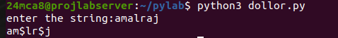
3.a=input("enter the string 1:")
b=input("enter the string 2:")
swap_a=a[0]+b[1]+a[2:]
swap_b=b[0]+a[1]+b[2:]
swap=swap_a+' '+swap_b
print(swap)
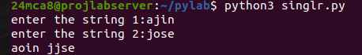
4.str=input("enter string:")
res=len([ele for ele in str if ele.isalpha()])
print(f"count of alphabets:{res}")
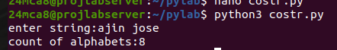

5s=input("enter your string:")
if s[-3:]=="ing":
print(s+"ly")
else:
print(s+"ing")
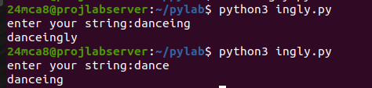

6.names=["ajin,amal,raj,shine"]
total=0
print(names)
for name in names:
total=name.lower().count('a')
print(f"the letter a has occur {total} times")

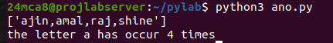

7.
ol1 = "red, blue, green".split(", ")
col2 = "maroon, cyan, emerlad, blue, red".split(", ")
print(col1)
print(col2)
print(set(col1)-set(col2))
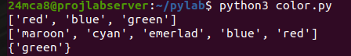

8.colors = input("Enter colors seperated by a comma: ")
colors = [color.strip() for color in colors.split(",")]
print("First color = {}, last color = {}".format(colors[0], colors[-1]))
9.integers =input("Enter numbers (comma seperated): ")
int_list = [ number.strip() for number in integers.split(",") ]
new_list = []
for number in int_list:
if int(number) > 100:
number = number.replace(number, "score")
new_list.append(number)
print(new_list)
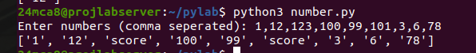
10.mport math
import random
nums = []
for i in range(10):
nums.append(math.floor(random.random() * 10))
print(f'Old list: {nums}')
new_nums = []
for i in range(0,len(nums)):
if (nums[i]%2 != 0):
new_nums.append(nums[i])
print(f'\nnew list without even numbers: {new_nums}')

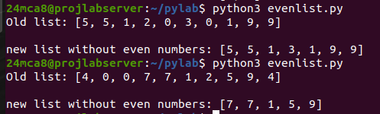
11. longest.py
list = "help, write out, where is, cut justify, go to line".split(", ")
print(list)
length = max([ len(word) for word in list ])
word = ""
for i in range(len(list)):
if len(list[i]) == length:
word = list[i]
print(f"The longest word : {word} \nlength: {length}.")
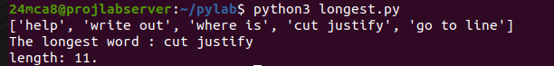
12.list1 = [int(num) for num in input("Enter 1st list numbers (space seperated):").split()]
list2 = [int(num) for num in input("Enter 1st list numbers (space seperated):").split()]
if(len(list1) == len(list2)):
print("Length is same")
else:
print("Length is not same")
sum1=sum(list1)
sum2=sum(list2)
if( sum1==sum2):
print("Sum is Same")
else:
print("Sum is different")
same1=set(list1)
same2=set(list2)
if same1==same2:
print(f" the same values in both list are {same1}")
else:
print("there are no same values")
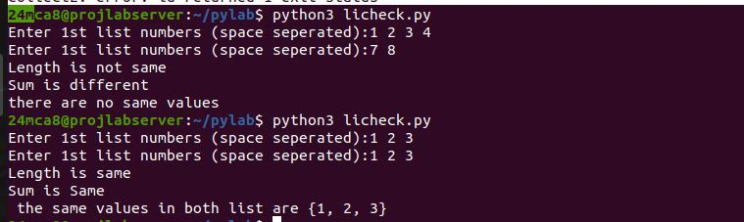
13.sentence=input("enter the sentence: ")
word=sentence.split(" ")
occdict=dict()

for i in word:
if i in occdict:
occdict[i]=occdict[i]+1
else:
occdict[i]=1
print(occdict)
14.int_list = [int(num) for num in "-1,-2,0,42,21,1,4551,-142,-2".split(",")]
print("list = ", int_list, "\n")
positive_list = [num for num in int_list if num>0]
print("positive list = ", positive_list)
square_list = [num**2 for num in int_list]
print("square list = ", square_list)
word = "orange"
vowels = "a,e,i,o,u"
vowels_list = [letter for letter in word if letter in vowels]
print(f"Vowels list from {str(word)} = {vowels_list}")
ord_values = [ord(letter) for letter in word]
print(f"Ordinal Values = {ord_values}")

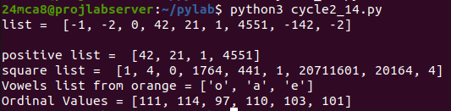
15.
person1 = {"name": "ajin","name2": "yadhu", "name3" : "mathew",}
print(person1)
print(f'Ascending : {sorted(person1.values())} \nDescending: {sorted(person1.keys(),reverse=True)}')
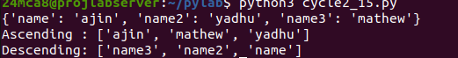

16.names = {"name1": "ajin", "name2": "mathew", "name3": "yadhu"}
age = {"age1":23, "age2" : 200, "age3":80}
print(f"the 1st dictionarie: {names}")
print(f"the 2nd dictionarie:{age}")
print(names | age)

