LAB CYCLE 3

PROGRAM 1

AIM:
Write a program to find the factorial of a number:

SOURCE CODE:
num=int(input("enter your number:"))
fact=1
if num<0:
print("enter a valid number")
elif num==0:
print("the factorial of 0 is 0")
else:
for i in range(1,num+1):
fact=fact*i
print(f"the factorial of {num} is {fact}")

OUTPUT:
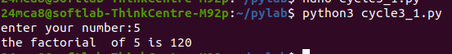

PROGRAM 2

AIM:
Generate a Fibonacci series of N terms

SOURCE CODE:
num=int(input("enter the number:"))
n1,n2=0,1
if num==1:
print("the fibonacci series of 1 is 0")
elif num<=0:
print("enter a valid number")
else:
print(f"the fibonacci series of number {num}; ")
for i in range(1,num+1):
print(n1)
n=n1+n2
n1,n2=n2,n

OUTPUT:
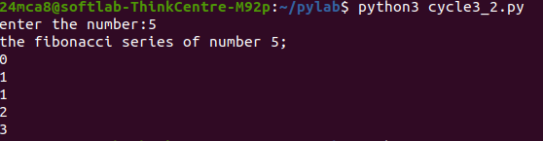

PROGRAM 3

AIM:
Write a program to find the sum of all items in a list.

SOURCE CODE:
total = 0
list1 =[int(num) for num in input("enter the numbers in the list: ").split()]
for ele in range(0, len(list1)):
total = total + list1[ele]
print("Sum of all elements in given list: ", total)

OUTPUT:
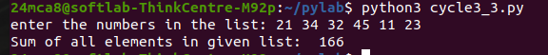

PROGRAM 4

AIM:
Generate a list of four digit numbers in a given range with all their digits even and
the number is a perfect square.

SOURCE CODE:
import math
start = int(input("Enter the start of the range:"))
end = int(input("Enter the end of the range:"))
result = []
for i in range(math.isqrt(start), math.isqrt(end) + 1):
square = i * i
if 1000 <= square <= 9999:
Even = True
for digit in str(square):
if int(digit) % 2 != 0:
Even = False
break
if Even:
result.append(square)
print("Four-digit perfect squares with all even digits:", result)

OUTPUT:
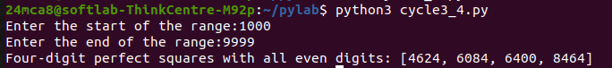

PROGRAM 5

AIM:
Write a program using a for loop to print the multiplication table of n, where n is
entered by the user.

SOURCE CODE:
num=int(input("enter your digit: "))
for i in range(1, 11):
print(num, 'x', i, '=', num*i)

OUTPUT:

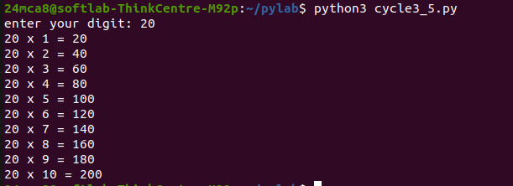

PROGRAM 6

AIM:
Write a program to display alternate prime numbers till N (obtain N from the user).

SOURCE CODE:

import math
n = int(input("Enter the Range: "))
Prime_numbers = []
for num in range(2, n + 1):
prime = True
for i in range(2, int(math.sqrt(num)) + 1):
if num % i == 0:
prime = False
break
if prime:
Prime_numbers.append(num)
print(f"Alternative Prime Numbers till {n} are:")
for p in range(0, len(Prime_numbers), 2):
print(Prime_numbers[p])

OUTPUT:
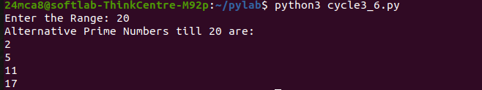

PROGRAM 7

AIM:
Write a program to compute and display the sum of all integers that are divisible
by 6 but not by 4, and that lie below a user-given upper limit.

SOURCE CODE:
limit=int(input("Enter the limit:"))
sum=0
for i in range(1,limit):
if i%6==0 and i%4!=0:
sum+=i
print(f"The sum of all integers upto {limit} that are divisible by 6 and not by 4:",sum)

OUTPUT:

PROGRAM 8

AIM:
Calculate the sum of the digits of each number within a specified range (from 1 to
a user-defined upper limit). Print the sum only if it is prime.

SOURCE CODE:
limit1 = int(input("Enter the starting range:"))
limit2 = int(input("Enter the Ending range:"))
for num in range(limit1, limit2+1):
digit_sum = 0
for digit in str(num):
digit_sum+=int(digit)
if digit_sum > 1:
prime=True
for i in range(2, int(digit_sum ** 0.5) + 1):
if digit_sum % i == 0:
prime = False
break
if prime:
print(f"Number = {num} ; Sum of Digits = {digit_sum}")

OUTPUT:
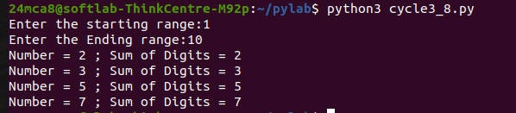
PROGRAM 9

AIM:
A number is input through the keyboard. Write a program to determine if it’s
Palindromic.

SOURCE CODE:
number = input("Enter a number:")
if number == number[::-1]:
print("The number is palindromic.")
else:
print("The number is not palindromic.")

OUTPUT :
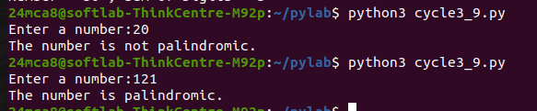
PROGRAM 10

AIM:
Write a program to generate all factors of a number. [use while loop]

SOURCE CODE:
number = int(input("Enter a number to find its factors: "))
divisor = 1
print(f"Factors of {number} are:")
while divisor <= number:
if number % divisor == 0:
print(divisor)
divisor += 1

OUTPUT:
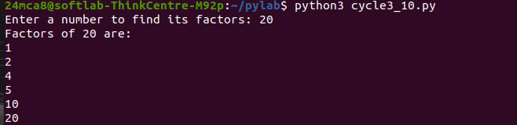

PROGRAM 11

AIM:
Write a program to find whether the given number is an Armstrong number or
not. [use while loop]

SOURCE CODE:
number = int(input("Enter a number to check if it is an Armstrong number: "))
original_number = number
num_digits = len(str(number))
sum_of_powers = 0
while number > 0:
digit = number % 10
sum_of_powers += digit ** num_digits
number //= 10
if sum_of_powers == original_number:
print(f"{original_number} is an Armstrong number.")
else:
print(f"{original_number} is not an Armstrong number.")

OUTPUT:

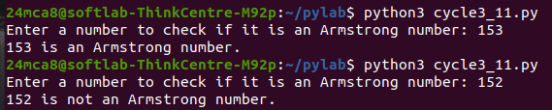
PROGRAM 12

AIM:
Display the given pyramid with the step number accepted from the user. Eg: N=4

SOURCE CODE:
n = int(input("Enter the number of steps: "))
for i in range(1, n + 1):
for j in range(1, i + 1):
print(i * j, end=" ")
print()

OUTPUT:

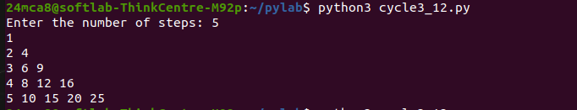

PROGRAM 13

AIM:
Construct following pattern using nested loop
SOURCE CODE:
n = int(input("Enter the number of rows: " ))
for i in range(1, n + 1):
for j in range(i):
print("*", end=" ")
print()
for i in range(n-1, 0, -1):
for j in range(i):
print("*", end=" ")
print()

OUTPUT:

