Lab cycle -4

experiment 1

aim:Write a program to print the Fibonacci series using recursion.

source code

def fibonacci(n):
if n <= 1:
return n
else:
return fibonacci(n - 1) + fibonacci(n - 2)

num_terms = int(input("Enter the number of terms: "))

if num_terms <= 0:
print("Please enter a positive integer")
else:
print("Fibonacci sequence:")
for i in range(num_terms):
print(fibonacci(i))

Output

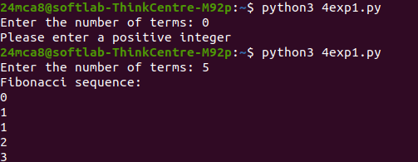

experiment 2

aim:Write the to implement a menu-driven calculator. Use separate functions for the
different operations.

Source code
def add(x, y):
return x + y

def subtract(x, y):
return x - y

def multiply(x, y):
return x * y

def divide(x, y):
if y == 0:
return "Error! Division by zero."
return x / y

while True:
print("\nSelect an operation:")
print("1. Addition")
print("2. Subtraction")
print("3. Multiplication")
print("4. Division")
print("5. Exit")

choice = input("Enter your choice: ")

if choice == '5':
print("Exiting..")
break

if choice in ('1', '2', '3', '4'):
num1 = float(input("Enter first number: "))
num2 = float(input("Enter second number: "))

if choice == '1':
print(f"Result: {num1} + {num2} = {add(num1, num2)}")
elif choice == '2':
print(f"Result: {num1} - {num2} = {subtract(num1, num2)}")
elif choice == '3':
print(f"Result: {num1} * {num2} = {multiply(num1, num2)}")
elif choice == '4':
print(f"Result: {num1} / {num2} = {divide(num1, num2)}")
else:
print("Invalid choice!")
Output
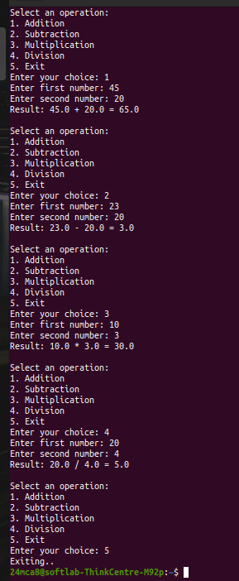

experiment 3

aim:Write a program to print the nth prime number.[Use function to check whether a number is] prime or not].

Source code

def is_prime(num):
if num <= 1:
return False
for i in range(2, int(num ** 0.5) + 1):
if num % i == 0:
return False
return True

def nth_prime(n):
count = 0
num = 2

while True:
if is_prime(num):
count += 1
if count == n:
return num
num += 1

n = int(input("Enter the position of the prime number you want to find (n): "))

if n <= 0:
print("Please enter a positive integer greater than 0.")
else:
print(f"The {n}-th prime number is: {nth_prime(n)}")
Output
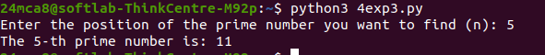
experiment 4

aim:Write lambda functions to find the area of square, rectangle and triangle.

Source code

Outputarea_square = lambda side: side * side

area_rectangle = lambda length, width: length * width

area_triangle = lambda base, height: 0.5 * base * height

while True:
print("\nChoose a shape to calculate the area:")
print("1. Square")
print("2. Rectangle")
print("3. Triangle")
print("4. Exit")

choice = input("Enter your choice: ")

if choice == '1':
side = float(input("Enter the side length of the square: "))
print(f"The area of the square is: {area_square(side)}")

elif choice == '2':
length = float(input("Enter the length of the rectangle: "))
width = float(input("Enter the width of the rectangle: "))
print(f"The area of the rectangle is: {area_rectangle(length, width)}")

elif choice == '3':
base = float(input("Enter the base length of the triangle: "))
height = float(input("Enter the height of the triangle: "))
print(f"The area of the triangle is: {area_triangle(base, height)}")

elif choice == '4':
print("Exiting...")
break
else:
print("Invalid choice!")
Output
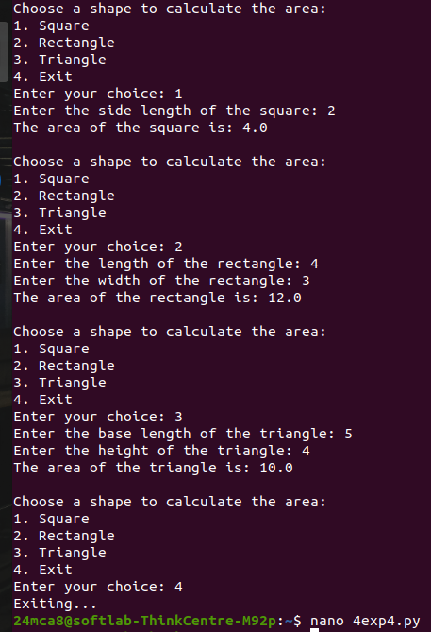

experiment 5

aim:Write a program to display powers of 2 using anonymous function. [ Hint use map and
lambda function)

Source code
lst=[int(num)for num in input("enter list elements(space seperated):").split()]
powers_of_2 = list(map(lambda x: 2 ** x, lst))

print(f"\nPowers of 2: {powers_of_2}")

Output
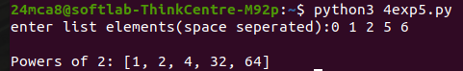

experiment 6

aim:Write a program to display multiples of 3 using anonymous function. [ Hint use filter and
lambda function)

Source code
number=list(map(int,input ( "enter the numbers:").split(",")));
multiples=list(filter(lambda x:x%3==0,number));
print(f" the multiples of 3 from the list:{multiples}");

Output
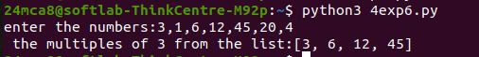
experiment 7

aim:Write a program to sum the series 1/1! + 4/2! + 27/3! + ….. + nth term. [ Hint
Use a function to find the factorial of a number].

Source code
def factorial(num):
if num == 0 or num == 1:
return 1
else:
result = 1
for i in range(2, num + 1):
result *= i
return result

def sum_series(n):
series_sum = 0
for i in range(1, n + 1):
term = (i ** i) / factorial(i)
series_sum += term
return series_sum

n = int(input("Enter the number of terms: "))

print(f"The sum of the series up to {n} terms is: {sum_series(n)}")

Output
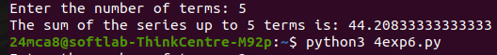
experiment 8

aim:Write a function called compare which takes two strings S1 and S2 and an integer n as
arguments. The function should return True if the first n characters of both the strings
are the same else the function should return False.

Source code
def compare(S1, S2, n):
return S1[:n] == S2[:n]

S1 = input("Enter the first string: ")
S2 = input("Enter the second string: ")
n = int(input("Enter the number of characters to compare: "))

result = compare(S1, S2, n)
print("Result:", result)

Output
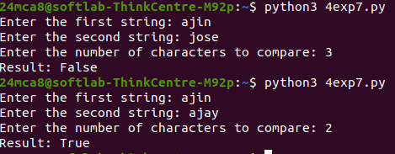

experiment 9

aim:Write a program to add variable length integer arguments passed to the function. [Also
demo the use of docstrings]

Source code
def add(*args):
"""
This is a program to add variable length integer arguments passed to the function.
arguments It is used pass any number of arguments to a function.
"""
return sum(args)
print("The Sum of First 10 numbers:", add(1,2,3,4,5,6,7,8,9,10))
print("\nThe Docstring is:")
print(add.__doc__)

Output
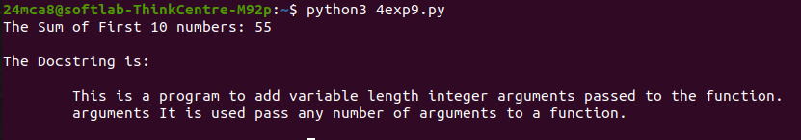
experiment 10

aim:Write a program using functions to implement these formulae for permutations and
combinations.
The Number of permutations of n objects taken r at a time: p(n, r) = n!/(n − r)!.
The Number of combinations of n objects taken r at a time is: c(n, r) = n!/(r! ∗ (n − r)!)

Source code
def factorial(num):
if num == 0 or num == 1:
return 1
else:
result = 1
for i in range(2, num + 1):
result *= i
return result

def permutations(n, r):
return factorial(n) // factorial(n - r)

def combinations(n, r):
return factorial(n) // (factorial(r) * factorial(n - r))

n = int(input("Enter the value of n (total objects): "))
r = int(input("Enter the value of r (objects taken at a time): "))

if r > n:
print("Invalid input: r should be less than or equal to n.")
else:
print(f"The number of permutations (P({n}, {r})) is: {permutations(n, r)}")
print(f"The number of combinations (C({n}, {r})) is: {combinations(n, r)}")

Output
