**PROGRAME 1**

**Aim:**Write a program that prompts the user to enter his first name and last name and then

displays a message “Greetings!!! First name Last name”.

**Source code**

first=input("enter your first name:")

last=input("enter your last name:")

print("greeting !!!",first,last)

**OUTPUT**

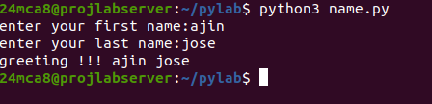

**PROGRAME 2**

**Aim:**Write a program to demonstrate different number data types in python.

**Source code**

a,b,c=10,10.5,10+5j

print("integer:",a)

print("float:",b)

print("complex number:",c)

print("type of integer:",type(a))

print("type of float:",type(b))

print("type of complex number:",type(c))

**OUTPUT**

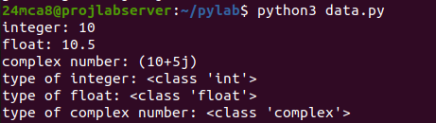

**PROGRAME 3**

**Aim:**Write a program to calculate the area of a circle by reading inputs from the user.

**Source code**

r=float(input("enter the radius of the circle:"))

area=3.14*r*r

print(f"area of circle {r} radius is {area:.4f}")

**OUTPUT**



**PROGRAME 4**

**Aim:**Write a program to calculate the salary of an employee given his basic pay (to be entered by

the user) . HRA = 10 percent of the basic pay, TA = 5 percent of the basic pay.

**Source code**

bp=float(input("enter your basic pay:"))

hra=bp*.1

ta=bp*.05

salary=bp+hra+ta

print(f"your salary is:{salary:.2f}")

**OUTPUT**



**PROGRAME 5**

**Aim:**Write a Python program to perform arithmetic operations on two integer numbers**.**

**Source code**

f=float(input("enter your first no.:"))

s=float(input("enter your second no.:"))

add=f+s

sub=f-s

div=f/s

multi=f*s

mod=f%s

print(f"addition:{f}+{s}={add:.2f}")

print(f"substration:{f}-{s}={sub:.2f}")

print(f"division:{f}/{s}={div:.2f}")

print(f"multiplication:{f}*{s}={multi:.2f}")

print(f"modulus:{f}%{s}={mod:.2f}")

**OUTPUT**

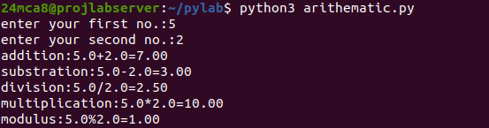

**PROGRAME 6**

**Aim:**Write a Python program to get a string which is n (non-negative integer) copies of a given

string.

**Source code**

strg=input("enter your string:")

n=int(input("no.of times your string typed:"))

if n>0:

print("resulting string:",strg*n)

else:

print("please enter a non-negative integer")

**OUTPUT**

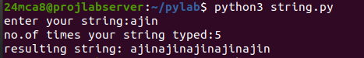

**PROGRAME 7**

**Aim:**Program to accept an integer n and compute n+nn+nnn.

[Hint : n = 5, then compute 5 + 55 + 555]

**Source code**

n=input("enter the integer:")

print(n,'+',n*2,'+',n*3)

sum=(int(n)+int(n*2)+int(n*3))

print(sum)

**OUTPUT**

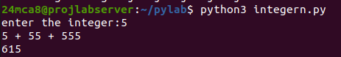

**PROGRAME 8**

**Aim:**Find biggest of 3 numbers entered.

**Source code**

a=int(input("enter the first no.:"))

b=int(input("enter the second no.:"))

c=int(input("enter the third no.:"))

if a>b and a>c:

print(f"{a} is greater")

elif b>c:

print(f"{b} is greater")

else:

print(f"{c} is greater")

**OUTPUT**

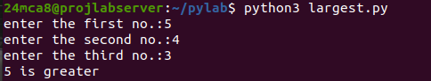

**PROGRAME 9**

**Aim:**programe to determine whether a year is leap year or not.

**Source code**

year=int(input("enter the year:"))

if year%400==0 or year%4==0 and year%100!=0:

print("it is a leap year")

else:

print("it is not a leap year")

**OUTPUT**

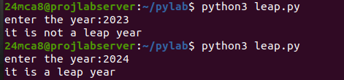

**PROGRAME 10**

**Aim:**write a python programe to determine the rate of entry_ticket in a trade based on age as follows:

|  |  |
| --- | --- |
| **AGE** | **RATE** |
| <10 | 7 |
| >=10 and <60 | 10 |
| >=60 | 5 |

**Source code**

n=int(input("enter the no.of people:"))

c=int(input("enter the no.of people below age 10:"))

a=int(input("enter the no.of people age between 10 to 60:"))

o=int(input("enter the no.of people age 60 and above:"))

child=c*7

adult=a*10

old=o*5

total_fair=child+adult+old

print(f"the total fair of {n} people is {total_fair}")

**OUTPUT**

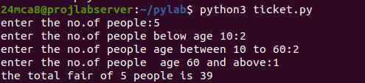

**PROGRAME 11**

**Aim:**write a python program to solve a quadratic equation.

**Source code**

import math

a=float(input("enter the coefficent of a:"))

b=float(input("enter the coefficent of b:"))

c=float(input("enter the coefficent of c:"))

d=(b*b)-(4*a*c)

if a==0:

print("coefficent of a cannot be zero")

elif d==0:

sol3=-b/(2*a)

print(f"the solution is {sol3}")

elif d>0:

sol1=(-b+math.sqrt(d))/(2*a)

sol2=(-b-math.sqrt(d))/(2*a)

print(f"this has 2 real solutions {sol1:.2f} and {sol2:.2f}")

else:

sol4=(-b)/(2*a)

sol5=math.sqrt(abs(d))/(2*a)

print(f"the real part={sol4} and imaginary part={sol5} and -{sol5}")

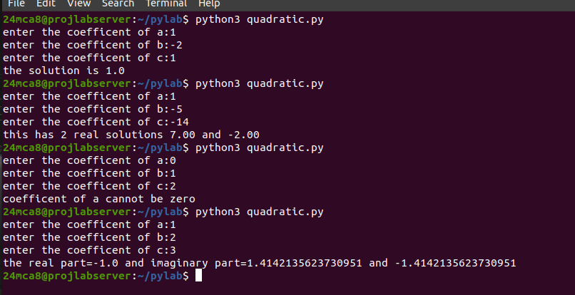**OUTPUT**

|  |  |
| --- | --- |
|  |  |
|  |  |
|  |  |