

**Emojify : TEXT TO EMOJIFICATION**

**TY B.Tech. Mini Project Report**

**SUBMITTED BY**

**Varun Dangri [T204115]**

**Hutesh Vidhate [T204014]**

**Ajit Kumar [T208048]**

**GUIDED BY**

**Prof. RANJANA BADRE**

**SCHOOL OF COMPUTER ENGINEERING AND TECHNOLOGY,**

**MIT ACADEMY OF ENGINEERING, ALANDI (D), PUNE-412105**

**MAHARASHTRA (INDIA)**

**MAY, 2021**



**Emojify : TEXT TO EMOJIFICATION**

**TY B.Tech. Mini Project Report**

*submitted in partial fulfilment of the*

*requirements for the award of the degree*

*of*

**Bachelor of Engineering**

*in*

**Computer Engineering & Technology**

**BY**

**Ajit Kumar,Hutesh Vidhate,Varun Dangri**

**SCHOOL OF COMPUTER ENGINEERING AND TECHNOLOGY**

**MIT ACADEMY OF ENGINEERING, ALANDI(D), PUNE-412105**

**MAHARASHTRA (INDIA)**

**MAY, 2020**



**CERTIFICATE**

It is hereby certified that the work which is being presented in the TY B.Tech. Mini Project Report entitled **“*Emojify : Text To Emoji*”,** in partial fulfillment of the requirements for the award of the **Bachelor of Technology in Computer Engineering & Technology** and submitted to the **School of Computer Engineering & Technology, Alandi(D), Pune, Affiliated to Savitribai Phule Pune University (SPPU), Pune** is an authentic record of work carried out during an Academic Year 2019-2020, under the supervision of **Prof. Rajana Badre mam,** **School of Computer Engineering & Technology.**

**Ajit Kumar PRN No.** **0120180520 Exam Seat No. T208048**

**Hutesh Vidhate PRN No.**  **0120180099 Exam Seat No. T204014**

**Varun Dangri PRN No.** **0120180554 Exam Seat No. T204115**

**Date:**

|  |  |
| --- | --- |
| *Signature of Project Advisor* | *Signature of Dean* |
| **Project Adviser** | **Dean** |
| School of Computer Engineering &Technology, | School of Computer Engineering &Technology, |
| MIT Academy of Engineering, Alandi(D), Pune | MIT Academy of Engineering, Alandi(D), Pune |

**(STAMP/SEAL)**

|  |  |
| --- | --- |
| *Signature of Internal examiner/s* | *Signature of External examiner/s* |
| *Name………………………………* | *Name………………………………* |
| *Affiliation…………………………* | *Affiliation…………………………* |
|  |  |

## ACKNOWLEDGEMENT

We would like to express our deepest appreciation to all those who provided us the possibility to complete this report. A special gratitude we will give to our Minor project guide, Prof. Ranjana Badre who invested his full effort in guiding us in achieving the goal.

Furthermore, we would also like to acknowledge with much appreciation the crucial role of the class teacher, who gave the permission to use all required help and the necessary support to complete the micro project on “Emojify”

We sincerely thanks to our Minor project coordinator Padma Nimbore mam proved to be a constant motivation for the knowledge acquisition and moral support during our course curriculum.

We appreciate the guidance given by other staff members of SCET for improving our presentation skills thanks to their comment and advice.

|  |  |
| --- | --- |
| **1** | **Varun Dangri** |
| **2** | **Hutesh Vidhate** |
| **3** | **Ajit Kumar** |

# CONTENTS

|  |  |  |  |
| --- | --- | --- | --- |
| Acknowledgements | | | No |
| Abstract | | | 5 |
|  | Introduction | | 6 |
|  | 1.1 | Motivation for the project | 6 |
|  | 1.2 | Problem Statement | 6 |
|  | 1.3 | Objectives and Scope | 6 |
|  | 1.4 | Organization of the report | 6 |
|  | Literature Survey | | 7 |
|  | System Design | | 9 |
|  | 3.1 | Block diagram/ Proposed System setup | 9 |
|  | 3.2 | Activity Diagram | 10 |
|  | 3.3 | Architecture Diagram | 10 |
|  | 3.4 | Related mathematical modelling | 11 |
|  | Implementation and Results | | 12 |
|  | 4.1 Results | | 12 |
|  | Conclusion | | 14 |
| References | | | 14 |

**ABSTRACT**

Emoji's have become a new language and Standard for online communication. It can be more effective to add emoji to text messages to show more emotional and sentimental feelings. The keyboard can predict emoji's but only base on certain keywords and tags are associated with emoji's. A prediction system can be integrated with the keyboard which predicts emoji after typing a sentence, the user has to manually select an emoji. This also reduces time and the use of available emoticons. There will be automatic emoji prediction which will reduce time and efforts for searching emoji. This will be predicted using LSTM algorithm and will show the prediction on basis of emotions present in the sentence. **LSTM worked better than RNN** i.e. accuracy of the model is more by using LSTM than RNN. When we move from RNN to LSTM, we are introducing more & more controlling knobs, which control the flow and mixing of Inputs as per trained Weights. And thus, bringing in more flexibility in controlling the outputs.

# INTRODUCTION

## Motivations

* Research in the field of Machine learning Prediction
* Gamification of Ideas
* Emoji prediction tools used in converting emoji by text automatically.
* Some examples of use of ML on social platforms

## Problem Statement

Design and develop the system to predict the emoji based on emotion and meaning of sentences using LSTM



## Objectives and Scope

1. To have a effective communication.
2. To reduce the time to pick the correct emojis from a list .(By writing sentence it will predict emoji automatically)
3. To have a effective communication.
4. To draw the reader’s attention and enhance the understanding of the messages.

# LITERATURE SURVEY

**1. Author:** Nikhil Bija. Mountain View,CS(US) & Satheeshkumar karuppussamy

**Title :** System and methods for suggestion emoji

**Volume :** Jun. 29,2017

**Publisher :** Patent application publication

**Findings :** The present disclosure relates to language direction and, in particular system and methods for suggestion for suggesting emoji.

**2. Author** : Rahman Mahte Ranjith Nair Vysakh Nair & Athira Pillai & Prof. Manasi Kulkarni

**Title** : Emoticon Suggestion with Word Prediction using NLP

**Volume** : Volume: 07 & Issue: 5|May|20

**Publisher** : IRJET

**Findings** : This system contain two systems

1. Word prediction
2. Emoticon prediction

* **Word prediction model :**

It uses brown corpus. Implementing bigram and trigram word prediction is achieved.

* **Emoticon prediction :**

This data is fed to the second part i.e emoticon suggestion which uses ‘GloVe Vector’ and cosine similarity.

The present study examined whether emoji use would be quantitatively and/or qualitatively altered in alexithymia. 646 individuals (Mean Age = 23.11, SD = 7.03; 424 Female) with varying levels of alexithymia took part in a series of vignettes where they were positioned as senders of hypothetical text messages. Participants were tasked to opt in or out of tagging an emoji onto positive and negative text messages. Emoji use frequency was diminished at the high end of the alexithymic continuum, relative to the middle and low spectrums. However, emoji for positive and negative text messages were used with similar patterns of frequency across alexithymic groups of varying severity, suggesting that emoji use is quantitatively but not qualitatively altered in alexithymia.

1. **Authors** : Rahman Mahte, Ranjith Nair, Vysakh Nair, Athira Pillai, Manasi Kulkarni

**Publication date** : 2020

**Description** : Emojis are a very important part of communication in today’s world. It is used to express emotions during a conversation. Building a system which can suggest emoticons based on the text provided can be very useful. It can be used to express emotions efficiently and easily. While dealing with the semantics of the sentence it can be used to predict the emotion in the sentence and emojis can be predicted accordingly. Typing each and every word to complete a sentence is also a very time consuming task with the help of word prediction models this task can be made much easier. So in our project combining two models ie Word prediction and emoji suggestion will improve textual communication. Emoticons add life to sentences and word prediction helps in framing correct sentences. It makes sentences more understandable and appealing. A system which can help in quoting the correct emoji into a sentence easily can be very useful in today’s world.

1. **Authors** : Toshiki Tomihira, Atsushi Otsuka, Akihiro Yamashita, Tetsuji Satoh

**Publication date** : 2018/11/19

**Book** : proceedings of the 20th international conference on information integration and web-based applications & services

**Description** : In recent years, Unicode has been standardized; and with the penetration of SNSs, the use of emojis has become common. Emojis, as they are also known, are most efective in expressing emotions in sentences. Sentiment analysis in natural language processing so far has involved learning by manual labeling of sentences. By using suitable emojis estimated from sentences, people might express their emotions more clearly and laconically. In this paper, we propose a new model that learns from sentences using emojis as labels, collecting Japanese tweets from Twitter as the corpus. We verify and compare multiple models based on EncoderDecoder Model of Recurrent Neural Network (RNN) and Convolutional Neural Network (CNN). Our sophisticated experiments demonstrate that emojis are efective in expressing tweet emotion

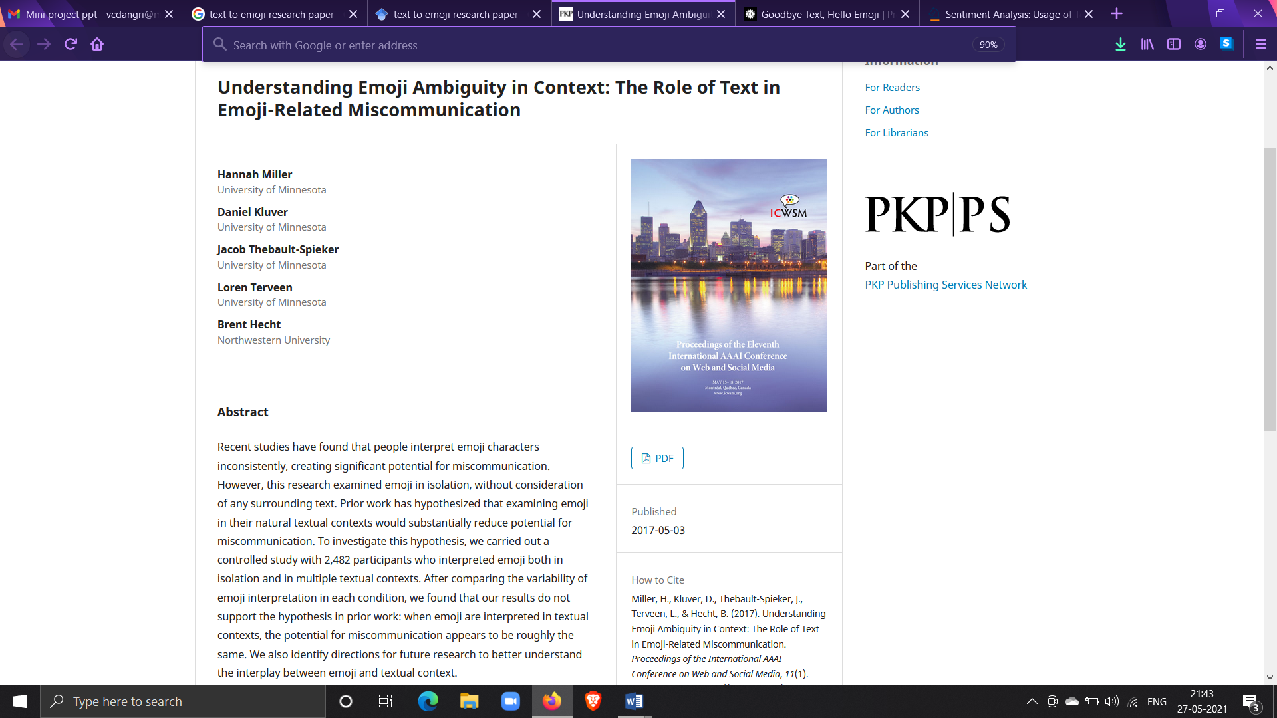

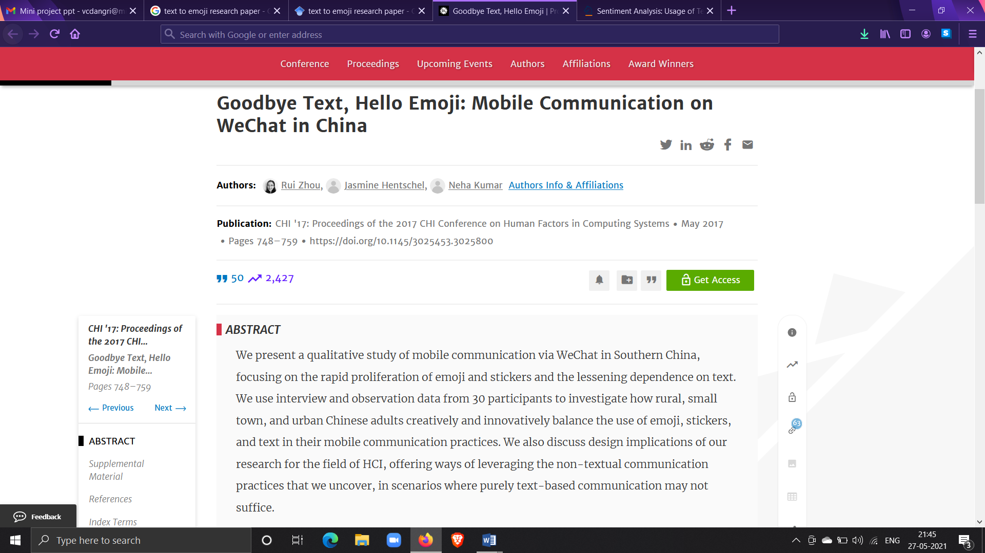

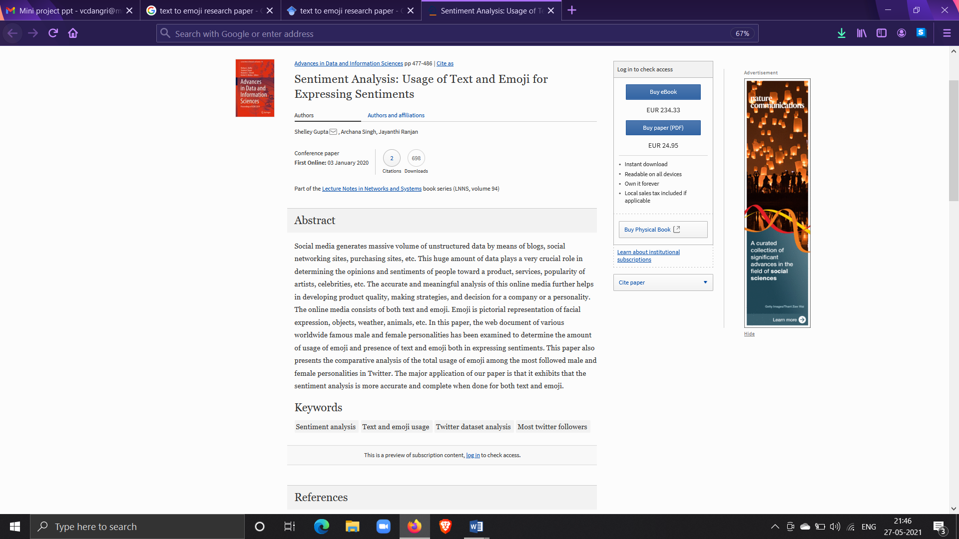 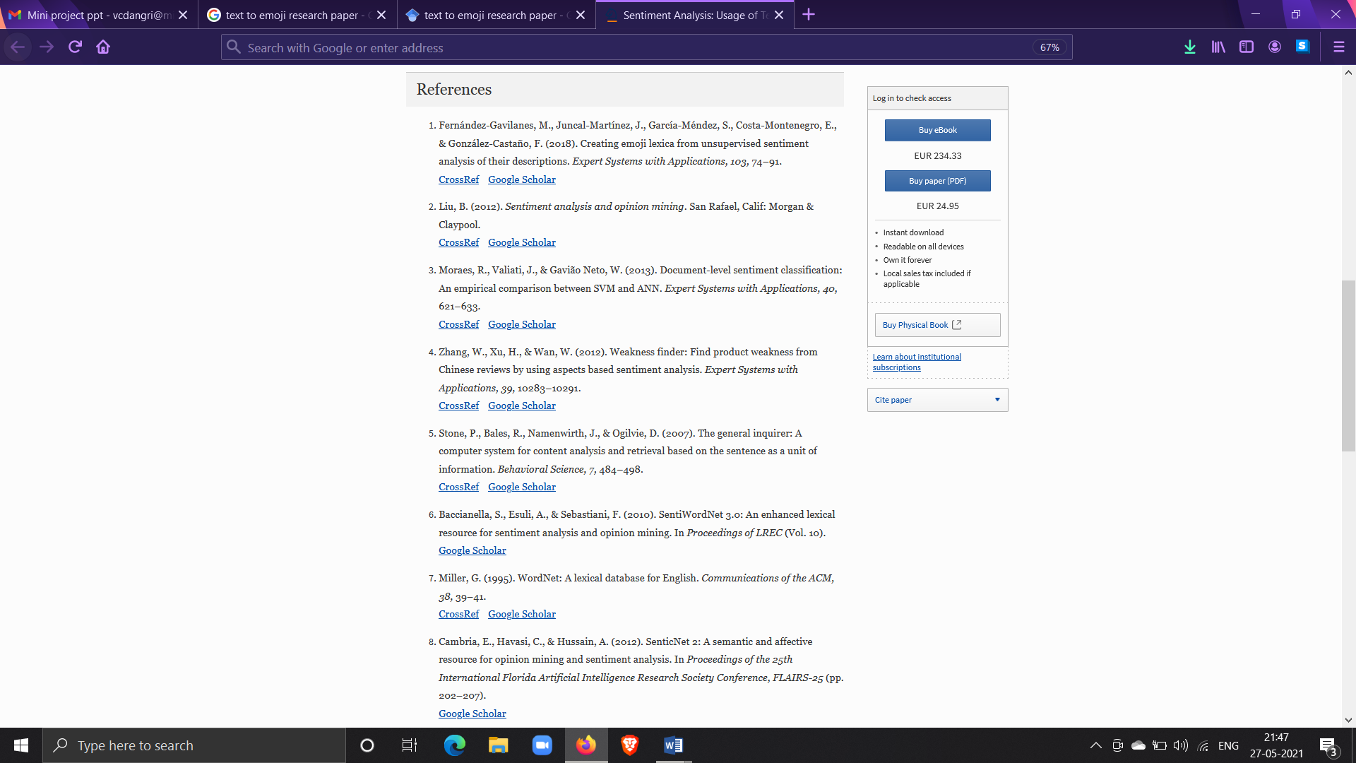

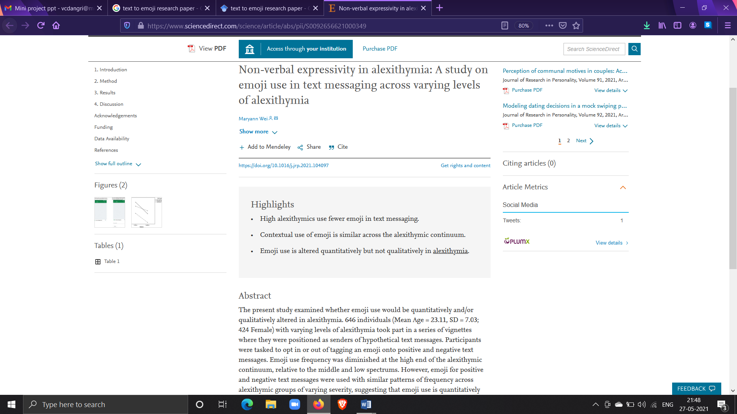 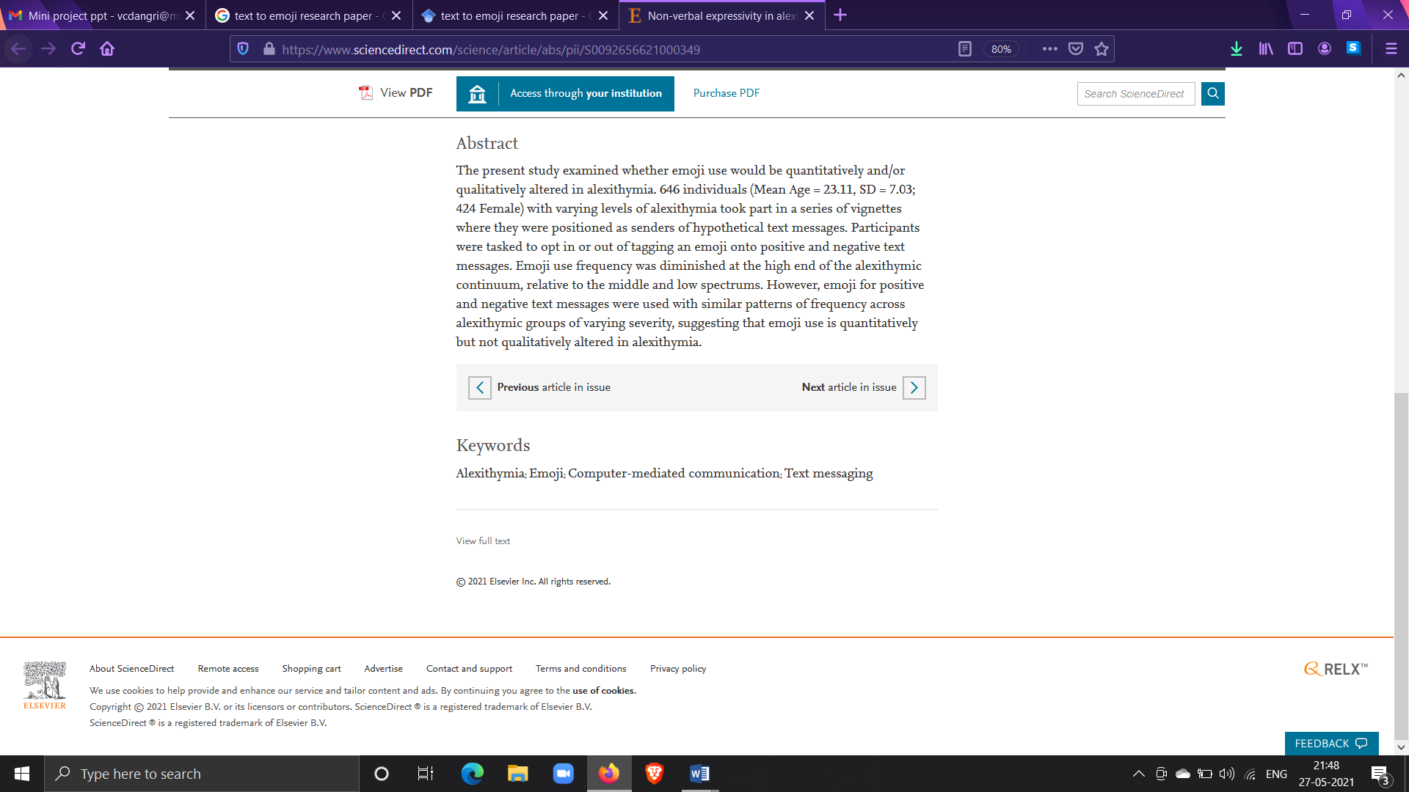

# SYSTEM DESIGN

|  |  |
| --- | --- |
| 3.1 Block diagram/ Proposed System setup     1. Proposed system setup      1. Block diagram |  |
|  |  |
| 3.2 Activity Diagram     1. Activity Diagram |  |
| 3.3 Architecture Diagram     1. Architecture Diagram   3.4 Related mathematical modelling:  LSTM cell     1. Lstm cell  * Source : <https://colah.github.io/posts/2015-08-Understanding-LSTMs/?source=post_page--------------------------->   **LSTM cell Architecture:**     1. Lstm cell architecture  * Source :[https://colah.github.io/posts/2015-08-Understanding-LSTMs/?source=post_page](https://colah.github.io/posts/2015-08-Understanding-LSTMs/?source=post_page---------------------------)---------------------------   **Mathematical expression:**     1. Mathematical expression   Source : <https://colah.github.io/posts/2015-08-Understanding-LSTMs/?source=post_page--------------------------->     1. Equation lstm   **So the LSTM cell contains the following components**   * Forget Gate **“f”** ( a neural network with sigmoid) * Candidate layer **“C`"**(a NN with Tanh) * Input Gate **“I”** ( a NN with sigmoid ) * Output Gate **“O”**( a NN with sigmoid) * Hidden state **“H”** ( a vector ) * Memory state **“C”** ( a vector) |  |
|  |  |

# IMPLEMENTATION DETAILS

5.1 Results

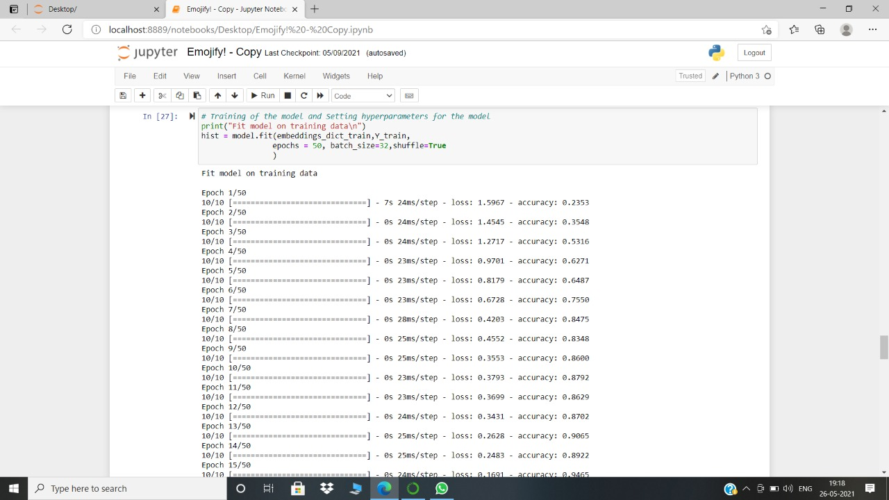

1. Result

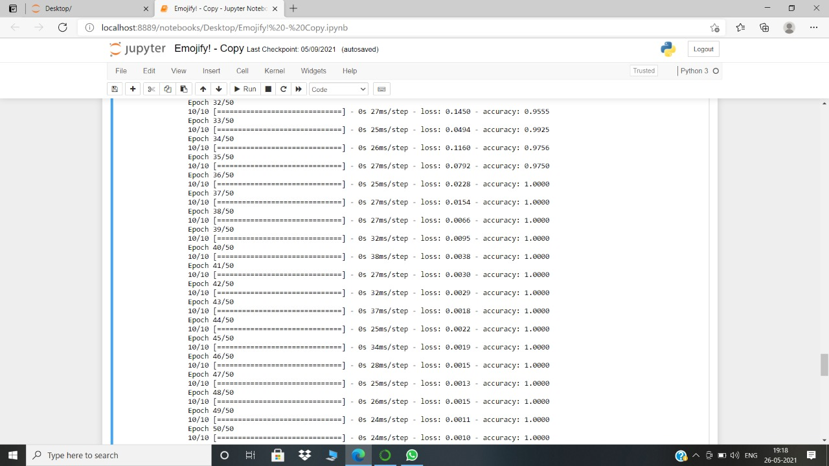

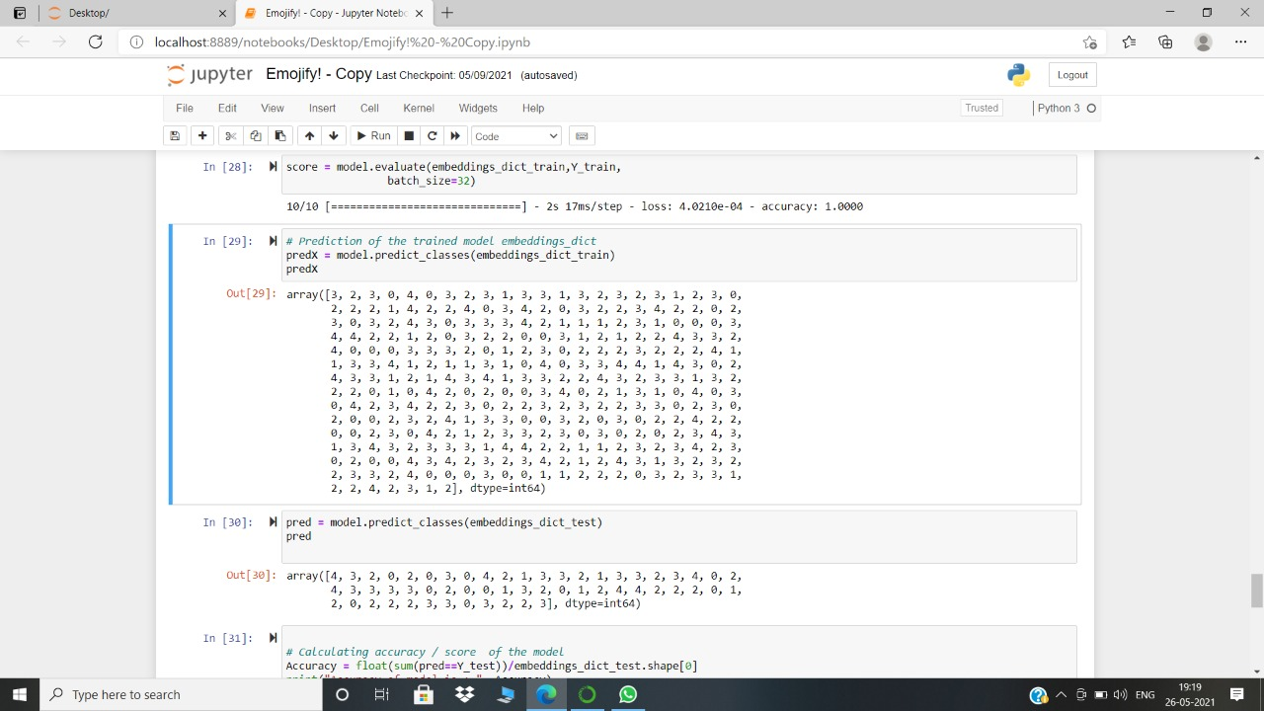

1. Accuracy

# CONCLUSION & FUTURE SCOPE

* The human brain processes images 60,000 times faster than it processes **text**. Including an **emoji** with the message can help the reader **better** understand what he/she is trying to say and avoid any confusion that might be had.
* The word to emoji model converts each and every word to an emoji if it crosses a certain threshold (cosine similarity). Each word is then compared to this map and the emoji with the highest cosine similarity is printed.

Number of emojis = 3415

**REFERENCES**

* <https://ojs.aaai.org/index.php/ICWSM/article/view/14901>
* <https://dl.acm.org/doi/abs/10.1145/3025453.3025800>
* <https://link.springer.com/chapter/10.1007/978-981-15-0694-9_45>
* <http://blog.emojics.com/emojis-increase-user-engagement/>
* **Jeff Blagdon. 2013. How emoji conquered the world: The story of the smiley face from the man who invented it.**
* **http://www.theverge.com/2013/3/4/3966140/ how-emoji-conquered-the-world.**
* **Karen Church and Rodrigo de Oliveira. 2013. What's up with WhatsApp? Comparing Mobile Instant Messaging Behaviors with Traditional SMS. In Proc. MobileHCI 2013. ACM Press, 352--361.**
* **• Sebastien Cuendet, Indrani Medhi, Kalika Bali, and Edward Cutrell. 2013. VideoKheti: Making Video Content Accessible** to Low-Literate and Novice Users. In Proc. CHI 2013. ACM Press, 2833--2842.
* <https://www.zipwhip.com/blog/heres-how-each-generation-prefers-to-text-with-your-business/>
* <http://blog.emojics.com/emojis-increase-user-engagement/>
* <https://emojipedia.org/stats/>
* [Emoji Report 2016](https://cdn.emogi.com/docs/reports/2016_emoji_report.pdf)