ADAMAWA STATE UNIVERSITY MUBI (ADSU)
FACULTY OF SCIENCE
DEPARTMENT OF COMPUTER SCIENCE

REG NUMBER: 23D/360086
COURSE CODE: CSC 403
COURSE TITLE: INTRODUCTION TO SOFTWARE ENGINEERING

ASSIGNMENT
Q1. WHAT DO YOU UNDERSTAND BY THE TERM SOFTWARE LIFE CYCLE?
The Software Life Cycle (SLC), often referred to synonymously with the Software Development Life Cycle (SDLC), represents a conceptual and operational framework that encapsulates the entire existence of a software product. It is a systematic, multi-step process used by software engineering teams to ensure the production of high-quality, reliable, and cost-effective software systems.
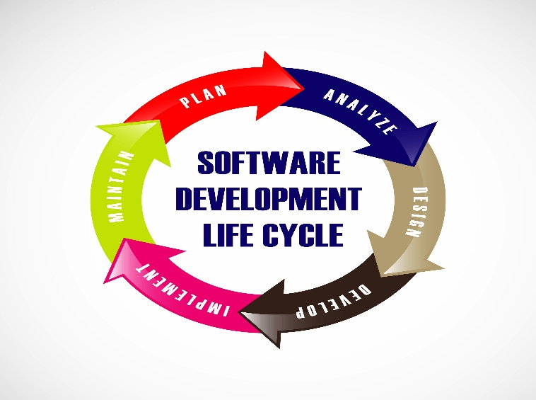
From a technical standpoint, the life cycle provides a structured methodology for transforming a user's initial concept into a fully functional software solution. It governs the transition between various states of development—ranging from abstract requirements to concrete executable code—and extends until the software is eventually decommissioned (retirement). The primary goal of the SLC is to minimize technical debt, mitigate project risks, and ensure that the final product aligns strictly with the Software Requirement Specifications (SRS).
Factors Influencing the Choice of Software Development Model
- Volatility of Requirements: This refers to how likely user needs and system requirements are to change during the development process. Projects with frequently changing requirements require flexible development models.
- Criticality: This describes the level of risk associated with system failure. For example, medical systems require very high reliability compared to social media applications, where failure is less critical.
- Time-to-Market: This refers to how quickly the software product must be released to users. Projects with strict deadlines often require rapid development approaches.
- Resource Availability: This involves the availability of skilled personnel, technical tools, and financial resources. Limited resources may influence the choice of simpler development models.
Q2. ENUMERATE THE STAGES INVOLVED IN THE SOFTWARE LIFE CYCLE
The software life cycle is decomposed into several distinct, high-level phases. While different models may name or group these differently, the core technical stages include:
1. Requirement Engineering
Requirement Engineering is the process of collecting, analyzing, documenting, and validating both functional and non-functional requirements from stakeholders. It ensures that the developers clearly understand what the users need before development begins.
2. Architectural and System Design
This stage involves defining the overall software structure, system architecture, data organization, and interface design. It serves as a blueprint that guides developers during the implementation phase.
3. Implementation (Coding)
Implementation is the stage where design specifications are converted into executable programs using appropriate programming languages. Developers write, compile, and debug source code to create functional software.
4. Verification and Validation (Testing)
This stage focuses on testing the software to identify errors and confirm that it meets specified requirements. Verification ensures the system is built correctly, while validation ensures the right system is built.
5. Deployment and Delivery
Deployment involves installing the completed software in the production environment and making it available to end users. It may include user training, configuration, and system integration.

6. Operations and Maintenance
This is the continuous process of updating, improving, and fixing the software after deployment. It includes correcting hidden errors, enhancing performance, and adapting the system to new user or environmental needs.
Q3. WHAT ARE SOFTWARE LIFE CYCLE MODELS?
Software Life Cycle Models are descriptive and prescriptive patterns that define how the various stages of the SDLC are sequenced and managed. They serve as a process strategy or a "roadmap" for the development team, dictating the flow of work, the frequency of iterations, and the criteria for moving from one phase to the next.
Selecting a specific model depends heavily on the Project Constraints, which include:
Q4. COMPREHENSIVELY EXPLAIN THE VARIOUS SOFTWARE LIFE CYCLE MODELS
1. Waterfall Model
The Waterfall Model is a linear and sequential development approach in which each phase must be completed before the next one begins. It relies heavily on proper documentation and detailed planning before coding starts. This model is suitable for projects with stable and well-defined requirements.
2. V-Model
The V-Model is an improved version of the Waterfall Model that emphasizes testing at every stage of development. Each development phase is linked to a corresponding testing phase. It focuses on Verification (building the product correctly) and Validation (building the right product).
3. Incremental Model
In the Incremental Model, software is developed in small functional parts known as increments. Each increment adds new features to the system. This allows early delivery of a working product and helps in incorporating user feedback.
4. Iterative Model
The Iterative Model starts with a basic version of the system and improves it through repeated cycles of development. Each cycle includes design, implementation, and review. This model allows gradual refinement of system requirements.
5. Spiral Model
The Spiral Model is a risk-driven development model that combines iterative development with risk analysis. Each cycle consists of planning, risk assessment, engineering, and evaluation. It is best suited for large and complex projects.
6. Agile Model
The Agile Model focuses on flexibility, teamwork, and continuous improvement. Development is carried out in short time periods called sprints. It encourages regular customer feedback and frequent delivery of working software.
7. Prototype Model
The Prototype Model involves developing an early working version of the system to help users understand the system requirements. It is very useful for applications with complex user interfaces where visual feedback is important.

REFERENCES
- Bass, L., Clements, P., & Kazman, R. (2021). Software Architecture in Practice (4th ed.). Addison-Wesley Professional.
- Bourque, P., & Fairley, R. E. (Eds.). (2014). Guide to the Software Engineering Body of Knowledge (SWEBOK v3.0). IEEE Computer Society.
- Martin, R. C. (2017). Clean Architecture: A Craftsman's Guide to Software Structure and Design. Prentice Hall.
- Sommerville, I. (2020). Software Engineering (10th ed. Global Edition). Pearson Education Limited.
- Schwaber, K., & Beedle, M. (2002). Agile Software Development with Scrum. Prentice Hall.

