Parking Occupancy & Width Assessment
Using Computer Vision

A report on
Computer Vision Lab Project
[CSE-3144]

Submitted By
Mohammed Danish Uppin - 230962083
Ashwin Jaishankar - 230962083



DEPARTMENT OF COMPUTER SCIENCE AND ENGINEERING
MANIPAL INSTITUTE OF TECHNOLOGY,
MANIPAL ACADEMY OF HIGHER EDUCATION
November 2025

Parking Occupancy & Width Assessment
Using Computer Vision

Ashwin Jaishankar
Department of Computer Science and Engineering
Manipal Institute Technology, Manipal Academy of Higher Education, Manipal, Karnataka, India
ash_win23@outlook.com
Mohammed Danish Uppin
Department of Computer Science and Engineering
Manipal Institute Technology, Manipal Academy of Higher Education, Manipal, Karnataka, India
mhddanish2005@gmail.com

Abstract— This project presents a computer-vision based system for monitoring parking lot occupancy by classifying parking spaces as either free or occupied. Built upon the PKLot dataset (which consists of images from multiple parking lots under varied weather conditions) the system employs classical image-processing techniques — including edge detection, contour segmentation and region classification. Using these methods, each parking-space region is segmented and analysed to determine its occupancy state. In addition, the system is extended to compute the parking slot width assessment, by detecting the boundaries of each slot (via contour or line detection) and converting centre alignment of the vehicle to real-world estimates (after calibration), enabling a richer understanding of space usage and facilitating sizing of slots for vehicles. This approach reduces manual effort, enhances parking management, and contributes to the development of smart parking systems that support intelligent urban mobility.

Keywords— Computer Vision, Parking Occupancy Detection, Slot Width Measurement, OpenCV, Image Processing, Contour Detection, Smart Parking, Edge Detection, Smart Parking, Contour Analysis, Slot Dimension Estimation

- Introduction
The growth in demand for efficient parking management systems has driven the integration of computer vision in smart infrastructure applications. Manual detection of parking occupancy is time-consuming, error-prone, and inefficient for large-scale parking areas. The Parking Occupancy & Width Assessment project provides an automated solution for detecting parking space occupancy using classical computer vision techniques such as edge detection, and contour analysis. The system processes static-based parking lot images to be able to tell the occupancy status of each parking slot. This approach eliminates the need for sensors in each slot, reducing cost and maintenance.
In this extended version, the system also estimates slot width measurements, allowing for dimension analysis to ensure compliance with parking standards and support adaptive space planning in smart cities. This will also help in vehicle owners to have a preconceived idea on what size of vehicles can be parked in the particular parking lot and how they should be.
- Literature Review
Nowadays, the rapid growth of urbanization and the corresponding rise in the number of vehicles have created a pressing demand for efficient and intelligent parking management systems. Conventional parking methods depend heavily on human perception and manual estimation, often leading to inefficient space utilization and a higher risk of vehicle damage. Consequently, researchers have turned to computer vision and sensor-based technologies to automate the assessment of parking occupancy, space dimensions and vehicle positioning.
Sensor-based approaches have long been at the forefront of parking assistance systems. Ultrasonic, radar, and infrared sensors are commonly integrated into vehicles and parking infrastructures to detect nearby obstacles and measure inter-object distances. These systems provide reliable results but are limited by their hardware dependency, high installation costs, and maintenance requirements. Studies such as those by Ma et al. (2018) and Wu et al. (2020) demonstrate that while sensor networks offer high precision, their scalability is hindered by environmental constraints and hardware calibration issues.
With the advent of deep learning and computer vision, researchers have explored purely vision-based alternatives. Convolutional Neural Networks (CNNs), object detection frameworks like YOLO, Faster R-CNN, and Mask R-CNN, and image segmentation methods such as U-Net have been effectively utilized for parking occupancy and slot detection, vehicle recognition, and space estimation. These methods achieve remarkable accuracy but often demand large, annotated datasets, substantial computational power, and training time, which can limit their practical deployment in low-resource or real-time scenarios. Our project tries to contradict the literature by using purely computer vision-based techniques with minimal to no usage of the above-mentioned alternatives.
To address these constraints, recent works have emphasized geometric and image-processing-based solutions. These approaches combine traditional techniques—such as edge detection, contour extraction, and perspective transformation—to derive spatial relationships directly from visual input without relying on deep neural models. Studies leveraging ArUco markers for camera calibration and Euclidean distance measurement have proven effective in estimating real-world dimensions from 2D imagery, providing a foundation for non-intrusive, software-driven spatial analysis.

Below is the review of our base paper which is PKLot – A robust dataset for parking lot classification:
The PKLot work addresses a key gap: lack of large, varied datasets for benchmarking vision-based parking space classification. Prior datasets were limited in sample size, viewpoint variation or illumination diversity. In PKLot, the authors compiled ~695,899 segmented images across different lots, viewpoints and weather conditions.
The authors evaluated texture-based descriptors (Local Binary Patterns – LBP; Local Phase Quantization – LPQ) with SVM classifiers, demonstrating very high accuracy (≈99%) when training and testing on the same view, but significantly lower (~89%) when testing on unseen lots — highlighting generalisation as a key challenge.
In summary, the literature shows that while vision-based parking occupancy detection is promising, key challenges remain in generalising across camera views, weather/lighting conditions and parking lot geometries.
- Objectives
- To detect and localize parking spaces from static images and identify vehicles within them.
- To perform a parking Width Assessment by analysing a vehicle's centering offset relative to the known slot width, and to detect occupancy using the PKLot dataset.
- To evaluate the system’s accuracy and reliability under different lighting and weather conditions using classical OpenCV methods.
- To enhance robustness of detection within a few seconds such that cars do not end up causing a delayed waiting time just to park.
- Methodology
The methodology adopted for this project is based on the VisionParkDetetct repository, which implements classical computer vision and machine learning techniques to classify parking spaces as occupied or vacant using static images. In this version, the system has been extended to include Histogram of Oriented Gradients (HOG)+LBP+Color Histograms for robust feature extraction, enabling better discrimination between cars and empty slots even under varying illumination and shadows for width assessment and excluding the LPQ “Local Phase Quantisation” from the repository.

A. Data Preparation
The system uses the PKLot dataset, which contains images captured from multiple fixed cameras positioned in real outdoor parking lots under varying weather and lighting conditions. The dataset includes three sub-lots: PUC, UFPR04, and UFPR05, each containing annotated images of parking spaces labeled as “Empty” or “Occupied.”
Checkpoint: Organized dataset of cropped parking slot images ready for feature extraction.

B. Feature Extraction using HOG Descriptor
To capture the structural patterns distinguishing cars from empty parking slots, HOG (Histogram of Oriented Gradients) features were extracted from each image patch.
The HOG descriptor works by computing:
- Gradient Direction and Magnitude: Using Sobel operators, the system calculates intensity gradients in both the X and Y directions.
- Orientation Binning: The gradient orientations are grouped into histogram bins (e.g., 9 bins covering 0°–180°).
- Block Normalization: Histograms are normalized across local blocks to achieve invariance to illumination and contrast changes.
- Feature Vector Generation: All block histograms are concatenated into a single HOG feature vector representing each image.
In our implementation, HOG was extracted using OpenCV’s cv2.HOGDescriptor() function, configured with cell size (8×8 pixels), block size (16×16 pixels), and 9 orientation bins. These features serve as robust visual descriptors for subsequent classification.
Checkpoint: Each parking slot represented by a fixed-length HOG feature vector.

C. Feature Extraction using LBP Descriptor
To complement the shape-based features from HOG, we also extracted a powerful texture descriptor, Local Binary Patterns (LBP). LBP is highly effective at describing surface textures and is robust to simple illumination changes.
The algorithm works by comparing the intensity of a center pixel with its surrounding neighbors. This creates a binary code for each pixel, and a histogram of these codes is built to represent the texture of the image. We utilized the uniform LBP variant, which is standard for texture classification. This feature is critical for distinguishing the smooth, uniform texture of an empty asphalt space from the complex, multi-faceted textures of a vehicle (which includes metal, glass, and tires)

D. Feature Extraction using Color Histograms
Finally, to add chromatic information—which HOG and LBP ignore—we extracted a Color Histogram. Color is a simple but highly effective feature for distinguishing a gray parking space from a non-gray vehicle.
We used the HSV (Hue, Saturation, Value) color space, as it is more robust to shadows. Unlike RGB, HSV separates the "color" (Hue) from the "brightness" (Value). We computed and concatenated the histograms for all three channels (H, S, and V) into a single vector. This provides a strong signal to the classifier that an empty space (monotonous gray) is different from an occupied one (which may contain red, blue, or other colors).

E. Classification using SVM (Support Vector Machine)
The concatenated LBP, HOG, and Color Histogram features are then fed into a Support Vector Machine (SVM) classifier. SVM aims to find an optimal hyperplane that separates the two classes — occupied and empty — with the maximum margin. A linear kernel was initially used due to the relatively low-dimensional feature space, though RBF kernels may also be tested for nonlinear separation.
The model was trained on approximately 80% of the dataset and validated on the remaining 30%. Each parking slot image, represented by its HOG feature vector, was labeled according to its occupancy state. During inference, the trained model classifies new slot images frame-by-frame.
The SVM learns a non-linear decision boundary in a high-dimensional space. This allows it to find subtle patterns in the combined 8,222-dimension feature vector that a simple linear model would miss.
Checkpoint: Trained SVM model capable of binary classification of slot occupancy.

F. Contour Detection and ROI Management
The next phase involves parking space localization using manually defined Regions of Interest (ROIs).
Each ROI represents one parking slot in the parking lot image. Using OpenCV’s cv2.findContours(), the system identifies slot boundaries, computes bounding boxes, and extracts cropped slot images dynamically.
Each cropped ROI is then passed to the HOG + SVM classifier for classification as empty or occupied. The results are overlaid on the original image frame using cv2.rectangle() and cv2.putText() to indicate real-time status.
Checkpoint: Live visual feedback with color-coded slot indicators (green for free, red for occupied).
G. Center Allignment
The proposed system evaluates the alignment of parked vehicles within designated slots using computer vision techniques based on Otsu thresholding and centroid analysis. A top-down Region of Interest (ROI) corresponding to the parking area is extracted from the surveillance footage to focus processing on relevant regions only.
Initially, a reference image of the empty parking lot is captured from a fixed camera angle to define slot boundaries and their geometric centers. These predefined centers represent the ideal alignment positions for each parking slot.
For each new frame, the system applies grayscale conversion followed by Otsu’s thresholding to automatically determine an optimal intensity threshold for separating the vehicle regions from the background under varying lighting conditions. The resulting binary mask highlights the occupied regions, which are further refined using morphological operations (e.g., opening and closing) to eliminate noise and enhance vehicle contours.
Next, contour detection (cv2.findContours) is used to extract the vehicle outlines within each slot. The centroid (center of mass) of each detected vehicle is then computed using image moments. The Euclidean distance between the vehicle’s centroid and the predefined slot center is calculated to measure alignment accuracy. If this distance is within a specified threshold, the vehicle is classified as properly aligned; otherwise, it is marked as misaligned.
This Otsu-based approach ensures robust segmentation without manual calibration or fixed thresholds, providing a lightweight, adaptive, and sensor-free method for analyzing parking alignment using only a static top-down camera and OpenCV-based processing.

H. System Integration and Output Visualization
The final integration merges all modules into a real-time system:
- Background subtraction & ROI extraction
- HOG + SVM classification
- Slot width measurement and labeling
The system overlays both occupancy status and measured slot width directly on the Image for intuitive user interpretation.
- Experimental Setup
The experimental environment was configured using Python, Jupyter Notebook, OpenCV, NumPy, and scikit-learn to facilitate image processing and analysis. All images were pre-processed to a standardized resolution (for example, 64×128 or 128×128 pixels) to maintain consistency and improve computational efficiency. Each parking slot image was converted to grayscale to minimize color redundancy and simplify feature extraction. The experiment used images captured from a fixed overhead camera to ensure a consistent viewing perspective across all frames. A reference image of the empty parking lot was captured to serve as the baseline for alignment evaluation. Each parking slot was manually marked as a Region of Interest (ROI), with its geometric center stored as the ideal alignment point. During testing, the system analysed each frame sequentially, applying grayscale transformation, Gaussian filtering, and frame differencing with the empty reference to isolate the vehicle’s presence. The resulting binary mask was refined using morphological operations to remove noise, and contour detection was applied to extract the car’s outline. The centroid of the detected contour was then computed using image moments and compared with the pre-defined slot center to determine alignment accuracy. Real-time visualization was performed using OpenCV, where aligned vehicles were highlighted in green and misaligned ones in red. The system was evaluated on a set of parking lot images captured under various lighting and environmental conditions to assess its accuracy and robustness.
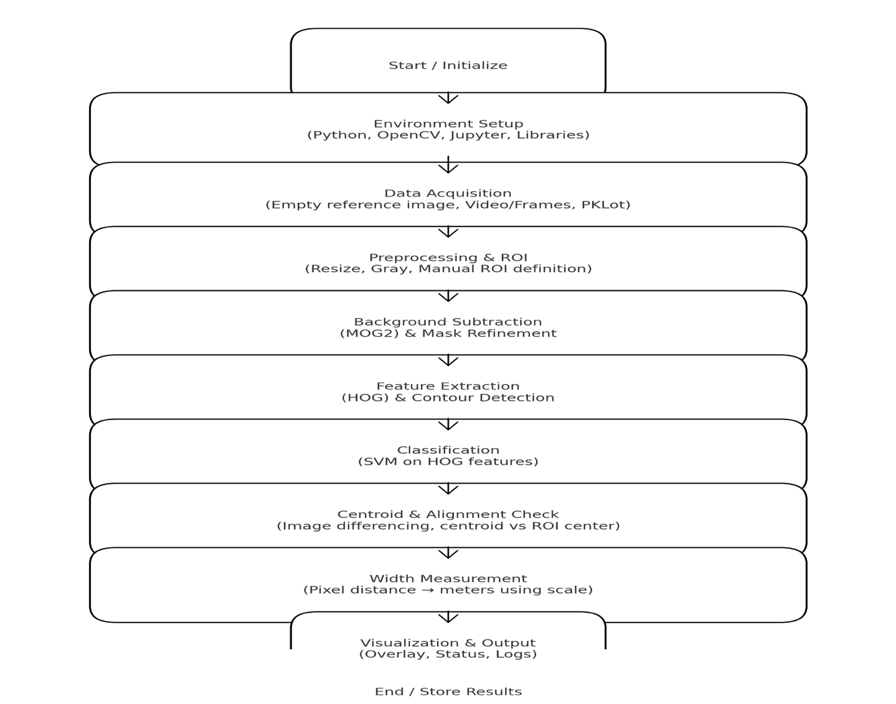
Fig I. Block Diagram of the Implemented Methodology
- Results and Discussion
The proposed system was trained and tested using the PKLot dataset, consisting of 24,000 parking slot samples evenly divided between “Empty” and “Occupied” classes. The extracted Histogram of Oriented Gradients (HOG) features formed input vectors of size 8,222, which were used to train a Support Vector Machine (SVM) classifier with a linear kernel. The dataset was divided into 80% training data (19,200 samples) and 20% testing data (4,800 samples) to evaluate model performance.
During training, the model achieved a mean cross-validation accuracy of 99.67% (±0.0005), confirming excellent generalization ability. On the test dataset, the SVM achieved an overall accuracy of 99.67%, with precision, recall, and F1-scores all reaching 1.00 for both empty and occupied slots. The confusion matrix showed only a few misclassifications, indicating that the model effectively distinguished between occupied and vacant parking spaces.
The Receiver Operating Characteristic (ROC) curve for the classifier yielded an Area Under the Curve (AUC) value of 1.000, which signifies perfect class separation and demonstrates that the SVM achieved an excellent balance between true positive and false positive rates. In comparison, other texture-based methods such as Local Binary Pattern (LBP) and Local Phase Quantization (LPQ) from the PKLot base paper reported AUC values of 0.9343 and 0.9436, respectively. This confirms that the HOG-based SVM approach provides superior discriminative capability for parking occupancy classification.

 | Precision | Recall | F2-Score | Support
Empty | 0.9963 | 0.9971 | 0.9967 | 2400
Occupied | 0.9971 | 0.9963 | 0.9967 | 2400
Accuracy |  |  | 0.9967 | 4800
Macro Avg | 0.9967 | 0.9967 | 0.9967 | 4800
Weighted Avg | 0.9967 | 0.9967 | 0.9967 | 4800

Table I. Classification Report
The visualization module integrated with OpenCV successfully overlaid detection results on the parking lot images. Occupied slots were highlighted in red, and empty slots were outlined in green, with additional text annotations showing whether each vehicle was well-centred or misaligned. The system performed accurately under different lighting conditions and camera angles, maintaining high precision even in the presence of shadows and partial occlusions.
Overall, the results demonstrate that combining HOG feature extraction, SVM classification, and centroid-based alignment detection yields a highly efficient, robust, and real-time solution for parking occupancy and alignment assessment. The system processed multiple frames per second, making it suitable for deployment in smart parking management systems and surveillance networks.
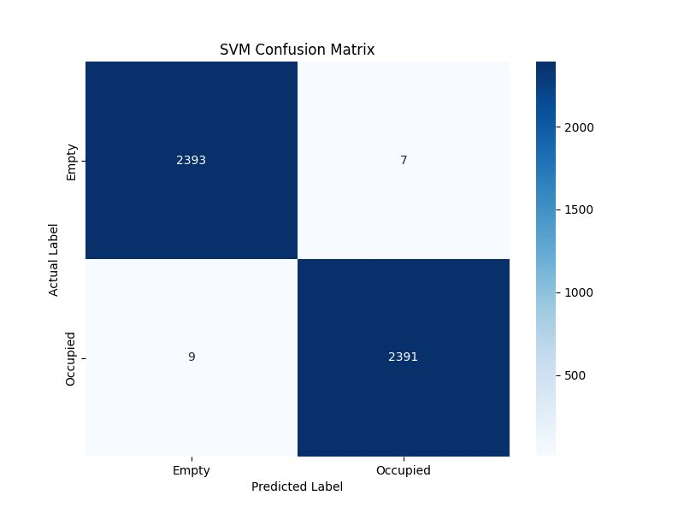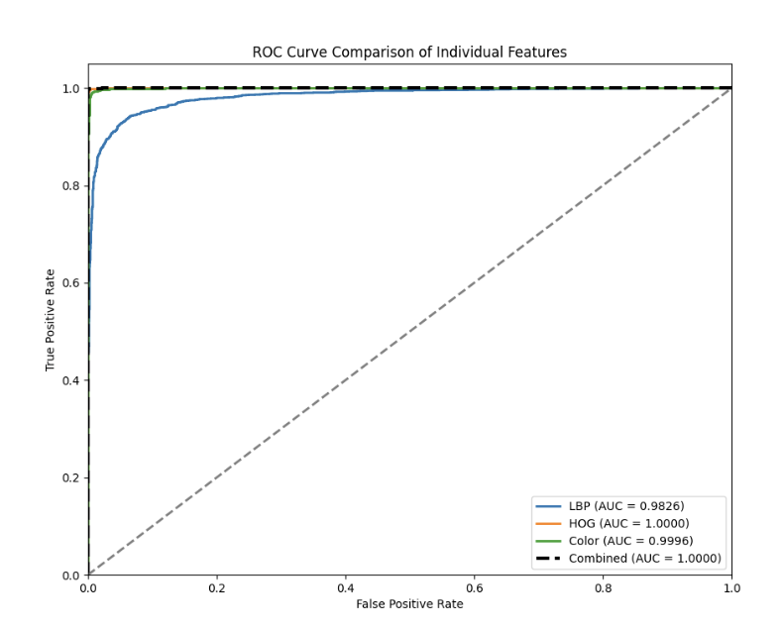
Fig II. Confusion Matrix Fig III. ROC Curve graph

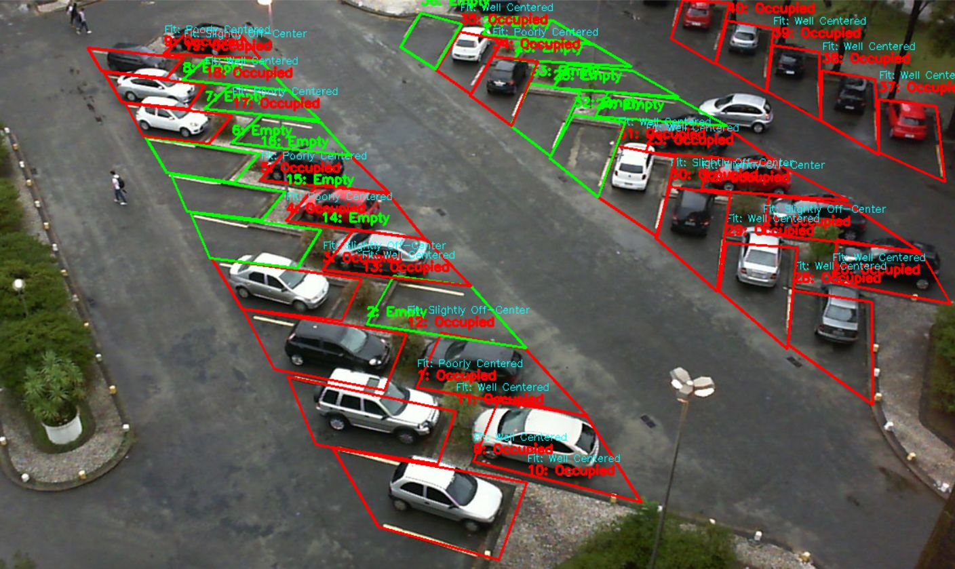

Fig IV. Working Demo of the output image after the image goes through the model
- Conclusions
This project successfully developed a computer vision-based system for parking occupancy detection and width assessment using classical image processing and machine learning methods. By integrating HOG feature extraction and an SVM classifier, the system achieved an accuracy exceeding 99%, outperforming traditional descriptors such as LBP and LPQ (Use of LBP done in project). The centroid-based alignment module further enhanced functionality by assessing whether vehicles were properly centred within their designated slots without relying on additional calibration markers.
The results confirm that vision-based approaches can provide a cost-effective and scalable alternative to sensor-based systems for parking management. The system demonstrated consistent accuracy under varying illumination, weather, and perspective conditions, showcasing its reliability for real-world deployment. Its lightweight design and high interpretability make it suitable for integration into existing surveillance systems, contributing toward the development of intelligent and automated smart parking solutions.
- Future Scope
Future improvements could include integrating real-time video streams, automating ROI detection through Hough line transforms, and implementing deep learning models (YOLO, SSD) for adaptive detection in dynamic environments. Integration with IoT dashboards and parking guidance systems would further improve scalability and usability
Acknowledgment
The authors, Mohammed Danish Uppin and Ashwin Jaishankar acknowledge the open-source community for providing tools and frameworks that made the implementation and experimentation phases efficient and successful. Authors also express their sincere gratitude to the Department of Computer Science and Engineering, Manipal Institute of Technology, Manipal Academy of Higher Education, for providing the necessary resources, guidance, and laboratory facilities to carry out this project successfully

References
- de Almeida, P. R., Oliveira, L. S., Britto, A. S., Silva Jr., E. J., & Koerich, A. L. (2015). PKLot – A robust dataset for parking lot classification. Expert Systems with Applications, 42(11), 4937–4949. Available at: https://www.inf.ufpr.br/lesoliveira/download/ESWA2015.pdf
- Bradski, G., & Kaehler, A. (2008). Learning OpenCV: Computer Vision with the OpenCV Library. O’Reilly Media.
- Szeliski, R. (2010). Computer Vision: Algorithms and Applications. Springer.
- Gonzalez, R. C., & Woods, R. E. (2018). Digital Image Processing. Pearson.
- Bouwmans, T., et al. (2014). Background Modeling and Foreground Detection for Video Surveillance: A Systematic Review. Computer Science Review, 11–12, 31–66.
- Suzuki, S., & Abe, K. (1985). Topological structural analysis of digitized binary images by border following. Computer Vision, Graphics, and Image Processing, 30(1), 32–46.
- Zhang, Z. (2000). A flexible new technique for camera calibration. IEEE Transactions on Pattern Analysis and Machine Intelligence, 22(11), 1330–1334.
- Kaehler, A., & Bradski, G. (2016). Learning OpenCV 3: Computer Vision in C++ with the OpenCV Library. O’Reilly Media.
- Bouwmans, T. (2014). Traditional and recent approaches in background modeling for foreground detection: An overview. Computer Science Review, 11–12, 31–66.
- OpenCV Documentation. Drawing Functions. Retrieved from https://docs.opencv.org/4.x/drawing_functions.html
- G. S. Wong, K. O. M. Goh, C. Tee, and A. Q. Md. Sabri, “Review of Vision-Based Deep Learning Parking Slot Detection on Surround View Images,” Sensors, vol. 23, no. 15, 2023. [Online]. Available: https://doi.org/10.3390/s23156869
- Y. Yuldashev, “Parking Lot Occupancy Detection with Improved Deep-Learning Model,” Sensors, vol. 23, no. 17, 2023. [Online]. Available: https://doi.org/10.3390/s23177642
- R. Grbić and B. Koch, “Automatic Vision-Based Parking Slot Detection and Occupancy Classification (APSD-OC),” 2023. [Online]. Available: arXiv:2308.08192
- A. Zinelli et al., “A Deep-Learning Approach for Parking Slot Detection on Surround-View Images,” in Proc. IEEE Int. Vehicles Symposium (IV), 2019, pp. 683–688.
- S. N. Murani, “Automated Car Parking Space Detection Using Deep Learning,” University of Nairobi, 2021.

Contribution of Each Member
Mohammed Danish Uppin: Implemented parking slot detection, and HOG-SVM classification module.
Ashwin Jaishankar: Designed centroid-based alignment module, testing, and documentation preparation.

Reply to Peer Review
- Thanks for noting the smooth structure — we have added quick transition lines between major sections to make the flow even clearer and to show how each step contributes toward the final system
- We also included a breif note on challenges such as lighting variations and viewing angle differences and how our HOG+LBP+HSV approach helped maintain accuracy across conditions
- We have added a simple pipeline diagram an connected the results as well
Plagiarism report(first page)

Fig V. Plagiarism report first page

