**Capstone-Project Report**

**Introduction:**

New York City's demographics shows that is large and ethnically diverse metropolis. With its diver’s nature, comes diver’s food items. There are many restaurants in New York City, each belonging different category like Indian, French, Chinese, German etc divers. So as part of this project, we will list and visualize all major parts of New York City that has great Indian restaurants.

**Approach**

* Collect the New York city data from <https://cocl.us/new_york_dataset>
* Using Foursquare API, we will find all venues for each neighbourhood.
* Filter out all venues that are Indian Restaurants.
* Find rating, tips and like count for each Indian Restaurants using Foursquare API.
* Using rating for each restaurant, we will sort that data.
* Visualize the Ranking of neighbourhoods using folium library(python)

**Data Source:**

Data For this project we need the following data:

New York City data that contains list Boroughs, Neighbourhoods along with their latitude and longitude.

Data source:

<https://cocl.us/new_york_dataset>

Description: This data set contains the required information. And we will use this data set to explore various neighbourhoods of New York city. Indian restaurants in each neighbourhood of New York city.

Data source: Foursquare API Description: By using this ape we will get all the venues in each neighbourhood. We can filter these venues to get only Indian restaurants.

Geospacer data Data source:

<https://data.cityofnewyork.us/City-Government/Borough-Boundaries/tqmj-j8zm>

Description: By using this geo space data we will get the New York Borough boundaries that will help us visualize choropleth map.

**Analysis Questions**

* What is best location in New York City for Indian Cuisine?
* Which areas have potential Indian Restaurant Market?
* Which all areas lack Indian Restaurants?
* Which is the best place to stay if I prefer Indian Cuisine?

**Data Cleaning:**

Data Downloaded from online was cleaned and sorted as required for the analysis purpose. Initially Data was downloaded in JSON format and converted the required columns along with Latitude and Longitude details into a data frame. Only the required columns were considered into the final dataset that was formed (Borough, Neighbourhood, Latitude and Longitude).

Data refined from this step had few missing values and I decided to eliminate all the missing records for better view of the data

This step was achieved by the method def get_new_york_data ():

**Analysis:**

Now that I have got the data required, I started my focus towards the analysis questions. To do that

Firstly, we need to know the count of neighbourhood in each borough of New York City.

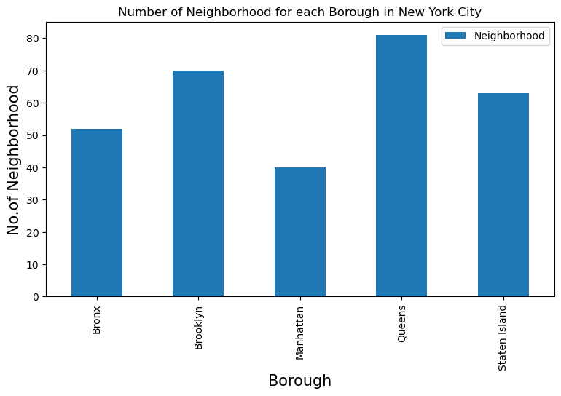

Above graph clearly indicates the Borough QUEENS has a greater number of Neighbourhood.

Secondly, we need to know the List of Indian Restaurants in available in each borough. We found a total of 306 INDIAN Restaurants available. We achieve this with the help of below function.

get venues ():

We made a call to Foursquare API for all the Latitude and longitude data we had extracted from the New York dataset. So, for every call made to foursquare API with latitude and longitude data, we will get the corresponding Restaurant details. From this Restaurant details I have filtered out only INDIAN RESTAURANTS. So now I have 306 Indian Restaurants in total.

Thirdly, I filtered out the number of Indian restaurants in each borough.

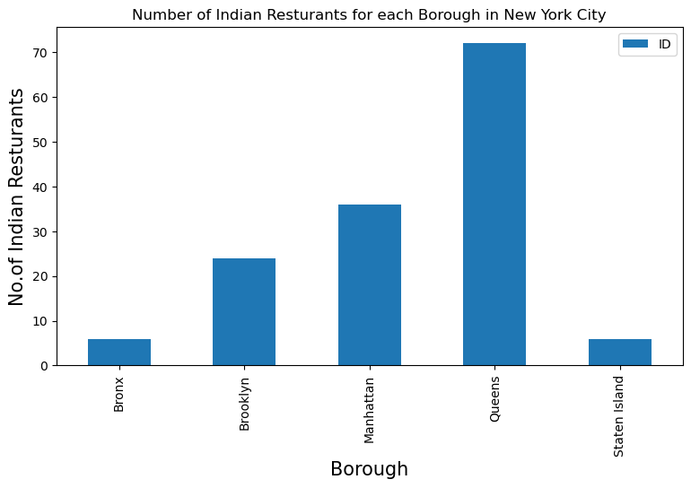

Above Graph clearly shows that Queens had a greater number of INDIAN Restaurants in New York City.

Next, we have to find out the Number of Restaurants in Each Neighbourhood of Queens.

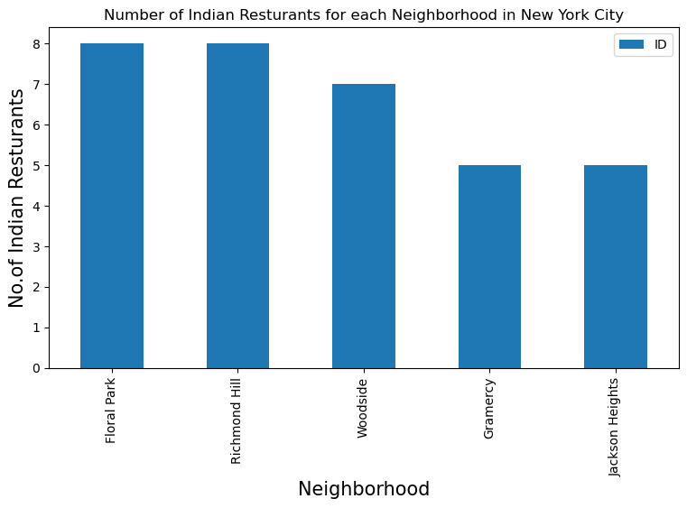

Above Graph clearly shows that Floral Park has a greater number of Indian Restaurants and sums to 8

**Conclusion:**

In this study I was able to Analyse and find out the answers for the questions stated above.

I found that

* Astoria (Queens), Blossvale (Queens), Civic Centre (Manhattan) are some of the best neighbourhoods for Indian cuisine
* Manhattan have potential Indian Restaurant Market
* Staten Island ranks last in average rating of Indian Restaurants
* Manhattan is the best place to stay if you prefer Indian Cuisine