https://codenuclear.com/how-arraylist-works-internally-java/

Collection interview study material

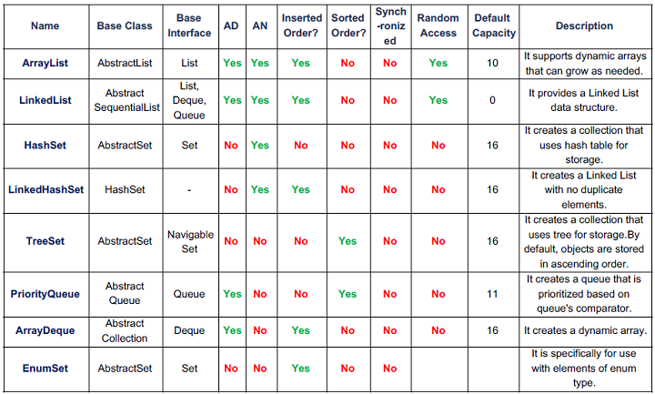

performance
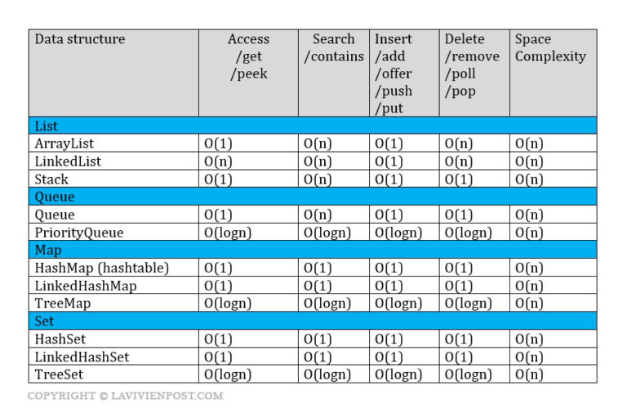

Time complexcity of collection framworks

E.G : to need to send the file to your friend which lives across the country.

Electronic transform O(n) , where s is the size of the file . This means that the time to transfer the file increases linearly with the size of the file

Ariplane Transfer O(1) with respect to the sixe of the file , as the size of the file increases it wont take any longer to get the file to your friend

ArrayList Interview Question

point to remember

public class ArrayList<E> extends AbstractList<E>
implements List<E>, RandomAccess, Cloneable, java.io.Serializable

MAX_ARRAY_SIZE = Integer.MAX_VALUE – 8
t

int newCapacity = oldCapacity + (oldCapacity >> 1);

If the size of the current elements (including the new element to be added to the ) is greater than the maximum size of the array

private void add(E e, Object[] elementData, int s) {
if (s == elementData.length)
elementData = grow();
elementData[s] = e;
size = s + 1;
}

Internally an ArrayList uses an object[] Array.

private transient Object[] elementData; --- in java 7
transient Object[] elementData; --- java 8 ( removed to provide access to nested class i.e. Itr, ListItr, SubList)

1 How to convert Array to ArrayList and vise-versa
https://javarevisited.blogspot.com/2011/06/converting-array-to-arraylist-in-java.html

2 I have an arraylist say of 500,000 elements such that the value of each element of the arraylist is same as the index. For ex: list.get(0) = 0; list.get(1) = 1 ...etc. But only one element is out of sync with this ordering [i.e list.get(i) != i]. How do you find that element.

Ans :
with java -8 function
OptionalInt foundInt = IntStream.range(0, list.size())
.parallelStream()
.filter(i -> i != list.get(i))
.findAny();

3 How do you increase the current capacity of an ArrayList?

The capacity of an ArrayList is automatically increased when we try to add more elements than the current capacity. However to manually increase the current capacity, ensureCapacity() method is used.

4)how arraylist works internally java

https://codenuclear.com/how-arraylist-works-internally-java/

4) Immutable vs Unmodifiable collection

unModifiable collection : When the source collection changes unModifiable Collection will always present with latest values.
List<String> modifiableList = new ArrayList<String>();
modifiableList.add("a");

List<String> unModifiableList = Collections.unmodifiableList(modifiableList);
modifiableList.add("b");

try {
unModifiableList.add("b");
} catch (UnsupportedOperationException e) {

}
System.out.println(modifiableList);
System.out.println(unModifiableList);

Ans :
UnsupportedOperationException
[a, b]
[a, b]

Immutable collection : immutable Collection can be treated as a readonly copy of another collection and can not be modified.

//immutableList

List<String> immutabList=Collections.unmodifiableList(new ArrayList<String>(modifiableList));
modifiableList.add("c");
try{ immutableList.add("c"); }catch(Exception ex){}

modifiableList:[a, b, c]
immutableList:[a, b]

