Chapters 4 and 5 — Implementation, Results and Conclusions
Draft of 12 October 2026

4.0 Implementation and Results

4.1 Introduction
This chapter reports how the methodology of Chapter 3 was implemented and what it produced: an XGBoost model for breast-cancer risk, SHAP explanations of that model, an analysis of how the explanations differ for Black patients, and an interactive dashboard.
The chapter follows the four objectives set out in Section 1.4.
Objective (Section 1.4) | Where it is addressed
1. Conceptual framework for integrating SHAP into a healthcare AI pipeline | 4.2 (pipeline) and 4.10 (dashboard as the integration point)
2. Diagnostic performance of the XGBoost model (accuracy, precision, recall, F1, AUC) | 4.5 and 4.6
3. SHAP analysis: most influential clinical features, strengths and weaknesses | 4.7 to 4.9
4. Perceived interpretability and trust among medical professionals | 4.10 (the dashboard is the study instrument; the study itself is future work)

An additional analysis, requested during implementation, examines how the features affect the model's predictions for people of the Black race (4.8). It is reported with confidence intervals throughout because the subgroup is small.
Three departures from the proposal. They arise from the data and are explained where they occur.
1. Prediction target (4.3). The TCGA-BRCA clinical data contain only malignant cases, so "benign versus malignant" cannot be constructed. The model predicts death during follow-up instead, keeping the recall-first design.
2. Missing-data handling (4.4). "Not recorded" for several clinical fields was strongly associated with the outcome, so those fields were encoded with clinical defaults rather than left as missing.
3. Race as an input (4.8). Race is deliberately included so that its use by the model can be audited, and a race-blind twin model is trained for comparison.

4.2 Implementation environment and pipeline
The whole study is implemented in Python as one executed Jupyter notebook plus a Streamlit dashboard, so every reported number can be traced to a cell.
Software environment
Component | Version | Role
Python | 3.12.10 | Language
pandas / NumPy / SciPy | 3.0.2 / 2.4.4 / 1.17.1 | Data handling and statistics
scikit-learn | 1.8.0 | Splitting, cross-validation, baselines, metrics
XGBoost | 3.2.0 | Classifier
SHAP | 0.53.0 | TreeSHAP explanations
Matplotlib / seaborn / Plotly | 3.10.8 / 0.13.2 / 6.7.0 | Figures (notebook and dashboard)
Streamlit | 1.58.0 | Dashboard

Random seed 42 is used throughout, so the notebook reproduces the reported numbers. A full execution takes about two minutes on a standard laptop.
Pipeline (the conceptual framework of Objective 1). The implemented workflow has seven stages, and the last two branch from the trained model.
1. Acquire the TCGA-BRCA clinical tables (UCSC Xena and cBioPortal) and join them by patient barcode.
2. Clean and encode, after auditing missing data.
3. Split into training, validation and test sets, stratified by race and outcome.
4. Train XGBoost: hyper-parameter search, early stopping, recall-first threshold.
5. Evaluate: held-out test set, repeated cross-validation, and performance by race with bootstrap confidence intervals.
6. Explain with SHAP: global, local, interaction, and Black-versus-White comparisons, then test the explanations for stability and clinical alignment.
7. Export the model, the per-patient SHAP values and the audit tables to the dashboard.
Code organisation. A small shared module (src/brca_xai/data.py) holds the download, cleaning and feature-encoding code. Both the notebook and the dashboard import it, so a patient is converted to model inputs in exactly the same way during training and during use. The code is available at github.com/Vik2ry/explainable-breast-cancer.

4.3 Data acquisition and cohort description
The analysis cohort is 982 women with a primary breast tumour, of whom 143 (14.6%) died during follow-up; 179 are Black (29 deaths), 743 White (111 deaths) and 60 Asian (3 deaths).
Sources. As specified in Section 3.2.1, the data come from TCGA-BRCA. Two public tables are joined on the patient barcode: the UCSC Xena clinical matrix (receptor status, histology, menopausal status) and the cBioPortal PanCancer Atlas patient table (self-reported race, age, pathologic T, N and M, overall survival). Xena alone has no race field, which is why the second source was needed.
Inclusion criteria. Female patients with a recorded race of White, Black or African American, or Asian, and a known survival status. This removed 12 male patients, one American-Indian patient (too few for any inference) and 90 patients with unrecorded race, which makes race-stratified analysis impossible for them.
Prediction target. TCGA-BRCA includes no benign lesions, so the proposal's benign-versus-malignant label cannot be built. Four candidate targets were screened with five-fold cross-validated AUC: death during follow-up (0.66), basal-like subtype (0.70) and triple-negative status (0.69), both of which are circular because the receptor results they depend on had to be withheld, and late stage from non-TNM features (0.56, effectively unpredictable). Death during follow-up (the TCGA overall-survival event) was chosen because it is non-circular, has usable signal, and a missed case has a direct clinical cost, consistent with the recall-first design of Chapter 1.
Table 4.1: Cohort description by race
Characteristic | White | Black | Asian | All
Patients, n | 743 | 179 | 60 | 982
Age at diagnosis, mean (SD) | 58.5 (13.0) | 56.2 (13.5) | 53.8 (12.2) | 57.8 (13.1)
Stage III to IV, % | 25.2 | 21.7 | 23.3 | 24.5
ER-positive, % | 80.4 | 60.6 | 66.1 | 75.8
PR-positive, % | 70.4 | 49.7 | 58.9 | 65.8
HER2-positive, % | 18.0 | 16.4 | 31.9 | 18.5
Basal-like (PAM50), % | 15.6 | 33.3 | 11.9 | 18.5
Median follow-up, months | 31.5 | 27.0 | 12.7 | 28.8
Deaths, n (%) | 111 (14.9) | 29 (16.2) | 3 (5.0) | 143 (14.6)

Black patients in this cohort are somewhat younger at diagnosis (56 versus 59 years), have about twice the share of basal-like tumours (33% versus 16%) and lower ER and PR positivity (61% and 50% versus 80% and 70%). This matches the disparity profile reported in the literature. The Asian group has only three deaths, so it is reported for completeness and supports no inference.
Median follow-up is short (2.4 years), so "died during follow-up" undercounts eventual deaths for every group. Section 4.9 tests how much this matters.
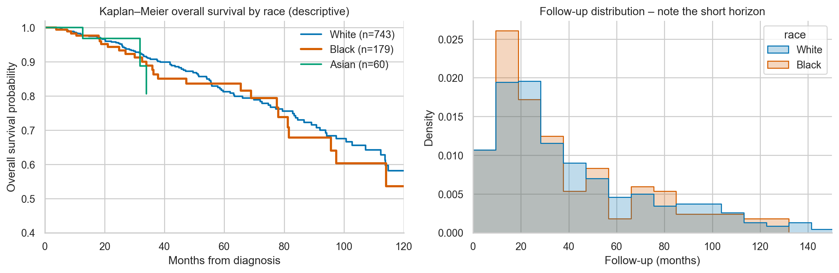
Figure 4.1: Kaplan-Meier overall survival by race (left) and follow-up distribution (right)

4.4 Preprocessing and the missing-data audit
The most consequential preprocessing finding was that, for four clinical fields, a missing value predicted death; encoding them naively would have inflated the model's apparent accuracy with a documentation artefact.
Features retained. Eleven inputs known at diagnosis: age, race (two indicator variables, White as reference), tumour size (T), nodal status (N), distant metastasis (M1), ER, PR, HER2, and two histology indicators (lobular, other; ductal as reference). Excluded on purpose: treatment and follow-up variables and year of diagnosis (leakage), AJCC stage group (a deterministic function of T, N and M, which would split SHAP credit between collinear columns), and PAM50 subtype (needs a gene-expression assay and is collinear with receptor status).
The audit. For each field, the death rate among patients with and without a recorded value was compared with a Fisher exact test.
Table 4.2: Outcome association of missing values
Field | Missing, n (%) | Death rate if missing | Death rate if recorded | Fisher p | Action
HER2 | 139 (14.2) | 33.1% | 11.5% | < 0.0001 | Not recorded treated as not positive
Menopausal status | 109 (11.1) | 36.7% | 11.8% | < 0.0001 | Dropped (correlated with age, rho = 0.70)
Nodal status (N) | 18 (1.8) | 61.1% | 13.7% | < 0.0001 | NX treated as N0
Metastasis (M) | 156 (15.9) | 9.0% | 15.6% | 0.035 | MX treated as M0
ER | 52 (5.3) | 19.2% | 14.3% | 0.31 | Kept as missing
PR | 55 (5.6) | 16.4% | 14.5% | 0.69 | Kept as missing
Tumour size (T) | 3 (0.3) | 33.3% | 14.5% | 0.38 | Kept as missing
Histology | 2 (0.2) | 0.0% | 14.6% | 1.0 | Kept as missing

The M-stage pattern matters for the race analysis. "M not assessed" (MX) was 2.5 times more common among Black patients (31.8% versus 12.9% of White patients) and carried a lower death rate (7% versus 19% for M0 among Black patients). A model fed this as a missing value would have learned that missing M protects Black patients, a conclusion about documentation practice, not biology.
Resulting encoding. Following the AJCC convention, MX is coded as M0 and NX as N0, unrecorded HER2 as not positive, and menopausal status is dropped. ER, PR, T and histology gaps are left as missing, because XGBoost and TreeSHAP handle missing values natively and their missingness carries no outcome signal. Section 4.6 quantifies what the protection costs in apparent accuracy.

4.5 Model development
The final model is a shallow, heavily regularised XGBoost classifier of 129 trees (depth 2) whose decision threshold of about 10% was set to catch at least 80% of deaths.
Data split (Section 3.2.3). The data were split 60/20/20 into training (588 patients, 86 deaths), validation (197, 28 deaths) and test (197, 29 deaths) sets. The split is stratified on race and outcome together, so every partition keeps Black patients and deaths among them (Black deaths: 17 training, 6 validation, 6 test). A plain random split on a cohort this size can leave a subgroup with no events in the test set.
Baseline comparison. Logistic regression, random forest and default XGBoost were compared with 5 x 3 repeated stratified cross-validation on the training set.
Table 4.3: Baseline models (mean +/- SD across folds)
Model | ROC-AUC | Average precision
Logistic regression | 0.589 +/- 0.072 | 0.287 +/- 0.064
Random forest | 0.623 +/- 0.066 | 0.286 +/- 0.073
XGBoost, default settings | 0.584 +/- 0.047 | 0.264 +/- 0.070
XGBoost, tuned (slightly optimistic) | 0.620 +/- 0.059 | 0.333 +/- 0.085

The differences are much smaller than the fold-to-fold spread, so XGBoost is not shown to be better than simpler models on this data. It was retained because it is the model the study examines, it handles missing values and non-linear effects natively, and TreeSHAP gives exact attributions for it. The same explanation workflow would apply to the logistic model.
Tuning and early stopping. A 60-draw randomised search with 5 x 2 repeated cross-validation, scored by ROC-AUC on the training set only, selected the hyper-parameters (best cross-validated AUC 0.629). The search range for the minimum child weight was set to 0.05 to 3, because XGBoost measures it in hessian units, about 0.12 per patient for a logistic loss at 15% prevalence; the default range of 1 to 10 would forbid any split on a rare but decisive group such as the 16 M1 patients. The selected values were learning rate 0.028, depth 2, minimum child weight 0.13, L1 penalty 0.09, L2 penalty 2.6, gamma 0.07, row sampling 0.82 and column sampling 0.71. With a cap of 1000 trees, early stopping on the validation set (patience 30) kept 129.
Class imbalance and the recall-first threshold. Classes were not re-weighted, because re-weighting distorts the predicted probabilities, which should remain interpretable as risks for the calibration analysis and the dashboard. Instead, the proposal's focus on recall (Section 1.1) is met through the decision threshold. It was set to the largest value giving at least 80% recall on out-of-fold predictions within the training set (0.101). The validation and test sets played no part in choosing it. Later fairness analyses use the same rule applied to out-of-fold predictions for all 982 patients (0.105).

4.6 Diagnostic performance (Objective 2)
The model discriminates modestly (held-out AUC 0.74, out-of-fold AUC 0.65), catching 93% of deaths on the test set at the cost of flagging three quarters of survivors.
Table 4.4: Held-out test set (n = 197, 29 deaths), threshold 0.101, point estimate (95% bootstrap CI)
Metric | Value
AUC | 0.74 (0.63 to 0.84)
Average precision | 0.40 (0.28 to 0.56)
Accuracy | 0.35 (0.29 to 0.41)
Precision | 0.18 (0.16 to 0.20)
Recall | 0.93 (0.83 to 1.00)
Specificity | 0.25 (0.19 to 0.32)
F1-score | 0.30 (0.26 to 0.33)
Brier score | 0.11 (0.10 to 0.12)

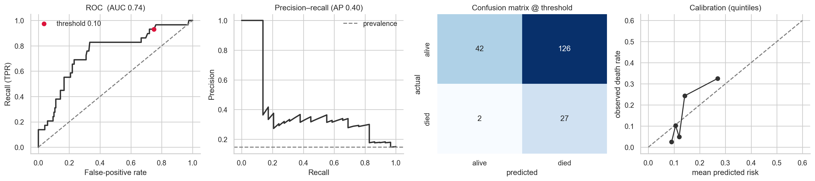
Figure 4.2: Test-set ROC curve, precision-recall curve, confusion matrix and calibration
The low accuracy and precision are the expected price of a recall-first threshold at 15% prevalence: to catch nearly all deaths, many patients who survive are flagged. Test recall (93%) overshoots the 80% target. The interval is wide because the test set holds only 29 deaths, so this should not be read as the model's true recall.
Out-of-fold estimate for all patients. Because the test set is small, every patient was also scored five times by models that had never seen them (5 x 5-fold cross-validation, predictions averaged). The out-of-fold AUC is 0.65, and mean predicted risk matches the observed death rate (14.3% versus 14.6%). These models reuse patients that informed hyper-parameter choice, so the estimate is slightly optimistic; the strict estimate is Table 4.4.
Table 4.5: Performance by race, out-of-fold, threshold 0.105 (95% bootstrap CI)
Group | n | Deaths | AUC | Recall | Specificity | Precision | Mean predicted / observed
All | 982 | 143 | 0.65 (0.60 to 0.70) | 0.80 (0.74 to 0.87) | 0.33 (0.30 to 0.36) | 0.17 (0.16 to 0.18) | 14.3% / 14.6%
White | 743 | 111 | 0.66 (0.60 to 0.71) | 0.80 (0.72 to 0.86) | 0.33 (0.30 to 0.37) | 0.17 (0.16 to 0.19) | 14.4% / 14.9%
Black | 179 | 29 | 0.61 (0.48 to 0.73) | 0.83 (0.69 to 0.97) | 0.23 (0.17 to 0.29) | 0.17 (0.14 to 0.20) | 15.1% / 16.2%
Asian | 60 | 3 | not interpretable (3 deaths)

Discrimination is lower for Black patients, but the interval is wide and overlaps that of White patients. Recall is at least as high; the cost is a lower specificity (23% versus 33%), meaning more Black patients who survive are flagged. Section 4.8 tests these gaps formally.
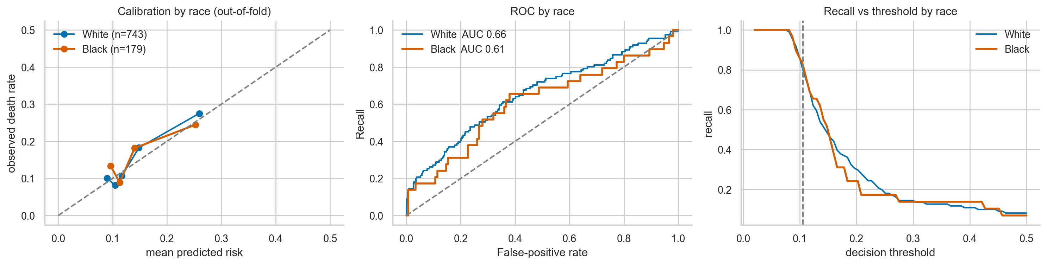
Figure 4.3: Calibration, ROC and recall-versus-threshold by race (out-of-fold)
Ablation: the cost of removing the missing-data artefact. With the same hyper-parameters and folds, a naive encoding that keeps missing values as a signal reached an out-of-fold AUC of 0.77 (Black 0.75, White 0.77), against 0.65 (Black 0.61, White 0.66) for the final model. In the naive model, menopausal status, HER2, nodal status and M-stage together carried 63% of all attribution (19.5%, 18.1%, 18.4% and 6.9%). The 0.11 AUC difference is therefore largely a registry artefact that would not transfer to another hospital. The protected model is the honest one.
Comparison with the literature. The 97% to 99% accuracies reported in Table 2.2 (for example Suresh et al., 2023, 98.4%) concern benign-versus-malignant classification on the Wisconsin dataset, an easier task on image-derived features. They are not comparable with a mortality model built from routine clinical variables, ~143 events and short follow-up.

4.7 SHAP analysis (Objective 3)
Age, ER status, tumour size and distant metastasis drive the model, together with a nearly additive structure: the strongest pairwise interaction is about 0.01 log-odds, against main effects of 0.1 to 1.0.
Method. SHAP values (Lundberg and Lee, 2017) were computed with TreeSHAP (Lundberg et al., 2020), which gives exact Shapley values for tree ensembles, on the log-odds scale. For a patient x, logit p(x) = phi0 + sum of phi_j(x), where phi0 is the cohort-average log-odds and phi_j(x) is feature j's push. A positive value raises the predicted mortality risk. The baseline log-odds is -1.78, corresponding to a baseline risk of 14.5%. Additivity was verified numerically: the largest discrepancy between the sum of SHAP values and the model's predicted probability was 1.8 x 10^-7, so the explanations are exact for this model. They were computed for all 982 patients using the final model.
Global importance (Section 3.2.4). Table 4.6 gives each feature's share of total mean absolute SHAP, with two other importance measures for comparison.
Table 4.6: Global feature importance (share of total)
Feature | SHAP | XGBoost gain | Permutation, drop in test AUC (+/- SD)
Age at diagnosis | 0.331 | 0.121 | +0.108 +/- 0.038
ER positive | 0.164 | 0.095 | +0.041 +/- 0.025
Tumour size (T) | 0.118 | 0.110 | +0.033 +/- 0.015
Distant metastasis (M1) | 0.108 | 0.181 | +0.056 +/- 0.016
Nodal status (N) | 0.095 | 0.086 | +0.010 +/- 0.009
Histology: lobular | 0.088 | 0.093 | +0.003 +/- 0.014
Histology: other | 0.045 | 0.091 | -0.003 +/- 0.008
Race: Asian | 0.024 | 0.071 | +0.006 +/- 0.006
PR positive | 0.021 | 0.046 | -0.001 +/- 0.004
Race: Black | 0.007 | 0.070 | +0.001 +/- 0.003
HER2 positive | 0.000 | 0.036 | 0.000 +/- 0.000

The three measures agree on the ranking (Spearman correlation between SHAP and gain 0.90, between SHAP and permutation 0.84). Permutation importance, computed on a 197-patient test set with 29 deaths, is noisy, with standard deviations comparable to the values, so it serves as a coarse cross-check. HER2 carries no usable signal once its missing-value artefact is removed, and the two race indicators together account for about 3% of attribution.
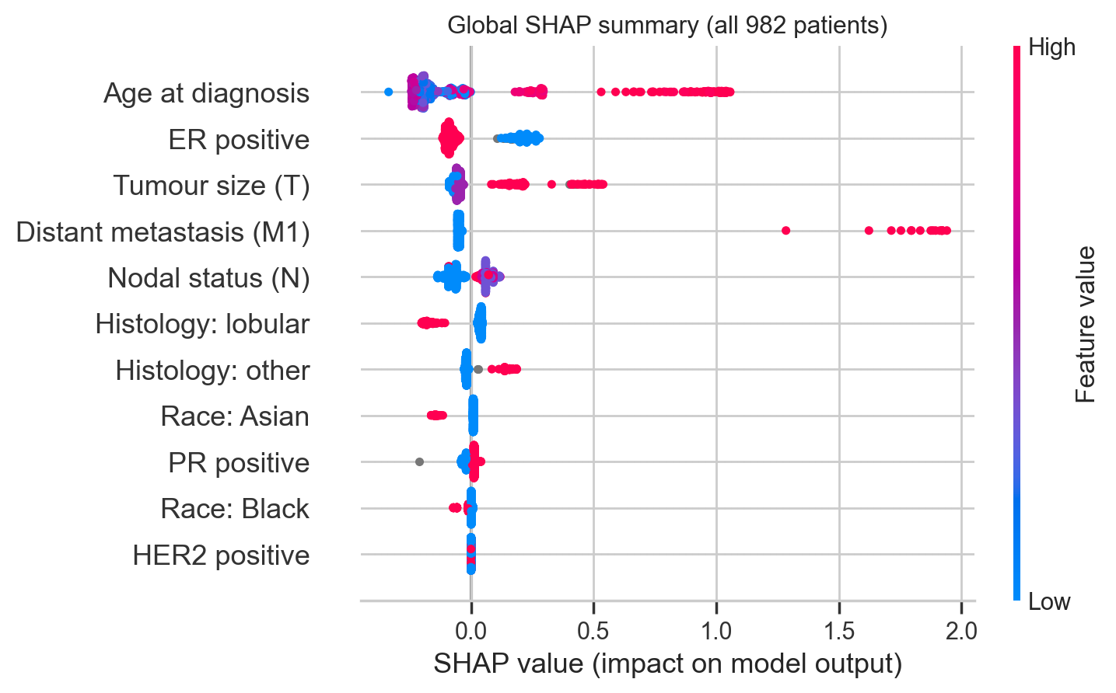
Figure 4.4: SHAP summary plot for all 982 patients. Each dot is a patient; colour is the feature value.
Shape of each effect. The dependence plots (Figure 4.5) show that the effects are step-like rather than smooth, as expected for shallow trees.
- Age. About -0.1 log-odds under 40, -0.2 between 41 and 68, then a rise to about +0.25 at ages 72 to 77 and about +1.0 from 78. Part of the late rise probably reflects deaths from other causes in older women, since the outcome is all-cause death.
- Tumour size. About -0.08 for T1 and -0.05 for T2, +0.18 for T3 and +0.47 for T4.
- Nodal status. About -0.07 for N0 and +0.05 to +0.10 for N1 to N3. The small differences among N1, N2 and N3 should not be over-read.
- ER status. ER-negative tumours receive about +0.2 and ER-positive about -0.08.
Colouring the age and nodal plots by race shows no visible separation between Black and White patients, an observation tested formally in Section 4.8.
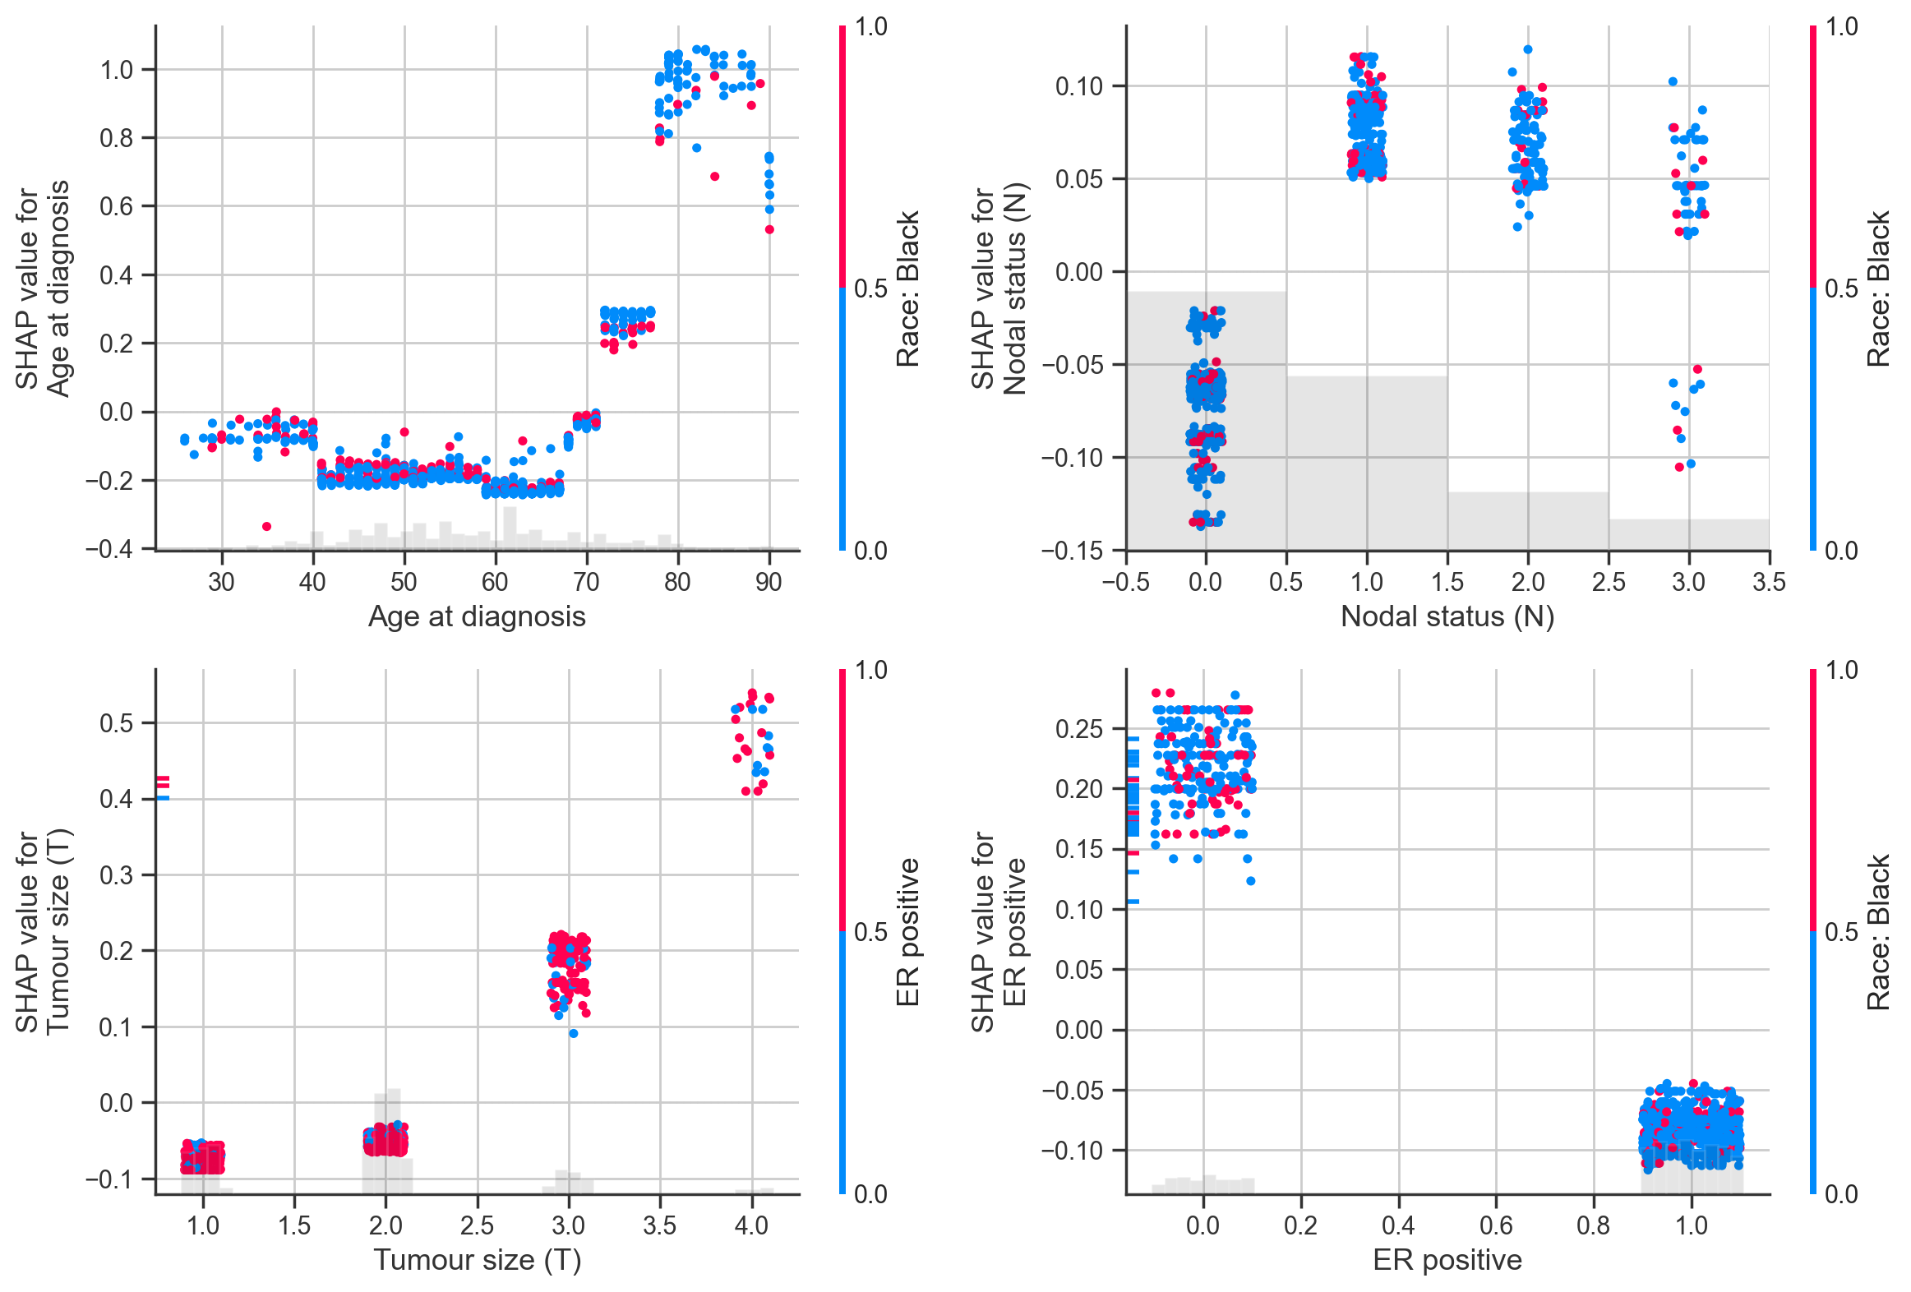
Figure 4.5: SHAP dependence plots for age, nodal status, tumour size and ER status
Interactions. SHAP interaction values show that the model is close to additive. The strongest pairs (age with ER, nodal status with ER, tumour size with nodal status, age with nodal status) have mean absolute interaction of only about 0.01 log-odds. Explanations built from per-feature contributions therefore capture nearly all of the model's behaviour.
Local explanation. Figure 4.6 shows the explanation for a Black patient who died but was not flagged (a false negative): a 51-year-old with a T2, N0, ER-positive tumour, scored 8.6% out-of-fold. Her age (-0.20 log-odds), ER-positive status (-0.08), node-negative status (-0.06), absence of metastasis (-0.05) and T2 tumour (-0.05) all pushed her score down, and only small positive pushes (lobular histology +0.04, PR positive +0.02) opposed them. The final model scored her 10.2% (out-of-fold 8.6%), just below the threshold. A clinician can thus see why the model missed her: her profile is the typical low-risk one.
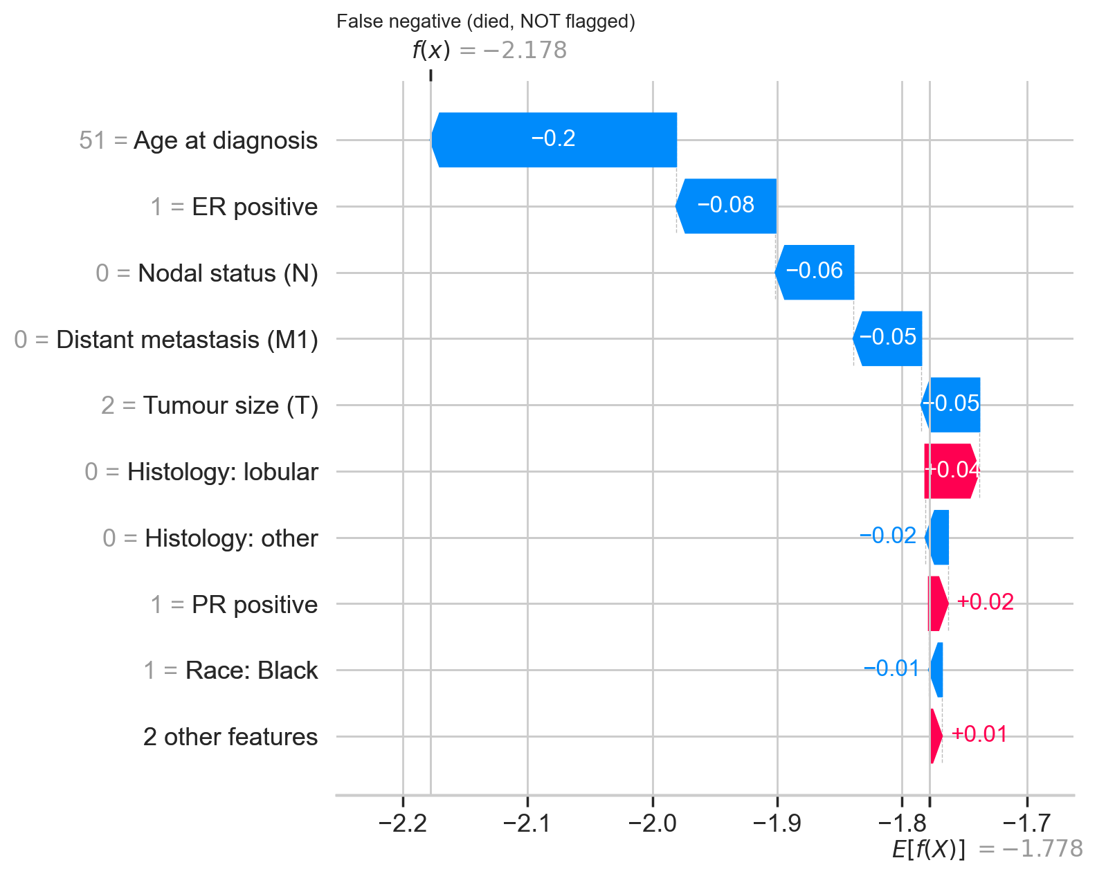
Figure 4.6: SHAP waterfall for a Black patient who died but was not flagged

4.8 How features affect predictions for Black patients
For Black patients the model relies mainly on age, ER status and distant metastasis; its overall risk scores are almost identical to those for White patients, and it makes almost no direct use of the race variable.
SHAP describes what the trained model does. It does not explain why outcomes differ between groups in real life. Race in TCGA is self-reported and stands in for social, environmental, access-to-care and ancestry factors that are not in the data, so the findings below are descriptive and generate hypotheses. The subgroup is small (179 patients, 29 deaths), so every comparison carries a bootstrap 95% confidence interval. A difference is called material only if the interval excludes zero and the size passes a practical threshold (2 percentage points of importance share, or 0.05 log-odds).
4.8.1 What the model relies on, Black versus White. Table 4.7 gives each feature's share of total attribution within each group.
Table 4.7: Share of total mean absolute SHAP by race (difference with 95% CI)
Feature | Black | White | Difference (Black minus White) | Material
Age at diagnosis | 0.278 | 0.348 | -0.069 (-0.106 to -0.034) | Yes
ER positive | 0.195 | 0.156 | +0.040 (+0.021 to +0.062) | Yes
Distant metastasis (M1) | 0.124 | 0.109 | +0.015 (-0.029 to +0.066) | No
Tumour size (T) | 0.119 | 0.119 | 0.000 (-0.016 to +0.017) | No
Nodal status (N) | 0.104 | 0.093 | +0.011 (+0.003 to +0.020) | No
Histology: lobular | 0.068 | 0.095 | -0.027 (-0.038 to -0.016) | Yes
Histology: other | 0.046 | 0.046 | 0.000 (-0.008 to +0.010) | No
Race: Black | 0.026 | 0.003 | +0.023 (+0.020 to +0.027) | Yes, but tiny in absolute terms (see 4.8.3)
PR positive | 0.026 | 0.021 | +0.005 (+0.002 to +0.009) | No
Race: Asian | 0.013 | 0.013 | 0.000 | No
HER2 positive | 0.000 | 0.000 | 0.000 | No

The model relies less on age and more on ER status for Black patients. This fits the cohort: ER-negative tumours are more common among Black patients (39% versus 20%), so ER status separates risk more sharply within that group.
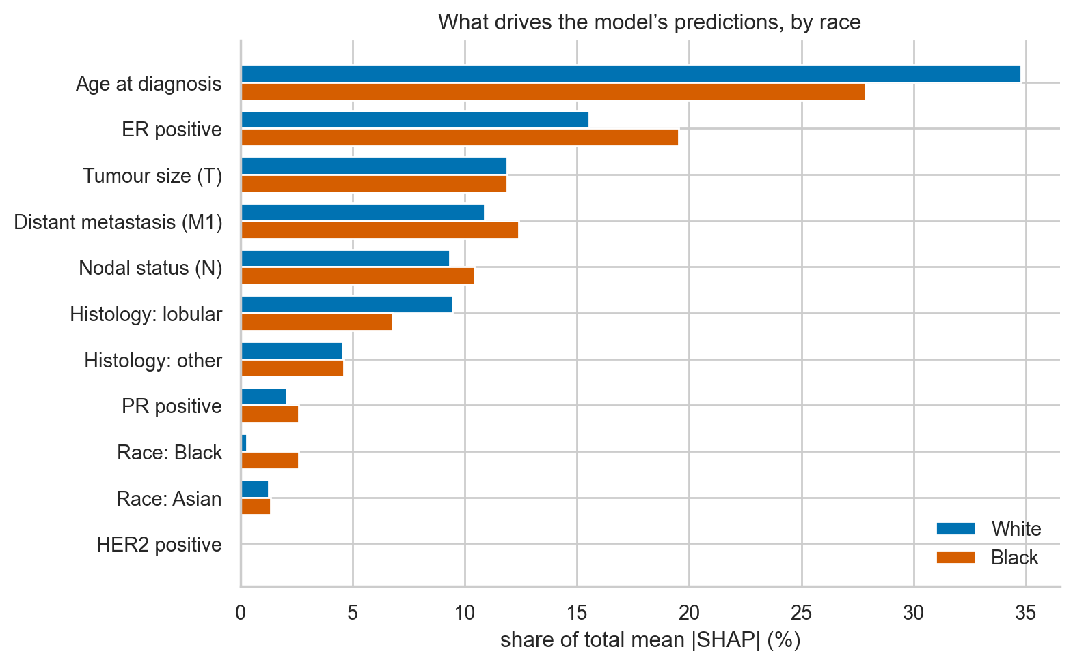
Figure 4.7: Feature reliance by race
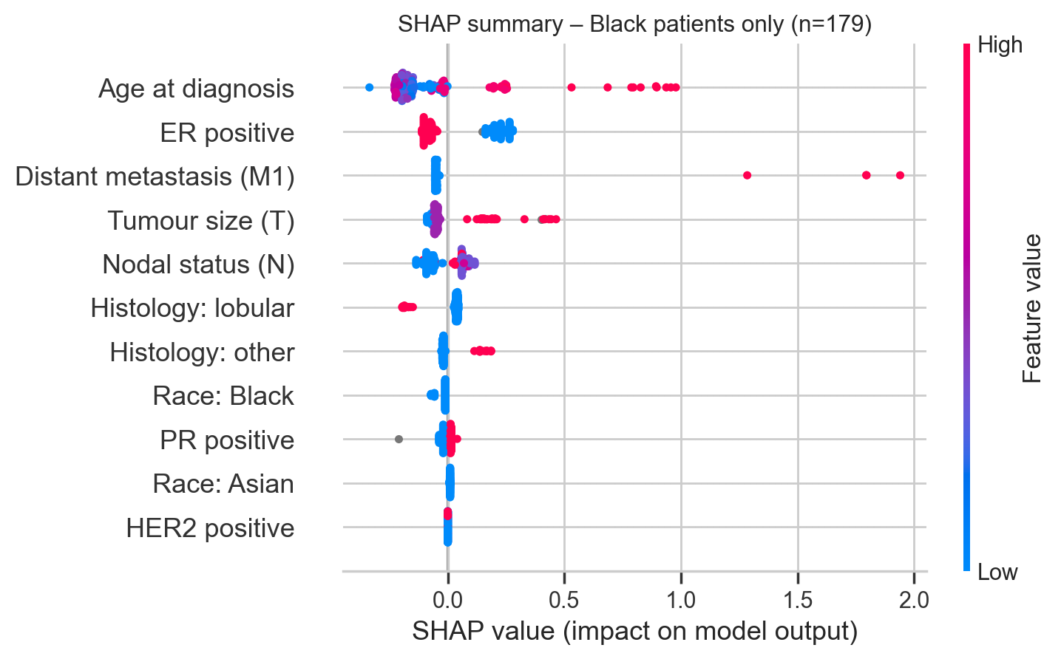
Figure 4.8: SHAP summary restricted to the 179 Black patients
4.8.2 Decomposing the risk gap. Because SHAP values add up, the difference in mean log-odds between two groups splits exactly into per-feature pieces. Mean predicted risk is 14.7% for Black and 14.5% for White patients, a gap of only +0.027 log-odds. Within that near-zero gap, ER status contributes +0.051 (95% CI +0.028 to +0.075), the only material contribution: the higher share of ER-negative tumours raises Black patients' predicted risk. Lobular histology contributes +0.032 (+0.021 to +0.043), below the materiality bar. Pulling the other way are age (-0.024; the Black cohort is younger, but the interval, -0.067 to +0.021, includes zero) and the race indicator itself (-0.021, discussed next).
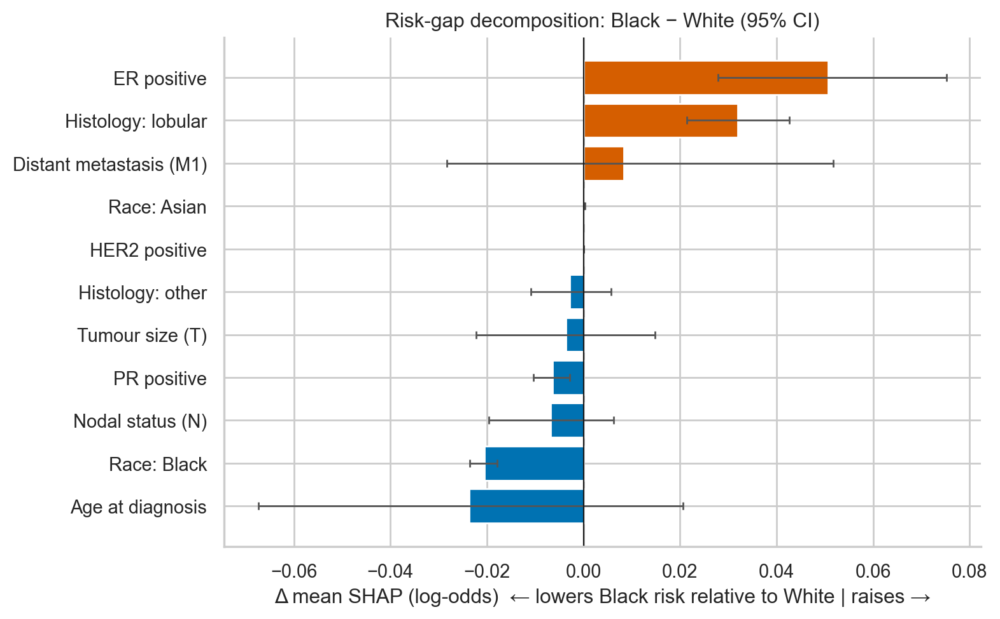
Figure 4.9: Contribution of each feature to the Black-minus-White gap in mean predicted risk (log-odds, 95% CI)
4.8.3 Does the model use the race variable directly? Two tests were used. First, the SHAP value of the race indicator among Black patients averages -0.019 log-odds (95% CI -0.022 to -0.016), negative for every Black patient. Second, a counterfactual test re-scored each Black patient as White with all clinical values unchanged: the predicted risk changes by -0.30 percentage points on average (95% CI -0.42 to -0.20; largest single change 3.1 points). The model therefore gives Black patients a very slightly lower score for the race indicator alone. This is statistically distinguishable from zero but clinically negligible, and the race indicator ranks 10th of 11 features by importance. A negative effect is consistent with the model attributing the higher mortality of ER-negative disease to ER status rather than to race. Because the model was trained on 29 Black deaths, it should not be read as evidence of a biological effect.
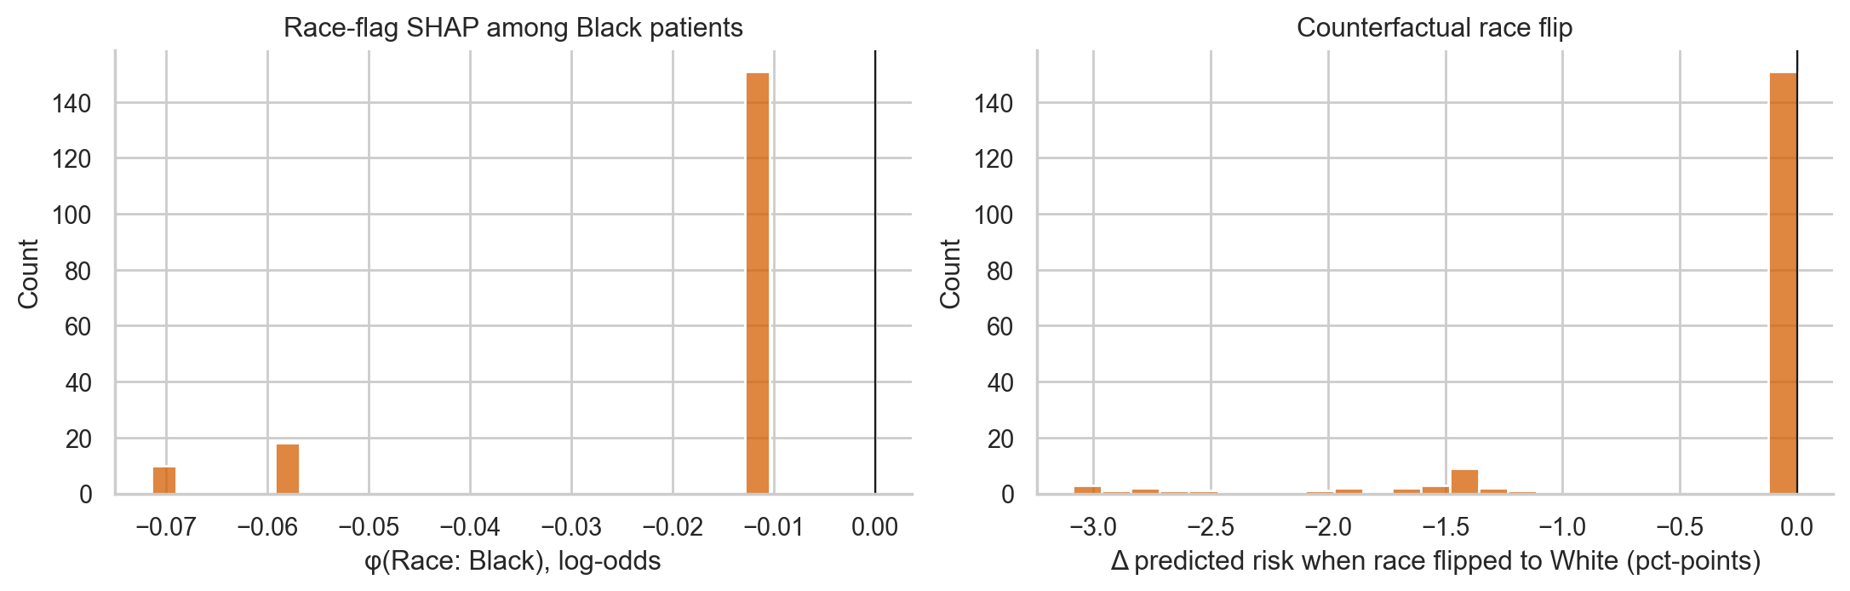
Figure 4.10: Direct race effect: SHAP value of the race indicator (left) and change in predicted risk when race is flipped to White (right)
4.8.4 The race-blind twin. The same model was retrained without either race indicator. Out-of-fold AUC was 0.648, against 0.654 with race, with no meaningful difference for Black patients (0.613 versus 0.609) or White patients (0.654 versus 0.655). Race therefore adds nothing measurable to accuracy. Attributions for Black patients stay similar on the shared features (rank correlation 0.88); the nodal-status share rises from 0.104 to 0.201 once race is removed, so the model appears to redistribute the small race effect onto correlated features. Not using race in a deployed version would cost no accuracy.
4.8.5 Are errors distributed equally? At the single out-of-fold threshold (0.105), the gaps between Black and White patients are:
Table 4.8: Group fairness at a single threshold (Black minus White, 95% bootstrap CI)
Metric | Black | White | Gap | 95% CI of the gap
Recall (equal opportunity) | 0.828 | 0.802 | +0.026 | -0.14 to +0.17
False-positive rate | 0.773 | 0.668 | +0.106 | +0.03 to +0.18
Precision | 0.171 | 0.174 | -0.003 | -0.03 to +0.03
AUC | 0.609 | 0.655 | -0.046 | -0.19 to +0.08

The model does not miss more deaths among Black patients (the recall gap is small and its interval is wide). The false-positive rate is higher by about 11 points, with an interval that excludes zero, so more Black patients who survive are flagged high-risk. Four metrics were compared without correction for multiplicity, so this is a signal to investigate, not a verdict. Calibration slopes are 1.28 (0.97 to 1.63) for White and 0.90 (0.07 to 1.64) for Black patients; the Black interval is too wide to say that calibration differs. Absence of a significant gap is not evidence of equity when there are only 29 events.
4.8.6 Error analysis. Five of the 29 Black patients who died were missed. Compared with the 24 who were caught, all five missed patients had ER-positive, PR-positive tumours (versus a third of those caught), and they were mostly node-negative (mean N 0.33 versus 1.09). The model misses deaths in patients who look low-risk on routine variables, as the false-negative explanation in Figure 4.6 illustrates. With five patients, this is anecdotal.

4.9 Trustworthiness of the explanations
The explanations pass the clinical-alignment check, but for Black patients only age is a stable top feature; the rest of the ranking changes with the training sample and the outcome definition.
This section addresses the consistency, stability and clinical-alignment evaluation promised in Section 2.3.
4.9.1 Stability across re-training. The model was retrained on 100 stratified bootstrap resamples, and the SHAP profile for the 179 Black patients was recomputed each time.
Table 4.9: Importance share for Black patients across 100 bootstrap re-trainings
Feature | Median share | 95% range | Share of runs in the top 3
Age at diagnosis | 0.308 | 0.145 to 0.505 | 0.98
Nodal status (N) | 0.172 | 0.024 to 0.317 | 0.70
Tumour size (T) | 0.119 | 0.037 to 0.256 | 0.45
Distant metastasis (M1) | 0.121 | 0.041 to 0.208 | 0.44
ER positive | 0.100 | 0.013 to 0.235 | 0.32
PR positive | 0.025 | 0.005 to 0.122 | 0.03
Histology: lobular | 0.025 | 0.001 to 0.104 | 0.01
Histology: other | 0.023 | 0.000 to 0.149 | 0.07
Race: Asian | 0.013 | 0.004 to 0.026 | 0.00
Race: Black | 0.012 | 0.000 to 0.070 | 0.00
HER2 positive | 0.009 | 0.000 to 0.080 | 0.00

Age is in the top three in 98% of runs. Nodal status, tumour size, distant metastasis and ER status compete for the other places, and the mean pairwise rank correlation between runs is only 0.68. The final model's Black-patient top three (age, ER, M1) is one plausible ordering among several. Features that matter in every run (age) can be reported with confidence; the finer ordering cannot.
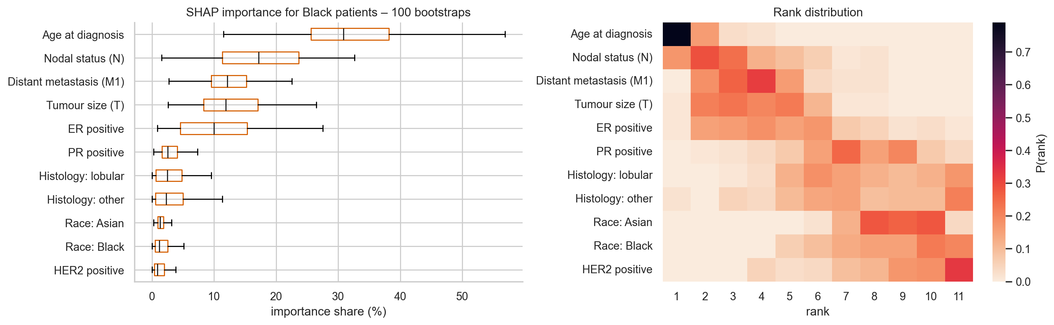
Figure 4.11: Importance shares and rank distribution for Black patients over 100 bootstraps
4.9.2 Alignment with clinical knowledge. For six features with an established direction of effect, the Spearman correlation between the feature's value and its SHAP value was checked. Five of six agree in all groups: older age, larger tumour, nodal involvement and metastasis raise predicted risk, and ER positivity lowers it (among Black patients, rho = 0.20, 0.87, 0.75, 0.26 and -0.85 respectively). The exception is PR status, where PR-positive patients receive a slightly higher score (rho = +0.87). The magnitude is negligible, as PR carries only 2% of the attribution. The data explain it: among ER-positive patients the death rates are indistinguishable (12.0% PR-negative, 13.5% PR-positive), the follow-up is short, and the 15 ER-negative PR-positive patients have an unusually low death rate (6.7%), so the model has no genuine PR signal to learn.
4.9.3 Sensitivity to the outcome definition. "Died during follow-up" mixes patients followed for three years with those followed for fifteen. The analysis was repeated with the outcome redefined as death within 24, 36 or 60 months, keeping only patients whose status at that horizon is known.
Table 4.10: Sensitivity analysis
Horizon | Patients (deaths) | Black patients (deaths) | Out-of-fold AUC: all / Black / White | Rank correlation of Black-patient SHAP importance with the primary analysis
24 months | 587 (36) | 104 (8) | 0.67 / 0.65 / 0.67 | 0.49
36 months | 472 (64) | 84 (14) | 0.71 / 0.65 / 0.72 | 0.64
60 months | 334 (93) | 59 (17) | 0.72 / 0.64 / 0.73 | 0.57

Model discrimination is similar or slightly higher with a cleaner outcome, but the Black-patient feature ranking agrees only moderately with the primary analysis. Age is the one feature that stays in the top three in every definition; nodal status gains importance (its share roughly doubles), PR status gains at longer horizons, and ER status and M1 lose importance. With 8 to 17 events, these subgroup rankings are suggestive, not established.

4.10 The interactive dashboard (Objectives 1 and 4)
The results are delivered through a Streamlit dashboard that lets a clinician enter a patient, see the risk score and the SHAP explanation, and inspect how the model treats Black patients; it is also the instrument for the planned physician study.
Architecture. The dashboard re-trains nothing. It loads the saved XGBoost model, the cohort with per-patient SHAP values and out-of-fold risks, and the audit tables written by the notebook. For a patient entered by the user, it encodes the inputs with the same module used in training and computes a fresh TreeSHAP explanation. Every number it displays therefore traces to a notebook cell. The code and artefacts are at github.com/Vik2ry/explainable-breast-cancer.
Features.
Tab | Function
Patient explainer | Enter or load a patient: predicted risk, percentile, screening flag, SHAP bar chart with odds multipliers, a plain-language summary, a race counterfactual and what-if curves for age, tumour size and nodal status by race
Global SHAP | Importance bars, an interactive summary plot, dependence plots with optional race overlay, and the interaction matrix; filterable to All, Black, White or Asian patients
Black patients and equity | Reliance by race, risk-gap decomposition, direct race effect, error rates at a user-set threshold, calibration, stability table, and a patient browser
Cohort explorer | Filter by race, age, T, N, ER, outcome and split; risk distribution, scatter and SHAP importance update for the selection; CSV download
Model and threshold | Test metrics, ROC and precision-recall curves, a threshold slider with confusion matrix, the cohort table
About | How to read SHAP, design choices, ethics and a study protocol

The SHAP integration points (Objective 1). The pipeline of Section 4.2 shows where interpretability supports a clinical decision.
Pipeline stage | What SHAP contributes | Where it appears
Data audit | Exposes data artefacts, as in the naive model whose reasoning rested 63% on missing-value fields | Sections 4.4 and 4.6
Model validation | Checks that effects match clinical knowledge | 4.9.2
Subgroup audit | Shows what drives scores per group and whether race is used | 4.8, equity tab
Individual decision | Explains one patient's score and what-if changes | Patient explainer
Governance | Provides evidence for regulators and clinicians that the model is transparent | Equity tab, About tab

Use in the physician study (Objective 4). The study itself was outside the scope of this implementation. The dashboard supports a protocol in which clinicians see cohort patients with and without the SHAP chart, state their own risk estimate before and after, and rate trust (1 to 7) and agreement with the explanation, with an extra question on whether the race what-if changed their view. Ethical approval and recruitment must be arranged before it starts.
Deployment. The dashboard runs locally with streamlit run app.py and is prepared for Streamlit Community Cloud from the public repository. It carries a visible notice that it is a research prototype, not for clinical use. It stores nothing that a user enters.

4.11 Discussion
The results support using SHAP to make an XGBoost clinical model transparent, but they also show that transparency can expose weaknesses that accuracy figures conceal.
Performance in context. The model's AUC (0.74 on the test set, 0.65 out-of-fold) is far below the 97% to 99% accuracies in Table 2.2 (Suresh et al., 2023; Taminul et al., 2024; Michael et al., 2022). Those studies classify benign versus malignant disease from the Wisconsin dataset, ultrasound images or a Bangladeshi hospital cohort, tasks that are differently posed, so the figures are not comparable. The closest comparison is Moncada-Torres et al. (2021), who used XGBoost with SHAP to predict survival in Dutch breast-cancer patients and reported a concordance index of 0.73. The present model's discrimination is of a similar order, which is plausible for routine clinical variables. The comparison with Kabiraj et al. (2020), who reported 74.7% accuracy with XGBoost and random forest on a UCI dataset, also shows how much reported performance depends on the dataset and the task.
Explanation as a data-quality tool. Section 4.4 shows a benefit the proposal anticipated (Section 1.1: SHAP can help "identify data leaks and potential overfitting"). The naive model scored 0.77 AUC while 63% of its attribution rested on four fields whose missingness predicted death. The artefact was found because the SHAP ranking gave an unexpectedly high importance to menopausal status, not through accuracy metrics, which would have rewarded it. This directly addresses the gap in Section 2.3 on data quality.
Explainability and consistency of the explanation. SHAP, XGBoost gain and permutation importance agree on the ranking (Section 4.7), the effects match clinical expectation for five of six features (4.9.2), and the model is almost additive. These are the strengths of SHAP for this model: exactness, local and global views from one framework, and consistency with other methods. The weaknesses are equally clear. Explanations are only as stable as the model: for Black patients only age ranks consistently in the top three (4.9.1), and the ranking changes with the outcome definition (4.9.3). Correlated features (ER and PR, age and menopause) share credit in ways that depend on the model, and PR's counter-intuitive sign is an example. SHAP explains the model, not the disease; the age effect above 78 years probably reflects deaths from other causes.
Health equity. Dankwa-Mullan (2024) and the regulatory sources cited in Section 1.2 call for transparency about how AI treats different groups. The equity analysis gives a concrete and cautiously reassuring picture: the model does not use race materially, scores the two groups' average risk almost identically, and misses no more Black deaths than White deaths. It also gives a signal that needs follow-up: a higher false-positive rate for Black patients. All of it rests on 29 deaths, and the analysis shows how much uncertainty such a subgroup carries. A model whose Black-patient explanation changes when the outcome is redefined should not be used to draw biological conclusions.
Meeting the objectives. Objective 1 is met by the pipeline and its integration points (4.2, 4.10). Objective 2 is met with the full set of metrics and confidence intervals (4.6). Objective 3 is met by the global, local, interaction, subgroup and stability analyses (4.7 to 4.9). Objective 4 is partly met: the instrument exists, but the physician study has not been run.

5.0 Conclusions

5.1 Summary of the study
This study used SHAP to explain an XGBoost model built on TCGA-BRCA clinical data and delivered the explanations through an interactive dashboard, with particular attention to how the model treats Black patients.
The benign-versus-malignant task in the proposal could not be built from TCGA, so the model predicts death during follow-up in 982 women (143 deaths; 179 Black patients, 29 deaths), keeping the recall-first design. An audit found that "not recorded" values for HER2, nodal status, M-stage and menopausal status predicted death, so they were encoded with clinical defaults. The final model reached an out-of-fold AUC of 0.65 (test AUC 0.74, 95% CI 0.63 to 0.84), against 0.77 for an unprotected model whose accuracy partly reflected the artefact. SHAP showed that age, ER status, tumour size and distant metastasis drive predictions, and that the model is nearly additive. For Black patients, the model leans mainly on age, ER status and distant metastasis, uses the race variable almost not at all, and gives average risk scores nearly identical to those of White patients. A higher false-positive rate for Black patients was the one nominally significant gap in error rates.

5.2 Conclusions per objective
Three of the four objectives were met in full; the fourth has its instrument built but its study not yet run.
1. Objective 1 (conceptual framework). A seven-stage pipeline integrates SHAP at five points: data audit, model validation, subgroup audit, individual decision and governance (Sections 4.2 and 4.10). The audit stage proved its value by exposing a data artefact that accuracy metrics rewarded.
2. Objective 2 (diagnostic performance). The XGBoost model has modest discrimination for mortality risk: test AUC 0.74 (0.63 to 0.84), recall 0.93, specificity 0.25, F1 0.30; out-of-fold AUC 0.65. A recall-first threshold catches most deaths at the cost of many false alarms. XGBoost was not shown to outperform logistic regression or random forest on this data. Performance figures are not comparable with the 97% to 99% reported for benign-versus-malignant tasks.
3. Objective 3 (SHAP analysis). SHAP identified age, ER status, tumour size and distant metastasis as the most influential features. The explanations are exact, agree with gain and permutation importance, and match clinical expectation for five of six features. Their weaknesses are dependence on correlated features and, for the Black subgroup, instability: only age is reliably a top-three feature.
4. Objective 4 (physician trust). Not yet evaluated. The dashboard and a study protocol are ready; a study with clinicians remains to be run after ethical approval.
On the question of Black patients. The model does not meaningfully use race (average effect -0.3 percentage points; no accuracy gain from including it). Differences in how the model reads Black patients arise from clinical variables, chiefly ER status, which is more often negative in this group, and a younger age profile. Recall is similar across groups, but false positives are more frequent for Black patients (77% versus 67%). These findings rest on 29 deaths and are hypotheses, not proof of fairness or of bias.

5.3 Contributions to knowledge
The study contributes a reproducible workflow, an equity-focused use of SHAP, and an open interactive tool.
- A SHAP-centred pipeline with a data-audit stage. It shows how explanation-driven checks can expose informative missingness that inflates accuracy by 0.11 AUC.
- A subgroup SHAP methodology. It combines per-group importance with bootstrap intervals, an exact decomposition of the between-group risk gap into per-feature pieces, a direct race counterfactual, a race-blind twin and a stability test across 100 re-trainings.
- An evaluation of explanation quality. Consistency across three importance measures, alignment with clinical knowledge, and sensitivity to outcome definition address the gap in Section 2.3 on the lack of standard interpretability metrics.
- Evidence on one dataset about race and SHAP. For TCGA-BRCA, the model does not depend on race, and subgroup explanations are only partly stable, which is useful guidance for future subgroup studies.
- An open dashboard and code. An interactive dashboard and a fully executed notebook are provided for teaching and for the physician study.

5.4 Limitations
The conclusions are bounded by the choice of target, the short follow-up, the small number of Black deaths and the single data source.
- Target substitution. Death during follow-up replaces benign versus malignant. The pipeline is target-agnostic, and only the data-loading function would change for a dataset with benign lesions.
- Small subgroup. 29 deaths among Black patients (and 3 among Asian patients, who could not be analysed). Intervals are wide, and test-set subgroup estimates were too noisy to use.
- Censoring and short follow-up. The median follow-up is 2.4 years, and death during follow-up is a lower bound on mortality. A time-to-event model would use this information better; it was not used because the proposal specifies classification.
- Association, not causation. SHAP explains the model. Race is self-reported and a proxy for unmeasured factors.
- Correlated features. ER, PR and age share credit in model-dependent ways.
- Single source and population. TCGA is a convenience sample of resected tumours from academic centres, not representative of Nigerian or general populations. No external validation was done.
- Exploratory subgroup comparisons. Four fairness metrics were compared without multiplicity correction.
- No user study. Objective 4 is not evaluated, so claims about physician trust are not supported by data.

5.5 Recommendations and future work
The most valuable next steps are to run the physician study, validate on an external cohort and use a survival model.
For practice
1. Do not use race as a model input in any deployed version: it adds no accuracy and carries ethical risk.
2. Audit missing-data patterns, by group, before training any clinical model, and report the audit.
3. Report subgroup results with confidence intervals and stability checks, and treat small-subgroup explanations as hypotheses.
4. Investigate the higher false-positive rate for Black patients before any deployment.
For future research
1. Run the physician user study (Objective 4) with the dashboard, after ethical approval. Suggested measures: clinician risk estimates with and without SHAP, trust (1 to 7), agreement with the explanation.
2. Validate externally on an independent cohort such as METABRIC, and on Nigerian clinical data, which would test generalisability to the setting of the authors' institution.
3. Use a survival objective (Cox or survival XGBoost) with SHAP, to make full use of follow-up time and censoring.
4. Add clinical monotonic constraints (older age, larger tumour, nodal and distant spread raise risk; ER positivity lowers it) and test whether explanation stability improves.
5. Use genetic ancestry in place of or alongside self-reported race, where available.
6. Recalibrate by group and evaluate group-specific thresholds if calibration or false-positive differences persist with more data.
7. Compare explanation methods such as LIME and counterfactual explanations with SHAP on the same model, which Section 1.6 noted was out of scope here.

References cited in Chapters 4 and 5
Entries are taken from the reference list of the proposal; add any further sources to the main thesis list.
- Dankwa-Mullan, I. (2024). Health equity and ethical considerations in using artificial intelligence in public health and medicine. Preventing Chronic Disease, 21:240245.
- Kabiraj, S. et al. (2020). Breast cancer risk prediction using XGBoost and random forest algorithm. 11th International Conference on Computing, Communication and Networking Technologies (ICCCNT 2020).
- Lundberg, S. M., & Lee, S.-I. (2017). A unified approach to interpreting model predictions. Proceedings of NeurIPS 2017, 4765-4774.
- Lundberg, S. M., Erion, G., Chen, H., et al. (2020). From local explanations to global understanding with explainable AI for trees. Nature Machine Intelligence, 2(1).
- Michael, E., Ma, H., Li, H., & Qi, S. (2022). An optimized framework for breast cancer classification using machine learning. BioMed Research International, 2022, 1-18.
- Moncada-Torres, A., van Maaren, M. C., Hendriks, M. P., Siesling, S., & Geleijnse, G. (2021). Explainable machine learning can outperform Cox regression predictions and provide insights in breast cancer survival. Scientific Reports, 11(1), 6968.
- Suresh, T., Assegie, T. A., Ganesan, S., Tulasi, R. L., Mothukuri, R., & Salau, A. O. (2023). Explainable extreme boosting model for breast cancer diagnosis. International Journal of Power Electronics and Drive Systems (IJPEDS), 13(5).
- Taminul, I., Alif, S., Sazia, T., et al. (2024). Predictive modeling for breast cancer classification in the context of Bangladeshi patients by use of machine learning approach with explainable AI. Scientific Reports. https://doi.org/10.1038/s41598-024-57740-5
Data sources. The Cancer Genome Atlas (TCGA-BRCA) clinical data via the UCSC Xena hub (xena.ucsc.edu) and the cBioPortal TCGA PanCancer Atlas 2018 patient table, accessed 12 October 2026. Code: github.com/Vik2ry/explainable-breast-cancer.

