TITLE OF THE PROJECT

BY

LAST NAME , Other Names
(REGISTRATION NUMBER OF THE CANDIDATE)

DEPARTMENT OF THE CANDIDATE
BAZE UNIVERSITY
ABUJA

MAY, 2023
[Project Title]

project Submitted in Partial Fulfilment of the Requirement
for the Degree of

B. Sc.
In
Computer Science [Student Major]

By

LAST NAME, Other Names

To

The Department of Computer Science
Baze University, Abuja

MAY, 2026

DECLARATION
This is to certify that this project entitled [Project Title], which is submitted by [Student Name] in partial fulfilment of the requirement for the award of degree for B.Sc. in Information Technology to the Department of Computer Science, Baze University Abuja, Nigeria, comprises of only my original work and due acknowledgement has been made in the text to all other materials used.

Date: Date Month Year Name of Student:

APPROVED BY ……………………………
Head
Department of Computer Science

CERTIFICATION
This is to certify that this project entitled Project Title, which is submitted by Student NAME in partial fulfilment of the requirement for the award of degree for B.Sc. in Information Technology to the Department of Computer Science, Baze University Abuja, Nigeria is a record of the candidate’s own work carried out by the candidate under my/our supervision. The matter embodied in this project is original and has not been submitted for the award of any other degree.

Date: Supervisor: Name

APPROVAL
This is to certify that the research work, Dental Management System and the subsequent preparation by [Your Name] with [Student ID] has been approved by the Department of Computer Science, Faculty of Computing and Applied Science, Baze University, Abuja, Nigeria.

By

Full name Date/Sign
Supervisor

Dr. Usman Abubakar Idris Date/Sign
Head, Department of Computer Sciences

Prof. Rufai Aliyu Date/Sign
Dean, Faculty of Computing and Applied Science

---------------------------------------
External Examiner Date/Sign

ACKNOWLEDGEMENT

Students should acknowledge every member of faculty of the department

DEDICATION
[This is the dedication page.]

ABSTRACT

[The abstract provides a clear summary of the project, indicating both content and tone of the project. An abstract includes the method(s) used to analyze the problem, a brief description of the research design, a listing of the key results, a brief description of the significance of the results, selected key conclusions. First-person narrative should not be used in the abstract.]
Single line spacing and no paragraphing
Not more than 250 words and should reflect what has been done, how it has been done, findings and conclusions of the work.
This should be written after the entire work is completed.

TABLE OF CONTENTS
DECLARATION ii
CERTIFICATION iii
APPROVAL iv
ACKNOWLEDGEMENT v
DEDICATION vi
ABSTRACT vii
LIST OF TABLES xi
LIST OF FIGURES xii
LIST OF ABBREVIATIONS xv
CHAPTER 1: INTRODUCTION 1
1.1 Overview 1
1.2 Background and Motivation 1
1.3 Statement of the Problem 1
1.4 Aim and Objectives 1
1.5 Significance of the Project 1
1.6 Project Risks Assessment 1
1.7 Scope/Project Organization 1
CHAPTER 2: LITERATURE REVIEW 2
2.1 Introduction 2
2.2 Historical Overview 2
2.3 Related Works 2
2.4 Summary 2
CHAPTER 3: REQUIREMENTS, ANALYSIS, AND DESIGN 3
3.1 Overview 3
3.2 Proposed Model 3
3.3 Methodology 3
3.3.1 Method 1 (e.g Interview) 4
3.3.2 Method 2 (e.g Observation) 4
3.4 Tools and Techniques 4
3.5 Ethical Consideration 4
3.6 Requirement Analysis 4
3.7 Requirements Specifications 4
3.7.1 Functional Requirement Specifications 4
3.7.2 Non-Functional Requirement Specifications 4
3.8 System Design 4
3.8.1 Application Architecture 4
3.8.2 Use Case 4
3.8.3 Data Design 4
3.8.4 Activity Diagrams 4
3.8.5 Dataflow Diagram 4
3.8.6 Control Flow Diagram 4
3.8.7 Entity-Relationship Diagram (ERD) 4
3.8.8 User Interface Design 5
CHAPTER 4: IMPLEMENTATION AND TESTING 6
4.1 Overview 6
4.2 Main Features 6
4.3 Implementation Problems 6
4.4 Overcoming Implementation Problems 6
4.5 Testing 6
4.5.1 Tests Plans (for Unit Testing, Integration Testing, and System Testing) 6
4.5.2 Test Suite (for Unit Testing, Integration Testing, and System Testing) 6
4.5.3 Test Traceability Matrix (for Unit Testing, Integration Testing, and System Testing) 6
4.5.4 Test Report Summary (for Unit Testing, Integration Testing, and System Testing) 6
4.5.5 Error Reports and Corrections 6
4.6 User Guide 6
4.7 Summary 6
CHAPTER 5: DISCUSSION, CONCLUSION, AND RECOMMENDATION 7
5.1 Overview 7
5.2 Objective Assessment 7
5.3 Limitations and Challenges 7
5.4 Future Enhancements 7
5.5 Recommendations 7
5.6 Summary 7
REFERENCES 8
APPENDICES 9

LIST OF TABLES
Table 2. 1: xxxxxxxxxxx 2
Table 2. 2: Test results 2

LIST OF FIGURES
Figure 3. 1:xxxxxxxxxx 3
Figure 3. 2: Model Diagram 4

LIST OF ABBREVIATIONS
CPU Central Processing Unit
ERD Entity Relationship Diagram
IT Information Technology

From declaration to list of abbreviation page number will be iii, iv,, iv…………………..

From here page number will be 1,2,3,4,5,…………………………
Typing Instructions
(a) Size: Use A4 paper (21.0x29.7cm)
(b) Typing: The following points should be noted:
- Type on one side only using Microsoft Word and Times New Romans.

(ii) For the main body of the project use font size twelve (12).
- Use 1.5 spacing throughout, except for abstract (single spacing), the indented quotations and footnotes which should be typed in single spacing.
(iv) Use Block Paragraphing i.e Leave one extra line space between paragraphs
- Provide adequate margins - 3.5cm on left hand side margin, 2.5cm on top, bottom and right-hand side margins.
- for header 1; before = 12pt , after= 8
- for header 2: before =8pt, after=6pt
- And the rest of the paragraphs will be 6pt

Tables & Figures
(a) Tables
i. Table within should be brief and clear. Very long tables should normally be inserted in the appendix at the end of the project.
ii. Each table should have a clear and self-explanatory title. Tables should be numbered consecutively with Arabic numeral that conform with the chapter throughout the project. e.g. for chapter four Tables 4.1, table 4.2, table 4.3 etc. The title of the table shall be bold and on top of the table close to the body of the table. The content of the table shall be centralized.
iii. Tables with grid lines should be avoided as this is an old method of table formatting.
iv. Content of tables should be extensively discussed within the body of the work, with proper references to the table.
Table captions should be up.

(b) Figures and Plates
- Figures include graphs, charts, drawings, diagrams, maps, and computer print-outs. The term ‘Figure’ thus refers to any type of graphic illustration other than a table. Figures should be clear, elegant and simple to interpret. Arabic numerals should be used in numbering figures with reference to the chapter e.g Figure 4.7.
- A description of Figures and figure references should be included in the body of the work. Source of the figure should be included if figure is not from student.
- Figure captions should be brief and informative
- Figures captions should be just below the figure (image)

LIST OF ABBREVIATIONS
CPU Central Processing Unit
ERD Entity Relationship Diagram
IT Information Technology

Note:
Plagiarism report
Plagiarism should report of no more than 20% should be added here. AI content not more than 10%

- Hard Cover Colour is “Maroon”
- Submit 4 Hard Copies to me with A CD (Project Document + Codes and description (readME))
Games
Desktop/Mobile/Web
AI/Machine learning
Scientific

CHAPTER 1: INTRODUCTION

1.1 Overview

1.2 Background and Motivation

1.3 Statement of the Problem

1.4 Aim and Objectives

1.5 Significance of the Project

1.6 Project Risks Assessment

1.7 Scope/Project Organization

CHAPTER 2: LITERATURE REVIEW

2.1 Introduction

2.2 Historical Overview

2.3 Related Works

2.4 Summary

Table 2. 1: xxxxxxxxxxx

    - Literature review should be at least 25 pages.
    - A detailed summary of reviewed literature should also be provided in a table.
Table 2. 2: Test results
Test ID | Description | Input | Expected Output | Actual Output | Status
TC01 | Login with valid credentials | user: admin, pass: 1234 | Access granted | Access granted | Pass
TC02 | Login with invalid password | user: admin, pass: wrong | Access denied | Access denied | Pass
TC03 | Empty username field | user: "", pass: 1234 | Error message shown | No error shown | Fail

CHAPTER 3: REQUIREMENTS, ANALYSIS, AND DESIGN

3.1 Overview

3.2 Proposed Model

3.3 Methodology
Figure 3.1 shows …..

Figure 3. 1:xxxxxxxxxx

3.3.1 Method 1 (e.g Interview)

3.3.2 Method 2 (e.g Observation)

3.4 Tools and Techniques

3.5 Ethical Consideration

3.6 Requirement Analysis

3.7 Requirements Specifications

3.7.1 Functional Requirement Specifications

3.7.2 Non-Functional Requirement Specifications

3.8 System Design

3.8.1 Application Architecture

3.8.2 Use Case

3.8.3 Data Design

3.8.4 Activity Diagrams

3.8.5 Dataflow Diagram

3.8.6 Control Flow Diagram

3.8.7 Entity-Relationship Diagram (ERD)
In figure 3.2 …..
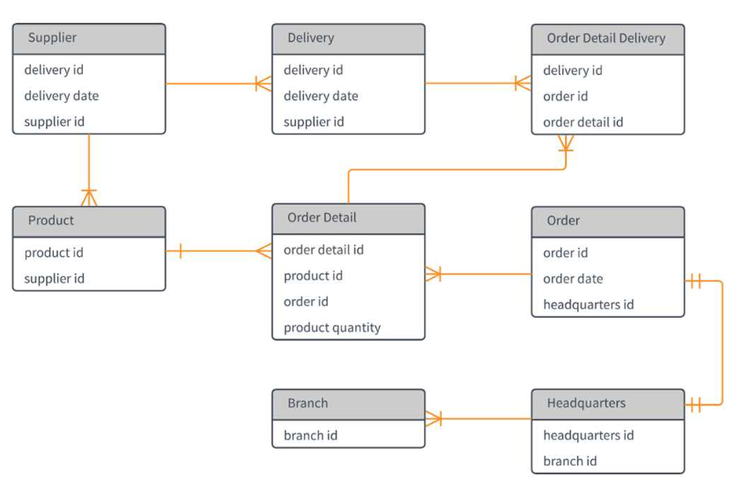
Figure 3. 2: Model Diagram

3.8.8 User Interface Design

CHAPTER 4: IMPLEMENTATION AND TESTING

4.1 Overview

4.2 Main Features

4.3 Implementation Problems

4.4 Overcoming Implementation Problems

4.5 Testing

4.5.1 Tests Plans (for Unit Testing, Integration Testing, and System Testing)

4.5.2 Test Suite (for Unit Testing, Integration Testing, and System Testing)

4.5.3 Test Traceability Matrix (for Unit Testing, Integration Testing, and System Testing)

4.5.4 Test Report Summary (for Unit Testing, Integration Testing, and System Testing)

4.5.5 Error Reports and Corrections

4.6 User Guide

4.7 Summary

CHAPTER 5: DISCUSSION, CONCLUSION, AND RECOMMENDATION

5.1 Overview

5.2 Objective Assessment

5.3 Limitations and Challenges

5.4 Future Enhancements

5.5 Recommendations

5.6 Summary

REFERENCES
All documentations should follow the APA 7th Edition referencing style. See https://www.scribbr.com/apa-style/apa-seventh-edition-changes/

Apa example

Akintaro, S. (2024, April 30). Nigerian banks lose N2.09 billion to frauds in Q4 2023 – FITC. Nairametrics. https://nairametrics.com/2024/04/30/nigerian-banks-lose-n2-09-billion-to-frauds-in-q4-2023-fitc/
George, G., Adeshina, S., & Boukar, M. M. (2024). The Influence of Activation Functions in Deep Learning Models Using Transfer Learning for Facial Age Prediction. International Journal of Intelligent Systems and Applications in Engineering, 12(2), Article 2.
Halimaa, A., & Sundarakantham, K. (2019). Machine learning based intrusion detection system. 2019 3rd International Conference on Trends in Electronics and Informatics (ICOEI), 916–920. https://ieeexplore.ieee.org/abstract/document/8862784/
Nadeem, M., Palaniappan, S., & Haider, W. (2021). Impact of Postgraduate Students dropout and delay in University: Analysis using machine learning algorithms. International Journal, 10(3). https://www.academia.edu/download/67591798/ijatcse461032021.pdf

APPENDICES
This where you document some of your codes

