

**Department of Information and Communication Engineering**

**BEUTH University of Applies Science, Berlin**

The project **Anti Theft Surveillance System** presented by;

1. Muhammad Ahmad Falak 886100
2. Ahmed Khan 886391

**Dr Thomas Scheffler**

Professor, Project Supervisor

**Table of Contents**

Abstract

Chapter 1

Introduction

1.1Problem statement

1.2Objective

1.3Progressive Goal:

1.4System Level Block Diagram

Chapter 2

Theory Related to Project

2.1.Raspberry Pi

### 2.2 GPIO, Interfacing and other ports________________________________________________

2.3PIR-Sensor

2.3.1 Construction_________________________________________________________________

2.4 Software Development__________________________________________________________

2.4.1 PHP_____________________________________________________________________

2.4.2 SQL Database________________________________________________________________

Chapter 3

Implementation of Project

3.1 Python and Idle File

3.2 Software Implementation

**Chapter 4**

Results

4.0 Project Results

Future Recommendations

References

**List of figures**

***1.4.1 Block Diagram ………………………………………***

***2.1.1 Raspberry pi………………………………………….***

***2.2.1 GPIO pins…………………………………………….***

***2.2.2 Camera Module……………………………………***

***2.3 PIR-sensor………………………………………………***

***2.3.1 Construction…………………………………………***

***3.2.1 webpage……………………………………………***

***3.2.2 login id………………………………………………***

***4.1.1 Hardware………………………………………………***

***4.1.2 Run in module…………………………………………***

***4.1.3 waiting for motion…………………………………***

***4.1.4 Create Motion………………………………………………***

***4.1.5 Motion Created…………………………………………***

***4.1.6 Email Notification……………………………………***

Chapter 1

Introduction

## Problem statement

We have designed the anti-theft surveillance system which detect the motion of burglar and notify the Owner via Email and notification also send to the Login Portal of Owner, which is password Protected and can only access by the Owner.

## Objective

The Objective of this Project is to increase the safety of the citizens of this country by using available technology. Additionally, there is always room for improvement in security and surveillance which can assist law enforcement in investigation processes, just like it is seen overseas. According to Numbeo, world’s largest user contributed 8 database, the concern for homes being broken into and things getting stolen is 68.82 which is considered High. Implementing a system like this has the chances of deterring the number of breaking and entering offences and will definitely increase the rate of solved cases like this due to high probability of prompt action by user and easier identification of the perpetrators. Overall, combining previous knowledge with newly acquired skills over the course of the time given to assemble this project to create something that can be used to make the lives of people easier or safer was the crux behind this idea.

## Progressive Goal:

The main goals of this project are

* **FLEXIBILITY** - The main goal of the presented work is to develop a cheap, flexible, open-source, easy to deploy, use and relocate video-surveillance system.
* **LOW COST** - The total cost of the system should be as low as possible, without sacrificing good operational results.
* **Automaticity** - The system, both the platform and plug-ins, should fulfill its premise with as little human intervention as possible.
* **Size** - Single-board computers are often very small - the Raspberry Pi is about the size of a credit card. Some available protective cases also include mounting points, which make these devices easily storable and relocatably.

## System Level Block Diagram

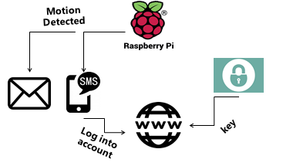

**FIG 1.1 - Block Diagram**

Chapter 2

Theory Related to Project

### Raspberry-pi

The Raspberry-pi (figure 2.1.1) is a development kit which is used as complete hardware simulator.

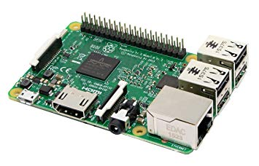

Figure 2.1.1 Raspberry-pi

The Raspberry Pi (RPi) is a single board computer fitted with a processor, memory, input/output and other features commonly found on a functional computer. The RPi was developed by the Raspberry Pi foundation in the United Kingdom in 2012. Several models of the microcontroller have been released over the years differing in price and functionalities. All models feature a Broadcom system on a chip (SoC), which includes an ARM compatible central processing unit (CPU) and an on chip graphics processing unit (GPU, a VideoCore IV). The operating system and program memory are stored on Secure Digital (SD) Cards. USB, HDMi, Composite video output and 3.5mm audio jack is fitted on the board as well. Lower level output is provided by GPIO pins which support common protocols. Raspbian, a Debian-based Linux distribution and third party Ubuntu and Windows is provided by the foundation for download.

### GPIO, Interfacing and other ports

Raspberry Pi has got 40 general purpose input/output pins also known as GPIO. They are the means by which a Raspberry Pi can interact with other devices. These pins can be programmed in ways to suit the device it is been connected to. Each pin has its own designated work. The details of their functions are shown in (Fig 2.2.1) below. 11 There are 4 USB 2.0 ports for connecting USB devices. More than 4 USB devices can also be connected using USB HUB. An Ethernet port (RJ45 10/100 MBit/s) is fabricated on the board as well. It can be used to connect to the internet instead of using USB Wi-Fi dongle which results in faster internet speed. Other devices which have Ethernet connectivity can also be connected via this port.For video input, there is a 15-pin MIPI camera interface (CSI) connector through which a Raspberry Pi Camera (Fig 2.2.2) can be connected. For video output, there are numerous ports. HDMI port is used to connect to HDMI supported monitors, TRRS jack for composite video output and MIPI display interface (DSI) for raw LCD panel displays. Raspberry Pi does not have any audio line-in option. However, for audio output it has an independent analog output via a 3.5mm phone jack. The HDMI port also serves as an audio output for cables supporting both audio and video. There is a micro-SD card slot which when loaded with a memory card acts as a storage medium for the Pi and also the operating system needed to run the Raspberry Pi is stored in that card.

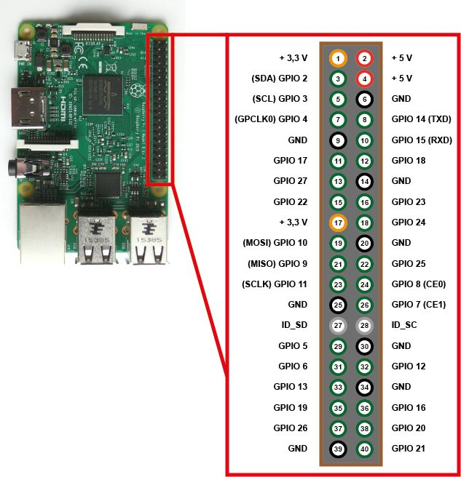

**Figure 2.2.1 GPIO**

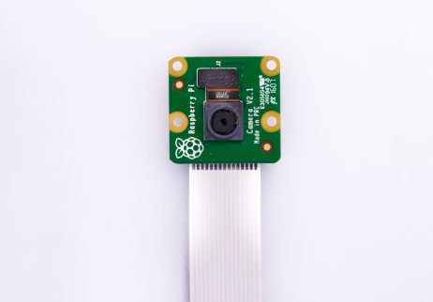

**Figure 2.2.2 Camera Module**

### Pir-Sensor

Raspberry Pi motion detectors or home automation and / or outdoor applications (as classic motion detectors) are easier than ever to implement.Raspberry Pi motion detector responds and moves, with the "strength" of movement controlled by an adjustable resistor (potentiometer). So you can set the motion sensor very sensitive, or try to avoid "noise". As soon as something moves, a signal is sent that can be received and responded by the Raspberry Pi.

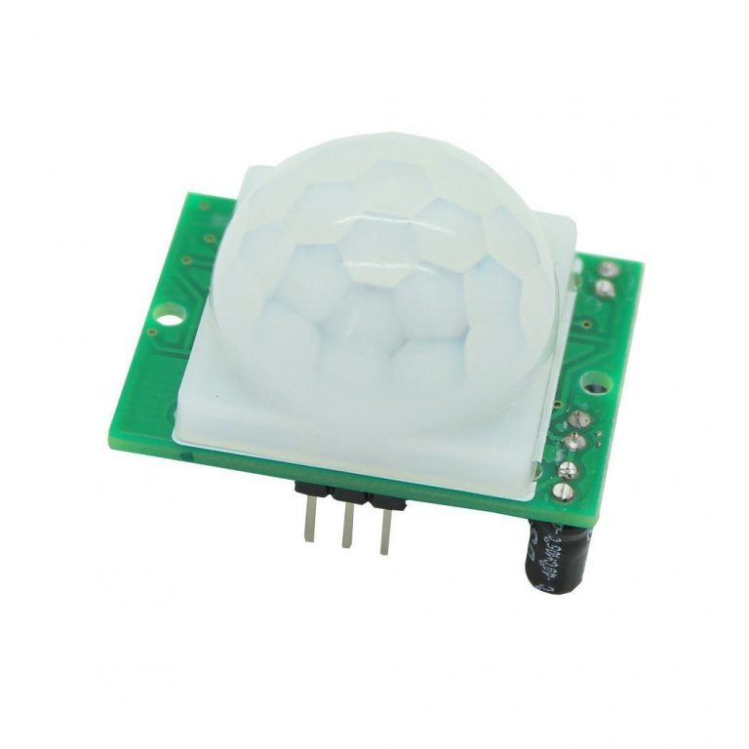

Figure 2.3 PIR sensor

* + 1. Construction

Der Aufbau ist sehr einfach, da nur ein Pin bei Bewegung aktiviert werden muss. Die Pins am PIR sind beschriftet:

* VCC an Pin 2 (5V)
* OUT an Pin 16 (GPIO 23)
* GND an Pin 6 (Ground)

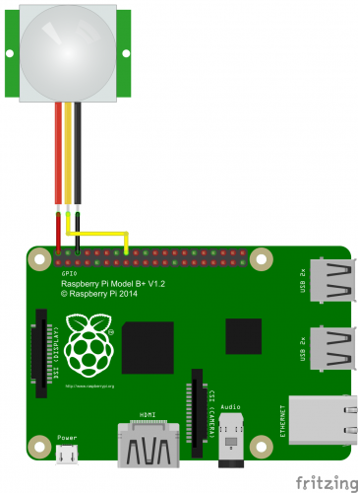 **FIG 2.3.1 Construction**

**4.1 Software Development**

**4.1.1 PHP**

After Detecting the motion notification send to the User Account which is controlled by PHP (acronym for Hypertext Preprocessor).PHP is a widely used open source scripting language used mostly for web development and HTML. PHP is the most efficient script as for this project, it controls the uploading from the Raspberry pi to the User account. It also connects the server to our SQL (Structured Query Language) database, in this case we are using MySQL database.

4.1.2 SQL Database

Database is a collection of information that can be accessed by various end points and can be modified as required by the user. MySQL software is a database server and is a trademark of Oracle Corporation. With MySQL, the software used to manage the database is PhpMyAdmin, the most popular PHP applications and MySQL administration tools, with a large community of users and contributors.

Chapter 3

Implementation of Project

3.1 Python and Python IDLE

The codes used in this system for running the RPi and sending notification has been written in Python language in its entirety. Python is a widely used high level general purpose programming language. Python supports multiple programming paradigms, including object-oriented, imperative and functional programming or procedural styles. It features a dynamic type system and automatic memory management and has a large and comprehensive standard library. Most Python implementations can function as a command line interpreter, for which the user enters statements sequentially and receives the results immediately Python IDLE is a development environment with abilities beyond that such as auto completion and syntax highlighting.

import smtplib

import RPi.GPIO as GPIO

import time

GPIO.setmode(GPIO.BCM)

GPIO_PIR = 7

print ("PIR Module Test (CTRL-C to exit)")

GPIO.setup(GPIO_PIR,[GPIO.IN](http://gpio.in/))

Current_State  = 0

Previous_State = 0

smtpUser = '[wattoorocx1@gmail.com](mailto:wattoorocx1@gmail.com)'

smtpPass = 'messibarcelona'

toAdd ='[wattoorocx@gmail.com](mailto:wattoorocx@gmail.com)'

fromAdd=smtpUser

Subject='Python Script'

header ='[wattoorocx@gmail.com](mailto:wattoorocx@gmail.com)' + toAdd + '\n' + '[wattoorox1@gmail.com](mailto:wattoorox1@gmail.com)' + fromAdd + '\n' + 'SECURITY SYESTEM' + Subject

body='Motion detected in your room.Please login to your Account'

try:

  print ("Waiting for PIR to settle ...")

  while GPIO.input(GPIO_PIR)==1:

    Current_State  = 0

  print ("Ready")

  while True :

    Current_State = GPIO.input(GPIO_PIR)

    if Current_State==1 and Previous_State==0:

      print ("  Motion detected!")

      print ("header + '\n' +body")

      s=smtplib.SMTP('[smtp.gmail.com](http://smtp.gmail.com/)',587)

      s.ehlo()

      s.starttls()

      s.ehlo()

      s.login(smtpUser,smtpPass)

      s.sendmail(fromAdd,toAdd,header + '\n' +body)

      s.quit()

      Previous_State=1

    elif Current_State==0 and Previous_State==1:

      print ("  Ready")

      Previous_State=0

    time.sleep(0.01)

except KeyboardInterrupt:

  print ("  Quit")

  GPIO.cleanup()

### 3.2 Software Implementation

To make out project more advance we create a website in which every user has its own login id and password protected. After detection motion he get a notification in his email and he can also check it from his website. In future we use camera which capture the image and uploaded to the id of user id.

All script for making website is uploaded on my github account which is given below

<https://github.com/AjWattoo/Dynamic-login-and-Registration-Form->

Our website look like this

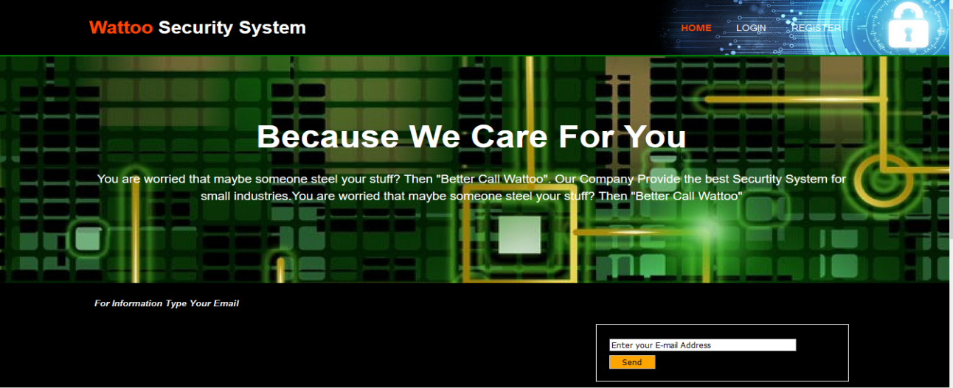

**FIG 3.2.1 webpage**

User have to put his login and password here to check the notification from our raspberrypi

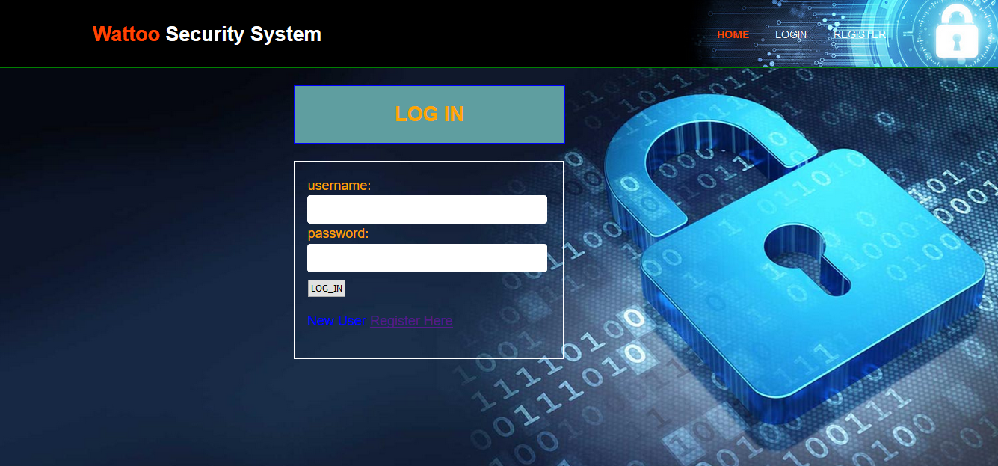

**FIG 3.2.2 Login id**

# Chapter 4

Results

# 4.1 Project Results

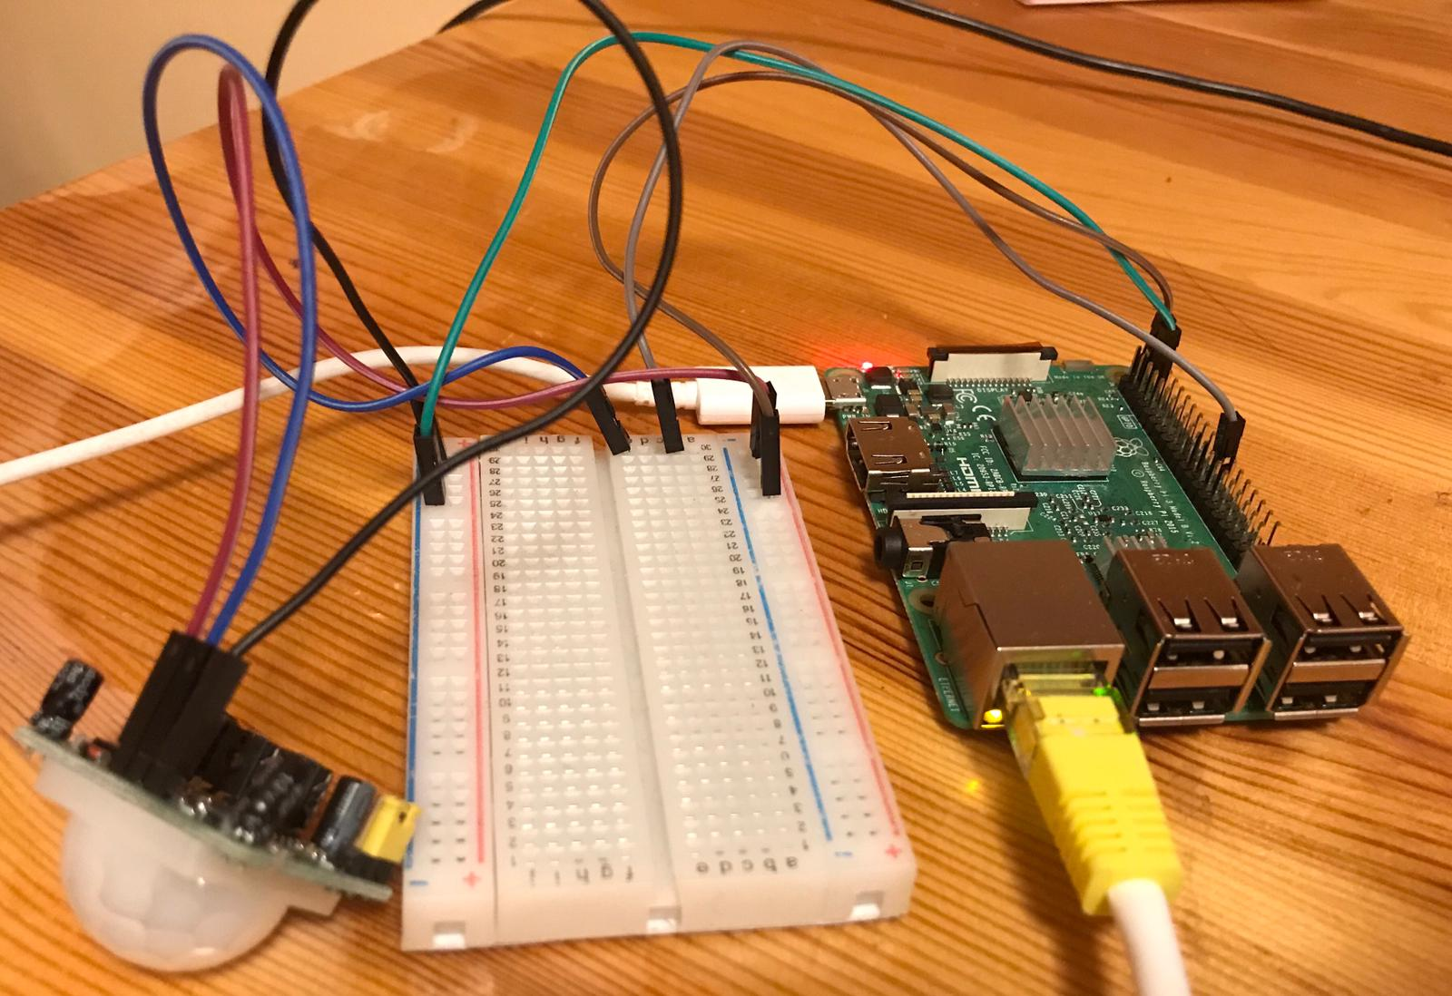

**FIG 4.1.1 Hardware**

Run the module from Idle file

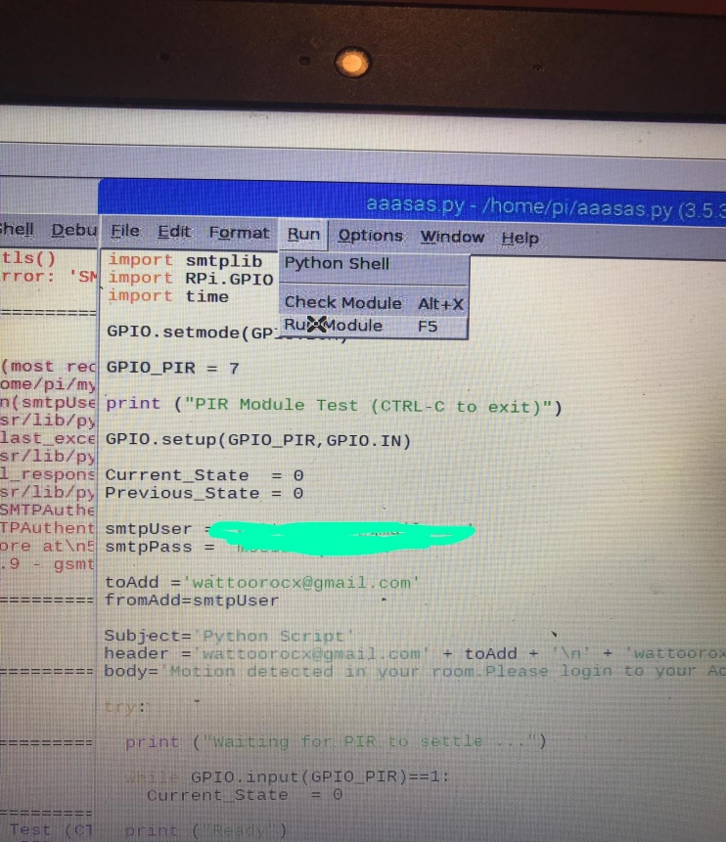

**Fig 4.1.2 Run the module**

It will wait untill it detect the motion

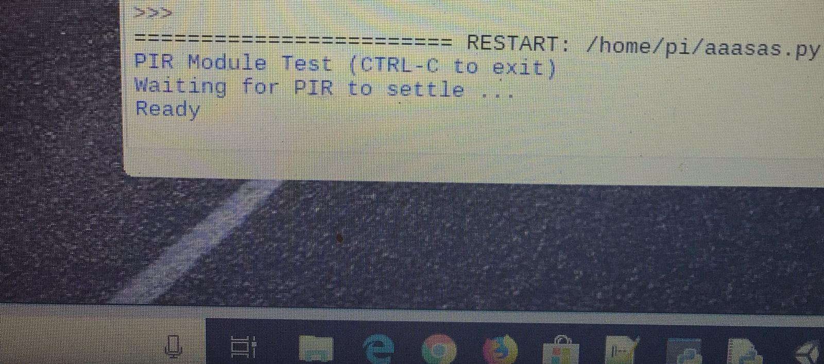

**Fig 4.1.3 Waiting for motion**

Move hand from motion sensor

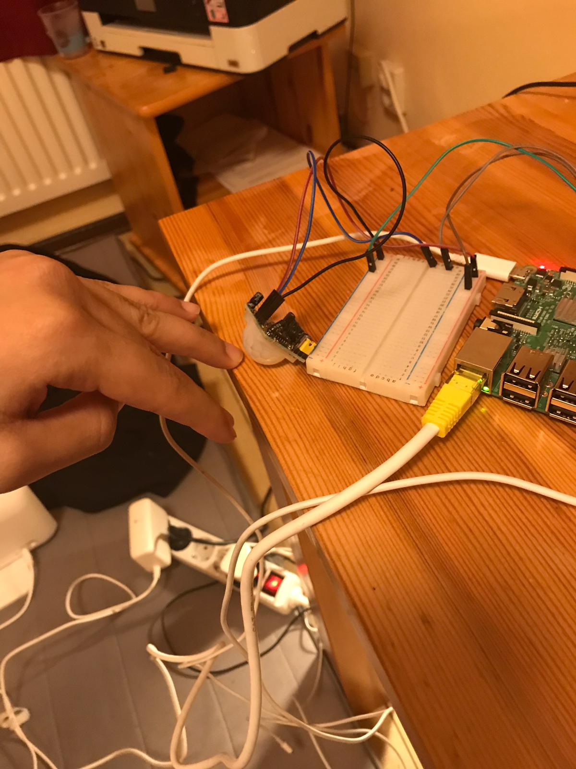

**Fig 4.1.4 Create Motion**

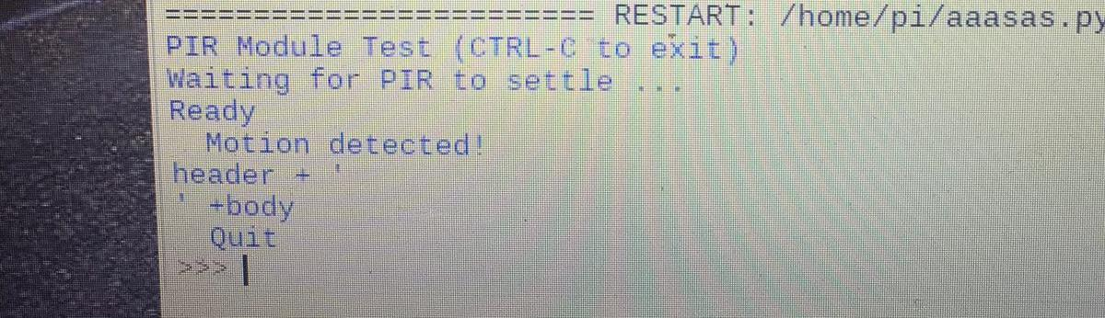

**Fig 4.1.5 Motion Detected**

You receive a email after detection the motion

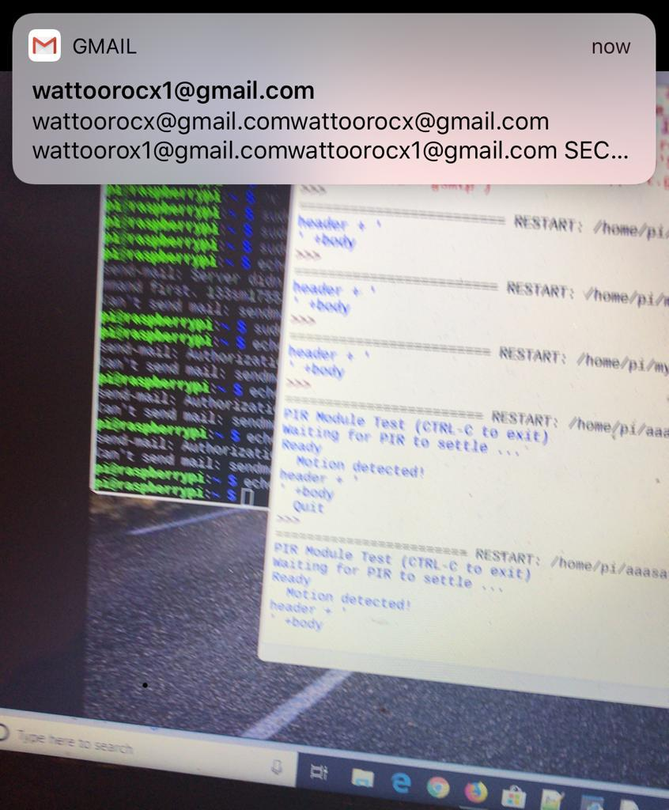

**Fig 4.1.6 Email Notification**

Then you have to log into your account to see the picture of person whose motion is detected which will be implement in future

## Future Recommendation:-

## When motion is detected camera make a video of a person and show live in the portal of user.

**References:**

**Research .https://pdfs.semanticscholar.org/157e/0e0cdf462c68df3307d75e4bd7505d71cab0.pdf**

**For detecting motion**

[**https://dataissexy.wordpress.com/2013/06/29/raspberry-pi-pir-motion-detection-and-alerting-to-sms-raspberrypi-sms-sensors/**](https://dataissexy.wordpress.com/2013/06/29/raspberry-pi-pir-motion-detection-and-alerting-to-sms-raspberrypi-sms-sensors/)

**Send email**

[**https://www.youtube.com/watch?v=0kpGcMjpDcw&t=6s**](https://www.youtube.com/watch?v=0kpGcMjpDcw&t=6s)

**Connect pi to php**

**https://www.youtube.com/watch?v=pMx0hVjAygo**