BIRLA INSTITUTE OF TECHNOLOGY AND SCIENCE, PILANI

**First Semester 2025- 26**

**SSWT ZG628T DISSERTATION**

**MID SEMESTER EVALUATION FORM**

ID No .**2021wa15838**  Name of Student: **Ajad Ramjit Chauhan**

Name of Supervisor: Shafique Khan

Name of the Examiner(s):- GANESH PAWADE

Dissertation Title: **Intelligent AWS EC2 Cost Optimization and Stale Resource Management**

**Section II**

(To be filled by the Supervisor in consultation with the examiner(s))

**Comments on the dissertation from Examiner and Supervisor (Select Y or N)**

1. **Quantum of work**
   * **Justifiable as efforts for 8 weeks duration Y / N**
   * **Work is in line with the commitments made in outline Y / N**
2. **Type of work**
   * **Client assignment Y / N**
   * **Organization specific task Y / N**
   * **General study project such as white paper Y / N**
   * **Any other (kindly elaborate below in a line or two if Y Y / N**
3. **Nature of work**
   * **Routine in nature Y / N**
   * **Involved creativity and rational thinking Y / N**

**Kindly elaborate below if answer for above is “Y”**

1. **Evaluation methodology**
   * **Evaluation done based on presentation to supervisor and examiner Y / N**
   * **Evaluation done through Viva conducted by supervisor and examiner Y / N**
   * **Student regularly interacted with supervisor and incorporated**

**the suggestions made Y / N**

* + **Brief description on the report submitted, quality of presentation and suggestions given for improvement**

1. **Mid semester evaluation matrix**

|  |  |  |  |  |  |
| --- | --- | --- | --- | --- | --- |
| **Dimension Rank🡪** | **1** | **2** | **3** | **4** | **5** |
| **Student abilities in general** | | | | | |
| Understanding of the subject of dissertation |  |  |  |  | **✔** |
| Creative thinking ability to come up with new ideas |  |  |  | **✔** |  |
|  |  |  |  |  |  |
| **Viva / Seminar presentation** | | | | | |
| Communication ability |  |  |  | **✔** |  |
| Organization of material |  |  |  | **✔** |  |
| Response to review questions |  |  |  | **✔** |  |
| Cohesive thinking ability |  |  | **✔** |  |  |
| **Report submitted** | | | | | |
| Report structure and format |  |  |  | **✔** |  |
| Technical content of the report |  |  | **✔** |  |  |
| Explanation on the significance of the assignment |  |  |  | **✔** |  |
| Analysis of alternative approaches |  |  | **✔** |  |  |

Any other comments:No

Date: 21/09/2025 Signature of examiner(s) Signature of Supervisor

# INTRODUCTION

1.1 Background  
Cloud has made it incredibly easy to launch what we need, when we need it—and that’s its greatest strength and its biggest trap. In day‑to‑day work, development or test EC2 instances stay on long after a sprint ends, and storage such as EBS volumes or snapshots outlives the project that created them. Over time, these “quiet” resources add up to real spend, even when they deliver no value.

1.2 Problem Statement  
Manually chasing idle instances and forgotten storage doesn’t scale. It’s slow, error‑prone, and distracting for teams whose focus should be delivery. Without automated detection and a simple way to act on waste, organizations leave savings on the table and see bills rise without a clear explanation.

1.3 Purpose and Objectives  
This dissertation develops an automated, AWS‑native system that finds waste early and makes it easy to fix safely. It will:

* Analyze EC2 utilization to surface idle instances that are candidates for schedule, stop, or rightsizing.
* Detect stale resources—including unattached EBS volumes, old snapshots, and unused Elastic IPs—that quietly incur charges.
* Automate cleanup using serverless functions with approvals and guardrails.
* Visualize costs, findings, and realized savings through an interactive dashboard.
* Establish lightweight rules and tagging practices for ongoing cost governance.

1.4 Scope  
The project delivers a working prototype in a single AWS account, focused on EC2, EBS, Elastic IPs, and Snapshots. It includes: (a) detection logic and automation workflows, and (b) a self‑service dashboard for visibility and approval‑based actions. The outcome is a practical, low‑overhead approach that teams can adopt without changing how they ship software.

# SYSTEM ANALYSIS & DESIGN

**2.1. Proposed System**  
The proposed system is a cloud-native, event-driven application that operates on a schedule. It will:

1. **Monitor:** Continuously collect EC2 system metrics (CPU, Network, Disk) using the CloudWatch Agent.
2. **Analyze:** Use AWS Lambda functions to query these metrics and apply algorithms to identify idle instances.
3. **Detect:** Use Lambda functions to scan the AWS environment for resources that meet the criteria for being "stale."
4. **Act:** Automate the stopping of idle instances and deletion of stale resources, with safeguards.
5. **Visualize:** Present all findings, cost data, and historical trends in a Streamlit dashboard for user insight and manual override.

**2.2. Technology Stack & Justification**

| **Technology** | Justification |
| --- | --- |
| **AWS Lambda** | Serverless compute for event-driven, pay-per-use automation. Eliminates need to manage servers. |
| **Amazon CloudWatch** | Centralized monitoring and metrics repository. Provides data for idle analysis and triggers functions. |
| **AWS Cost Explorer API** | Provides granular access to cost and usage data for visualization and reporting. |
| **AWS CLI / Boto3** | The primary tools for programmatically interacting with AWS services to describe and manage resources. |
| **Python** | The chosen runtime for Lambda functions and the Streamlit dashboard due to its rich SDK (Boto3) and data libraries. |
| **Streamlit** | A rapid application development framework for building interactive data dashboards in pure Python. |
| **IAM** | AWS Identity and Access Management is critical for enforcing the principle of least privilege and securing the system. |

# SYSTEM Architecture

The system is designed with a serverless, event-driven architecture for maximum cost-efficiency and scalability.

## 3.1 Architecture & Implementation

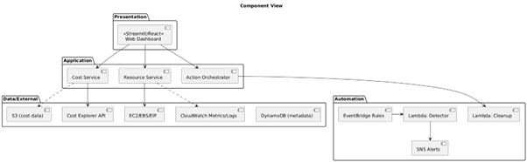

## 3.2 Artitechture component and its purpose

| **Component** | **Purpose** | **Free Tier Impact** |
| --- | --- | --- |
| EC2 t2.micro | Primary compute resource | 750 hours/month included |
| CloudWatch Agent | System metrics collection | Basic monitoring free |
| Lambda Functions | Automated cleanup & control | 1M requests + 400K GB-s free |
| SNS | Alert notifications | 1000 notifications/month free |
| S3/DynamoDB | Cost data storage | 5GB storage free |
| EventBridge | Scheduled automation | Free for AWS service targets |
| Streamlit Dashboard | Cost visualization interface | Run locally or minimal EC2 usage |
|  |  |  |

## 3.3 Flow diagram

# WEEKLY PROGRESS SUMMARY (Weeks 1-9)

# Weeks 1-2: Research, Setup, and Requirements

### What was accomplished

* Examined core references—the AWS Well‑Architected Framework, serverless design patterns, and recent work on cloud cost optimization—to ground design choices in proven practice.
* Captured clear functional and non‑functional requirements, focusing on accuracy of detection, safety (approval‑based cleanup), and low operating cost.
* Established a secured AWS Free Tier environment for development and testing, with billing alerts enabled.
* Implemented least‑privilege IAM policies to protect actions like cost queries and resource cleanup.
* Prepared a productive local toolchain (AWS CLI, Python, VS Code, Git) for rapid, reproducible iteration.

### Challenges and how they were addressed

* Scope realism: Balanced ambition with the dissertation timeline by prioritizing high‑impact features first (idle EC2 detection, stale resource signals, approval‑based cleanup), deferring nice‑to‑have items.
* Service selection: Narrowed the AWS surface area to EC2, CloudWatch, Lambda, EventBridge, SNS, S3, DynamoDB, and Cost Explorer—services that deliver the most value for monitoring, automation, and cost insights.

Troubleshooting readiness  
A practical runbook is in place for the most common early issues:

* CloudWatch Agent setup and metric flow verification.
* Lambda timeout/memory tuning and idempotency patterns.
* Cost Explorer permission and region constraints for API access.
* Streamlit dashboard connectivity and port/security‑group checks.

### Key learnings

* Security is foundational: least‑privilege IAM and guardrails around cleanup actions build trust and reduce risk.
* The AWS shared responsibility model informs design decisions—from data handling to credential scope.
* Serverless services (Lambda, EventBridge, SNS) reduce operational overhead and cost compared to always‑on servers, making them ideal for this use case.

### Status and deliverables

* **Status: Completed on schedule.**
* Deliverables: Literature Review, Secured AWS Account (Free Tier) with billing alerts, and a Functional Requirements Specification (FRS) aligned to the dissertation plan.

# Weeks 3–4: EC2 Launch and Monitoring and metrics collection.

* Stood up a t2.micro on Amazon Linux 2 and attached a purpose‑built IAM role—tight permissions for CloudWatch and EC2 only.
* Wrote a minimal IAM policy (for example, cloudwatch:PutMetricData, ec2:DescribeTags) to keep blast radius small.
* Installed the unified CloudWatch Agent and shipped a custom config.json to capture memory, disk, and network—signals the default EC2 metrics miss.
* Verified every metric stream in CloudWatch to close the loop from host to dashboard.
* Setting up budget and alarm for threshold CPU utilization reached.

What was tricky—and how it was solved

* Agent config pitfalls: iterated on the JSON until all target metrics appeared with sane units and intervals.
* IAM precision: refined permissions through test‑and‑tighten cycles to prevent over‑granting.

What this phase taught

* Practical IAM craftsmanship (roles, policies, instance profiles).
* AWS SNS to notify alert and alarms.
* The difference between default vs enhanced monitoring—and why the latter matters for right‑sizing and idle detection.
* A repeatable recipe for a secure, observable EC2 baseline.

**Status: Completed**Deliverables: EC2 t2.micro; CloudWatch Agent installed and configured; CPU, memory, disk, and network collection active.

# Weeks 5–6: Load Simulation and Signal Capture

* Chose stress‑ng for its fine‑grained controls on Amazon Linux; installed and validated.
* Designed a simple but revealing plan: 25% CPU for an hour, 80% CPU for 30 minutes, and multi‑hour idle.
* Ran tests, watched the CloudWatch dashboard in real time, and archived metrics for analysis.

Roadblocks and resolutions

* Dialing in utilization on t2.micro: tuned worker counts, timeouts, and sleep cycles to hit target CPU percentages.
* Stability under stress: monitored temperature and I/O saturation, keeping SSH access reliable during peaks.

Why it matters

* Learned how to create predictable load and read the metric story it produces.
* Built a labeled dataset (idle vs active) that will power the idle‑detection logic in later automation.

**Status: Completed**Deliverables: stress‑ng installed and tuned; load plan executed; usage pattern dataset archived.

# Week 7: CloudWatch dashboard creation

**Activities Completed:**

* Designed a logical layout for the CloudWatch dashboard to display key metrics clearly.
* Created a new dashboard named EC2-Optimization-Monitor.
* Added the following widgets:
  + **CPU Utilization:** Line graph showing CPU percentage.
  + **Memory Usage:** Line graph showing mem_used_percent.
  + **Disk I/O:** Line graph showing disk read/write bytes.
* **Network Traffic:** Line graph showing network packets in/out.
* Configured the time range to 1 day and enabled auto-refresh for real-time monitoring.
* Tested the dashboard during a final load simulation to ensure all widgets populated correctly.

**Challenges Faced:**

* Selecting the most relevant metrics and statistics (Average, Maximum) for each widget to provide the most insightful view.
* Organizing the dashboard for clarity and ease of use.

**Key Learnings:**

* The capabilities and limitations of the CloudWatch dashboard service.
* Best practices for cloud infrastructure monitoring and visualization.
* This dashboard serves as the primary debugging tool for the automation logic.

# Weeks 8–9: Turning Bills into Insights

* Enabled programmatic Cost Explorer access; built a Python script with Boto3 (get_cost_and_usage) to pull daily costs.
* Flattened the nested API response into a clean Pandas DataFrame and persisted as CSV (S3 integration planned next).
* Spun up a Streamlit app (dashboard.py) to load the CSV, plot daily costs, and support quick visual checks.

Hurdles and how they were cleared

* Complex JSON, simple table: wrote parsing helpers to standardize dates, services, and amounts.
* Local today, S3 tomorrow: designed the storage boundary so switching to S3 is a config change, not a rewrite.

What this unlocks

* Comfortable with Cost Explorer APIs and the mechanics of daily cost pipelines.
* Faster feedback loops via Streamlit for spotting anomalies and validating savings over time.

**Status: Completed**  
Deliverables: Cost Explorer enabled; CLI/Python scripts for cost retrieval; local cost store; Streamlit cost dashboard

# OUTPUT & DELIVERABLES

## EC2 instance & IAM setup

## CloudWatch Agent Configuration

## CloudWatch Dashboard

## AWS Cost CLI

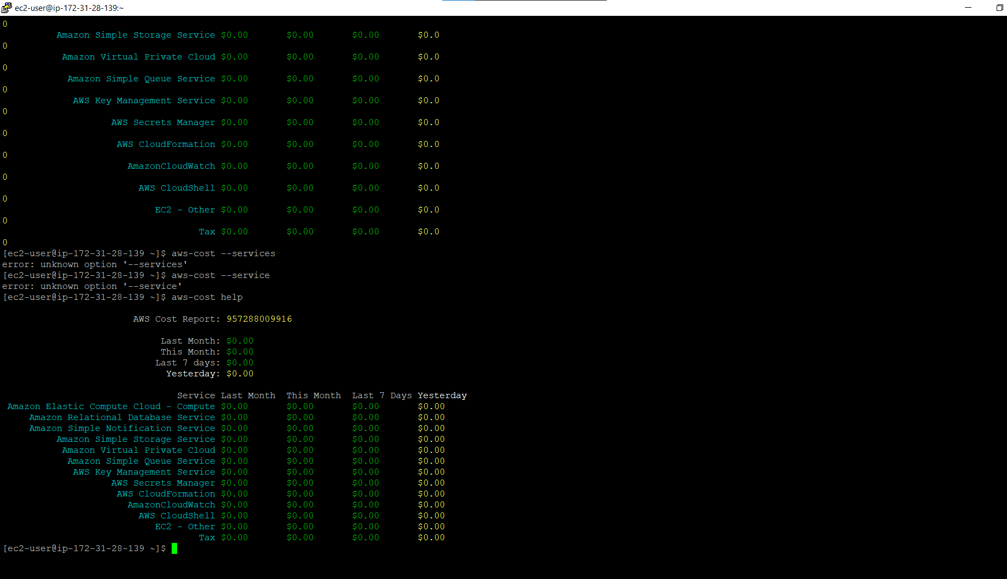

## AWS Lambda Function

## CHALLENGES & SOLUTIONS

* IAM precision
  + The challenge: Write policies that are truly least‑privilege yet still let Lambda and EC2 do their jobs.
  + What worked: Started from the smallest possible permission set, validated behavior with policy simulation and safe dry‑runs, then added only what was proven necessary.
* Data parsing
  + The challenge: The Cost Explorer response (get_cost_and_usage) is deeply nested and hard to analyze directly.
  + What worked: Built a stepwise parser using Pandas’ json_normalize to flatten the payload into a tidy DataFrame ready for charts, QA, and archival.
* Load generation
  + The challenge: Produce predictable, repeatable load on a modest t2.micro without causing instability.
  + What worked: Standardized on stress‑ng with targeted flags (for example, --cpu 1 --cpu-load 50), iterating to hit specific utilization targets while keeping the instance responsive.
* Cross‑service access
  + The challenge: Ensure Lambda can safely interact with EC2, CloudWatch, and Cost Explorer without over‑permissioning.
  + What worked: Defined a dedicated role (LambdaCostOptimizationRole) with trusted relationships and narrowly scoped custom policies, reviewed and refined as services were integrated.

# CONCLUSION & FUTURE ROADMAP

Conclusion  
The project is on track and has moved decisively from design to execution. In nine weeks, it delivered a secure AWS foundation, a reliable monitoring pipeline, repeatable load generation, a cost data workflow, and a working visualization layer. These pieces now form a cohesive platform on which the core contribution—intelligent, approval‑aware automation—will be built next.

What this means in practice:

* The environment is safe by default (least‑privilege IAM, controlled automation).
* The signals needed for decisions (metrics, costs, tags) are flowing and validated.
* The dashboard provides immediate visibility and a path to action.

Next, the focus shifts to decision logic and automation quality:

* Codify idle and stale‑resource rules with tunable thresholds.
* Add approval workflows and guardrails to make cleanup safe and auditable.
* Quantify savings with before/after comparisons surfaced directly in the dashboard.

# Plan for Weeks 10-16

| **Week** | **Task** | **Deliverable** |
| --- | --- | --- |
| **10-11** | Develop Lambda functions for idle instance detection and stale resource scanning. | Python scripts using Boto3 to identify idle EC2s and stale EIPs, EBS, Snapshots. |
| **12** | Develop the cleanup Lambda function and integrate with DynamoDB for logging. | A secure function to stop/delete resources, triggered manually based on DynamoDB records. |
| **13** | Implement SNS notifications for alerting and user approval workflows. | Email alerts sent to users when resources are flagged for cleanup. |
| **14** | Migrate data storage from local files to Amazon S3 and DynamoDB. | Cost data stored in S3, cleanup candidates logged in DynamoDB. |
| **15** | Enhance Streamlit dashboard with interactive controls and historical analysis. | Dashboard with buttons to trigger cleanup and view savings reports. |
| **16** | End-to-end testing, cost-benefit analysis, final documentation, and report submission. | Final system test report, dissertation document, and presentation. |

# REFERENCES

1. AWS Well-Architected Framework (2023). *Pillar: Cost Optimization*. Amazon Web Services.
2. Sbarski, P. (2017). *Serverless Architectures on AWS*. Manning Publications.
3. Armbrust, M., et al. (2010). *A view of cloud computing*. Communications of the ACM.
4. Li, Z., et al. (2020). *Serverless Resilience: Using AWS Lambda for Event-Driven Recovery*. IEEE Cloud Computing.
5. Gartner (2022). *Avoiding Common Pitfalls in Cloud IaaS Migration*.
6. Boto3 Documentation (2025). *AWS SDK for Python*. <https://boto3.amazonaws.com/v1/documentation/api/latest/index.html>