**Purpose and features of the space management tool**

The tool optimizes building space allocation, ensuring compliance with functional and regulatory standards. It analyzes spatial data from IFC-format models, checks compliance with benchmarks, and generates reports and visualizations to improve efficiency, transparency, and space utilization.

**Visualization and scope refinement**

**BPMN FOR USE CASE**

**BPMN FOR TOOL**

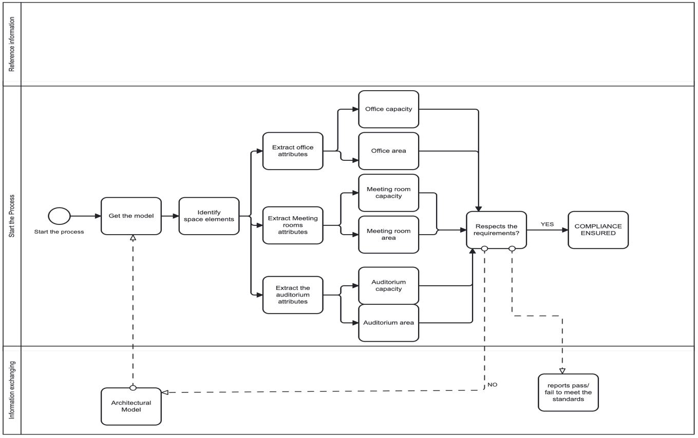

The shift between the BPMN USE CASE and BPMN TOOL is a progression toward clarity, efficiency, and alignment with the Space Management Tool's purpose. BPMN FOR TOOL likely provides a more focused depiction of workflows or interactions relevant to the tool's scope, ensuring stakeholders can quickly grasp the essential processes without unnecessary complexity, representing a narrowed or refined scope of the tool, focused on specific compliance checks.

**Applications and benefits**

Valuable during design development and technical design stages, the tool supports architects, engineers, facility managers, and construction managers by validating spatial planning, optimizing usage, and ensuring regulatory adherence through actionable insights and detailed outputs.