**Retail sales**

**Retail**: Retail is nothing but selling of goods and services from seller to buyer.

The overall commonly used application for retail sales.

**ERP (ENTERPRISE RESOURCE PLANNING):**

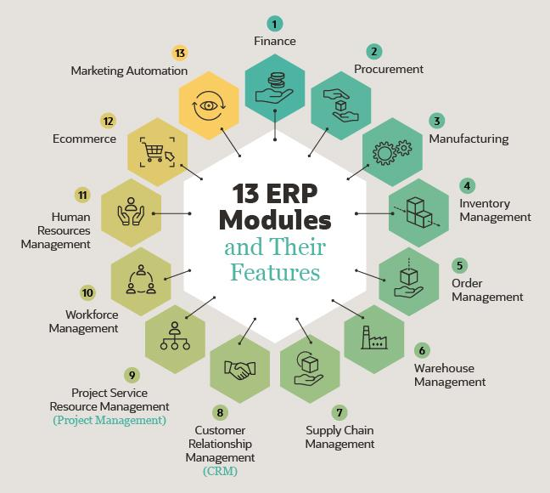

It also includes professional service automation (service resource management), human resources management, ecommerce and marketing automation.

**Retail modules:**

1. E-commerce platforms
2. Payment gateways
3. Customer relationship management (CRM)
4. Order fullfillment
5. Inventory management
6. Marketing automation

**Module implementation and some applications used are:**

1. E-commerce platforms: E-commerce platforms are software applications that enable businesses to create online stores and manage their online sales. Popular e-commerce platforms include Shopify, Magento, WooCommerce, and BigCommerce.
2. Payment gateways: Payment gateways are software applications that enable businesses to process online payments securely. Popular payment gateways include PayPal, Stripe, and Authorize.net.
3. Customer relationship management (CRM) software: CRM software is used to manage customer data and interactions. It can be used to store customer contact information, track customer interactions, and manage customer support tickets. Popular CRM software includes Salesforce, Hubspot, and Zoho CRM.
4. Order fulfilment software: Order fulfilment software is used to manage the process of fulfilling customer orders, from picking and packing to shipping and tracking. Popular order fulfilment software includes ShipStation, ShipBob, and ShipWorks.
5. Inventory management software: Inventory management software is used to manage product inventory and track stock levels. It can be used to generate purchase orders, monitor product movements, and automate restocking orders. Popular inventory management software includes QuickBooks, Fishbowl Inventory, and TradeGecko.
6. Marketing automation software: Marketing automation software is used to automate marketing tasks and campaigns, such as email marketing, social media marketing, and lead generation. Popular marketing automation software includes Mailchimp, Marketo, and Hubspot Marketing.

**Workflow drawing:**

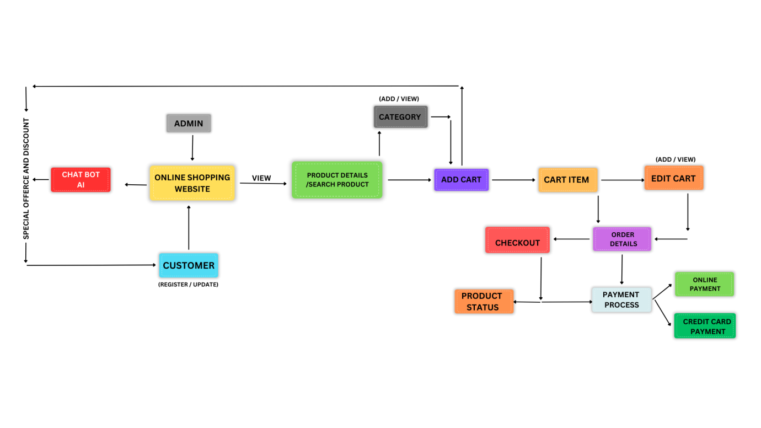

**Customers**:

Create a table to store customer information, including details such as customer ID, name, contact information, and shipping address.

* It allow customers to browse products, view product details, and add products to their shopping cart.

**Products**:

Create a table to store product information, including product ID, name, description, price, and stock quantity.

* Enable customers to add, remove, or update quantities of products in their shopping cart. The shopping cart information is stored in the shopping cart table.

**Order**:

Create a table to store order information, including order ID, customer ID, order date, and total order amount.  
  
**Order Details**:

Create a table to store the details of each order, including order ID, product ID, quantity, and subtotal.

* When the customer is ready to place an order, they proceed to the checkout process. This involves gathering the customer's shipping information and creating an order in the orders table. The order details, including the products, quantities, and subtotals, are stored in the order details table.

**Payment Processing:**

* Integrate a payment gateway to handle the payment process securely. This involves validating the customer's payment information and capturing the payment.
* Once the payment is successfully processed, update the order status and proceed with order fulfilment.

**Shopping Cart**:

If you want to support a shopping cart functionality, create a table to store the temporary cart information, including customer ID, product ID, quantity, and status.

**Data modelling :**

