1.What are whycon markers and how do they work?

WhyCon is a version of a vision-based localization system that can be used with low-cost web cameras, and achieves millimiter precision with very high performance. The system is capable of efficient real-time detection and precise position estimation of several circular markers in a video stream. It can be used both off-line, as a source of ground-truth for robotics experiments, or on-line as a component of robotic systems that require real-time, precise position estimation.

2.What are AruCo markers and how do they work?

An aruco marker is a fiducial marker that is placed on the object or scene being imaged. It is a binary square with black background and boundaries and a white generated pattern within it that uniquely identifies it. The black boundary helps making their detection easier. They can be generated in a variety of sizes

3.Difference between open-loop and closed loop controllers?

the main difference between open-loop and closed loop controllers are closed loop controllers have feedback back block to optimize or reduce error in input

4.what is meant by PID controller

PID controller is a controller that continuously calculates an error value e(t) as the difference between a desired setpoint (SP) and a measured process variable (PV) and applies a correction based on proportional, integral, and derivative terms (denoted P, I, and D respectively)

That is how it gets its name

5.Flow chart to explain the working of a PID algorithm

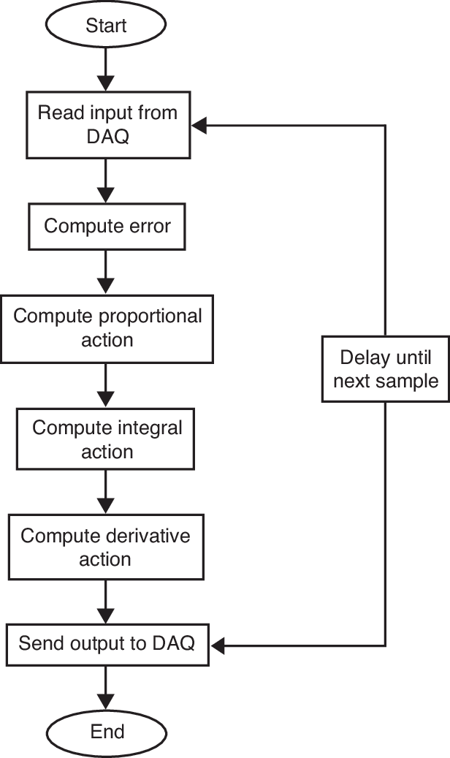

6. Optimum way to tune a PID controller

The optimum way to tune a PID controller is to built a PID controller in Simulink/MATLAB to adjust the values of P, I, D parameters and to check the performance of controller, and generally, P and D parameters affect a lot to the system. So, if you can establish the equations of the system, it could be a useful way to obtain the optimal parameters of PID controller.

7. References

1.Wikipedia,

2.PID controller working working flow chat downloaded from(https://www.researchgate.net/figure/Flow-chart-for-the-PID-controller-system_fig2_284724963)