

A Minor Project Report

On

**GARBAGE MANAGEMENT SYSTEM USING IOT**

Submitted on partial fulfilment of requirements for the award of the

Degree of

**BACHELOR OF ENGINEERING**

in

**COMPUTER SCIENCE AND ENGINEERING**

Under the guidance of

**Dr. P. PANDIARAJ , Assistant professor/CSE**

Submitted by

GOBALA KRISHNAN.G (927621BCS032)

AJAI.R (927621BCS301)

GOBI.V (927621BCS303)

KAVINRAJ (927621BCS304)

**DEPARTMENT OF COMPUTER SCIENCE AND ENGINEERING**

**M.KUMARASAMY COLLEGE OF ENGINEERING**

(Autonomous)

**KARUR-639 113**

APRIL 2023



**M.KUMARASAMY COLLEGE OF ENGINEERING**

(Autonomous Institution affiliated to Anna University, Chennai)  **KARUR-639 113**

**BONAFIDE CERTIFICATE**

Certified that this minor project report **“Garbage Management System Using**

**IoT”** is the bonafide work of **“GOBALA KRISHNAN.G (92721BCS032),**

**AJAY.R (92721BCS301), GOBI.V (92721BCS303),**

**KAVINRAJ.N(92721BCS304)”** who carried out the project work during the academic year 2022-2023 under my supervision.

Signature Signature

**Dr.P.PANDIARAJA M..E.,Ph.D.,** **Dr.M.MURUGAESAN M.E.,Ph.D.,**

**SUPERVISOR, HEAD OF THE DEPARTMENT,**

Department of Computer Science Department of Computer Science and Engineering,  and Engineering,

M. Kumarasamy College of M. Kumarasamy College of

Engineering**,**  Engineering,

Thalavapalayam, Karur-639 113. Thalavapalayam, Karur-639 113.



**DEPARTMENT OF COMPUTER SCIENCE AND ENGINEERING**

**VISION OF THE INSTITUTION**

To emerge as a leader among the top institutions in the field of technical education

# MISSION OF THE INSTITUTION

* Produce smart technocrats with empirical knowledge who can surmount the global challenges.
* Create a diverse, fully-engaged, learner-centric campus environment to provide quality education to the students.
* Maintain mutually beneficial partnerships with our alumni, industry, and Professional associations

# VISION OF THE DEPARTMENT

To achieve education and research excellence in Computer Science and Engineering

# MISSION OF THE DEPARTMENT

* To excel in academic through effective teaching learning techniques
* To promote research in the area of computer science and engineering with the focus on innovation
* To transform students into technically competent professionals with societal and ethical responsibilities.

# PROGRAM EDUCATIONAL OBJECTIVES (PEOs)

**PEO 1:** Graduates will have successful career in software industries and R&D divisions through continuous learning.

**PEO 2:** Graduates will provide effective solutions for real world problems in the key domain of computer science and engineering and engage in lifelong learning.

**PEO 3:** Graduates will excel in their profession by being ethically and socially responsible

# PROGRAM OUTCOMES (POs)

Engineering students will be able to:

1. **Engineering knowledge:** Apply the knowledge of mathematics, science, engineering fundamentals, and an engineering specialization to the solution of complex engineering problems.
2. **Problem analysis:** Identify, formulate, review research literature, and analyze complex engineering problems reaching substantiated conclusions using first principles of mathematics, natural sciences, and engineering sciences.
3. **Design/development of solutions:** Design solutions for complex engineering problems and design system components or processes that meet the specified needs with appropriate consideration for the public health and safety, and the cultural, societal, and environmental considerations.
4. **Conduct investigations of complex problems:** Use research-based knowledge and research methods including design of experiments, analysis and interpretation of data, and synthesis of the information to provide valid conclusions.
5. **Modern tool usage:** Create, select, and apply appropriate techniques, resources, and modern engineering and IT tools including prediction and modeling to complex engineering activities with an understanding of the limitations.
6. **The engineer and society:** Apply reasoning informed by the contextual knowledge to assess societal, health, safety, legal and cultural issues and the consequent responsibilities relevant to the professional engineering practice.
7. **Environment and sustainability:** Understand the impact of the professional engineering solutions in societal and environmental contexts, and demonstrate the knowledge of and need for sustainable development.
8. **Ethics:** Apply ethical principles and commit to professional ethics and responsibilities and norms of the engineering practice.
9. **Individual and team work:** Function effectively as an individual, and as a member or leader in diverse teams, and in multidisciplinary settings.
10. **Communication:** Communicate effectively on complex engineering activities with the engineering community and with society at large, such as, being able to comprehend and write effective reports and design documentation, make effective presentations, and give and receive clear instructions.
11. **Project management and finance:** Demonstrate knowledge and understanding of the engineering and management principles and apply these to one’s own work, as a member and leader in a team, to manage projects and in multidisciplinary environments.
12. **Life-long learning:** Recognize the need for, and have the preparation and ability to engage in independent and life-long learning in the broadest context of technological change.

# PROGRAM SPECIFIC OUTCOMES (PSOs)

**PSO1: Professional Skills:** Ability to apply the knowledge of computing techniques to design and develop computerized solutions for the problems.

**PSO2: Successful career:** Ability to utilize the computing skills and ethical values in creating a successful career.

**ABSTRACT**

The IoT Garbage Management System is an intelligent solution for efficient and effective waste management. It utilizes sensors, IoT technology, and real-time monitoring to track the fill level of garbage bins and alert waste management services when bins require attention. This system aims to reduce waste overflow, improve collection efficiency, and enhance overall waste management processes. By implementing the IoT Garbage Management System





**ABSTRACT WITH PO AND PSO MAPPING**

|  |  |  |
| --- | --- | --- |
| **ABSTRACT** | **POs MAPPED** | **PSOs**  **MAPPED** |
| The IoT Garbage Management System is an intelligent solution for efficient and effective waste management. It utilizes sensors, IoT technology, and real-time monitoring to track the fill level of garbage bins and alert waste management services when bins require attention. This system aims to reduce waste overflow, improve collection efficiency, and enhance overall waste management processes. By implementing the IoT Garbage Management System, cities and communities can reduce waste-related costs, promote sustainable waste practices, and enhance overall public hygiene. | PO1(3)  PO2(3)  PO3(2)  PO4(2)  PO5(2)  PO6(1)  PO7(3)  PO8(2)  PO9(3)  PO10(3)  PO11(2)  PO12(2) | PSO 1(3)  PSO 2(2) |

Note:1-Low, 2-medium, 3-High

**SUPERVISOR HEAD OF THE DEPARTMENT** **LIST OF CONTENTS**

**CHAPTER No. TITLE PAGE No.**

**Abstract vi**

**List of Figures ix**

**Acronyms/List of Abbreviation** **x**

**Introduction 1**

* 1. Overview 2
  2. Domain introduction 3
  3. Problem Statement 4
  4. Objective 5

**Literature Survey 6**

**Feasibility Study 7**

**Project Methodology 8**

* 1. Block diagram 8
  2. Module Description 10

**Result and Discussion 12**

**Conclusion Future Work 13**

**References 14**

**Appendix I-Coding 15**

**LIST OF FIGURES**

**FIGURE No. TITLE PAGE No.**

1

1.1 Garbage Management System

8

* 1. Block diagram
  2. Circuit diagram of sensing module 9

12

5.1 Implementation of garbage management

**ACRONYMS**

IDE - Integrated Development Environment

GPS - Global Positioning System

MCU - Micro Controller Unit

GSM - Global System Mobile communication

**CHAPTER 1**

## INTRODUCTION

This chapter discussed and describe selected paper and previous journal that trace a similar technique and topics that can be referenced for the Garbage Management System using IOT. This chapter also provides research based on the similar existing system, similar sensors used and IOT board that can be a guideline or a sample to upgrade or to develop a new better system compared the existing system.

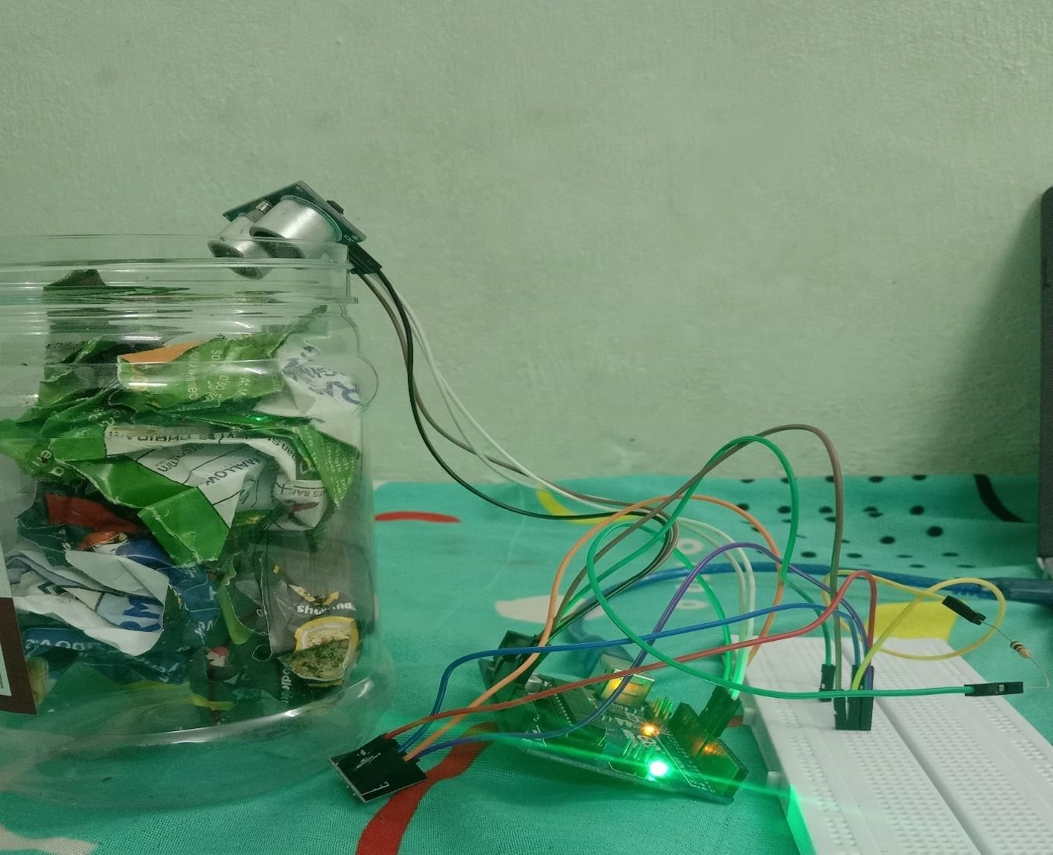

Figure: 1.1 Garbage Management system

**1.1 OVERVIEW**

A Garbage management system is project that use technology to keep track the level of garbage in particular area and navigating and it also has the GPS tracker have alert message when the garbage is full and the alert message.

**1.2 DOMAIN INTRODUCTION**

We developed the blind stick with help of IoT to track the location of the bind people. Internet of Things (IoT) is the networking of physical objects that contain electronics embedded within their architecture in order to communicate and sense interactions amongst each other or with respect to the external environment. In the upcoming years, IoT-based technology will offer advanced levels of services and practically change the way people lead their daily lives. Advancements in medicine, power, gene therapies, agriculture, smart cities, and smart homes are just a very few of the categorical examples where IoT is strongly established. IoT systems send massive data from devices, and this data needs to be managed efficiently to generate meaningful output. To store this huge amount of data, the IoT cloud is used. It provides tools to collect, process, and store data. Data is readily available and remotely accessible through the internet. It also provides a platform for analytics

Arduino board designs use a variety of microprocessors and controllers. The boards are equipped with sets of digital and serial input/output (I/O) pins that may be interfaced to various expansion boards ('shields') or breadboards (for 4 prototyping) and other circuits. The boards feature serial communications interfaces, including Universal Serial Bus (USB) on some models, which are also used for loading programs. The microcontrollers can be programmed using the C and C++ programming languages, using a standard API which is also known as the Arduino language, inspired by the Processing language and used with a modified version of the Processing IDE. In this project we use C++ language, C++ is a cross-platform language that can be used to create high-performance applications. C++ gives programmers a high level of control over system resources and memory.

**1.3 PROBLEM STATEMENT**

There are several problems with the current existing system that are being identified. This will reflect the need for a new efficient system for monitoring and manage the garbage. The problems are listed as below:

1. Current garbage collection is inefficient, time waste and required a huge amount of human energy.
2. It will create an unhygienic condition for surrounding environment

and creates bad smell which can lead to spread some deadly disease.

**1.4 OBJECTIVE**

The main aim is to make new technology easier to use identify the level of garbage. Our objectives is to make a smart garbage management with alerting ability and connected with the IoT to help managing the garbage. Updates the status of each dustbin on the municipal. Help to reduce the environmental impact of garbage disposal.

* + - To identify level of the garbage and maintain the level.
    - To avoid the overflow of the garbage.
    - Sent alert message to information about garbage when it is full.

**CHAPTER 2**

## LITERATURE SURVEY

The characteristics and composition of the urban waste i.e. sewage and municipal solid waste was studied by various workers in the world. Literature shows evidence of the work carried out on the health risk assessment due to urban waste. The impact of urbanization on the water quality as well as soil quality was also studied by various researchers in the different parts of the world.

At International level, there are various organizations including private and government which are working in the field of environment and are engaged in research and development in the field of waste management. The international agencies like World Health Organization (WHO), Environmental Protection Agency (EPA) and United Nations Environment Program (UNEP) are engaged in developing new technologies for waste management and its disposal including its characterization.

Management of Municipal Solid Waste for various cities and towns has been widely studied throughout the world. As the huge quantities of solid waste generated in the urban areas is the major problem, the majority of researchers concentrated on this issue. Numbers of researchers have tried to find out new techniques for solid waste management. Mahar et.al., 2007[1] reported the review and analysis of solid waste management situations in urban areas of Pakistan. According to him poor solid waste management is one of the major causes for environmental degradation in Pakistan. According to Rajput et.al., 2009[2], municipal firm squander production displayed divergent fashion and a beneficial Page | 8 parallel with monetary development in expression of kg/capita/day firm waste production at humanity weighing machine.

**CHAPTER 3**

## FEASIBILITY STUDY

1. **Idea**

We design our project "GARBAGE MANAGEMENT SYSTEM" using

C++ language and IoT devices with help of Arduino controller and Arduino IDE.

1. **Economic Feasibility:**

There is very important aspect to be consider while developing of project. we decided to the technology based on minimum possible cost factor.

1. **Technical Feasibility:**

This includes the study of functions, performance and efficiency and the ability to process the raw data by the micro-controller units. The various input and output characteristics of the boards based on their performance have been studied.

1. **Documentation:**

The documentation is completed after getting approval of supervisor.

**CHAPTER 4**

## PROJECT METHODOLOGY

**4.1 BLOCK DIAGRAM**

We are using the concept of IoT (Internet of things) for implementing the garbage monitoring in the society. The device will send it’s exact location coordinates, with an alert message to the concerned person for getting clean as soon as possible. We have built by using three main hardware components that is GSM module, GPS module, Arduino Uno.



**Satlite**



**Arduino**



**GPS**

**Module**



**Power**

**Supply**



**Mobile**

**Phone**



**Ultra Sonic**

Figure 4.1 Block diagram

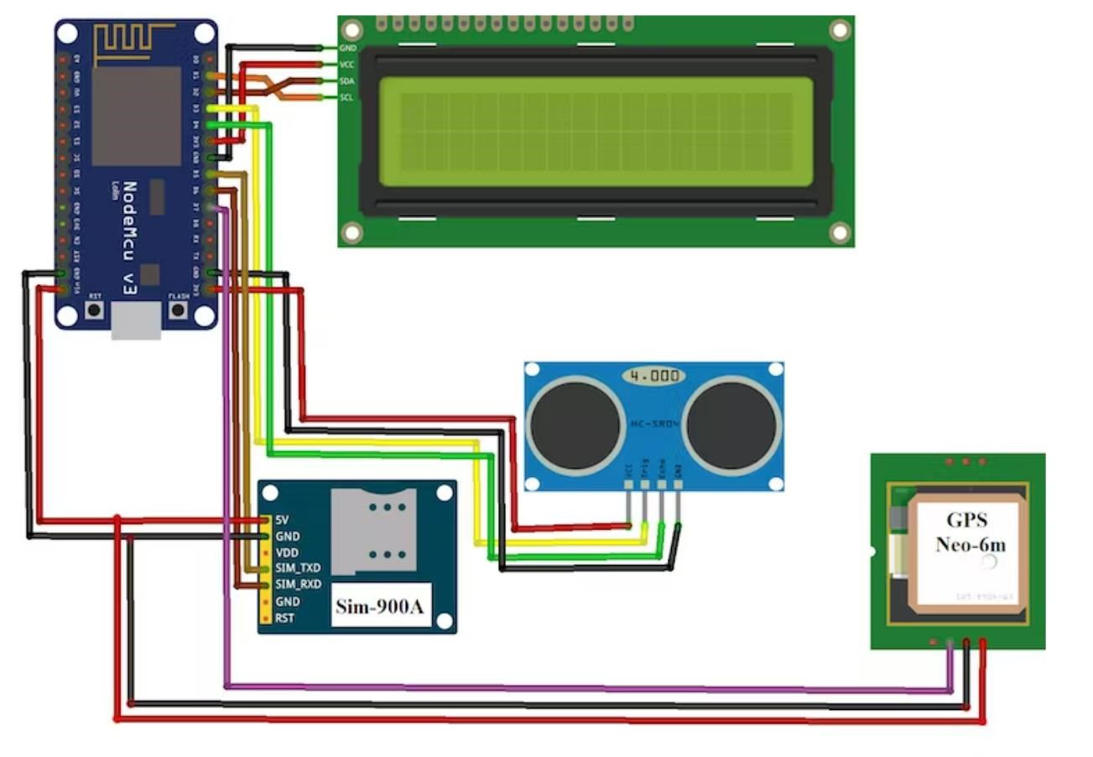

Figure 4.2 Circuit diagram of sensing module

## 4.2 MODULE DESCRIPTION

**1.Sensing module:**

**Objective:**

To detect the level of the garbage with help of ultrasonic sensor.

**Methodology used:**

In ultrasonic sensor radar method used by sending frequency waves more than 20,000Hz and reflected waves from the object or taken as reading to calculate.

**Merits:**

* The components are cheaper and cost efficient.
* They give very accurate value and more sensitive.

**Demerits:**

* They consume more power
* They do not have very good life time.

**2.Processing module:**

**Objective:**

To process the raw data fetched from the ultrasonic sensors and these data has been with help of the Arduino board and Arduino IDE.

**Methodology used:**

The formulas for processing the raw data have been dumped into the board by using USB cable in C++ language with help of Arduino IDE and the processed data has been sent and after processing data.

**Merits:**

* Can be used for any type of project implementation.
* Low cost and consumes less power.
* With multiple input and output.

**3. GPS module:**

**Objective:**

This GPS module is used to track the position of the dustbin that is it is used to find the particular latitude and longitude of the garbage and where it’s is locating and it the information is transferred to the particular authoritarian with the help of GSM module.

**Merits:**

○ GPS are often used anywhere within world, it’s powered by world satellites, so it is often accessed anywhere, a solid tracking system and a GPS receiver are all you would like**.**

**Demerits:**

Sometimes GPS signals aren’t accurate thanks to some obstacles to signals like extreme atmospheric conditions like geomagnetic storms.

**CHAPTER 5**

**RESULTS AND DISCUSSION**

Figure 5.1 Implementation of garbage management

The above image deals with implementation of ultrasonic sensor and GPS module. It gives the alert when the dustbin is filed or empty and so on. It also has the embedded GPS module paired with IoT to get alert in the way message. The use of ultrasonic sensor gives better reliability when compared to the other sensors like IR sensors. Thus, the project has been successfully completed with help of our guide.

**CHAPTER 6**

## CONCLUTION AND FUTURE WORKES

**CONCLUSION**

The “Garbage Management system” is developed with help of IoT and Arduino IDE has been developed to avoid the overflow of dustbin in roads and streets by notifying the collector via an SMS and give the precise location. The system provides an efficient and effective way of garbage collection.

**FUTURE WORKES**

* Inclusion of the control room will effectively help monitor the garbage level from the Central Office.
* Integrating the system with an application based website to have an exact location on the map.

REFERENS

1. Pratik N, Poornesh V, Shashikant3, Shreedhar Kudva& Saritha N (2015) SMART BLIND STICK. International Journal of Latest Trends in Engineering and Technology.

1. Smart Blind Stick For Visually Impaired People With Live Monitoring Shruti Desai, Mrunali Bichukale, Shraddha Kamthe, Archana Borate, AG.Nadaph.

1. B.Vijaylashmi, Renuka.S, PoojaChennur, Sharangowda.Patil. “SELF

DEFENSE SYSTEM FOR SAFETY WITH LOCATION TRACKING AND SMS ALERTING THROUGH GSM

NETWORK” International Journal Research in Engineering and Technology (IJARTET), 2015 May.

1. Zul Azizi Hailani, Sakinah Jamaludin, “An Electronically Guided Walking Stick For The Blind” University Tenaga Nasional, Malaysia.

1. Ann Mary Thomas, Annu Reji Philip, Tessy Elsa Peter, and Er R P

Nishanth, "Dust Bin Monitoring System," International Journal of Advanced Research in Computer and Communication

Engineering.Vol. 5, Issue 3, March 2016, pp. 1063-1065, 2016.

1. H Kasliwal Manasi and B Suryawanshi Smitkumar, "A Novel Approach to Garbage Management Using Internet of Things for Smart Cities," International Journal of Current Trends in Engineering & Research (IJCTER), e-ISSN 2455–1392 Volume 2 Issue 5, pp. 348 – 353, 2016.

**Appendix I-Coding**

**Sensing Module:**

|  |
| --- |
| //Prateek  //www.prateeks.in    #define BLYNK_PRINT Serial  #include <Ultrasonic.h>    #include <SPI.h>  #include <WiFi101.h>  #include <BlynkSimpleMKR1000.h>    // You should get Auth Token in the Blynk App. // Go to the Project Settings (nut icon). char auth[] = "hftydytfuygiuguyfytced9";    // Your WiFi credentials.  // Set password to "" for open networks. char ssid[] = "justdo"; char pass[] = "phuhbjjnk";    BlynkTimer timer; int distance = 0;  int thresh[3] = {25, 50, 75};  Ultrasonic ultrasonic(12, 13);    WidgetLED green(V1);  WidgetLED orange(V2);  WidgetLED red(V3);    void setup()  {  // Debug console  Serial.begin(9600);  Blynk.begin(auth, ssid, pass);  //Blynk.begin(auth, ssid, pass, "blynk-cloud.com", 8442);  //Blynk.begin(auth, ssid, pass, IPAddress(192,168,1,100), 8442);  }  void loop()  {  distance = ultrasonic.distanceRead(); serial.println(distance); |
| Blynk.run();  if(distance<thresh[0]){ green.on();  } else if(distance<thresh[1]) green.on(); orange.on();  } else if(distance<thresh[2]) green.on(); orange.on(); red.on();  } else{ green.off(); orange.off(); red.off(); delay(100);  } |