CA-2

727721EUIT006-AJAI BALAAJI S B

1.

Create a Ec2 instance with server and keypair name as “ec2usecase2”

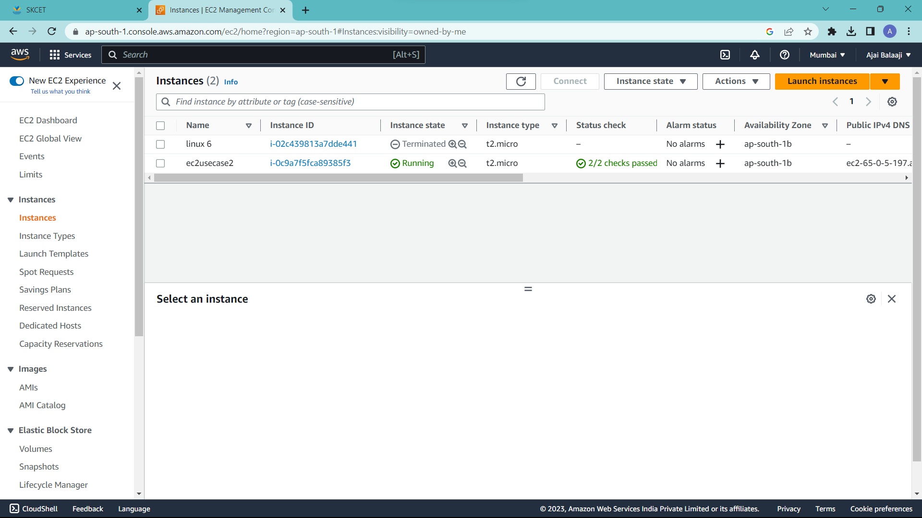

Select AMI from the linux OS platform

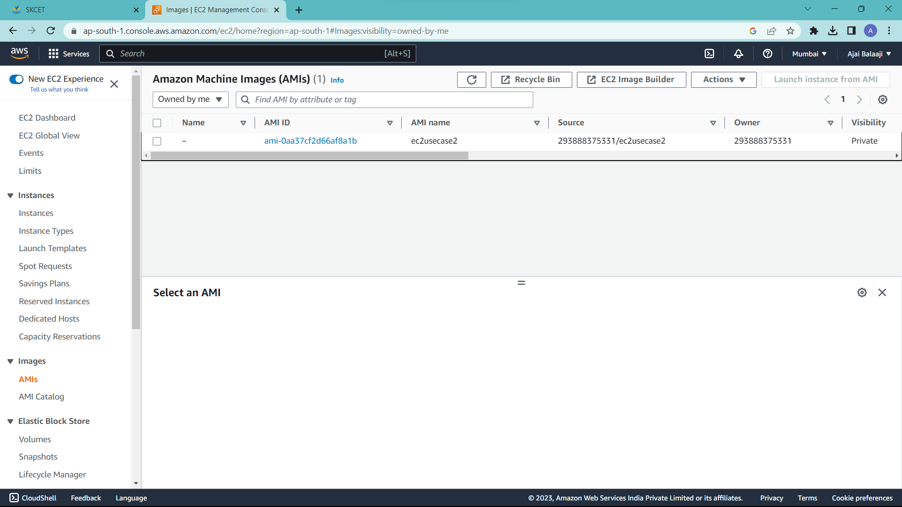

Increase the root EBS volume size to 10GB

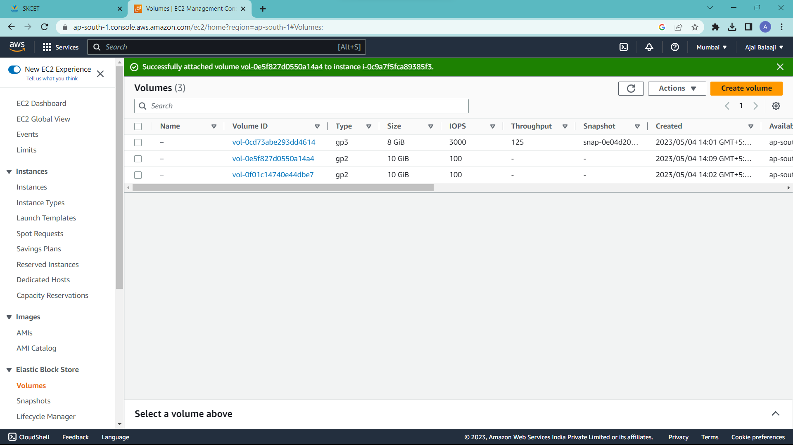

Expose Port No.22

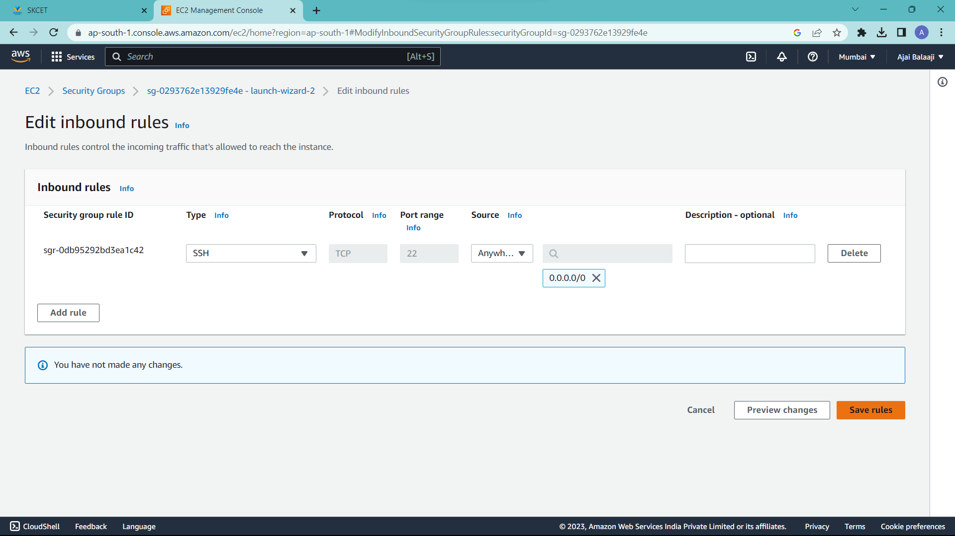

2.

Create EC2 instance with server and keypair name “ec2usecase1”.select windows os platform

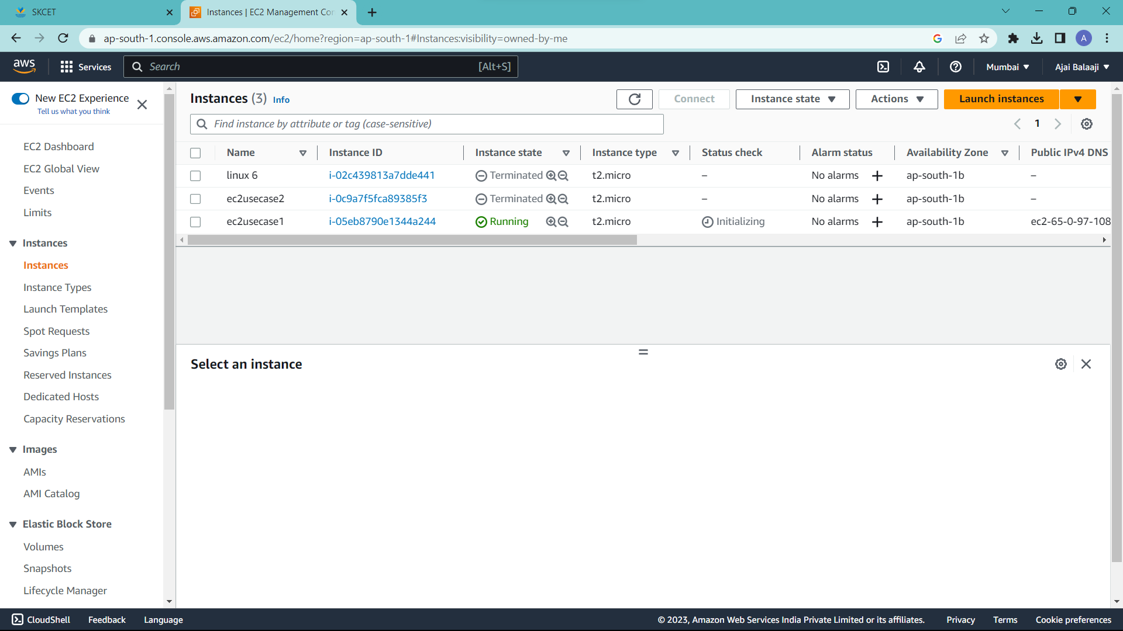

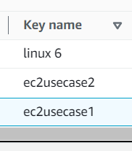

Ensure Auto assign public IP enabled

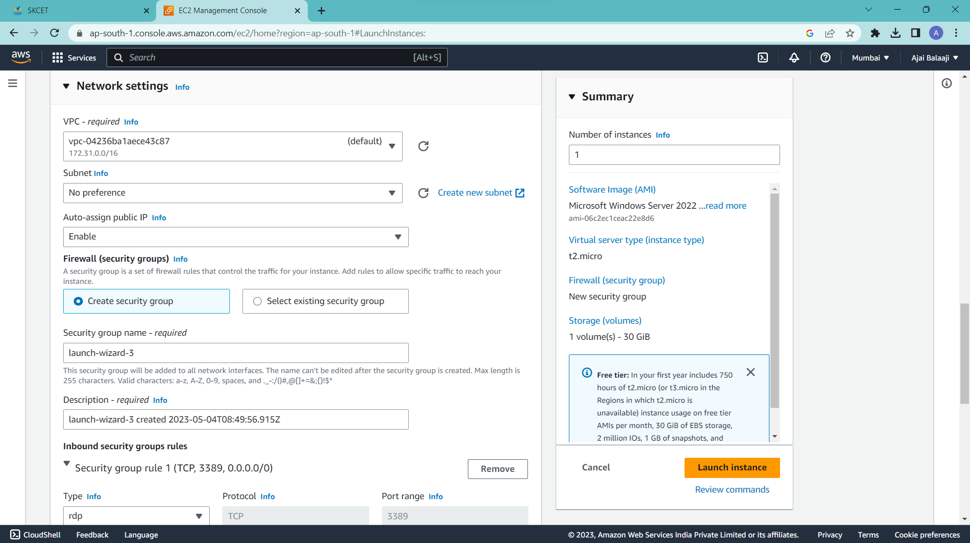

Expose port No.3389

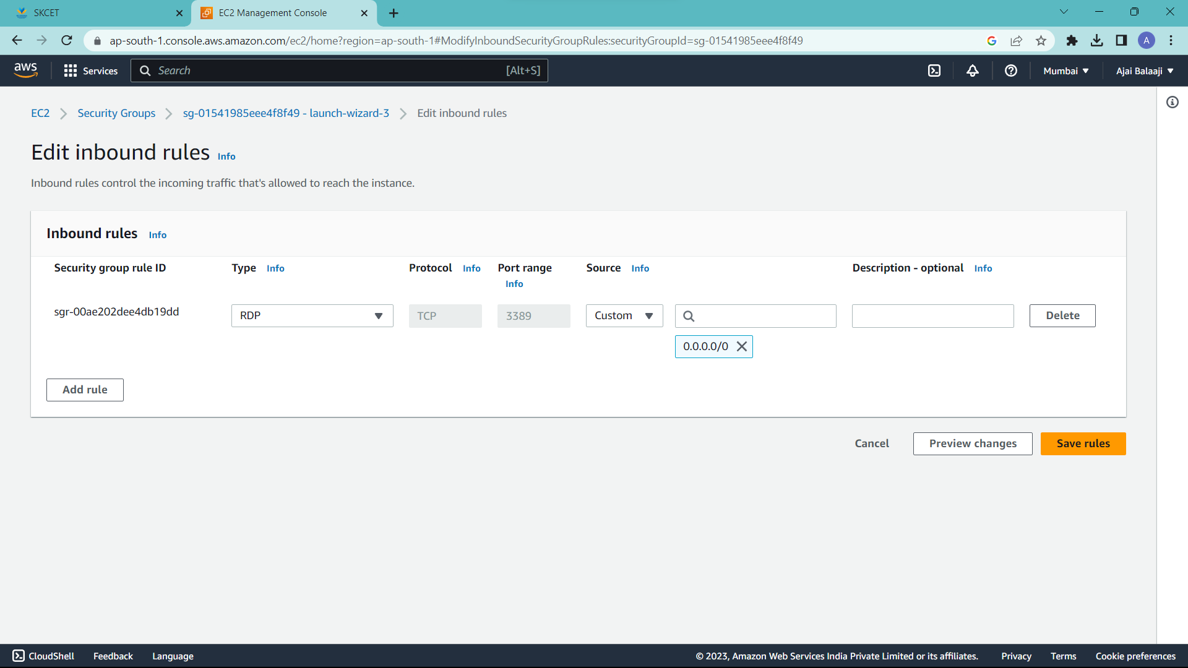

3.

Create a user group “EC2-Admins”

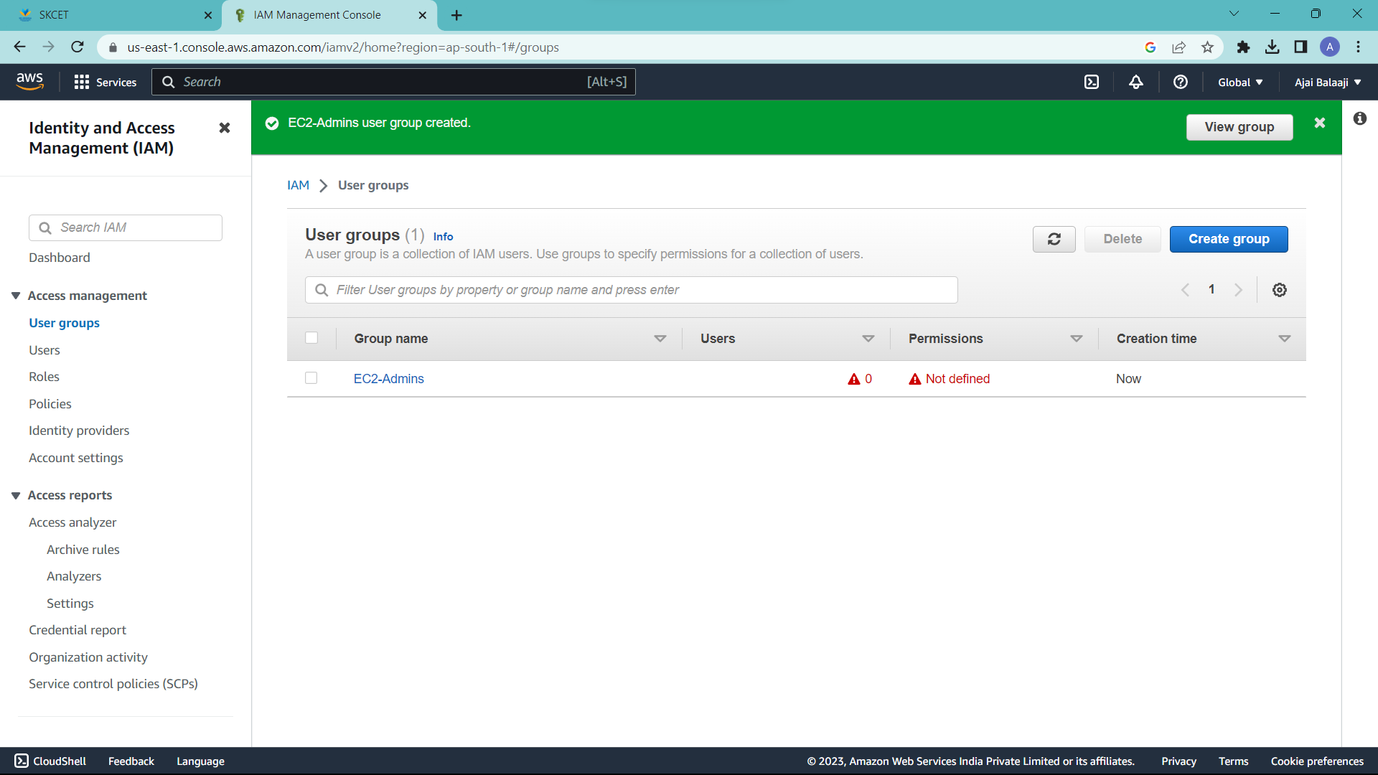

Create a user “EC2Admin1”

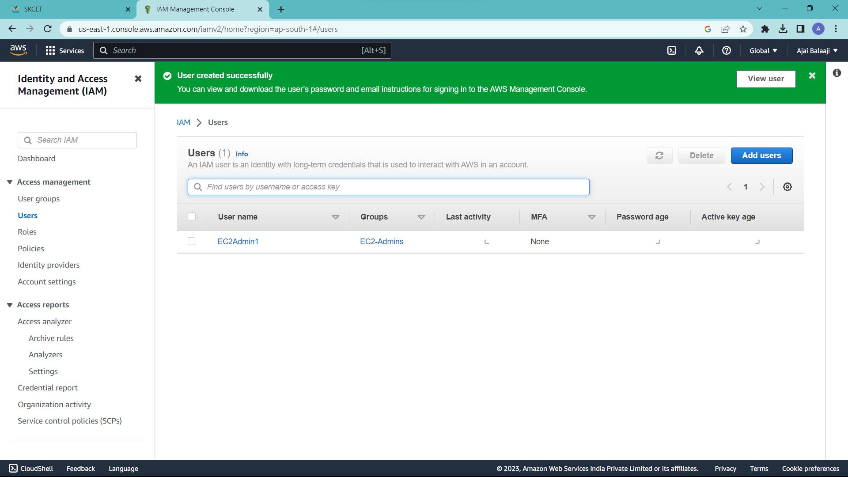

Add policy “AmazonEC2FullAccess”

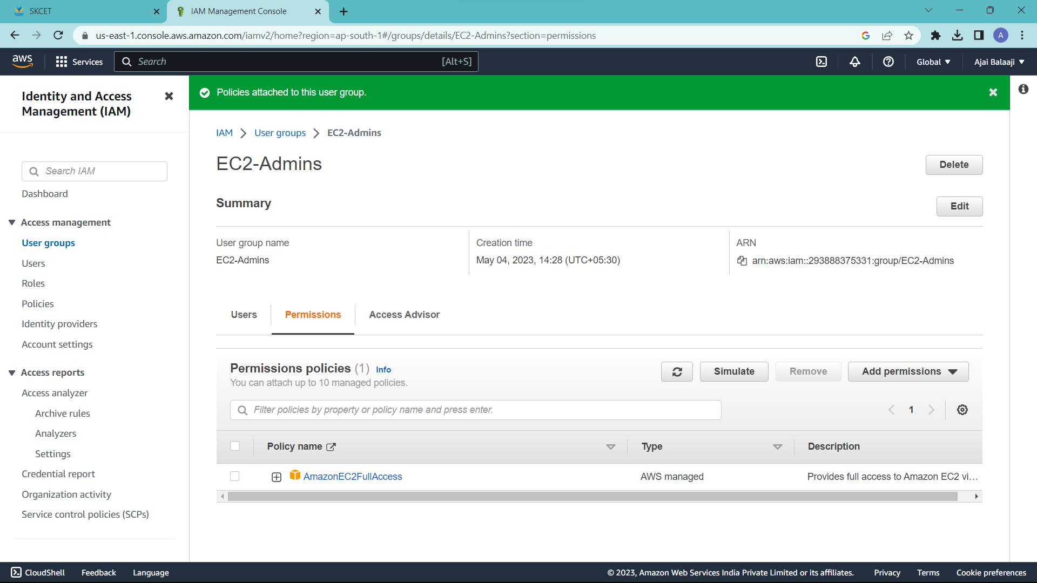

Then add another policy “AutoScalingFullAccess”

