**CC-1**

**AJAI BALAAJI S B**

**727721EUIT006**

[**727721euit006@skcet.ac.in**](mailto:727721euit006@skcet.ac.in)

**3.**

Create a S3 bucket in Stockholm region

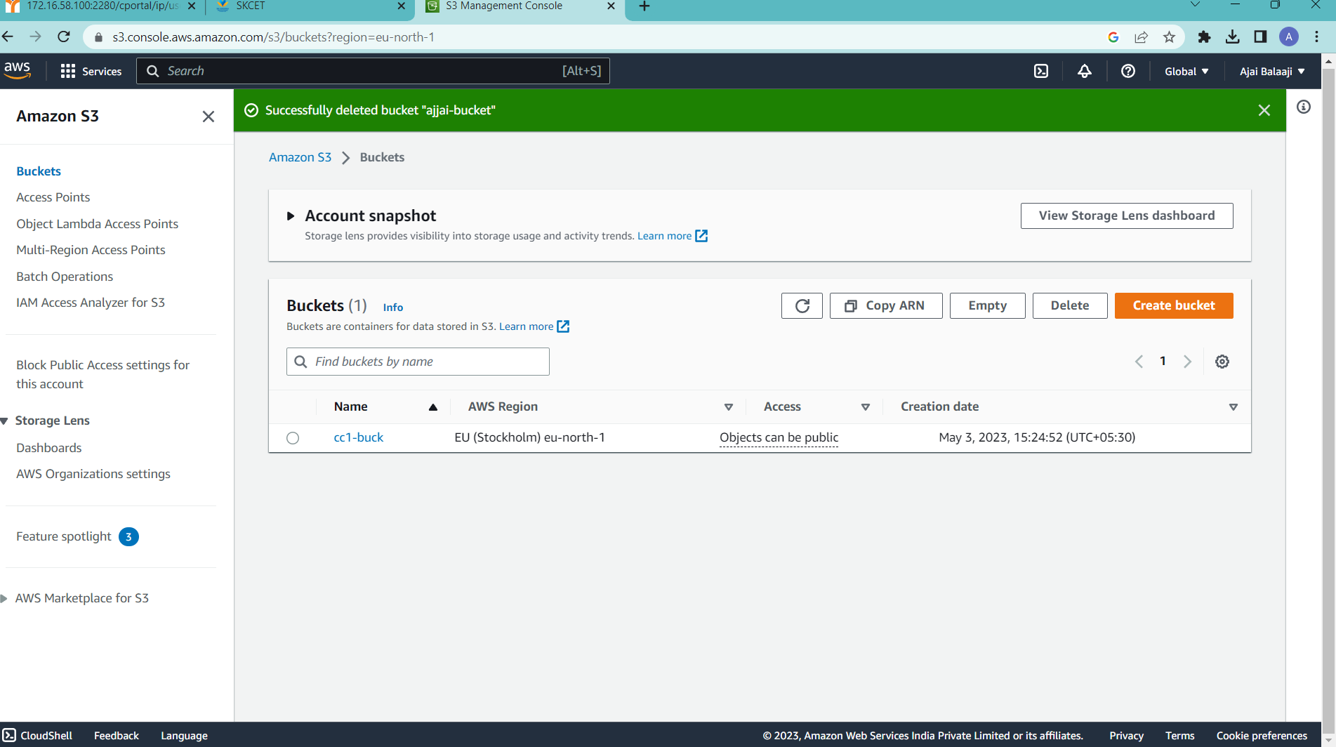

2.upload a file named “Accounts.txt”

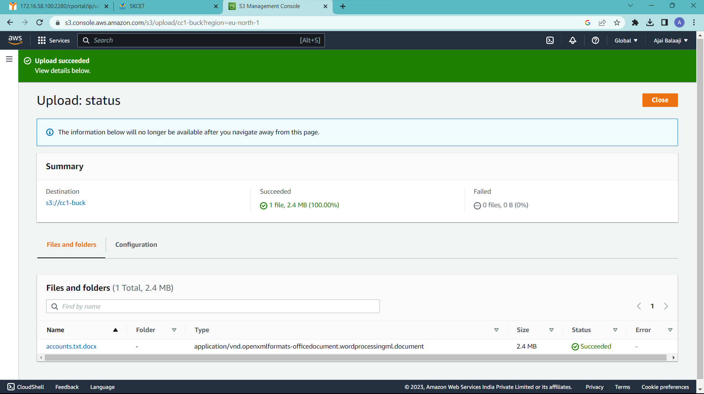

3.Access denied

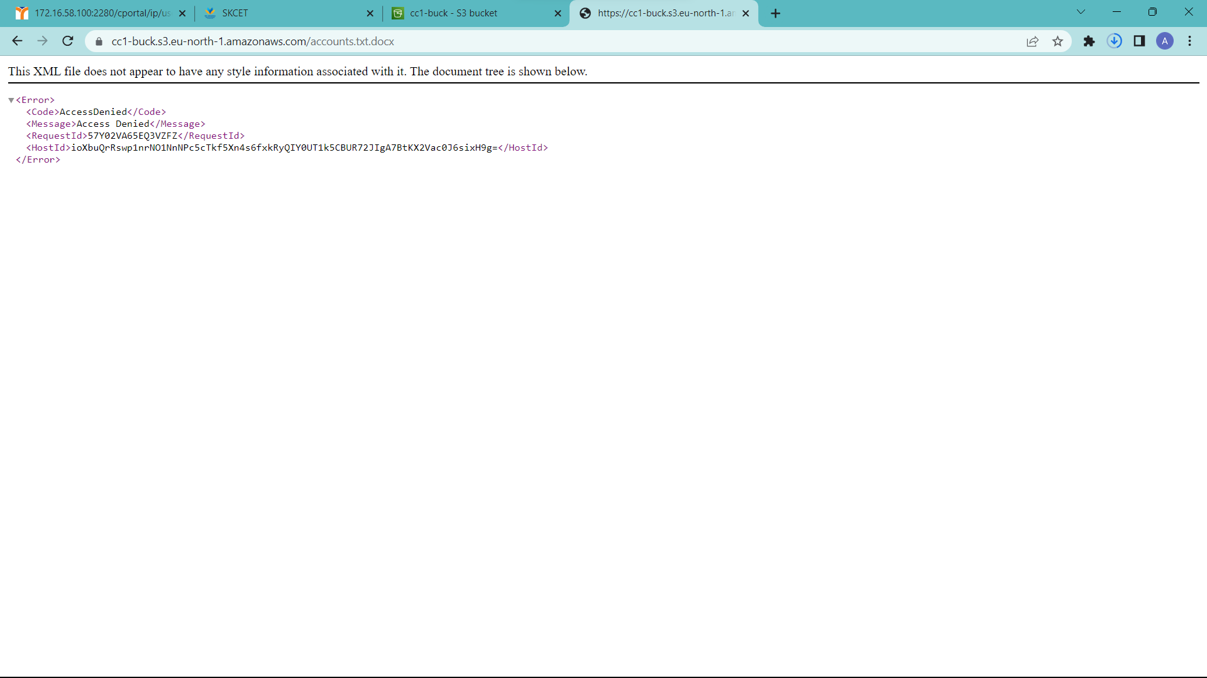

4.file made to access publicly

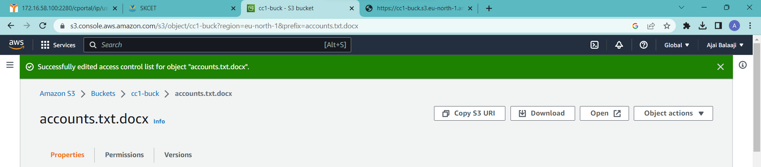

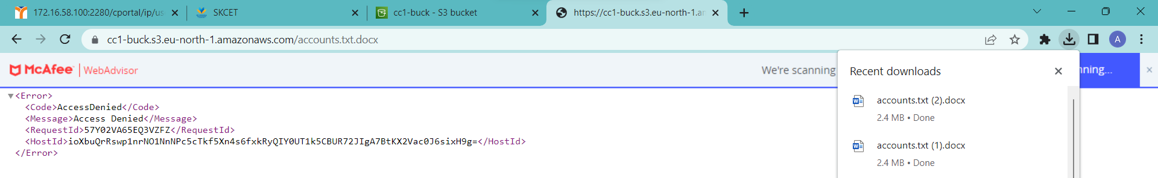

**1.**

Create an EC2 instance in us-east-1

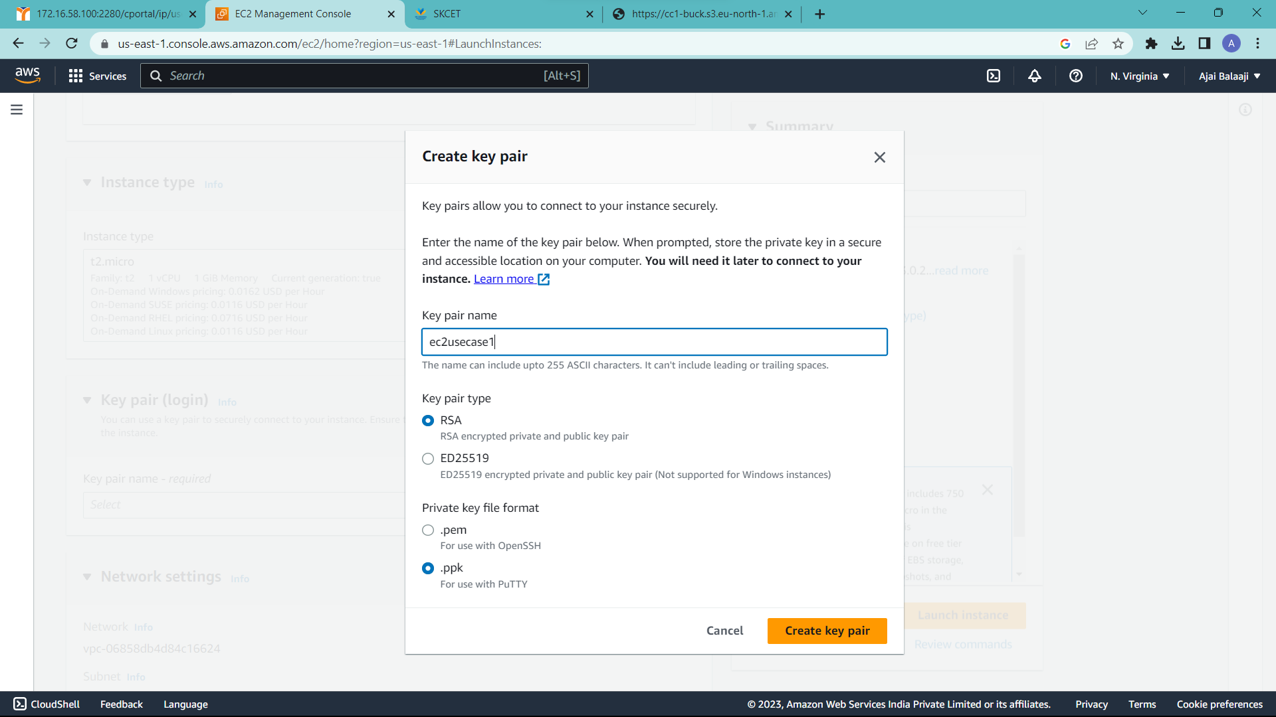

Allow Http and SSH traffic

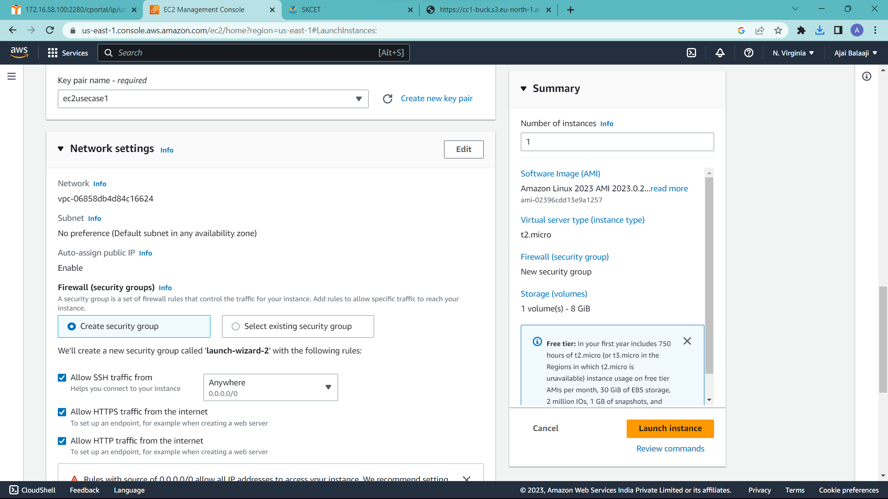

Create AMI named Amazonlinux 2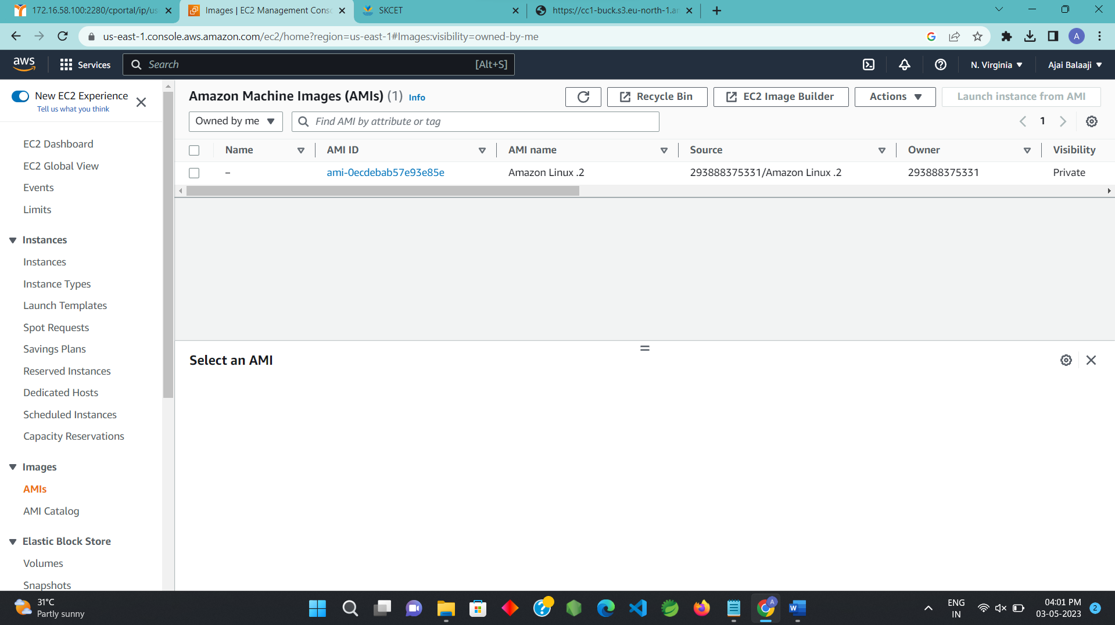

**2.**

Create user Network-L1-user1

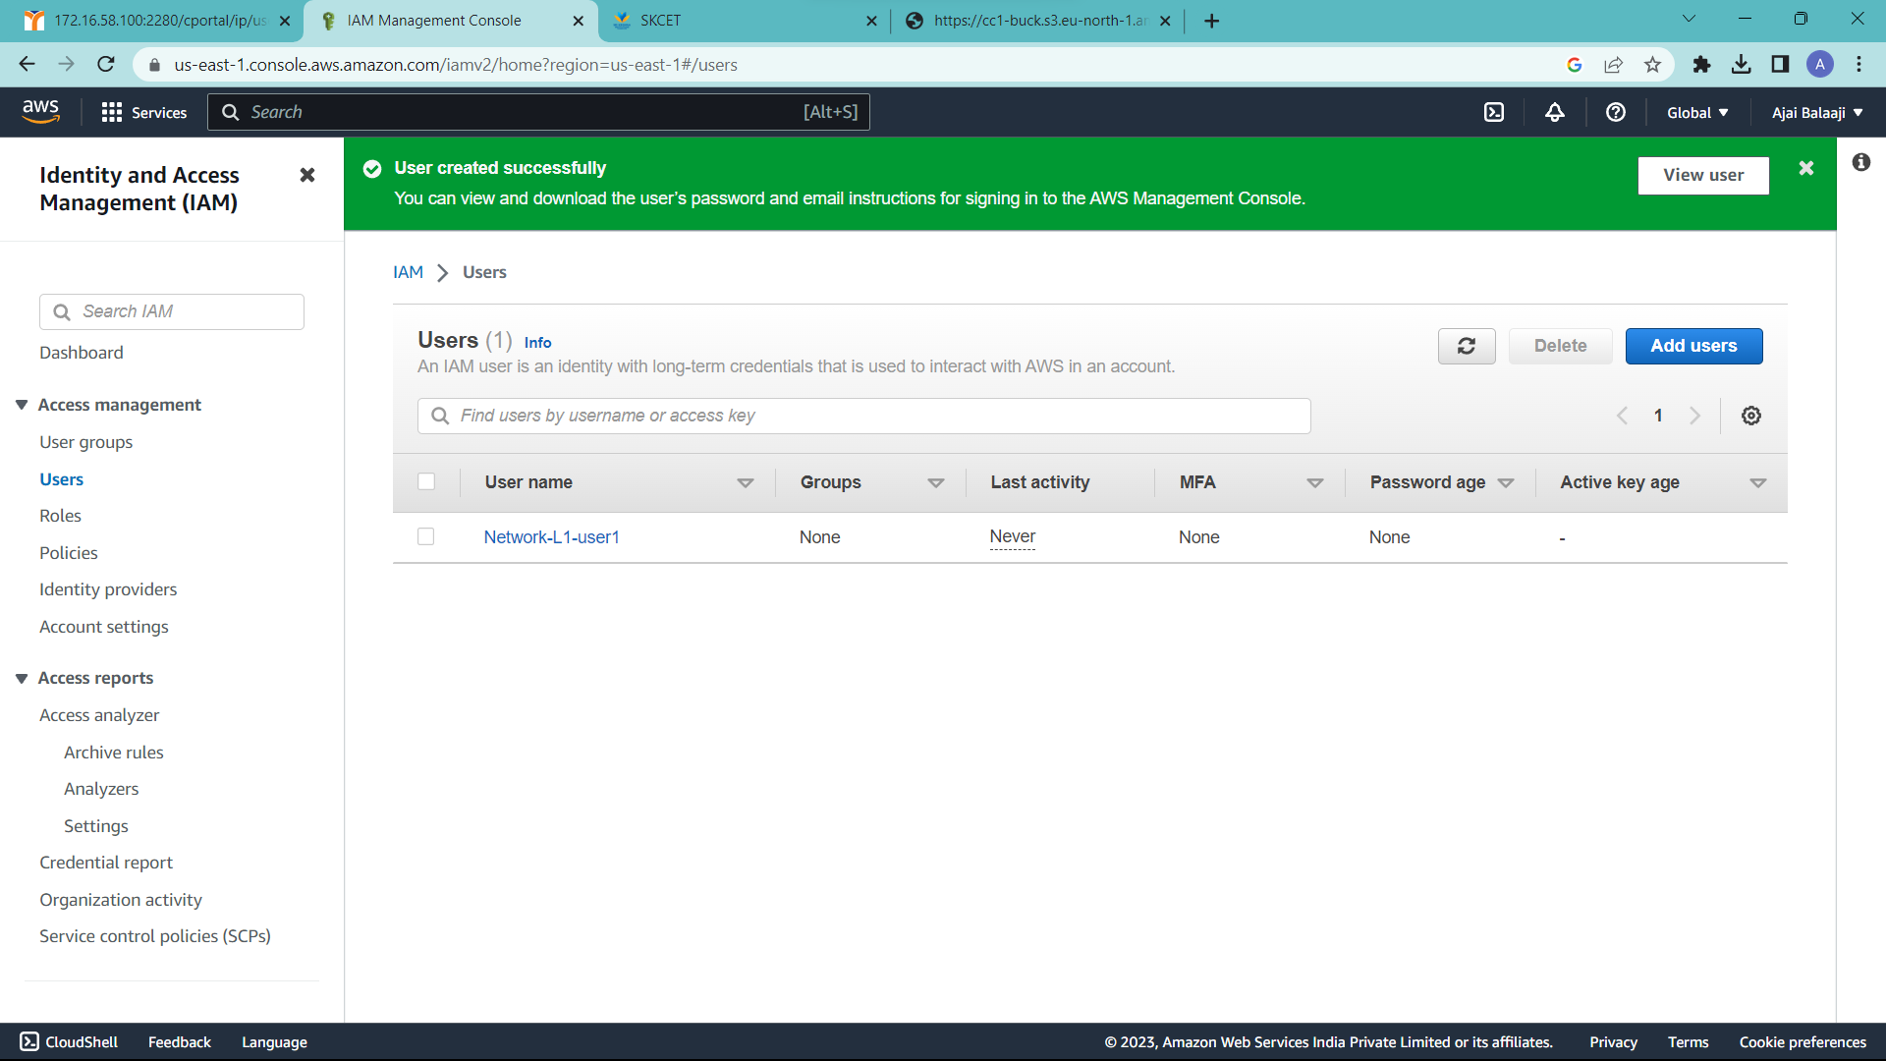

Create user group Network-L1-Team and attach policy AmazonVPCReadonlyAccess

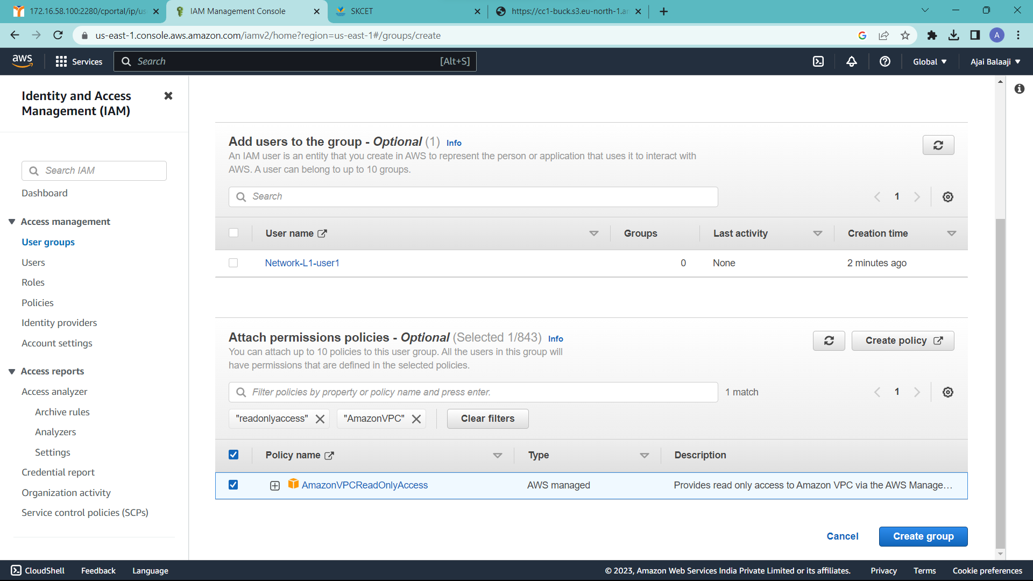

Attach AWSNetworkManagerReadOnlyAccess

