Ajai Balaaji S B

727721EUIT006

1.ADD TO CART

**package** com.selenium.test2.selenium1;

**import** org.openqa.selenium.By;

**import** org.openqa.selenium.WebDriver;

**import** org.openqa.selenium.WebElement;

**import** org.openqa.selenium.chrome.ChromeDriver;

**import** org.openqa.selenium.chrome.ChromeOptions;

**import** org.openqa.selenium.support.ui.Select;

**import** io.github.bonigarcia.wdm.WebDriverManager;

**public** **class** Ca1 {

**public** **static** **void** main( String[] args ) **throws** InterruptedException

{

WebDriverManager.*chromedriver*().setup();

ChromeOptions co=**new** ChromeOptions();

co.addArguments("--remote-allow-origins=*");

WebDriver driver=**new** ChromeDriver(co);

driver.manage().window().maximize();

driver.get("https://www.amazon.in/Nike-Mens-DD1649-All-Star-2021/dp/B08VS53KPH/ref=sr_1_2?crid=D9RQZP0EONDR&keywords=jordan+shoes+for+men&qid=1681292195&sprefix=jordan%2Caps%2C1089&sr=8-2");

driver.findElement(By.*id*("add-to-cart-button")).submit();

String t=driver.getTitle();

System.***out***.println(t);

String cart=driver.findElement(By.*xpath*("//*[@id=\"NATC_SMART_WAGON_CONF_MSG_SUCCESS\"]/span")).getText();

**if**(cart.equals("Added to cart"));

System.***out***.println("added to cart ");

driver.navigate().back();

WebElement sort1=driver.findElement(By.*xpath*("//*[@id=\"quantity\"]"));

sort1.click();

Select select=**new** Select(sort1);

select.selectByIndex(1);

String drop=driver.findElement(By.*xpath*("//*[@id=\"quantity\"]")).getText();

**if**(drop.equals("2"));

System.***out***.println("update");

}

}

DELETE

**package** com.selenium.test2.selenium1;

**import** org.openqa.selenium.By;

**import** org.openqa.selenium.WebDriver;

**import** org.openqa.selenium.chrome.ChromeDriver;

**import** org.openqa.selenium.chrome.ChromeOptions;

**import** io.github.bonigarcia.wdm.WebDriverManager;

**public** **class** delete {

**public** **static** **void** main( String[] args ) **throws** InterruptedException

{

WebDriverManager.*chromedriver*().setup();

ChromeOptions co=**new** ChromeOptions();

co.addArguments("--remote-allow-origins=*");

WebDriver driver=**new** ChromeDriver(co);

driver.manage().window().maximize();

driver.get("https://www.amazon.in/Nike-Mens-DD1649-All-Star-2021/dp/B08VS53KPH/ref=sr_1_2?crid=D9RQZP0EONDR&keywords=jordan+shoes+for+men&qid=1681292195&sprefix=jordan%2Caps%2C1089&sr=8-2");

driver.findElement(By.*id*("add-to-cart-button")).submit();

driver.get("https://www.amazon.in/gp/cart/view.html?ref_=nav_cart");

driver.findElement(By.*cssSelector*("[value='Delete']")).click();

String t=driver.getTitle();

System.***out***.println(t);

}

}

OUTPUT

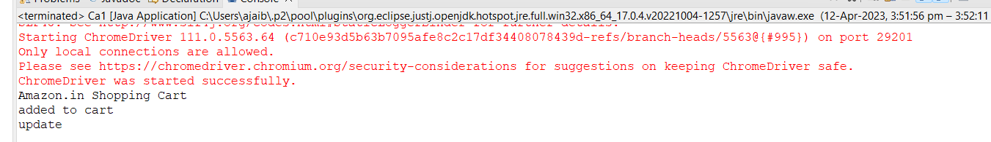

ADD TO CART

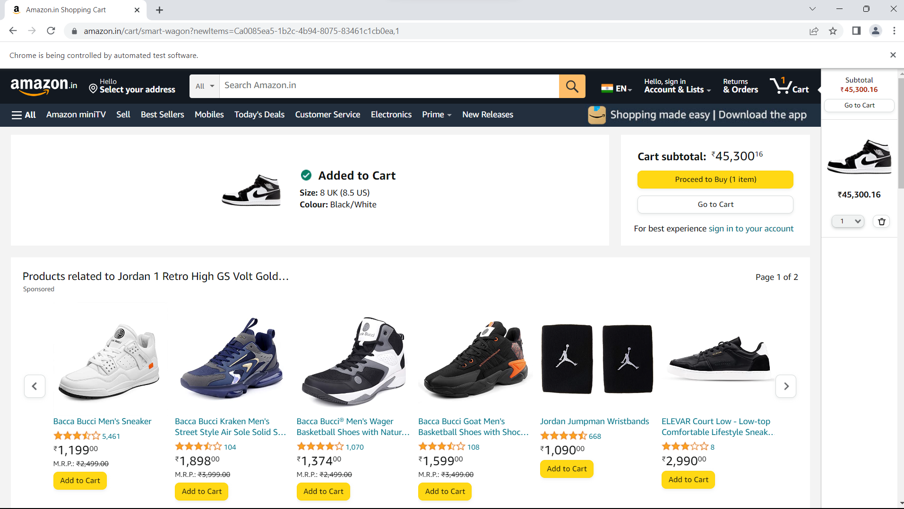

REMOVE

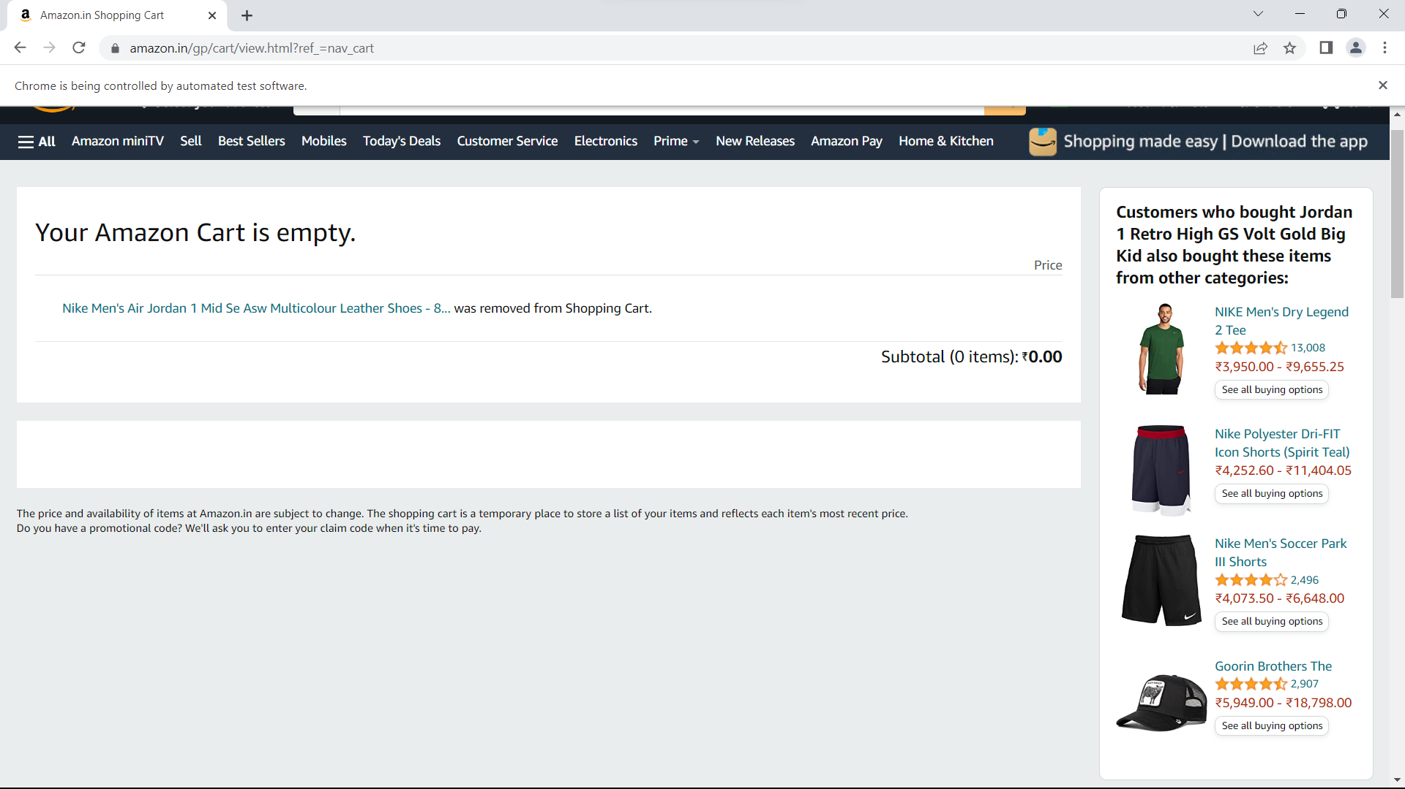

UPDATE

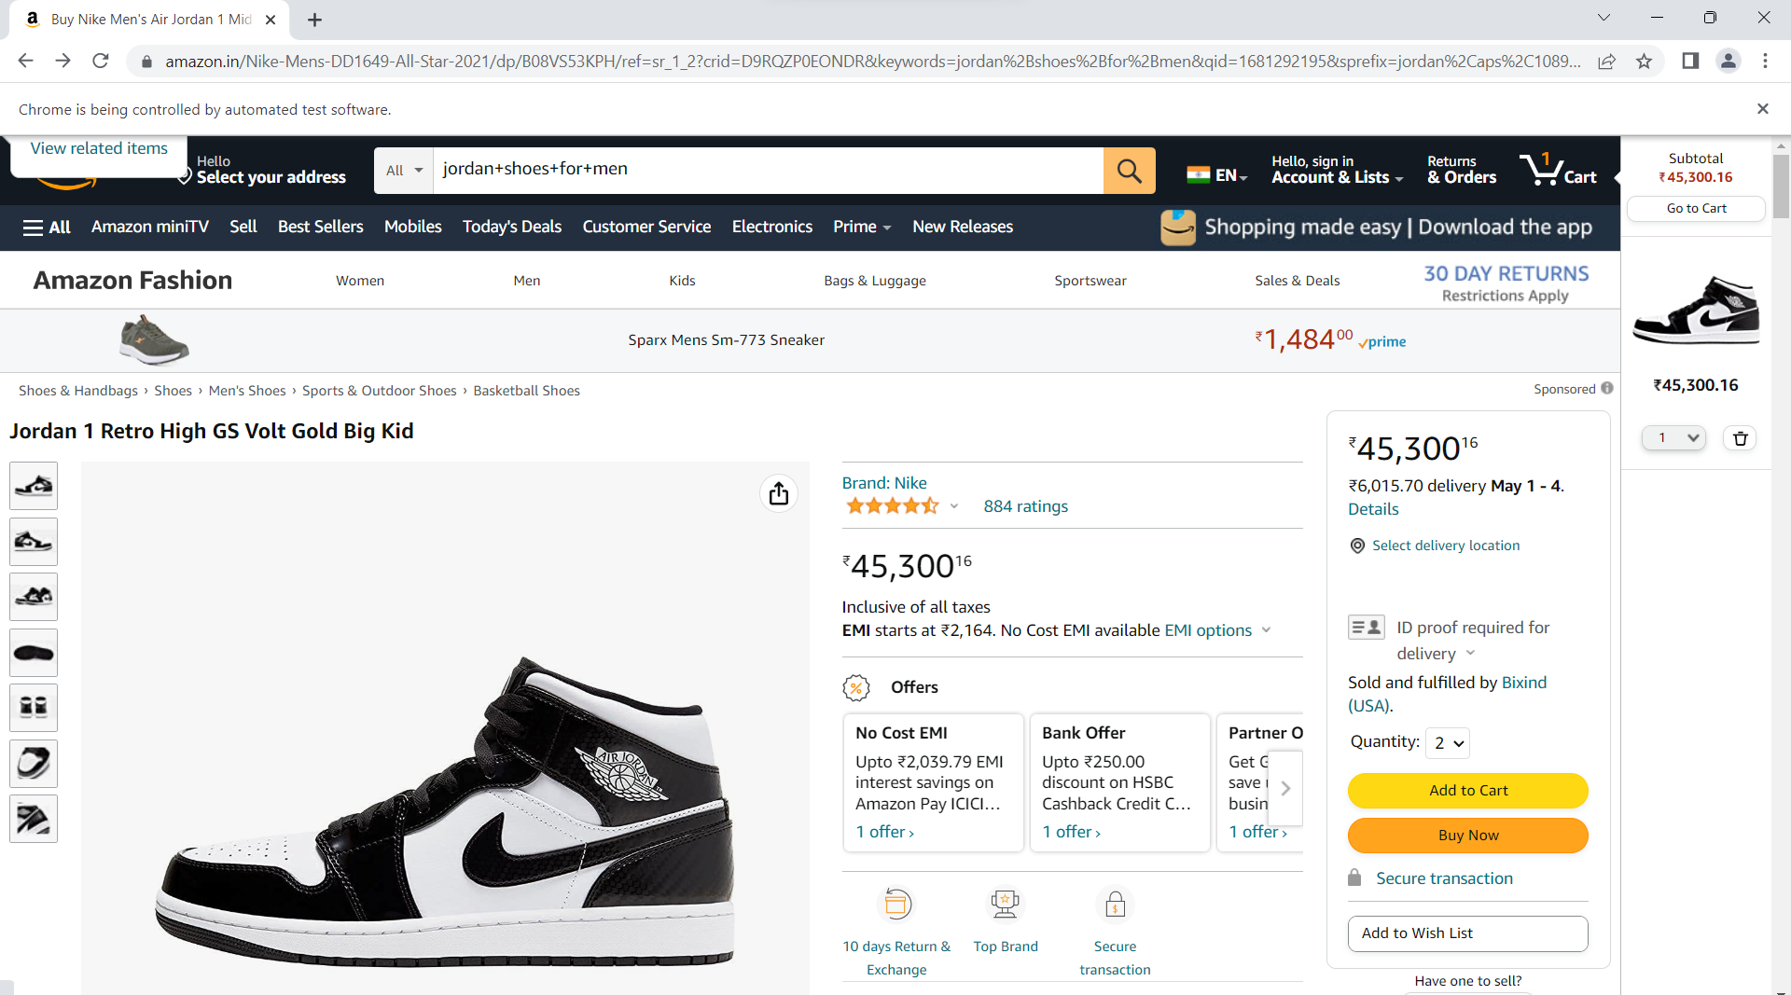

2.

**package** com.selenium.test2.selenium1;

**import** org.openqa.selenium.By;

**import** org.openqa.selenium.Keys;

**import** org.openqa.selenium.WebDriver;

**import** org.openqa.selenium.WebElement;

**import** org.openqa.selenium.chrome.ChromeDriver;

**import** org.openqa.selenium.chrome.ChromeOptions;

**import** io.github.bonigarcia.wdm.WebDriverManager;

**public** **class** Ca12

{

**public** **static** **void** main( String[] args ) **throws** InterruptedException

{

WebDriverManager.*chromedriver*().setup();

ChromeOptions co=**new** ChromeOptions();

co.addArguments("--remote-allow-origins=*");

WebDriver driver=**new** ChromeDriver(co);

driver.get("https://www.amazon.in/");

driver.manage().window().maximize();

String actualTitle=driver.getTitle();

System.***out***.println("Page title is : " + driver.getTitle());

String expectedTitle = "Online Shopping site in India: Shop Online for Mobiles, Books, Watches, Shoes and More - Amazon.in";

**if**(actualTitle.equalsIgnoreCase(expectedTitle))

System.***out***.println("Title Matched");

**else**

System.***out***.println("Title didn't match");

WebElement txt1=driver.findElement(By.*id*("twotabsearchtextbox"));

txt1.sendKeys("jordan Sneakers");

driver.findElement(By.*id*("twotabsearchtextbox")).sendKeys(Keys.***ENTER***);

}

}

2.2

package com.selenium.test.SeleniumTest.SeleniumTest4;

import java.util.List;

import org.openqa.selenium.By;

import org.openqa.selenium.JavascriptExecutor;

import org.openqa.selenium.Keys;

import org.openqa.selenium.WebDriver;

import org.openqa.selenium.WebElement;

import org.openqa.selenium.chrome.ChromeDriver;

import org.openqa.selenium.chrome.ChromeOptions;

import io.github.bonigarcia.wdm.WebDriverManager;

public class cia2

{

public static void main( String[] args ) throws InterruptedException

{

WebDriverManager.chromedriver().setup();

ChromeOptions co=new ChromeOptions();

co.addArguments("--remote-allow-origins=*");

WebDriver driver=new ChromeDriver(co);

driver.get("https://www.amazon.in/");

driver.manage().window().maximize();

String actualTitle=driver.getTitle();

System.out.println("Page title is : " + driver.getTitle());

String expectedTitle = "Online Shopping site in India: Shop Online for Mobiles, Books, Watches, Shoes and More - Amazon.in";

if(actualTitle.equalsIgnoreCase(expectedTitle))

System.out.println("Title Matched");

else

System.out.println("Title didn't match");

WebElement txt1=driver.findElement(By.id("twotabsearchtextbox"));

txt1.sendKeys("Watch");

driver.findElement(By.id("twotabsearchtextbox")).sendKeys(Keys.ENTER);

JavascriptExecutor js=(JavascriptExecutor) driver;

js.executeScript("window.scrollBy(0,1000)","");

List<WebElement> l1=driver.findElements(By.xpath("//h5[@class='s-line-clamp-1']"));

for(WebElement link:l1)

{

System.out.println(link.getText());

}

js.executeScript("window.scrollBy(0,1000)","");

List<WebElement> l2=driver.findElements(By.xpath("//h5[@class='s-line-clamp-1']"));

for(WebElement link:l2)

{

System.out.println(link.getText());

}

}

}

OUTPUT

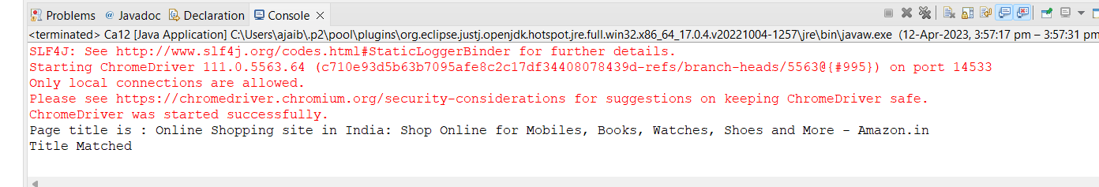

2.2

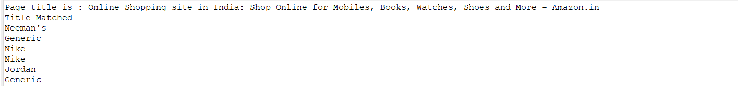

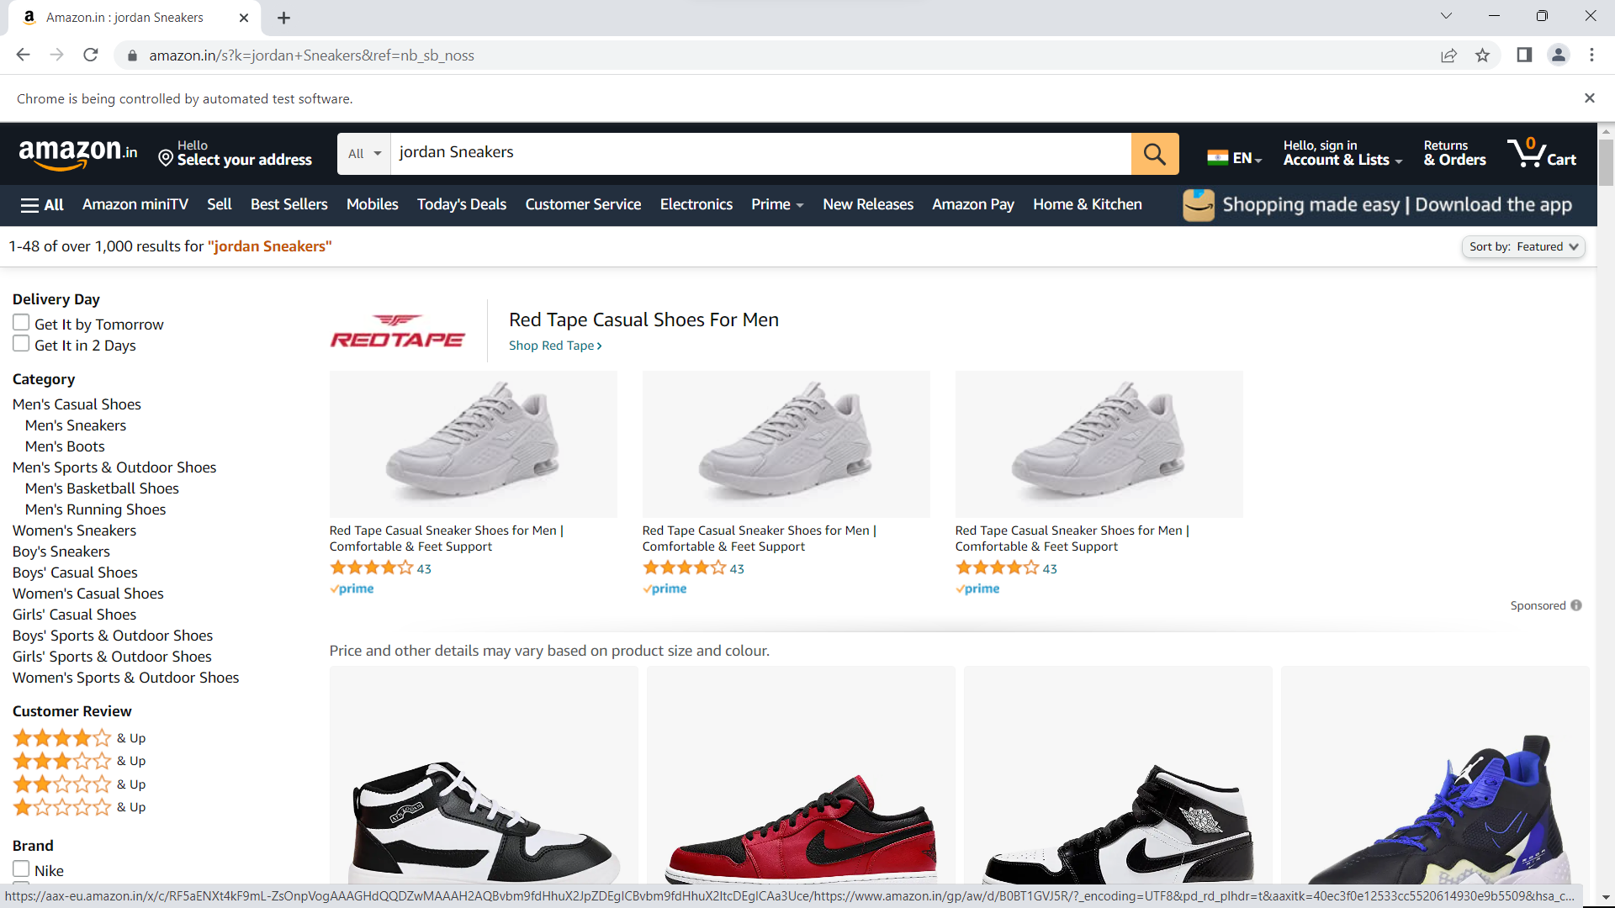

2.2

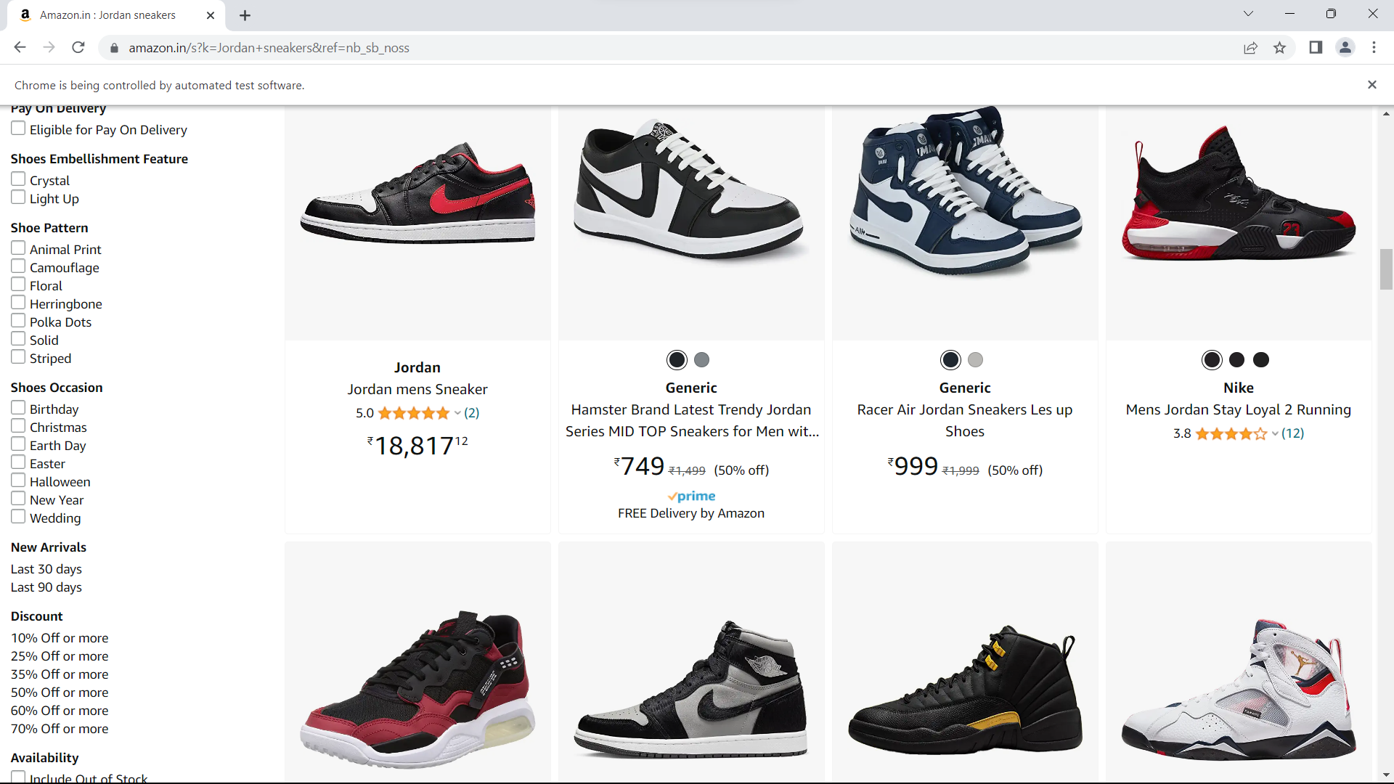

3.

**package** com.selenium.test2.selenium1;

**import** org.openqa.selenium.By;

**import** org.openqa.selenium.Keys;

**import** org.openqa.selenium.WebDriver;

**import** org.openqa.selenium.chrome.ChromeDriver;

**import** org.openqa.selenium.chrome.ChromeOptions;

**import** io.github.bonigarcia.wdm.WebDriverManager;

/**

* Hello world!

*

*/

**public** **class** Ca3

{

**public** **static** **void** main( String[] args ) **throws** InterruptedException

{

WebDriverManager.*chromedriver*().setup();

ChromeOptions co = **new** ChromeOptions();

co.addArguments("--remote-allow-origins=*");

WebDriver driver=**new** ChromeDriver(co);

driver.get("https://www.amazon.in/ref=nav_logo");

driver.manage().window().maximize();

String title=driver.getTitle();

System.***out***.println(title);

**if**(title.equals("Online Shopping site in India: Shop Online for Mobiles, Books, Watches, Shoes and More - Amazon.in")) {

System.***out***.println("Verified title of the page");

}**else** {

System.***out***.println("Title not matched");

}

driver.findElement(By.*id*("nav-link-accountList")).click();

driver.findElement(By.*id*("ap_email")).sendKeys("ajaibalaaji@gmail.com");

driver.findElement(By.*id*("ap_email")).sendKeys(Keys.***ENTER***);

driver.findElement(By.*id*("ap_password")).sendKeys("Ajai@2809");

driver.findElement(By.*id*("ap_password")).sendKeys(Keys.***ENTER***);

Thread.*sleep*(2000);

String name=driver.findElement(By.*id*("nav-link-accountList-nav-line-1")).getText();

**if**(name.equals("Hello, Feviliya")) {

System.***out***.println("Successfully, signed in");

}**else** {

System.***out***.println("Sign in failed");

}

System.***out***.println("Testing Ended");

driver.quit();

}

}

OUTPUT

