AWS

🡺**What is AWS - Traditional VS Cloud Computing - Why Cloud Computing**

🡺**What is AWS - Traditional VS Cloud Computing - Why Cloud Computing**

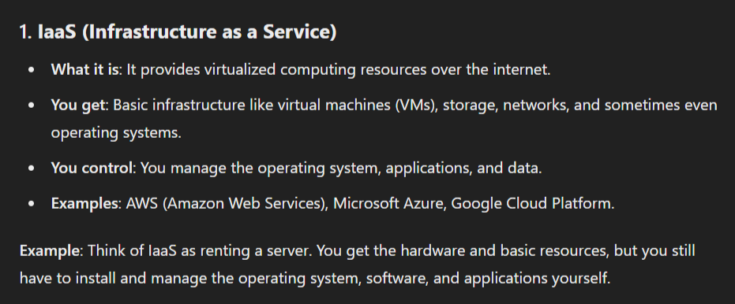

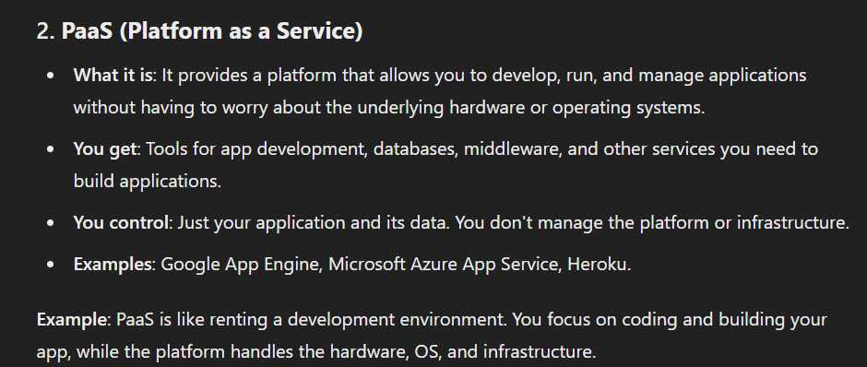

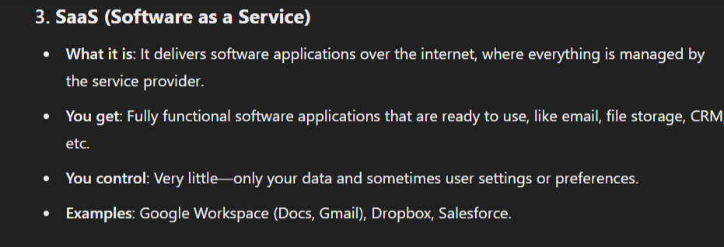

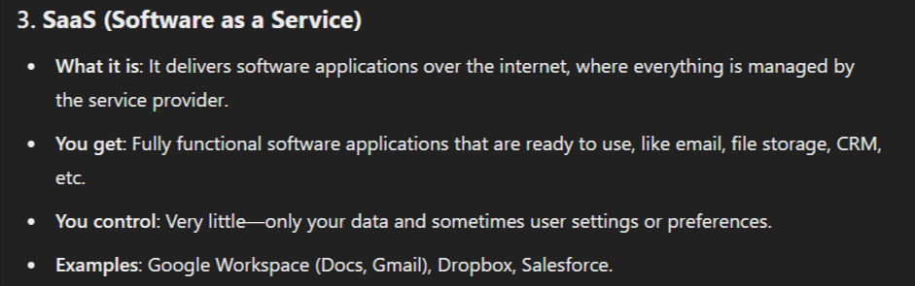

🡺Creating EC2 instance and access it locally

1.command to know the os info : cat /etc/os-release

2.command to know the ram info : free -m

3.command to know the cpu in :lscpu

4.command to know the storage info : df -h