Angular





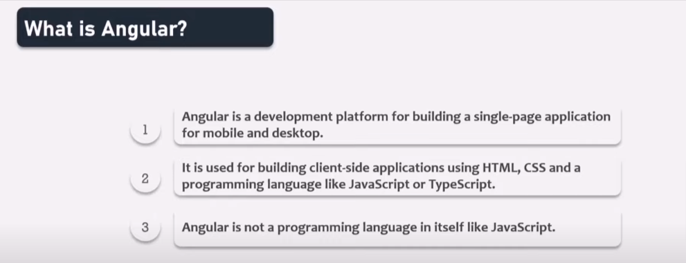

🡺Diffrence between server-side and client-side application :

Server side appliation : server side application runs on the server, headling request from the client,and processing data and sending requsest is done by the server itsef .

Cleint side application : runs on the user device. They are resposible for the reprsentation of data on the user interface , making request to the server , representing data that has been recived from the server .

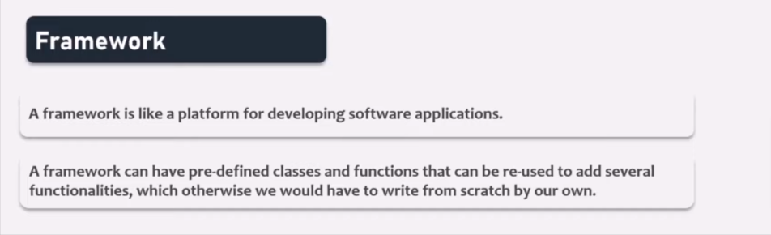

Diffrence between liberary and framework :

the main difference is who is in control: when you use a library, you call the library where and when you need it. When you use a framework, the framework dictates the structure and calls your code.



What is one way data binding in React?

Ans : passing data from parent to child only .

Advantages :

i)simple to debug error because data flow is unidirectional so what can debu the parent because data is coming from it

ii)set a stadard convetion for data passing

 

Note : react has one way binding ?

🡺Instalation of angular

i)install nodejs

ii)install angular cli (to check wether it has installed or not run command : ng version)

iii)to create project run command : ng new project_name

iv)to run angular project run command : ng serve