Form

1.autocomplete=”on/off” :

The autocomplete attribute specifies whether a form should have autocomplete on or off.

When autocomplete is on, the browser automatically complete values based on values that the user has entered before.

Tip: It is possible to have autocomplete "on" for the form, and "off" for specific input fields, or vice versa.

 <form action="/action_page.php" method="get" autocomplete="on">

  <label for="fname">First name:</label>

  <input type="text" id="fname" name="fname"><br><br>

  <label for="email">Email:</label>

  <input type="text" id="email" name="email"><br><br>

  <input type="submit">

</form>

2.allow multiple select in select : use of : multiple

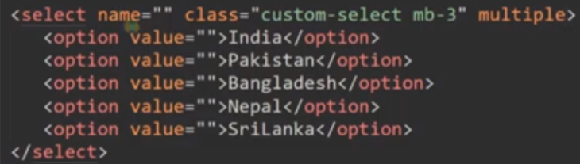

Note : we can also define the no of option show : by using size=”3” ;

3. for choosing only one option form the radio : by using same name

4. during check box put the same id for label and input

