HTML🡪

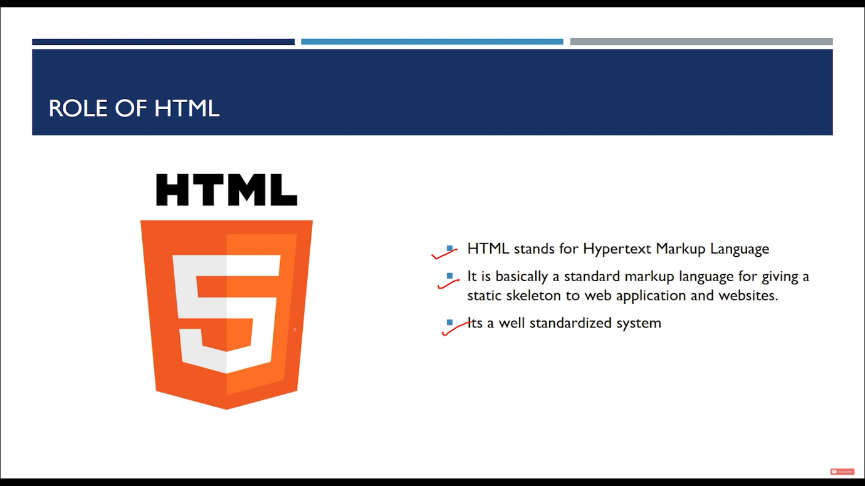

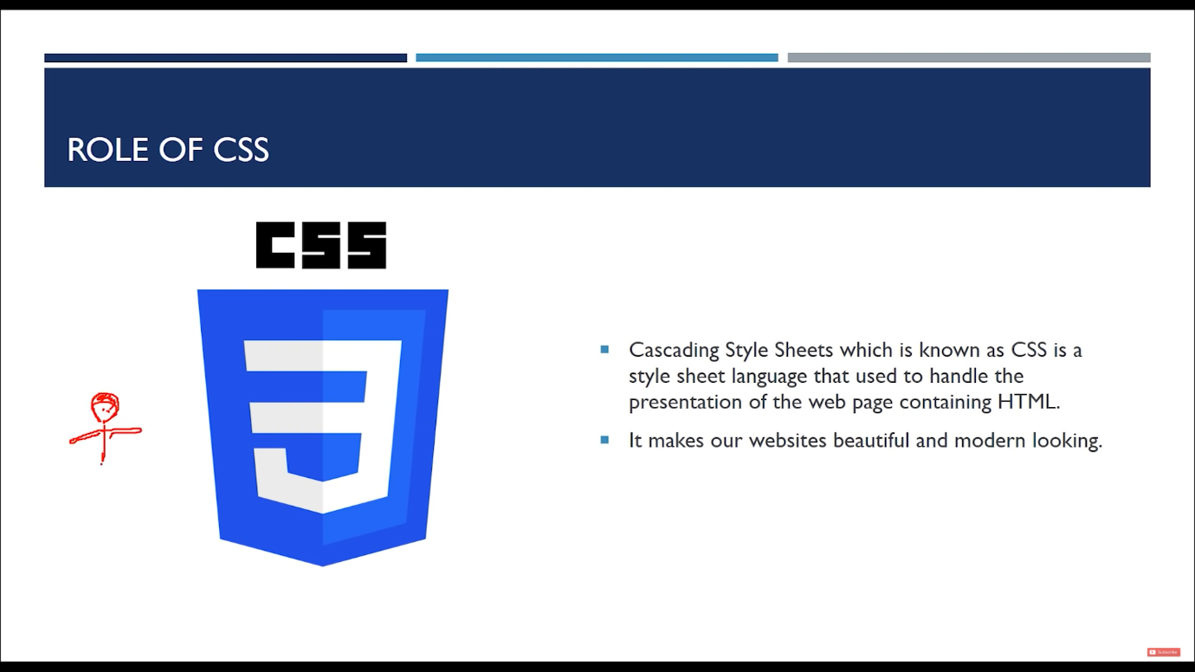

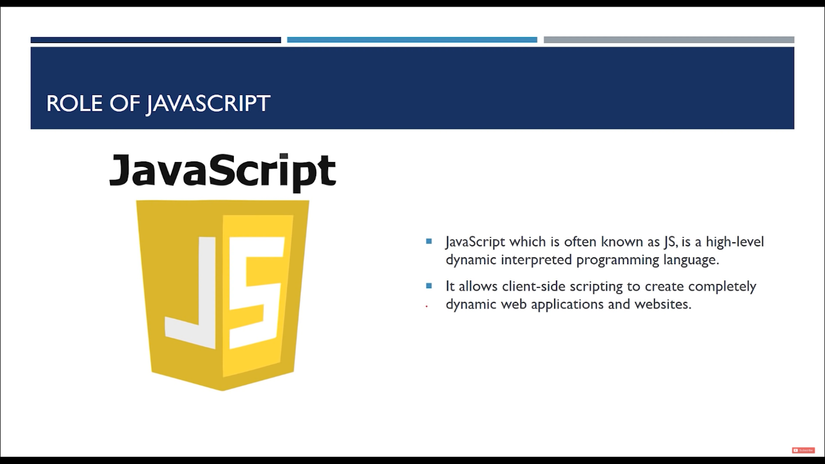

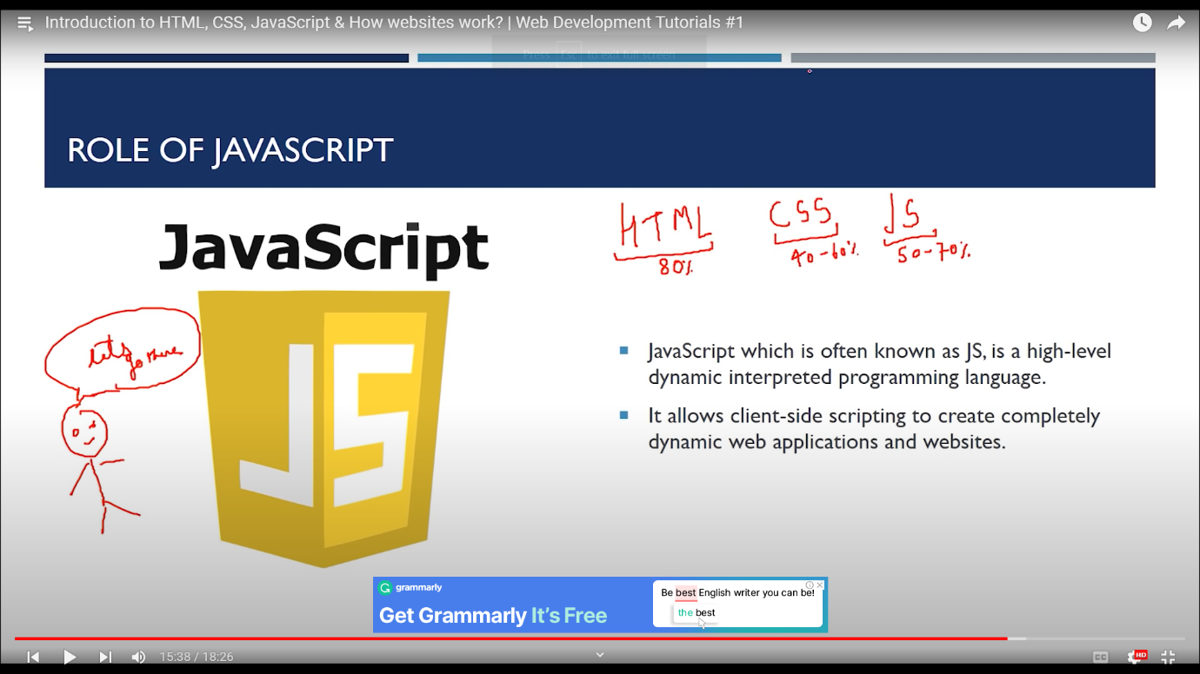

Shortcut🡪

1. ! – to get body of html (boiler plate)
2. Copy line down- shift +alt + down arrow
3. Copy line up- shift + alt +up arrow
4. Setting of zoom I- setting then search zoom then tick the default icon
5. Alt + down arrow to move a thing down

HTML SYNTAX-

Comment out syntax- <!—body --> eg . <! -- my name is Ajaj alam -->

<!DOCTYPE html>  
<html> // html opening tag  
<head> // opening of head  
<title>Page Title</title>  
</head> // closing of head  
<body>  
  
<h1>My First Heading</h1>  
<p>My first paragraph.</p>  
  
</body>  
</html> // html closing tag

* The <!DOCTYPE html> declaration defines that this document is an HTML5 document
* The <html> element is the root element of an HTML page (opening tag)
* The <head> element contains meta information about the HTML page
* The <title> element specifies a title for the HTML page (which is shown in the browser's title bar or in the page's tab)
* The <body> element defines the document's body, and is a container for all the visible contents, such as headings, paragraphs, images, hyperlinks, tables, lists, etc.
* The <h1> element defines a large heading
* The <p> element defines a paragraph

Meta information – thing that require to describe a website (information about information)

<!DOCTYPE html>

<html>

<head>

    <meta charset="UTF-8" />

    <meta http-equiv=="X-UA-Compatible" content="IE=edge">

    <meta name="viewport" content="width=device-width,initial-scale=1.0" />

    <meta name="description" content="This is description" />

    <meta name="keywords" content="html, html tutorial , web devlopment" />

    <meta name="robots" content="INDEX, FOLLOW" />

    <title>Document</title>

    <!--THIS IS HOW WE INCLUCDE EXTERNAL CSS-->

    <link rel="prsheet" href="pr.css" />

    <!-- this is how we add java script  -->

    <script src="pr.js"></script>

</head>

<body>

    ajaj alam

</body>

</html>

Heading in html🡪 6 type of heading in html

<h1> ajaj </h1> // biggest heading

<h2> ajaj </h2> // heading smaller than h1

<h3> ajaj </h3> // heading smaller than h2

<h4> ajaj </h4> // heading smaller than h3

<h5> ajaj </h5> // heading smaller than h5

<h6> ajaj </h6> // smallest heading

Paragraph->

For dummy text--

<p>lorem5</p> // it will give me 5 dummy text

<p>lorem400</p> // it will give 400 dummy text

Note- to arrange these text in well manner we need to do 1 this

Setting->command pallet --> toggle word warp

ii) p*4 then press enter we will have 4 paragraph

iii) if we want to helight something in paragraph then we need to use

<strong> helighting text </strong>

iv) if we want to add some emphasis then we can use

<em> emphasis content </em>

v) if we want a new line like \n then we can use

<br> (note we do not use closing tag here bcz br is self closing )

vii) <hr> for _____________________________________________

vi) division tag ---

<div>

Is ke ander kuch likh sakte hai

</div>

Tag and attributes 🡪

Adding link in our web page—(by using anchor tag)

<body>

< a href =<http://google.com>> go to google </a>

Note –

Target attributes –

Target = “blank” // open the link in new tab

Eg- <a href = “http://google.com” target=”_blank” >go to google

* Adding internal link < a href=”/linkname.uskaid” target=”_blank” > go to <a/>

<!DOCTYPE html>

<html lang="en">

  <head>

    <meta charset="UTF-8" />

    <meta http-equiv="X-UA-Compatible" content="IE=edge" />

    <meta name="viewport" content="width=device-width, initial-scale=1.0" />

    <title>link and images</title>

  </head>

  <body>

    <!-- for provinding link we can use ancor tag <a href -->

        <a href="http://google.com" target="_blank">go to google<br></a>

        <a href="http://facebook.com" target="_blank">go to facebook<br></a>

        <a href="http://twitter.com" target="_blank">go to twitter<br></a>

        <a href="http://linkedin.com" target="_blank">go to linkedin<br></a>

        <a href="/C_Programming/chapter 6/p.html" target="_blank">go to p </a>

  </body>

</html>

Image🡪

<img src=” “ alt =”” >

<!DOCTYPE html>

<html lang="en">

<head>

    <meta charset="UTF-8" />

    <meta http-equiv="X-UA-Compatible" content="IE=edge" />

    <meta name="viewport" content="width=device-width, initial-scale=1.0" />

    <title>link and images</title>

</head>

<body>

    <img src="C:\Users\91930\Music\Pictures\Saved Pictures\4DO66881.jpg" alt="time is money" />

</body>

</html>

LIST🡪

1. order list : eg

syntax🡪

<body>

<ol>

<li> this is first item of unordered list </li>

<li> this is second item of unordered list </li>

<li> this is theird item of unordered list </li>

</o>

Output🡪

1. This is the first item of unordered list
2. This is the second item of unordered list
3. This is the theird item of unordered list

Unordered list🡪 syntax

<ul>

        <li>This is the first item of ordered list</li>

        <li>This is the second item of ordered list</li>

        <li>This is the theird item of ordered list</li>

    </ul>

</body>

Attribute of list🡪

1. Unordered list attribute
2. <ul type=”disc>
3. <ul type=”circle”>
4. <ul type=”square”>
5. Ordered list attributes🡪
6. <ol type=”1”>
7. <ol type=”A”>
8. <ol type =”a”>
9. <ol type =”i>
10. <ol type = “I”>

<!DOCTYPE html>

<html lang="en">

<head>

    <meta charset="UTF-8">

    <meta http-equiv="X-UA-Compatible" content="IE=edge">

    <meta name="viewport" content="width=device-width, initial-scale=1.0">

    <title>list</title>

</head>

<body>

    <ol type="i">

        <li>This is the first item of unordered list</li>

        <li>This is the second item of unordered list</li>

        <li>This is the theird item of unordered list</li>

    </ol>

    <ul type="disc">

        <li>This is the first item of ordered list</li>

        <li>This is the second item of ordered list</li>

        <li>This is the theird item of ordered list</li>

    </ul>

</body>

</html>

List ke ander list 🡪

<!DOCTYPE html>

<html lang="en">

<head>

    <meta charset="UTF-8">

    <meta http-equiv="X-UA-Compatible" content="IE=edge">

    <meta name="viewport" content="width=device-width, initial-scale=1.0">

    <title>list</title>

</head>

<body>

    <ol type="i">

        <li>This is the first item of unordered list</li>

        <ul type = "suare">

            <li>Ajaj</li>

            <li>Anurag</li>

            <li>saddam</li>

        </ul>

        <li>This is the second item of unordered list</li>

        <li>This is the theird item of unordered list</li>

    </ol>

    <ul type="disc">

        <li>This is the first item of ordered list</li>

        <li>This is the second item of ordered list</li>

        <ol type="i">

            <li>SADDAM</li>

            <li>Ajaj</li>

            <li>ANURAG</li>

        </ol>

        <li>This is the theird item of ordered list</li>

    </ul>

</body>

</html>

TABLE🡪

<!DOCTYPE html>

<html lang="en">

<head>

    <meta charset="UTF-8" />

    <meta http-equiv="X-UA-Compatible" content="IE=edge" />

    <meta name="viewport" content="width=device-width, initial-scale=1.0" />

    <title>table</title>

</head>

<body>

    <h3>TABLE</h3>

    <table>

        <thead>

            <tr>

                <th>name</th>

                <th>class</th>

                <th>rollno</th>

            </tr>

        </thead>

        <tbody>

            <tr>

                <td>AJAJ ALAM</td>

                <td>B.TECH(CSE)</td>

                <td>2020UMT1399</td>

            </tr>

            <tr>

                <td>RIZWAN</td>

                <td>B.TECH(CSE)</td>

                <td>2020CSP1399</td>

            </tr>

            <tr>

                <td>saddam</td>

                <td>B.TECH(CSE)</td>

                <td>2020CSP1399</td>

            </tr>

            <tr>

                <td>AYAN</td>

                <td>B.TECH(CSE)</td>

                <td>2020CSP1399</td>

            </tr>

        </tbody>

    </table>

</body>

</html>

Form🡪

<!DOCTYPE html>

<html>

<head>

    <meta charset="UTF-8" />

    <meta http-equiv="X-UA-Compatible" content="IE=edge" />

    <meta name="viewport" content="width=device-width , initial-scale=1.0" />

    <meta name="description" content="This is description" />

    <meta name="keywords" content="html , html tutorial , web development" />

    <meta name="robots" content="INDEX , FOLLOW" />

    <title>List and table</title>

</head>

<body>

    <form action="backend.php">

        <div>name : <input type="text" name="Myname" /></div><br>

        <div>id : <input type="text" name="Myid" /></div><br>

        <div>E mail : <input type="email" name="MyEmail/>"</div><br><br>

        <div>

            date : <input type="date" name="My name">

        </div><br>

        <div>

            time : <input type="time" name="time">

        </div><br>

        <div>

            bonus : <input type="number" name="bonus">

        </div><br>

        <div>

            are you eligible ? <input type="checkbox" name="myeligblity">

        </div><br>

        <div>

            gender : male <input type="radio" name="myGender" > female <input type="radio" name="myGender">

            other <input type="radio" name="myGender">

        </div>

        <div>

            write about yourself :<br> <textarea name="myText" rows="10" cols="20"></textarea>

        </div>

        <input type="submit" value="submit now">

        <input type="reset" value="reset">

    </form>

</body>

</html>

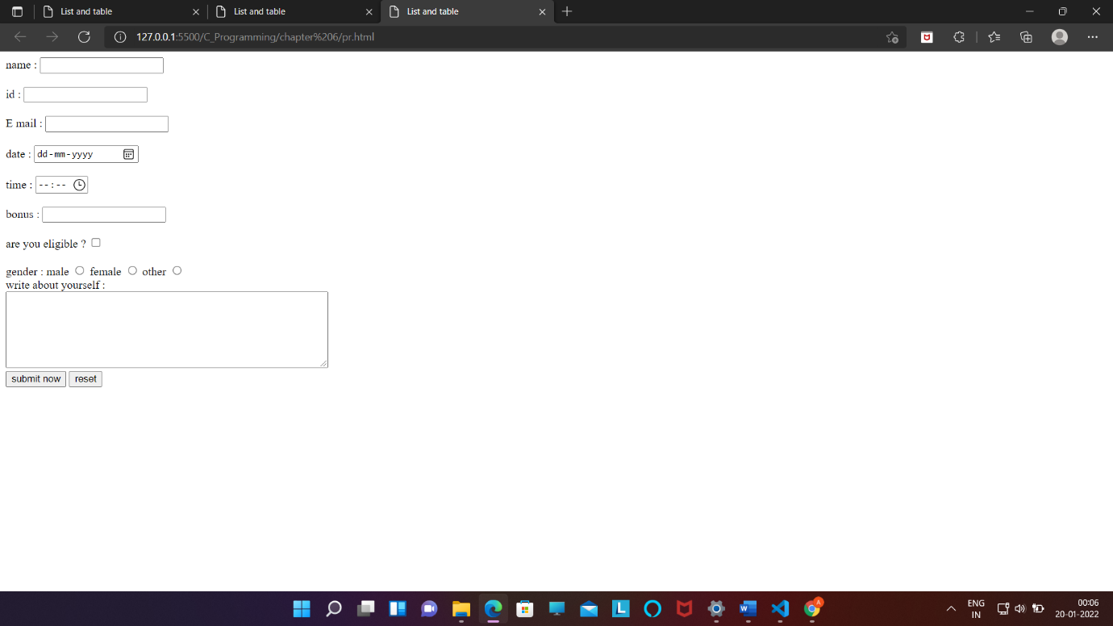

Checked –

For default checked---

<div>

            are you eligible ? <input type="checkbox" name="myeligblity" checked>

        </div><br>

Lable🡪

<div>

            <label for="name">name :</label>

             <input type="text" name="Myname" id="name" /></div><br>

Select🡪

 <label for="car">CAR:</label>

            <select name="mycar" id="car">

                <option value="ind">indica</option>

                <option value="swf">swif</option>

            </select><br>

By default select🡪

 <select name="mycar" id="car">

                <option value="ind" selected>indica</option>

                <option value="swf">swif</option>

            </select><br>

Final form code🡪

<!DOCTYPE html>

<html>

<head>

    <meta charset="UTF-8" />

    <meta http-equiv="X-UA-Compatible" content="IE=edge" />

    <meta name="viewport" content="width=device-width , initial-scale=1.0" />

    <meta name="description" content="This is description" />

    <meta name="keywords" content="html , html tutorial , web development" />

    <meta name="robots" content="INDEX , FOLLOW" />

    <title>List and table</title>

</head>

<body>

    <form action="backend.php">

        <div>

            <label for="name">name :</label>

            <input type="text" name="Myname" id="name" />

        </div>

        <br />

        <div>id : <input type="text" name="Myid" /></div>

        <br />

        <div>E mail : <input type="email" name="MyEmail/>" </div>

            <br /><br />

            <div>date : <input type="date" name="My name" /></div>

            <br />

            <div>time : <input type="time" name="time" /></div>

            <br />

            <div>bonus : <input type="number" name="bonus" /></div>

            <br />

            <div>

                are you eligible ? <input type="checkbox" name="myeligblity" checked />

            </div>

            <br />

            <div>

                gender : male <input type="radio" name="myGender" /> female

                <input type="radio" name="myGender" /> other

                <input type="radio" name="myGender" />

            </div>

            <div>

                write about yourself :<br />

                <textarea name="myText" rows="10" cols="20"></textarea>

            </div>

            <label for="car">CAR:</label>

            <select name="mycar" id="car">

                <option value="ind" selected>indica</option>

                <option value="swf">swif</option>

            </select><br>

            <input type="submit" value="submit now" />

            <input type="reset" value="reset" />

    </form>

</body>

</html>

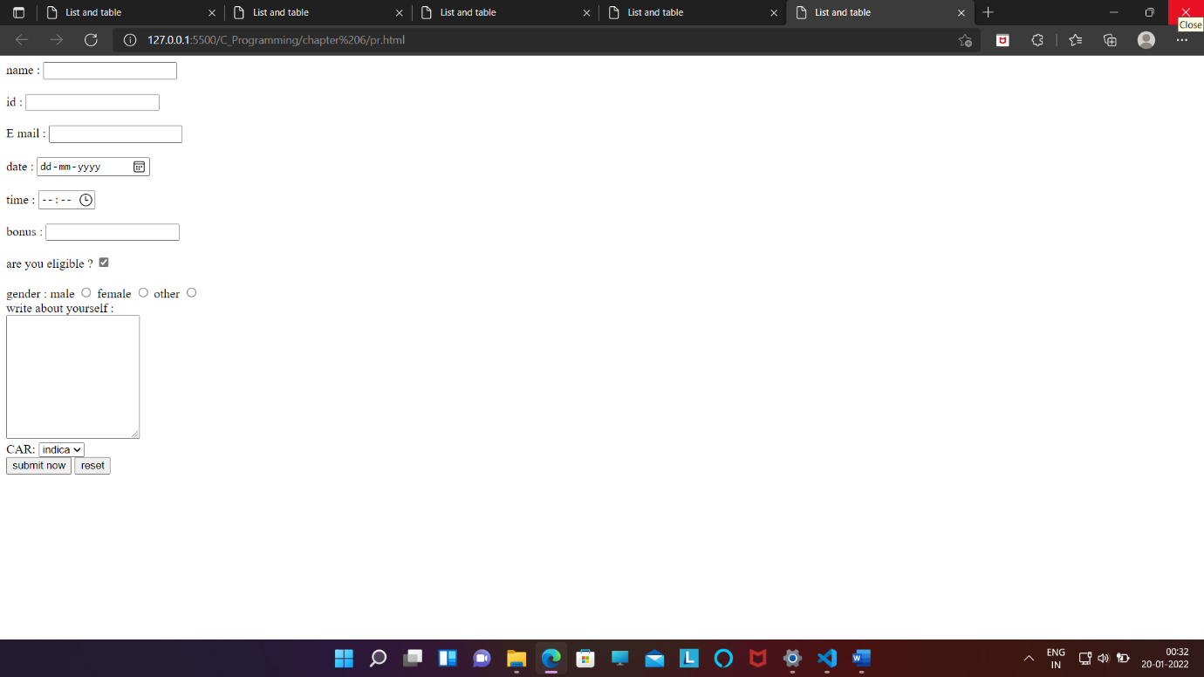

Inline and block element 🡪

1. Inline element- jo kewall apana jagha le eg : <span></span> or <a></a>
2. <body>
3. <span>My name is Ajaj Alam .</span>
4. <span>My father name is Nabizan Ahmad .</span>
5. </body>

Output--My name is Ajaj Alam . My father name is Nabizan Ahmad

1. Block element – jo pura ek block le le

Eg - <div></div> or <p></p>

Way of checking inline or block element🡪

Eg checking ancor tag is inline or block element –

<body>

    <a>My name is ajaj alam .</a>

    <a>My brother name is ajaj alam .</a>

    <a>My father name is ajaj alam .</a>

    <a>My mother name is ajaj alam .</a>

</body>

Class , id , emit 🡪

<!DOCTYPE html>

<html lang="en">

<head>

    <meta charset="UTF-8">

    <meta name="viewport" content="width=device-width, initial-scale=1.0">

    <meta http-equiv="X-UA-Compatible" content="ie=edge">

    <title>Ids and classes in HTML</title>

</head>

<body>

    <h3>Ids and classes tutorial</h3>

    <div id="mainBox" class="redBg blackBorder">

        this is mainbox

    </div>

    <span class="redBg"></span>

    <!-- Select and press ctrl + / to comment -->

    <!-- Emmet -->

    <!-- . is for class and # is for id -->

    <span class="redBg"></span>

    <span id="mainSpan"></span>

    <div class="redBg blackBorder anotherClass"></div>

    <!-- Emmet takes div tag as default -->

    <div class="blackBackground"></div>

    <!-- Creating multiple elements using Emmet -->

    <!-- span.myClass.myClass2.myClass3*4 + <Tab> to print 4 similar elements using Emmet -->

    <span class="myClass myClass2 myClass3">First</span>

    <span class="myClass myClass2 myClass3">Second</span>

    <span class="myClass myClass2 myClass3">Third</span>

    <span class="myClass myClass2 myClass3">Fourth</span>

</body>

</html>

<body>

    <div id="mainbox" class="redBg"></div>

</body>

Emit is just a short cut of writing anything in vs code for web development

Shortcout for id-> # (by default it will take div)

Eg – div#mainbox

<div id="mainbox"></div>

ii) span#mainbox

<span id="mainbox"></span>

Shortcut for class 🡪 .

Eg – i) .regbg

<div class="redBg"></div>

ii) div#mainbox.redbg.blackcl.somthing

<div class="redbg blackcolour somthing" id="mainbox"></div>

Semantic tag🡪 <https://developer.mozilla.org/en-US/docs/Glossary/Semantics>

Youtube--https://www.youtube.com/watch?v=G6I1VJ8kBQM&t=634s

# 1-<header>

The **<header>** [HTML](https://developer.mozilla.org/en-US/docs/Web/HTML) element represents introductory content

<body>

    <header>

        <h3>Types of dog breeds</h3>

    </header>

</body>

E.g.-

<body>

    <header class="page-header">

        <h1>Cute Puppies Express!</h1>

    </header>

    <main>

        <p>I love beagles <em>so</em> much! Like, really, a lot. They’re adorable and their ears are so, so snuggly soft!</p>

    </main>

</body>

# 2- <nav>: The Navigation Section element

The **<nav>** [HTML](https://developer.mozilla.org/en-US/docs/Web/HTML) element represents a section of a page whose purpose is to provide navigation links, either within the current document or to other documents.

<body>

    <header style="text-align: center;">

        <h1>Types of dog breeds</h1>

        <nav>

            <a href="http://google.com" target="_blank">google</a>|

            <a href="http://facbook.com" target="_blank">facbook</a>|

            <a href="http://twitter.com" target="_blank">twitter</a>|

            <a href="http://linkedin.com" target="_blank">linkedin</a>|

        </nav>

    </header>

</body>

# 3 - <section>: The Generic Section element

The **<section>** [HTML](https://developer.mozilla.org/en-US/docs/Web/HTML) element represents a generic standalone section of a document, which doesn't have a more specific semantic element to represent it. Sections should always have a heading, with very few exceptions.

4-The **<article>** [HTML](https://developer.mozilla.org/en-US/docs/Web/HTML) element represents a self-contained composition in a document, page, application, or site, which is intended to be independently distributable or reusable (e.g., in syndication

5-6) The **<figure>** [HTML](https://developer.mozilla.org/en-US/docs/Web/HTML) element represents self-contained content, potentially with an optional caption, which is specified using the [<figcaption>](https://developer.mozilla.org/en-US/docs/Web/HTML/Element/figcaption) element. The figure, its caption, and its contents are referenced as a single unit.

<figure style="text-align:center;">

        <img src="/media/cc0-images/elephant-660-480.jpg"

             alt="Elephant at sunset">

        <figcaption>An elephant at sunset</figcaption>

    </figure>

7-8) The **<details>** [HTML](https://developer.mozilla.org/en-US/docs/Web/HTML) element creates a disclosure widget in which information is visible only when the widget is toggled into an "open" state. A summary or label must be provided using the [<summary>](https://developer.mozilla.org/en-US/docs/Web/HTML/Element/summary) element.

<details>

        <summary>about my self :</summary>

        <p>Lorem ipsum dolor sit amet consectetur adipisicing elit. Tempora, facere.</p>

        <p>Lorem ipsum dolor sit amet consectetur, adipisicing elit. Repellendus veniam non aliquid aut facilis et.</p>

    </details>

9) The **<footer>** [HTML](https://developer.mozilla.org/en-US/docs/Web/HTML) element represents a footer for its nearest [sectioning content](https://developer.mozilla.org/en-US/docs/Web/Guide/HTML/Content_categories#sectioning_content) or [sectioning root](https://developer.mozilla.org/en-US/docs/Web/HTML/Element/Heading_Elements#sectioning_root) element. A <footer> typically contains information about the author of the section, copyright data or links to related documents.

10) The **<main>** [HTML](https://developer.mozilla.org/en-US/docs/Web/HTML) element represents the dominant content of the [<body>](https://developer.mozilla.org/en-US/docs/Web/HTML/Element/body) of a document. The main content area consists of content that is directly related to or expands upon the central topic of a document, or the central functionality of an application.

11) The **<aside>** [HTML](https://developer.mozilla.org/en-US/docs/Web/HTML) element represents a portion of a document whose content is only indirectly related to the document's main content. Asides are frequently presented as sidebars or call-out boxes.

