JSP

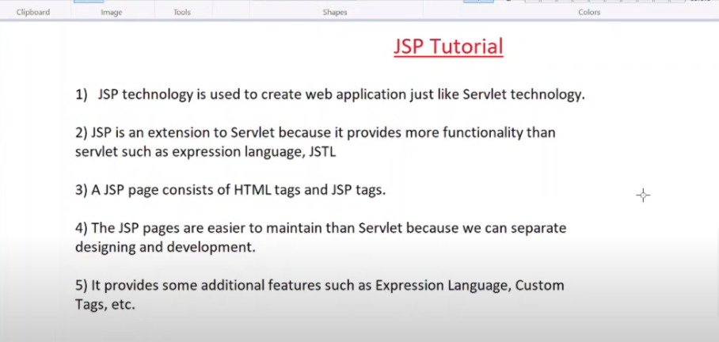

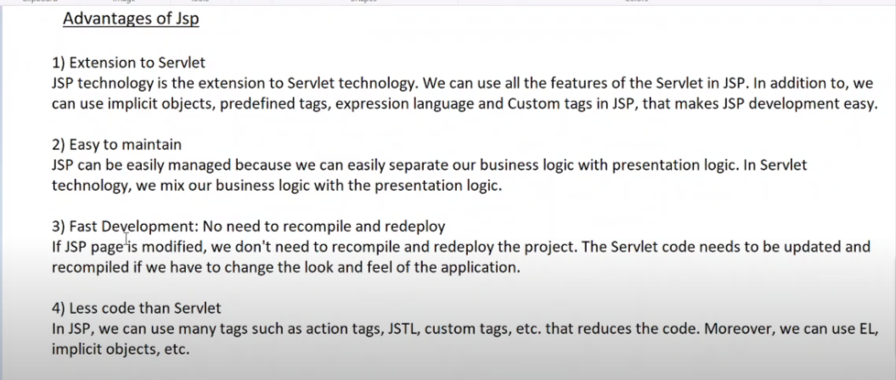

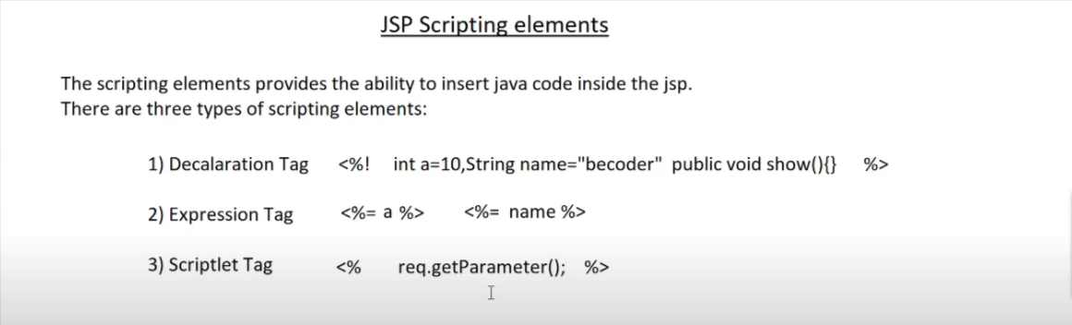

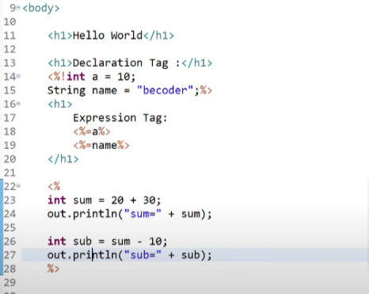

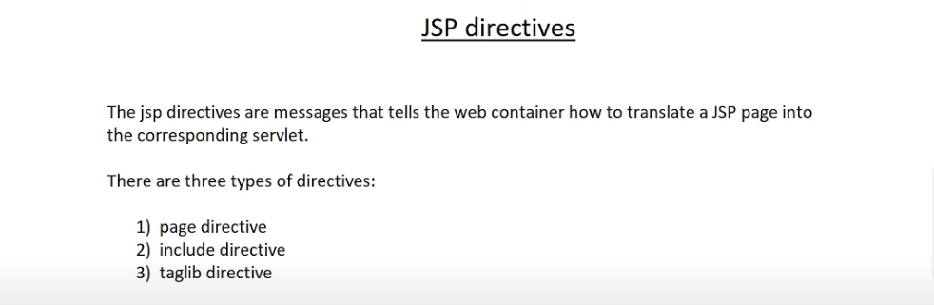

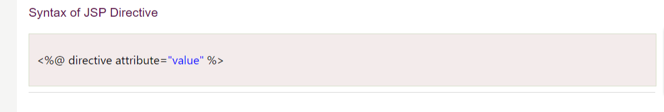

Most used page directive :

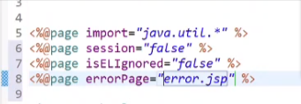

🡪include directive



🡪Taglib directive



1. Creating a maven project
2. Go to website : mvnreposetry and add two dependency in pom.xml 🡪 i)servlet ii)jstl

🡪Error handling in jsp

1.create a error_page.jsp file

2.use page directive to define error page and to use error page

🡪Creating custom tag in jsp :

1.create a class then extends that class to TagSupport inteface

2.in scr floder under it in library create tld file which is tag liberary descriptator

🡪Creating Custom tag with attributes

🡪web.xml for jsp

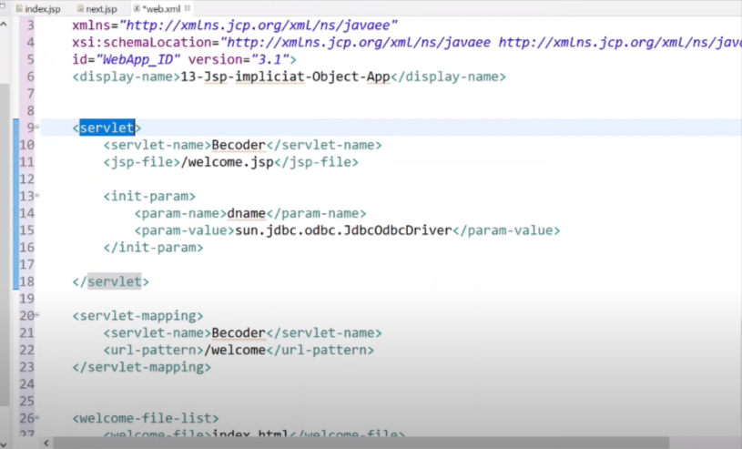

🡪Jsp Implict object

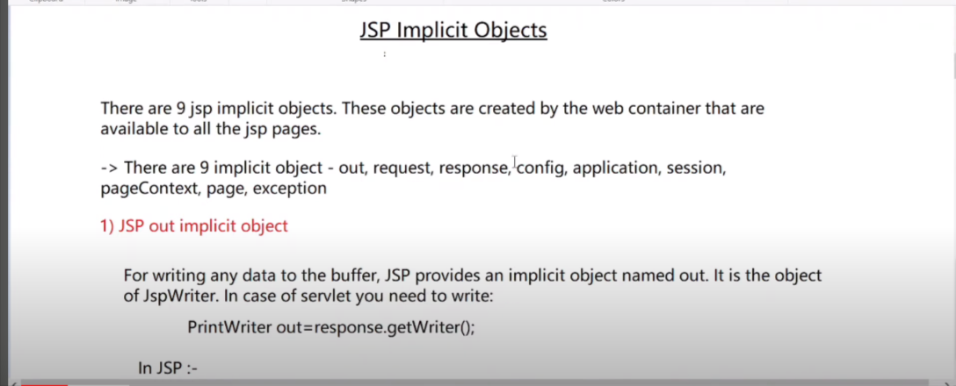

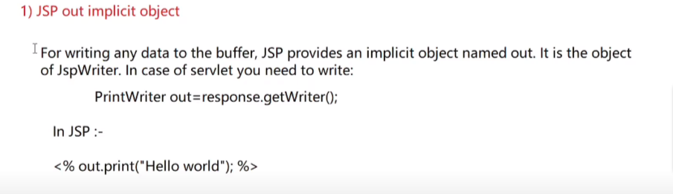

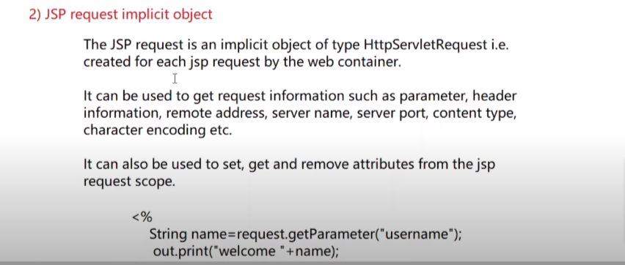

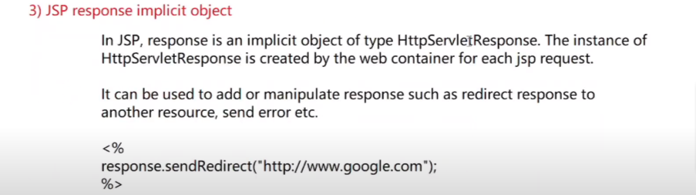

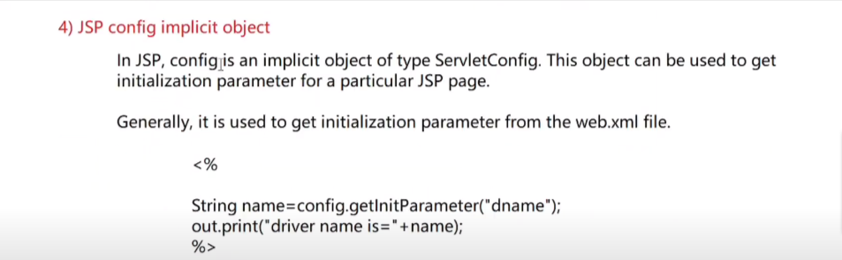

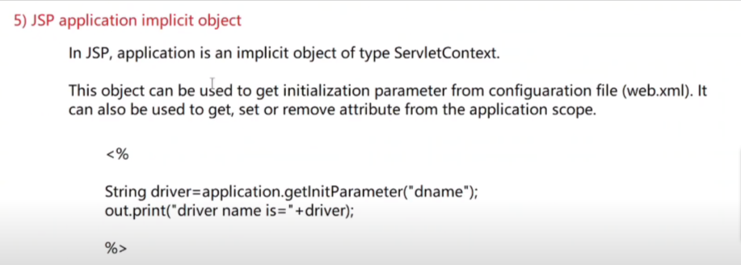

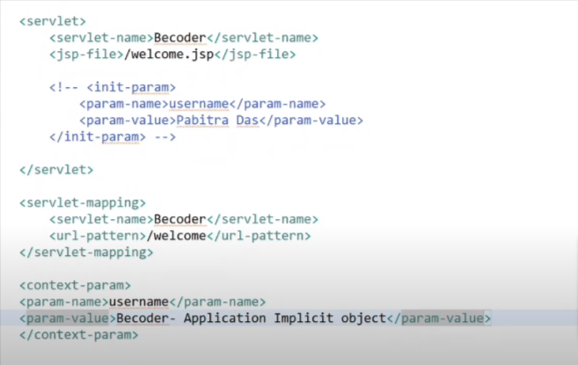

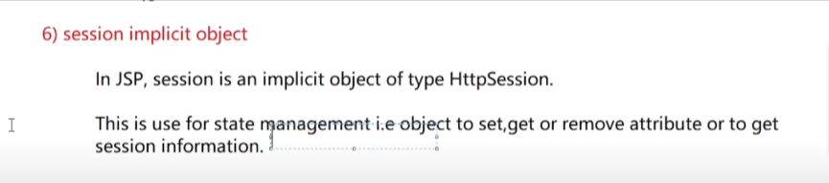



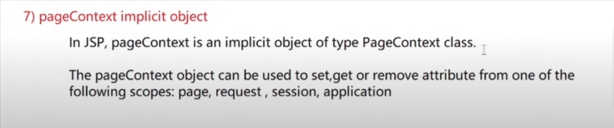

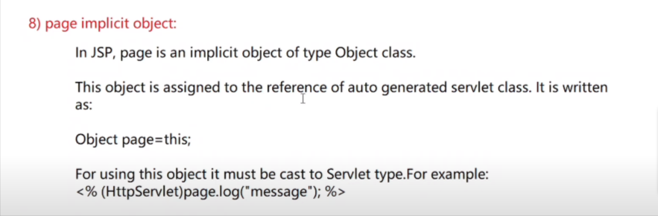

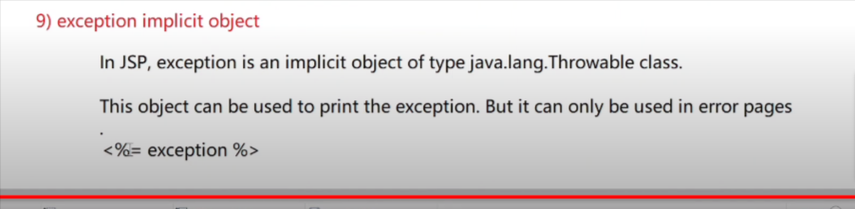

🡪Redirection in jsp

We will going to use jsp implicit object : response.sendRedirect(“”);