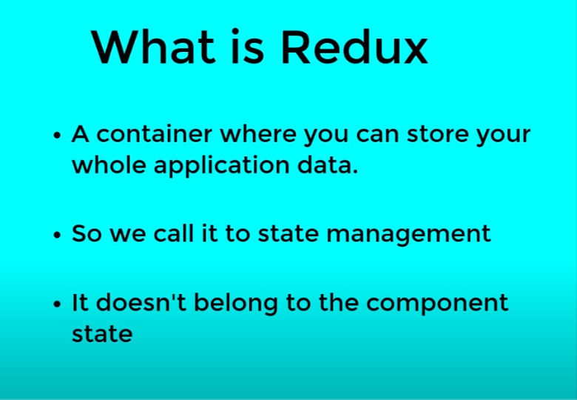

Redux Artitecture :

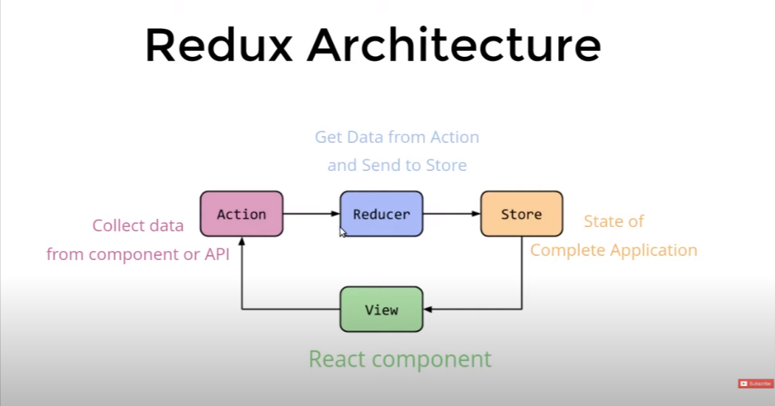

Q. can we have 2 store in application ?

ans : No because the artitucture of redux is uni directional

3.



link : search react-redux

4 . Redux floder sturcture

