**TITTLE: SMART PARKING**

**TABLE OF CONTENTS**

**CHAPTER NO. TITLE**

## ABSTRACT

## 1. INTRODUCTION

OVERVIEW

PROBLEM INTRODUCTION

## 2. EXISTING SYSTEM

EXISTINGSYSTEM

DISADVANTAGES OF EXISTING SYSTEM

PROPOSED SYSTEM

## 3. SYSTEM REQUIREMENTS

SOFTWARE REQUIREMENTS

HARDWARE REQUIREMENTS

**4. SYSTEM DESIGN**

CONCEPT DIAGRAM

FLOW CHART

## 5. MODULE

## MODULE DEDSIGN

## MODULE DESCRIPTION

## Admin module

## Employee Module

## Fingerprint Module

## 6. IMPLEMENTATION & TESTING

IMPLEMENTATION

TESTING

## 7. SOURCE CODE

LCD CODE

SLOT ALLOCATION

## 8. CONCLUSION

CONCLUSION

**CHAPTER 1**

# ABSTRACT _____________________________________________________

iii

The project entitled “SMART CAR PARKING SYSTEM” using IoT , The major motivation of this project is to reduce the traffic congestion in roads, multi-stored buildings and malls due to unavailability of parking spaces .The project displays the nearest empty slot if present with respect to user location. Our project aims to make efficient use of parking spaces. We track vacant slots in the parking space and assign that to the user. Smart parking system as described above can lead to an error-free , reliable, secure and fast management system. In recent times the concept of smart cities have gained great popularity. Thanks to the evolution of the Internet of things the idea of smart city now seems to be achievable. Consistent efforts are being made in the field of IoT in order to maximize the productivity and reliability of urban infrastructure. Problems such as, traffic congestion, limited car parking facilities and road safety are being addressed by IoT. The proposed Smart Parking system consists of an on-site deployment of an IoT module that is used to monitor and signalize the state of availability of each single parking space. A mobile application is also provided that allows an end user to check the availability of parking space and book a parking slot accordingly. The paper also describes a high-level view of the system architecture. Towards the end, the paper discusses the working of the system in form of a use case that proves the correctness of the proposed model.

# INTRODUCTION ___________________________________________________

## OVERVIEW

The Internet of Things (IoT) is the network of physical objects devices, vehicles, buildings, and other items embedded with electronics, software, ultrasonic sensors, and network connectivity that enables these objects to collect and exchange data. The IoT allows objects to be sensed and controlled remotely across existing network infrastructure, creating opportunities for more direct integration of the physical world into computer-based systems, resulting in improved efficiency, accuracy, and economic benefit; when IoT is augmented with sensors and actuators, the technology becomes an instance of the more general class of cyberphysical systems, which also encompasses technologies such as smart grids, smart homes, intelligent transportation, and smart cities. Each thing is uniquely identifiable through it is embedded computing system but is able to interoperate .

With the growth of population and economic development, the number of vehicles on the road is increasing day by day. Parking is becoming one of the major problems for cities, and is becoming very costly. For instance, finding parking space during work is challenging. It is more frustrating for the users to search for a parking spot in a parking lot. To overcome this problem many parking guidance systems have been proposed in recent years that try to enhance the basic parking system. All the systems require a mechanism to detect if a vehicle is in the parking spot. The person can register for the parking slot to park his/her car. A unique id is generated for registered users and time limit is given. The system will calculate the in and out tithe me of the vehicle which is placed in the parking slot and the amount will be detected from their account.

**PROBLEM INTRODUCTION**

viewed from various angles such as high vehicle density on roads. This results in annoying issues for the drivers to park their vehicles as it is very difficult to find a parking slot. The drivers usually waste time and effort in finding parking space and end up parking their vehicles and finding a space on the street which further leads to space congestion. In the worst case, people fail to find any parking space, especially during peak hours and the In recent research in metropolitan cities the parking management problem can be festival

**CHAPTER 2**

# EXISTING SYSTEM

**______________________________________________________________________________________**

## EXISTING SYSTEM

At present some countries have portals which users can gain information about parking areas via the internet. This system can give user the information about parking space, but it won’t be able to give which parking slot is vacant and occupied. Hence, such system cannot smartly handle the issue.

Car lifts along with automated robotic system, which automatically takes car to a particular parking spot as soon as the car enters on a platform. This system can not be installed by medium scale shopping malls, movie theatres as it can cost them a huge amount.

At many public places, the system only shows the availability but it cannot show the exact slot and path to the slot available. Hence, there is the need to smartly find the path to the vacant spot.

## DRAWBACKS OF EXISTING SYSTEM

1. 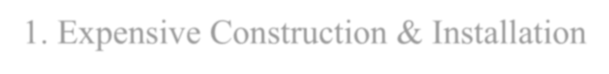Expensive Construction & Installation
2. Requires Regular Maintenance

1. System Breakdown

## PROPOSED SYSTEM

The proposed system is used by the user to reserve the parking slot. Here the user is able to reserve the car parking slot. Once he enter the slot the time period will get started later user leaves the slot he need to pay the amount for the period of time is placed his car in the slot area

System Design

The design of the system architecture describes the structure, behavior and views of the system and analysis. The goal of design is to produce a module of the system which is used to build the system. In the proposed system. Initially once the user enter into the parking he can view the real time parking slots that are available to park. After once he view the slot based on FIFO method the parking will get allocated to the users so once he selects the parking so he is able to reserve the parking area. So once he enters the parking area his parking time will get started, if the person will not take the car with in the selected time the alert message will gets. Then later he leave the area the time in and time out time will get calculated and the amount will be get paid.

# CHAPTER 3 SYSTEM REQUIREMENTS

_______________________________________________________________________________________

**SOFTWARE REQUIREMENTS**

ARDUINO IDE

## HARDWARE REQUIREMENTS

* ARDUINO UNO
* JUMPER WIRES
* INFRARED SENSORS
* 16*2 LED DISPLAY
* SERVO MOTOR

**ARDUINO UNO**

Arduino Uno is **an open-source microcontroller board developed by Arduino.cc**. It is based on the Microchip ATmega328P microcontroller. It is one of the most popular Arduino development board and is universally known as 'stock Arduino'. It is a small development board having size 2.7 in * 2.1 in.

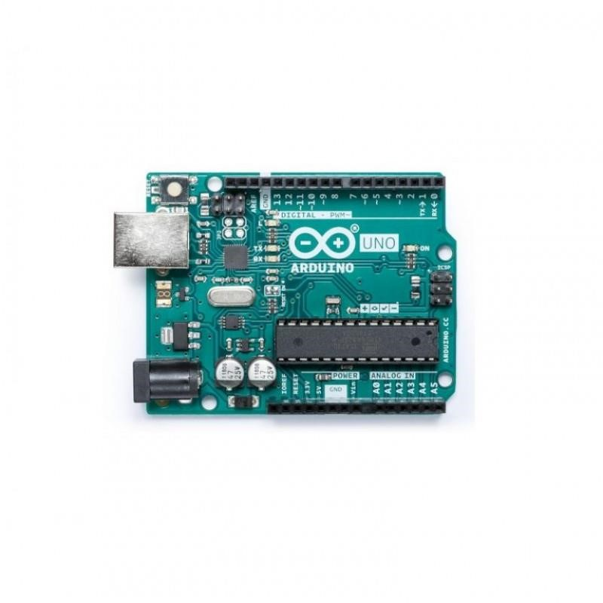

JUMPER WIRES

A jumper wire is an electric wire that **connects remote electric circuits used for printed circuit boards**. By attaching a jumper wire on the circuit, it can be shortcircuited and short-cut (jump) to the electric circuit.

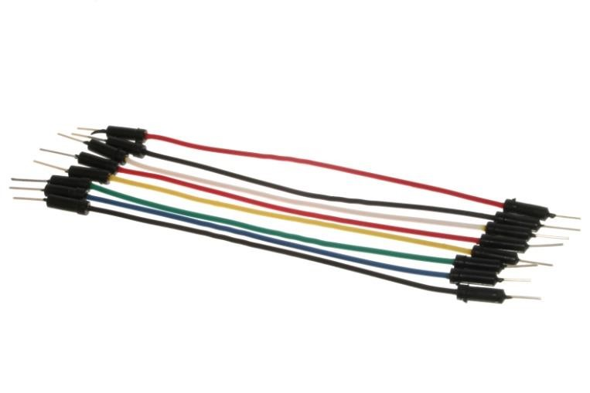

INFRARED SENSORS

An infrared sensor (IR sensor) is **a radiation-sensitive optoelectronic component with a spectral sensitivity in the infrared wavelength range 780 nm** … 50 µm. IR sensors are now widely used in motion detectors, which are used in building services to switch on lamps or in alarm systems to detect unwelcome guests.

Infrared sensors work **on the principle of reflected light waves**. Infrared light reflected from objects or sent from an infrared remote or beacon. Infrared sensors are also used to measure distance or proximity. The reflected light is detected and then an estimate of distance is calculated between sensor and object.

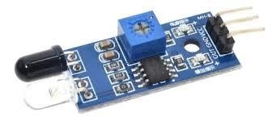

16*2 LED DISPLAY

A 16x2 LCD means **it can display 16 characters per line and there are 2 such lines**. In this LCD each character is displayed in 5x7 pixel matrix. The 16 x 2 intelligent alphanumeric dot matrix display is capable of displaying 224 different characters and symbols. This LCD has two registers, namely, Command and Data. It is one kind of electronic display module used in an extensive range of applications like various circuits & devices like **mobile phones, calculators,**  devices like **mobile phones, calculators, computers, TV sets**, etc. These displays are mainly preferred for multi-segment light-emitting diodes and seven seg**ments.**

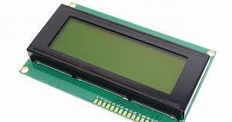

SERVO MOTOR

A servo motor is **an electromechanical device that produces torque and velocity based on the supplied current and voltage**. A servo motor works as part of a closed loop system providing torque and velocity as commanded from a servo controller utilizing a feedback device to close the loop.

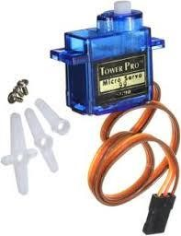

## CHAPTER 4

**SYSTEM DESIGN**

### CONCEPT DIAGRAM

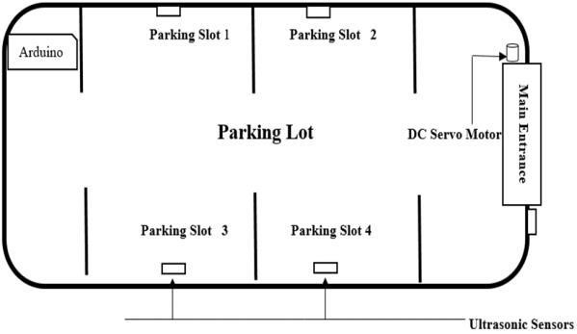

Above diagram shows the modular representation of the automated car parking lot. Here four (this number can be changed according to the demand of the parking slots) parking slots have been showed where ultrasonic sensors are placed. Outside the main entrance there is an ultra-sonic sensor to sense to presence of a car which is trying to make entrance inside the parking lot. The Arduino circuit is placed in a suitable place to which all the components are connected, and it is powered through a battery.

### FLOW CHART:

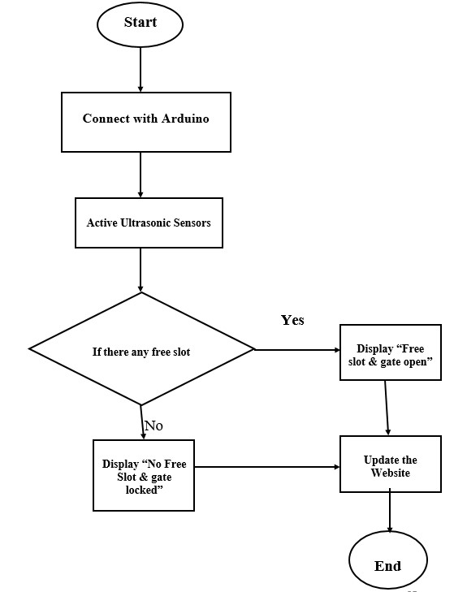

## CHAPTER 5

## MODULES

## 

### 

### MODULE-1: Gate Operation

* IR sensor is used at entry and exit gate to detect the car .
* The IR sensors are used to detect the parking slot availability**.**

### MODULE-2: Control module

* It contains everything needed to support the microcontroller.
* simply connect it to a computer with a USB cable or power it with a AC-to DC adapter or battery to get started.

# CHAPTER 6 SYSTEM IMPLEMENTATION AND TESTING _____________________________________________________

System implementation and deployment is the part in which the system will be implemented and deployed into real life to be used. The system can only be implemented and deployed when the system design and analysis is completed.

## IMPLEMENTATION

This model has the capacity of containing four cars. There are two sensors at the entrance to detect the presence of car before going inside or outside of the parking lot. The other sensors are plotted inside the parking lot to detect the car individually for each parking slot. A Servo motor has been used at the entrance to open and close the gate according to the signals sent by the sensors through Arduino.

The projection on the screen corresponds to the system model parking slots. This is a real time display regarding the status of the parking lot. The model of the parking lot has four parking slots. Thus, we can park maximum number of four cars through the system.

## TESTING

Different cases have been explained and showed through the pictures in the following sections. All those two pictures correspondent to each other while occurring an event. For example, when a car is on slot one the web is showing slot one is busy.

**Test Plans**

**Case 1 :**

In this case, if the parking slots are empty then the system will allow a car to enter into the parking lot.

**Case 2 :**

In this case, if there is only one car is parked inside the garage and rest of the slots are empty. Then, the system will allow a car to enter into the parking lot.

**Case 3:**

In this case , if two cars are parked inside the garage and rest of the slots are empty. Then, the system will allow a car to enter into the parking lot.

**Case 4:**

In this case, if three cars are parked inside the garage and only one slot is remained empty. Then, the system will allow a car to enter into the parking lot.

**Case 5:**

In this case, if four cars are parked inside the garage and there is no empty slot. Then, the sys-tem will not allow a car to enter into the parking lot.

# CHAPTER 7

# SOURCE CODE ________________________________________________

**LCD CODE**

// Arduino 16x2 LCD I2C Scanner

/*

Analog Pin 4 - SDA

Analog pin 5 - SCL

5V - Vcc

GND - GND

*/

#include <Wire.h> void setup() {

Wire.begin();

Serial.begin(9600);

Serial.println("\nI2C Scanner");

} void loop() { byte error, address; int Devices;

Serial.println("Scanning..."); Devices = 0;

for(address = 1; address < 127; address++ )

{

Wire.beginTransmission(address); error = Wire.endTransmission();

if (error == 0)

{

Serial.print("I2C device found at address 0x"); if (address<16) Serial.print("0");

Serial.print(address,HEX);

Serial.println(" !");

Devices++; } else if (error==4) {

Serial.print("Unknown error at address 0x"); if (address<16) Serial.print("0");

Serial.println(address,HEX);

} } if (Devices == 0)

Serial.println("No I2C devices found\n"); else

Serial.println("done\n"); delay(5000);

}

## SLOT ALLOCATION CODE

// AIT CAR PARKING

#include <Wire.h>

#include <LiquidCrystal_I2C.h>

LiquidCrystal_I2C lcd(0x27,16,2); //Change the HEX address

#include <Servo.h>

Servo myservo1;

int IR1 = 2; int IR2 = 4;

int Slot = 8; //Enter Total number of parking Slots

int flag1 = 0; int flag2 = 0;

void setup() { lcd.begin(16,2); lcd.backlight();

pinMode(IR1, INPUT); pinMode(IR2, INPUT);

myservo1.attach(3);

myservo1.write(100);

lcd.setCursor (0,0); lcd.print(" AIT ");

lcd.setCursor (0,1); lcd.print(" CAR PARKING ");

delay (2000); lcd.clear();

}

void loop(){

if(digitalRead (IR1) == LOW && flag1==0){ if(Slot>0){flag1=1;

if(flag2==0){myservo1.write(0); Slot = Slot-1;}

}else{ lcd.setCursor (0,0); lcd.print(" SORRY :( "); lcd.setCursor (0,1); lcd.print(" Parking Full "); delay (3000); lcd.clear();

}

}

if(digitalRead (IR2) == LOW && flag2==0){flag2=1; if(flag1==0){myservo1.write(0); Slot = Slot+1;}

}

if(flag1==1 && flag2==1){ delay (1000); myservo1.write(100); flag1=0, flag2=0;

}

lcd.setCursor (0,0); lcd.print(" WELCOME! "); lcd.setCursor (0,1); lcd.print("Slot Left: "); lcd.print(Slot);

}

# CHAPTER8

# CONCLUSION

**__________________________________________________________**

## CONCLUSION

The concept of Smart Cities has always been a dream for humanity. Since the past couple of years ago large advancements have been made in making smart cities a reality. The growth of Internet of Things and Cloud technologies have given rise to new possibilities in terms of smart cities. Smart parking facilities and traffic management systems have always been at the core of constructing smart cities. In this project, we address the issue of parking and present an IoT based Cloud integrated smart parking system. The system that we propose provides real time information regarding availability of parking slots in a parking area. Users from remote locations could book a parking slot for them by the use of our mobile application. The efforts made in this project are intended to improve the parking facilities of a city and thereby aiming to enhance the quality of life of its people

### 10.2 SCOPE FOR THE FUTURE ENHANCEMENT

* Several cities around the world are already beginning to trial self parking vehicles ,specialized AV parking lots and robotics parking valets.
* This project can be enhanced for tracking vehicle speed on the roads
* Developing a smart parking solution within a city solves pollution problem .
* Addition of Machine learning to store various other information of the vehicle like its color, design and number which would further add security