SERVER

A server is a computer or software system that provides services, resources, or data to other computers, known as clients, over a network. Servers are designed to handle specific tasks or functions, and they often operate 24/7 to ensure continuous availability. There are various types of servers, each serving different purposes. Here are some common types of servers:

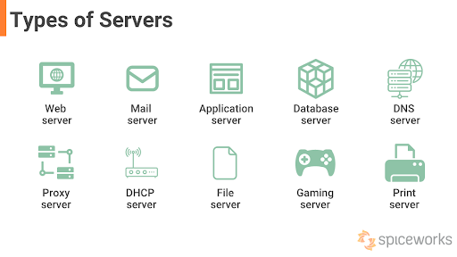

**Types of servers:**

**Web Server:** A web server is responsible for hosting websites and serving web pages to users' web browsers. Popular web server software includes Apache, Nginx, and Microsoft Internet Information Services (IIS).

**File Server**: A file server stores and manages files and provides access to them over a network. Users can upload, download, and manage files stored on the file server.

**Database Server**: Database servers store and manage databases, allowing clients to retrieve, update, or manipulate data. Examples include MySQL, PostgreSQL, and Microsoft SQL Server.

**Mail Server**: Mail servers handle email communication, both incoming and outgoing. They use protocols like SMTP (Simple Mail Transfer Protocol) and IMAP (Internet Message Access Protocol) to send and receive emails.

**Print Server:** A print server manages printers and allows multiple users to share printing resources over a network. It can handle print jobs and manage print queues.

**Application Server**: Application servers run applications and provide services to clients. They are often used in enterprise environments for business applications. Java EE and .NET are examples of platforms for developing application server-based applications.

**Proxy Server:** A proxy server acts as an intermediary between clients and other servers. It can be used for various purposes, including caching web content, improving security, and load balancing.

**DNS Server**: DNS (Domain Name System) servers resolve domain names into IP addresses, making it possible for users to access websites and services using human-readable names.

**FTP Server:** An FTP (File Transfer Protocol) server allows the transfer of files between clients and the server. It's commonly used for uploading and downloading files.

**Game Server**: Game servers host online multiplayer games, allowing players to connect, interact, and play together. They require low-latency connections to provide a smooth gaming experience.

**Backup Server**: Backup servers manage data backups and ensure data recovery in case of data loss or system failures.

**Virtualization Server**: Virtualization servers run virtual machines, allowing multiple operating systems to run on a single physical server. This helps optimize resource utilization and server management.

